Commentary: You are required to write ONE commentary of 1000 words, on a documentary or visual source. You may select your own passage on which to comment but you should do so in consultation with the module co-ordinator and ensure that you do not repeat material you use in your essay. Please upload this as assignment 2 on Moodle.

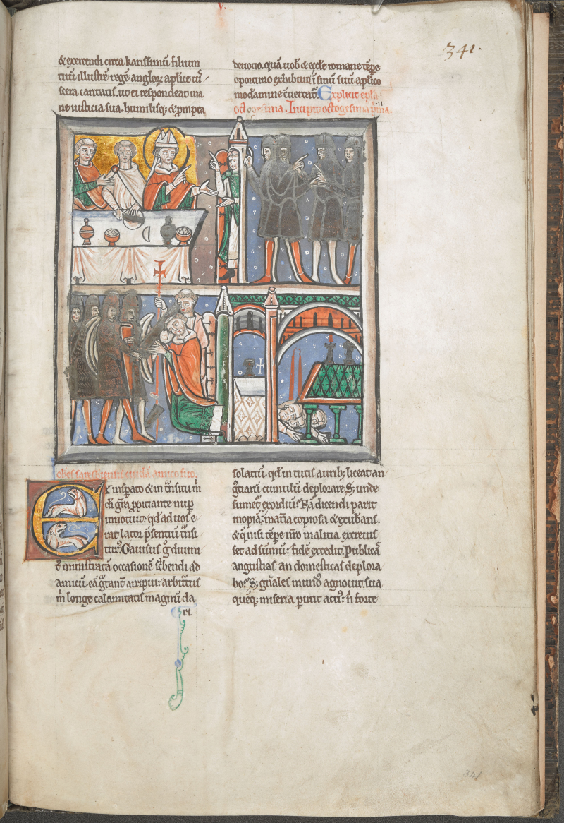

Thomas Becket was murdered in Canterbury Cathedral on the 29th of December in 1170. His murder, which led to him becoming a venerated saint, is considered to one of the most brutal murders of a Saint. Although there had not been a lot of material of manuscripts which contained the writings of Thomas Becket, in the 12th century, Alan of Tewksbury put together a manuscript, in which writings from Thomas Becket, this collection is earlier than John of Sailisbury’s collection, This visual source comes from a Thomas Becket manuscript, and is a visual depiction of the murder of Thomas Becket. Along with this image, there is a piece of document which gives a detailed account of the murder. This detailed account comes from one of Becket’s biographers; Edward Grim, a clerk who was visiting from Cambridge who tried to save Becket, even though when the murder took place, there were others in the Cathedral, such as John of Salisbury, William FItzStephen, Benedict of Peterborough and William of Canterbury.
In the source, it is a manuscript document which is split into four parts which show the scene of Thomas Becket’s murder. In the first part of the source, it depicts the knights of Henry II to be at the doors of Canterbury Cathedral, whilst inside the Cathedral, Becket recides. Becket himself is depicted with a golden halo around his head, which held great symbolic meaning in the middle ages. Gold was considered to be a colour of the divine. The colour gave a message of spiritual awareness, which connected them to God. In manuscript documents, ’Halos were golden most of the time’. Therefore, the fact that this colour has been used to surround Becket could hint to the fact that he was seen as a saintly figure, even when he was alive, or as Grim writes about Becket, he was an ‘invincible martyr’.
The second part of the visual source shows the knights entering Canterbury Cathedral, and according to Grim’s account, one of the knights is supposed to have said, ‘"Where is Thomas Becket, traitor of the king and kingdom?”, “Where is the archbishop?"’. Becket is said to have replied, ‘"The righteous will be like a bold lion and free from fear,”‘, “Here I am, not a traitor of the king but a priest; why do you seek me?”,’ “Here I am ready to suffer in the name of He who redeemed me with His blood; God forbid that I should flee on account of your swords or that I should depart from righteousness."’ This narration corroborates what historians’ have believed about the lead up to Becket’s death. Grim’s account depicts Becket to be a man who refused to show fear in the face of his own death. He also refused to leave Canterbury Cathedral, despite the fact that Henry II’s knights attempting to drag him out of the church.
In the third of the manuscript, Becket is wearing his Archbishop robes. This is significant as it shows that the knights are attacking the most important religious figure in England. Becket is posied in the prayer position, and Edward Grim is covering Becket with his own body, in an attempt to stop the blows of the swords upon Becket. Grim wrote that the ‘the impious knight’ lost his patience and temper with Becket and attacked him. Grim described the attack in great detail. The knight is supposedly to have proceeded to cut off the ‘summit of his crown which the sacred chrism consecrated to God, he wounded the sacrificial lamb of God in the head.’ In Grim’s writings, he even writes about his own attack whilst attempting to save Becket. ‘[Grim] lower arm of the writer was cut by the same blow. Indeed [the writer] stood firmly with the holy archbishop, holding him in his arms - while all the clerics and monks fled - until the one he had raised in opposition to the blow was severed.’. Although both visual and textual manuscript documents back up the idea that Grim was loyal to Becket, it could also be argued that Grim wanted it to be known that he, tried to defend Becket.
Grim writes that Becket did not fall to his knees until the third blow, and even while succumbing to his wounds, Becket is supposedly to have said, , ‘"For the name of Jesus and the protection of the church I am ready to embrace death."’. One of the knights proceeded to cut Becket’s head off, and according to Grim’s account, Becket’s ‘blood turned white from the brain yet no less did the brain turn red from the blood; it purpled the appearance of the church with the colours of the lily and the rose, the colours of the Virgin and Mother and the life and death of the confessor and martyr.’ Grim’s account adds that there was another man who came with the knights, and who also assisted in killing Becket, a cleric named Hugh de Horsea, and it was he who dealt Becket the fifth blow which ended Becket’s life, and scattered Becket’s ‘brains with the blood across the floor’,‘“We can leave this place, knights, he will not get up again."’
The fourth and last part of the visual image is a depiction of Canterbury Cathedral becoming a place of Pilgrimage for Thomas Becket. It depicts men lying underneath the tomb of Thomas Becket, with people, who are thought to be pilgrims, coming to see the tomb. Grim’s account supports this notion. Grim even compares Becket to Jesus Christ as Jesus ‘dying for our sins’ is similar to Becket dying to protect others. Many historians believe that Becket ‘offered himself for the murder when it was made clear that for his salvation and faith this martyr should fight for the protection of others so that the affairs of the church might be managed according to its paternal traditions and decrees’. Historians are dubious about Becket, as many believe that Becket knew what was going to happen, and some believe that he could have escaped, but that Becket embraced the idea of becoming a martyr and chose that path instead.

Bibliography
Primary
Alan of Tewkesbury, Cotton MS Claudius B II, f. 341r (4th quarter of the 12th century) <http://www.bl.uk/manuscripts/Viewer.aspx?ref=cotton_ms_claudius_b_ii_f341r> [accessed 16 January 2020].
Grim, Edward in Vita S. Thomae, Cantuariensis Archepiscopi et Martyris, ed. in James Robertson, Materials for the Life of Thomas Becket, (London: Rolls Series, 1875-1885) (7 vols.) Vol. II.

Secondary
Alexander, James W. , 'The Becket Controversy in Recent Historiography', Journal of British Studies, Vol. 9, .No. 2 , (1970), pp. 1-26 (p. 6), in <http://www.jstor.org/stable/175153> [accessed 22 January 2020].
Artelisa, Symbolism of Color, Medieval: Red, Blue, White and Gold History of Color # 4 (Sunday, March 25, 2012) <http://artelisaart.blogspot.com/2012/03/history-of-color-4-symbolism-of-color.html> [accessed 7 January 2020].
Simkin, John, Edward Grim (2016) <https://spartacus-educational.com/NORgrimm.htm> [accessed 10 January 2020].

Simkin, John, Edward Grim (2016) <https://spartacus-educational.com/NORgrimm.htm> [accessed 10 January 2020].
Alan of Tewkesbury, Cotton MS Claudius B II, f. 341r (4th quarter of the 12th century) <http://www.bl.uk/manuscripts/Viewer.aspx?ref=cotton_ms_claudius_b_ii_f341r> [accessed 16 January 2020].
Artelisa, Symbolism of Color, Medieval: Red, Blue, White and Gold History of Color # 4 (Sunday, March 25, 2012) <http://artelisaart.blogspot.com/2012/03/history-of-color-4-symbolism-of-color.html> [accessed 7 January 2020].
Grim, Edward in Vita S. Thomae, Cantuariensis Archepiscopi et Martyris, ed. in James Robertson, Materials for the Life of Thomas Becket, (London: Rolls Series, 1875-1885) (7 vols.) Vol. II.
Grim, Edward in Vita S. Life of Thomas Becket, (London: Rolls Series, 1875-1885)
Grim, Edward in Vita S. Life of Thomas Becket, (London: Rolls Series, 1875-1885)
Grim, Edward in Vita S. Life of Thomas Becket, (London: Rolls Series, 1875-1885)
Grim, Edward in Vita S. Life of Thomas Becket, (London: Rolls Series, 1875-1885)
Grim, Edward in Vita S. Life of Thomas Becket, (London: Rolls Series, 1875-1885)
Grim, Edward in Vita S. Life of Thomas Becket, (London: Rolls Series, 1875-1885)
Grim, Edward in Vita S. Life of Thomas Becket, (London: Rolls Series, 1875-1885)
Grim, Edward in Vita S. Life of Thomas Becket, (London: Rolls Series, 1875-1885)
Grim, Edward in Vita S. Life of Thomas Becket, (London: Rolls Series, 1875-1885)

