ASSESSMENT 1: BLOGGING TO COMMUNICATE

Marian Florin Filip

Marketing Fundamentals (LCBB4004)
Riaz Bhatti
University of Wales Trinity Saint David
London
3 January 2022

Table of Contents
Introduction 3
Blog Post 1: Eradicating Conventional Applications 3
Blog Post 2: The Microsoft Cloud Deal 5
Blog Post 3: Hardware 6
Blog Post 4: Remote Working Strategy 7
Blog Post 5: Improving Customer Experience 9
Blog Post 6: Cloud Computing Benefits 10
Conclusion 11
Bibliography 12

Introduction

https://www.weforum.org/organizations/centrica-plc
Centrica exists as the largest electricity and gas company in the United Kingdom.
Currently, the company boasts a market share of around 26 percent and employs approximately
29,500 people (Bennett 2020). The company serves more than 26 million customers in North America, Ireland, and the UK through its brands, including Bord Gáis Energy, Direct Energy, and British Gas (Bennett 2020). Recently, Centrica has undertaken a cloud migration project to boost its profitability and competitiveness within the globalized energy market. The management team also considers that replacing conventional applications with cloud-based applications would create benefits like increased productivity, cost-saving, and improved performance. Therefore, the management team has relied on blog posts in communicating crucial elements and benefits of cloud-based applications adoption.

Blog Post 1: Eradicating Conventional Applications
Nowadays, multinational companies have experienced serious challenges in handling huge data quantities using conventional applications. For example, Centrica struggled to handle the data spikes associated with its rapid expansion and increasing customer population. The data management problem normally presents in its contact centers during bad weather incidents (Babic, 2021). At this point, cloud migration occurs as an inevitable strategy for solving our data management problem.
You should understand that a cloud-based system serves as a scalable and responsive platform for the company. We have already made important steps in integrating cloud-based technologies with its customer service and human resource management. Particularly, Centrica has utilised an agile methodology in deploying a virtual workplace platform within five months. The cloud migration procedure allowed approximately 18,000 people to access our virtual workplace platform (Bennett 2020).
So, how has the cloud migration project influenced Centrica’s brands? Answering this question requires a person to understand that Centrica business encompasses North American business, distributed power and energy, UK business, central power generation, and energy marketing. Our strategic framework revolves around energy solutions, energy supply, energy optimization, energy insight, and wholesale energy. Centrica serves customers in these fields through its brands, including Bord Gáis Energy, Direct Energy, and British Gas.
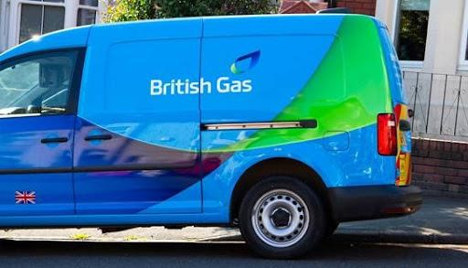
http://iftelsl.com/2021/06/20/centrica-selects-cognizant-as-its-sap-transformation-partner/ Image 3: British Gas Brand
Therefore, cloud computing technology has allowed Centrica to strengthen its brands.
The company has improved its brand image through an improved customer service strategy. For example, cloud-based systems now allow customers to access its services and products remotely.
We have further relied on cloud computing technology in managing our different outlets.

Blog Post 2: The Microsoft Cloud Deal
The cloud migration project for Centrica has involved transferring operations to the public cloud. In this regard, partnering with Microsoft Corporation has enabled the company to access cloud services like Office 365, Dynamics 365, and Microsoft Azure. Centrica’s management team considers that cloud migration addresses conventional IT constraints
(Forsdick 2021). At this point, a question may be raised regarding Centrica’s decision to acquire a public cloud instead of creating a private cloud.
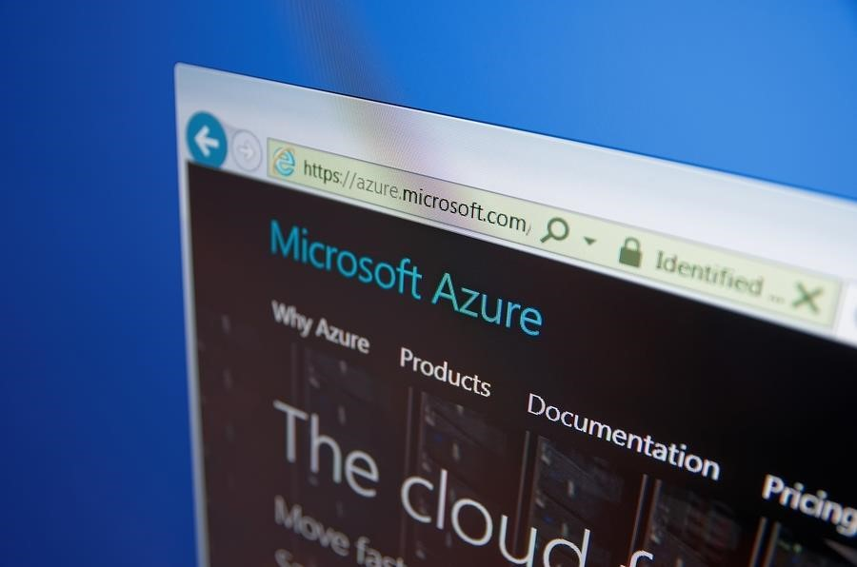
https://www.cloudpro.co.uk/it-infrastructure/6890/centrica-to-deploy-azure-and-office-365
Image 1: Microsoft Azure
Notably, public clouds offer companies benefits like reduced operation costs, nearunlimited scalability, and low integration cost. The public cloud is cheap, considering that the user does not need to buy software and hardware (FUJITSU, 2021). Instead, the user only needs to pay for services offered in the public cloud. Users incur minimal operation costs since public cloud providers perform upgrades or maintenance of their platform. Furthermore, the public cloud has near-unlimited scalability since it provides resources that effectively meet organisational needs.
Hence, it is undeniable that partnering with Microsoft has offered Centrica numerous benefits. Microsoft Azure cloud offers the company agility and speed that improves customers’ engagement. The platform supports the company in optimising operations, empowering employees, and transforming offerings. For example, adopting cloud-based systems like
Dynamics 365 and Office 365 serves as a crucial employees’ empowerment strategy.
Eventually, the cloud migration has supported Centrica company in improving service delivery and improving employees’ experience. Using Office 365 has supported us in empowering its global workforce. Transferring data to Microsoft Azure has enabled the company to digitise its operation in a manner that improves customer experience. Investing in Dynamics 365, Office 365, and Microsoft Azure has enabled Centrica to add value to its customers and employees.

Blog Post 3: Hardware
Centrica company understands that hardware acquisition serves as a crucial stage in the cloud migration process. As a result, we have partnered with HP company in our $400 million cloud migration project (HP 2011). We expect HP to move us to utility- and cloud-based computing in a manner that improves environmental stewardship, reduces operation costs, and promotes flexibility. Collaborating with HP in the cloud migration project promotes cost reduction, improves deployment speed, supports change management initiative, and enhances environmental sustainability.
Why do you think partnering with HP is an important initiative for the Centrica company? Answering this question requires an individual to comprehend Centrica’s response to the current market issues. For instance, you should understand that a cloud-based system has improved the company’s capacity to address changes occurring in electricity and gas markets today (HP 2011). At this point, the company values HP cloud-computing facilities due to flexibility, carbon footprint reduction capacity, and cost-effectiveness.
Centrica considers that collaborating with HP can support the migration process to a private cloud. The move indicates that the management team understands that a private cloud can facilitate long-term goals accomplishment. A private cloud offers us benefits like increased security, improved flexibility, reduced costs, enhanced resource utilisation, and regulatory compliance. For instance, we understand that improved flexibility can support the company in addressing the existing market dynamism.
HP offers Centrica next-generation technology that suits its cloud computing needs with minimal environmental impact and operation cost. Creating a private cloud using HP technological resources can support the company in creating services and products that boost customer satisfaction. In particular, improved data management can support us in improving customer care across our different outlets.

Blog Post 4: Remote Working Strategy
Centrica company understands that cloud computing technology can support its remote working initiative. Specifically, the remote working initiative has enabled the company to continue operating during the COVID-19 pandemic period. The tactic has allowed us to continue supplying our global customers with energy solutions and services during the pandemic. At this juncture, I know that you may be curious to understand our remote working initiative.
In this regard, you should understand that our remote working initiative during the pandemic involved moving 15,000 workers to the virtual workplace. We understood that moving a huge employee population to the virtual workplace would generate numerous challenges.
However, the pandemic forced the company to become agile in addressing customers’ needs while protecting them from infections. Embracing remote work strategy further required the management and employees to change their thinking and operational practices.
The company’s remote work strategy received huge support from the cloud migration process that occurred before the pandemic. Markedly, Centrica adopted the Citrix cloud platform immediately before the Covid-19 pandemic to create a virtual workplace for its employees (Forsdick 2021). Acquiring the cloud computing platform enables us to deploy desktops and cloud-hosted applications to our employees. The VPN migration to a cloud solution from an onpremise platform enabled the company to improve service delivery in North American and European markets.
The flexibility associated with the remote work strategy improved our service delivery process. For instance, we now have the capacity to handle home service calls and serve our clients. We can conclude that the pandemic provided a lesson about the significance of flexibility in serving our global customers. The pandemic has further highlighted the significance of simplifying processes, adopting change quickly, and investing in IT infrastructure. Currently, we have ensured that our workforce has the right technology to serve our global client population continuously.

Blog Post 5: Improving Customer Experience
Centrica company relies on cloud computing technology in improving the global customer experience. We understand that the cloud computing platform has improved service delivery in our North America, Ireland, and UK outlets. Using Citrix and Windows cloud computing platform supports us in offering high-quality services to our clients (Citrix 2021). We have accomplished the goal by improving connectivity with our clients in different geographical locations.
Centrica has relied on cloud computing technology in combining its various businessfacing units. For instance, we have focused on implementing our North American Business in the UK market to improve customer service. I understand that the North American Energy Portfolio empowers our customers to procure energy proactively and comprehend the energy market (Microsoft 2020). Our major goal is to establish a single portal that addresses five customer service pillars, including knowledge base usage, proactive support team, channel variety, customer satisfaction, and customer relationship management.
We understand that empowering employees can encourage them to offer better services to our clients. Our employee empowerment tactic revolves around the adoption of effective cloud computing platforms like Microsoft Office 365 and Microsoft Azure. Cloud computing technology enables our employees to communicate effectively with clients and escape workplace stressors. Improving the workplace experience encourages employees to protect the interests of the company’s employees.
We have observed that the cloud computing technology has supported us in transforming the end-user experience. Relying on the technology has supported the company in improving customer experience. For example, customers can view various services and products displayed

on the company’s website. Displaying these products and services on the website supports clients in making informed purchasing decisions. Acquiring high quality platform enables customers to acquire information quickly, which reduces times spent during online purchasing. High performing platforms supports the company in offering quick services to its customers in different energy markets.

Blog Post 6: Cloud Computing Benefits
The successful cloud migration process for the Centrica company is the source of our pride. We understand that acquiring cloud computing system serves as a mutually beneficial project for the company and its key stakeholders. Notably, we understand that stakeholder protection serves as a crucial strategy for addressing challenges associated with the globalised market. So, we cannot ignore the fact that cloud migration is an inevitable business survival strategy in the 21st Century.
Microsoft Azure acquisition represents a complex project that has offered Centrica company benefits like transparency, improved marketing, reduced operational cost, enhanced performance, and zero business interruptions. For instance, a single application has reduced
Centrica Trading’s operation cost by approximately 70 percent (Avanade Inc. 2020). The increased transparency is associated with the presentation of infrastructural costs on daily basis instead of processing monthly bills only. We understand that the transparency facilitates new ideas generation in regard to customer satisfaction and welfare optimisation.
Improved marketing and performance benefits the company and its clients. The cloud computing system has supported the company in standardising and simplify its desktop while enhancing cost savings and flexibility. The company relies on its standardised system in relaying crucial information about its services and products. Using the cloud technology enables the company to reduce operational cost which facilitates the reduction of product and services prices. The strategy makes the products highly affordable among its clients, which facilitates the creation of a huge loyal customer base.
The benefits associated with the cloud computing system justified the efforts the management put in addressing different challenges. Our company experienced various challenges during the cloud migration, including Centrica Trading interruption and change resistance. First, the company relied on the agile methodology in migrating multiple cloud applications simultaneously without creating outages. Surprisingly, the company migrated several applications in a day without experiencing disruption. The company further trained employees and communicated changes to prevent change resistance.

Conclusion
Centrica is a major electricity and gas company that understands the cloud computing platforms’ capacity to increase its profitability and competitiveness. Utilising blog posts enables the company to offer the public comprehensive details about its cloud-based applications. The cloud migration tactic has supported the company in addressing inefficiencies associated with conventional data management systems. Combining public and private cloud systems enables the company to improve work processes and customer service. Therefore, the company has collaborated with HP and Microsoft companies in promoting access to hardware and cloud-based applications, respectively. The cloud computing technology has supported the company in improving customer experience and supporting remote working process.

Bibliography
Avanade Inc., 2020. Centrica Trading becomes one of the first energy trading companies in
Europe to move its data center applications to the cloud. Avanade Inc. https://www.avanade.com/-/media/asset/centrica-case-study.pdf?la=en&ver=1
Babic, P., 2021. Co-creating an agile, global, virtual desktop environment. Centrica. https://www.fujitsu.com/uk/imagesgig5/CS_2020Apr_Centrica-Citrix.pdf
Bennett, R., 2020. Centrica operations are boosted by development of cloud-based system.
Information Age. https://www.information-age.com/centrica-operations-boosteddevelopment-cloud-based-system-123488491/
Citrix, 2021.Centrica. Citrix.com. https://www.citrix.com/de-de/customers/centrica-plc-en.html Forsdick, S., 2021. How a cloud-first strategy helped Centrica adapt to pandemic challenges.
Global Intelligence for Digital Leaders. https://www.icio.com/strategy/digitalization/item/how-a-cloud-first-strategy-helped-centrica-adapt-topandemic-challenges
FUJITSU, 2021. Centrica: Fujitsu EMEIA. Fujitsu Global: Fujitsu Global IT services and solutions. https://www.fujitsu.com/emeia/about/resources/case-studies/cs-2020aprcentrica-citrix.html
HP, 2011. Centrica selects HP for $400 million technology migration. HP.
https://www.hp.com/us-en/hp-news/press-release.html?id=871822#.YZtPetBBzIV
Microsoft, 2020. Centrica boosts end-user computing and customer experience with Windows virtual desktop and Citrix. Microsoft Customers Stories. https://customers.microsoft.com/en-au/story/825324-centrica-azure

