Programme: Applied Computing
Module: Advanced Cybersecurity.
Module Code: ACCB6000
Lecturer: Dr. Mohammed Ghanem
(Assignment Title: Analysing, Ethically Hacking and
Securing an Enterprise Networ)
Submitted by: Md Gulam Hafiz,
Student ID: 2232603
University of Wales Trinity Saint David
London.

December 10, 2025

Table of Contents
Task 1: 1
Network Test: 1
Task 2: 8
2.2: Vulnerability assessment 12
Task 3: 19
Evaluation of Ethical Hacking in SWANSEA.ACCA 19
Introduction: 19
Conclusion: 27
Reference: 28

Task 1:
Virtual machines imported according to the assignment guideline and configured and tested them. See bellow all virtual machines are running and ping to each other.

Network Test:
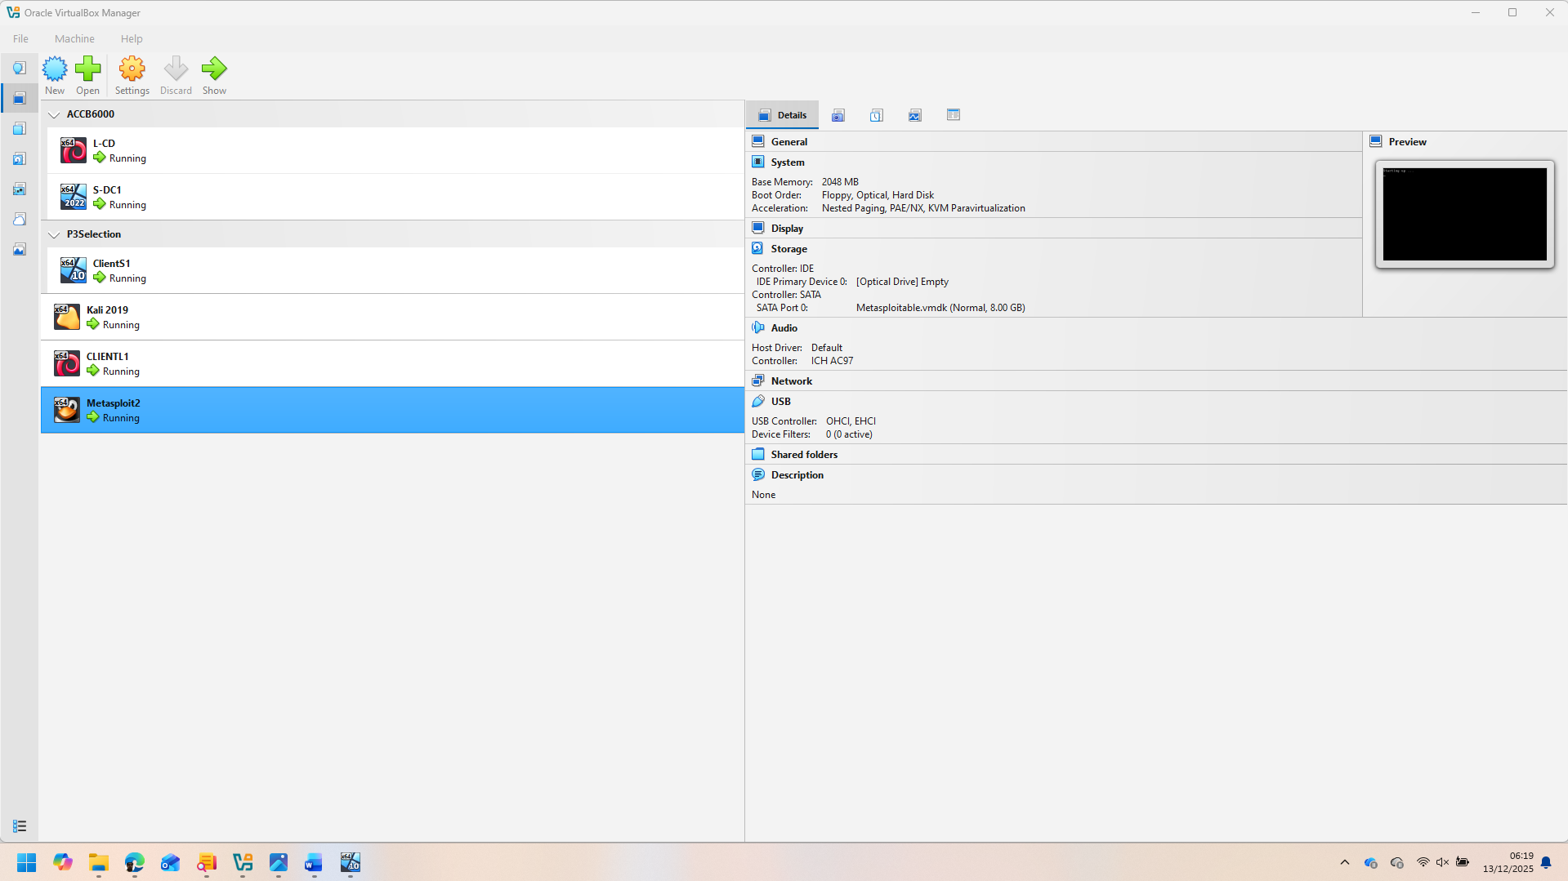
Photo of All machines in Linux Virtual Box
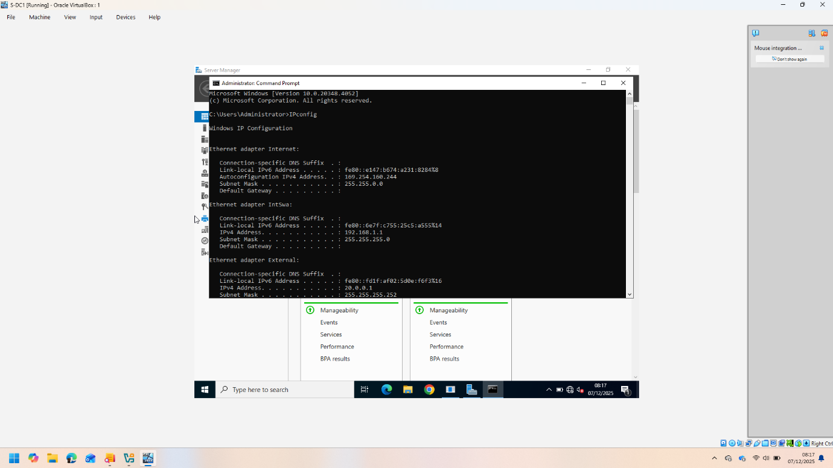
Figure 1(IP configuration of S-DC)
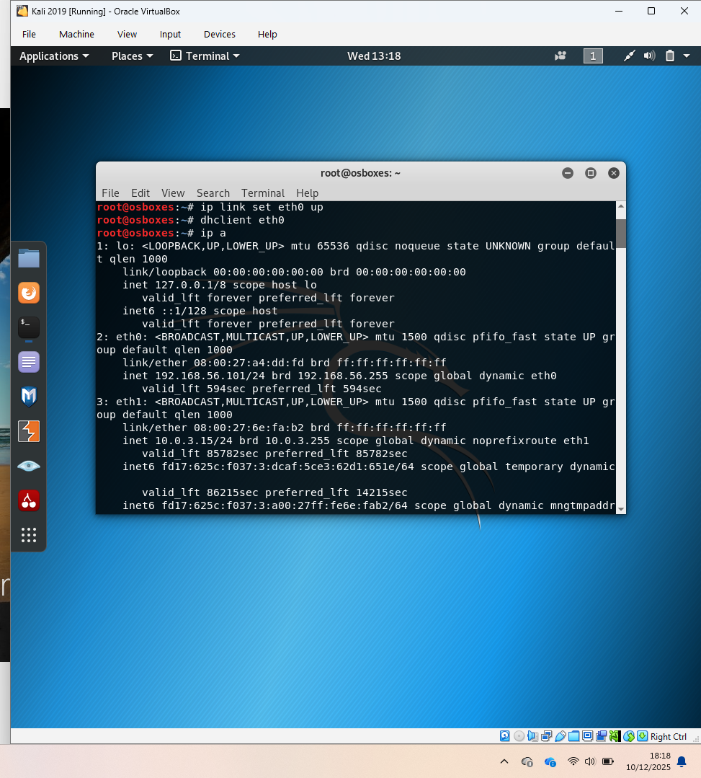
Figure:2 (IP configuration of Kali)
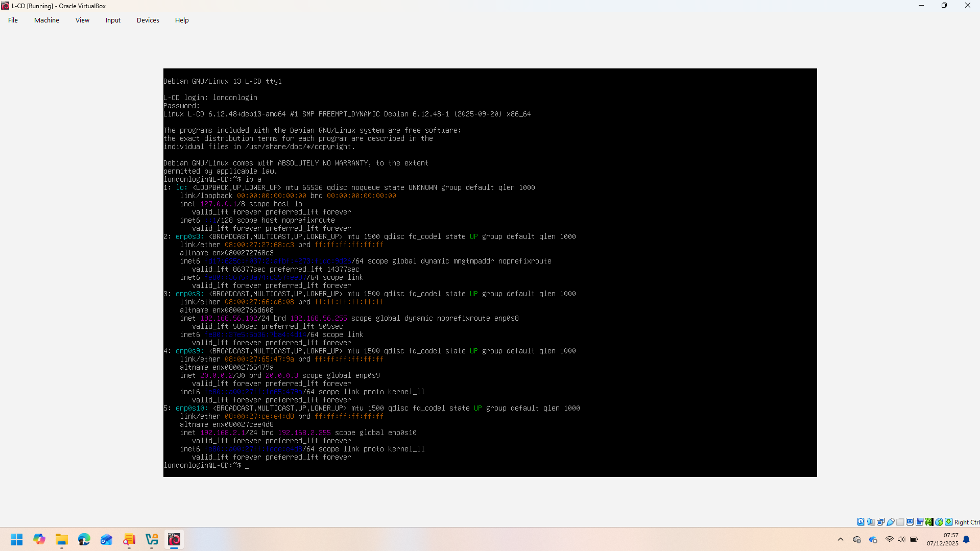
Figure:3 (IP configuration of L_Cd).
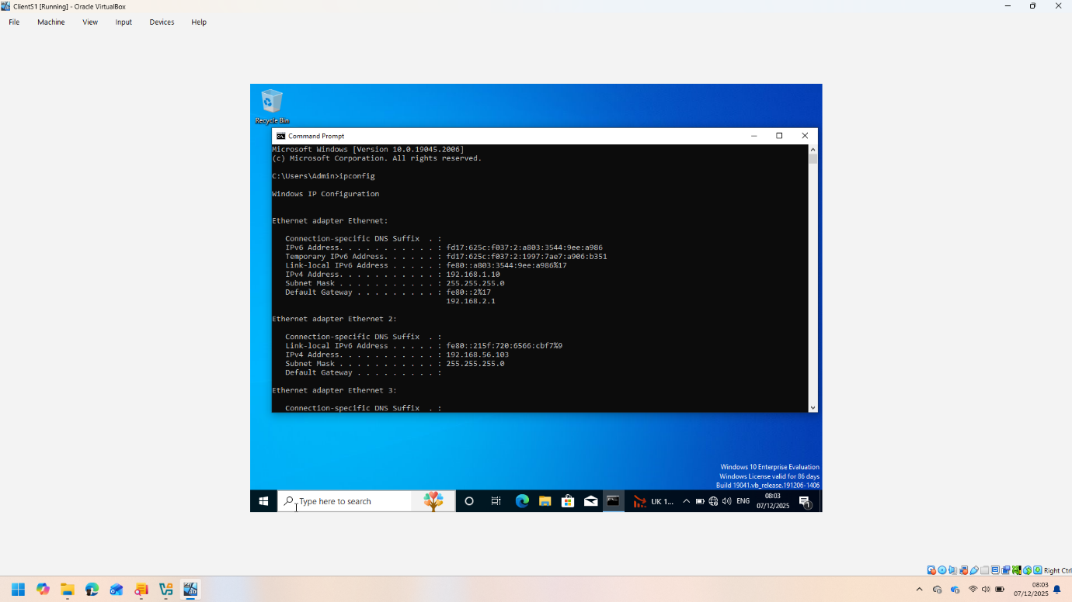
Figure:4 (IP configuration of ClientS1).
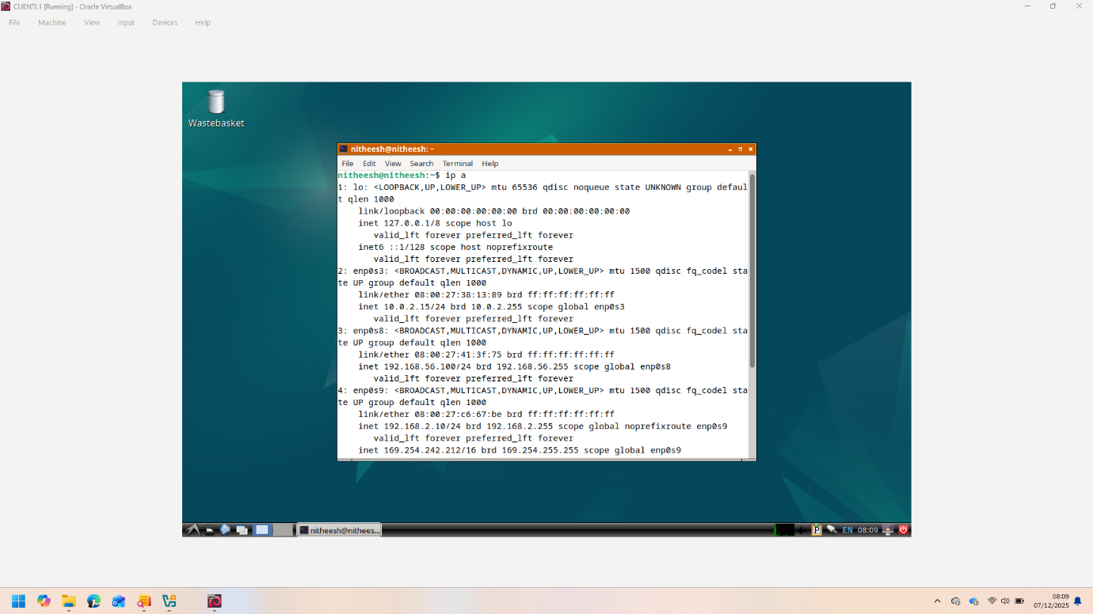
Figure:5 (IP configuration of ClientL1)
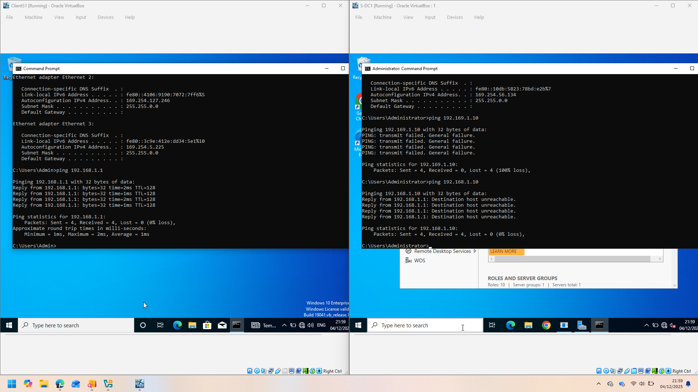
Figure:6(Ping between S_DC and ClientS1).
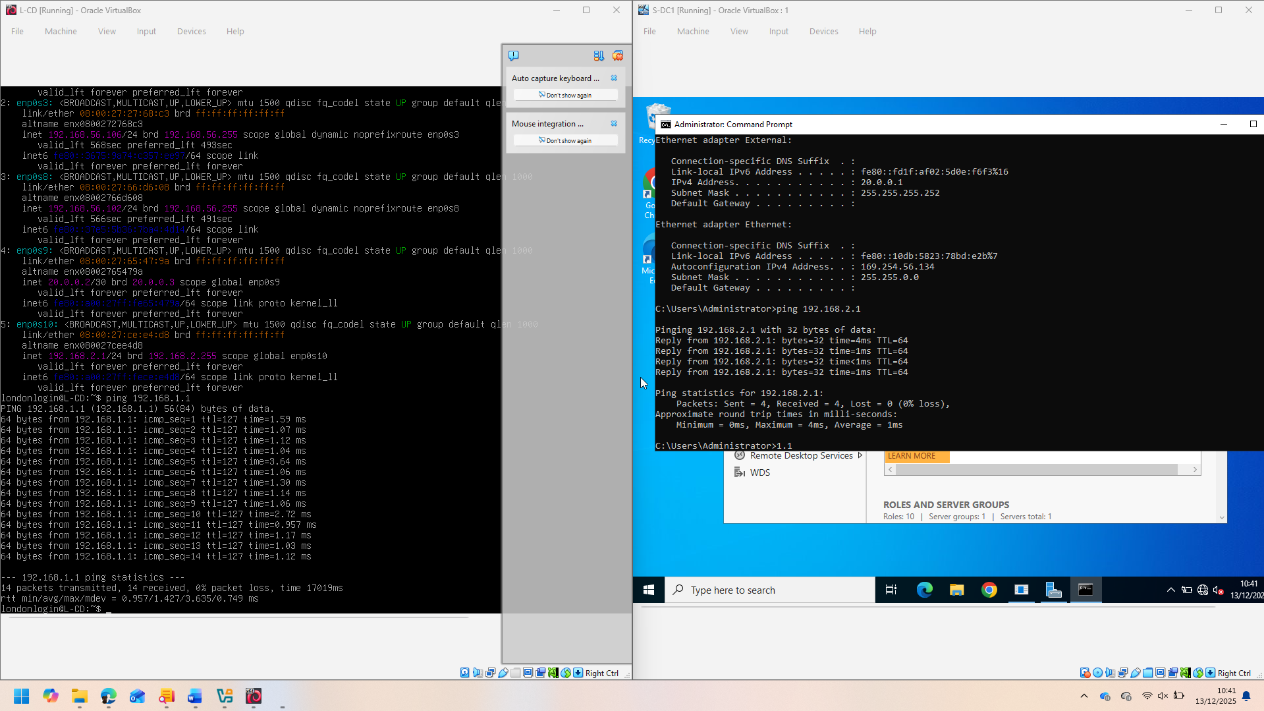
Figure:7 (PING S-DC and L-DC).
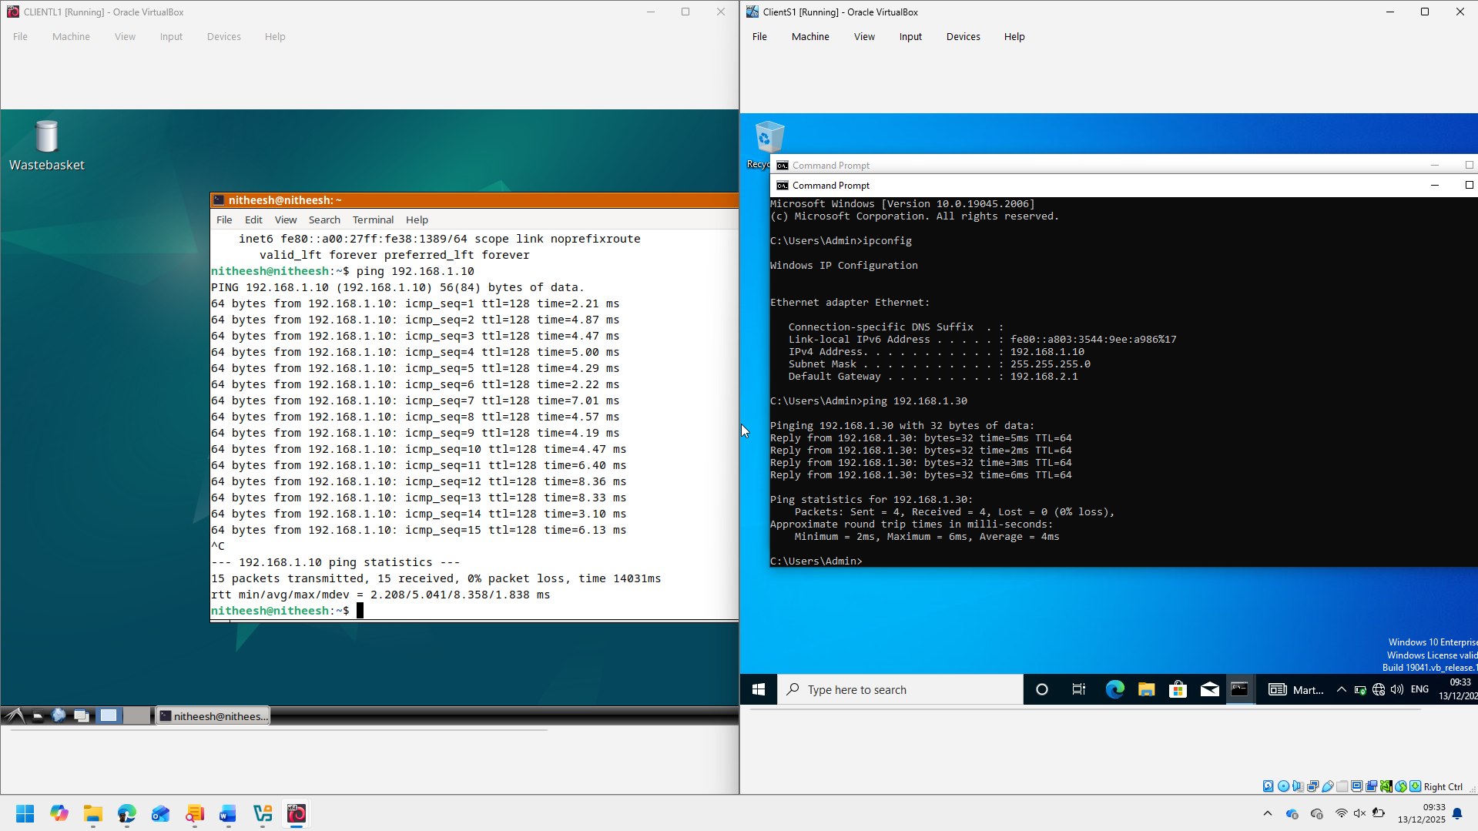
Fig:8(ClientS1 and ClientL1).
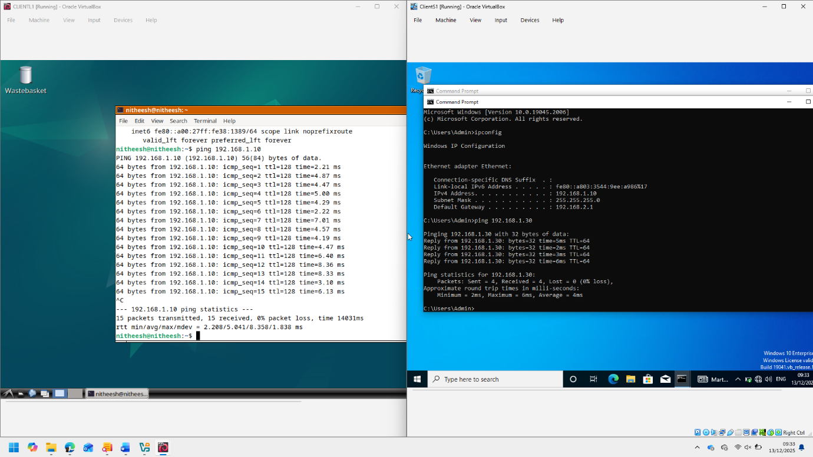
Fig:9(Ping ClientS1 and ClientL1).
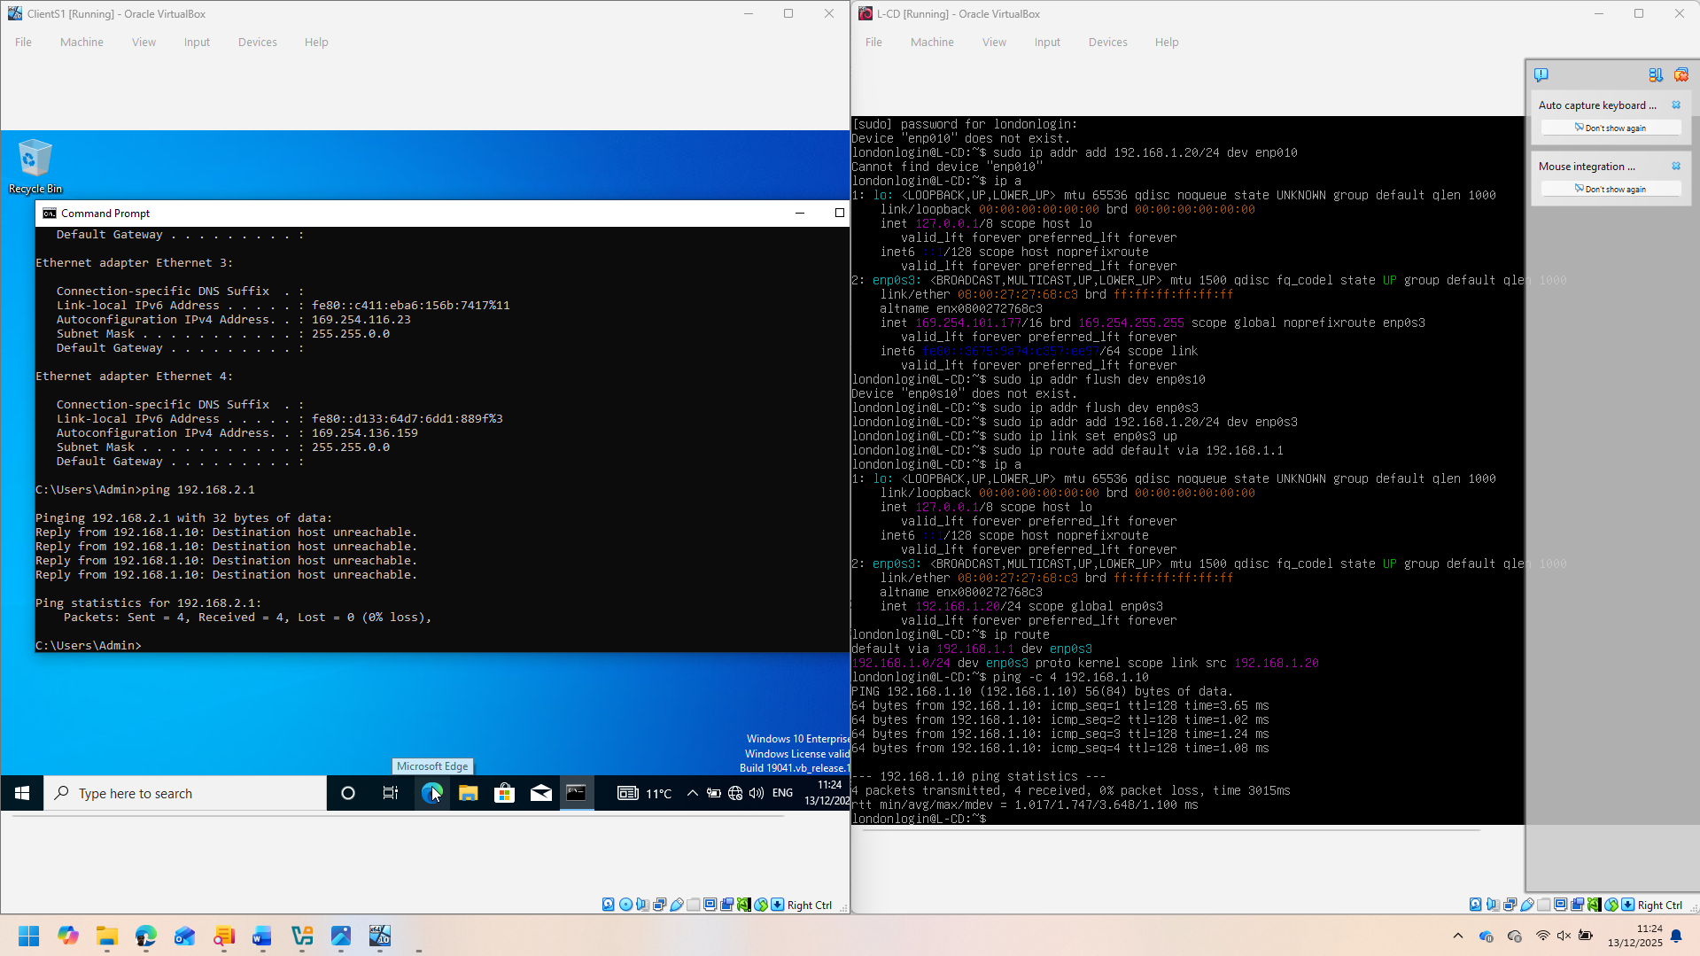
Fig:10(Ping L-CD and ClientS1).
Fig:11(ping L-CD and S-DC).
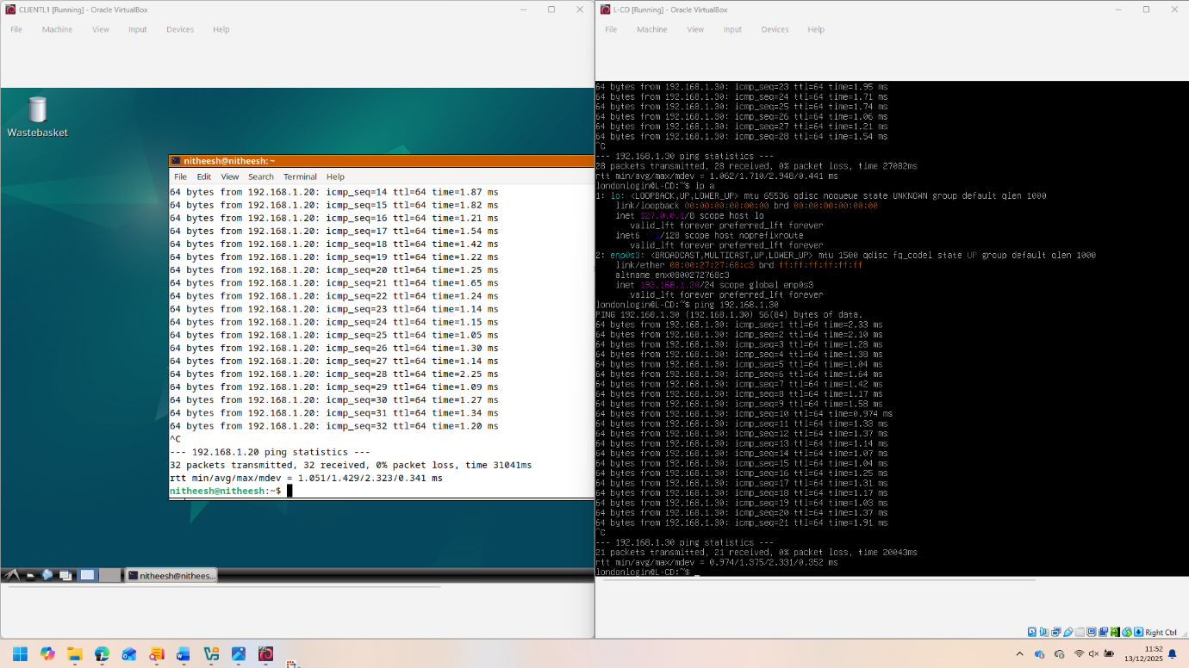
Fig:12 (Ping L-CD and ClientL1).

Task 2:
  - Network Security Assessment of Swansea. ACCA Network.

2.1 A security centric operative system has been deployed by following the guideline of the recognised cyber security framework like Nist.
To evaluate the weaknesses of the network Kali Linux has been used which is equipped with effective tools like: Nmap, Nessus, Metasploit and Wireshark.

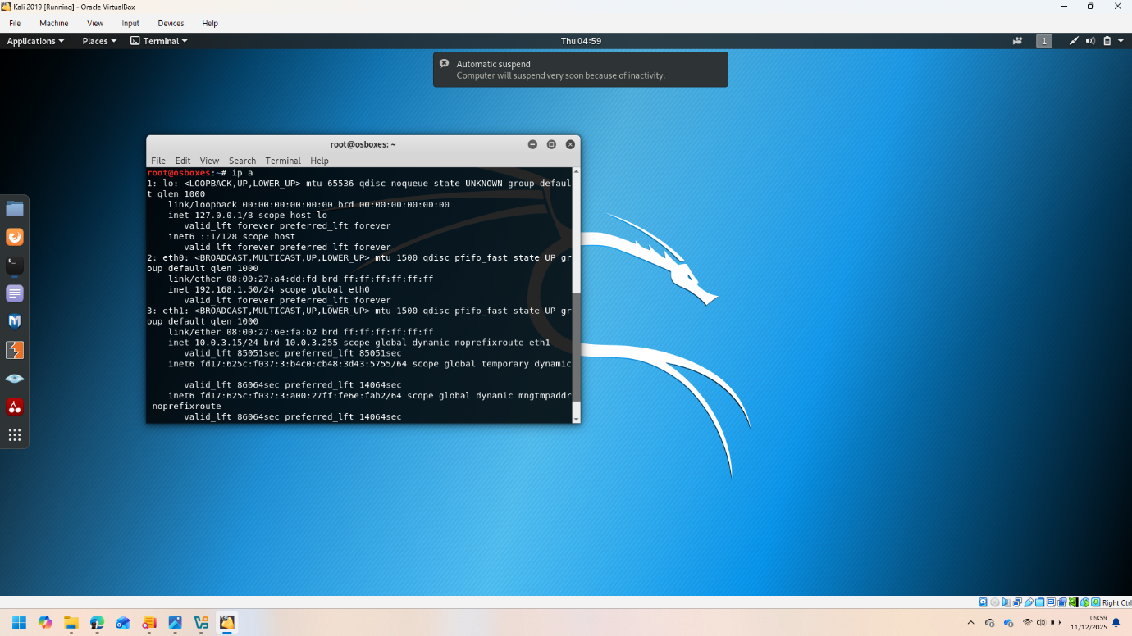
Kali 2019 IP configuration.
The connectivity has been tested across the network. See below the screenshots of successful connectivity.
- S_DC and ClientS1 successful connection,
2: S-DC and ClientL1 connection:
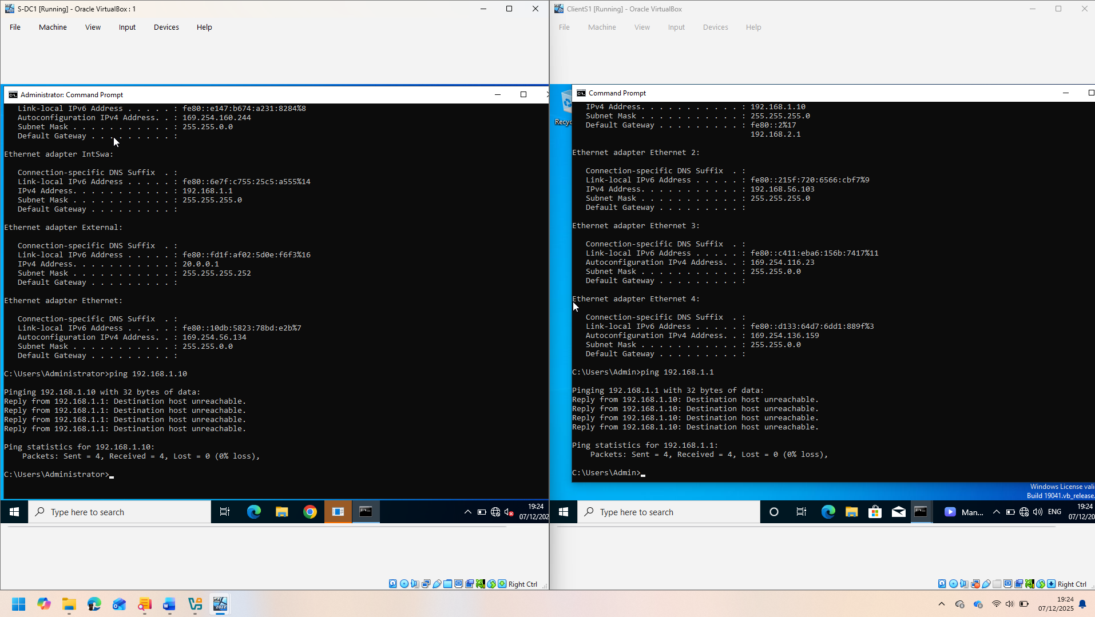
3:S-DC and L-CD connections.

4:ClientS1 and ClientL1 connection.
5:L-CD and ClientL1 connection.
6:L-CD and ClientS1 connection.
2.2: Vulnerability assessment: This assessment has been done according to NIST SP 800-115.
2.2.1: Information Gathering:
Using Nmap hosts and open ports have been identified.
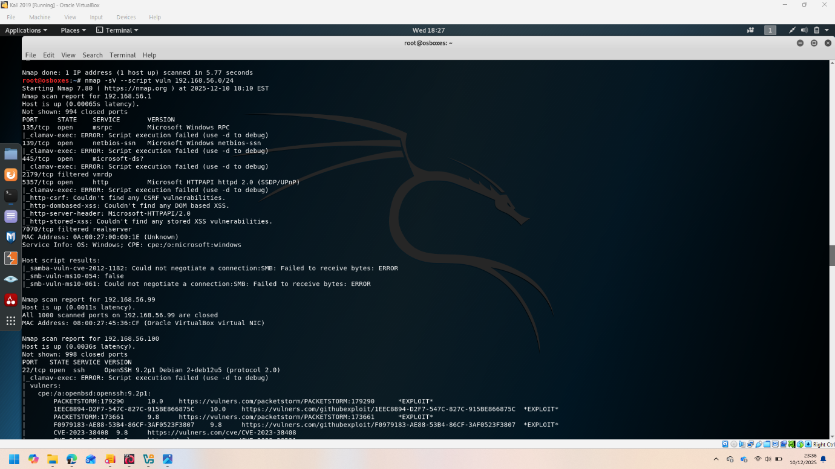
Nmap Fig 1.
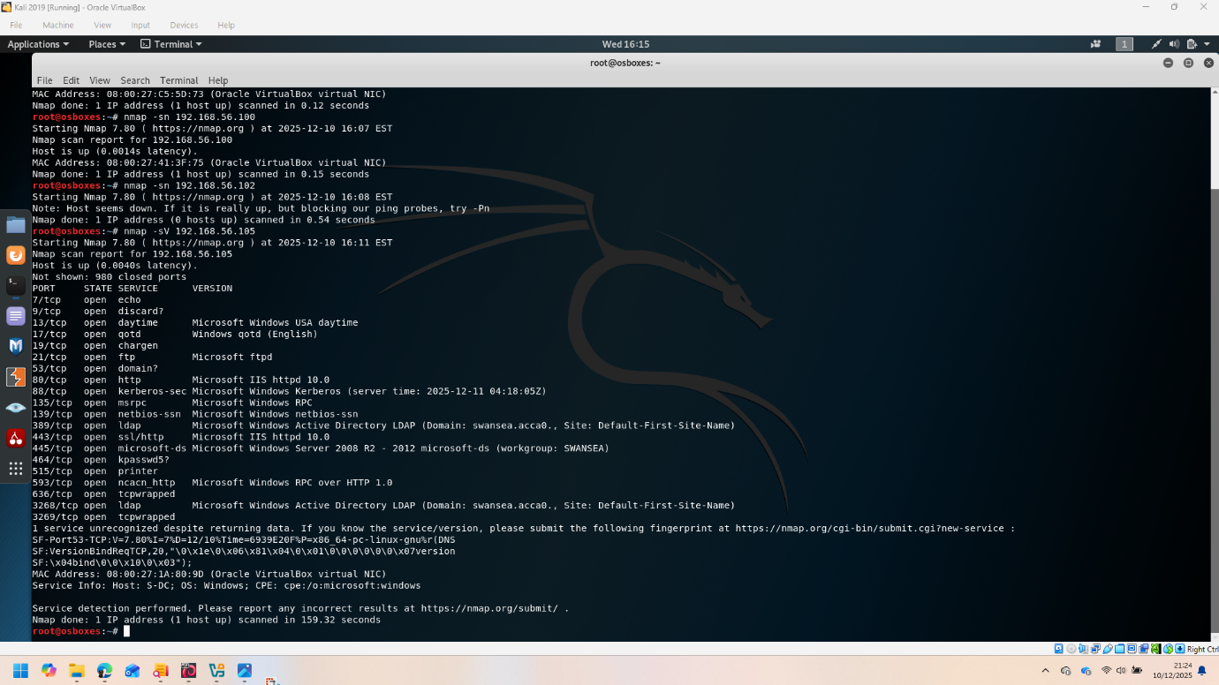
Nmap Fogure:2
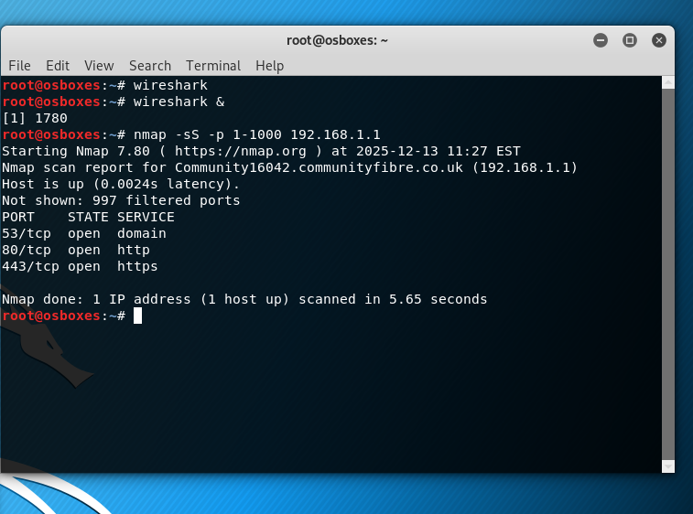
Finding Vulnerabilities using Nmap.
2.2.2: Scanning Using Nessus: Weaknesses of the network has identified using Nessus.

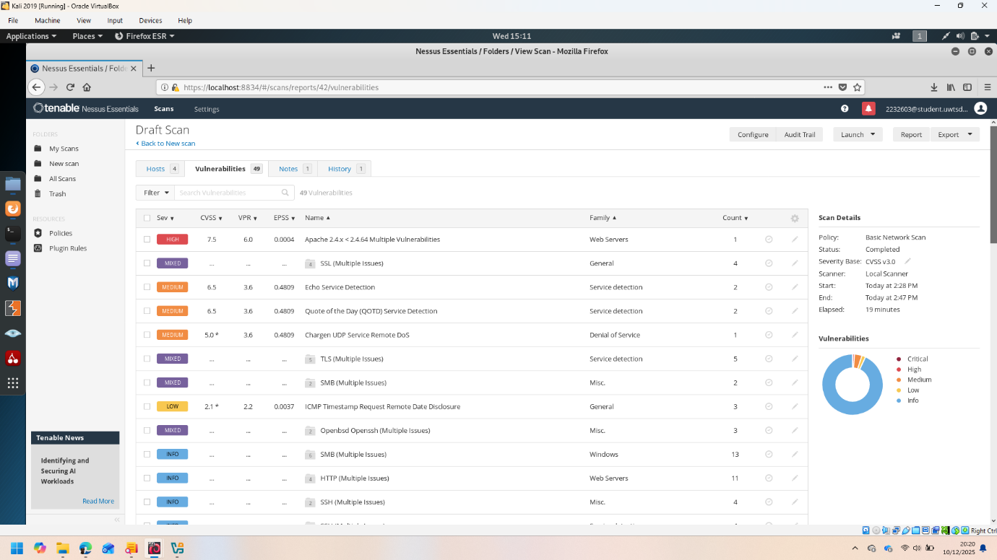
Fig:1. All machine are in Nessus vulnerability scan.
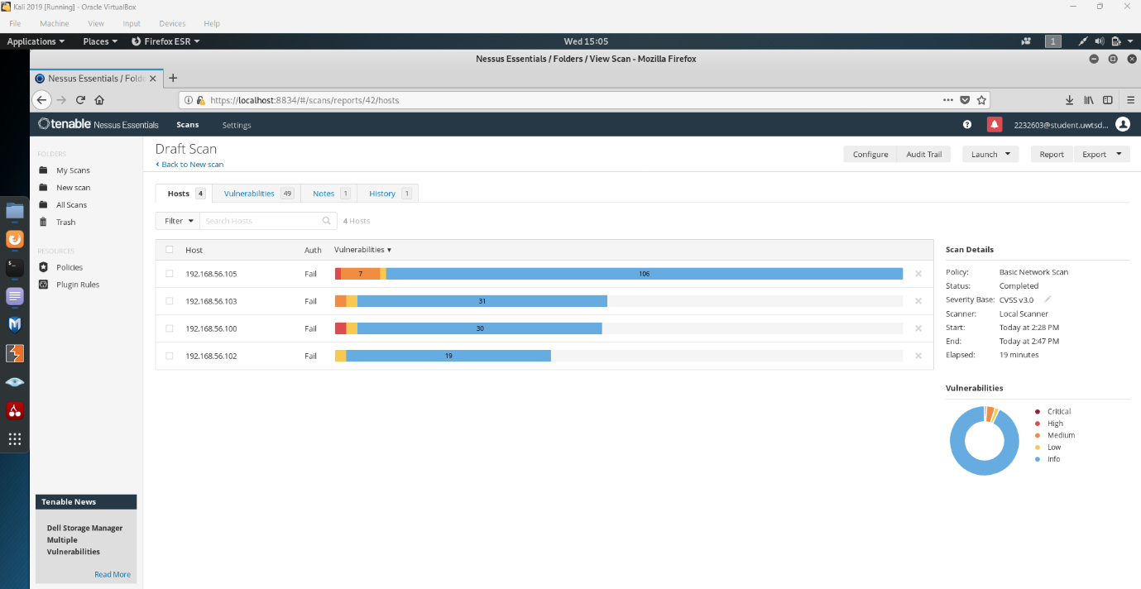
Fig:2 Nessus vulnerability scan.
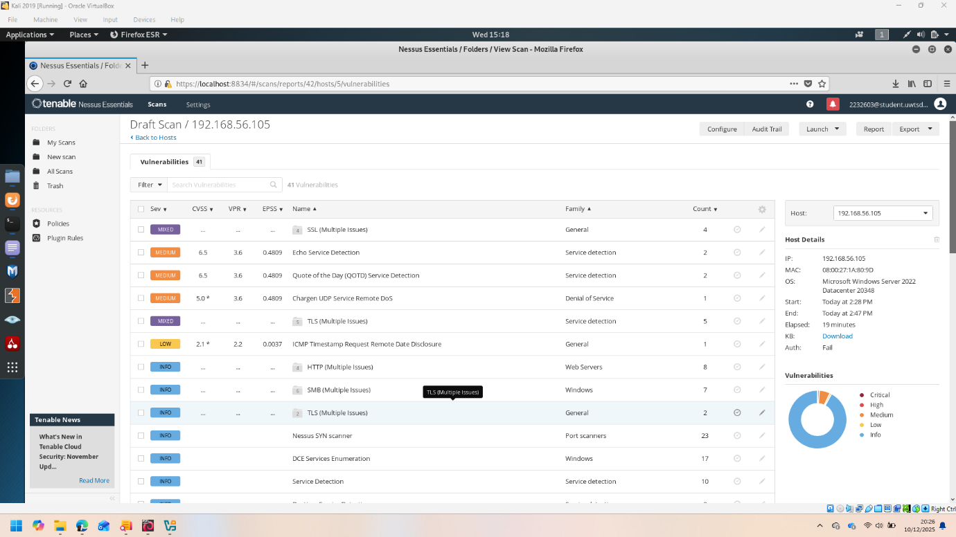
S_DC Nessus vulnerability scan.
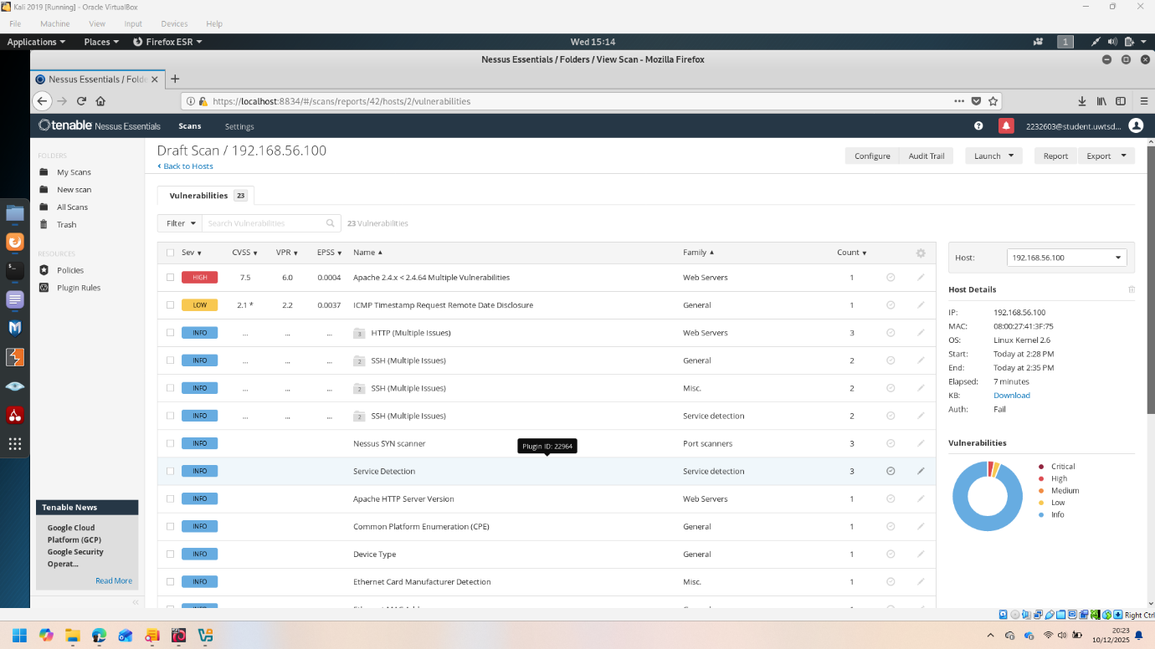
CLIENTL1 nessus vulnerability scan.
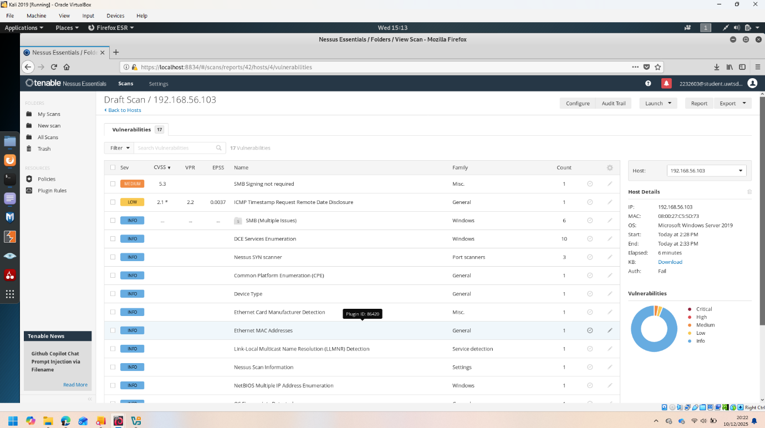
ClientS1 Nessus vulnerability scan.
2.2.3. Summary of the Vulnerabilities:
I)High: SMBv1 Enabled, Missing IIS Patches,
ii)Medium: Outdated OpenSSH, Weak RDP,
iii)Low: ICMP Timestamp, IIS Header Disclosure.
2.2.4: Wireshark Examination. The network traffic has been observed using Wireshark.
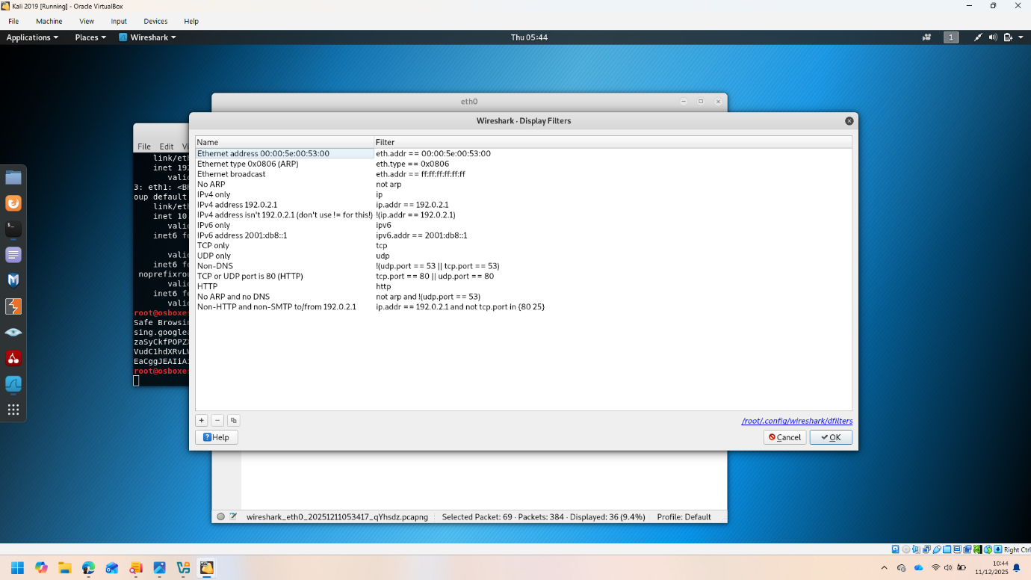
Wireshark Fig:1
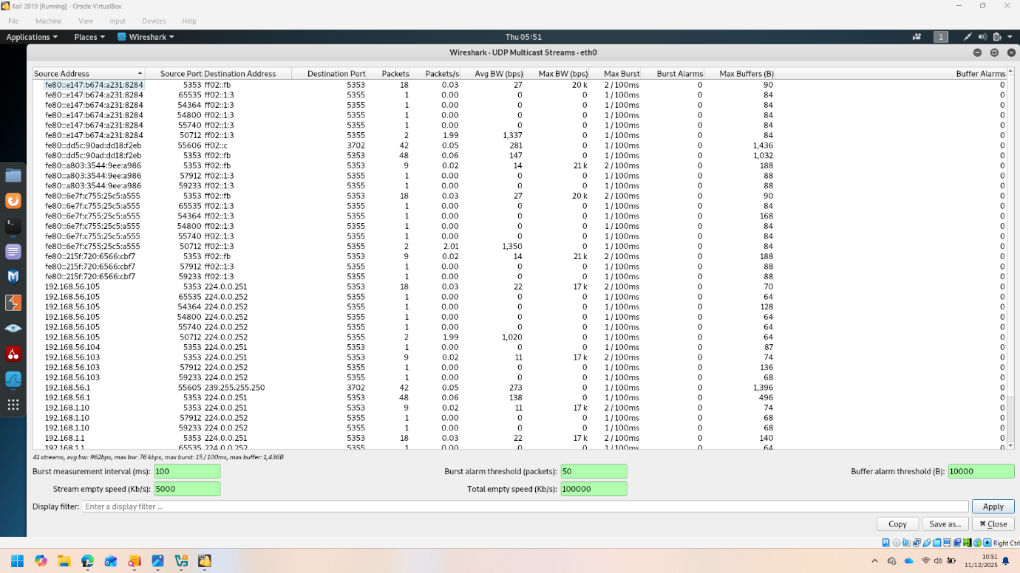
Wireshark Fig:2
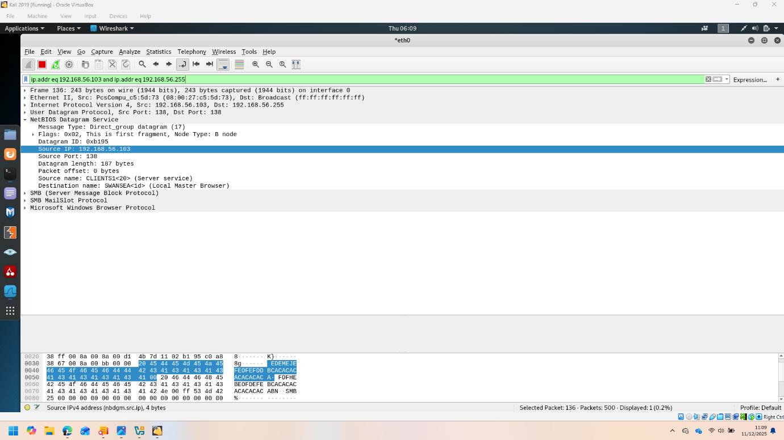
Packet Capture by Wireshark Fig:3
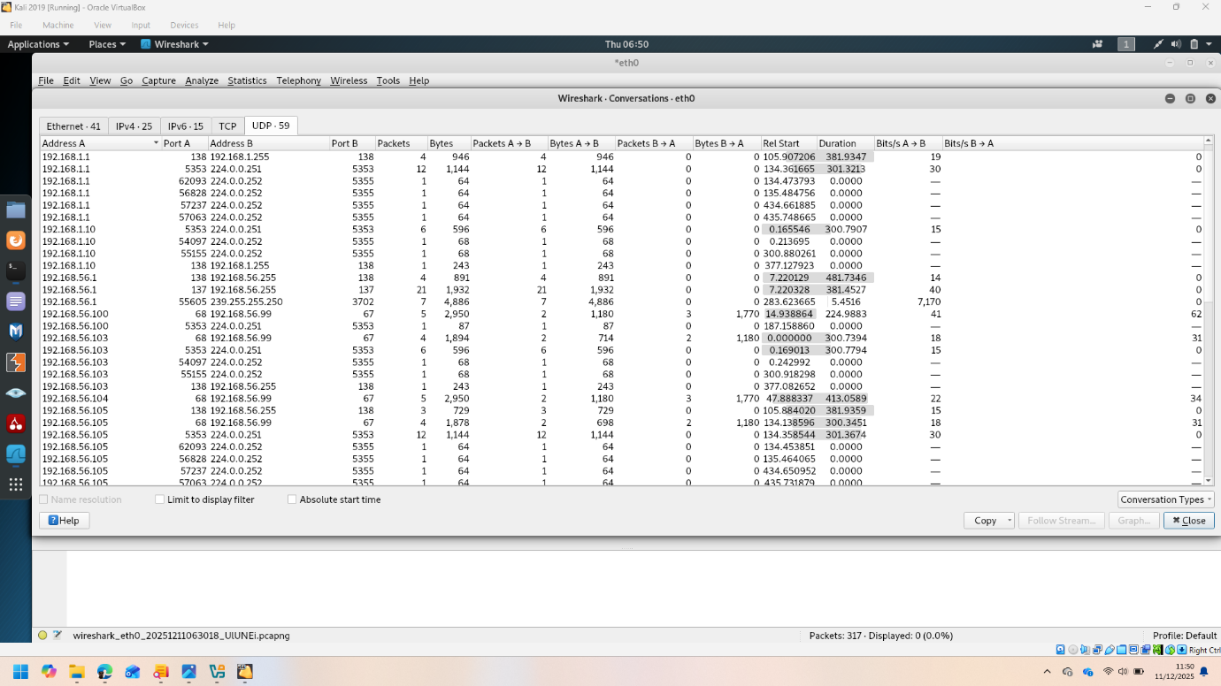
Destination and Source of Packets.
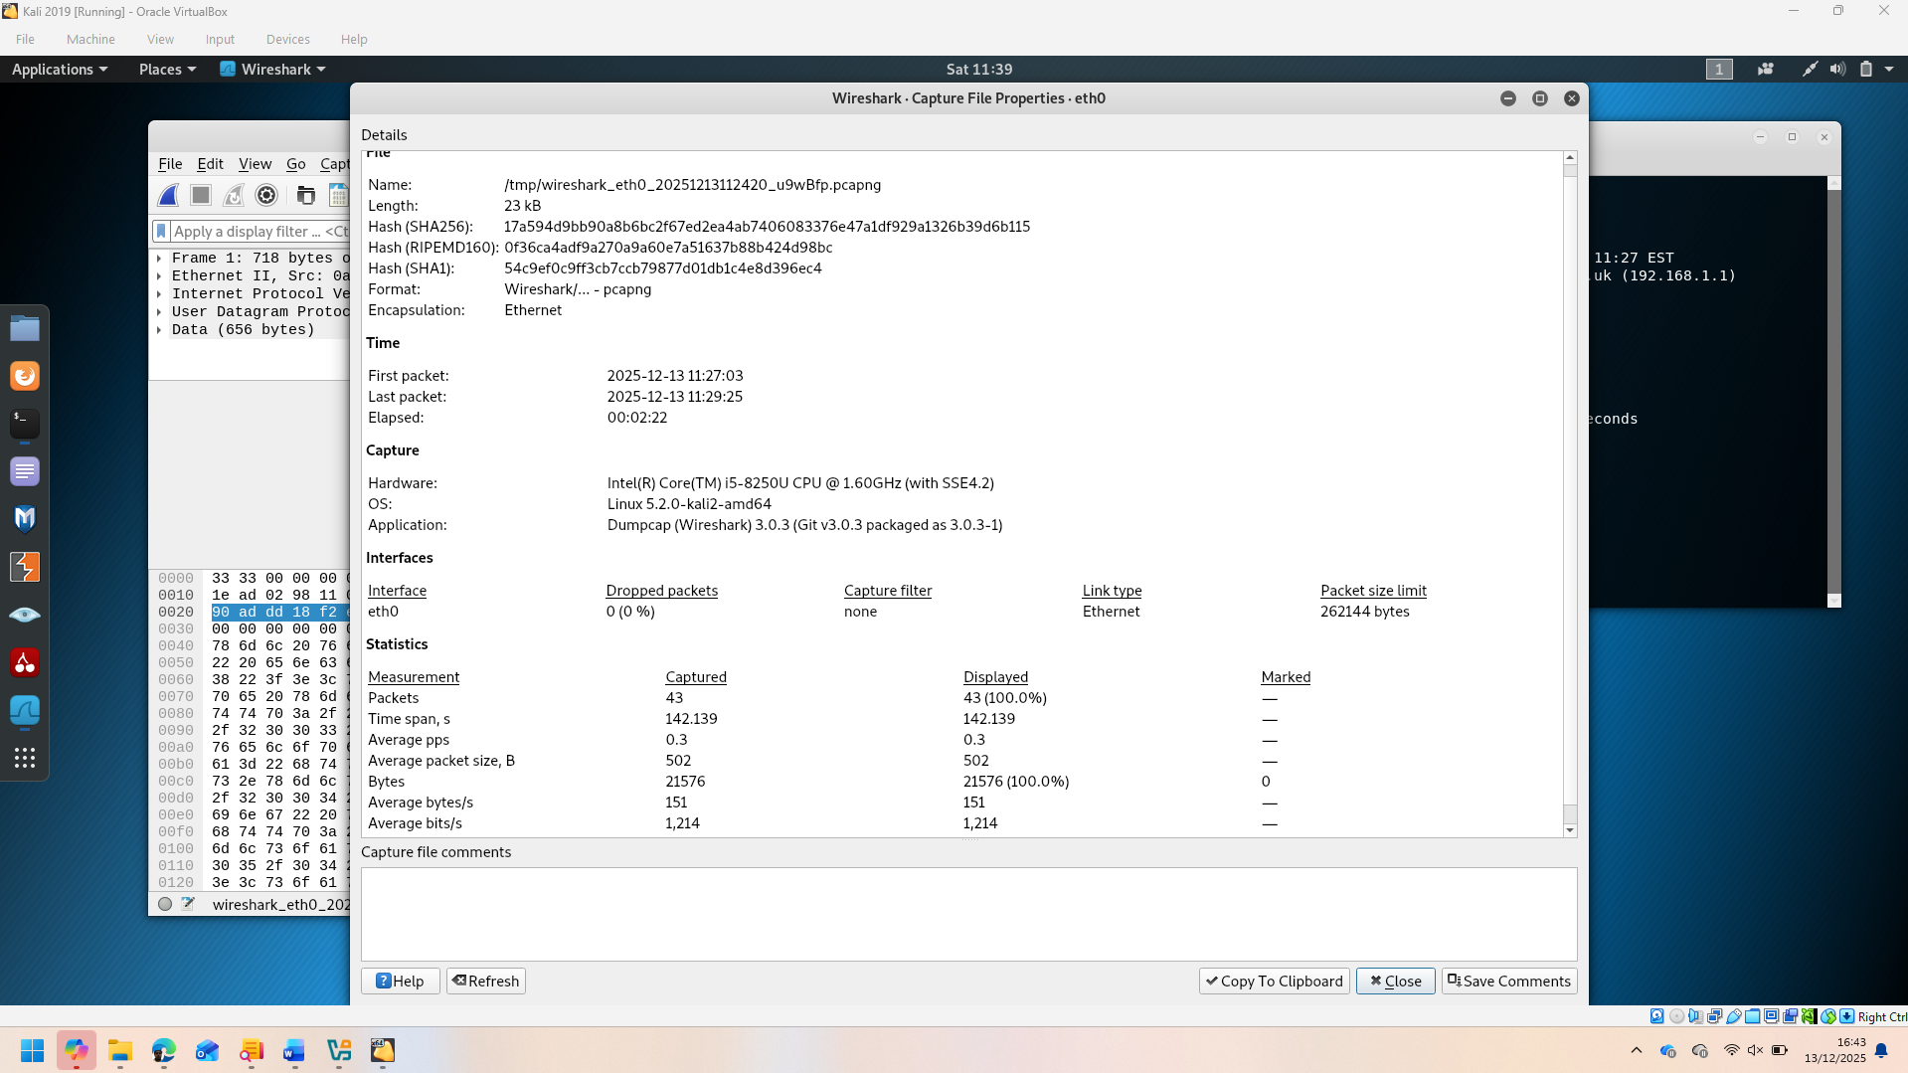
File properties captured by Wireshark.
Conclusion: In this network vulnerability has been identified successfully using different types of Tools.

Task 3:

Evaluation of Ethical Hacking in SWANSEA.ACCA
Introduction: Due to the emerging expansion of digital infrastructure, the modern organisations are becoming increasingly dependent on Network based system to run their academic, administrative and to manage the financial systems. Though this networking systems increase effectiveness and efficiency at the same time it also creates security risk. Unauthorised access to systems, spreading malware, information leakage and denial of service types of cyber threat is becoming more complex and critical day by day. Educational institution like SWANSEA.ACCA and other professional organisation and industries are especially vulnerable to cyber threats, because the handle sensitive personal, academic and financial data.
Ethical hacking is also known as penetration testing is an active cyber security system. It is a practice of real time cyber-attack to find out the vulnerability within an authorised and controlled environment. Ethical hackers work within the guideline of cyber security legislation and ethical framework. Their intention is not to do harm rather than they help to improve the security systems.
This report covering all the task of the assignment has presented a full and comprehensive ethical hacking. It has been created using the framework of industry-standard guidelines. Kali Linux has been used as an attacking system and Metasploitable2 has been used as an intentional weak target.
It follows the real time SWANSEA.ACCA network environment securely and aligning with the law. In this report, reconnaissance, vulnerability, exploitation and post exploitation steps has been explain clearly. Beside this ethics and laws are considered carefully and has proposed some suggestions.

2.Task 1-Recoinnaisance and collection of Information’s
2.1 Motive of Reconnaissance: It is the first and number one most important step of ethical hacking. In this step as much information is collected of the targeted system so that eminent attack surface can be understood. Ethical and unethical each hacker depends on enough collected data. Without enough information the attack may be failed or consume the risk of unwanted lose.
Generally, reconnaissance are two types, active and passive. Passive reconnaissance collect data without contacting with the target. It collects data from the open sources. On the other hand, in active resonance data is collected directly communication with the targets like port scanning. This active resonance has been done in the authorised lab environment.
2.2: Used tools and Environment: In the reconnaissance stage Kali Linux has been used which is a popular penetration testing operating system. Nmap has been used as a main tool for network discovery and security auditing. By using Nmap, open
ports, active service, service version and operating related information can be known.
As a target system Metasploitable2 has been used which is intentionally created a Linux virtual machine to conduct security training.
2.3. Network discovery and Port scanning:
Nmap service scan has been used in the target system identified open ports and active service. The outcome of scan shows there are FTP, SSH, Telnet, HTTP, samba, MYSQL, PostgreSQL and Apache Tomcat services are active. So many open ports of a system indicate the weakness of the security. Every open port can be used as door entry of an attack.
Nmap Scan.Fig 1
Nmap open ports discovery. Fig 2.
2.4: Results of Reconnaissance:
Main results of reconnaissance stage are:
1.Network is open to many unnecessary services.
3.Lack of network segmentation and access controls.
4.No visible firewall or absence of security systems.
5. Old and risk Pron software version.
This result justifies moving on the next step of security assessments.
3.Task 2-Vulnerability assessment.
Aim of vulnerability assessment.
In Vulnerability assessment stage information are analysis collected from reconnaissance. After analysing the information known weaknesses are identified. In this stage without attacking the target only do the risk assessment so that impact of the attack can be understood.
3.2 Identified weaknesses:
This is assessment has identified the following weaknesses:
1) VSFTPD 2.3.2 backdoor weakness- this FTP version has a backdoor which allows unauthorised shell access.
ii) samba Username script weakness- root ownership can be gain by remote control access.
iii) Plain text service (FTP and Telnet)- is run without data encryptions.
iv) Weak defend configuration- increases the risk of brute force and malpractices.
V) Outdated web service- tomcat ad Apache has known weakness.

3.3 Risk analysis: these weaknesses increase the risk of secrecy, integrity, and demand of services, especially remote code execution weakness gives the chance to take control of whole system.

4 task 3- Exploitation:
4.1 Aim of an exploitation:
In exploitation stage analysed that the identified weaknesses can be misused in real life or not. It helps to reduce the impact of the security breaches.
4.2 Used tools: Metasploit Framework
For exploitation Metasploit Framework has been used. It is an professional penetration testing platform where there is different module of exploitation and payloads.
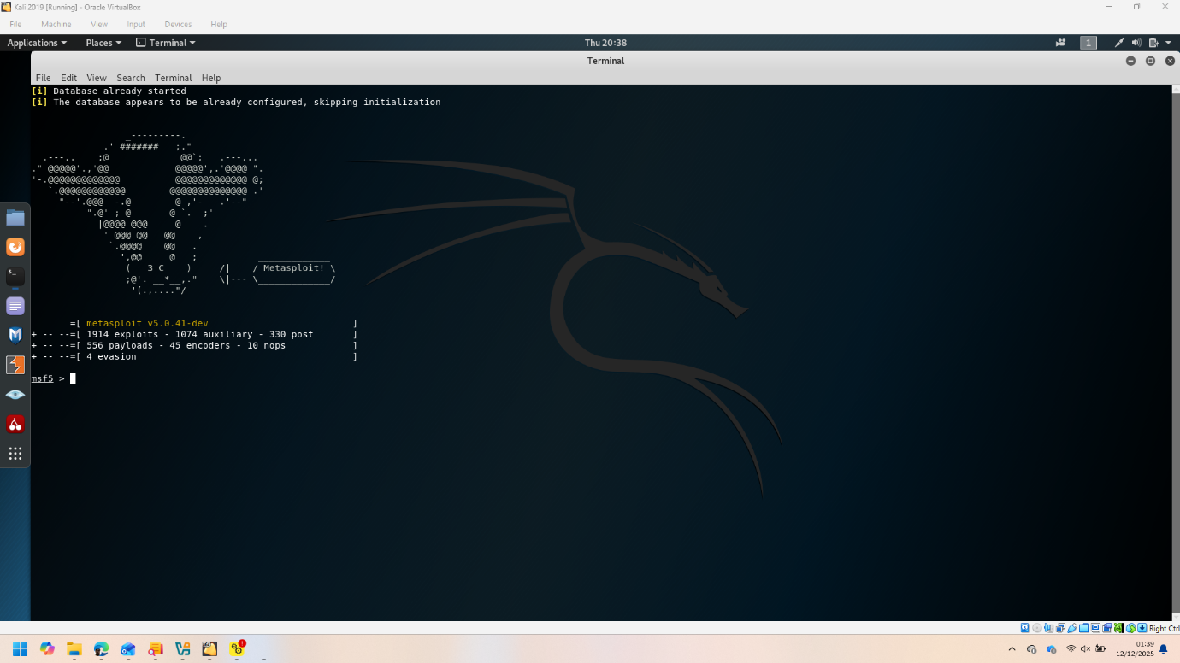
Fig:1 Metasploitaion.
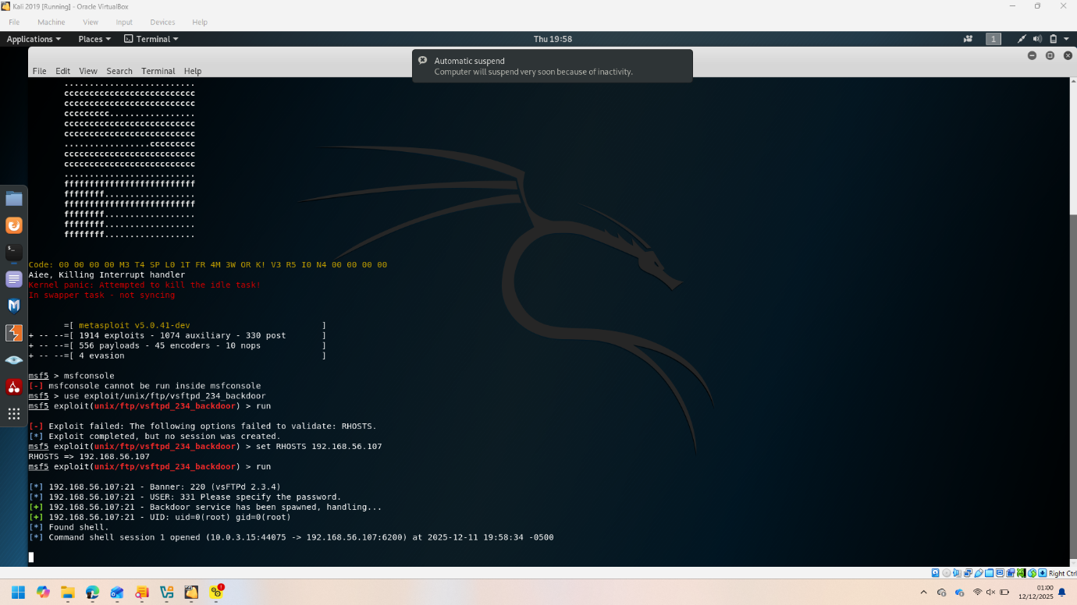
Fig:2 Meatsploitaion.
Fig:3 Metasploitaion.
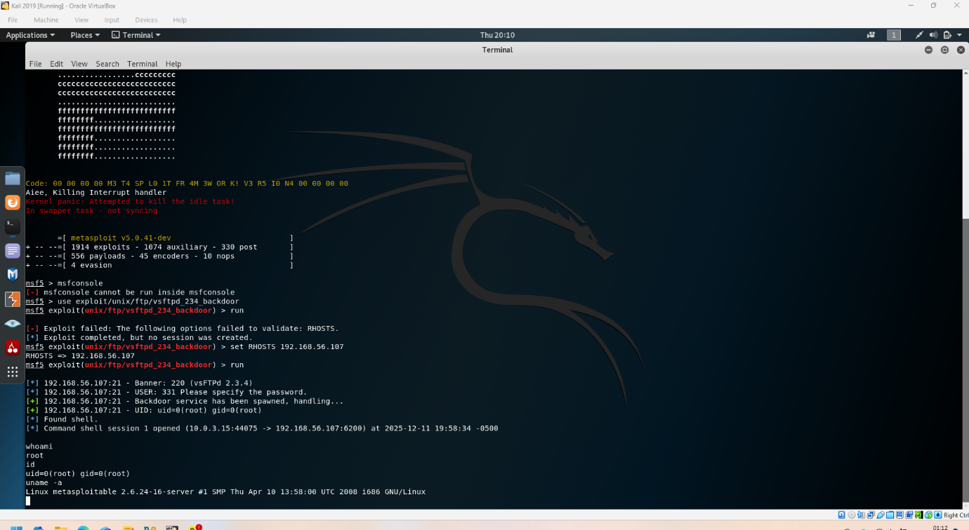
Fig;4 Metasploitaion.
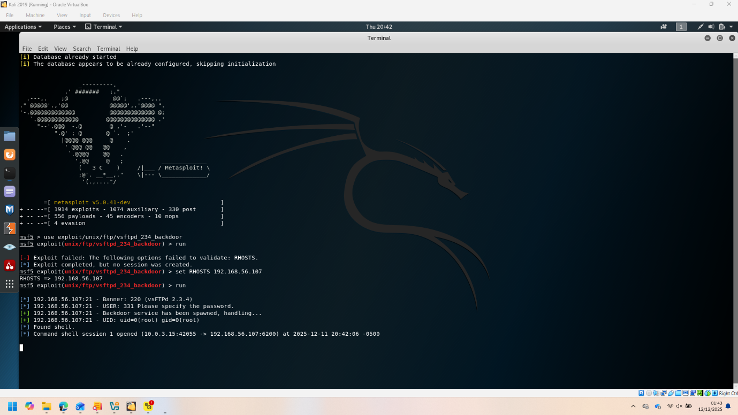
Fig:5 Metasploitaion.
4.3. VSFTPD exploitation:
For VSFTPD 2.3.4– using a specific exploitation module successfully a backdoors shell opened. This is proven that an unauthorised access is possible in the system.
4.4 privileged analysis:
After the shell access, using the system command it is analysed that the attacker has gain control of the whole system. As a result, it has
4.5 Alternative Exploitation- Samba.
Using Samba usermap script exploit, successfully get the root shell that exposes the several weaknesses of the system.
5 task 4- post-exploitation:
5.1 Aim of post-exploitations.
In post exploitation stage it evaluated that how much damage has been caused by the attack and what the attacker does with the information.
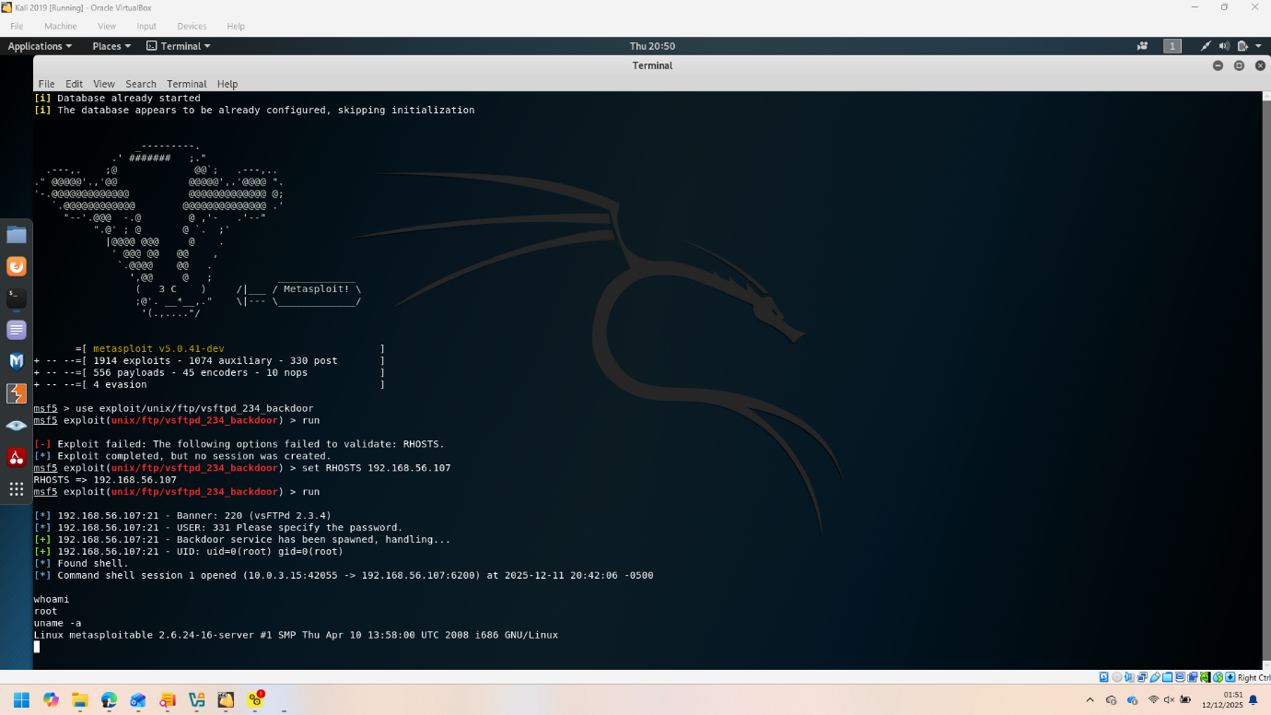
Fig:Post Exploitation.
5.2 post Exploitation activities:
In this stage the following activities has been done:
i) user privileged check.
ii) Operating system and kernel information collection.
iii) Probable persistent techniques identification.
5.3: Severity of the damage.
The system is totally damage by the root access. If the attacker want, can steal the data, install malware or can attack more in the network.
5.4 Visible barriers.
In the post exploitation there was no barriers. Lack of IDS login system makes the identification harder.
6. Ethical & legal provisions: The whole activities have been done the control environment. Ethical hacking should be done by the authorised legislation and with professionalism.
7: Suggestion and preventive measures:
Based on this assessment the following suggestions have been proposed.
i) Stop the un-necessary services.
ii) Every software should be patch and updated.
iii) Introduce strong authentication system.
iv) Ensure use of encrypted protocol,
v) Firewall and IDS installation. And
Vi) Regularly assess the security.

Conclusion:
It has been proved by this assessment that old software, weak configuration, insufficient security systems keep a system in serious dangers. By the Step-by-step reconnaissance, vulnerability assessment, exploitation and post exploitation the weaknesses have been analysed.
Ethical hacking is a tool to assess the security status of an organisation. By adapting the proposed preventive measures will help to reduce the noticeable cyber security risks, the organisation like SWANSEA.ACCA-

Reference:
[1] E. Skoudis and T. Liston, Counter Hack Reloaded: A Step-by-Step Guide to Computer Attacks and Effective Defenses, 2nd ed. Upper Saddle River, NJ, USA: Pearson Education, 2005. [Online]. Available: Electronic book
[2] R. Messier, CEH v11 Certified Ethical Hacker Study Guide, 2nd ed. Hoboken, NJ, USA: John Wiley & Sons, 2021. [Online]. Available: Electronic book
[3] R. M. Harrison and T. Herr, Cyber Insecurity: Navigating the Perils of the Next Information Age. Lanham, MD, USA: Rowman & Littlefield, 2016. [Online]. Available: Electronic book
[4] Institute of Electrical and Electronics Engineers (IEEE), “IEEE Xplore Digital Library.” [Online]. Available: https://ieeexplore.ieee.org. [Accessed: Day–Month–Year].
[5] Association for Computing Machinery (ACM), “ACM Digital Library.” [Online]. Available: https://dl.acm.org. [Accessed: 25–October–2025].
[6] Elsevier, “ScienceDirect.” [Online]. Available: https://www.sciencedirect.com. [Accessed: 10–November–2025].
[7] OWASP and Veracode, “Application Security: Knowledge Base,” 2022. [Online]. Available: https://owasp.org. [: 05–December–2025].
[8] K. Orrey, “Vulnerability Assessment,” n.d. [Online]. Available: https://www.kaspersky.com/resource-center/definitions/vulnerability-assessment. [Accessed: 15–November–2025].
[9] Software Testing Help, “19 Powerful Penetration Testing Tools Used by Pros in 2022,” Oct. 25, 2022. [Online]. Available: https://www.softwaretestinghelp.com. [: 01–12–2025].
[10] U.S. Government, “Department of Defense Cyber Crime Center (DC3): A Federal Cyber Center,” n.d. [Online]. Available: https://www.dc3.mil. [Accessed: Day–Month–Year]

