Application Development

Lecturer - Kemi Ademoye
Scott Howells
Student P Number – 1701604
Table of Contents
Introduction 2
Abstract 2
Requirements 2
Design 2
Implementation 3
Evaluation 9
Bibliography 10
References 10

Introduction
The following report will be based on the creation of a ASP.NET MVC web application that was designed and implemented within Visual Studio that integrates an SQL Server Express LocalDB that allows for storing and managing its data. The report will identify the key methods used within the implementation as well as the main concepts of the web application.

Abstract
The report will highlight the key features that was used in the creation of the web application. It will evaluate the concepts, principles and the techniques used within the development and creation of the application and will give a clear and concise view on the subject matter.

Requirements
The web application that was constructed is based around musicians and their music. The application contains a database for music artists as well as their music and potential concert dates. The purpose of the application is to allow users to view the different types of musicians from multiple background genres and sample their music by listening to some of their songs from an interactive button that will enable a music video from the chosen artist to appear. The links to each artist will be available through an image of the respectable act and will contain key information on them. The users will be able to book a ticket to a concert (if available) through the use of another two databases that allow the user to choose a ticket type and the booking concert types. The target audience is of a any age. Music is a concept that everyone at every age loves and it would be unfair to target an age group audience over another. It was imperative to include all the key information and design for all age groups to understand. As there are many millions of artists in the world there will need to be a follow up update on the web application to include more artists with their respectable information and links.
The main requirements to the web application was to allow data to be displayed. There needed to be interactivity with the displayed results with a form of validation. Finally, the feature to manipulate data using CRUD operations was also required.

Design
The design features that were implemented needed to follow a strategic method of ease in order to ensure all age groups are comfortable with navigating throughout the web application as well as observe the content on the pages with relative ease. The design implemented is very basic and consists of very little clutter in order for viewers to register what the web application consists of.
The option when displaying the data of musicians to reduce the number of artists on that page is available in order to allow for a more clear and concise view. The option to also increase how many artists are viewed on that page is also available for those whom rather see all the acts available without scrolling through pages. The white background allows for better human computer interaction (HCI) [1] as it is consistent and has been proven to be effective over a longer period of time when users view web pages. Other colours consist of the RGB scheme however, the colour scheme will only work in certain scenarios whereas the colour white has been found consistently effective [2]. The text was displayed at a reasonable size to ensure all users are able to view it. The text was also centered on many of the pages in order to allow maximum efficiency.
Below consists of the screengrab of the web application and it is demonstrating the design.
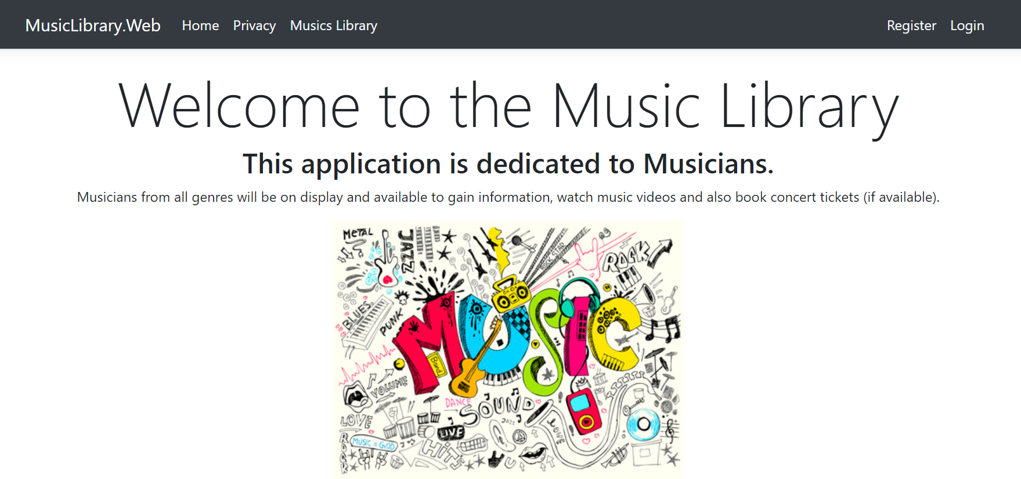
Figure 1 – Web Application Design

Implementation
When implementing the project, it was important to meet the requirements that were set and to construct the features using key methods. In order to display the data, there first needed to be a database with tables included so that data can be inserted. After constructing a table, the data of the musicians and the relevant information was added into an INSERT query that ultimately allowed for the data to be uploaded to the database and to be displayed on the web application. Entities and Enums were used in order to set up what data would be inputted with the resulting information being accessed by the users available through the use of multiple .Web folders, classes and views.
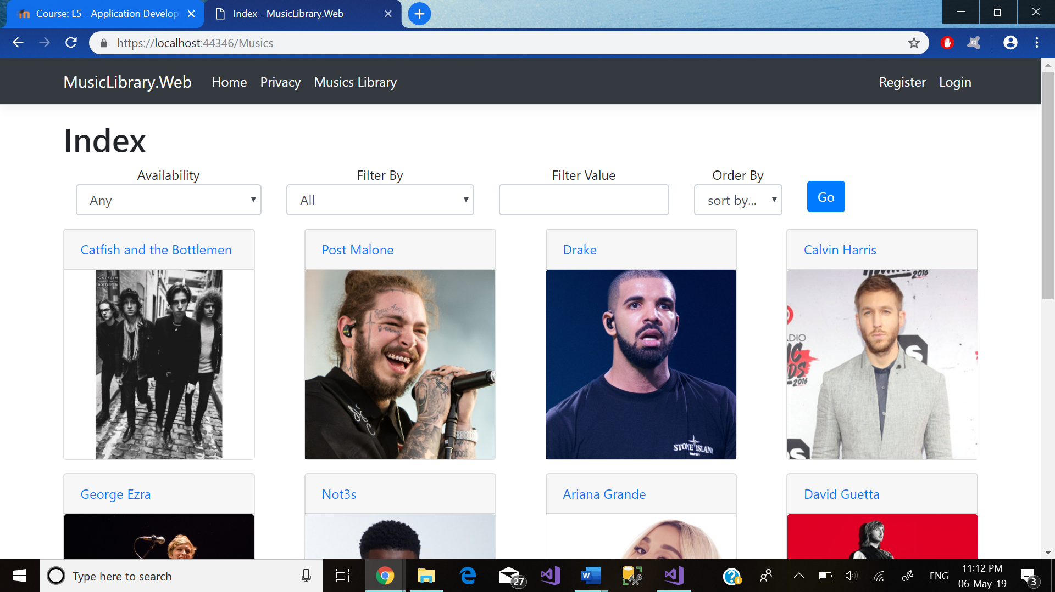
Figure 2

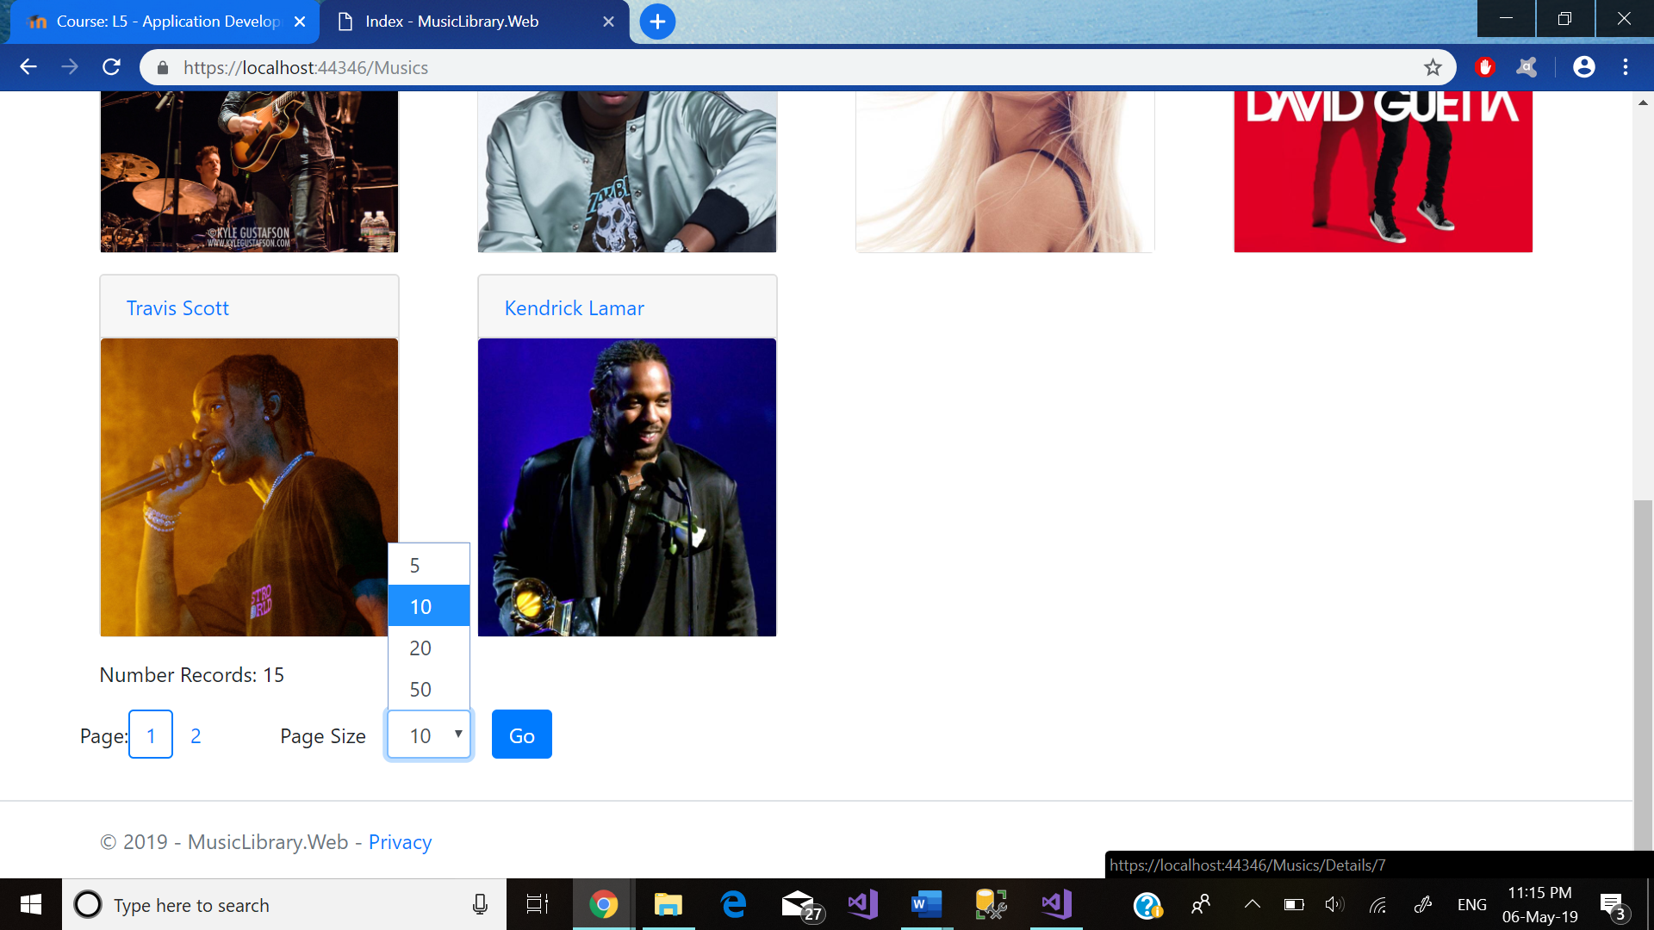
Figure 3

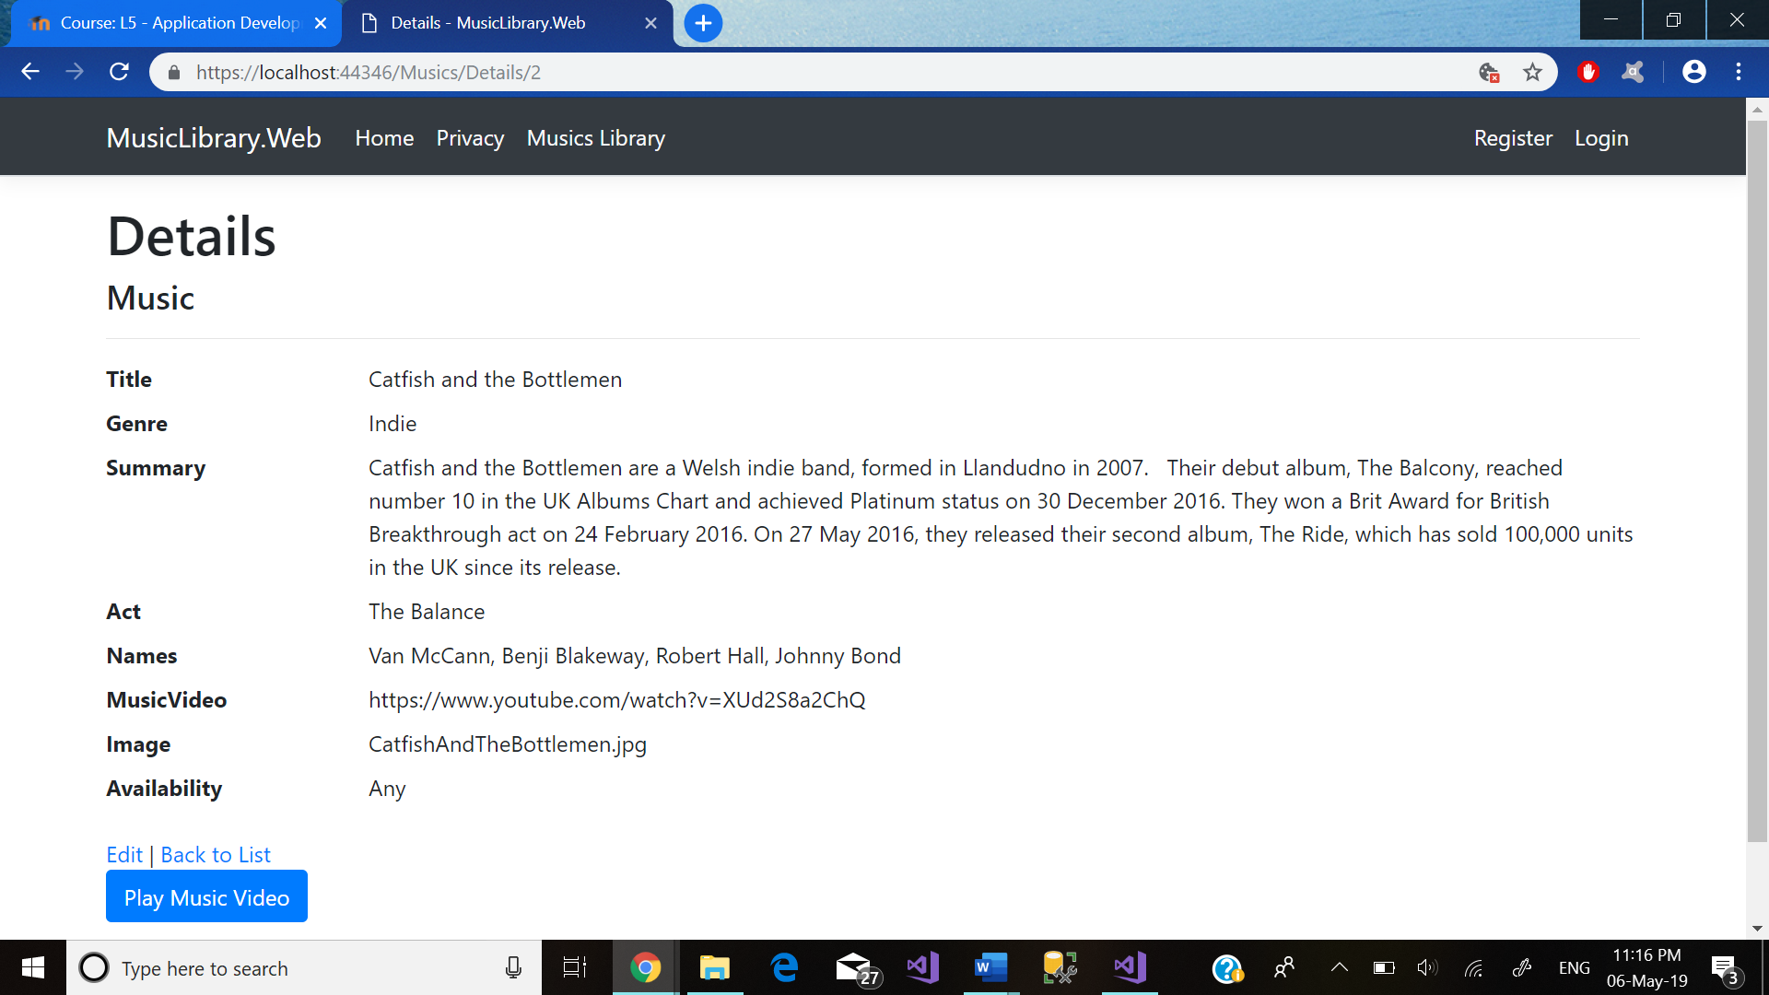
Figure 4
Figure 2 above illustrates the acts that have been implemented into the database via the query that was performed. Figure 3 is an example of the availability of reducing or increasing the acts that are on show within that page. Figure 4 is an example of the relevant data that was included on the respected acts information page when selecting the respected acts name or image in order to book a ticket, listen to a song or check the information.
The availability to register onto the site as well as login was important in order for users to book tickets with the correct privacy. The ability to register and login have been made available to view below within figures 5 and 6.
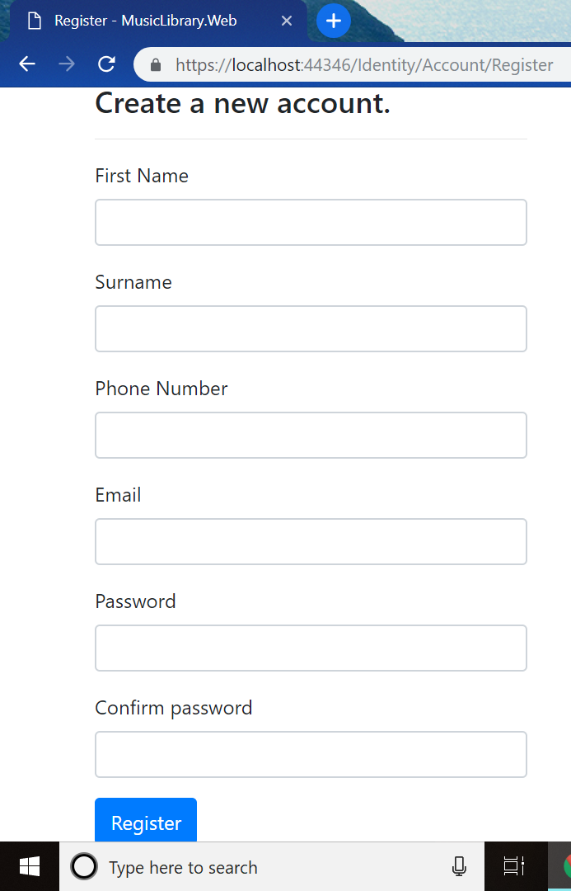
Figure 5
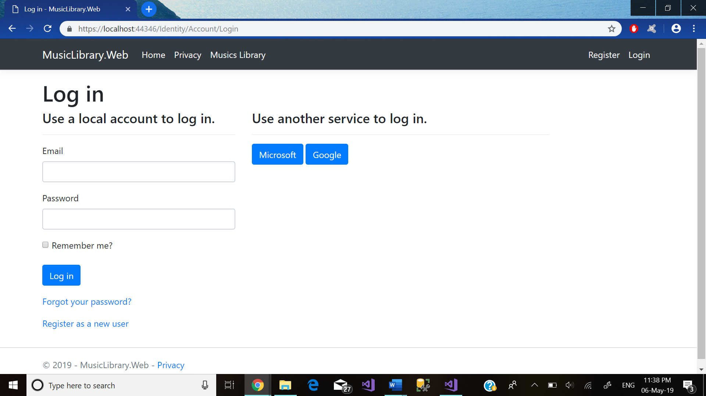
Figure 6
Figure 6 also illustrates the feature to log in through the use of a Microsoft or Google account. The credentials to these accounts have already been saved within the manage user secrets file on the web application. The user will instantly be logged into his/her account when clicked upon. This is a form of interactivity querying as it supports memory caching and allows for a faster approach when logging in whilst allowing it to be much more interactive [3].
Validating the web application means to input the correct information that meets the requirements. The validation technique was used when a user attempted to enter incorrect details when attempting to log in. Below in figures 7, 8 and 9 are screengrabs of the validation working correctly.
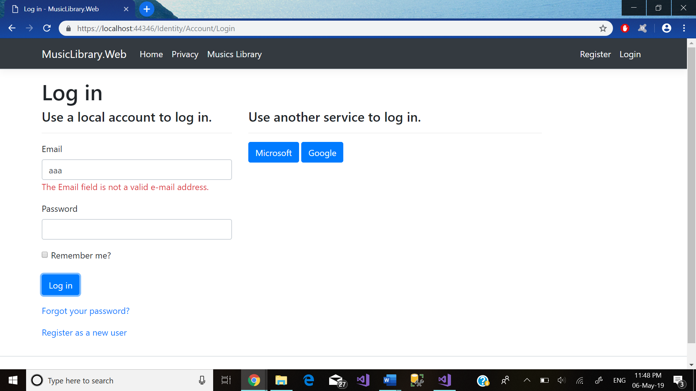
Figure 7
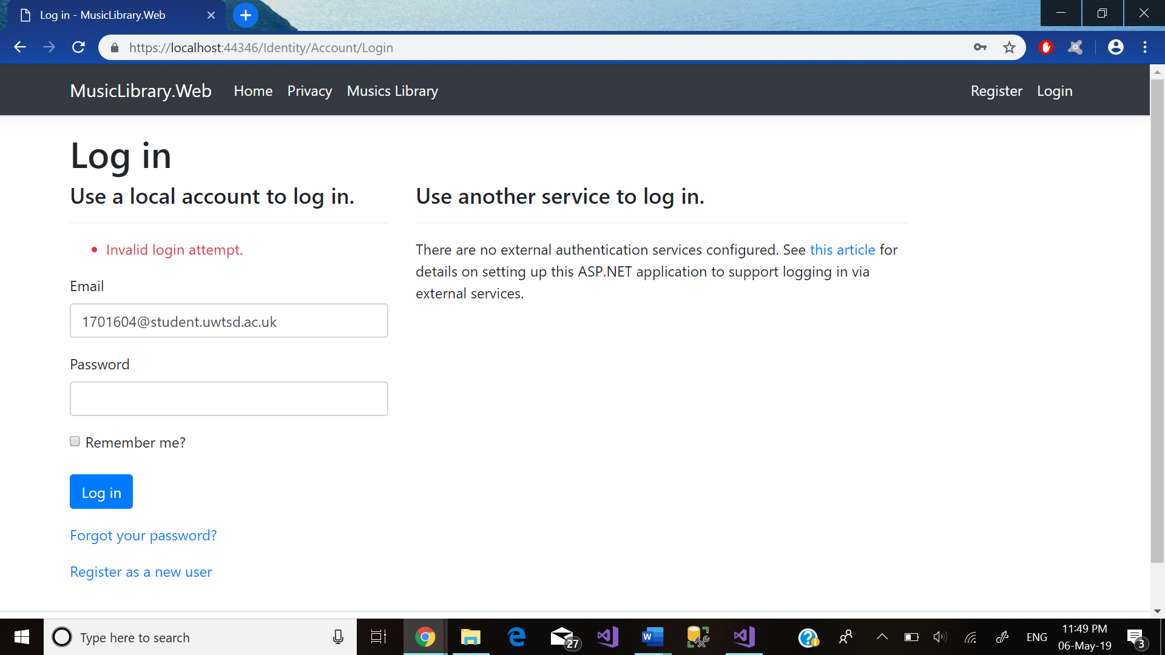
Figure 8
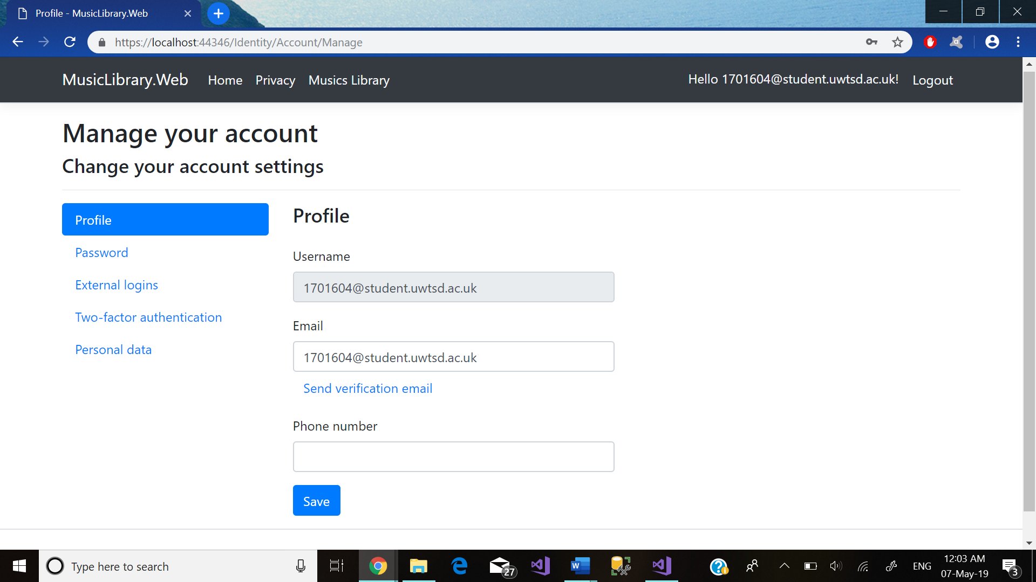
Figure 9
Figure 7 issues a warning message that the email is not entered correctly whilst figure 8 has the correct email however the incorrect password.
CRUD Operations also stand for create, read, update and delete [4], and they allow for the creation, edit and delete features that have been implemented in order to interact with the music library. The ability to create a new act with the option to create the information of that act is made available within the web application. The featured option to also edit the acts information is also available. Despite the CRUD operations being made available it is restricted to the view of the admin as potential harm can be forged if all users are able to use these features. Below are the figures which demonstrate the CRUD operations in use:
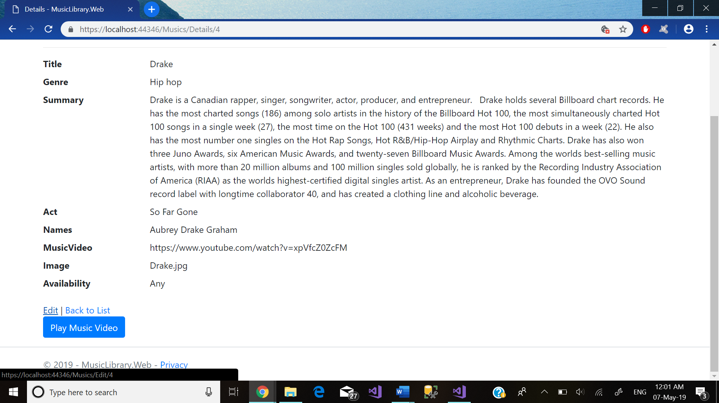
Figure 10
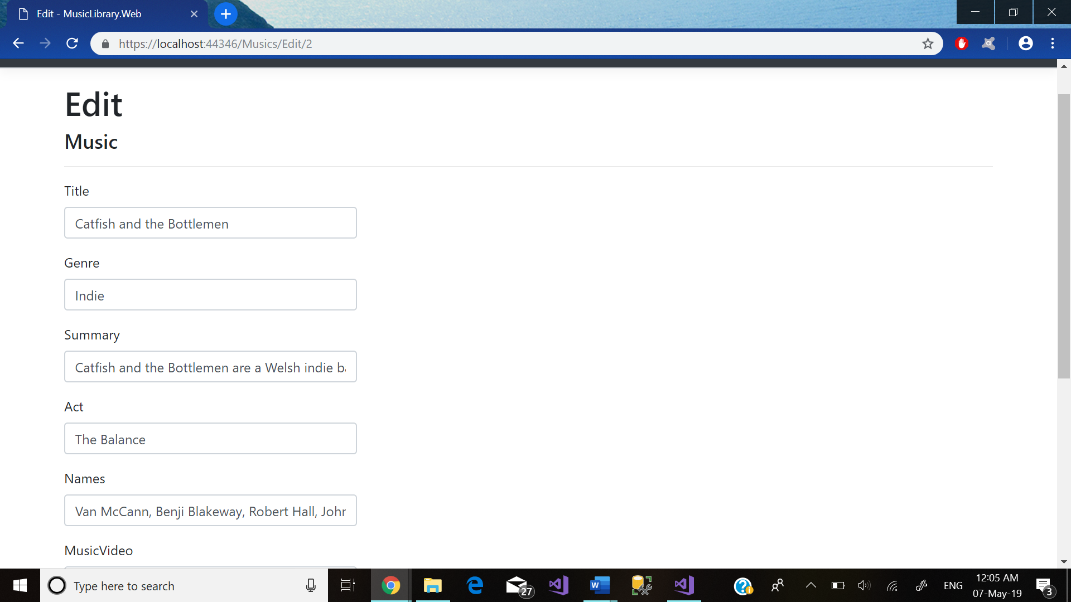
Figure 11
This section of the implementation will highlight the main folders, views/view models and controllers that were used in order to implement the web application. The main folders that were regularly used were the repos folder and all the contents within it. This folder was needed as it often references the database and all its content to be viewed. The SortFilterOptions folder contained the different filter options. Other folders that were used however not regularly as when implemented there was no need to revisit was the Data, EF, Entities, Enums and the Migrations found in the .data class. The ViewModels folder contained the concerts and music that were available. The views folder within the .web class contained the most regularly accessed classes. It contained what was being viewed on the web application with the home page, musics page, concerts and bookings available. The controllers controlled what would be viewable on the web application.

Evaluation
Overall the web application that was constructed offered many of the main points that were initially required and were successfully implemented. Despite this, the web application lacked some features that was imperative in order for the web application to be considered successful. The booking of a ticket to see the concert section failed and was ultimately abandoned. The reason being the application got corrupted and when salvaged a lot of the application refused to run. A backup was also corrupted and thus a prototype from early on was adopted and attempted to include the main features that were on show such as the data display, CRUD operations, validation and interactivity features. Changes will have to be made and the web application updated to include the other features that were lost as well as updating concerts, musicians and songs. Despite the negative points there is a successful operating web application which provides the features documented above. The application reflects a real-world scenario and provides a good stead into what could be a respectable and popular web application. The design implemented was accurate and the navigation was also simple for all ages to use. The content on the web application was informative and placed on the web application in a suitable area on the page.

Bibliography
Catfish and the Bottlemen - https://en.wikipedia.org/wiki/Catfish_and_the_Bottlemen
Post Malone - https://en.wikipedia.org/wiki/Post_Malone
Drake - https://en.wikipedia.org/wiki/Drake_(musician)
Calvin Harris - https://en.wikipedia.org/wiki/Calvin_Harris
George Ezra – https://en.wikipedia.org/wiki/George_Ezra
Not3s – https://en.wikipedia.org/wiki/Not3s
Ariana Grande - https://en.wikipedia.org/wiki/Ariana_Grande
David Guetta – https://en.wikipedia.org/wiki/David_Guetta
Travis Scott – https://en.wikipedia.org/wiki/Travis_Scott
Kendrick Lamar – https://en.wikipedia.org/wiki/Kendrick_Lamar
Stormzy – https://en.wikipedia.org/wiki/Stormzy
Take That – https://en.wikipedia.org/wiki/Take_That
Def Leppard – https://en.wikipedia.org/wiki/Def_Leppard
Metallica – https://en.wikipedia.org/wiki/Metallica
Dua Lipa – https://en.wikipedia.org/wiki/Dua_Lipa
Privacy image - https://www.vpngeeks.com/online-privacy-guide/
Music image - https://www.reliablecounter.com/blog/5-rules-music-blog-submission/

References

[1] | M. Rouse, "HCI (human-computer interaction)," SearchSoftwareQuality, September 2005. [Online]. Available: https://searchsoftwarequality.techtarget.com/definition/HCI-human-computer-interaction. [Accessed 8 April 2019].
[2] | T. Komischke, "Colors and the UI," InfoQ, 25 November 2008. [Online]. Available: https://www.infoq.com/articles/Colors-UI. [Accessed 8 April 2019].
[3] | J. W. Howell, "Use Interactive Query with HDInsight," Microsoft Azure, 22 Feburary 2018. [Online]. Available: https://docs.microsoft.com/en-us/azure/hdinsight/interactive-query/apache-interactive-query-get-started. [Accessed 8 April 2019].
[4] | Stackify, "What are CRUD Operations: How CRUD Operations Work, Examples, Tutorials & More," Stackify, 2 May 2017. [Online]. Available: https://stackify.com/what-are-crud-operations/. [Accessed 8 April 2019].

marking criteria and Student FEEDBACK

This section details the extent to which the assessment criteria are demonstrated by you, which in turn determines your mark. The marks available for each category of skill are shown. Lecturers will use the space provided to comment on the achievement of the task(s), including those areas in which you have performed well and areas that would benefit from development/improvement.

Common Assessment Criteria Applied (Assignment 2) | Marks available | Marks  awarded
1. Engagement with Literature Skills

There is some evidence of engagement with literature skills, but there is room for improvement in the range of references consulted. Expanding the scope will also help you to enhance your overall understanding, discussion and implementation of concepts. (Grade mark: 40.00%) | 5 | 2
2. Knowledge and Understanding Skills

The submitted work does not include the required research element and as such no marks have been awarded for this element of the assignment. Please ensure that you read the assignment brief and especially the marking scheme more carefully in future. (Grade mark: 0.00%) | 25 | 0
3. Cognitive and Intellectual Skills

A good evaluation of the application has been provided identifying its limitations. Your testing approach is generally good, but needs to be improved to further demonstrate different test cases of the application's functionality. Some of your test cases are for default functionality provided with the VS application template which works straight out of the box. I am more interested in functionality that you have created. (Grade mark: 60.00%) | 20 | 12
4. Practical Application Skills

A good attempt featuring a simple application based on the class tutorial but there is room for improvement. Requirements have been well thought out. Generally, the application is incomplete and requires more functionality as the functionality is currently limited to displaying data. The edit and create views are not working and require adding the functionality to make them work, but you did manage to implement the drop down lists, and also remember to implement authorisation as members of the public currently have access to the edit and create views. (Grade mark: 60.00%) | 45 | 27
5. Transferable Skills for Life and Professional Practice

The report is of a good standard. (Grade mark: 60.00%) | 5 | 3

Assignment Mark (Assessment marks are subject to ratification at the Exam Board. These comments and marks are to give feedback on module work and are for guidance only until they are confirmed. ) | Late Submission Penalties (tick if appropriate) |  | 44%
 | Up to 1 week late (40% Max) |  | 44%
 | Over 1 week late (0%) |  | 44%

