Computational Thinking - Design and Implementation of a Lego Mindstorms Solution to a Series of Problems
Joseff Thomas
Digital Degree Apprenticeship
School of Applied Computing
Date of submission 20th of January 2020

Contents
1. Use Case Documentation & Diagram 3
2. Business Process Modelling Diagrams 3
2.1. Rectangle 3
2.2. Right-Angle Triangle 5
2.3. Circle within a Square 6
2.4. Join Symbol 7
3. Lego Mindstorm EV3 Programming 8

Use Case Documentation & Diagram

The author will be part of a group which have been tasked to build a Lego Mindstorm EV3 robot. The group will need to program the robot to draw a number of shapes and repeat the shape three times and increase the size of the shape 10cm each time.
The robot will have to be able to detect an obstruction, halt the motor and raise the alarm. If the obstruction is able to be moved, the robot will move the obstruction and continue the program. If the robot can’t move the obstruction, the robot will raise the alarm and halt the program. An obstruction that can be moved will be colour red, and blue for obstruction that cannot be moved. The robot will be programmed to ignore the colour black which is the colour of the pen.
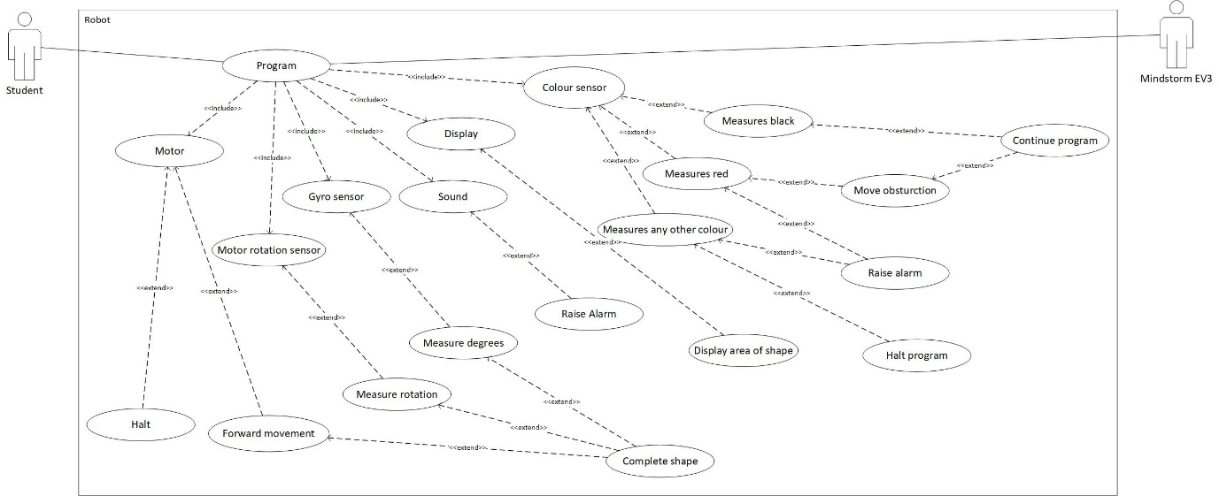
Once the robot has completed the shape, the robot will calculate the area of the shape and display the answer on the display.

Business Process Modelling Diagrams

Rectangle

Area of the rectangle
10x20= 200cm
20x30=600cm
30x40=1,200
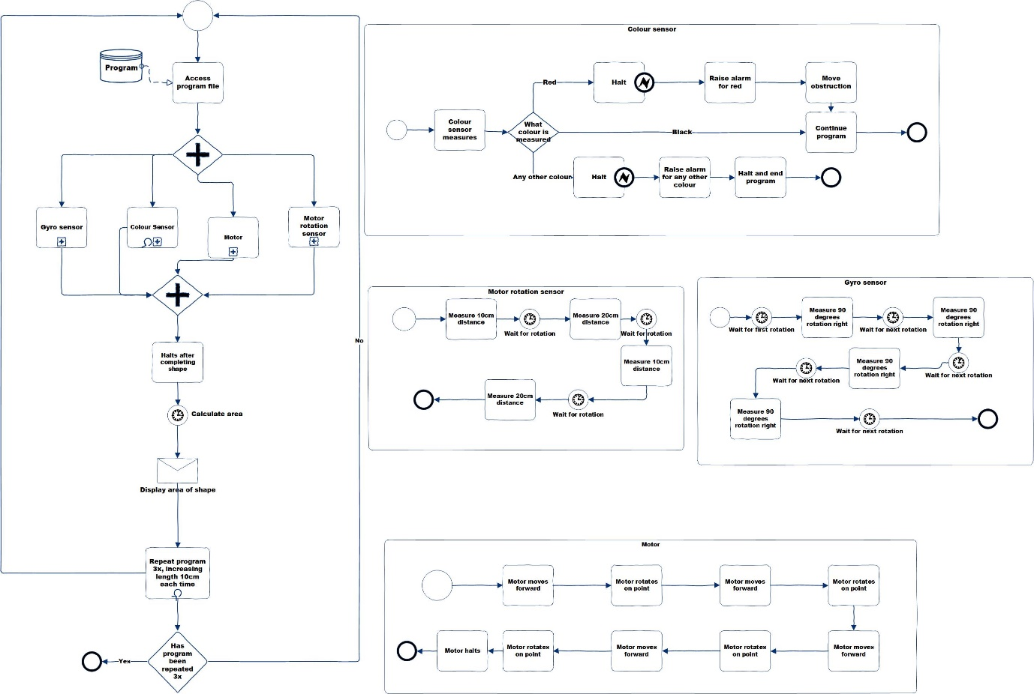

Right-Angle Triangle

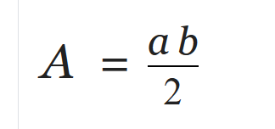
First drawing area of shape is 75 cm and C is 18cm
Second drawing, the area of the shape is 250cm and c is 32cm
Third drawing, the area of the shape is 525cm and C is 46cm
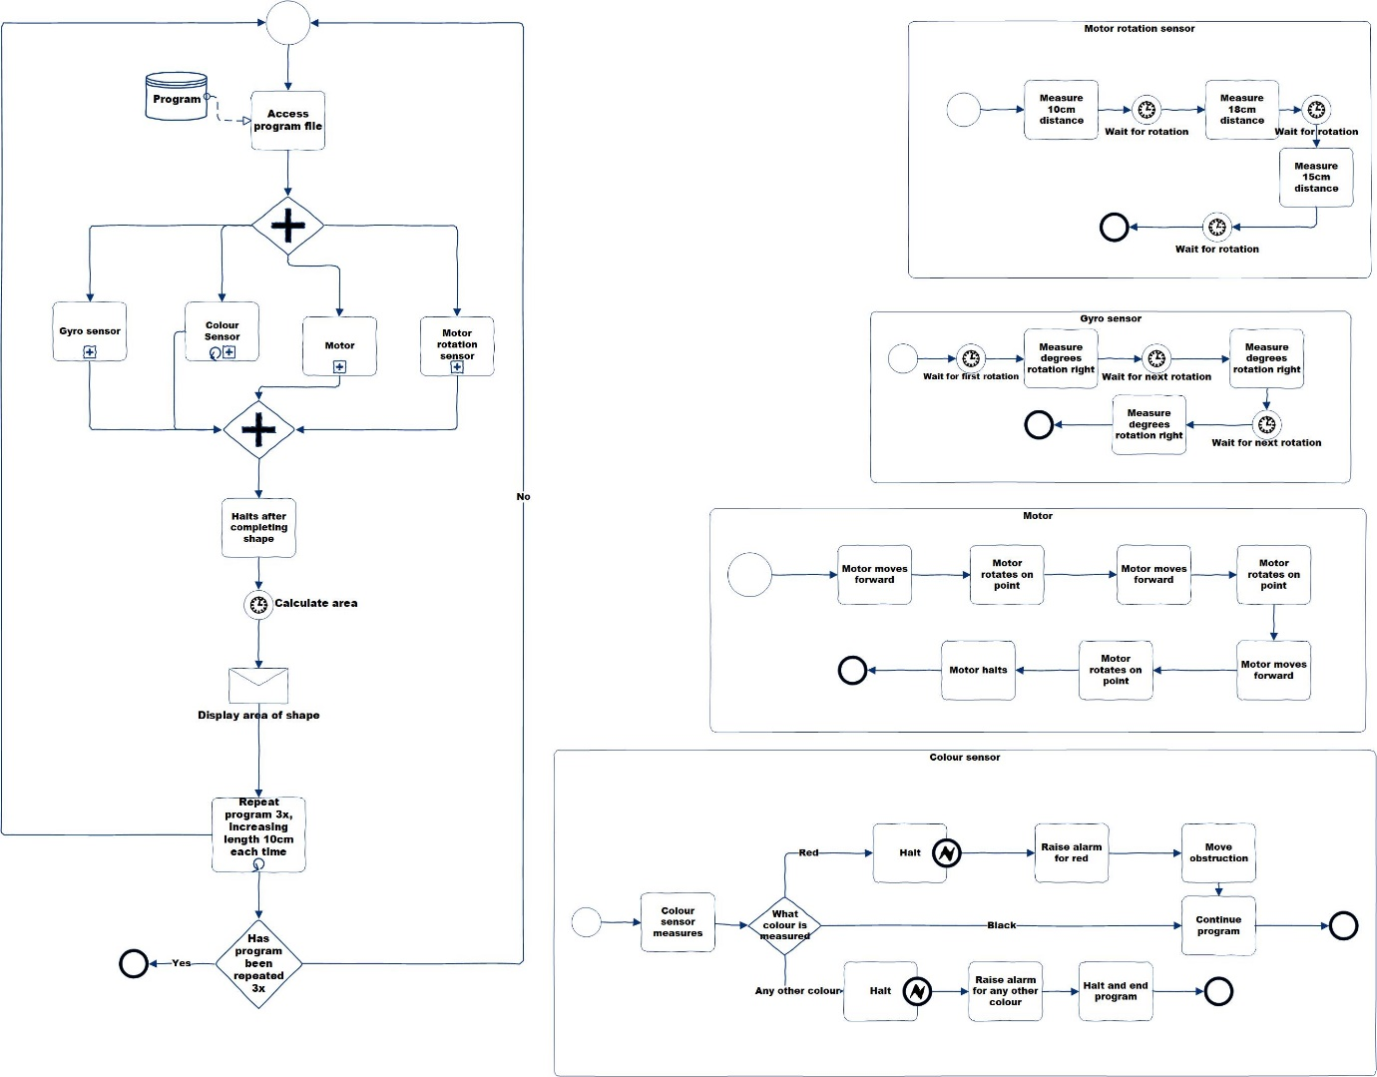

Circle within a Square

Radius of circle
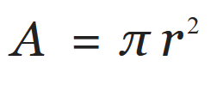
Area of the circle is 78.5cm
First drawing, the area of the circle is 314.1cm
Second drawing, the area of the circle is 706.9cm
Third drawing, the area of the circle is 1256.6cm
Area of the square
First, 10x10= 100cm
Second, 20x20=400cm
Third, 30x30=900cm
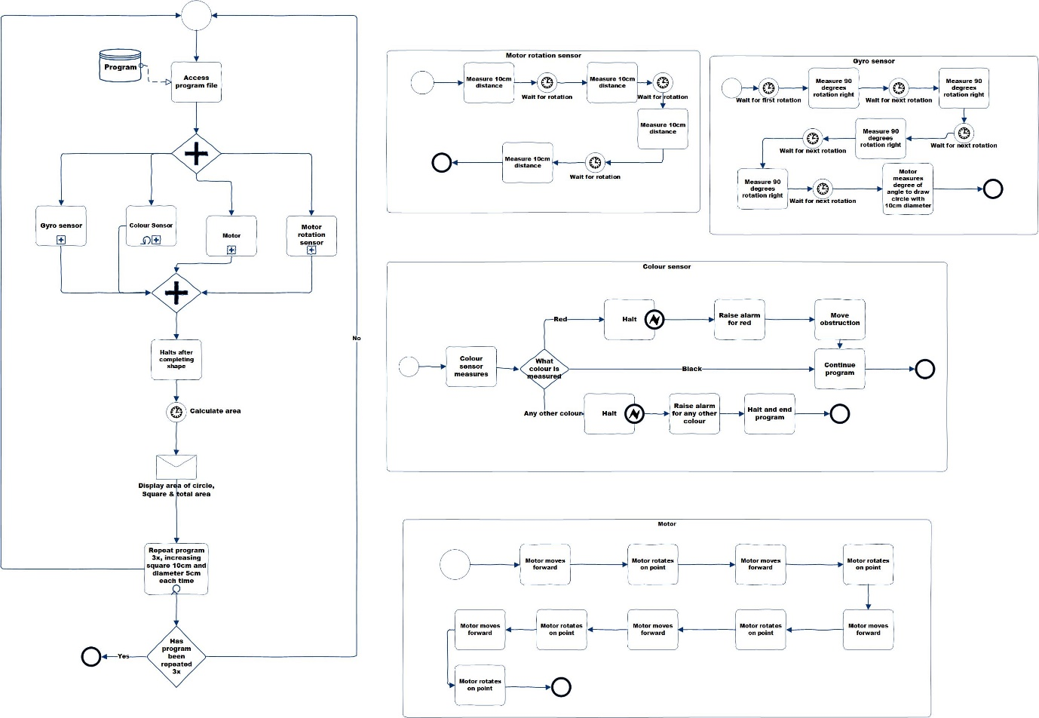

Join Symbol

Area of the symbol
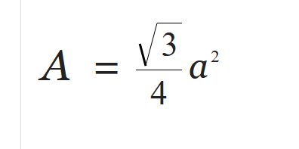
First drawing, one symbol 43.3cm, together the area is 86.6cm
Second drawing, one symbol 173.2cm and together the area is 346.4cm
Third drawing, 389.7cm and together the area is 779.4cm
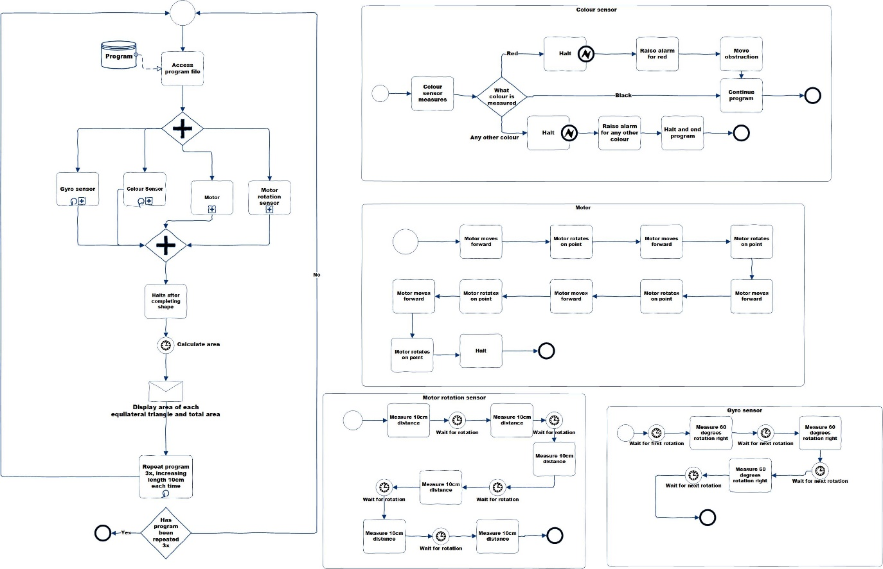

Lego Mindstorm EV3 Programming

Below are screenshots of programming for the rectangle that the robot drew. The author has also got photos of the robot completing the diagram and repeating the diagram, increasing the size 10cm each time.

Photos of Programming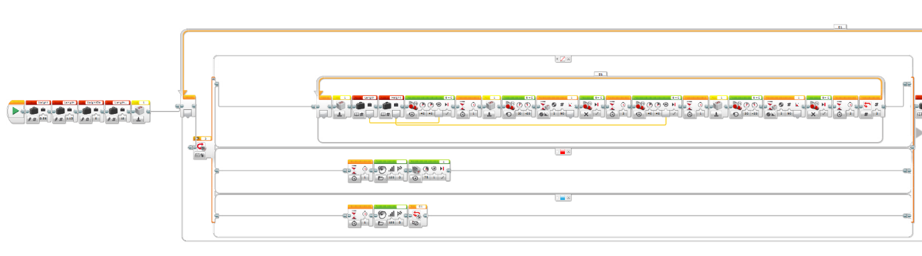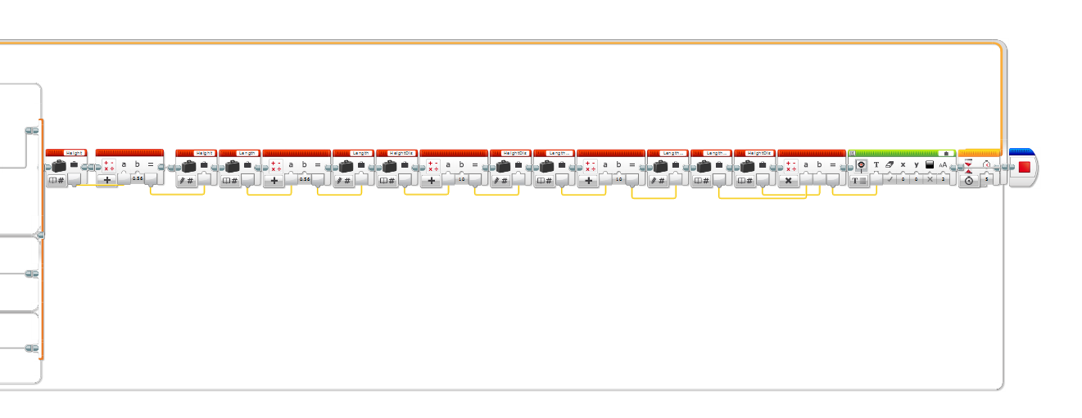

Photos of the robot in action.
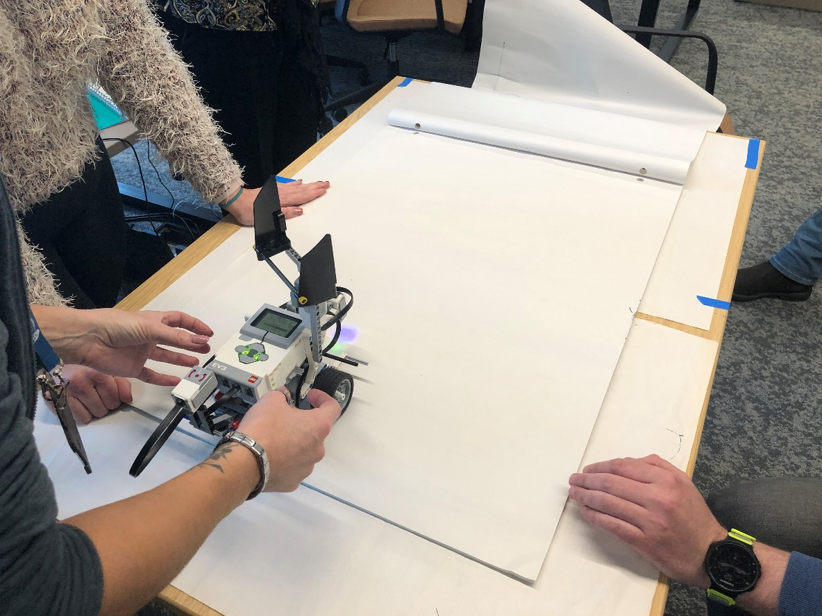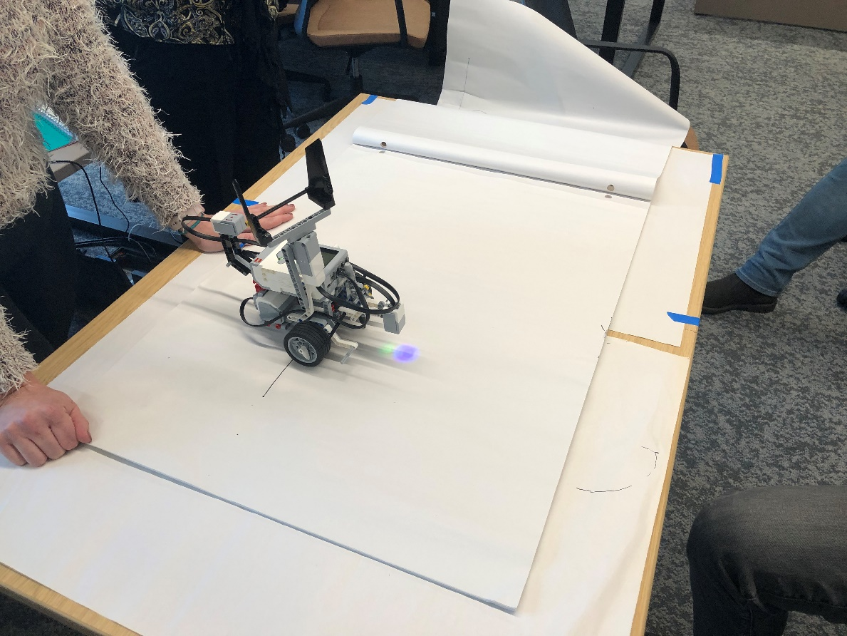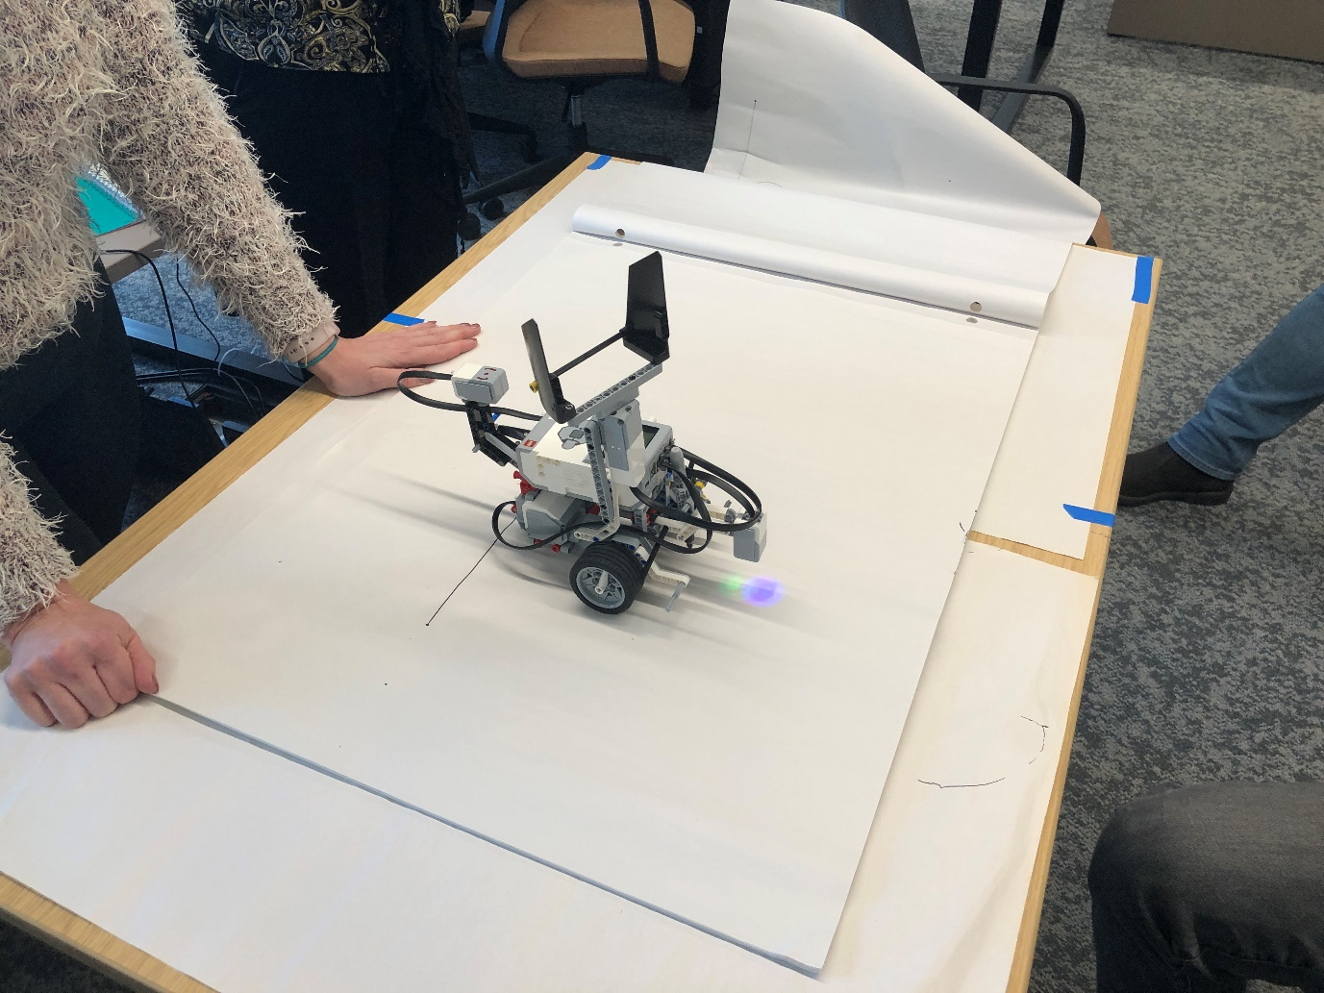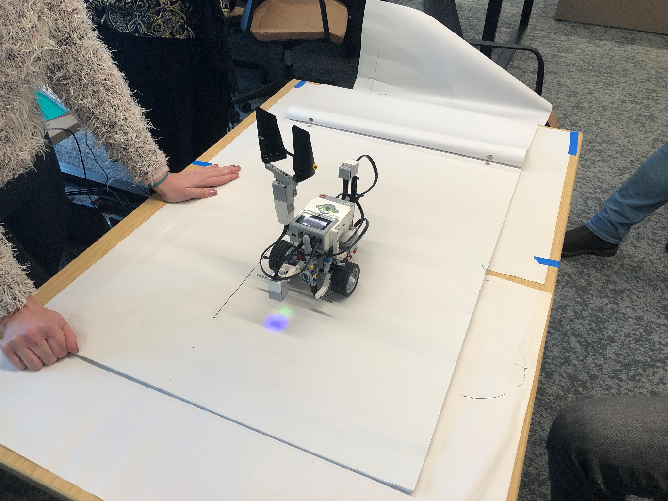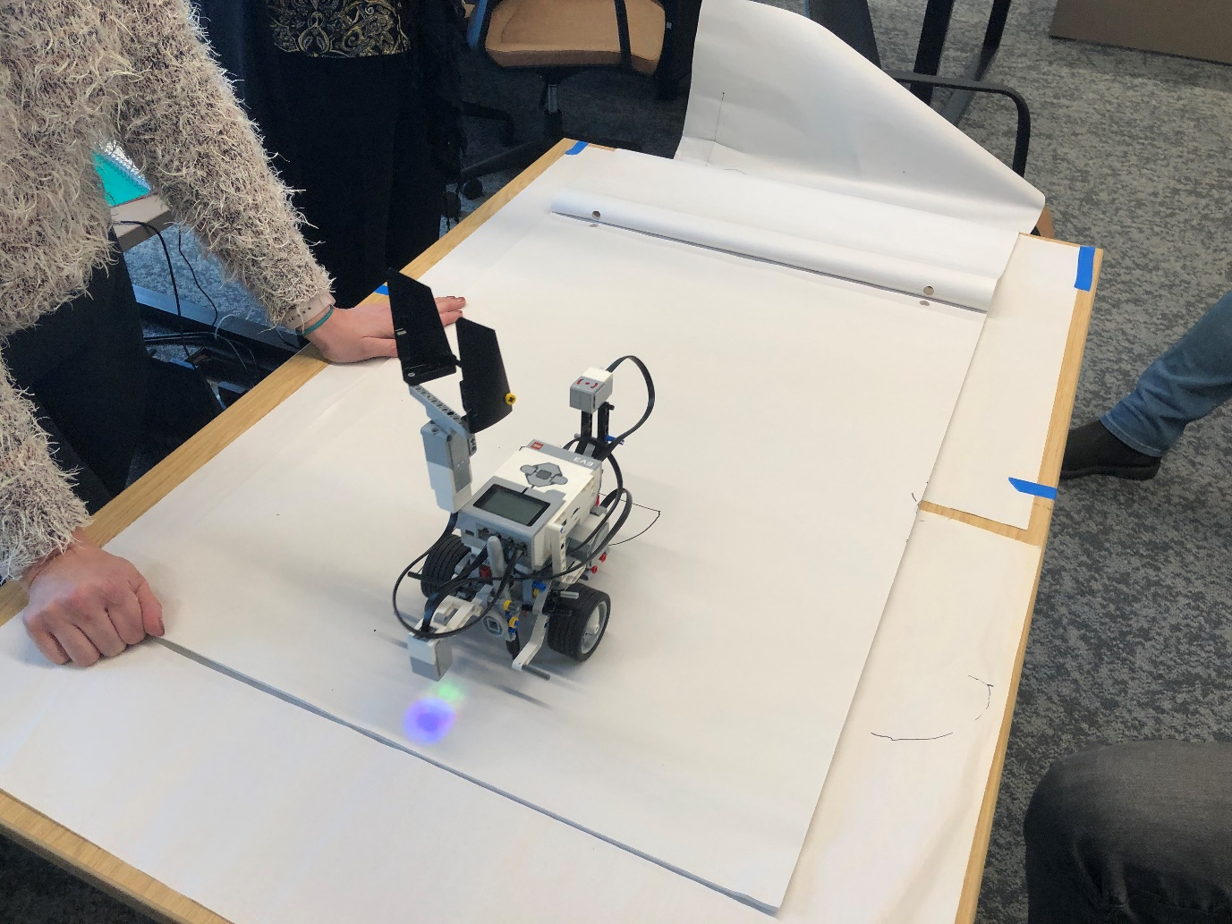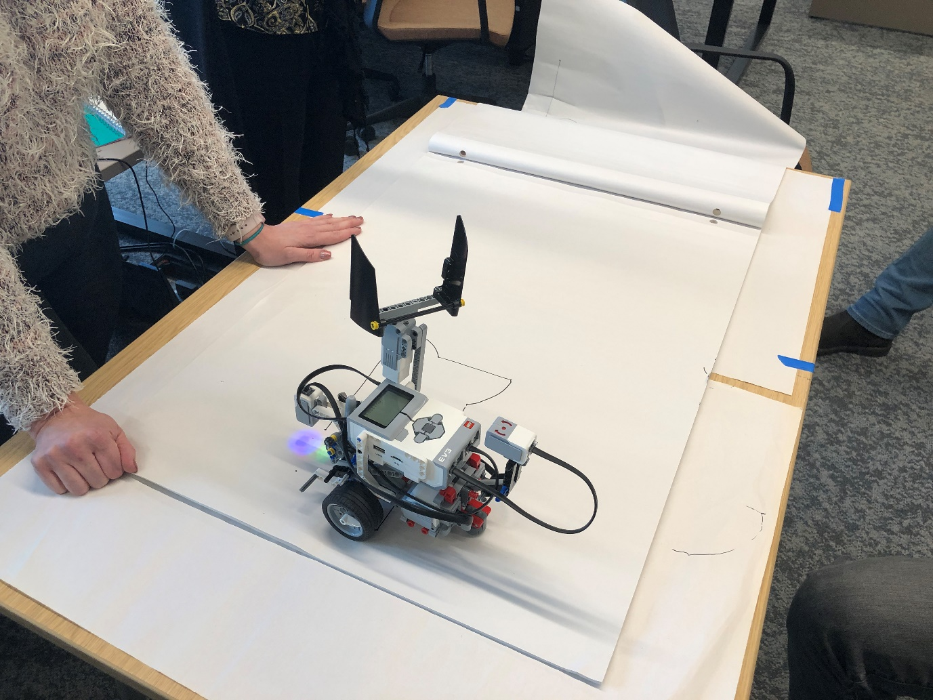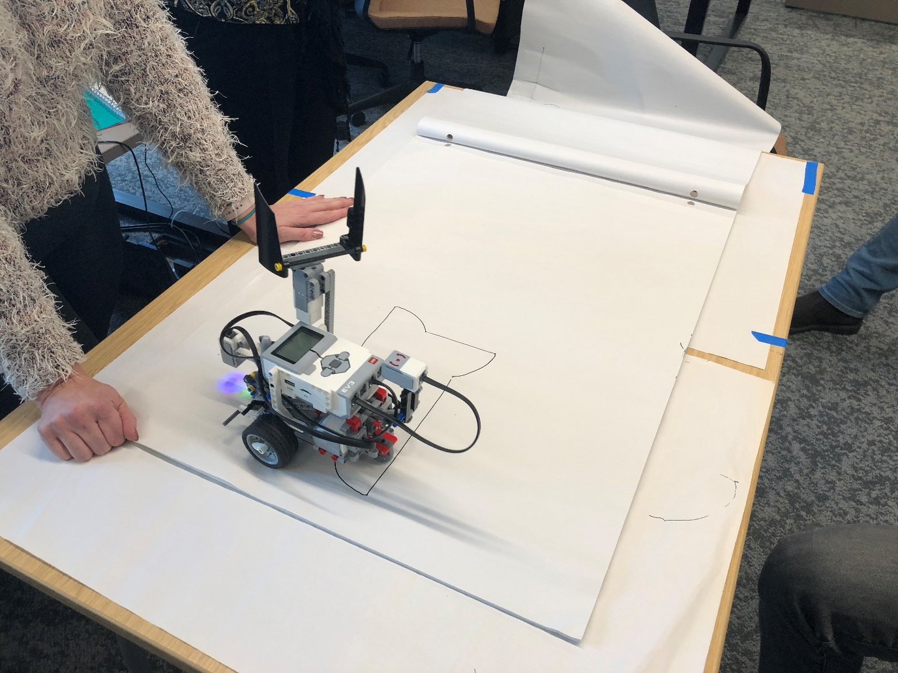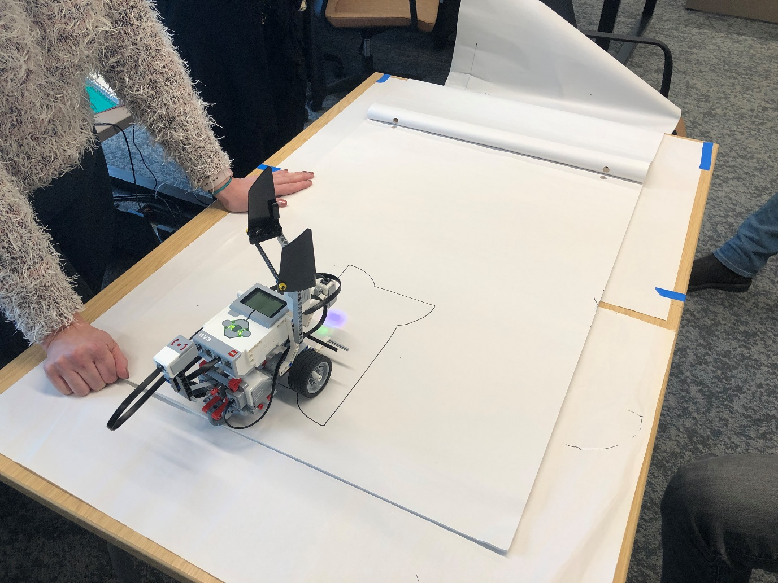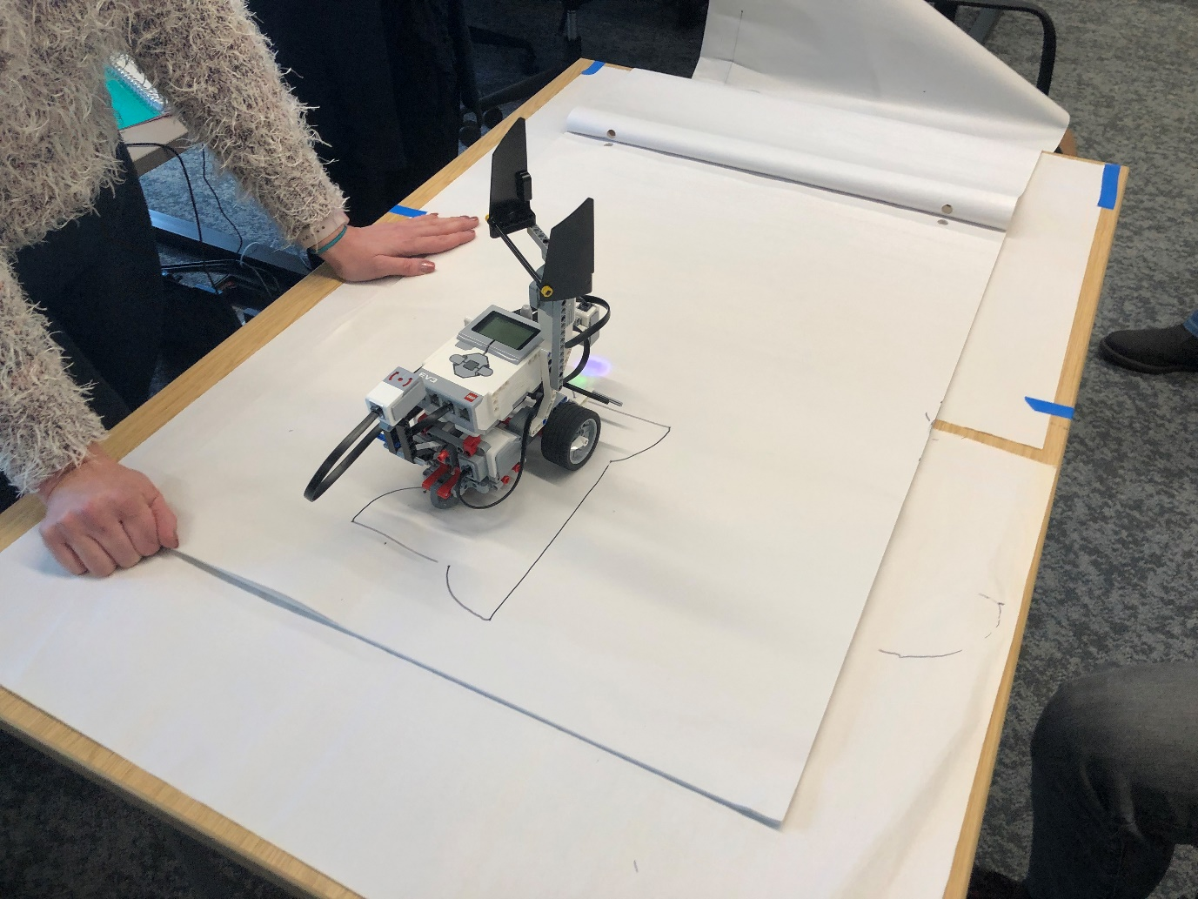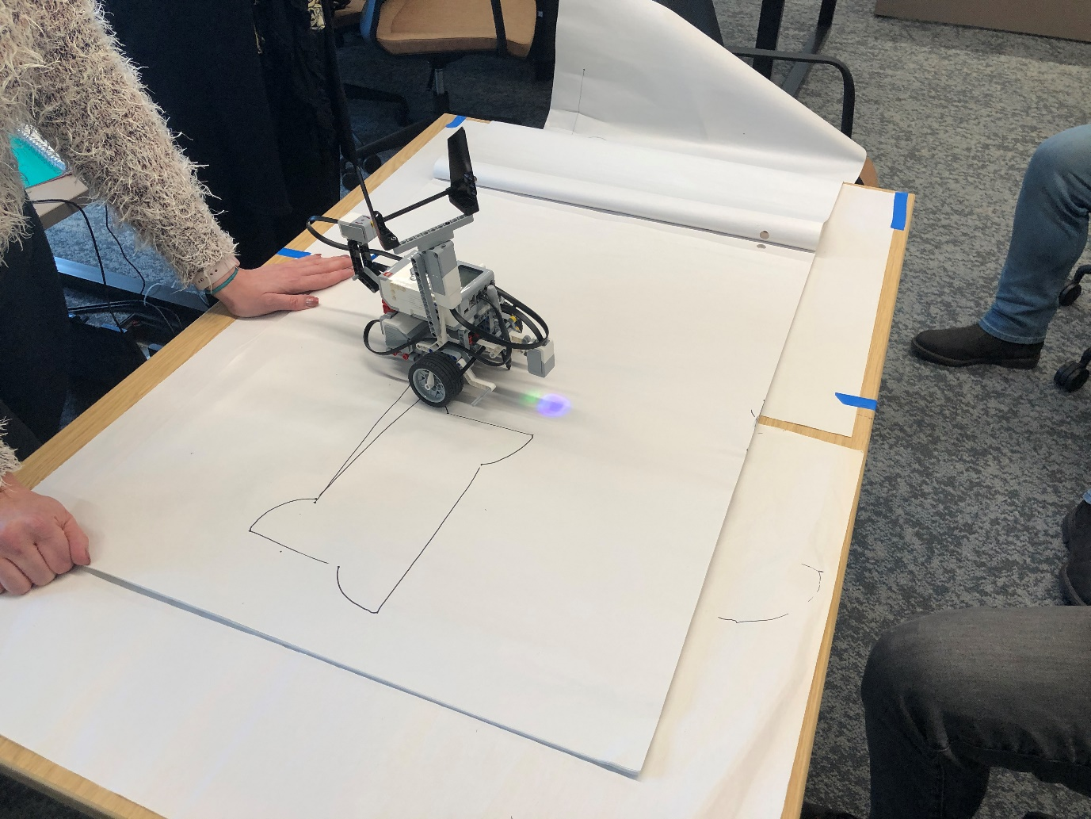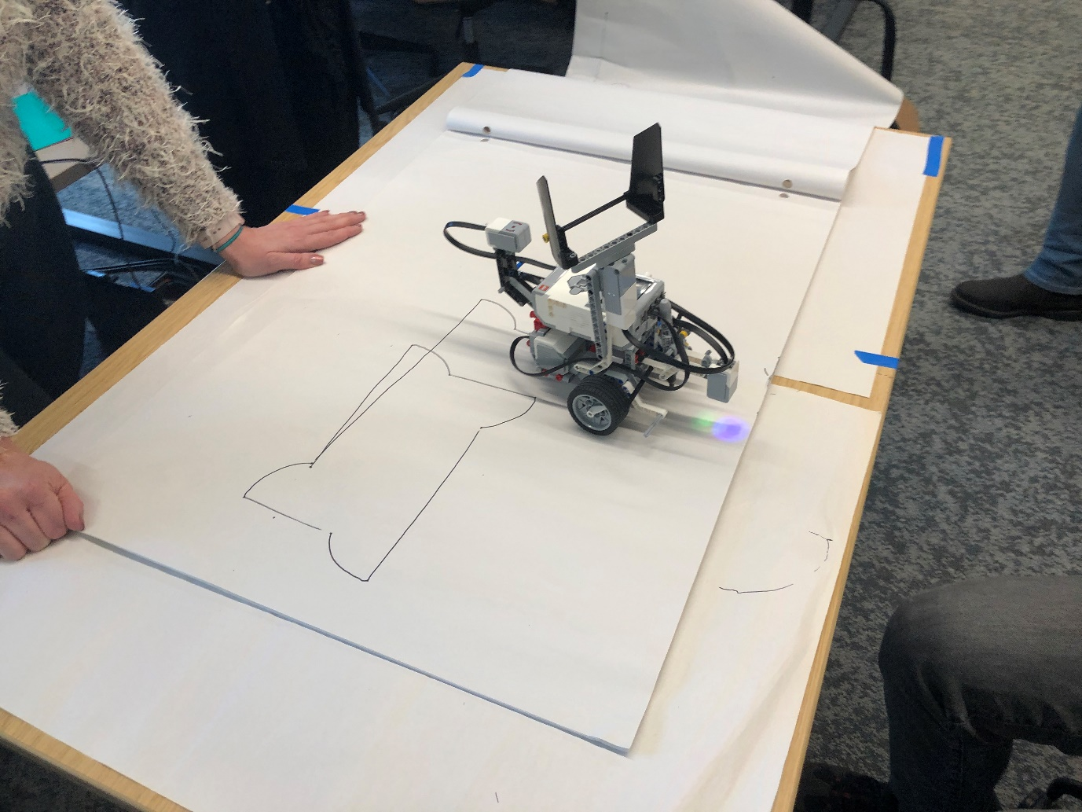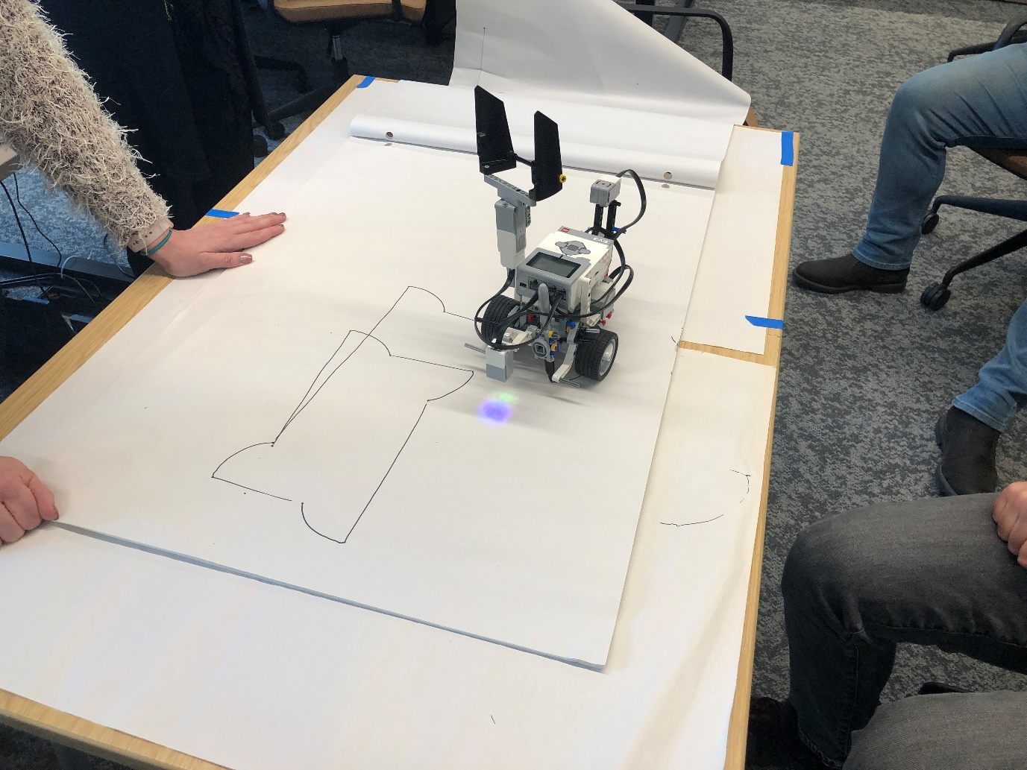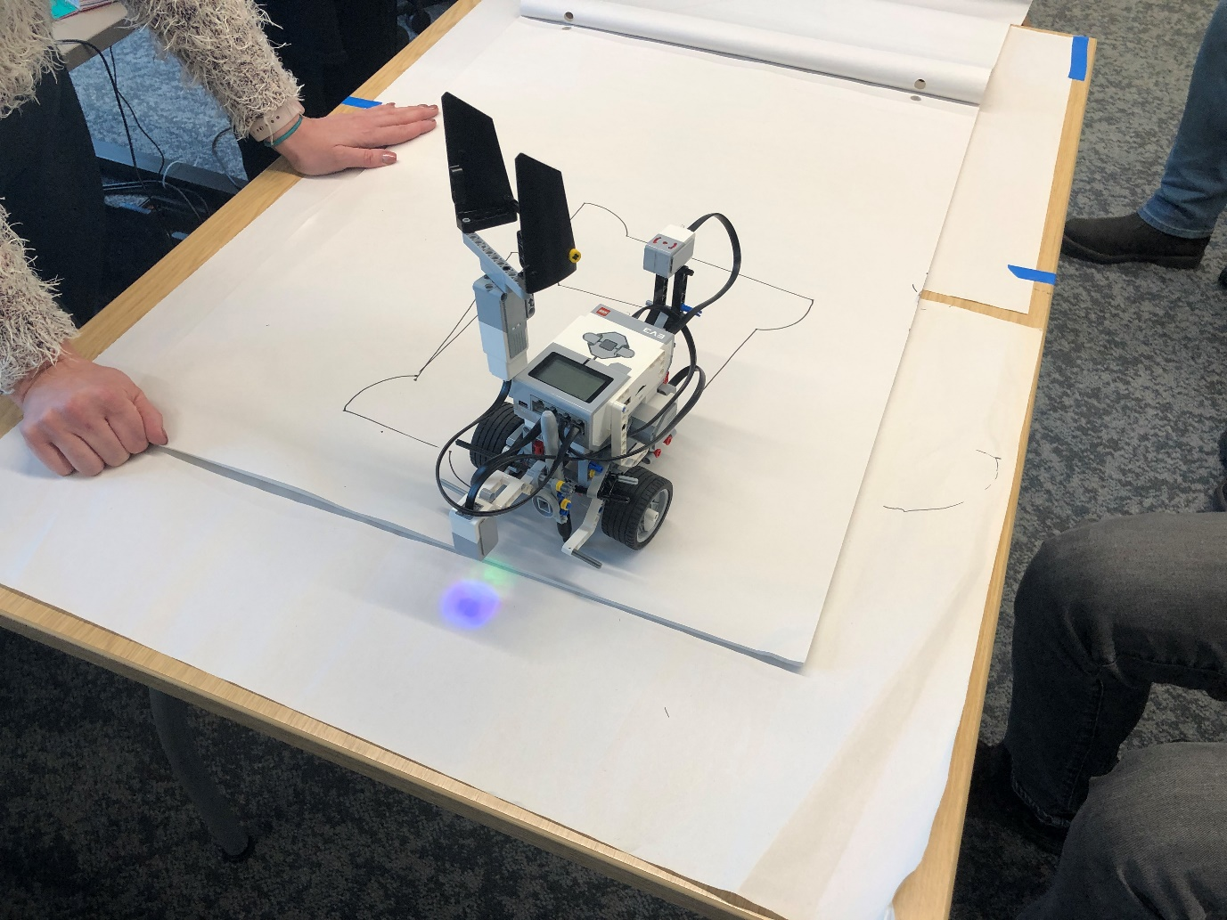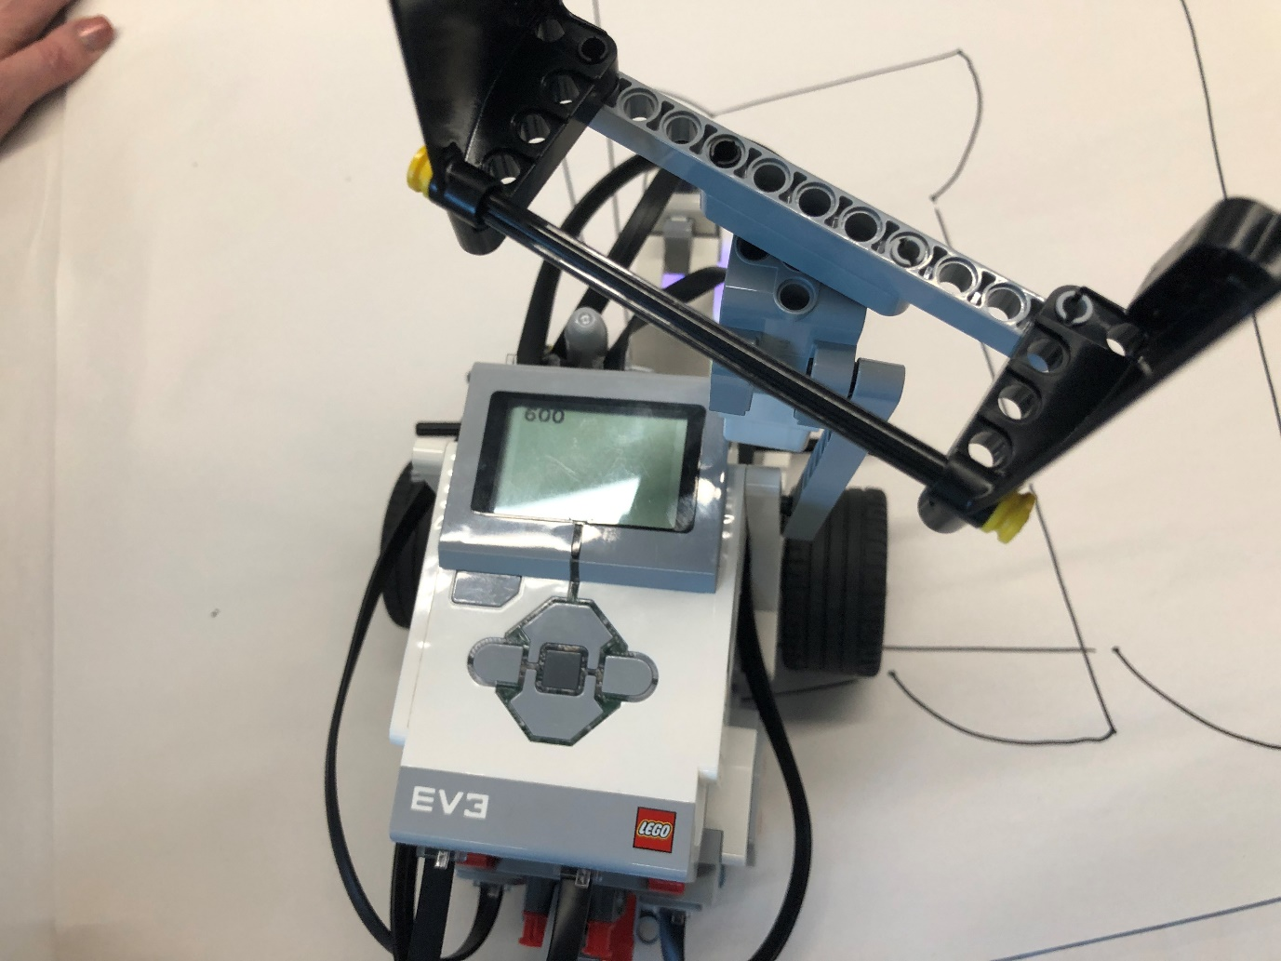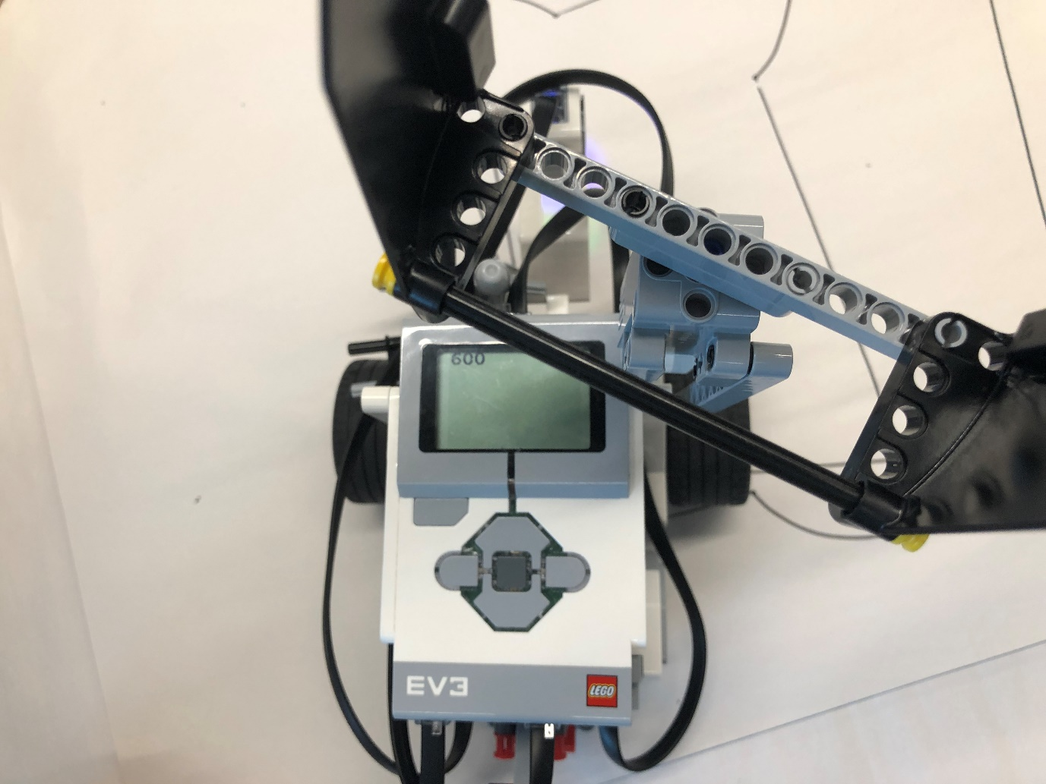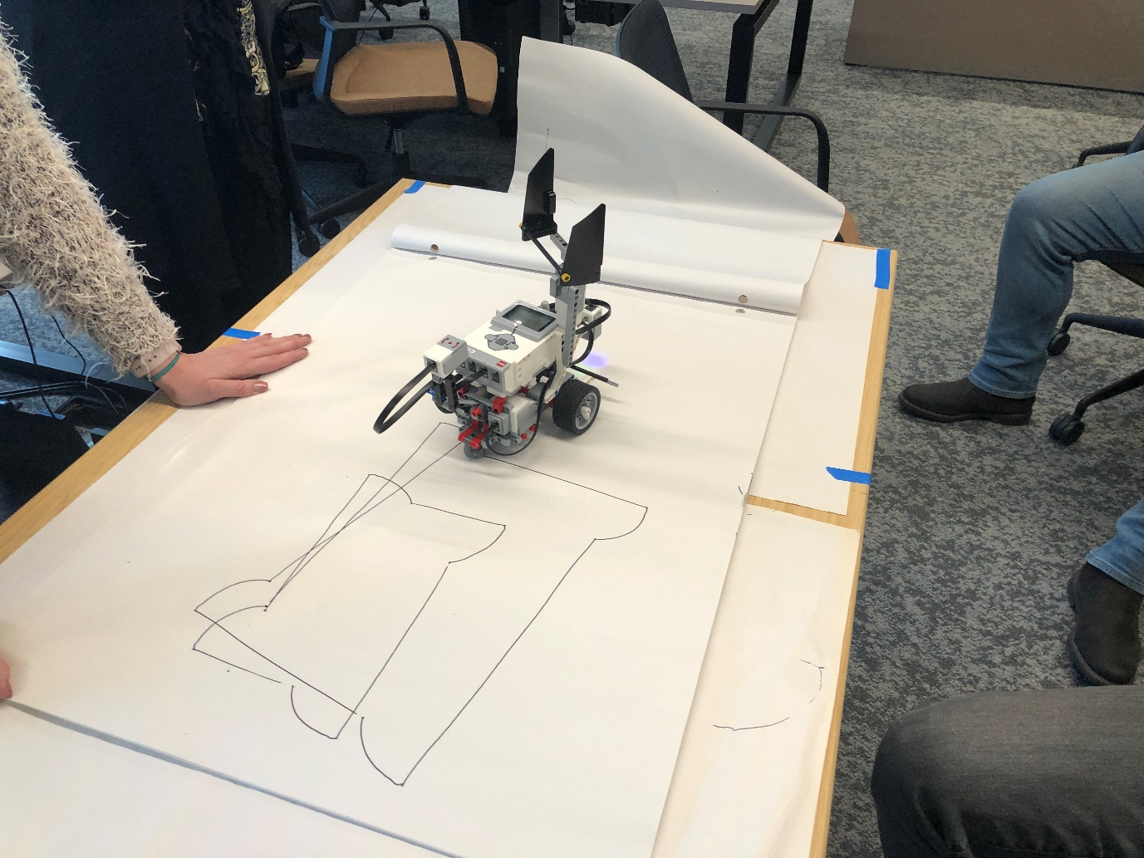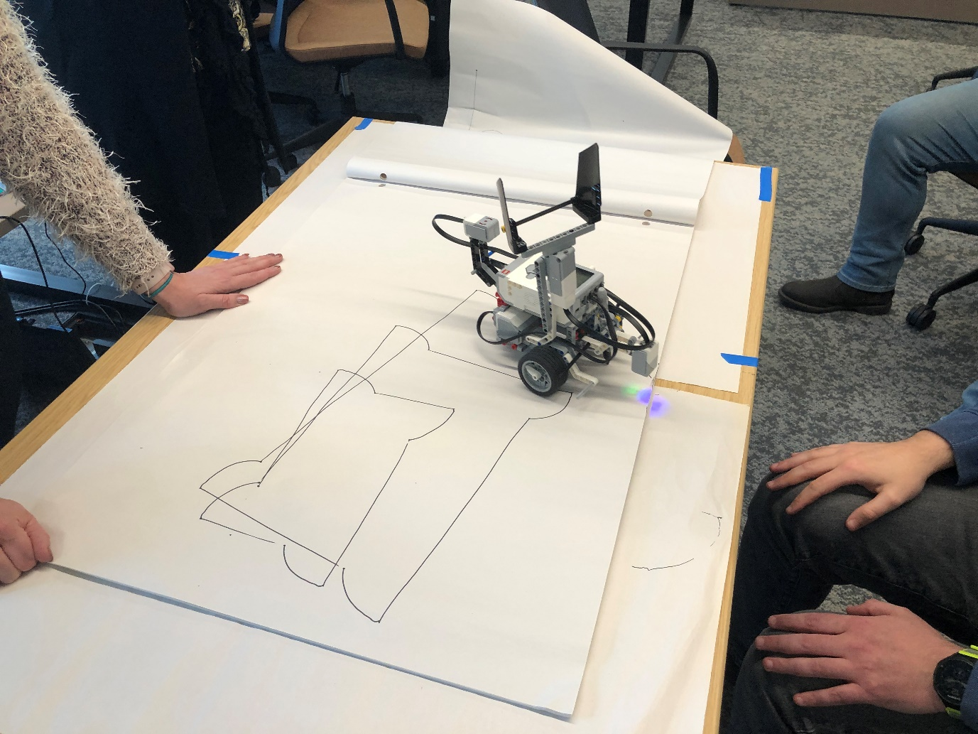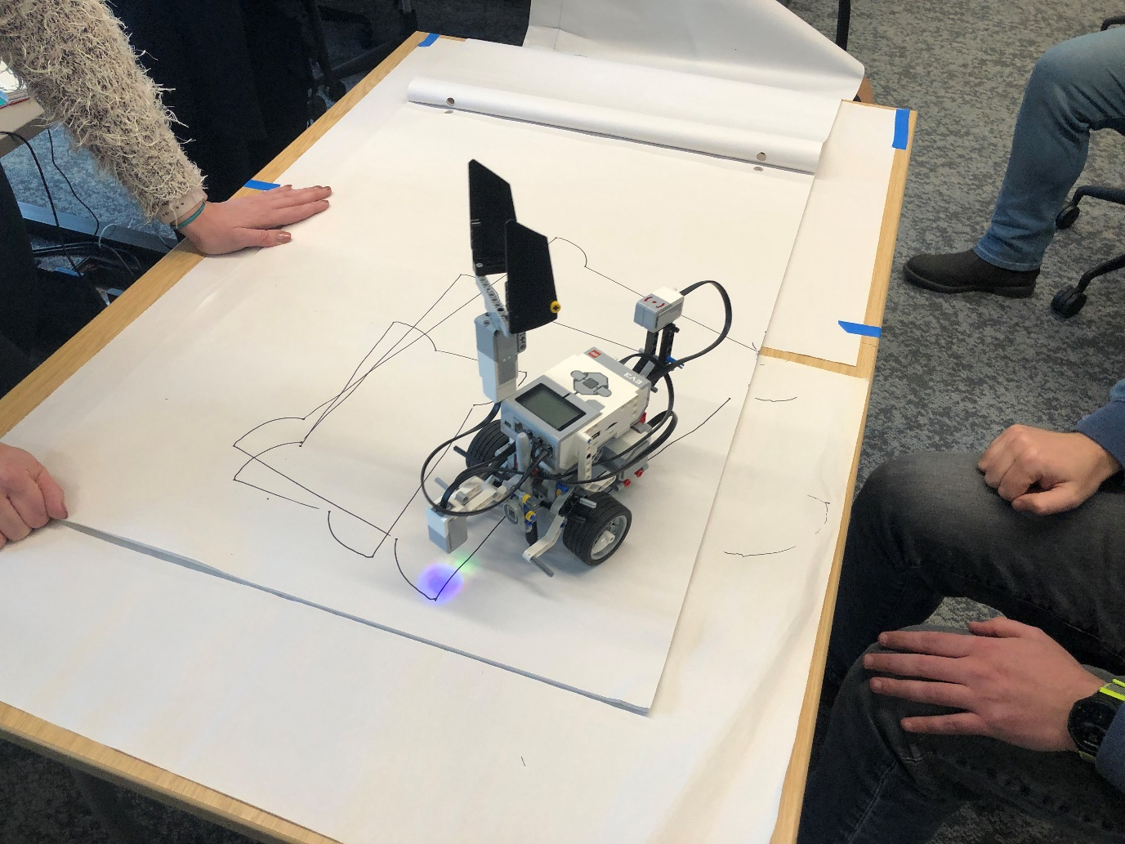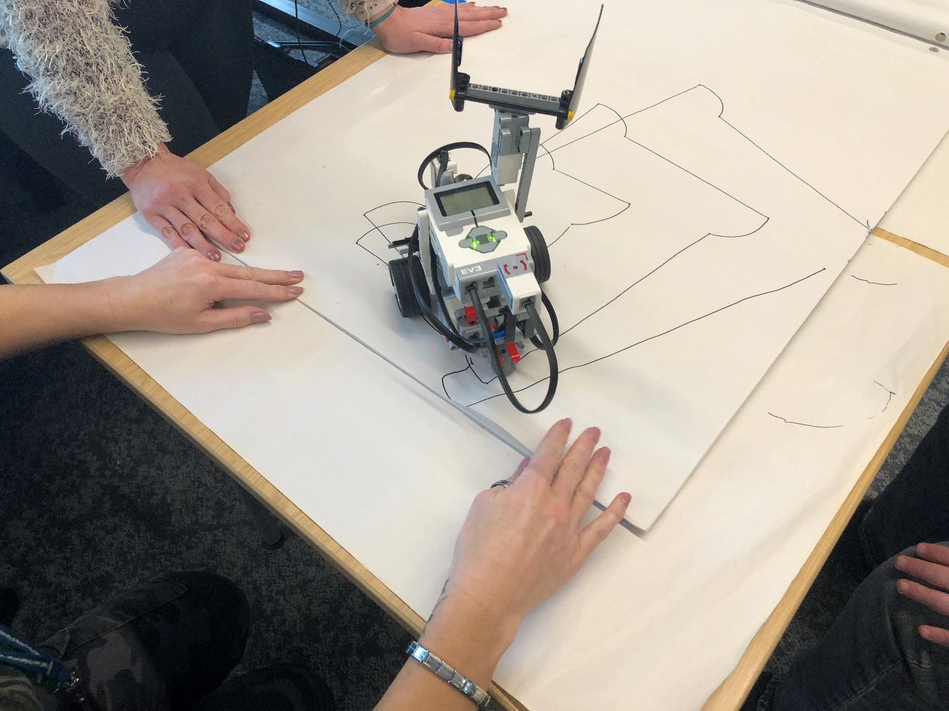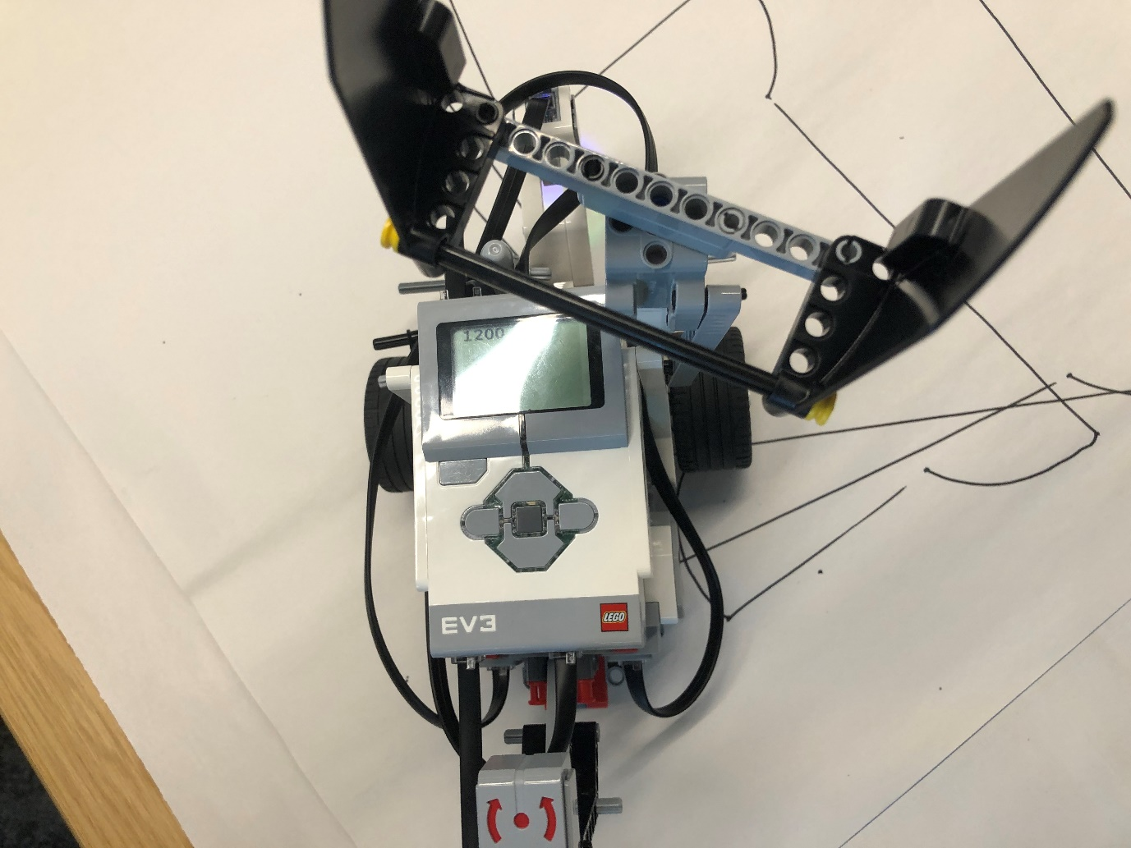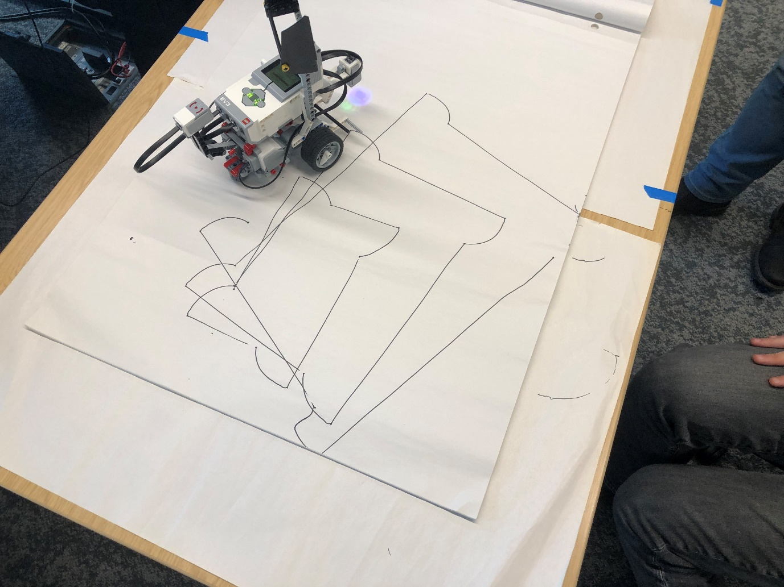
The group programmed the robot to sound an alert, make a signalling motion and display red object obstruction.
Photos of the program
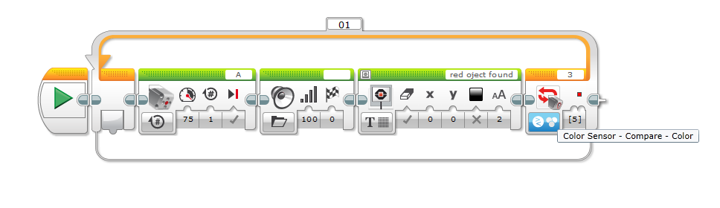

Photos of the robot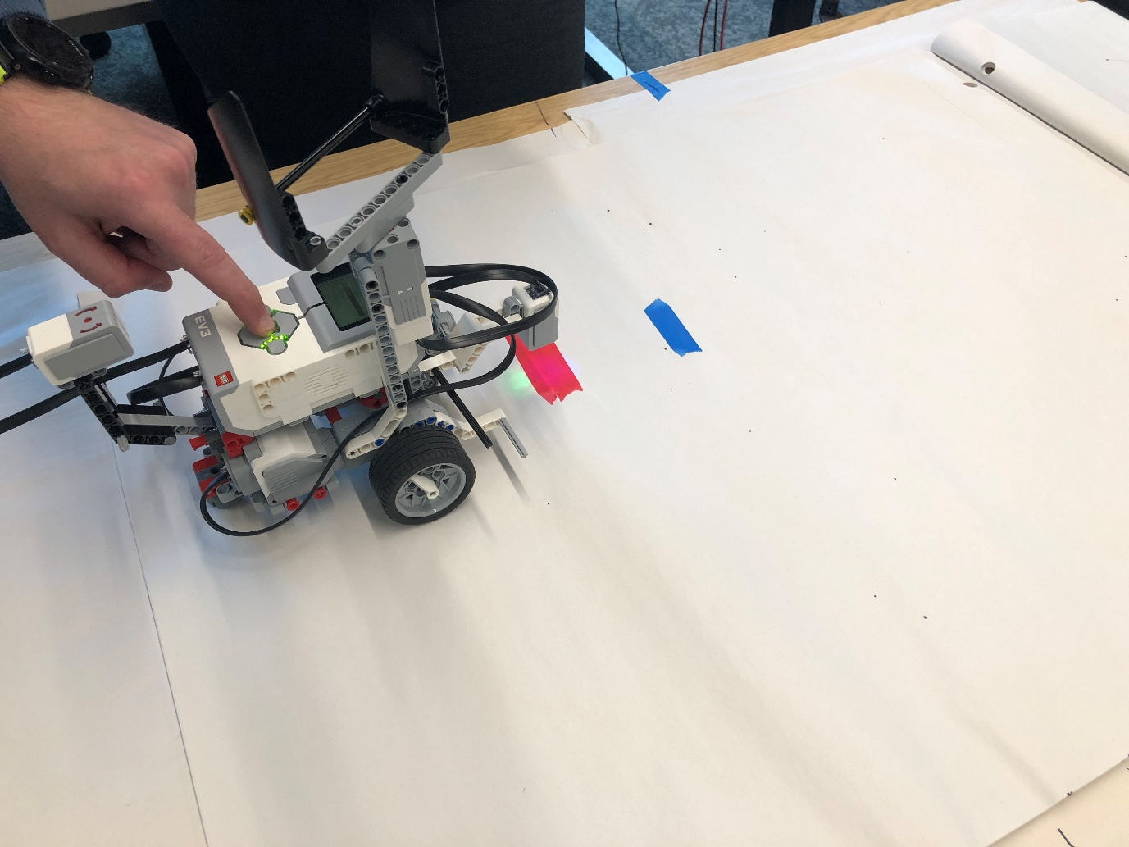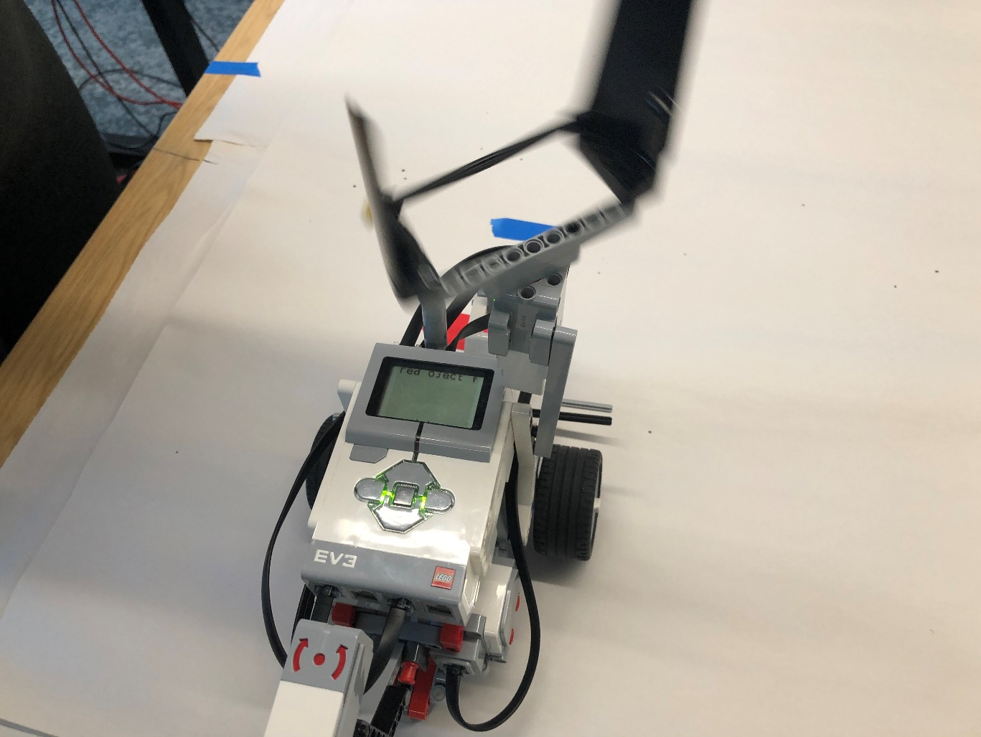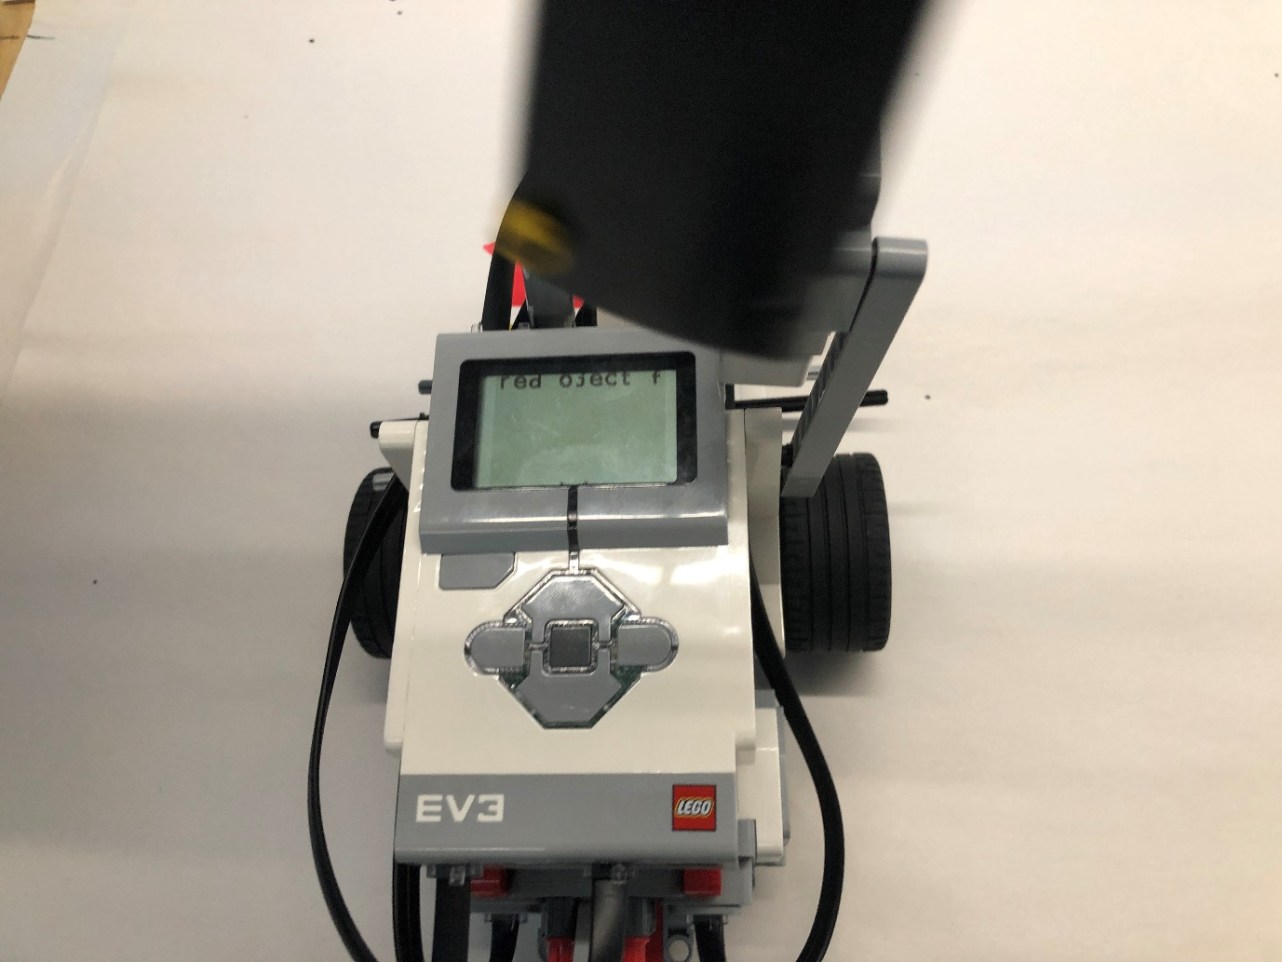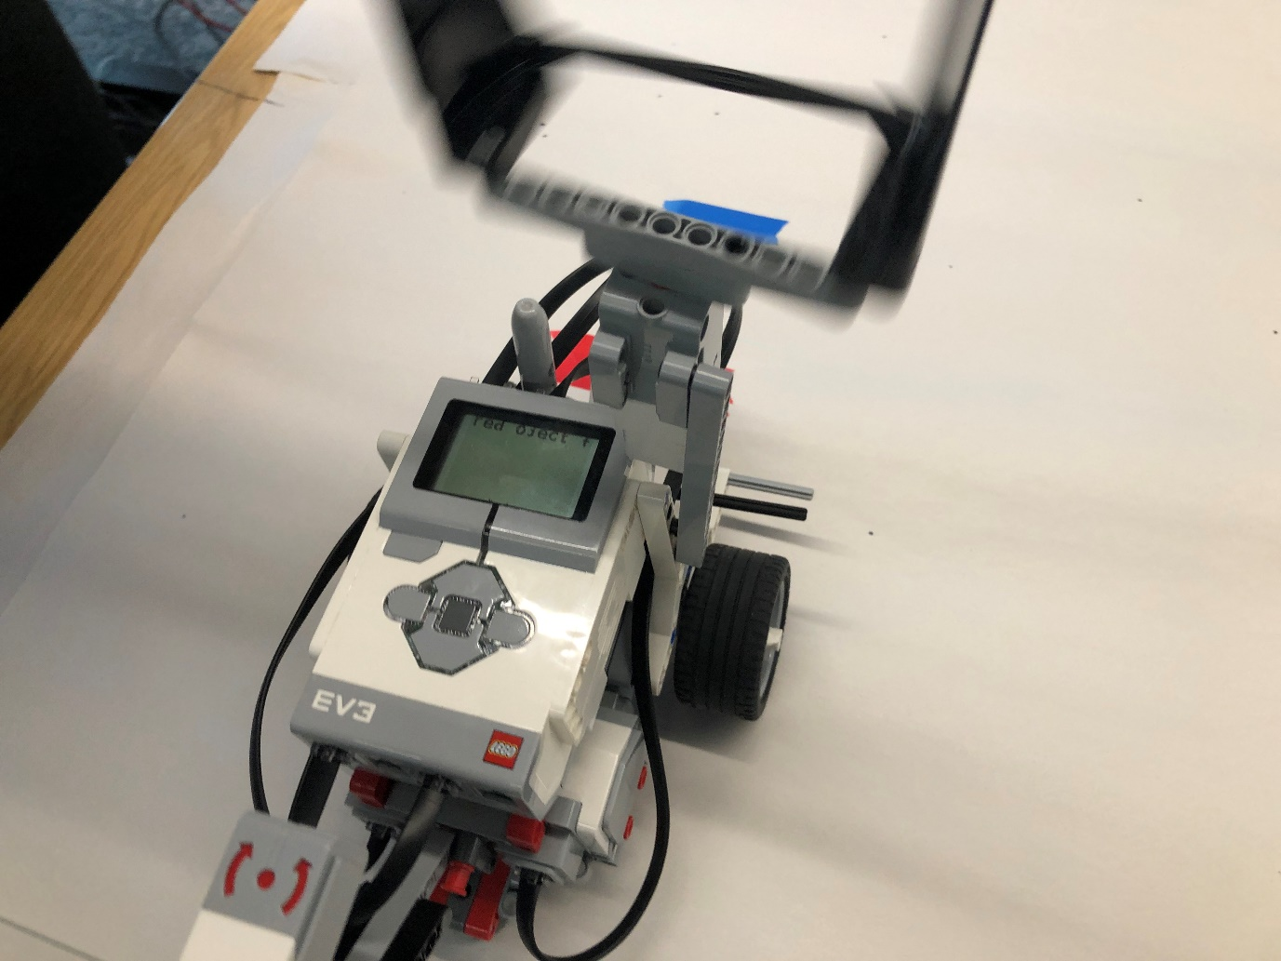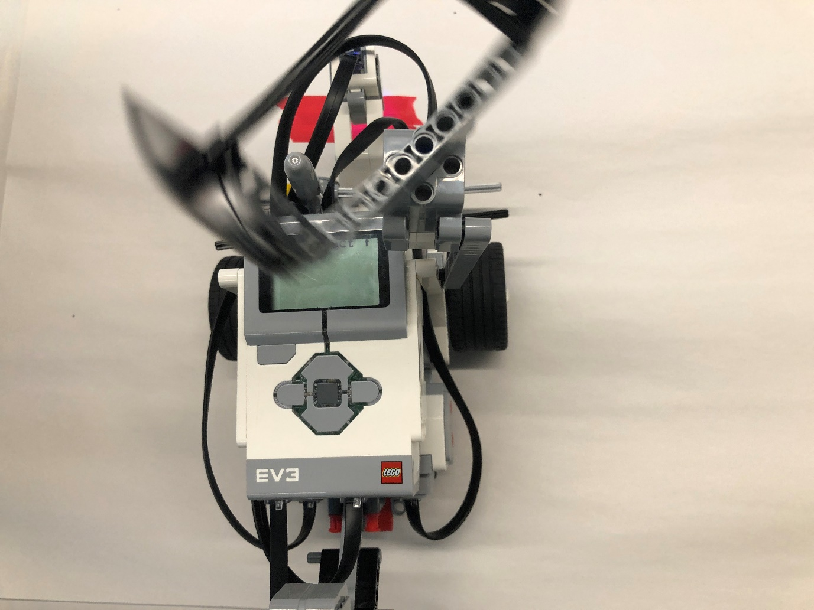

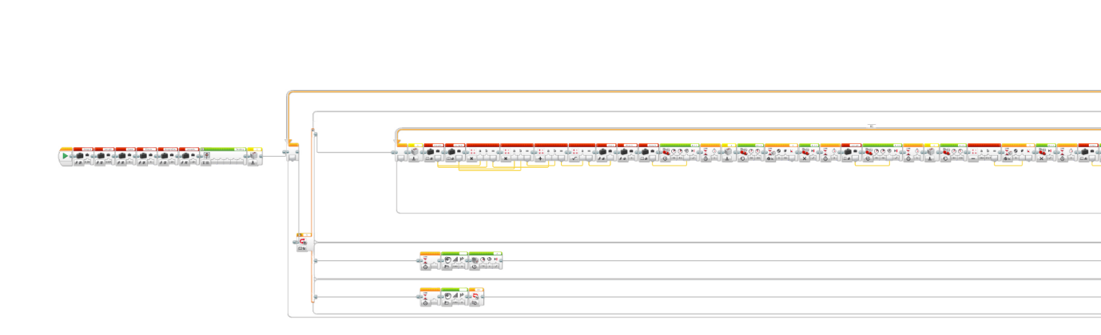
The screenshot below is the programming for the right-angle triangle. The group ran out of time before being able to test the programming on the robot.



