7/10/2026
Rabia Naeem (2310492)

BSc Applied Computing
Data Warehousing & Data Mining
Data Warehousing

Abstract
This report explores how data warehousing supports strategic decision-making in NHS England. It starts by contrasting Online Transaction Processing (OLTP) systems with data warehouses, emphasizing their distinct roles in day-to-day operations versus analytical reporting. The architecture of a healthcare data warehouse is then outlined, focusing on the Extract, Transform, Load (ETL) process and the value of data marts tailored for executive, financial, and clinical needs.
A star schema design is proposed to structure patient activity data using fact and dimension tables, enhancing query speed and business intelligence capabilities. The report also identifies critical internal and external data sources, lays out an ETL implementation roadmap, and addresses essential data quality and governance considerations, including regulatory compliance and access controls. Overall, the proposed framework illustrates how a robust data warehouse can deliver accurate, integrated, and trustworthy insights to drive evidence-based decisions and improve performance across NHS England.

Contents
Abstract 1
Introduction 3
1.1 OLTP vs. Data Warehouse 5
1.2 Data Warehouse Architecture and ETL 5
1.3 Data Marts for Management Decision-Making 7
1.4 OLTP Normalisation vs. Data Warehouse Dimensional Modelling 9
Task 2 10
2.1 Source System Identification 10
2.2 Star Schema Design 11
2.3 Data Marts and schema 13
2.4 ETL Plan 14
2.5 Data Quality and Governance 15
References 15

Introduction
Healthcare organisations accumulate extensive data each day from clinical encounters, operations, workforce management, and financial transactions. NHS England, one of the world’s largest health systems, collects information from hospitals, community services, specialist treatment centres, and public health initiatives. Despite successful day-to-day support, the data often resides in isolated databases, hindering a unified view of healthcare performance across regions and services.
As demand for care rises, NHS England requires timely, accurate information to inform strategic planning, improve patient outcomes, optimise resource use, and sustain financial viability. Integrating data from multiple operational systems is therefore essential to enable effective performance monitoring and evidence-based management.
A data warehouse offers a centralised repository that consolidates data from diverse sources and transforms it into information suitable for analysis and reporting. By applying data warehousing technologies, NHS England can derive insights into patient flow, workforce capacity, treatment outcomes, financial performance, and service quality. These insights aid senior leadership in identifying trends, forecasting future needs, and making informed decisions to enhance healthcare delivery.
This analysis assesses the role of data warehousing in NHS England. It distinguishes Online Transaction Processing (OLTP) systems from data warehouses, outlines data warehouse architecture and ETL processes, discusses data marts for management decision-making, and contrasts normalised database designs with dimensional modelling approaches. The report also proposes a star schema design, identifies pertinent data sources, sketches an ETL implementation plan, and considers essential data quality and governance requirements necessary for a successful data warehouse solution.

1.1 OLTP vs. Data Warehouse
NHS England relies on a suite of operational OLTP systems (e.g., electronic patient records, patient administration, workforce management, and financial applications) to run day-to-day care processes, delivering rapid, transaction-level data to clinicians and administrators for routine care. This operation-focused role of OLTP and its goal of timely, accurate data for frontline staff is consistently described in healthcare BI literature and hospital data warehouse case studies [1], [2], [3]. Hospital BI perspectives discuss OLTP as the source of current transactional data that feeds analytics only after extraction and integration through ETL processes [1], and outpatient/hospital DW projects emphasize the separation of operational and analytic duties to preserve care continuity [2], [3].
A data warehouse aggregates data from multiple OLTP sources to enable analytics, benchmarking, and strategic decision-making, providing a consolidated, historical, and integrated foundation for reporting and BI. This central repository concept with data marts for targeted analytics is described across BI literature and hospital implementations, illustrating the “single platform” that supports dashboards and executive insights across domains [4], [1], [5], [3], [6]. The healthcare-specific literature reinforces that DWs underpin performance monitoring, governance, and research-ready datasets in clinical settings [2], and that clinicians and managers benefit from unified data views for oversight and planning [1], [5].
The ETL pipeline extracts data from source systems, transforms by cleaning, standardizing, deduplicating, validating, and applying business rules, then load into the central warehouse—is repeatedly described as the backbone of reliable analytics in DW/DM architectures [7], [1], [3], [8]. Healthcare deployments emphasize non-disruptive ETL that operates in background (overnight or low-activity windows) to avoid affecting patient care while delivering timely analytics to leadership [1], [2], [3].

1.2 Data Warehouse Architecture and ETL
A centralized NHS data warehouse provides a single, integrated platform that consolidates data from diverse operational systems to support reporting, business intelligence (BI), and strategic planning. This consolidated view enables senior leaders to monitor performance across hospitals, regions, and services, reducing reporting fragmentation and enabling cross-organizational insights [10], [11], [12]. The broader literature repeatedly frames such warehouses as a “single source of truth” that underpins governance and evidence-based decision making in healthcare contexts [10], [11], [13].
Architecture flow and core components
Source systems and data acquisition: Operational systems including Electronic Patient Records (EPR), Patient Administration Systems (PAS), clinical applications, workforce management, and financial systems continue day-to-day operations while supplying data for the warehouse. This separation of routine care from analytic extraction aligns with typical enterprise BI patterns in healthcare and other large organizations [11], [10], [12].
ETL process (Extract, Transform, Load):
Extract: relevant data are retrieved from each source system.
Transform: data are cleaned and standardized, duplicates are removed, errors are corrected and values are validated, and business rules enforced to ensure consistency.
Load: transformed data are loaded into the central warehouse to support reporting and analyses [10].
Central data warehouse: The warehouse stores and organizes data to underpin dashboards, reports, and analytics, acting as the historical, consolidated backbone for decision support and performance management [11], [12], [13].
Data marts and analytics layer: Subject-specific data slices (e.g., CEO/Finance/Clinical Marts) surface through the warehouse to support executive, financial, and clinical analyses. Marts help deliver domain-driven analytics while preserving governance and a coherent data model [13], [12].
Operational benefits and ETL scheduling
Non-disruptive ETL: ETL operates independently of clinical workflows, typically running during low-activity periods (e.g., overnight) so patient care remains uninterrupted while providing timely, integrated information to decision makers [11]. This separation between analytics and real-time operations is consistently described as a key operational benefit in DW/DM deployments [11].
Timeliness and reliability for leadership: The combined central warehouse and targeted data marts yield timely, integrated dashboards and reports used by senior leaders to support evidence-based decisions spanning hospitals, regions, and services [11], [12], [13].
Data marts: scope, governance, and patterns
Purpose and governance: Data marts deliver subject-specific data subsets (executive, financial, clinical) to support leadership dashboards and decision support, while maintaining an overall governed data ecosystem [13], [12]. This approach helps standardize reporting and sustain trust across units.
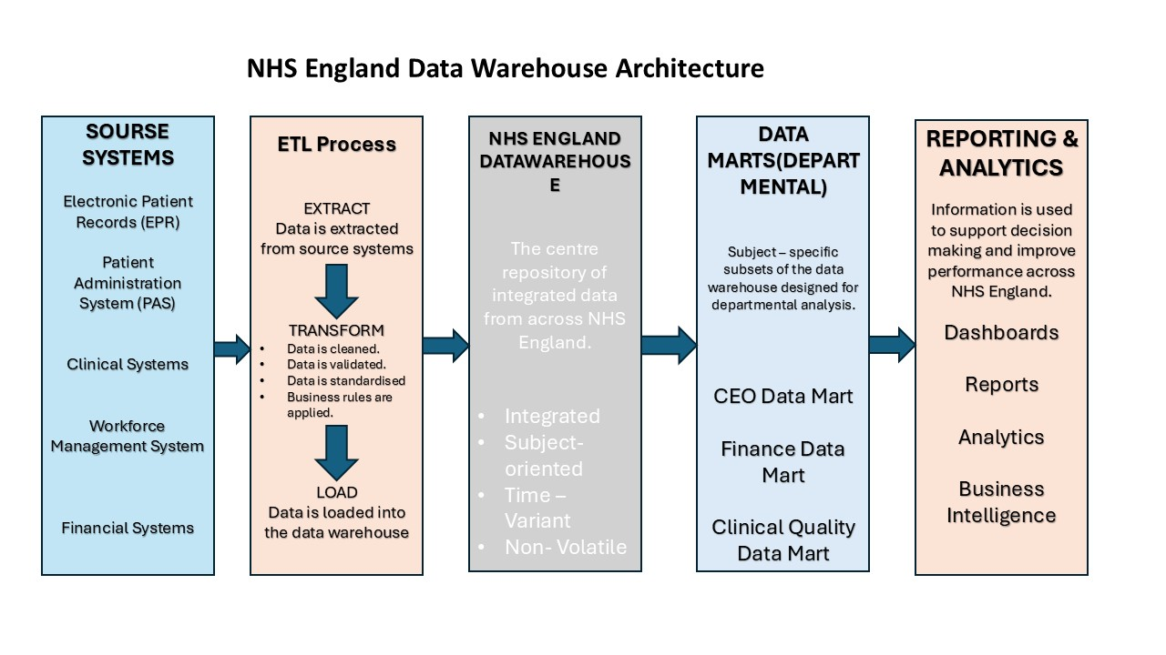Figure 1 NHS England Data Warehouse Architecture and ETL Process
Figure 1 illustrates how data from NHS England's operational systems, including EPR, PAS, clinical, workforce and financial systems, is integrated through the ETL process into a central data warehouse. The warehouse supports departmental data marts and provides dashboards and reports for strategic decision-making.

1.3 Data Marts for Management Decision-Making
Data marts are focused slices of a data warehouse designed to meet the reporting and analytical needs of specific NHS leadership roles (CEO, Finance Director, Medical Director). They derive from a centralized NHS data warehouse and provide faster, role-tailored insights while preserving a single version of the truth through shared, conformed dimensions and a common data model [17], [18], [19]. This approach aligns with the Kimball-style emphasis on dependent data marts anchored to a conformed central warehouse, enabling efficient governance and domain-specific analytics [18], [19].
Chief Executive data mart
Design aims: deliver a strategic, system-wide view by aggregating data across EPR, PAS, workforce, and finance sources to support top-down decision making and service planning [17], [19]. Dashboards should highlight trends and performance trajectories, supporting proactive service improvements and resource allocation decisions. The data mart should leverage a star/snowflake schema with shared dimensions (time, geography, region) to enable cross-domain insights while maintaining data quality through ETL governance [17], [18].
Finance Director data mart
Design aims: integrate financial ledgers with operational activity to enable spend analyses, budgeting versus actuals, and cost-effectiveness assessment. Reporting perspectives focus on overspend detection, cost per episode or pathway, and resource utilization, enabling timely financial planning and efficient allocation of NHS resources. A governance-aligned data model and ETL discipline are essential to ensure consistency with the central warehouse and to support auditable finance reporting [17], [20], [19].
Medical Director data mart
Design aims: combine clinical data from EPR, labs, and diagnostics to monitor care quality. Outputs should cover treatment outcomes, readmission rates, infection rates, mortality, length of stay, and guideline adherence. Datamarts enable focused clinical dashboards, supporting evidence-based practice and patient safety improvements while leveraging standardized clinical dimensions and metrics drawn from the warehouse [19].
Figure 2 illustrates how the NHS England data warehouse supports three specialised data marts designed for the Chief Executive, Finance Director, and Medical Director. Each data mart provides role-specific information derived from the same integrated data warehouse, enabling managers to access relevant insights while maintaining a single, consistent source of organisational data.
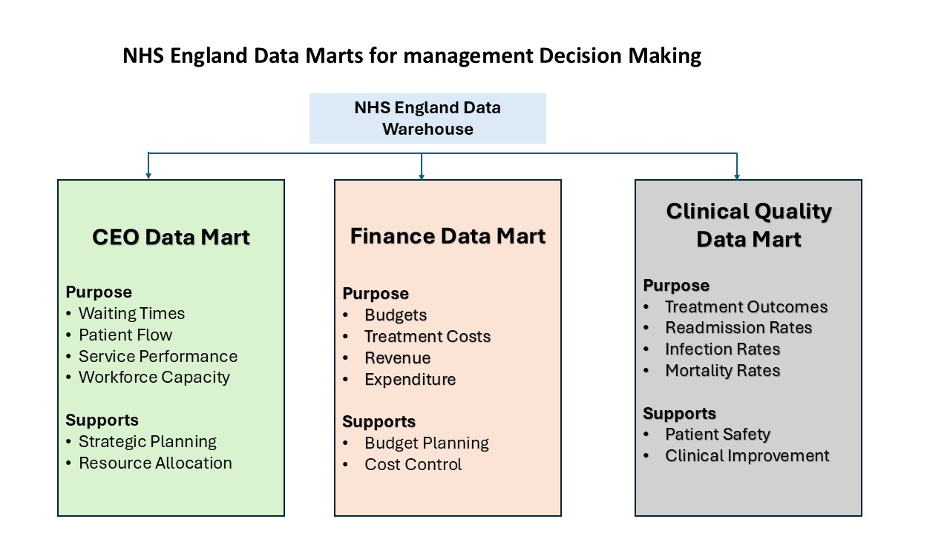
Figure 2 NHS England Data Marts for Management Decision-Making
Benefits and governance
Rationale: role-specific data marts reduce reporting burdens and speed decision-making without sacrificing data integrity. They complement the central warehouse by providing domain-driven analyses aligned with governance, privacy, and data-quality standards described in clinical data warehouse literature and governance-focused reviews [20]. These design principles support scalable, transparent, and timely executive, financial, and clinical analytics within NHS England’s architecture [17], [18].

1.4 OLTP Normalisation vs. Data Warehouse Dimensional Modelling
OLTP systems used by NHS England, including Electronic Patient Records (EPR), Patient Administration Systems (PAS), workforce management, and financial applications, are typically implemented with normalized relational schemas to minimize data redundancy and maintain data integrity across many concurrent transactions that support daily clinical and admin activities such as registrations, scheduling, and recording treatments [18], [19]. While this design excels at fast inserts, updates, and deletes, it makes analytical reporting more costly due to the need to perform complex joins across multiple tables [18], [19]. By contrast, data warehouses employ dimensional modelling tailored for read-heavy reporting and business intelligence, most commonly realized as a star schema with a central fact table surrounded by dimension tables (e.g., DimPatient, DimTime, DimLocation, DimTreatment) to enable intuitive, multi-dimensional queries and rapid aggregations [18], [21], [24]. A representative NHS-oriented star schema features a central FactPatientActivity linked to the surrounding dimensions and measures such as visits, length of stay, and total cost, supporting straightforward analyses like cost by treatment and region over time [18], [21]. Data marts derived from the central data warehouse provide role-specific analytics for the Chief Executive, Finance Director, and Medical Director without requiring queries across the entire warehouse, with ETL processes populating the star schema from OLTP sources in non-disruptive windows to protect ongoing care while delivering timely insights [20], [24], [25]. Overall, dimensional modelling improves query performance, simplifies reporting, and supports faster, evidence-based decision-making, enabling NHS England to monitor waiting times, costs, outcomes, and utilization more efficiently than would be feasible from normalized OLTP structures alone [18], [21], [23], [25].
Figure 3 illustrates a star schema designed for NHS England's data warehouse. The schema shows how a central fact table is linked to multiple dimension tables, enabling efficient multidimensional analysis of patient activity, treatments, hospitals, locations, and time.
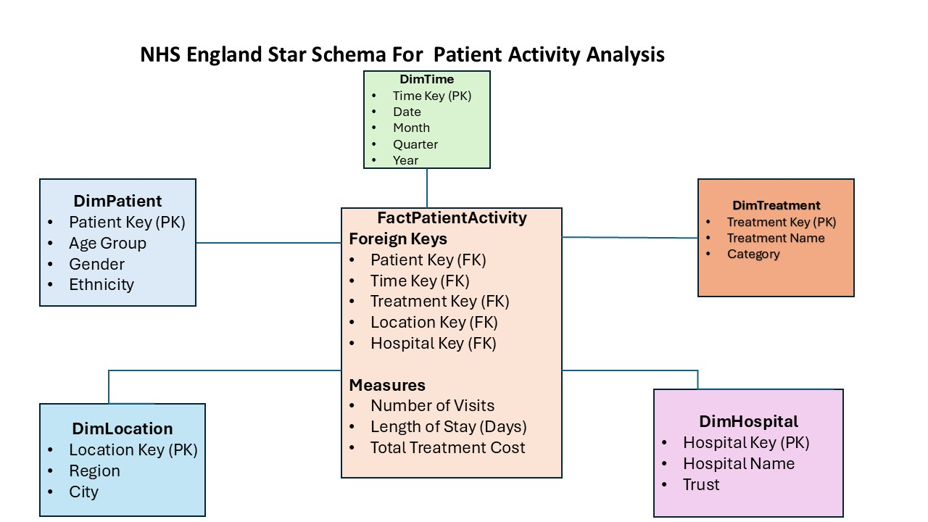
Figure 3 NHS England Star Schema for Patient Activity Analysis
The star schema shown in Figure 3 stores healthcare measures in the central FactPatientActivity table, while the surrounding dimension tables (DimPatient, DimHospital, DimTime, DimTreatment, and DimLocation) provide descriptive information that supports multidimensional analysis and business intelligence reporting.

Task 2

2.1 Source System Identification
Internal Data Sources
NHS England's data warehouse will integrate data from several internal operational systems to provide a comprehensive view of healthcare services. Electronic Patient Records (EPR) contain patient demographics, diagnoses, treatments, medications, and clinical outcomes, making them one of the primary data sources for the warehouse [26], [27]. Patient Administration Systems (PAS) store patient registrations, appointments, admissions, discharges, and waiting list information, supporting patient flow analysis and operational reporting [26], [28]. Clinical information systems provide laboratory results, diagnostic imaging, pharmacy records, and procedure information that support clinical performance monitoring [10], [27]. Workforce management systems maintain staff information, shift schedules, attendance, payroll, and human resource data, enabling workforce planning and resource allocation [31], [27]. Financial systems record budgets, expenditure, invoices, and treatment costs, supporting financial reporting and cost analysis [27], [30].
External Data Sources
External data sources include Office for National Statistics (ONS) demographic data, public health datasets, and national NHS performance indicators. These datasets provide additional population health information, benchmarking, and performance comparisons across healthcare organisations, enabling NHS England to monitor trends and support evidence-based strategic decision-making [32], [33], [27].

2.2 Star Schema Design
A star schema is a dimensional data model commonly used in data warehouses to support fast querying, reporting, and business intelligence. It consists of a central fact table containing measurable business events that is connected to multiple dimension tables containing descriptive information. For NHS England, a star schema provides an efficient way to integrate patient, clinical, financial, and operational data from multiple source systems into a single analytical model. This design improves query performance, simplifies reporting, and enables healthcare managers to analyse trends, monitor performance, and make evidence-based decisions across hospitals and regions [18], [21], [24].
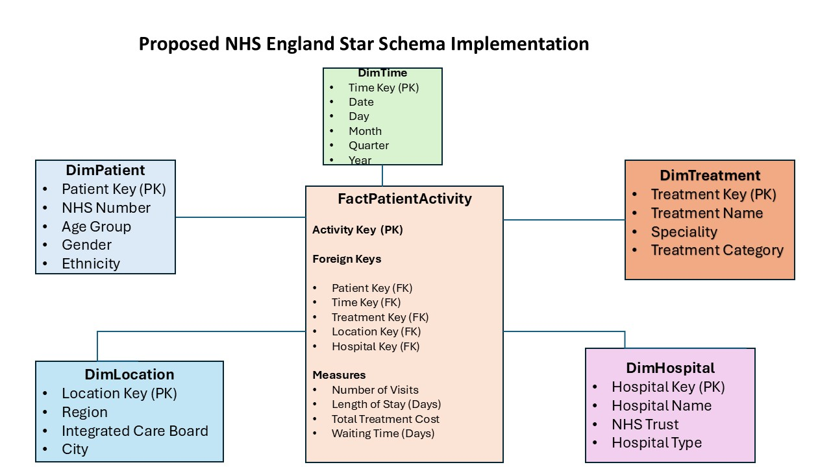
Figure 4. Proposed NHS England Star Schema Implementation
Table 1. FactPatientActivity Measures and Foreign Keys
FactPatientActivity | Description
 | Links to DimPatient
  PatientID (FK)
 | Links to DimHospital
  HospitalID (FK)
 | Links to DimTime
  TimeID (FK)
 | Links to DimTreatment
  TreatmentID (FK)
 | Links to DimLocation
  LocationID (FK)
 | Measure
  Number of Admissions
 | Measure
  Length of Stay
 | Measure
  Treatment Cost
 | Measure
  Waiting Time
Readmission Count | Measure

Table 2. Dimension Tables and Example Attributes
DimPatient | Patient ID, Name, Gender, Age, Ethnicity
DimHospital | Hospital Name, Trust, Hospital Type
DimTime | Date, Month, Quarter, Year
DimTreatment | Treatment Type, Diagnosis, Department
DimLocation | Region, City, County

Table 3. Master Data, Metadata and Aggregate Data
Data Type | Examples in NHS England Data Warehouse
Master Data | Patients, Staff, Hospitals, Departments, Treatment Types
Metadata | Data source (EPR, PAS), ETL schedule, Data owner, Last update
Aggregate Data | Monthly admissions, Average waiting time, Total treatment cost, Bed occupancy rate

As shown in Figure 4, the proposed star schema is designed to support NHS England's data warehouse by organising healthcare information into a structure that enables fast querying, efficient reporting, and effective business intelligence. The central FactPatientActivity table stores measurable healthcare events, including patient admissions, treatment costs, waiting times, length of stay, and readmission counts. Each record is linked to dimension tables through foreign keys, allowing users to analyse healthcare performance from multiple perspectives, such as patient demographics, hospitals, treatments, locations, and time periods [18], [21], [24].
The dimension tables provide descriptive information that supports multidimensional analysis. For example, the DimPatient table enables analysis by age, gender, and ethnicity, while DimTime allows trends to be examined by day, month, quarter, and year. Similarly, DimHospital, DimTreatment, and DimLocation allow managers to compare healthcare performance across hospitals, clinical departments and geographical regions. This dimensional design simplifies complex analytical queries that would otherwise require numerous table joins in traditional OLTP systems [18], [21].
Master data ensures that important organisational entities, such as patients, hospitals, staff, departments, and treatment categories, remain consistent throughout the data warehouse. Metadata provides information about the warehouse itself, including data sources, business rules, ETL schedules, data ownership, and refresh dates, enabling effective governance and improving data quality. Aggregate data stores pre-calculated summaries, such as monthly admissions, average waiting times, treatment costs, and bed occupancy rates, allowing dashboards and management reports to be generated more efficiently [20], [21], [24].
Overall, the proposed star schema enables NHS England to integrate data from multiple operational systems into a single analytical environment. It supports timely performance monitoring, financial analysis, clinical reporting, and strategic planning while improving decision-making through accurate, consistent, and easily accessible healthcare information [18], [20], [21], [24].
Therefore, the proposed star schema provides NHS England with a scalable and efficient data warehouse design that supports accurate reporting, business intelligence, and evidence-based decision-making while improving the quality, consistency, and accessibility of healthcare information across the organisation.

2.3 Data Marts and schema
Data marts are department-focused slices of a data warehouse that supply relevant data for reporting and decisions; NHS England can deploy distinct marts for tailored insights while relying on a single, integrated warehouse to preserve consistency and governance [17], [20], [21].
Table 4. NHS England Departmental Data Marts and Their Schemas
Data Mart | Schema / Tables | Example Data | Decision Supported
Finance Data Mart | FactFinance, DimHospital, DimTime, DimDepartment | Treatment costs, budgets, expenditure, revenue | Budget planning, cost control
Operations Data Mart | FactPatientActivity, DimHospital, DimTime, DimLocation | Admissions, waiting times, bed occupancy, discharge rates | Capacity planning, operational efficiency
Clinical Quality Data Mart | FactClinicalOutcome, DimPatient, DimTreatment, DimTime | Readmissions, mortality, infection rates, treatment outcomes | Clinical quality improvement and patient safety

NHS England’s warehouse can be partitioned into specialised, role-focused data marts that share a common model. The Finance Data Mart underpins financial management by holding facts like treatment costs, departmental spend, budgets, and revenue, linked to dimensions such as hospital, department, and time. This lets finance teams track expenditure, analyse cost patterns, and strengthen budget planning [17], [20].
The Operations Data Mart targets service performance, analysing admissions, waiting times, bed occupancy, discharge rates, and overall hospital activity. Using a FactPatientActivity table with hospital, location, and time dimensions helps managers gauge demand, spot bottlenecks, and deploy resources more effectively [18], [21].
The Clinical Quality Data Mart serves clinicians with measures on outcomes, readmissions, mortality, infections, and treatment effectiveness. Patient, treatment, and time dimensions enable granular quality analysis and support evidence-based improvements. Together, these specialised data marts provide each NHS department with tailored analytical information while maintaining a consistent and integrated enterprise data warehouse. This enables faster reporting, improved operational efficiency, and evidence-based strategic decision-making across NHS England [17], [20], [21].

2.4 ETL Plan
The ETL process lets NHS England consolidate data from diverse operational systems into the central warehouse. Data are extracted from sources, transformed to enhance quality and standardisation, and then loaded to enable reliable reporting and business intelligence [20], [21], [22].
Table 5. NHS England ETL Plan
Warehouse Table | Source System | Transformation | Load Destination
DimPatient | Electronic Patient Records (EPR) | Remove duplicates, standardise patient details, validate NHS numbers | Data Warehouse
DimHospital | Hospital Management System | Standardise hospital names and locations | Data Warehouse
DimTime | System Calendar | Generate date, month, quarter and year attributes | Data Warehouse
DimTreatment | Clinical Systems | Standardise diagnosis and treatment codes | Data Warehouse
FactPatientActivity | EPR, PAS, Clinical Systems | Calculate admissions, waiting times, treatment costs and readmission counts | Data Warehouse

As shown in Table 5, the ETL plan ensures that data from NHS England's operational systems are extracted, transformed, and loaded into the central data warehouse without disrupting day-to-day healthcare operations. During transformation, the data are cleansed, validated, standardised, and aggregated to raise quality and consistency before loading into the warehouse. Examples include removing duplicate patient records, harmonising treatment codes, and calculating summary metrics like waiting times and treatment costs. This ETL plan provides NHS England with accurate, consistent, and timely data for reporting, business intelligence, and evidence-based decision-making while maintaining high data quality and ensuring that operational healthcare services continue without interruption [20], [21], [22].

2.5 Data Quality and Governance
Sustaining high data quality and robust governance is critical for NHS England’s data warehouse. ETL should enforce validation, cleansing, deduplication, and standardisation to keep data accurate and consistent. Governance controls ought to include role-based access, audit logging, comprehensive metadata management, and adherence to UK GDPR and the Data Protection Act 2018 to safeguard patient privacy. During ongoing warehouse operations, continuous monitoring, audit logging, and metadata management maintain data quality and support secure reporting. These practices ensure reliable information, protect patient confidentiality, and enable trustworthy decision-making in compliance with UK GDPR and the Data Protection Act 2018 [20], [21], [27].

References
- Et. al. A. Rosita, “Introduction Study Of Business Intelligence Hospital Medical Recording Data,” Turkish Journal of Computer and Mathematics Education (Turcomat), vol. 12, no. 11, pp. 1043–1050, 2021, doi: 10.17762/turcomat.v12i11.5994.
- A. Obbo, W. Wasswa, and A. H. Basaza‐Ejiri, “Leveraging Data Warehousing for Healthcare Delivery – A case of Outpatient Department,” 2024, doi: 10.20944/preprints202406.1899.v1.
- J. Qu and J. Wang, “Real-time data warehousing in the big data environment: A comprehensive review of implementation in the internet industry,” Applied and Computational Engineering, vol. 88, no. 1, pp. 105–114, 2024, doi: 10.54254/2755-2721/88/20241643.
- R. J. Mositsa, J. A. van der Poll, and C. Dongmo, “Towards a Conceptual Framework for Data Management in Business Intelligence,” Information, vol. 14, no. 10, p. 547, 2023, doi: 10.3390/info14100547.
- T. K. Ivanovski, S. Honap, R. Matić, S. Marković, and L. Peyrin‐Biroulet, “Building a healthcare data warehouse: considerations, opportunities, and challenges,” Frontiers in Digital Health, vol. 7, 2025, doi: 10.3389/fdgth.2025.1691142.
- M. Mudongo, E. Thuma, N. P. Motlogelwa, T. Leburu-Dingalo, and P. Majoo, “Business Intelligence and Data Warehouse Technologies for Traffic Accident Data Analysis in Botswana,” pp. 231–247, 2021, doi: 10.5121/csit.2021.111720.
- M. Venkateswarlu and T. G. Vasista, “EXTRACTION, TRANSFORMATION AND LOADING PROCESS IN THE CLOUD COMPUTING SCENARIO,” IJEAST, vol. 8, no. 1, pp. 232–236, 2023, doi: 10.33564/ijeast.2023.v08i01.036.
- H. Chakiri, M. E. Mohajir, and N. Assem, “A data warehouse hybrid design framework using domain ontologies for local good-governance assessment,” Transforming Government People Process and Policy, vol. 14, no. 2, pp. 171–203, 2020, doi: 10.1108/tg-04-2019-0025.
- R. Bateja, S. K. Dubey, and A. K. Bhatt, “Integration of EHR and PHR leveraging cloud services for approving treatments,” International Journal of Health Sciences, pp. 4940–4959, 2022, doi: 10.53730/ijhs.v6ns8.13322.
- A. Bottle et al., “How an electronic health record became a real-world research resource: comparison between London’s Whole Systems Integrated Care database and the Clinical Practice Research Datalink,” BMC Medical Informatics and Decision Making, vol. 20, no. 1, 2020, doi: 10.1186/s12911-020-1082-7.
- F. A. Pereira, J. G. S. F. Costa, and L. M. G. Gonçalves, “A Data Lake and Analytics Platform with Application to COVID-19 Dynamic Analysis,” pp. 171–176, 2022, doi: 10.5753/sibgrapi.est.2022.23283.
- A. Lamer, C. Saint‐Dizier, N. Paris, and E. Chazard, “Data Lake, Data Warehouse, Datamart, and Feature Store: Their Contributions to the Complete Data Reuse Pipeline,” Jmir Medical Informatics, vol. 12, pp. e54590–e54590, 2024, doi: 10.2196/54590.
- K. J. Merceedi, A. A. Yazdeen, A. Kh. Ibrahim, M. B. Abdulrazzaq, and M. R. Mahmood, “Analyses the Performance of Data Warehouse Architecture Types,” Journal of Soft Computing and Data Mining, vol. 3, no. 1, 2022, doi: 10.30880/jscdm.2022.03.01.005.
- R. R. V. -, “ETL vs ELT: Evolving Approaches to Data Integration,” International Journal for Multidisciplinary Research, vol. 6, no. 5, 2024, doi: 10.36948/ijfmr.2024.v06i05.29481.
- M. Guentherman, E. Hartman, A. Schlegelmilch, E. A. Brinck, and C. Anderson, “Building a Management Information System with Inter-Agency Data Sharing to Improve Data-Based Decision Making Across Systems: Experiences From Wisconsin PROMISE,” Rehabilitation Counseling Bulletin, vol. 65, no. 1, pp. 6–22, 2020, doi: 10.1177/0034355220962182.
- G. Turcan and S. Peker, “A multidimensional data warehouse design to combat the health pandemics,” Journal of Data Information and Management, vol. 4, no. 3–4, pp. 371–386, 2022, doi: 10.1007/s42488-022-00082-6.
- K. Gagalova, M. A. L. Elizalde, É. Portales-Casamar, and M. Görges, “What You Need to Know Before Implementing a Clinical Research Data Warehouse: Comparative Review of Integrated Data Repositories in Health Care Institutions,” Jmir Formative Research, vol. 4, no. 8, p. e17687, 2020, doi: 10.2196/17687.
- E. Triandini, M. S. Rijal, and M. P. Ambara, “IMPLEMENTASI STAR SCHEMA DALAM PEMBANGUNANAN DATA WAREHOUSE PENJUALAN PRODUK TOUR,” Csrid (Computer Science Research and Its Development Journal), vol. 12, no. 1, p. 23, 2021, doi: 10.22303/csrid.12.1.2020.23-33.
- L. Kasprzyk and F. Devillet, A Data Cube Metamodel for Geographic Analysis Involving Heterogeneous Dimensions, ISPRS International Journal of Geo-Information, 2021. DOI: 10.3390/ijgi10020087
- N. Fana, A. AlShamrani, and K. A. Baba, Data Warehouse Design With ETL Method (Extract, Transform, And Load) for Company Information Centre, International Journal of Artificial Intelligence Research, 2021. DOI: 10.29099/ijair.v5i2.215
- A. Dhaouadi, A. Benhadj, and M. Abed, Data Warehousing Process Modeling from Classical Approaches to New Trends: Main Features and Comparisons, Data, 2022. DOI: 10.3390/data7080113
- L. Wardhani and D. Wiratama, Improving the Quality of Service: ETL Implementation on Data Warehouse at Pharmacy Industry, Jurnal Tekno Kompak, 2024. DOI: 10.33365/jtk.v18i1.3211
- A. Agapito, R. Scapolo, and M. D. De Marco, COVID-WAREHOUSE: A Data Warehouse of Italian COVID-19, Pollution, and Climate Data, International Journal of Environmental Research and Public Health, 2020. DOI: 10.3390/ijerph17155596
- T. Lokaadinugroho, S. I. Pratama, and C. S. Sulastri, Tableau Business Intelligence Using the 9 Steps of Kimball’s Data Warehouse & ETL of the Pentaho Data Integration Process Approach in Higher Education, Engineering Mathematics and Computer Science (emacs) Journal, 2021. DOI: 10.21512/emacsjournal.v3i1.6816
- Y. Yang, X. Li, and Z. Chen, Empowering Data Transformation: Transforming Raw Data into A Strategic Planning for E-Commerce Success, Journal of Information Systems and Informatics, 2024. DOI: 10.51519/journalisi.v6i1.665
- T. G. Ferris, “Unit cost and hope: Increased NHS resilience through tech-enabled transformation,” Future Healthcare Journal, vol. 11, no. 1, p. 100021, 2024, doi: 10.1016/j.fhj.2024.100021.
- L. McVey et al., “Hidden labour: the skilful work of clinical audit data collection and its implications for secondary use of data via integrated health IT,” BMC Health Services Research, vol. 21, no. 1, 2021, doi: 10.1186/s12913-021-06657-0.
- S. Harding et al., “Individualised variable-interval risk-based screening in diabetic retinopathy: the ISDR research programme including RCT,” Programme Grants for Applied Research, pp. 1–72, 2023, doi: 10.3310/hrfa3155.
- S. Kapil et al., “Untitled,” Review of Economic and Business Studies, vol. 15, no. 1, 2022, doi: 10.47743/rebs-2022-1.
- A. Tursunbayeva, R. Bunduchi, and C. Pagliari, “‘Planned Benefits’ Can Be Misleading in Digital Transformation Projects: Insights From a Case Study of Human Resource Information Systems Implementation in Healthcare,” Sage Open, vol. 10, no. 2, 2020, doi: 10.1177/2158244020933881.
- M. Lalani et al., “Assessing progress in managing and improving quality in nascent integrated care systems in England,” Journal of Health Services Research & Policy, vol. 29, no. 2, pp. 122–131, 2023, doi: 10.1177/13558196231209940.
- E. Roorda, M. Bruijnzeels, J. N. Struijs, and M. Spruit, “Business intelligence systems for population health management: a scoping review,” Jamia Open, vol. 7, no. 4, 2024, doi: 10.1093/jamiaopen/ooae122.

