
DHAKA REGENCY HOTEL & RESORT
Consultancy Report


ORION CONSULTANCY

Date: 31 May 2024

Prepared By: Tahmina Islam (2124414)
Prepared For: Jaliya De Silva
Table of Contents
Executive Summary: 3
Introduction: 4
Analysis of the Issues 5
PESTEL Analysis 6
SWOT analysis 8
TOWS analysis: 9
Recommendation and Change Management 10
The six-sigma approach 10
5- Whys Technique 12
Galbraith’s Star Model 14
McKinsey 7S model 16
Recommendation from Change Management 18
Action Plan 19
Conclusion 20
References 21

Executive Summary:
Hotel businesses around the world a flourished since humans have found their interest in travelling all around the world. This report explores the consultancy to respond to the issue for Dhaka Regency Hotel & Resort as they asked ORION Consultancy to consult on issues the hotel is experiencing. Dhaka Regency Hotel & Resort has faced the profitability problems for diverse types of issues such as poor fiscal management that can result from overspending in the operations to smooth and the process which eventually can lead to cash flow problems and financial distress for the business. Management of expenses and failure to adjust pricing strategies according to the market demand in a developing country like Bangladesh can impact the revenue and expenses growth over the time (UNB, 2024). Though the devaluation of domestic currency might increase the impact of inflation by several folds, hotel businesses might find it difficult to manage their operating cost related to the utilities and maintenance of the business in the market (Laws of Bangladesh, 2024). As hotels are based on service management, if they cannot control the overhead cost in the business & can easily erode their profitability in the market over time. If the demand is low, factors such as overstaffing can lead to inefficient usage of resources contributing to higher operating expenses by the business. Occupancy rates directly impact a hotel’s revenue as if the occupancy of the rooms in the business is not as expected then the meaningful change in price management or pricing strategies can impact the sales efforts of the business. Bangladesh is a hotel intense country, so customers find a lot of alternative options in the market from where they can choose the right hotel for them (Buhalis & Costa, 2006). Moreover, there are different environmental factors that impact the existence of problems in the hotel in this country and around the world. Being a developing country, Bangladesh do not have sufficient measures to use clean energy and reduce wastage from their daily operation. As price of utilities are getting higher that leads the hotel expenses higher (Dhaka Tribune, 2024). So, they are attracting the domestic citizens in taking services from the hotel, but customers from developed countries where there environmentally aware about the reservation of the surroundings, are not considering their services in the market.
Hotel business in international market started to experience turbulence in its operations and revenue generation process as the supply chain of the research exchange among countries has disturbed because of the Russia Ukraine war in the world economic context. Though businesses operating in the hospitality industry are trying to find the right set of strategies to get the maximum outcome from the daily operation but the limitations of the business to control of the economic outcomes has affected them directly as the stakeholders are exposed to the limitations in the market still they get ESG rate 6.2 (Etic Hotel, 2024). Here the average pricing of hotel services starts to rise due to the above-stated factors in the market, then the purchase capability of the customers reduced significantly. On top of that if the inflation affects the purchase ability of the customers than the impact felt by the hospitality industry is multifield as the overall efficiency in the process affected by the unavailability sufficient resources and support in this industry (UNB, 2023).
So, employing the right set of strategies in the market can provide a business with a competitive edge in this case in managing their opportunities and mitigation of the existing problems in the market. In this report, I will explain the PESTLE, SWOT & TOWS for analysing the issues. Then, the change management practices and procedures should include with the help of six sigma, 5- Whys technique, Galbraith’s star model and Mckinsey’s 7’s model. The recommendation briefly described with the help of Lewin’s change management model. Customers are the main goal of hospitality businesses and the revenue generated from their operations paid directly by the service received by the customers in the market. When the customers are not satisfied enough, then the business fails to generate effective outcome from the operations as the perception of the customers about the value they are receiving against the payment they are paying to the hotel business like Dhaka Regency often get impacted. Through understanding effective distribution of products and services, getting the maximum satisfaction out of the operations in the market, can create a better environment for hotel business to deliver valuable service to their intended customer’s base.

Introduction:
Hotel businesses play a significant role for its stakeholders with contributes to several types of factors at various destinations providing accommodation options for travellers who offer a range of rooms according to preferences (Ivanova & Ivanov, 2020). Among the popular higher mid-range hotels across the world, Dhaka Regency hotel and Restaurant is one of the businesses which can represent other Businesses with similar issues and opportunities in the hotel industry. The business is situated at Nikunjo, in Bangladesh which is the development country in the southeast Asia. As the business established in 2007 this hotel has been offering luxurious rooms and suits to their customers which offer comfortable and sophisticated rooms and services creating in satisfactory experience among the customers (Dhaka Regency Hotel & Resort, 2024a). As the business situated at the prime location of the country the hotel has developed its strategy position in the City Centre where both business and leisure travellers can stay and enjoy the facilities that the hotel has to offer. The growth of this business has accelerated in the first decade of the century and the business reached their position in during 2015. As the pandemic suddenly appeared in the hospitality sector, this industry shaken very toughly. Dhaka Regency hotel also faced challenges in this developing country as its domestic market locked down by the government to reduce the affection of covid virus. So, the business started to experience a downfall in its operations as the business failed to attract their expected number of customers to general revenue from their business operations (Xinhua, 2022). Following the pending business experience the results of inflation and overall change in the economic system which created a bad position in the industry to become profitable in their operations. In 2023, the business generated 47 million USD as their revenue which is slightly better than the previous struggling times, but this is not a satisfactory revenue that can ensure sufficient profitability from the operation considering the increase in the cost of products and salary expenses every year of their employees (Statista, 2024). So, the business is facing challenges in meeting their expected result from the operations that they are planning in the developing market.
ORION Consultancy is an expert firm to support these types of issues by providing good support through analysing the background context and existing issues to provide feasible solutions to those businesses. Also offering financial advice by finding out the existing challenges in their operation that are making their weaknesses more prevalent and causing losses on the business. With practical experience of several years in this field, ORION consultancy assist business through creating sufficient materials and strategic planning that can help business to utilize their competitive position more effectively.
As the business problems in increasing and stabilizing their revenue streams in this report various analytical framework to dissect the challenges faced by the hotel so that the internal and external factors that are influencing the performance of the hotel can be assessed. Different types of relevant models and theories will be used to understand the feedback mechanism and reputation management of the hotel to gain a comprehensive inside into the situation and provide possible solutions to the business that can help them to gain stable upward profitability trend in their business (Lee et al, 2017).
Analysis of the Issues:
The problems that are troubling the business might be multifaceted and it requires a thorough examination of the problems and the factors that affect them. Dhaka Regency hotel & resort has few issues that interrupted their business occupancy rate, change in operational expenses and quality of housekeeping services. Changing consumer demands, maintain the quality standards, online reputation management etc. affected the operational expanses of the hotel as well as the occupancy rate is hampered. The gap between expectations and the service delivered by the hotel can be the result of various internal and external factors which need to analyse to gain a proper insight into the revenue stream and reputation management of the hotel (Baron & Armstrong, 2007). In 2024, their revenue $56 million. However political imbalance interrupts the operation of the business in 2023 (Bangladesh monitor, 2024). The occupancy rate was getting down and expenses were high. GDP is getting lower than expected (Figure-1), Inflation rate is getting higher that cause the expenses of food is getting higher (Figure-3), but the wages are not increase on the base of inflammation (Figure-2). Foreign asset and domestic assets are hampered as well as the reserve money is getting lower than expected due to inflation (Table-3). But the revenue did not change significantly (Figure-4). In 2023, RevPAR was $1065.8 but in 2024, RevPAR grown in $1292.5 (Source: Appendix). Here if hotel businesses cannot differentiate themselves from their competitors are often seen to struggle to attract guests and increase the revenue from selling their services or distinctive amenities to the customers. The case study of The Park Hotel was revitalized the brand through few analyses such as- SWOT, Porter 5 forces, PESTLE, VRIO, BCG etc. Then they find out the solutions and the recommendation for targeting the market of the hotel and made an action plan that made a clear view of implementation of those recommendation (Avery and Dev, 2016). Below, I have discussed the PESTLE, SWOT, and TOWS for analysing the issues to find out the any external factors be contributing to the problems the hotel is experiencing, an overview of the hotel, the strengths, and the areas for consideration as well as highlighting the possible future directions for the hotel.
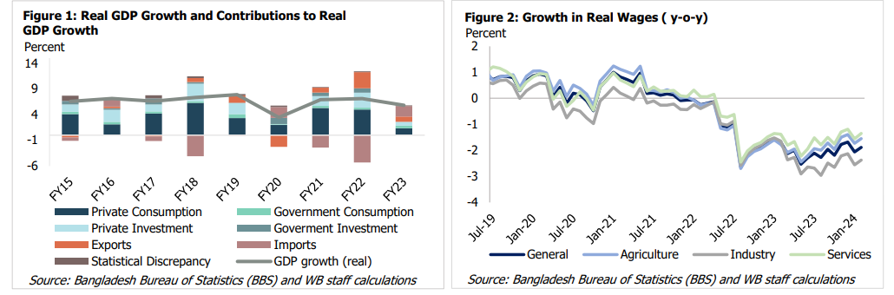
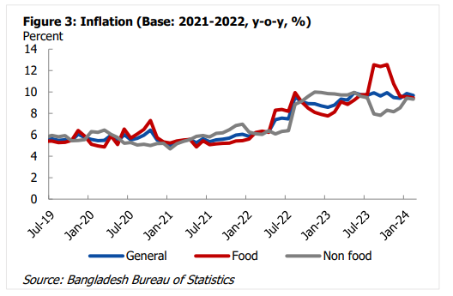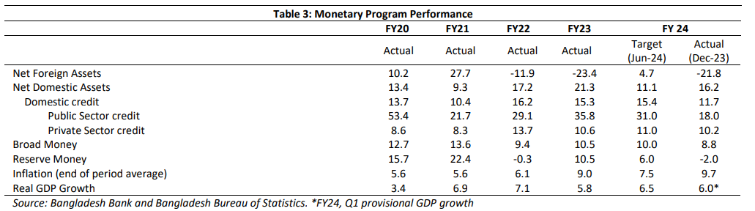

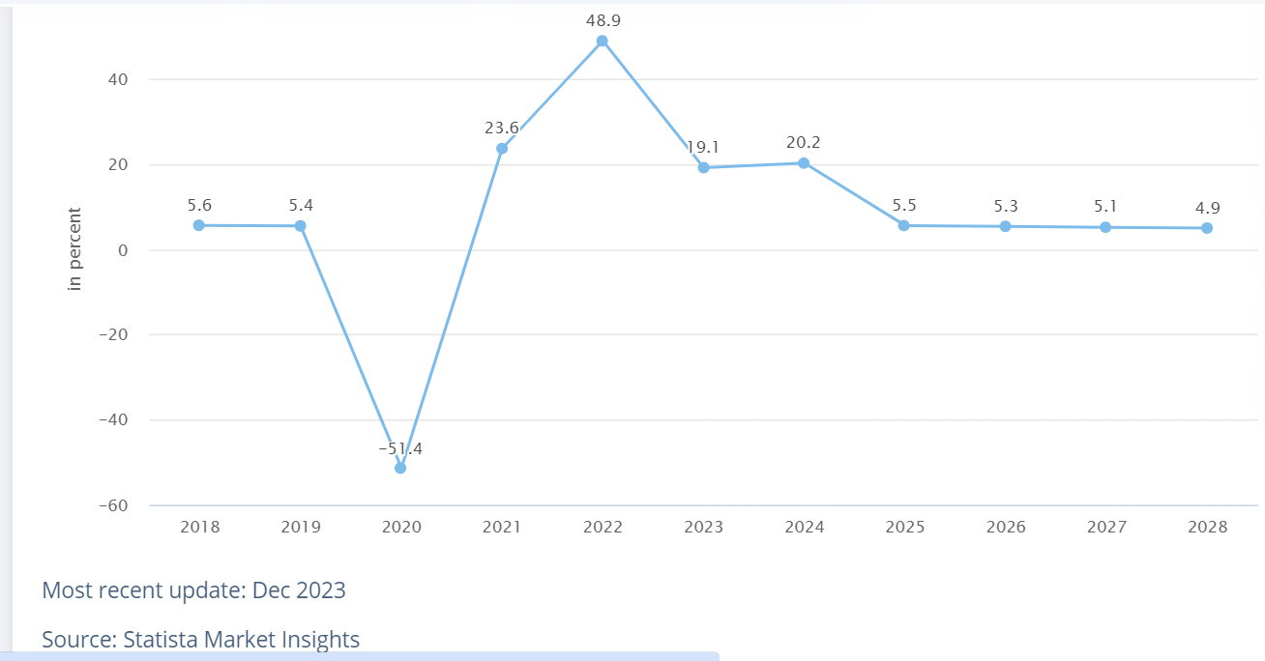
Figure: 4; Statista (2023)

PESTEL Analysis
To understand the analysis of external factors for Dhaka Regency hotel is given below:

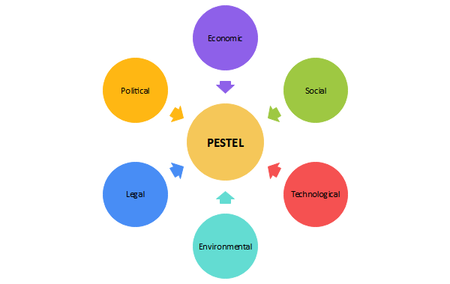
Source: Edraw Max (2024)

Political: The political landscape in Bangladesh can often influence the hospitality industry in the country as to provide more assistant to the businesses of a regulation modified along with policies so that the revenue generation for the government in charge can increased (Rezvi, 2020). Taxation policies or labour laws are often change by the unstable regulatory system in the country who is directly impact on the hotels operations and profitability as well as VAT over the time (Mowla, 2024). Failing to maintain the inflation, the government has changed the regulatory policies numerous times with increased the price of raw materials for the hotel creating a bed exposure of the business to the market (Burnes, 2014).
Economic: To state about the economic factors, the economy of Bangladesh is experiencing a growth in the GDP but the real income per capita among its citizens is not that satisfactory. After the COVID, GDP is slowed down as the price of raw materials and scarcity on supply of gas and electricity (World bank, 2024). So, the purchasing capability of hotel rooms and amenities offered by Dhaka Regency can be purchased by fixed and small group of customers to ensure the revenue generation process. Due to this reason economic downturns are often making the situation worse as the reduced travel budgets among the target customers impact decreased acceptance of the hotel among the travellers and other spending in the process (The Financial Express, 2024). So, due to this unstable economic situation in the market, the exchange rate and consumer spending keeps changing in Bangladesh, creating a tough environment for the businesses and increase their earnings from the operations in the market.
Social: Socio culture trend and lifestyle preferences among the normal citizens in the country are not mature enough to take services from the hotel often customers try to find budget hotels in this country while they are travelling (Ogunnaike et al., 2022). So, luxury hotels like Dhaka Regency must find opportunities and marketing strategies to get up to changing preferences among the target customers in the market to generate increasing acceptance and ensure a better exposure of the business in the market (Cetron & Davies, 2020). To generate sufficient sales, often such luxury hotel businesses try to attract the customers through few types of campaigns and budget deals so that the customers can get a habituated with the name of the brand and get habituate with the lifestyle (Brierley, 2006).
Technological: The development of technology factors in the country have increased the acceptance of the hotel which is only the positive factor in this case that drives the business towards their success. Automation and online booking platform have made it easier to book hotel rooms and take services from the hotel in the country (Buhalis & Costa, 2006). Benefits have transformed the hospitality industry in Bangladesh which has leveraged technology to enhance guest experience and stay comparative in the market (Hassan, 2021). Though there is still a gap in taking sufficient cyber security measures and ensuring data privacy in the process but the hospitality industry in the country is going through a positive transformation to address all these beneficial factors in its process (Christensen,2000).
Environmental: Often environmental regulations are not properly implemented in the market which creates loopholes for the business to exploit their opportunities creating a distrust among the concerned customers of Dhaka Regency.
Legal: The legal environment for the business is getting receive which time which is regarding
compliance and legal frameworks followed by the business so that the hospitality industry can be reshape, and a good outcome can be ensured from the operations of the businesses (British business bank, 2023). Different local government control regulators often visit the hotels and if there are any issues regarding the management of the quality of hotel services then a fine is implement in the process for making the business event about their improvement options and promote responsible tourism in the sector (Buttrick, 2009).

SWOT analysis: SWOT helps to identify strengths, weaknesses, opportunities, and threats for a specific project or your overall business plan to identify the areas of improvement, capitalize on advantage and mitigate the risks to stay ahead of market trends (CIPD, 2024). SWOT analysis for Dhaka regency hotel and resort are stated below:
Strength:  - Hotel’s location is near to the airport.  - Excellent MICE services.  - Strong independent hotel with brand image to its target customer.  - Advanced technology using as well as F & B service is available in 24hrs. | Weakness:  - Structural problem as its lobby starts from 5th floor.  - Staff is not courteous, not properly familiar with adequate.  - Slow services, not have proper toiletries.
Opportunity:  - Vast number of foreigners visit Bangladesh.  - Competitive price for quality of services.  - Significant profit on every sector.  - Tie up with big business, providing services to make profit. | Threat:  - Must compete with other rivals as they are strong to attract foreign and domestic customer.  - Political instability.  - Changing laws and legislation.

TOWS analysis: TOWS analysis is a strategic option based on SWOT analysis with focus on external factors to develop effective strategies to achieve a competitive edge and deliver exceptional customer service (Juhl, 2017). Urla had trying to find the alternative tourism where they analysed it with SWOT after that they optimize their findings with TOWS enlighten it towards the owners as well as the stakeholders (Pirnar, Kurtural, & Eris, 2019). The TOWS of Dhaka Regency Hotel and resort is given below:

SO strategy:  - As this hotel is situated at a prime location, so lots of foreigner find it easily.  - With excellent MICE service, they are marketing their services through social media.  - Hotel can focus the EPZ and their industrial belts area’s customers.  - Using advanced technology and providing quality service by tie up big business to make the business flourished. | WO strategies:  - There lobby start from 5th floor, but they got marketing in substantial number of extents.  - Staff is not courteous, but quality of services can enhance the hotels productivity.  - Significant profit and tie up with big business can speed up the services and they can budget to supply more toiletries.
ST Strategies:  - As it near to the airport so it will be easy for foreign and domestic customer to find out.  - Excellent MICE services can attract the customer while its politically stable.  - As the hotel has brand images, they can invest money to embrace the law and legislation. | WT strategies:  - It is a standard building with a gorgeous look.  - Service can improve that follows under the new laws and legislation.  - Organising staff training can hold in flexible condition by avoiding major political issues.

Recommendation and Change Management
The issues that suffer Dhaka Regency Hotel & Resort needs to identify and solve for better performance and growth. For identify the problem company needs to gather the data from interviews and surveys, checking the KPI performances, and observing work processes (Insycle, 2021). Now before stating the requirement of change management in this case first the recommended steps need to evaluate to suitable theories so that the foundation behind those recommendations were cemented. However, the Root Cause Analysis can be applied for identify the causes of the problem, its root causes. Then investigating the factors of creating problem. After that making strategies to overcome the problem (Landau,2023). To quantify the problem at a different scale, the Six sigma approach can help in providing the definition and analysis to the existing problems with proper measurement so that the improvement can brought in this process to properly address its revenue and profitability challenges over the past years (Fisman & Sullivan, 2014). Dhaka Regency has been facing problems in gaining sufficient attention from the target customers rather than growing it overtime they need to analyse their existing problems and challenges to take sufficient actions against those challenges to mitigate the problems and bring a better solution from the process.
The six-sigma approach:
The six-sigma approach is explained below:
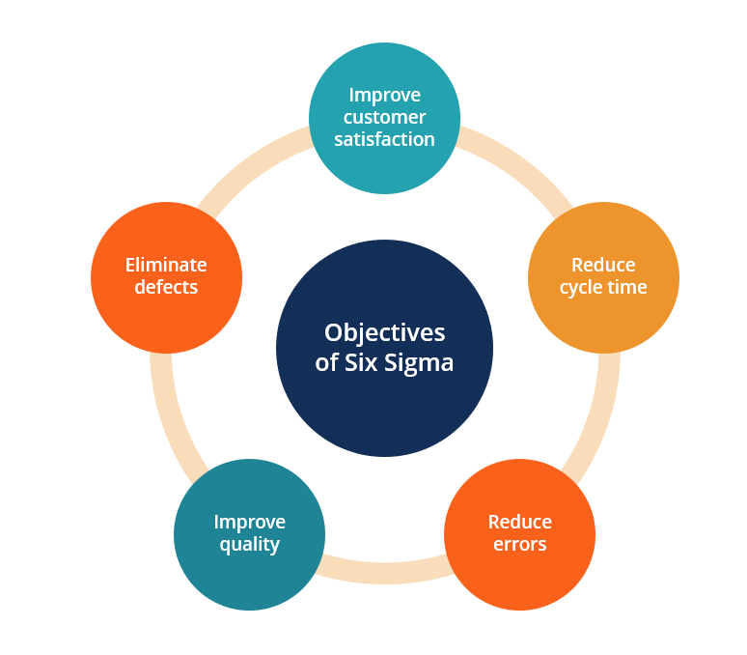

Source: CFI (2024)

Source: Simplilearn (2024)

Define
Defining the problem for improvement is the first step in this process to identify the specific areas of the business where the revolution process can optimise to get better result to increase in room occupancy rates or acceptance among the customers (Pyzdek & Keller, 2019). Additionally, the reduction in operational expenses then also ensure if the definition of the problem can indicate the potential solutions with proper measurement (Gino, 2018).
Measure
When the problem is identify measuring the relevant Matrix to understand the current context of the problem is require so that the income source of the hotel can developed to increase customer satisfaction overtime (Hammer &Champy, 2009). Measuring the intensity of the problems is very much important to tackle challenges in most places comparing the priority of the challenges to be mitigate in the business management. Though there might be diverse types of factors that are acting the reduction in revenue generation and increase in operational cost, but the fall in the average revenue per room and occupancy rate at the most crucial factors having the highest importance for making of challenges more critical (Hayes & Ninemeier, 2016).
Analyse
After the analysis of the root causes of the identified issues using statistical tools and techniques, the impact of the probability factors on the business can quantified and inefficiencies in the process are solved with suitable actions in the business market (Davenport & Stoddard, 1994).
Improve
As the business is finding the challenge to be tough to manage, they need to evaluate the analysed factors in this case so that they can ensure a better response from the business stakeholders in generating sufficient profitability from the business operations (Eisenhardt & Sull, 2001). When the processes are optimised, guest satisfaction level can be checked to get a closer look on the strategies that can ensure a workflow optimization in the process and reduce the expenses that are incurring in the process to make the business suffer from various issues that are hindering their growth and progress in the business market (Hitt, Ireland, & Hoskisson, 2016). Usage of sufficient technologies in this case often solves the problems faced by hotel businesses as the customers get more access.to the offerings made by the business in the market (Rogers, 2003).
Control
When the problems are analysed and the solutions are identified, then controlling the whole situation to ensure the best usage of the existing opportunities in the market can help the business to improve their condition in the business market (Jones & Lockwood, 2002).
Overall understanding of the control process can help businesses to maintain their reputation in the market and find a better approach to the existing problems so that those problems do not impact their business anymore. According to Blue Ocean strategy, When the problems are under control then implementing business opportunities becomes easier (Kim & Mauborgne, 2015).

5- Whys Technique
Now to understand the existing problems in depth. Five Whys technique is a highly effective to find out about the underline causes of problems in the market beyond surface level symptoms and addresses the fundamental reasons by taking the steps to solve the problems (Lean Enterprise Institute, 2018). Below here the steps are explained:
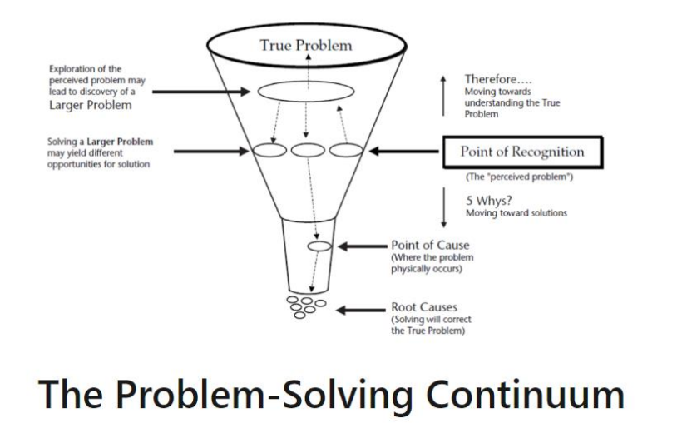
(Source: Ershadi et al., 2018)
First, detect the problem that are making the business to miss their milestones overtime. In this case of Dhaka Regency hotel, the problem is the decline and unstable revenue generation and profitability despite of having a prime location and reputation for luxury hospitality in the sector. This problem needs to analyse carefully to get a better result out of the existing opportunities in the market (Cetron & Davies, 2009).
Now finding the reason to help in understanding the factors that might affect the overall situation in this case (Christensen, 2000). Finding the reason for decline in the revenue and profitability can show the overall factors that affecting the hotel in this case.
Exploring the underlying factors that are contributing to the problem needs to be analyse so that there decrease in occupancy rate can be solved through potential measures (Christensen et al., 2018). The overall situation needs to be developed through a close inspection in the market so that using they visit resources in the country the business engages a better result after providing services to their target customers (Sutton & Rao, 2014).
If the second level cause is identifying the reason behind the factors developing in the process needs to be investigate (Eisenhardt & Sull, 2001). Why the occupancy rates are falling needs to be analyse in this case so that proper actions can be taken in the administration of the hotel that can provide them with the better result in ensuring the cell of the hotel rooms to be stable (Webster and Ivanov, 2014).
If the problems are solved by this level, then this process has effectively found out the factors and brought a proper solution to the process (Subramaniam, 2011). But if the process does not find the exact solution to address the problem, then the process of identification and evaluation of the problems need to be repeated so that it can uncover the root cause of declining revenue and profitability in the business market (Enz, 2010).
Galbraith’s Star Model:
Among the suitable options for evaluating the existing operations, Galbraith’s Star Model is a strategic management framework that emphasizes the alignment of various organizational elements to achieve effectiveness and performance (Kipping & Clark, 2012). To evaluate the underlying factors that can help this business to recover their position in the market, this model based on the context of Dhaka Regency needs to be explain:
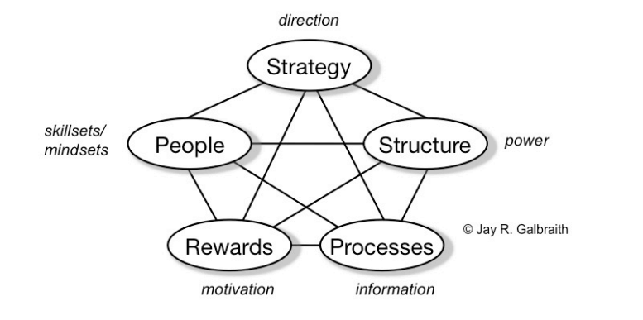
First, the strategy of the business needs to be there a lot on Saturday so that it can provide a better framework for the organisational decision-making process to allocate their resources to different divisions of the business that can provide a better solution to the existing problems in the business market. Here the reduction in the occupancy rate may be tackled through modification in the business in a unique way in the market (Whittington, R. et al, 2020). So, the target customer segments can put a better attention in the business operation outlining the key objectives such as revenue growth and brand reputation management in the business market (Lashley & Morrison, 2001). If the business has their own goal and objectives in operating their business in the market, then HR need to employ sufficient researched operations in the market to get required attention (Whittington, R & Molloy E, 2005). By aligning the strategic management of a business with the objectives of a business along with market dynamics and capabilities of the prisoner a clear road map about providing the best service to the customers and sustainability in the goals of the business overtime can be ensure (Galbraith, 1973).
After that, the structure of the business and administration hierarchy needs to be formed in such a way that the roles and responsibilities allotted to the employees are responsibly managed according to their calibres in different distinct sections. When the employees can develop and emotional relationship with their workplace, they tend to perform in a better way so that the business can run smoothly gaining more profitability from the business operations (Kotler & Armstrong,2018). In this case the structure of Dhaka Regency hotel needs to be designed through experts that can help in meeting its strategic objectives while facilitating coordination among the employees in the decision-making process of the business. Among the common operations that might need improvement can be stated as marketing needs to be responsive enough to the queries of the customers so that the customers can feel the support provided from the business executive in this process of providing everyday experience to their stay over in the hotel (Kotter, 2012).
After these steps, process restructuring needs to manipulate carefully so that the workflows and routine works can be changed carefully to maximise the satisfaction among the customers in the hotel (Lashley & Morrison, 2018). Operations such as reservation management or housekeeping protocols leads to be evaluated properly so that the quality assurance measures can eliminate any type of bottleneck in the process and adopt the best practices in the industry so that the operational efficiency of the business among the competitors in the industry can be managed(McGrath, 2009).
As employees are the main driving force of an organization, they need to be supported properly so that they can put their best in the operational processes of the hotel business. Rewards systems needs to be incorporated in the operational mechanism so that through incentive that desired behaviours among the employees within the organization can be ensured (Jones& Lockwood, 2002). Different types of activities based on the performance such as employee recognition program and career and sessions can be offered to the employees so that they can also make their vision aligned with the organisational vision in this case and provide a better service delivered to the guest that can contribute to the growth of the revenue generated from the process. Goals achievement can be expected from the business results in the market through efficient practices (Mavridopoulou & O’Mahoney, 2020).
As the quality of the service enjoyed by the customers will be directly connected with the services offered by the employees, people practice in Dhaka Regency hotel needs to be developed so that suitable policies and initiative related to employee recruitment development and retention in the organisation can be ensured. To provide sufficient training for the employees the quality of the service offered by these employees to the customers can be improved and the better result from the satisfaction of the customers in the market (Grant, 2016). By cultivating a culture of employee engagement, empowerment, and accountability, Dhaka Regency can build a high-performing workforce that contributes to its success. Super staring a network in the organisation employees will support themselves to get a better benefit out of the existing of efforts in the market and then cultivate a culture of employee engagement and empowerment which will eventually contribute to the accumulative success of the business in the market (McGrath, 2013).
So, based on Galbraith’s start model, business needs to structure the processes and strategic management systems in such a way that can foster a synergy approach the organisation while providing the best possible services to the customers which can help in establishing the experience in the mind of the customers which will help them to reconcile the hotel to stay when they need (Galbraith, Downey and Kates, 2002). The interconnectedness of strategy, structure, processes, rewards systems, and people practice in driving organisational effectiveness at Dhaka Regency Hotel & Resort can enhance its competitive position, improve operational performance, and deliver exceptional guest experiences in the business market.

McKinsey 7S model
To be more specific about the recommended steps in the business market that can help the business to attain their expected position in the market, the Kinsey 7S model can be remarkably effective in this case to deliver the expected results from the process (Cox et al., 2019). The steps are explained below:
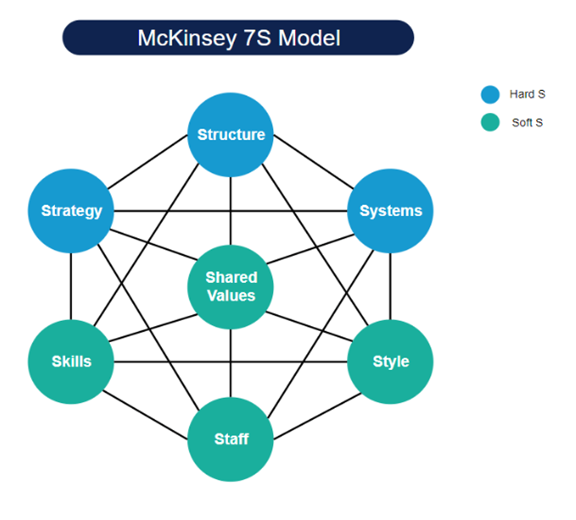
Source: Stanke (2014)

First, the systems that can facilitates the execution of task within Dhaka Regency hotel, for example inventory management and quality control protocols along with the feedback mechanism needs to be developed in such a way so that the customers can rely on the services provided by the business in this case. Such systems in the business market can optimise the operational efficiency in the process and get satisfaction from the customers in the market (Newton, 2010).
An especially important among the employees in the organization as the competition with the other business differentiated by the skills there on employees have served the target customers in the market. At Dhaka Regency staff should causes not only technical skills related to the hospital management part they also ensure the development of soft skills such as communication and problem solving in the customer service delivery process so that the customers can get a value-added service from the skilled employees of the business (Tushman, M. L., & O &C. A., 2002). In this case Dhaka Regency hotel and resort needs to invest more in employed training and development programmes that will enhance their skills existing in them provide a better assistance in those so that the customers can feel the premium vibe in the service delivery process.
The principles among the employees are often responsible for the behavioural patterns among the employees within the organisation (Andrew, Pinfield, and Rutter, 2019). As Dhaka Regency hotel is trying to ensure excellence, they need to respect diversity management and customer centric mind set among the employees recruiting employees from the sorted candidates in the market. If the organisation of culture is strong enough to foster a better culture based on the shared values between the organization and the employees, then teamwork among the employees can provide the business a better position in the business market (O’ Mahoney, 2021).
Every successful business is led by strategic and visionary leader in the market who led the approach adopted by the management and influence the organization positivity (Mintzberg, Ahlstrand & Lampel, 2009). The employees at Dhaka Regency hotel need to be directed in such a way so that they are adaptiveness and empathy can help them embrace change which is excellent to contribute to the success along the process. In this case having suitable leadership for the business for aligning the employees with organizational goals needs to be ensured.
Organisational human resources including employees at all levels needs to be developed after recruitment properly so that talented individuals are aligned with the values of the business and causes a better set of skills can demonstrate a commitment the to the organisation and deliver a better service in this case (Hayes & Ninemeier, 2016). When the employees are trained properly then a comparative advantage can be received by Dhaka Regency hotel can be enjoyed along with sustainable growth in the next years.
Along with all this factors structure of the business needs to be evaluated with such care that the structure in the management system can instruct employees in a logical manner and provide a better solution to the customers within the shortest period. When the organisation will have a better structure and systems management, they the business will be strong enough to survive the existing and arising comparativeness in the business market (Jensen, 2014). For achieving a long-term success from the operational processes of the business ensuring the implementation of right strategies to structure the operational processes can help Dhaka regency hotel to increase is occupancy rate and get a search in the revenue generation process through providing a quality service to the customers using their investing resources in the business.
Recommendation from Change Management
(Unfreeze, Change, Refreeze)
After the required solution to the existing problems has been identified the change management process needs to be evaluated in such a way that the sustainability of the solution in implementing in the process can be ensured (Johnson, 2005). The change management process in this case can be segmented into three steps which are discussed below:
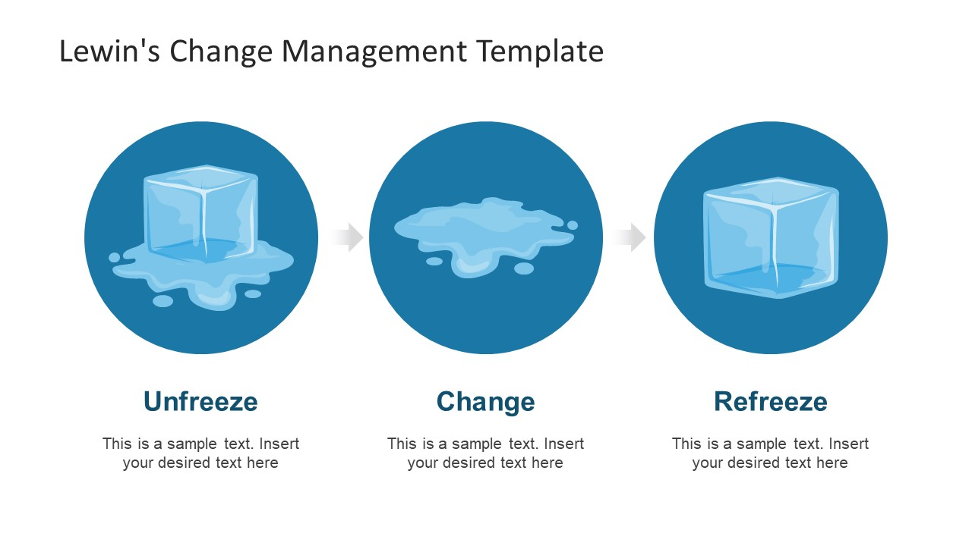
Source: Slide Model (2023)

Structure in the entire system needs to be unfreeze so that any change in the process can be welcome by the concerned parties in this case. The implementation of the changes in the process needs to be planned carefully so that the suitability of implementing such changes in the process can have a positive impact in the overall understanding of the customers about the value that are been delivered to them by the employees in business (Hammer & Champy, 2009). So, through unfreezing change management options in this case can help the hotel in preparing for the modification process and get a better outcome when the changes are being implemented throughout the whole business processes evolving the total system into an efficient one.
After the structure and systems unfreeze, suitable strategies need to be implemented in the process so that the strategic management can help in generating the expected outcome from the business market. Changing the right factors in the business and managing the structure of policies with the institutions in the market can get a better acceptance from the customers in this case (Fisman & Sullivan, 2014). The change management needs to be done in a proper manner so that businesses can ensured a smooth transition into the newly structure administrative position in the market while insulin customers and an interrupted experience offered by the business in this case.
When the implementation process is completed then a Refreeze the entire process can generate a better understanding and perspective about the business process in this case. Refreezing the structure with suitable system policies can help the process to remain unchanged by any other factors that can adulterated the regulations in the process and generate any unintended outcome from the business market. With a view to achieving a maximum benefit from the operations of the hotel, Dhaka Regency needs to ensure that if their new structure and strategic orientation is effective, then nothing can change their operations management collaborate with stake holder to get a better result out of the exiting issues in the market.
For achieving business success TQM (Total Quality Management) can assist, training, and monitor the employees to foster customer loyalty and achieving long term success (Hussain et al., 2020). According to the case study for TQM and hotel performance (Wang, Chen & Chen, 2011), Market orientation and TQM are linked to the overall performance of the hotels. To adapt those may enhance the productivity and understand the external factors that helps to build strong marketing strategy and track innovative technologies. As an example of Marriott Hotel International have using TQM to ensure decent quality services to their guests (Mukherjee, 2016).

Action Plan
After finding out the solutions that can provide a better assistance to tackling the challenges that hospital businesses are facing, by selecting suitable action steps that can provide a better support to implement their strategic planning to achieve their goals in the market. Action plans needs to be developed based on a secured and precise period so that the planning of maintenance this action can be properly directed the employees by the leaders in the organisation to get a better outcome than the previous times (Noordzife, 2014). So, the action planning needs to be developed with sufficient explanation to the planning that can deliver the required services to the business in the market. Action plan for Dhaka Regency hotel to implement the suggested changes in their corporate structure has been given below:
No | Main Problem | Solution | Desired Outcome | Time Scale | Completion Time | Planned Budget (£)
 | Reduction in occupancy rate | Providing  attracting  offers and  value addition  services to the  customers,  their attention  can  retained by  the business. | More positive  feedback  from the  customers  will allows them to  spread word of mouth to  increase the  sales of the  business. | 6 months | 31/12/2024 | 5000
 | Increase in  overhead  and  operational expenses | Finding the right solution to the supplier of raw | The expenses  need to have a stable  growth but a little amount over time | 3 months | 31/09/2024 | 4000
 | Inferior quality of housekeeping service | Proper training can provide and evaluate plans according to the training | Enhance guest satisfaction level and upgrade guest satisfaction level | 2 months | 01/08/2024 | 2000

Conclusion
My deepest thanks for Dhaka Regency Hotel & Resort to give us a chance to analysis and explore the issues. I am trying to find out the recommendation and change management process by using few theories for consideration. However, travelling is one of the most crucial factors in the development of human civilization, to proper management of the convenience offer to the customers in the hospitality sector, can be delivered to the future generation to ensure the sustainable result from the operations of businesses (Kotler, Bowen & Makens, 2014). While operating in the market, businesses might be exposed to several types of challenges which can create a challenging environment for them to make profitability with time. Likewise other hotel business in developing countries, Dhaka Regency hotel also faced similar challenges which has been carefully identified from the operational process in the business market. Throughout the changes in the economic context and the market opportunities to provide value addition services to the customers, hotels businesses suffered a lot as the expenses in providing services to their customers has become higher and to remain competitive in the market as they could not increase the fees of the rooms by that amount. So, over the past five years, the business has been experiencing a dramatic fall in their profitability and the growth of the business has been hindered. So, to ensure a better strategic management of the business, suitable operations have been suggested along with the process of immolating those changes in the market so that the outcome from business operations can generate sufficient success from their operations management in this case. By understanding the political, economic, social, technological, environmental, and legal landscape, Dhaka Regency can anticipate opportunities and threats, formulate strategic responses, and enhance its resilience in the dynamic hospitality industry.

Appendix:
In 2023; Total revenue (TR)=$47 million
Available rooms (Ar.) = 210
Total room revenue=TR/Ar.=$223809.52
RevPAR=Total room revenue/Ar.=$1065.8
In 2024; Total revenue (TR)= $56.6 million=$57 million (nearest number)
Available rooms (Ar.) = 210
Total room revenue= TR/Ar.=$271428.6
RevPAR= Total room revenue/Ar=$1292.5

References
- ANDREW, M.C., PINFIELD, S. and RUTTER, S., 2019. ‘Extending McKinsey’s 7S model to understand strategic alignment in academic libraries.’ Library Management, 40(5), pp. 313-326. (Accessed on: 11th May 2024).
- Azizul Hassan (2021). 'Technology Application in the Tourism and Hospitality Industry of Bangladesh'. Springer. (Accessed on:8th May 2024).
- Avery, j. & Dev, C. S., (2016). ‘The Park Hotels Revitalizing an Iconic Indian Brand Case Study Solution Analysis.’ Calameo. Available at: https://www.calameo.com/books/0071803267f78e3b3cf80 (accessed on: 20th May 2024).
- Bangladesh Bureau of Statistics (2023). Bangladesh economic review 2023. Dhaka: Bangladesh Bureau of Statistics. (Accessed on: 8th May 2024).
- Bangladesh Bank (2024). “Monetary Policy Statement, January- June 2024”. Dhaka, Bangladesh. (Accessed on: 9th May 2024)
- Bangladesh Bank (2023). “Major Economic Indicators, monthly update July 2023”. Dhaka, Bangladesh. (Accessed on: 12th May 2024)
- British Business Bank (2023). 'Why compliance is important for smaller businesses'. Available at: https://www.british-business-bank.co.uk/business-guidance/guidance-articles/business-essentials/why-compliance-is-important-for-smaller-businesses#:~:text=Rules%20and%20regulations%20are%20designed,governance%20and%20social%20impacts%20seriously. (Accessed on: 15th May 2024).
- Laws of Bangladesh (2024). ‘Laws and regulations.’ Available at: https://www.bdlaws.gov.bd/ (accessed on: 14th May 2024).
- Bangladesh Monitor (2024). ‘Dhaka Regency archives 90pc annual budget in 2023- executive director.’ Available at: https://bangladeshmonitor.com.bd/hotel-and-restaurant-details/dhaka-regency-achieves-90pc-annual-budget-in-2023-executive-director (accessed on 15th May 2024).
- Baron, A. and Armstrong, M. (2008) ‘Human Capital Management: achieving added value through people.’ London: Kogan Page. (Accessed on: 17th May 2024)
- Bob Stanke (2014). ‘McKinsey 7S Framework: Align Your Strategy, Structure, and Systems.’ [Blog]. Available at: https://www.bobstanke.com/blog/mckinsey-7s-framework (accessed on: 9th May 2024).
- Brierley, E. (2006). ‘Talent on tap: getting the best from freelancers, interims and consultants.’ London: Chartered Institute of Personnel and Development. Accessed on: 17th May 2024.
- Buhalis, D., & Costa, C. (2006). ‘Tourism management dynamics: Trends, management, and tools.’ Oxford: Butterworth-Heinemann. (Accessed on: 8th May 2024).
- Buttrick, R. (2009) The project workout: the ultimate handbook of project and programme management. 4th ed. Harlow: Financial Times Prentice Hall. (Accessed on: 10th May 2024).
- Burnes, B. (2014). ‘Managing Change.’ Great Britain: 6th Edition, Harlow, England: Pearson. Accessed on: 17th May 2024.
- Buttrick, R. (2009) The project workout: the ultimate handbook of project and programme management. 4th ed. Harlow: Financial Times Prentice Hal. (Accessed on: 12th May 2024)
- Cetron, M.J. et al. (2020) ‘Shaping the future of hospitality and travel: trends in energy, environmental, and labour force and work’, International hospitality review, 34(2), pp. 129–152. Available at: https://doi.org/10.1108/IHR-03-2020-0007. (accessed on: 14th May 2024).
- CFI (2024). ‘Six sigma.’ Available at: https://corporatefinanceinstitute.com/resources/management/six-sigma/ (accessed on: 5th May 2024).
- Cheng-Hua Wang, Kuan-Yu Chen, Shiu-Chun Chen (2012). 'Total quality management, market orientation and hotel performance: The moderating effects of external environmental factors.' International Journal of Hospitality Management. Available at: doi:10.1016/j.ijhm.2011.03.013 (accessed on: 20th May 2024).
- Christensen, C. M. (2000). ‘The innovator’s dilemma: When new technologies cause great firms to fail.’ Boston, Massachusetts: Harvard Business Review Press. Accessed on: 13th May 2024
- Christensen, C.M. et al. (2018) ‘Disruptive Innovation: An Intellectual History and Directions for Future Research’, Journal of management studies, 55(7), pp. 1043–1078. Available at: https://doi.org/10.1111/joms.12349. (Accessed on: 15th May 2024).
- CIPD (2024). ‘SWOT analysis.’ Available at: https://www.cipd.org/uk/knowledge/factsheets/swot-analysis-factsheet/#:~:text=A%20SWOT%20analysis%20is%20a,environment%20in%20which%20it%20operates. (accessed on: 8th May 2024).
- Cox, A.M. orcid.org/0000-0002-2587-245X, Pinfield, S. and Rutter, S. (2019). 'Extending McKinsey’s 7S model to understand strategic alignment in academic libraries.' Library Management, 40 (5). pp. 313-326. Available at: https://doi.org/10.1108/LM-06-2018-0052 (accessed on: 16th May 2024).
- Davenport, T.H. and Stoddard, D.B. (1994) ‘Reengineering: Business Change of Mythic Proportions?’, MIS quarterly, 18(2), pp. 121–127. Available at: https://doi.org/10.2307/249760. (Accessed on: 17th May 2024).
- Dhaka Regency Hotel & Resort (2024a). Available at: https://www.dhakaregency.com/index.php (accessed on: 1st May 2024).
- Dhaka Regency Hotel & Resort (2024b.). ‘About us.’ Available at: https://www.dhakaregency.com/about-us/ (accessed on: 1st May 2024).
- Eisenhardt, K. M., & Sull, D. N. (2001). ‘Strategy as simple rules.’ United States. Harvard Business Review. Pp.106-176. (Accessed on: 8th May 2024).
- Enz, C. A. (2010). ‘Hospitality strategic management: Concepts and cases.’ Second edition. John Wiley & Sons. (Accessed on: 7th May 2024).
- Endraw Max (2024). ‘What is A PESTEL Analysis with Examples.’ [Picture]. Available at: https://images.app.goo.gl/cNWcJkycym3XgN7P9 (accessed on: 23rd May 2024).
- Ershadi et al. (2018). ‘Root cause analysis in quality problem solving of research information systems: a case study.’ International Journal of Productivity and Quality Management. 24(2):284. Available at: DOI:10.1504/IJPQM.2018.10012949 (accessed on: 6th May 2024).
- Etic hotels (2024). ‘Etic green scores.’ Available at: https://etichotels.com/dhaka-regency-hotel--resort/-?src=countries&regid=3&conid=16&cityid=0&fromdt=na&todt=na&adlts=2&chlds=0&search_txt=Dhaka%20Regency%20Hotel%20&%20Resort,%20&search_id=ht-13451&hotel_id=13451 (accessed on: 12th May 2024).
- Fisman, R. & Sullivan, T. (2014). ‘The Org: How the Office Really Works.’ Murray Learning. London. (Accessed on: 16th May 2024)
- Galbraith, J. R. (1973). ‘Designing complex organizations.’ Addison-Wesley. (Accessed on: 17th May 2024).
- Galbraith, Downey, and Kates (2002). ‘Designing Dynamic Organizations.’ San Fransisco: Jossey-Bass. (Accessed on: 17th May 2024).
- Gino, F. (2018). ‘Rebel talent: Why it pays to break the rules at work and in life.’ The Brainwaves Video Anthology. [Video]. Available at: https://youtu.be/zTmFFmAqbEc?si=hVU2cx1QyLHNjNHu (accessed on: 15th May 2024).
- Grant, R. M. (2016). ‘Contemporary strategy analysis: Text and cases edition.’ John Wiley & Sons. Ninth edition. Chichester. West Sussex, United Kingdom.
- Golam Mowla (2024). ‘Restaurant businesses are thriving, dodging VAT.’ Dhaka Tribune. Available at: https://www.dhakatribune.com/bangladesh/344647/restaurant-businesses-are-thriving-dodging-vat (accessed on: 14th May 2024).
- Hussain et al. (2020). Relationship Between Total Quality Management Practices and Profitability: Case of Small Hotel Sector London (UK). (accessed on: 20th May 2024).
- Hammer, M., & Champy, J. (2009). ‘Reengineering the corporation: A manifesto for business revolution.’ New York: Harper Business Essentials. (Accessed on: 18th May 2024).
- Hayes, D. K., & Ninemeier, J. D. (2016). ‘Human resources management in the hospitality industry.’ Second edition. Hoboken, NJ: Wiley. (Accessed on: 14th May 2024)
- Hitt, M. A., Ireland, R. D., & Hoskisson, R. E. (2016). ‘Strategic management: Concepts and cases.’ Cengage Learning. (Accessed on: 16th May 2024).
- İge PIRNAR, Sinem KURTURAL , Engin Deniz ERİŞ (2019). ‘SWOT - TOWS ANALYSIS OF URLA DESTINATION’S ALTERNATIVE TOURISM DEVELOPMENT.’ International Journal of Contemporary Tourism Research. 235 – 244. Available at: http://dergipark.gov.tr/ijctr (accessed on: 3rd May 2024).
- Insycle (2021). ‘Data Collection Methods and Why They Are Critical for Business.’ [Blog]. Available at: https://blog.insycle.com/data-collection-methods#:~:text=Common%20qualitative%20data%20collection%20methods,%2C%20focus%20groups%2C%20and%20interviews. (Accessed on: 12th May 2024).
- Ivanova, M. and Ivanov, S. (2020). ‘Tourism Information Technology.’ Journal of Tourism Futures, 6(2), pp. 201–202. Available at: https://doi.org/10.1108/JTF-06-2020-153. (Accessed on: 13th May 2024).
- Jensen, C. (2014) ‘Sutton, Robert I. Huggy Rao. Scaling Up Excellence: Getting to More Without Settling for Less,’ Library Journal. Library Journals, LLC, pp. 62-. (Accessed on:13th May 2024).
- Johnson, M. (2005). ‘The Independent Consultant’s Survival Guide: starting up and succeeding as a self-employed consultant.’ London, Chartered Institute of Personnel and Development. (Accessed on: 11th May 2024).
- Jones, P., & Lockwood, A. (2002). ‘The Management of hotel industry.’ Cengage learning. (Accessed on: 9th May 2024).
- Kim, W. C., & Mauborgne, R. (2015). ‘Blue ocean strategy: How to create uncontested marketspace and make the competition irrelevant.’ Boston: Harvard Business Review Press. (Accessed on: 8th May 2024).
- Kipping, M. and Clark, T. (2012) The Oxford Handbook of Management Consulting. First edition. Oxford: Oxford University Press. Available at: https://doi.org/10.1093/oxfordhb/9780199235049.001.0001. (Accessed on: 8th May 2024).
- Kotler, P., & Armstrong, G. (2018). ‘Principles of marketing’ (17th ed.). Pearson. (Accessed on: 10th May 2024).
- Kotler, P., Bowen, J. T., & Makens, J. C. (2014). ‘Marketing for hospitality and tourism’ (6th ed.). Harlow, Essex: Pearson. (Accessed on: 16th May 2024).
- Kotter, J (2012). ‘Leading change.’ Boston, Massachusetts: Harvard Business Review Press. (Accessed on: 15th May 2024).
- Lashley, C. and Morrison, A.J. (2001) In search of hospitality: theoretical perspectives and debates. Oxford: Butterworth-Heinemann. (Accessed on: 16th May 2024).
- Lean Enterprise institute (2018). ' Clarifying the 5 ways problem -solving method '. [Video]. Available at: https://youtu.be/SrlYkx41wEE?si=R84S800cokr8PP32 (accessed on: 10th May 2024).
- Lee, S.M. et al. (2017) ‘Environmental Policy Performances for Sustainable Development: From the Perspective of ISO 14001 Certification’, Corporate social-responsibility and environmental management, 24(2), pp. 108–120. Available at: https://doi.org/10.1002/csr.1395. (Accessed on: 13th May 2024).
- Mavridopoulou, & O’Mahoney, J. (2020). ‘Elitism in Strategy Consulting: How Institutional Prestige Influences Recruitment.’ Management Consulting Journal, 3(1), 12–22. (Accessed on: 15th May 2024)
- McGrath, R. G. (2009). ‘Discovery-driven growth: A breakthrough process to reduce risk and seize opportunity.’ Harvard Business Review. Available at: https://hbr.org/2012/07/it-is-possible-to-drive (Accessed on: 16th May 2024).
- McGrath, R. G. (2013). ‘The end of competitive advantage: How to keep your strategy moving as fast as your business.’ Harvard Business Press. Accessed on: 16th May 2024.
- Minhazur Rahman Rezvi (2020). 'Exploring Politics of Social Safety Net in Bangladesh through Political Settlement: The Case of Rajakhali Union in Cox’s Bazar District'. Available at: https://doi.org/10.1177/0021909620970581. vol (56) issue (7). (Accessed on15th May 2024).
- Mukherjee, PN, (2006). 'Total Quality Management.' New York: PHI Learning Pvt, Ltd. (Accessed on: 20th May 2024).
- Newton, R (2010). The management consultant: mastering the art of consultancy. Harlow: Financial Times prentice Hall. (Accessed on: 17th May 2024).
- Noordzij, G. (2014). ‘Project Management of Hotel Opening Processes: Exploring Better Ways to Manage New Hotel Openings.’ North Charleston: CreateSpace. (Accessed on: 16th May 2024).
- Ogunnaike et al. (2022).' Social and Cultural Experiences with Loyalty towards Hotel Services: The Mediating Role of Customer Satisfaction'. Available at: https://doi.org/10.3390/su14148789 (accessed on: 16th May 2024).
- O’Mahoney, J. (2021). ‘How Small Consultancies Grow: Challenging Problem-Based Theorising.’ Management Consulting Journal, 4(1), 5–20. Available at: https://orca.cardiff.ac.uk/id/eprint/152800/3/JM%2010.2478_mcj-2021-0002.pdf (accessed on: 15th May 2024)
- Peter Landau (2023). ‘Root Cause Analysis: A Quick Guide.’ [Blog]. Available at: https://www.projectmanager.com/blog/root-cause-analysis-guide (accessed on: 13th May 2024).
- Pyzdek, T., & Keller, P. A. (2019). ‘The Six Sigma handbook.’ Fifth edition. New York: McGraw Hill Professional.
- Richard, B., Shi, W. and Yang, C. (2016) ‘Hotel revenue management: from theory to practice’, Anatolia. Routledge, pp. 283–284. Available at: https://doi.org/10.1080/13032917.2015.1115947. (Accessed on: 12th May 2024).
- Rogers, E. M. (2003). ‘Diffusion of innovations.’ Fifth edition. New York: Free Press. Accessed on: 13th May 2024.
- Slide Model (2023). ‘Lewin’s Change Model PowerPoint Template.’ [Picture]. Available at: https://images.app.goo.gl/RSFJnyrER7CX3P5n8 (accessed on: 12th May 2024).
- Simplilearn (2024). ‘What is Six Sigma: Everything You Need to Know About It.’ [picture]. Available at: https://images.app.goo.gl/iqpmonEZjenRU5EZ6 (accessed on: 8th May 2024).
- Statista (2024). ‘Revenue.’ Available at: https://www.statista.com/outlook/mmo/travel-tourism/hotels/bangladesh (accessed on: 14th May 2024).
- Statista. (2023). ‘Hotel industry in Bangladesh - Statistics.’ Available at: https://www.statista.com/search/?q=hotel+industry+in+bangladesh+statistics+&Search=&p=1&category%5B%5D=420&subCategory%5B%5D=&region%5B%5D=50 (accessed on: 15th May 2024).
- Subramaniam, N. et al. (2011) ‘The effects of perceived business uncertainty, external consultants and risk management on organisational outcomes’, Journal of accounting & organizational change, 7(2), pp. 132–157. Available at: https://doi.org/10.1108/18325911111139671. (Available at: 16th May 2024).
- Sutton, R. I., & Rao, H. (2014). ‘Scaling up excellence: Getting to more without settling for less.’ Crown Business. (Accessed on: 15th May 2024).
- The financial Express (2024). ‘Tourism industry faces Tk 15b losses due to political unrest.’ Available at: https://thefinancialexpress.com.bd/economy/bangladesh/tourism-industry-faces-tk-15b-losses-due-to-political-unrest (accessed on: 13th May 2024).
- Tushman, M. L., & O & C. A. (2002). ‘Winning through innovation: A practical guide to leading organizational change and renewal.’ Boston: Harvard Business Press.
- Tine Juhl (2017). ' SWOT & TOWS- An introduction'. [Video]. Available at: https://youtu.be/2xquSq0MSAc?si=qseMuyv81qgkkAjT (accessed on: 3rd May 2024).
- UNB (2024). ‘Consumers struggle with inflation in Dhaka kitchen markets.’ Available at: https://www.dhakatribune.com/bangladesh/dhaka/346746/consumers-struggle-with-inflation-in-dhaka-kitchen (accessed on:18th May 2024).
- UNB (2023). ‘Gas prices hiked for power plants, industries and commercial users.’ Dhaka tribune. Available at: https://www.dhakatribune.com/bangladesh/303010/gas-prices-hiked-for-power-plants-industries-and (accessed on: 1st may 2024).
- Webster, C. and Ivanov, S. (2014) ‘Transforming competitiveness into economic benefits: Does tourism stimulate economic growth in more competitive destinations?’ Tourism management (1982), 40, pp. 137–140. Available at: https://doi.org/10.1016/j.tourman.2013.06.003. (Accessed on 17th May 2024).
- Whittington, R., and Molloy E. (2005). ‘HR’s role in organisation: shaping change. Research report.’ London: Chartered Institute of Personnel and Development.
- Whittington, R. et al (2020) ‘Exploring Strategy: text and cases.’ 12th edition. Harlow: Pearson.
- World bank (2024). ‘Bangladesh Development Update.’ Available at: https://thedocs.worldbank.org/en/doc/f6dd176b982714b6e3b04d7ac672a0ab-0310012024/original/Bangladesh-Development-Update-April-2024-w-cover.pdf (accessed on: 16th May 2024).
- World Travel & Tourism Council (2023). ‘Travel & Tourism Economic Impact 2023: Bangladesh.’ Available at: https://www.wttc.org/economic-impact/country-analysis/country-profiles/
- Xinhua (2022). ‘Hospitality sector in Bangladesh suffers from COVID-19 impact.’ Available at: https://english.news.cn/asiapacific/20220411/83040be78b244a569d30b048ddaf1a98/c.html (accessed on: 1st May 2024).

