ASSIGNMENT 2
MODULE NAME | THE GLOBAL BUSINESS ENVIRONMENT
LECTURER | NADEEM MIRZA
STUDENT NAME | CATALINA STOIAN
STUDENT ID | 2119687

Contents
Introduction: 3
Covid-19 impact analysis of Automobile industry: 4
Survival and success factors of Jaguar Land Rover: 5
Megatrends of JLR: 8
Relevant newsletter of Jaguar Land Rover: 10
Conclusion: 12
References: 13

Introduction:
The automobile industry is already suffering from a decrease in GDP growth rate worldwide, even before the pandemic COVID-19 has hit. In order to reduce fatalities in automobiles, the authorities need to take different measures to improve air quality. Fuel prices are rising, registration costs are increasing, insurance is increasing, etc. This has created a burden on the industry. The lockdown implemented by the authorities to control the spread of COVID-19 was affecting financial status worldwide across the board, even though it slowed the speed at which COVID-19 spread (Rajamohan, 2020). In view of the severity of the COVID-19 due to its direct impact on all countries, the economic situation is expected to improve by 2023 if the great recession and COVID-19 are compared. As a result, the COVID-19 has a huge impact on Jaguar Land Rover and encounters various obstacles in its productions.

Covid-19 impact analysis of Automobile industry:
In consequence of COVID-19, the global economy and humanitarian situation have been damage. This pandemic has triggered a worldwide lockdown in all countries. However, the lockdown helped limit the spread of the disease, it has had devastating effects on the country, disrupting most value chains. In the automobile sector, the epidemic is impacting all aspects of industry with major manufacturers shutting down or operating with minimal staff (Belhadi, 2021). COVID-19's axle load reforms, structural reforms, and shift to shared mobility have largely brought the entire industry to a standstill. The implementation of structural reform, hub-and-spoke reform, and other initiatives have already had a significant impact on other industries. Auto producers are suffering from truncated demands due to the lockdown. Almost all companies have severed their research and development support, and they may not be able to recover past growth in mobility technologies and alternate fuels. COVID-19 has affected some research literature in the automobile industry.

While Jaguar Land Rover earnings improved from last year's COVID impact, the semiconductor shortage remains a significant problem for the company. Sales of 84.4k vehicles increased 72.6%, but a shortage of chips lowered sales by 30k units (27%) resulting in a pre-tax loss and a free cash outflow. The company reported a pre-tax loss of £110m but saw its free cash outflow improve by £574m compared to last year (Felix Brautgam, 2021). The demand for the chips, which are expected to improve in the second half of the year, remains strong with a record order book of 110k units. With £3.7 billion in cash and £1.9 billion of undrawn credit facility as of 30 June 2021, the business had strong liquidity of £5.7 billion - £0.8 billion of new bonds added in July and an increase in revolving credit facility added in August. The Reimagine strategy powered by Refocus is advancing qualitatively, financially, sustainably, and digitally (Nayak, 2022).

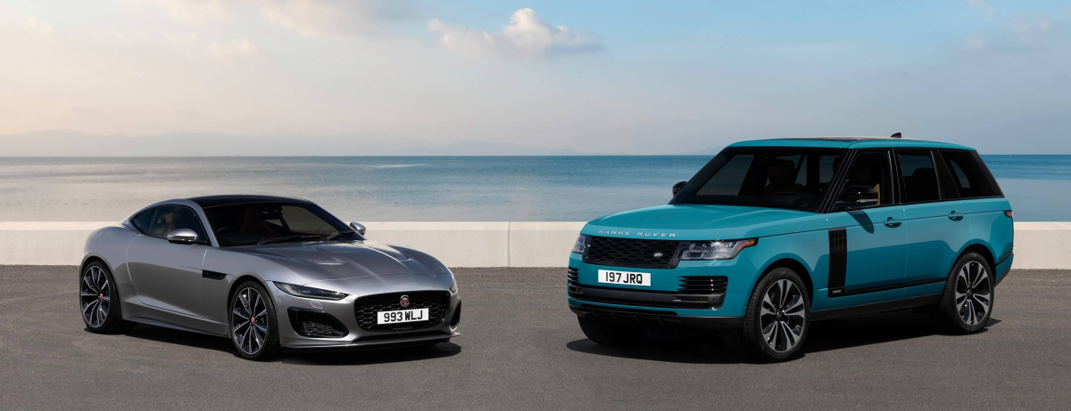
Figure 1: Jaguar Cars
Source: (Felix Brautgam, 2021)

Survival and success factors of Jaguar Land Rover:
This business blueprint lays out the most essential elements of the products and services Jaguar produces in order to define our more global role in society. To provide customers with experiences they will love forever (Kufelová, 2020). These strategic priorities are our road map to attaining our vision, and act as a guide to driving Jaguar Land Rover's value and strengthening our brands.
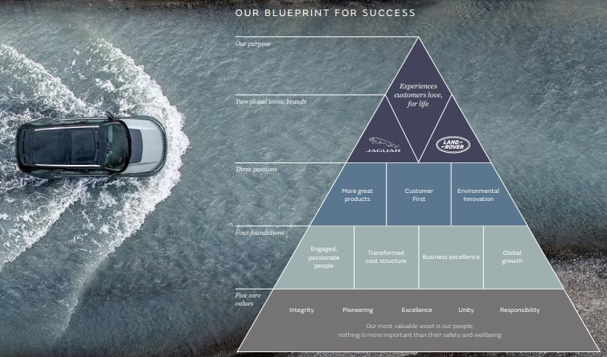
Figure 2: Success and Survival factor of JLR (Yeung, 2022)

Great products:
Introducing Jaguar Land Rover, a British brand that reimagines what luxury could be through design. The latest innovations take this brand to even greater heights. There have been quality and reliability issues with Jaguar and Land Rover models worldwide for years now. Land Rover ranks last out of 31 car manufacturers in a reliability survey, with 78.2%, almost 10 points behind the brand right above it (Yeung, 2022).
Customer first:
In addition to the Land Rover Discovery and Range Rover Sport, new plug-in hybrid electric vehicles. New models will be introduced at a later stage, including the new Land Rover Defender. An all-electric Jaguar model has also been awarded numerous awards. They give customer priority for build strong customer base. Every six months, members can choose a vehicle that matches their changing lifestyles.
Environmental inventions:
The Jaguar luxury brand will be reimagined from 2025 as a fully electric brand. The company will launch six pure electric Land Rover models by 2024, keeping its position as the world's leading luxury SUV brand. The Carbon Trust has certified carbon neutrality for UK manufacturing and product development sites. In terms of operating CO2 per vehicle, they have already reduced it by 46% and plan to continue decarbonising (Mukherjee, 2022). By using aluminum, we reduce the weight of our cars, enabling innovative powertrains. Using less virgin aluminium in the production of vehicles will reduce the need for it. Creating recycled aluminium uses 90 percent less energy than making it from scratch and reduces the demand for raw materials.
Global growth:
It was the first time both long-established car brands were owned by the same company when Jaguar Land Rover Automotive was created as a subsidiary of Tata Motors in 2008. Approximately 44 000 people were employed by Jaguar Land Rover by 2021. During the period considered, revenue continued to increase between 2011 and 2018, before declining for the first time in the period. Approximately 19.73 billion British pounds worth of revenues were generated by Jaguar Land Rover in 2021(Mukherjee, 2022).
JLR sold 269,000 cars globally during 2012, the company reported. It sold 614,300 cars during the year ending March 2018. The F-Pace is Jaguar's first SUV, and the Range Rover Velar is another strong seller, so this is impressive growth. In the fiscal year ending March 2018, top-line sales rose 1.7%. Unfortunately, sales of some of its most profitable volume models have fallen significantly over the past six months. Despite its magnitude, the fall-off did not seem to slow down during the month of March. During January through March, JLR sales declined 3.8%. Sales fell 7.8% in March alone. In the first three months of the year, the company's sales in the UK market dropped 21%, and in March they dropped 26%. Europe sales in the first three months dropped nearly 12% (Yeung, 2022). Getting proper stability on the market is proving quite difficult for Jaguar Land Rover. Employees are the greatest threat to the company's survival.

Megatrends of JLR:

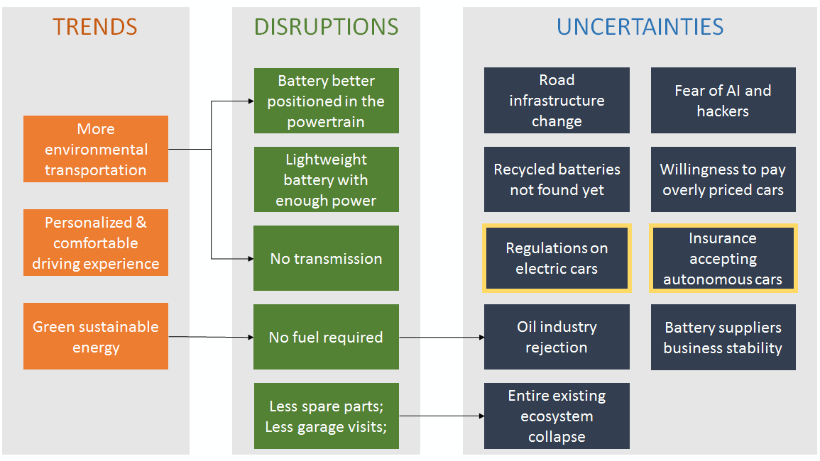
Figure 3: Megatrends of JLR (Grieveson, 2021)
As a collective term, 'megatrends' describe powerful forces of economic, societal, and technological change transforming the world today. They still have the power to change the landscape of investment and industry, even if they follow different development paths and happen at different rates (Grieveson, 2021). The environment and natural resources of the planet are having an increasing impact on individuals, businesses, and policymakers, which is why sustainability is becoming so important. In today's world, the industry is faced with new challenges. Research and development efforts are being directed toward new technologies. Four trends dominate the market and drive growth based on McKinsey's analysis:
Autonomous driving:
At the Future Tech showcase in Gaydon, UK, Jaguar Land Rover revealed some of its prototype technology where they are developing driver-focused autonomous capabilities that operate in all weathers. Researchers demonstrated the capability to control a Range Rover Sport remotely via a smartphone via a Remote Control Range Rover Sport research vehicle. Drivers can control steering, acceleration, and braking with the smartphone app and select high or low gear. Furthermore, if someone has parked too close to the car, the driver can use the smartphone app to reverse out of the space (Kumar, 2020).
Shared mobility:
Future mobility will be shared and vehicles will be available on demand. The company will invest in products and services that will meet this shift in demand as a result of thinking beyond today's market. There are already several InMotion companies making their mark in the market. Jaguar Land Rover is the power behind InMotion Ventures. From Seed to Series B, Jag Land Rover invests in startups globally and collaborates with their wider business to drive innovation. They invested £20m in Lyft as part of our partnership with Waymo (Yeung, 2022).
Connectivity:
In order to assure reliable mobile and data connection while on the move, the Touch Pro Duo Connectivity uses an external roof-mounted antenna. In addition to eight devices being able to connect wirelessly to the vehicle's high-speed 3G connection, this enables high-speed data transfer. Connecting to this feature will require a Wi-Fi or mobile network.
Electro mobility:
New electrified cars are being built in the UK by Jaguar Land Rover, protecting thousands of jobs. Jaguar has confirmed that its next-generation all-electric XJ will be the company's first model. In order to make the UK a leader in electric mobility, the company wants a giga-scale battery production plant in the country. Jaguar Land Rover is moving ahead with its electrification strategy by introducing UK electric vehicle production. Jaguar's flagship saloon, the XJ, is completing its final day of production today, as the last model rolls off the line



Relevant newsletter of Jaguar Land Rover:
Before COVID-19:
Tata Motors, a leading Indian automaker, created Jaguar Land Rover Automotive in 2008, combining two long-standing car brands for the first time under one roof. While revenues increased throughout the period of study, revenues started to decrease in 2018 for the first time (Salder, 2019).
Model of Land Rover:
The Land Rover was launched by Tata Motors in 2008. This plant produces many vehicles. Before pandemic, LRX concept, Evoque production, Hybrid model, Sport, SV Autobiography, Velar, Sport hybrid vehicles, etc. were on the market.

ACHIEVEMENTS BEFOR-AFTER COVID-19
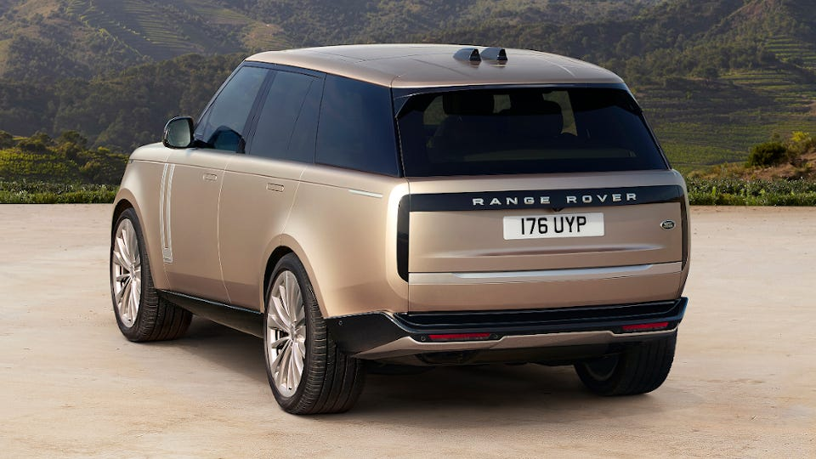
Figure 4: Jaguar Range Rover (Enda Mullen, 2021)

GBP in 2018:
Jaguar Land Rover's parent company Tata Motors generated 45.2 billion dollars in revenue in 2018, more than doubling since 2010. Jaguar Land Rover sold 25.8 billion British pounds worldwide that year, by comparison.

Annual global profit:
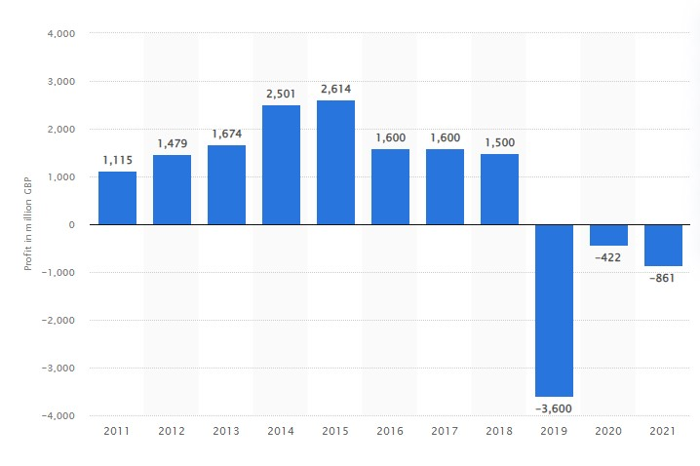
Based on the financial statements for financial years 2011 to 2020, this figure represents the company's pre-tax profit in million British pounds. The company made pre-tax profits of over a billion pounds in every year between 2011 and 2018. Although the company recorded 3.6 billion British pounds in losses in the 2019 financial year, it was the first pre-tax loss in this period of consideration (Halaj, 2021). A net loss of 422 million pounds was recorded in 2020. A loss of 861 million British pounds was incurred in 2021.
Figure 5: Annual global profit (Halaj, 2021)

Air Purification Technologies after pandemic:

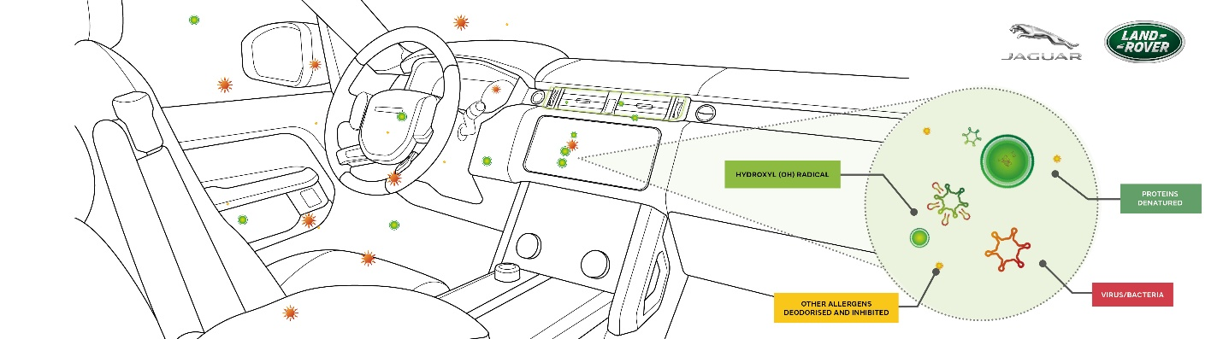
Figure 6: Air Purification Technologies
Source: (Dr Steve Iley, 2021)

The future cabin air purification technology from Jaguar Land Rover has been demonstrated in lab tests to inhibit viruses and airborne bacteria by 97%. To simulate the vehicle ventilation system in recirculation mode over a 30-minute cycle, Jaguar Land Rover teamed up with Perfectus Biomed Ltd, a leading microbiology laboratory. Approximately 97 percent of viruses and bacteria are inhibited by the product, according to independent research (Dr Steve Iley, 2021).

Conclusion:
Various industries, including the automobile industry, have suffered major damage as a result of COVID-19, resulting in significant reductions in product production and numerous obstacles that they have to face. Although data for the entire year 2020 is not available, the automobile industry has been affected by Corona, but its outlook is positive from April. With the previous recession in mind, purchasing new cars will be unaffordable since demand for used vehicles is expected to increase. The automobile industry must focus on regions with less decline in economic growth. The majority of companies are working on turning their fortunes around by 2022 (Halaj, 2021). The implementation of image processing by autonomous vehicles faces many challenges.

References:
Belhadi, (2021). "Manufacturing and service supply chain resilience to the COVID-19 outbreak: Lessons learned from the automobile and airline industries." Technological Forecasting and Social Change 163: 120447.
Dr Steve Iley, (2021). “JAGUAR LAND ROVER’S FUTURE AIR PURIFICATION TECHNOLOGY.” https://www.jaguarlandrover.com/news/2021/03/jaguar-land-rovers-future-air-purification-technology-proven-inhibit-viruses-and-0
Enda Mullen, (2021). “Jaguar Land Rover unveil new fifth generation Range Rover.” https://www.birminghammail.co.uk/news/midlands-news/jaguar-land-rover-unveil-new-21980521
Felix Brautgam, (2021). “JAGUAR LAND ROVER RETAIL SALES.” https://media.jaguar.com/news/2021/04/jaguar-land-rover-retail-sales-124-q4-fiscal-202021-continuing-recovery-covid-19
Grieveson, (2021). "Avoiding a Trap and Embracing the Megatrends: Proposals for."
Halaj, (2021). "The Decision-Making Process in Jaguar Land Rover Nitra."
Kufelová, (2020). "Impact of the Covid-19 pandemic on the automotive industry in Slovakia and selected countries." SHS Web of Conferences. Vol. 83. EDP Sciences.
Kumar, (2020). "COVID-19 global pandemic: impact on management of supply chain." International Journal of Emerging Technology and Advanced Engineering 10.4: 132-139.
Mukherjee, (2022). "A case for Tata Motors' acquisition of Jaguar Land Rover: strategic implications of the takeover." International Journal of Strategic Business Alliances 7.1: 69-80.
Nayak, (2022). "An impact study of COVID‐19 on six different industries: Automobile, energy and power, agriculture, education, travel and tourism and consumer electronics." Expert systems 39.3: e12677.
Rajamohan, (2020). "Impact of COVID-19 on stock price of NSE in automobile sector." Int. J. Adv. Multidiscip. Res 7.7: 24-29.
Salder, (2019). "Placing entrepreneurship and firming small town economies: manufacturing firms, adaptive embeddedness, survival and linked enterprise structures." Entrepreneurship & Regional Development 31.9-10: 806-825.
Yeung, (2022). "Megatrends and new research agendas in the automotive industry." A Research Agenda for Manufacturing Industries in the Global Economy. Edward Elgar Publishing.

