
Reflective project report
Engineering Group Project

April 29, 2022
UNIVERSITY OF WALES TRINITY SAINT DAVID

Table of Contents
Introduction 2
Project Plan 3
Main goals and objectives 3
Success metrics 3
Collaborator roles 3
Scope and budget 3
Milestones 4
Gantt chart 4
Aims of Reflective Analysis 9
Methods of Analysis 9
Analysis of Project Final Design Solution 10
Decision Matrix Analysis 10
Evaluation of Decision Matrix Analysis 16
Analysis of Project success 17
Identified Improvements and Success 17
Effectiveness of Self-Management and Communications Skills 18
Conclusion 20
Bibliography 21

Introduction
The project I have chosen to analyse was previously carried during my apprenticeship at BAE Systems Land UK, on placement in the engineering design department. The purpose of the project was to re-design a component water gap testing rig to improve both its maintainability and ergonomics for the operator and maintenance teams. This would allow maintenance activities to be carried out in less time and less frequently, saving both maintenance costs and reducing disruption to production. This was an individual project and was therefore, managed and carried out by me with exception to the manufacturing stage in which all components were produced by the on-site carpenter’s workshop.

The component water gap test is used to evaluate the shock sensitivity of reactive components and is used for batch testing during production. An activating sensor sends a shockwave through a container of water to the reactive component, that is suspended above the water container at a specified height. The testing rig provides a mounting solution for the component and the test equipment. Following the introduction of the previous component water gap testing rig multiply issues were found that both disrupted maintenance and operator activities. The current design created difficulties when attempting to position and secure equipment and components onto the rig due to small structural profiles and blind locating holes that were enhanced by poor lighting within the production building. It was also difficult to clean which presents a safety hazard due to a build-up of hazardous material around the rig.

The project involved re-designing the existing testing rig to meet the same requirements and give significant improvements to maintainability and set-up procedures. There was no budget set for the project however, a maximum cost of £50 per unit was specified for each testing rig with a total of thirty units to be produced. A maximum timescale of thirty-four weeks was set for completion of the project including the manufacture of a prototype testing rig and the creation of a presentation that outlines project performance.

Project Plan

Main goals and objectives
The main objective of this project is to improve the maintainability and ease of use of the water gap testing rig. This is to reduce the time required to carry out maintenance and the set-up times for operators during production activities. Another objective is to save the cost of maintenance and the frequency that maintenance is required, preventing unnecessary production downtimes and costs. The project is to be completed within thirty weeks with the goal of producing at least one prototype carrying out testing and analyses.

Success metrics
A new testing rig design should allow maintenance to be carried out easily with minimal costs and production downtime. The operators should be able to set-up and clean the testing rig with minimal time and effort, with no surfaces able to trap dirt and foreign debris leading to build-up of energetic material. There should also be sufficient space and locating aids for an operator to manoeuvrer and position sensors and test equipment.

A basic design is to be implemented that limits the structural profile of the testing rig to allow visibility of sensors from a frontal view and provide clear access for maintenance. The amount of fixings used in the construction should be limited as much as reasonably possible to aid disassembly where required and reduce costs. All sharp edges should be removed to prevent injury to any persons using the rig. The chosen material must prevent the egress of contamination or absorption of liquids where possible, including corrosion. The ability of one person to safely carry the testing rig comfortably should be maintained, with a suitable weight not exceeding 5Kg. The product should also produce minimal waste when disposed in its end-of-life stage, with recyclable and sustainable materials chosen where possible reducing the environmental impact. Another success metric is to ensure that the new design can be manufactured on-site with the tools and equipment available, adopting basic manufacturing processes and assembly techniques.

Collaborator roles
The project was individually managed by me with no other team members involved in the planning or concept stage. However, the manufacturing of the testing rigs including the prototype was to be carried out by the on-site carpenters with use of the engineering drawings I supply. The main objectives and goals were also discussed with the operators and maintenance teams before concluding. progress reports were also be relayed back to my line manager every four weeks to ensure progress is continuing and any issues could be resolved.

Scope and budget
No budget has been specified for this project as all the research and design work will be carried out by me. However, a maximum cost of £50 per testing rig has been stated including both material and manufacturing costs. Therefore, with thirty units required a total manufacturing budget has been set at £1,500 including the prototyping.

Milestones
Milestone | Description
Defining project requirements | Carry out topic research on maintainability and produce a project proposal with achievable outcomes, outlining the main requirements.
Project planning stage | Produce a project plan providing a Gantt chart with deadlines set for each task and identify project milestones.
Project feasibility stage | Produce a feasibility study that analyses the project plan assessing the effects of legislation and ethics.
Design development stage | A range of design solutions should be evaluated with a 3D model and 2D engineering drawings produced for the final solution.
Project outcomes and evaluation stage | Manufacture a prototype and analyse the findings with operators. Recommendations for future improvements should also be highlighted.
Presentation and project completion stage | A project report should be completed that includes all findings and evaluates final design. A presentation should also be completed and presented to stakeholders.

Table 1: Project milestones identified and a description of each.

Gantt chart
The main planning and monitoring tool used in for this project was a Gantt chart. According to (Geraldi & Lechter, 2012) a Gantt chart is a simple tool used to connect project activities and durations. The bars on the chart represent an objective for a specific task with the length of the bar corresponding to the time duration set to complete it. The tasks are then grouped to breakdown the project into milestone objectives, which signifies a new stage in the development. The Gantt chart can also be used to track processes throughout the project and identify tasks that may be ahead or behind schedule and require closer attention by project management. Figures one-point-one to one-point-three show the Gantt chart used for planning and monitoring the project with each task stated against their specific timescale, along with the project milestones.

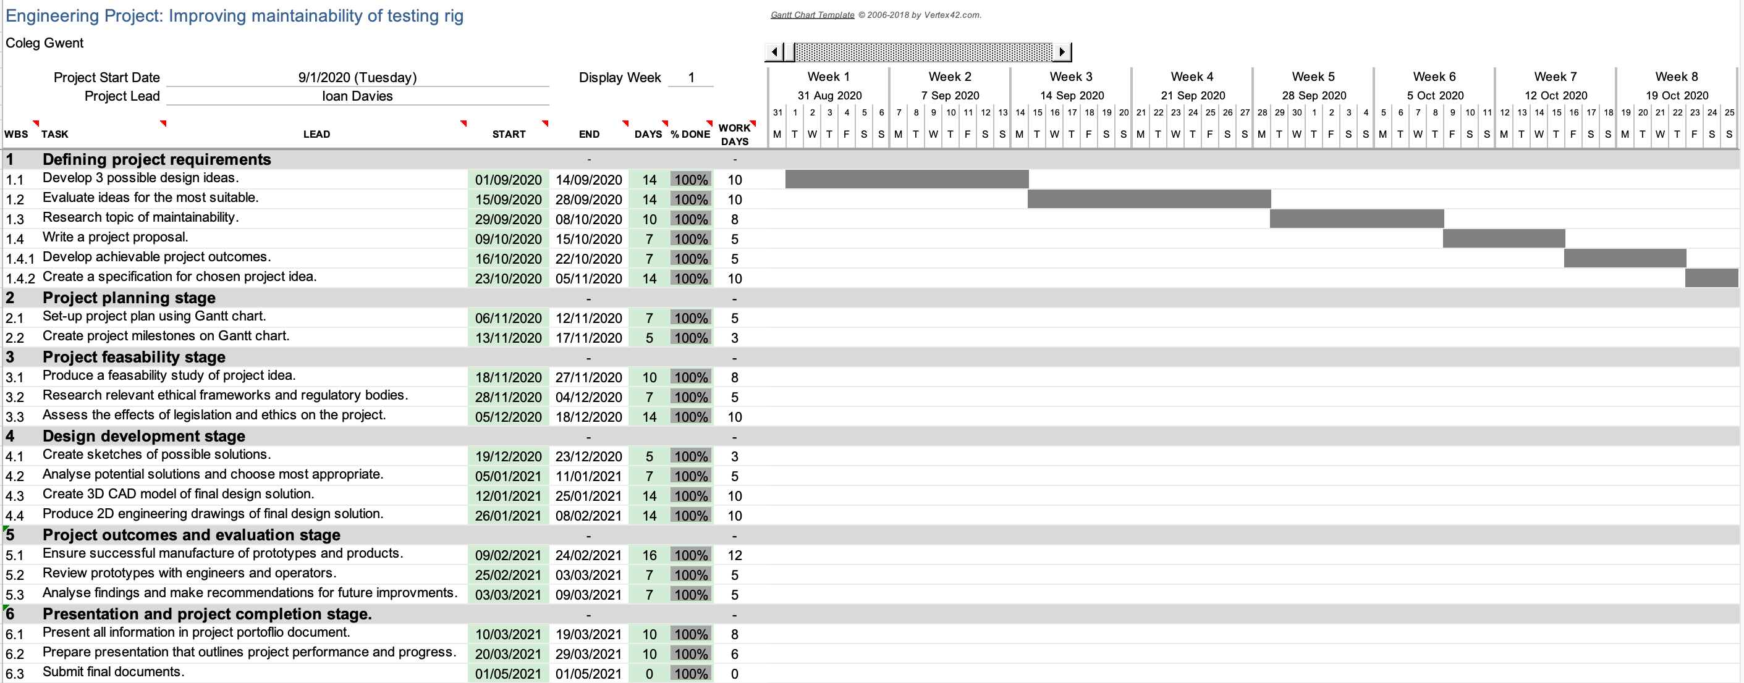

Figure 1: Project Gantt chart displaying tasks completed in weeks one to eight.

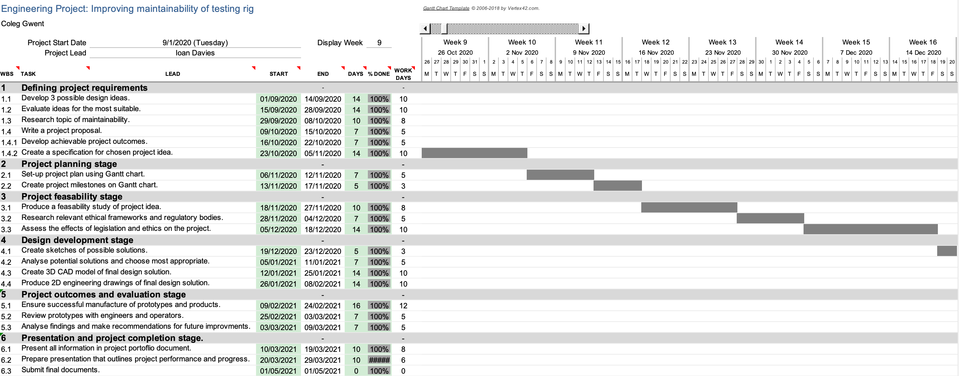

Figure 1.1: Project Gantt chart displaying tasks completed in weeks nine to sixteen.

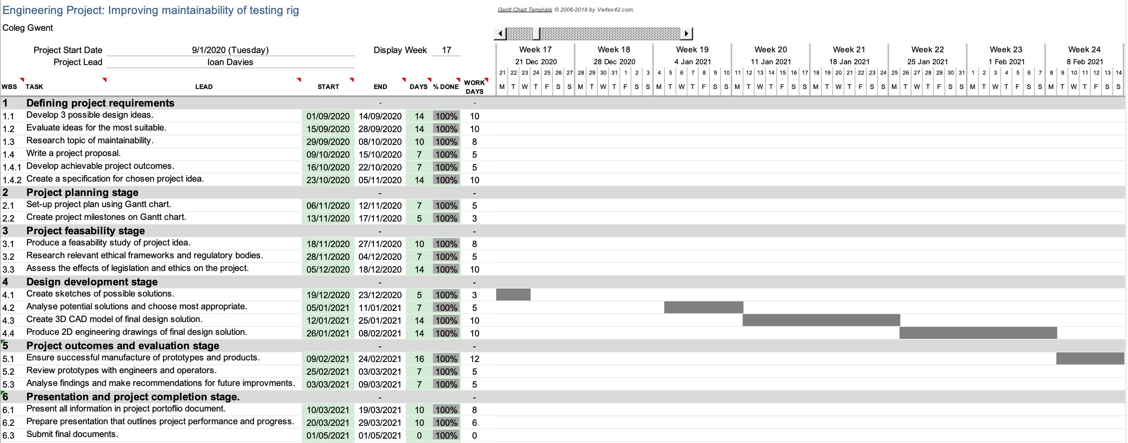

Figure 1.2: Project Gantt chart displaying tasks completed in weeks seventeen to twenty-four.

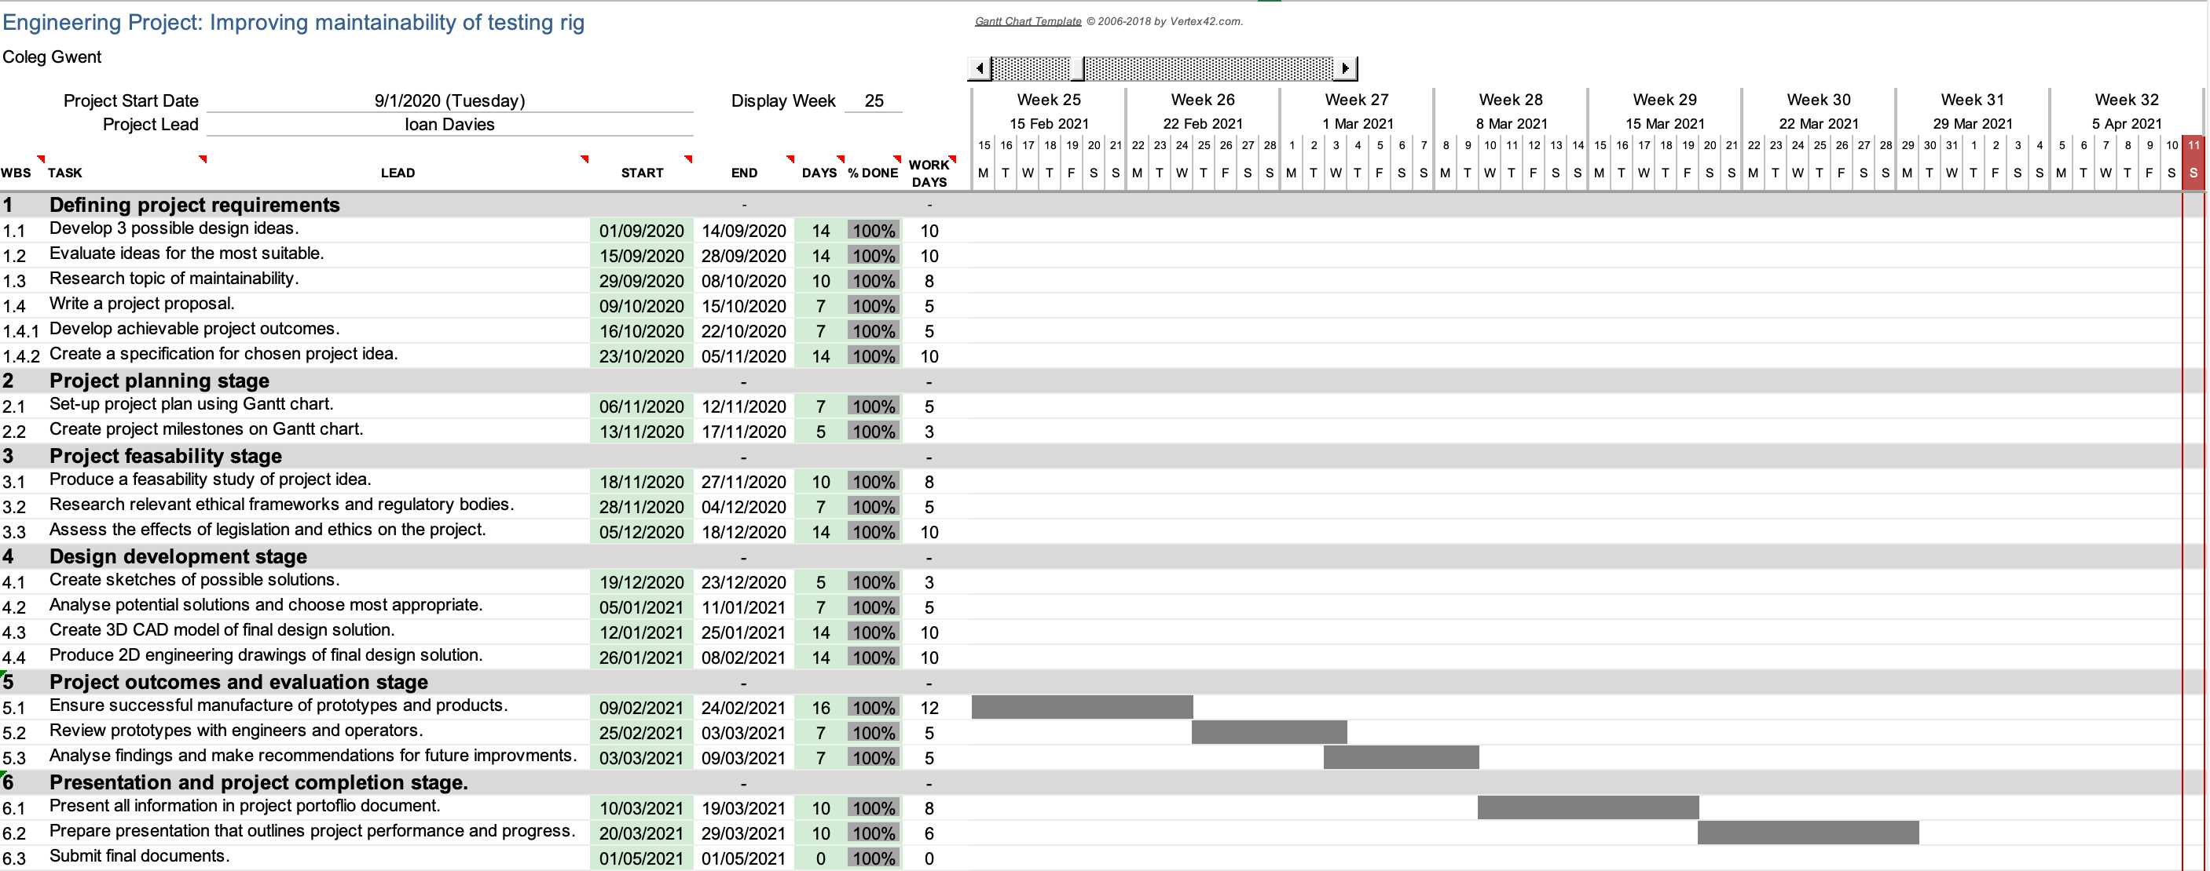

Figure 1.3: Project Gantt chart displaying tasks completed in weeks twenty-five to thirty-two.

Aims of Reflective Analysis
The purpose of this reflective analysis is to help evaluate my project and reflective on what could be improved upon to further enhance it. I also aim to highlight the skills and knowledge gained from these practical experiences and how aspects of the project processes and planning could be implemented in other projects or engineering tasks. Additionally, I aim to evaluate the success of the project’s final design solutions paying close attention to the design features and how they compare to the specifications and success metrics set out in the planning stage. Furthermore, I aim to investigate the effectiveness of my self-management and evaluate how effective my communication skills were between myself, and other members involved in the project.

By conducting this reflective analysis, I expect to highlight the main areas of improvement that would further increase the project’s success and quality. This will include both the projects’ final design outcomes and my personal skills in communication and self-management. I also hope to prove or disprove how effective the new design solution is compared to the initial design specification and improving maintainability.

Methods of Analysis
One of the main methods I plan to use to analyse the projects final design solution is an Engineering Design Decision Matrix. A Decision Matrix is used to define design attributes and weight their importance, to give a ranking against other design alternatives or specifications as explained by (Kuang-Hua, 2014). This tool can be used to evaluate the success of a final design or even a design concept by marking design categories or attributes with numerical figures based on a pre-determined scale. Therefore, by producing a decision matrix I can score the projects final design solution against the specification categories numerically and determine how successful the design is and highlight areas for improvement.

A Decision matrix has many advantages as it is relatively simple to complete and allows a stakeholder or customer to agree on the weights of the design attributes before scoring is conducted. Therefore, accurate analysis can be carried out and decisions made on how successfully the final design solution meets the specification criteria. Potential design failures can also be identified easily by low scoring categories. However, the main disadvantage of the decision matrix tool is that the weights and scores are often subjective and may not be accurate to the actual design solution. It can often overlook product features that may only be identified with more detailed analysis tools. As suggested by (Olabanji & Mpofu, 2014) decision matrix should be used alongside another analysis tool such as the analytical hierarchy process, for more accurate results.

Following the decision matrix analysis, I plan to focus further analysis into the maintainability of the final design solution and therefore, evaluate the success of implementing improvements to the maintainability within the given constraints. Furthermore, I plan to highlight the key design features that could be improved to further enhance the success of the projects final design solution.

Analysis of Project Final Design Solution

Decision Matrix Analysis
The decision matrix in tables three to five was carried out against the projects design specification by highlighting the key categories for comparison. A score was then awarded by analysing how successfully the final design solution shown in figures three and four, meets the requirements of the specification with numerical values from one to ten (ten the highest score and meets the specification exactly). A basic breakdown of the design specifications key features can be found in table two.

Categories | Key design points and features
Function | - Provide locating fixtures for both the component being tested and the activating sensor  - Test piece must be in an elevated position above activating sensor, which must be inserted from underneath  - Must hold a maximum weight of 5kg comfortably  - Minimum open space requirements of 150mm x 150mm for operator access and maintenance  - Locating aid for positioning of activating sensor such as a tapered hole through to test piece  - Minimum sensor locating hole diameter of 10mm (critical dimension)  - Easy to clean surfaces as far as reasonably practical
Appearance | - Simple structure with minimal components  - Views of test piece should be unobstructed  - Any fixings should be easy to locate and remove to aid maintainability  - Material surface should be coated to prevent corrosion or prevent egress of liquids and moisture  - All sharp edges to be removed
Reliability | - No wearing components such as rubber seals or bearings.  - Avoid use of components that require regular lubricating or grease applications  - A sturdy structure that can withstand general mobility and basic wear and tear  - Test may be destructive, and structure is not required to withstand all damage. Potential one time use per test with damage repairable through maintenance activities
Environmental conditions | - For indoor testing use only  - Easy to transport and store. Maximum unit weight of 5kg, maximum length of 1000mm and maximum height of 500mm (excluding retort clamp)

Table 2: breakdown of the project final design specification with the key design feature requirements only.

Table 2: (continued).

Disposal | - All construction materials should be recyclable (excluding fixtures and adhesives)  - No oil or grease is to be applied to surfaces  - Use non-toxic coatings or resins only  - Testing rig components should be re-usable where possible in assembly of new rigs
Manufacture requirements | - Wooden dowels used in construction only. sparking metal fixings are to be avoided  - Ability to manufacture on-site  - Ability to assemble and disassemble without the need for specialist tools  - Push fits and temporary fixings used where possible  - Requirement of thirty units  - Maximum unit cost of £50

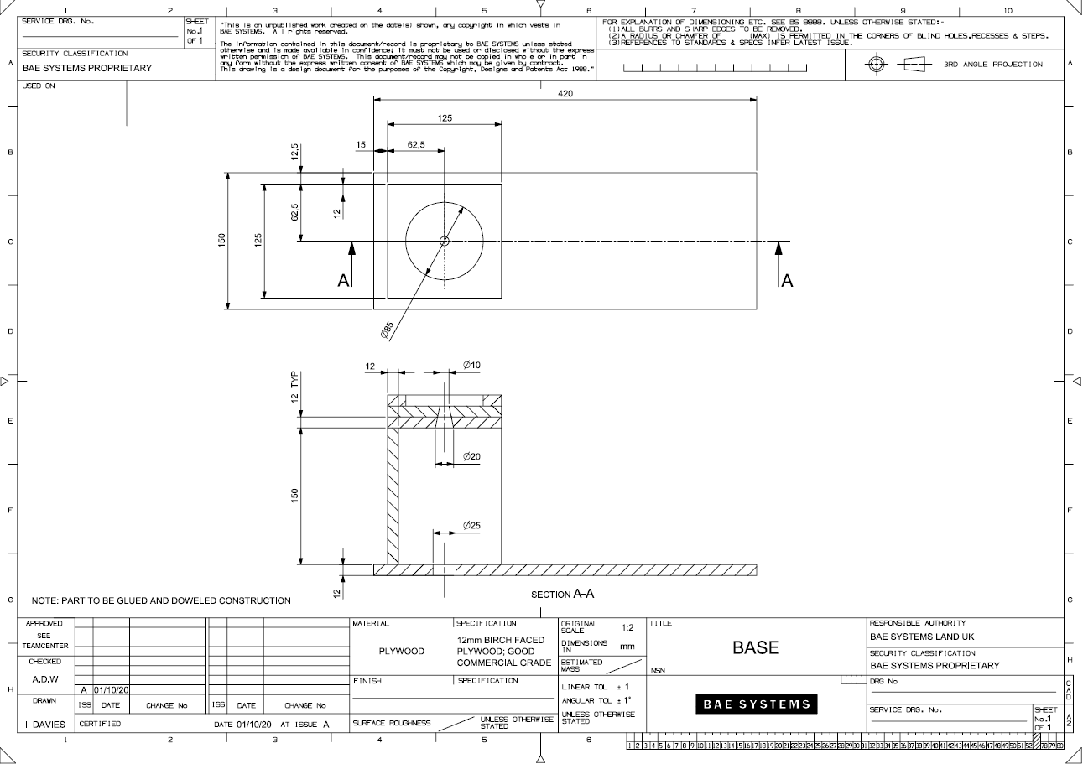

Figure 3: Project final design solution, 2D engineering drawing of new base component.
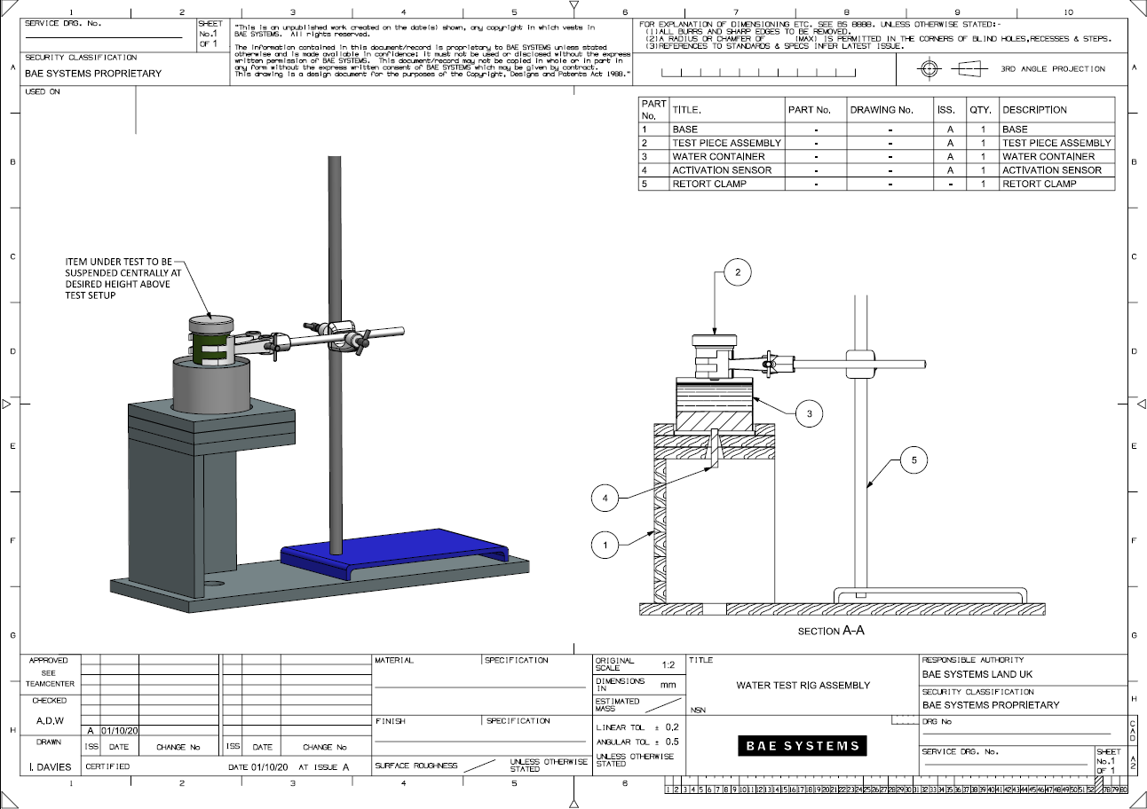

Figure 4: Project final design solution, assembly drawing of Water Gap Test Rig.

Category | Achieved | Not Achieved
Function | 1 | 0
Appearance | 1 | 0
Reliability | 1 | 0
Environmental Conditions | 1 | 0
Disposal | 1 | 0
Cost | 1 | 0
Manufacture Requirements | 1 | 0

Table 3: Matrix marking the final project design solution against each category of the specification as achieved (one) or not achieved (zero).

Category | Rating
Function | 9
Appearance | 8
Reliability | 8
Environmental Conditions | 9
Disposal | 9
Cost | 9
Manufacture Requirements | 9
Total | 61

Rating: | 0 (Very Poor) - 10 (Excellent).

Table 4: Matrix scoring how successfully the final project design solution meets the specification.

Figure 5: Graph of the final design solution rating against the specification category according to data in table 4.

Evaluation of Decision Matrix Analysis
Following the results of the decision matrix analysis of the project final design solution, I have identified that all categories of the specification have been successfully met as shown in table three. The function category was given a high rating of nine against the specification. The new design has improved maintainability by reducing the time and cost required to carry out maintenance activities. The point to highlight is that a 150mm x 150mm minimum access space has been achieved, which provides more space for operators and maintenance to access the activating sensor location and underside of the test piece as shown in figure three. The tapered hole also provides a locating aid for operators to first locate and position the activating sensor below the test piece, with a diameter of 10mm as mentioned in the specification. The test piece can clearly be positioned at an elevated position as shown in the figure four assembly. Finally, a shellac coating has been applied to the surface of the plywood to provide an easy to clean surface that will prevent the wood absorbing moisture and other foreign materials. A score of nine was given as although I strongly believe the test rig would comfortably hold a weight of 5kg, this has not been proven within this analysis.

The second category of the specification is appearance and was given a rating of eight. Following the specification, the testing rig has a simple structure with minimal components that make up its construction. Another key point of this category was to ensure that a view of the test piece should not be obstructed by structural components, which has also been achieved. As previously stated, the surface also has a coating of shellac to prevent egress of moisture into the plywood that may result in rot and warping. The specification also mentions that any fixings should be easy to locate and remove however, the current construction and assembly techniques do not allow for fixings to be easily located and may be damaged when disassembling and is the reason for a lower rating. There was also a requirement for all sharp edges to be removed, although this is stated on the drawing the addition of chamfers and edge blends may have been more effective.

Furthermore, we have reliability which I have also given a rating of eight. The main requirement of this category centred around avoiding the use of wearing components and lubricants. The final project design solution clearly does not incorporate the use of any wearing components such as rubber seals. There is no requirement for lubricants or grease when the testing rig is in use or during maintenance activities. This design solution also provides a sturdy structure that is capable of withstanding basic wear and tear that occurs through use. As mentioned in the specification damage may occur during testing however, most damage can be repaired through maintenance activities without the need for complete disposal or replacement. This further increases the maintainability of the test rig with no lubricant replenishment required and only plywood repairs potentially required.

Additionally, I gave a rating of nine when scoring the final design against the environmental conditions category of the specification, which explains the requirements for environment in which the test rig will be used. As the specification states the testing rig is to be used in an indoor environment there are no concerns regarding the effects of the weather. The testing rig also needed to be compact in design to be easily stored and transported by manual handling of one person. Therefore, a maximum weight of 5kg was stated with a maximum height of 500mm and length 1000mm. By reviewing the dimensions in figure three I can see that the testing rigs height and length is far below the stated maximum with a maximum length of 420mm and a height of 186mm. The estimated mass is also below the stated maximum weight of 5kg excluding the retort clamp.

Evaluating the success of the final design against the disposal category of the specification I decided on a high rating of nine. Firstly, the material chosen for manufacturing the testing rig was plywood and although is a class B recycling wood (treated) it can still be successfully shredded and completely recycled with minimal processing. This excludes the wooden dowel fixings due to the contamination with adhesives. No oils or greases are applied to any of the testing rigs surface with only a non-toxic shellac coating used for protection. Natural shellac is only mixed with alcohol and is both non-toxic and eco-friendly causing no harm to the environment or persons when using or disposing of the treated wood. It is also possible for the components to be re-used into assembly of new rigs if damage occurs, with the ability to remove and replace plywood panels with minimal effort and cost.

Finally, we have the manufacture requirements and cost categories of the specification which have both been rated nine. A high rating has been given as all key points of the specification category have been achieved to a high standard by the final design solution. Firstly, wooden dowels have been used as the sole fixing method in the assembly to avoid the use of metal fixings that create a potential sparking hazard and increase costs. Butt joints are used with dowels and then held in place with wood adhesive, this creates an assembly that can be assembled and disassembled without the need for specialist tools. The specification also states that a minimum quantity of 30 units is to be produced, due to the simplicity of the design and manufacturing process this will be easy to achieve including the ability to manufacture on-site. With only basic hole saw, drilling and band saw equipment needed for the manufacturing process. Early estimates of per unit material costs total £13.04, which is far below the maximum unit cost of £50, resulting in a substantial cost saving.

Analysis of Project success

Identified Improvements and Success
In this section of the report, I will analyse how effectively the final project design solution improves maintainability for both maintenance teams and operators and highlighting areas of improvement that would further enhance the project. Maintainability is defined as “the probability that a failed component will be restored or repaired to a specified condition within a specified period when maintenance is performed” (Pham & Rham, 2021).

When considering the characteristics of increasing the ease of maintenance activities on a specific component or system, product design must be reviewed with respect to maintainability features at the concept stage according to (Dhillon, 2020). By analysing the design concepts and highlighting the features that will increase the ease of maintenance activities, guidelines or product specifications can be produced for components or systems that require a high level of maintainability. Following the assumption that the specification is then successfully achieved the resulting component or system will reflect this high level of maintainability and ease of maintenance. Analysing the project specification and key design feature requirements shown in table two, the product design has clearly been reviewed with respect to maintainability features and design requirements have been included to ensure that ease of maintenance will improve. For example, a requirement was set in the reliability category to avoid the use of wearing components or components that require lubricants such as bearings and rubber seals, which successfully increases the ease of maintenance and maintainability.

(Kanniyapan, et al., 2015) suggests that the maintainability of a structure depends on appropriate material selection. To achieve a prolonged life span and sustain its intended functions the structure material must have the ability to resist defects from common deterioration. Poor material selection can seriously affect the maintainability of a structure or specific component and its ability to function correctly. For example, a component designed for a high friction environment will require a wear resistant material, poor material selection material would lead to significantly more maintenance requirements and the component would have to be replaced more often than if a suitable material was selected. (Mateus & Braganca, 2021) also mentions that successful material selection ensures prolonged longevity of a component or structures life and is critical in reducing the maintenance requirements in both cost and frequency of activities.
The material selected for final project design solution was Birch Faced Plywood at a good commercial grade, with a shellac surface treatment applied. This is a cheap material when compared to other hardwood options and metals such as Aluminium alloys. Any scratches or dents can easily be repaired by gently sanding or applying wood filler where appropriate or to refresh the surface appearance. The material is also very easy to clean as dirt can be simply wiped away. The shellac coating provides protection against moisture and liquid spillage, further reducing the need for maintenance activities or replacement of components. If replacement of the components is required, this will be at a much lower cost to the other materials mentioned and will not require special tools to assemble or disassemble.

Although the project final design solution does successfully increase the ease of maintenance and maintainability, there are also features that can be introduced or improved to further enhance the design. One of the first features that could be introduced to the design is leading edges with chamfers or slots, that allow easier alignment of components in the assembly as suggested by (Taylor, 2019). By analysing the technical drawing in figure three it would be possible to introduce slots in the base to aid in the assembly when fixing the two up right boards in position and alignment support for the retort clamp. This would ease alignment and reduce the time required for re-assembly during repairs and maintenance activities along with reduced operator set-up time with the clamp position. However, it is also important to consider the additional manufacturing requirements of this feature, in which the on-site carpentry shop would have the capabilities to produce.

Another improvement that could be implemented to the project final design solution is by introducing non-sparking fixings to the assembly that will not require adhesives and can be easily removed and re-assembled using basic tools. Brass threaded wood inserts can be used to replace the current wooden dowel and adhesive construction. A threaded insert is set into a hole and fixed in place with adhesive on one side of the joint, a countersunk hole is then drilled in the opposite side to allow a screw to sit, the screw is then tightened into the threaded insert to secure the joint. This would allow each component of the assembly to be easily removed and then re-assembled during maintenance activities and repairs. This feature is supported by (Boothroyd, et al., 2001) who describes the use of threaded inserts that when used alongside leading edges or slots to aid locating and fixing components will significantly reduce the time and effort required during assembly.

Effectiveness of Self-Management and Communications Skills
Throughout the project I believe that my self-management and communication skills have been very effective. The first area to analyse is time management and planning skills as an individual and through project tasks. I feel that my time was used very effectively throughout the project due to good planning and time management, evidence of which is shown in the Gantt chart in figure one to one point three with all the project tasks and milestones completed successfully by the set deadlines. I was able to manage myself and organise each task accordingly to ensure tasks followed the structure of the project plan and were completed within the specified timeframe. I also ensured that there were no delays that would cause tasks to overlap simultaneously. This was achieved by efficient tracking of tasks throughout the project using the Gantt chart, to ensure that any delays to tasks would not run into the next scheduled milestone.

The project was conducted individually with no other team members however, I did receive helpful knowledge and guidance by colleagues and my line manager through the design and realisation phase. The manufacturing of the first concept was to be carried out by the on-site carpenter. Although the project was individually driven, I was still required to communicate with both my line manager, carpenter, maintenance teams, and operators throughout to ensure its success. Both the design and planning stages of the project required significant communication between me and the relevant persons. Following successful face-to-face meetings with maintenance and operators a list of key requirements was produced by identifying their current issues and needs, which was then implemented into final specification for the projects final design solution. Three possible design solutions were developed for the project before a review with the carpenter to ensure that the carpentry shop had the capabilities to manufacture the components, along with assembly processes and material costs. Through these communications I was able to evaluate and choose the most appropriate design solution to carry forward and begin producing CAD models. I feel that this demonstrates successful communication skills and the ability to take the knowledge gained to further enhance the project and reduce the time required during the design stages.

Conclusion
I can conclude that the project and the final design solution was successful, and all objectives were achieved. Firstly, the project was completed on time and within the final deadline that was set, with a total of thirty-four weeks provided to complete the project. All tasks set out in the project plan including the design and manufacture of a final design solution along with a presentation highlighting the project performance was completed within thirty weeks. Every milestone was also met, with appropriate time-management skills preventing delays to the project throughout. The main reason for such successful time management was due to the detailed project planning and Gantt chart produced.

The Gantt chart defines the project tasks and goals and when they should be completed to meet a final deadline. I believe that the project plan was well structured and enabled me to break the workload into smaller more manageable sections, which is demonstrated with the use of milestones that group the tasks into shorter deadlines. This also improved how the project progress was monitored, with each milestone and task having its own individual tracking bar where the percentage of completion was recorded manually. Therefore, any tasks or objectives that begin to fall behind schedule can be identified and resolved through successful project management, adding another level to the flexibility and versatility to the project plan. The Gantt chart provides a very useful visual aid for monitoring the project progress.

The project also produced a successful final design solution that met all the key requirements in the specification. Each category of the specification was successfully met with a total decision matrix rating of sixty-one out of a possible seventy, with all categories scoring eight or above. All the critical features outlined in the specification have been successfully implemented into the projects final design solution, providing significant improvements to the maintainability and functionality of the testing rig while maintaining a low unit cost and the ability to manufacture on-site. However, improvements to the final design solution have been identified and the additional features would enhance the success of the design, I believe that project has more than adequately met the specification to a standard that provides a successful design solution with the given constraints.

One of the key skills I have learnt from this project is the ability to produce and implement detailed project plans and the importance of producing a Gantt chart. Understanding the importance of a detailed project plan set the foundations for a successful project and ensured that tasks were always on track and could monitored in an effective way. The skills captured during this project can be used not only in future engineering projects but also through further study and my current job role, as planning provides the foundation for all these activities mentioned. Overall, I feel that the project was successful and the main objective of improving the maintainability of the Water Gap Testing Rig was achieved, with a suitable final design solution produced.

Bibliography
Boothroyd, G., Dewhurst, P. & Knight, W., 2001. Product Design for Manufacture and Assembly. 2nd Edition ed. New York: CRC Press.

Dhillon, B. S., 2020. Reliability, Maintainability, and Safety for Engineers. 1st Edition ed. London: CRC Press.

Geraldi, J. & Lechter, T., 2012. Gantt charts revisited. International Journal of Managing Projects in Business, 5(4), pp. 4-6.

Kanniyapan, G. et al., 2015. Implementing Maintainability in Building Material Selection. Jurnal Teknologi, pp. 2-5.

Kuang-Hua, C., 2014. Design Theory and Methods using CAD/CAE. 1st Edition ed. s.l.:Elsevier Inc..

Mateus, R. & Braganca, L., 2021. Selection Criteria for Building Materials and Components in Line with the Circular Economy Principles in the Built Environment, Guimaraes: MDPI.

Olabanji, O. & Mpofu, K., 2014. Comparison of Weighted Decision Matrix, and Analytical Hierarchy Process for CAD Design of Reconfigurable Assembly Fixture. ScienceDirect, Volume 23, pp. 264-269.

Pham, H. & Rham, M., 2021. Safety and Reliability Modelling and its Applications. 1st Edition ed. s.l.:Elsevier.

Taylor, A., 2019. Design for Maintainability. [Online]
Available at: https://www.design1st.com/Design-Resource-Library/design_tips/Design_for_Maintainability.pdf
[Accessed 12 May 2022].

