
Batman Textiles
Secure the Network from Common Threats and Attack
Mohammed Ansari - 2024571

Contents

Abstract 2
Introduction 4
Task 1 - Potential security breaches to Batman Textiles 5
Task 2 – Threats, vulnerability, attacks and Cybersecurity Importance 6
Task 3 – Security Implementation 8
Introduction to Packet Tracer course – Cisco networking academy. 10
Task 4 - Guideline for “Batman Textiles” staff members, and customers to responsibly use their digital space 11
Conclusion 12
References 13

List of Figures/ Tables

Figure 1 – Standard Information Security Model ………………………………………………………………………….. 9
Table 1 – Various Open Source, Cyber Security Tools ……………………………………………………………………. 9

Abstract

This report has been compiled for Bruce, the founder of Batman Textiles. The report is aimed at helping you understand how your business’s network security was compromised, and as such, offer solutions to overcoming the network security problems you faced. Your business was attacked with ransomware (REKTLocker), and as a result, all of your business documents/ services were encrypted with “.rekt”. It was found that important security factors were neglected, such as access control, user access privilege and by adding free Wi-Fi network to the existing network. To overcome these problems, a number of proposed solutions are recommended including: establishing an information security policy, controlling access to systems using passwords, ensuring that anti-virus software’s are always up-to-date, using interference detection system and using a backup and recovery system.

Introduction

The profits of wireless networks are convenience, mobility, productivity, deployment, expandability and cost. Technology is speedily growing in a world driven by social networks, online transactions, cloud computing, and automated processes. However, technological development comes with advancement of cybercrime, which continually develops new attack types, tools and techniques that allow attackers to penetrate more complex or well-controlled environments, and produce increased damage and remain invisible. [1]

In your case, complementary Wi-Fi was offered to customers, which was also open to all employees. However, the network was not isolated from the business network. This provided opportunity for a disgruntled employee to disrupt the system. It is now apparent that important documents/services related to Batman Textiles have been encrypted with “.rekt” file format.

Task 1 - Potential security breaches to Batman Textiles

This section will provide an overview of the potential security / data breaches to your company.

A data breach is the intentional or inadvertent exposure of confidential information to unauthorized users. Data leakage is a form of data breach. Data leakage can be caused by internal and external information breaches, either intentionally (e.g., data theft by intruders or sabotage by insider attackers) or inadvertently (e.g., accidental disclosure of sensitive information by employees and partners). It poses serious threats to organizations, including significant reputational damage and financial losses. [2]

Possible Security Breach 1: Dissatisfied / Unhappy Employees

In the above scenario, employees had full access to all the business applications. It can be misused and harmful to the network or business applications, if any dissatisfied/unhappy employees want to damage the business. [3] This appears to be the case, given that one of the Sales Head was not happy about being withdrawn, and contemplates disrupting the business operations. According to the Australian Cyber Security Centre (ACSC), security breaches can be made by either current or former employees, as well as business associates or any other third party, with legitimate access to corporate network. [4]

Possible Security Breach 2: Non-Secured Network

Free Wi-Fi facility was offered to all of customers, without taking networking security into consideration, as a private business network was being made public. Un-secured network can bring greater risk as they may be more likely to carry malware, which can compromise sensitive data. The Forge Rock 2021 Breach Report, reveals that attacks involving usernames and passwords increased by a staggering 450% in 2020 from 2019, translating into more than 1 billion compromised records in the U.S. alone. [6]

Possible Security Breach 3: User Access Control

Full access was granted to business applications, to all employees. In this scenario, risk of user mishandling / carelessness / human error is very high. A study from Intel Security showed that internal employees account for 43% of corporate data leakage, and half of these leaks are accidental. Accidental leaks mainly result from unintentional activities due to poor business processes, such as failure to apply appropriate preventative technologies and security policies, or employee oversight. [7]

Task 2 – Threats, vulnerability, attacks and Cybersecurity Importance

This section is aimed at providing you with an overview on the importance of cybersecurity and the different types of vulnerabilities, threats and attacks.

Your workstation was attacked and your documents were encrypted by “.rekt” file format. REKTLocker is ransomware type malware that silently penetrates the system and encrypts various files. During encryption, REKTLocker attaches names of encrypted files with ".rekt" extensions. Following successful encryption, REKTLocker changes the desktop wallpaper, and creates a text file ("Readme.txt") and places it on the desktop. The wallpaper and text file inform victims of the encryption. Public (encryption) and private (decryption) keys are generated when encrypting files using asymmetric cryptography. Decryption without the private key is impossible, since it is stored on remote servers controlled by cyber offenders. Creators of REKTLocker attempt to sell this key to victims. Currently, there are no tools capable of restoring files encrypted. Therefore, only system and files from a backup can be restored. [8]

Threats

A threat is a malicious act that aims to corrupt or steal data or disrupt an organization’s system. A threat has the potential to cause serious damage to your computer system. Threats can lead to attacks on computer systems, networks and further. [9] The basic threats in wireless communication are Interception, Alteration and Disruption. Your company was attacked by ransomware (REKTLocker), possibly by a dissatisfied / unhappy employee, and as a result, all of your business documents / services were encrypted with “.rekt”. There are many different types of threats, when hackers can get into a network, they can add malicious software, virus, phishing and ransomware association which may lead to data/ ID theft, disruption of the services, ransom demand after adding ransomware e.g. REKTLocker where all the business documents / services encrypted with “.rekt” [8]

Vulnerabilities

Vulnerability is a cyber-security term that refers to a defect or weakness present in a system itself that allows information security to be exposed to a threats or attacks. [9]

The main vulnerability here, is unsecured network, this is because you did not apply any security measures. This increases the likelihood of being attacked by hackers, which may disrupt the business system. Hackers may attack using different tools like phishing, ransomware, man-in-the-middle attacks etc. Given that an employee was not happy about being let go and contemplates disrupting “Batman Textiles” operations, it is likely that the system was attacked as a form of retaliation.

Attacks

Communications in wireless networks has been facilitating numerous emerging applications that require packet delivery from one or more senders to multiple receivers. Communications are susceptible to various kinds of attacks due to insecure wireless channels. Communications in wireless networks remains a challenging and critical issue. [10]

Cyber-attack is any attempt to gain unauthorized access to a computer, computing system or computer network with the intent to cause damage. Cyber-attacks aim to disable, disrupt, destroy or control computer systems or to alter, block, delete, manipulate or steal the data held in the systems. There are many different types of Wireless Network Attacks, some of which include: Malicious association - when wireless network of a company is accessed by a wireless device, such as cracking laptop instead of a company access point (AP). Hackers can steal password or can plant Trojan; Ad-hoc networks - are defined as peer-to-peer networks between wireless computers that do not have an access point in between them. The hazards are data stealing and placing virus; Man-in-the-middle attacks - A man-in-the-middle attacker entices computers to log into a computer which is set up as a soft AP (Access Point); Network Scanning & Password Cracking - the objectives of this activity is to find the vulnerabilities and security level of the network / control signal strength / regulate the accessibility of the target network / Map the target network. After scanning the network, the attacker might continue to get into the network. There is also social engineering, this is the art of utilizing human behaviour to breach security without the victim realizing that they have been manipulated. Social engineering can be categorized into two categories which are technology based deception and human based deception. [7]

Cyber security is important in the of network world where people are doing online work and it can provide opportunity for users to protect their personal information on the network. It allows protecting from all cybercrimes also protects the confidential data, integrity and availability of system and resource data. [7]

Task 3 – Security Implementation

This section is aimed at showing you how security could be applied in your network infrastructure.

You could create cybersecurity policies: These policies usually require a professional so that every vector is covered. Policies tell administrators and employees how to handle specific attacks such as phishing, social engineering, spam, and physical threats (e.g., piggybacking).

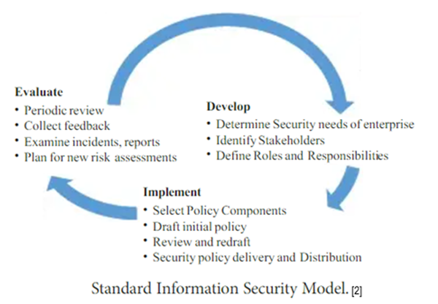
Figure 1 – Standard Information Security Model [2]

VARIOUS OPEN SOURCE CYBER SECURITY TOOLS
No. | TOOLS | OBJECTIVE | ADVANTAGE
1 | Wire Shark | Monitors data traffic over the grid system. | It protects confidentiality of the data
2 | OSQuery | Manages the changes in the host by enabling visibility. | More secure in terms of vulnerability.
3 | Cryptostopper | Situates trap files. | Traps and responds to cyber threats
4 | Metasploitable | Exploits the intended report. | Vulnerability assessment and practice.
5 | SQL invader | Combating vulnerabilities for web applications. | Enabled with database visibility.
6 | OSSIM | Cost effective solution for host security | Intrusion detection system. Preservation of information.
You could also offer company-wide security training: All employees should be trained to detect phishing and social engineering to report it, rather than engage with attackers. A further security measure would be to implement threat intelligence and monitoring applications: Implement a SIEM (security information and event management) to help employees analyse events and alert administrators to suspicious network activity. An intrusion detection system (IDS) helps to detect and block potential attacks. These systems work with prevention systems to automatically block access, should an attacker find a vulnerability. Making frequent backups is also very important. A backup strategy is a part of a good disaster recovery plan and improves business continuity.

Table 1 – Various Open Source, Cyber Security Tools [6]

Introduction to Packet Tracer course – Cisco networking academy.
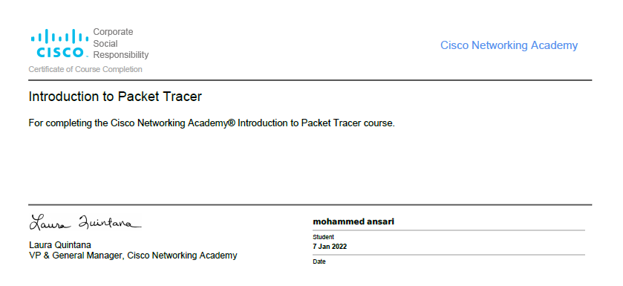


Task 4 - Guideline for “Batman Textiles” staff members, and customers to responsibly use their digital space

The following are recommended guidelines for staff members and customers to safely use their digital space.

Ensure that passwords are properly protected, since they provide access to personal information. Protect your login passwords. Select strong and unique characters in your password for each account. Always use a different password for each account and change them periodically. Do not save password for web sites or programs online. To prevent an attacker from leveraging personal information to answer challenge questions, provide a false answer to a fact-based question. This will prevent leveraging user’s personal information [8]

Use multi-factor authentication whenever possible. When logging into web based applications such as webmail, banking, and social networking sites. This prevents others from intercepting, reading, and potentially altering your data while in transit between you and the site. Ensure the web site supports Transport Layer Security (TLS) when logging in to online and financial transactions, you will find that most web browsers provide an indication that TLS is enabled and is shown as “https:” in the URL or displayed as a lock icon. [5]

Always use secure email protocols, particularly if using a wireless network. Configure your email client to use the TLS option (Secure IMAP or Secure POP3). Do not open attachments or click links from unknown emails. Check the identity of the sender (via phone call, in-person) and delete the email if verification fails. Never open emails that make strange offers that seem “too good to be true”. Avoid posting personal information on social networking sites such as address, phone number, place of employment, and other personal information that can be misused. [8]

Be careful what you download, cybercriminals try to trick you into downloading malware—programs or apps that carry malware or try to steal information. Do not download apps that look suspicious or come from a site you do not trust. [7]

Shop online from Secure Sites: Only purchase from sites that provide secure, encrypted connections. Check the website’s address seems to be genuine by looking for subtle misspellings, extra words, characters or numbers or a completely different name from that original business name. [7]

Conclusion
Cybercrimes is one of the largest crime in today’s time. Hackers are like thieves, sitting online and watching all data online. Organizations are facing the result of cyber-crime, like disruption, leaking information of their work, project, plans, infrastructure details etc. Cyber security takes all measures to protect online crime and use as safeguards for all networks, programs, software and data.
The protection of a network is a must and prevents all intentional and unintentional intrusion. Steps of prevention protect systems and ensure assurance, integrity of information and data. [7]

From analysis, it is likely that Batman Textile was hacked by disgruntled employee. As the WI-FI network was open to external parties and combined with the business WI-FI, this gave the hacker access to the business network and subsequently was given the opportunity to apply ransomware. This meant that all documents/services were locked by the .REKT extension. It is therefore, recommended that you keep both networks (Business & Complimentary Wi-Fi) separate, by using different switches / routers for each network connection with a strong firewall controlling getting access to the network system and further train employees on how to keep their digital space safe.

References
[1] A, Bendovschi. “Cyber-Attacks – Trends, Patterns and Security Countermeasures” Procedia Economics and Finance, vol. 28, p. 24-31, December, 2015. DOI: 10.1016/S2212-5671(15)01077-1

[2] A, Bhardwaj, G. V. B. Subrahmanyam, V. Avasthi, and H. Sastry, “Design a Resilient Network Infrastructure Security Policy Framework” Indian Journal of Science and Technology, vol 9, no. 19, May 2016. DOI: 10.17485/ijst/2016/v9i19/90133,

[3] M. K. Pratt, “Cyber-Attacks – Threats and vulnerabilities” TechTarget, January 2021 [online] Available at: https://www.techtarget.com/searchsecurity/definition/cyber-attack [Accessed: 18 May 2022]

[4] Imperva. “Cyber Attack”. Imperva [online] Available at: https://www.imperva.com/learn/application-security/cyber-attack/ [Accessed: 25 May 2022]

[5] J. Williamson, “Best Practice in Multi-factor Authentication”, International Journal of Advance Engineering and Research Development, vol. 3, no. 1, May 2021. [Online] Available at: https://www.researchgate.net/publication/351852137_Best_Practice_in_Multi-factor_Authentication [Accessed: 25 May 2022]

[6] V. Sundareswaran, “Study Of Cybersecurity in Data Breaching”, International Journal of Advance Engineering and Research
Development, vol. 5, no. 3, March 2018. [Online] Available at: https://www.researchgate.net/publication/325300571_STUDY_OF_CYBERSECURITY_IN_DATA_BREACHING/link/5b045c4d4585154aeb07f22e/download [Accessed: 25 May 2022]

[7] L. Tabassum, “Cybersecurity and Safety Measures”, International Research Journal of Modernization in Engineering Technology and Science, vol. 2, no. 6, June 2020 [online] Available at: https://papers.ssrn.com/sol3/papers.cfm?abstract_id=3641388 [Accessed: 2 May 2022]

[8] NSA, “Best Practices for Keeping Your Home Network Secure”, NSA, September 2016 [online] Available at: https://www.dni.gov/files/NCSC/documents/campaign/NSA-guide-Keeping-Home-Network-Secure.pdf [Accessed: 2 May 2022]

[9] B. A. Obotivere, A. O. Nwaezeigwe, “Cyber Security Threats on the Internet and Possible Solutions”, International Journal of Advance Engineering and Research
Development, vol. 9, no. 9, Sept 2020. [Online] Available at: https://www.researchgate.net/publication/346861524_Cyber_Security_Threats_on_the_Internet_and_Possible_Solutions [Accessed: 25 May 2022]

[10] S. Kanawat, P. Parihar, “Attacks in Wireless Networks”, International Journal of Smart Sensor and Adhoc Network, Vol. 1, no. 2. August 2011. DOI:10.47893/IJSSAN.2011.1033

