School of International Hotel Management
BA International Hotel Management
BMIH6005 Organisational Consultancy
Name of student: Dobir Miah
Student ID: 2019720
Name of company: Positive Consultancy firms
Report of Premier Inn Hotel Ltd.

Executive summary
The operation of large businesses like Premier Inn Hotel Ltd requires analysis of the environment as well as the identification of opportunities and risks. Companies must have qualities in order to capture the market more successfully, but they also frequently have shortcomings. Many strategies must be put into action to address the vulnerabilities in order to weaken them and improve the likelihood of success. The issue with Premier Inn Hotel Ltd is that the business is having management problems, which are caused by both internal and external business risks. While running a business, a variety of challenges can be seen, and a company like Premier Inn Hotel Ltd must have a variety of techniques and assessments to achieve them. The sole industry in which Premier Inn Hotel Ltd. engages in business is the hospitality industry. The company was first introduced to the hospitality industry in 1987 and is a subsidiary brand of Whitbread PL. The company's headquarters are in the UK city of Dunstable. More than 800 hotels make up Premier Inn Hotel Ltd, which conducts business in practically all nations that are conducive to hospitality and tourism. The organization offers more than 72,000 rooms, including both elegant and reasonably priced ones, and it operates in more than 100 countries. The study includes a SWOT and PESTLE analysis to examine the problems Premier Inn Hotel Limited is experiencing. The findings of the analysis present that the company has lack financial resources are unable to maintain communication effectively and has a poor leadership approach. Premier Inn Hotel Ltd must request loans from commercial banks and deduct the additional costs of the company in order to lessen the weakness caused by a lack of financial resources. In order to overcome its lack of financial resources, Premier Inn Hotel Ltd. must apply for a mortgage from a UK commercial bank and acquire a loan with a low-interest rate. Also, it will assist the business in paying for supplies and other expenses that will support it during a difficult time. Due to the paperwork that Premier Inn Hotel Ltd must complete in order to obtain the loan, it will take around two months to complete the process. Large company Premier Inn Hotel Ltd. will require a sizable loan at a hefty interest rate. Technology will be required by Premier Inn Hotel Ltd for communication. To improve informal communication, the organization would need social media platforms as well as other technology infrastructure. It will assist the business in successfully conducting business and connecting with both consumers and employees. Premier Inn Hotel Ltd. must use forceful leadership to lessen the weakness of its approach to leadership methods. By doing this, the company's employees will benefit from a free workplace environment, motivation to achieve their goals and other amenities that will assist the business in effectively engaging its workforce.

Table of Contents
Introduction 1
Scope and analysis 1
Overview of Premier Inn Hotel Ltd 1
PESTLE analysis 2
SWOT analysis 4
Main body 6
Internal issues of Premier Inn Hotel Ltd 6
Lack of finance 6
Communication lacking 8
Poor leadership 10
Findings and results 11
TWOS analysis of Premier Inn Hotel Ltd 11
Action plan 13
Recommendations 15
Conclusion 16
Reference list 17

Introduction
The purpose and aim of the report are to highlight the operation and management effectiveness of a hotel company named Premier Inn Hotel Ltd. In order to operate a business effectively, it is important to make effective management and management decisions to reduce the risk of the business and identify the areas which need improvements and development. The report will analyse the internal environment as well as the external business environment of Premier Inn Hotel Ltd and the report will also discuss various plans and processes which can be used by Premier Inn Hotel Ltd to resolve all the existing threats and weaknesses of the company.
The problem that Premier Inn Hotel Ltd is that the company is facing issues in business management and the issues are related to internal business weaknesses and external threats. There are various issues that can be seen while operating a business and a business organization like Premier Inn Hotel Ltd needs to take various approaches and assessment methods to overcome them (Yup Chung, 2021). To analyse the issues that Premier Inn Hotel Ltd is facing, the report will present PESTLE and SWOT analysis. The PESTLE analyses will help to evaluate the external threats and opportunities that Premier Inn Hotel Ltd is currently facing due to various external factors such as political factors, social factors, environmental factors and so on. On the other hand, a SWOT analysis will also help to identify the strengths and weaknesses of Premier Inn Hotel Ltd as well as mark different types of threats that the company is facing from external factors.

Scope and analysis

Overview of Premier Inn Hotel Ltd
Premier Inn Hotel Ltd is the largest brand of hotel management and the company has more hotels and resorts than any other company in the UK. Premier Inn Hotel Ltd is a private limited company and the company only operates in the hospitality business sector. the company is a subsidiary brand of Whitbread PL and the company was first introduced in the hospitality business in the year of 1987 (www.acas.org.uk, 2020). The company has its head office in Dunstable city of the UK. Premier Inn Hotel Ltd has more than 800 hotels and the company operates its business in almost every country which is suitable for hospitality and tourism. The company operates its business in more than 100 countries and the company has more than 72,000 rooms which contain rooms that are affordable and luxurious (Premier Inn, 2021). Premier Inn Hotel Ltd has its hotel and resorts in different countries like the Republic of Ireland, Germany, India, Qatar, Jersey, the UK, the USA and so on. Premier Inn Hotel Ltd is operating business for more than 36 years and the company has gained a huge level of brand image due to their good service to the customers. Premier Inn Hotel Ltd takes the service provided to the customers as their first priority and the company also applies innovative approaches to be more advanced compared to their competitors in the hotel business (Premier Inn, 2021). Premier Inn Hotel Ltd follows the approach that every customer is important and they do not treat their customers based on their purchase ability. The company has trained their workers to be more friendly with the customers and understand their needs and demand which the company fulfils and increases the customer’s satisfaction. Premier Inn Hotel Ltd has an 8.9 rating out of 10 which makes it one of the good hospitality providing companies in the UK as well as in the world (GOV.UK, 2023). The feedback of the customers of Premier Inn Hotel Ltd is positive most of the time because the company takes the feedback of the customers seriously and regularly focuses to provide services based on the demand of the customers. The company applies direct and indirect approaches to gain the feedback of the customers (GOV.UK, 2022). In the direct approach, the workers of Premier Inn Hotel Ltd ask the customers to provide feedback at the time of checkout. By doing so, the customers of Premier Inn Hotel Ltd suggest the company make certain changes in the operation which help to enhance the performance of Premier Inn Hotel Ltd. To analyse the business environment of Premier Inn Hotel Ltd, both PESTLE and SWOT analyses are given below:

PESTLE analysis
PESTLE analysis is a tool which is used to analyse and examine the external business environment and highlight various types of threats and opportunities that are available in the market. PESTLE analysis considers various types of factors and the name PESTLE stands for Political, economic, social, technology, legal and environmental factors (Whittington et al., 2020). To understand what types of market opportunities and threats are available in the market for Premier Inn Hotel Ltd, A PESTLE framework is presented below:
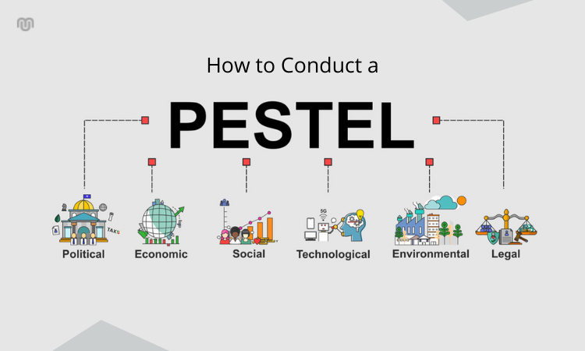
Figure 01: PESTLE analysis of Premier Inn Hotel Ltd.
Source: (Tucker, 2022).
Political factors: The changes in the trade policy have impacted negatively on Premier Inn Hotel Ltd because now the company have to face more complicated paperwork which also takes a lot of time and is a threat to Premier Inn Hotel Ltd (Tinnirello, 2021). But the UK is a politically stable country which makes a good opportunity for business of Premier Inn Hotel Ltd because the company gets all kinds of support and facilities from the government.
Economic factors: The current inflation rate of the UK is 10.20% which is a threat to Premier Inn Hotel Ltd. Due to the high rate of inflation, Premier Inn Hotel Ltd had to purchase resources and materials at a high price which also decreases the level of profit of the company and acts as a threat (Tichaawa, 2021). But the interest rate of the UK has decreased by 2% which is an opportunity for Premier Inn Hotel Ltd. Due to the low level of interest rate, the company is able to take loans and the lower rate of interest decreased the cost of the capital which has impacted positively (Sunuantari, 2020).
Social factors: The people of the UK are becoming more attracted to tourism and making their lifestyle more joyful which is an opportunity for Premier Inn Hotel Ltd. As people search for more places for tourism, the demand for Premier Inn Hotel Ltd increases which is an opportunity. But the income level of the people of the UK has decreased due to Brexit and issues like covid-19. Therefore, it is a threat to Premier Inn Hotel Ltd.
Technological factors: The level of innovation in the tourism sector are increasing which is an opportunity for Premier Inn Hotel Ltd. Due to the development of technology, Premier Inn Hotel Ltd is able to collect payment and place orders online which is an opportunity for the company (Soliman and Mansour, 2020). But technologies are continuously changing and Premier Inn Hotel Ltd had to change accordingly which is increasing the cost and acts as a threat to Premier Inn Hotel Ltd.
Legal factors: The health and safety law in the tourism industry has become more complex due to the impact of covid-19 which has impacted negatively on the company. The company had to take more initiative to reduce the risk which is a threat (Slabey and Austrom, 2020). But the process of starting a business has become easier in the UK which is an opportunity for Premier Inn Hotel Ltd to start more businesses in the country (Simons, 2022).
Environmental factors: The changes in the climate is a threat to Premier Inn Hotel Ltd because most of the tourist takes tours to enjoy nature and due to climate change, the landscapes are also changing which is a threat (Simanjuntak, 2019). On the other hand, Premier Inn Hotel Ltd is applying green energy sources to reduce the negative impact on climate which is an opportunity to increase the brand image of the company.

SWOT analysis
SWOT analysis is another tool to analyse both the internal and external environment of a company. It highlights the business weaknesses, along with the strengths of the company. It also presents business opportunities and threats which helps to make an effective decision for the company (Shatnawi, 2022). The SWOT analysis of Premier Inn Hotel Ltd is presented below:
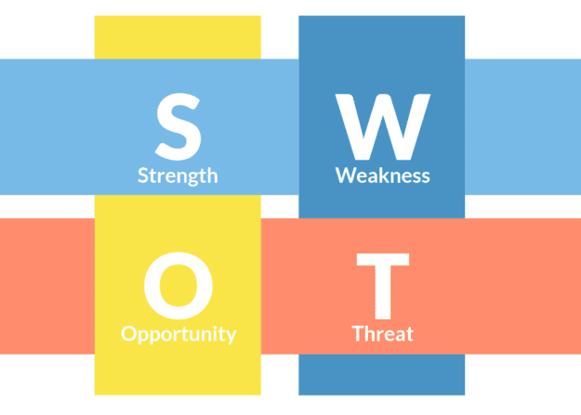
Figure 02: SWOT analysis of Premier Inn Hotel Ltd.
Source: (Shaltry, 2021).
Strengths of Premier Inn Hotel Ltd | Weaknesses of Premier Inn Hotel Ltd.
Trained workers: The main strength of Premier Inn Hotel Ltd is its trained workers. The workers of Premier Inn Hotel Ltd are trained and they are able to understand the demand of the customers and provide service accordingly (Semrad, 2019).  Wide range: Premier Inn Hotel Ltd has more than 800 hotels and 72000 rooms which is another strength of the company to obtain a large number of customers (Premier Inn, 2021).  High brand value: Premier Inn Hotel Ltd has a high brand value which is another strength of Premier Inn Hotel Ltd. The company is known for their good services which provides them with a more competitive advantage (Rose, 2021). | Lack of finance: Due to the pandemic covid-19, Premier Inn Hotel Ltd had a huge financial loss and the company is now short of financial resources which is a weakness.  Communication lacking: Premier Inn Hotel Ltd has poor communication infrastructure which is another weakness of the company. The company uses old communication models and tools (Schreyögg, 2021).  Poor leadership: The leadership approach of Premier Inn Hotel Ltd is poor and the company uses an autocratic leadership approach which is a weakness.
Opportunities for Premier Inn Hotel Ltd | Threats for Premier Inn Hotel Ltd.
Low-interest rate: the interest rate of the UK has decreased by 2% which is an opportunity for Premier Inn Hotel Ltd. Due to the low level of interest rate, the company is able to take loans and the lower rate of interest decreased the cost of the capital which has impacted positively (Rezaee, 2020).  Lifestyle changes: The people of the UK are becoming more attracted to tourism and making their lifestyle more joyful which is an opportunity for Premier Inn Hotel Ltd. | Inflation rate: Due to the high rate of inflation, Premier Inn Hotel Ltd had to purchase resources and materials at a high price which also decreases the level of profit of the company and acts as a threat.  Changes in technology: Technologies are continuously changing and Premier Inn Hotel Ltd had to change accordingly which is increasing the cost and acts as a threat to Premier Inn Hotel Ltd (Portny, 2021).

Main body
Based on the analysed data of Premier Inn Hotel Ltd, various internal and external issues can be seen and they impact the activities of the company directly. Issues that are related to internal business operations can be managed by taking various steps and activities. For example, from the SWOT analysis of Premier Inn Hotel Ltd, internal issues like lack of finance, communication lacking and poor leadership can be witnessed. Also, from the external environment analysis or PESTLE analysis, various issues like technological changes, inflation rate, environmental changes and so on can be witnessed (PMI, 2022). To reduce the negative impact various steps and the working process can be adopted by the management of Premier Inn Hotel Ltd and some of them are presented below:

Internal issues of Premier Inn Hotel Ltd
Some of the internal issues of Premier Inn Hotel Ltd and their mitigation approach is presented below:

Lack of finance
Lack of finance refers to the shortage of money and other liquid assets in a business which is used to purchase materials and other essential needs. According to Partington (2021), a business organization needs a moderate level of financial resources to conduct the work effectively because from purchasing materials to providing wages and salaries to the workers, financial resources are needed. There are various causes available which have caused the lack of finance for Premier Inn Hotel Ltd and covid-19 pandemic is one of them. Due to the impact of covid-19, hotel and tourism companies had to close their service because the government of the UK as well as other countries has prevented tourism in order to reduce the infection rate (Parkin, 2020).
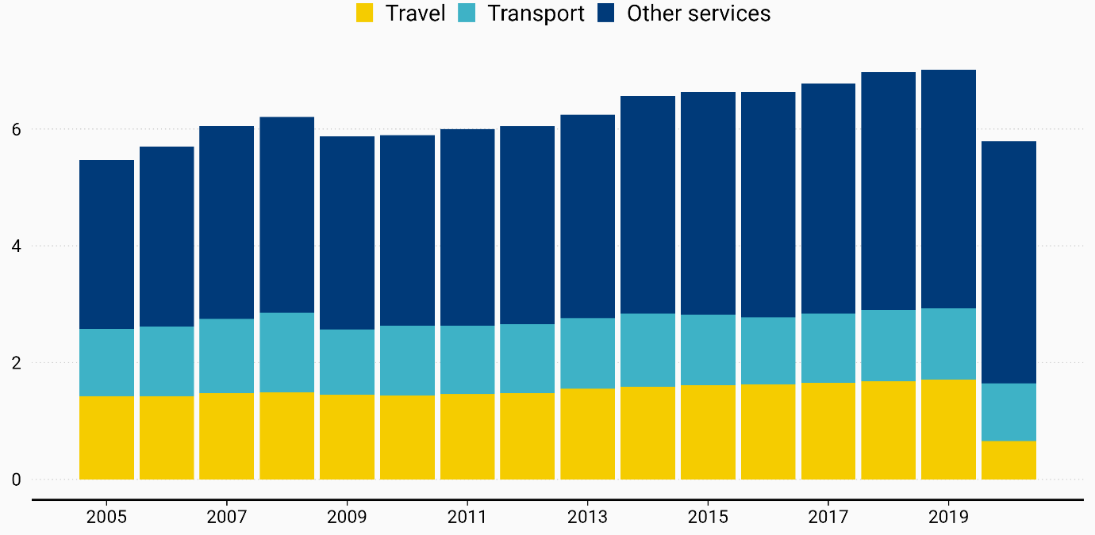
Figure 03: Fall or tourism business in covid-19 pandemic.
Source: (Pace, 2021).
The statistic above presents that the hospitality and tourism industry faced its peak time in 2019 and the industry reached more than 7 billion in the market. But in the time of covid-19 the beginning of 2020, the country applied lockdown to prevent further infection and forced people to stay in their houses (Olsson and Spjelkavik, 2020). Therefore, Premier Inn Hotel Ltd and other hotel companies gained no customers yet the company had to face a high rate of fixed costs such as maintenance bills, telephone bills, rents and other costs which has decreased the amount of reserved money of Premier Inn Hotel Ltd. The statistic presents that the company used to operate the business in 2019 in a 7 billion market but the marker reduces by 4.8 billion in 2020 and it reduced further which has decreased the financial resources of Premier Inn Hotel Ltd (Noordzife, 2014). Therefore, Premier Inn Hotel Ltd had to cut down the cost and increase their sale to fill the lacking of financial resources. there are various approaches which can be applied by Premier Inn Hotel Ltd to overcome the shortages of financial resources and some of them are presented below:
Taking a loan: The interest rate in the UK has decreased by 2% which is an opportunity for Premier Inn Hotel Ltd. Due to the low level of interest rate, the company is able to take loans and the lower rate of interest decreased the cost of the capital which has impacted positively. This is an opportunity for Premier Inn Hotel Ltd which the company is able to utilize to reduce the lacking of financial resources (Müller, Drouin and Sankaran, 2021). As per Morse and Beckman (2020), if a company has a lacking of financial resources, the company is unable to meet the demand for resources which are needed to operate a business successfully. If a company has a low amount of materials then the company is unable to manufacture products or services which will ultimately bring success to the company. Therefore, it is essential for a company to have a high level of financial resources which will help to operate the company effectively (Moeslein, 2020).
Cost management approach: Another approach which is effective in mitigating the issue of meeting the lacking of financial resources is the cost management approach. By the statement of Mensah (2023), companies should operate a business by reducing costs because when a company reduces the cost of operation, the risk of losing more financial resources decreases and enhances the positivity of gaining more profit for the business. To apply the cost management approach, the management of Premier Inn Hotel Ltd needs to train the workers (Makhlouf, 2023). the management needs to educate the workers about how to use the resources effectively and decrease wastage which will ultimately decrease the cost of the company and will also help to increase the financial risk of the company.

Communication lacking
Communication lacking refers to the disability of a company to pass the information and data to another person which prevents the activity of the company. In other words, when a company is unable to pass the information to its stakeholders and does not exchange thoughts, ideas, or feedback is known as communication lacking (Lim and Loosemore, 2019). There are two types of communication approaches which are used by the company to maintain communication with its stakeholders and they are presented below:
Formal communication: Formal communication is known as the official communication approach for any company and it is well organized and presents value in communication. Laurie A (2020) commented that, the formal communication approach is the professional approach for people and business organizations to exchange their thoughts and ideas. Premier Inn Hotel Ltd has a strong formal communication approach and the company usually uses the formal approach to pass advertisements and offers to the customers and shareholders (Kwong D, 2020).
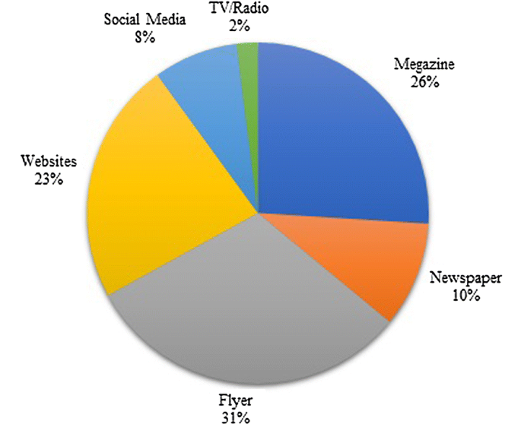
Figure 04: Communicational tools of Premier Inn Hotel Ltd.
Source: (Kaspar, 2020).
Premier Inn Hotel Ltd uses the formal approach of communication to communicate with its stakeholders and the company is pretty good at it. To inform the stakeholders of the company, Premier Inn Hotel Ltd uses flyers the most and the company also applies the communicational approach of highlighting information in the website of the company (JasiAAska and Hab, 2021). Other approaches like newspapers, magazines, and social media are also used by Premier Inn Hotel Ltd to communicate with the customers which are very effective.
Informal communication: According to, the most effective way to collect information and to make a good bond with another person, is informal communication used which is the normal approach of exchanging thoughts and ideas using voice notes or writing (J. Turner, 2018). The informal approach to communicating with Premier Inn Hotel Ltd is not very good because the company has only reception where the customers and other stakeholders are able to collect information. To improve the scenario, Premier Inn Hotel Ltd can use social media and digital approaches to communication and train their workers to gain effectiveness in communication. Using social media pages, Premier Inn Hotel Ltd is able to collect information from its customers and can also inform them about the service of the company (Iqbal, 2022). It will help the find an effective communicational bond with the customers and the same approach can be applied to the workers of the Premier Inn Hotel Ltd. By doing so, the workers of Premier Inn Hotel Ltd will be able to communicate with the management effectively which will impact the working environment positively and it will also reduce the wastage rate of the company (Hyvari, 2021).

Poor leadership
Another weakness of Premier Inn Hotel Ltd is the poor leadership approach Gite and Navodit (2021) stated that leadership is the process of understanding a group of workers and directing them to obtain any task or mission. Ghazi (2021) commented that poor leadership means when a leader is unable to meet the demand of the workers and also unable to understand their thoughts of them in completing the task. Poor leadership is the main reason which decreases the working environment of Premier Inn Hotel Ltd and the leader applies autocratic leadership which forces the workers of Premier Inn Hotel Ltd to follow the leaders. It reduces the level of innovation in Premier Inn Hotel Ltd which also decreases the working environment of Premier Inn Hotel Ltd as well as the working satisfaction level of the company (GOV.UK, 2023). According to Fisman and Sullivan (2014), autocratic leadership forces the workers to follow the leader of a company where the leader thinks that he is superior and takes all the decisions of the workers based on his own will. Therefore, certain demands of the workers are not met which makes the dissatisfied and reduces the working condition of the company (Eva M Smith, 2020). To overcome the situation and to decrease the negative impact of poor leadership, the management of Premier Inn Hotel Ltd can take two different leadership approaches which are presented below:
Democratic leadership: Democratic leadership approach refers to the process of driving the workers and the workforce based on their decision. In other words, democratic leadership is the process where the leader of the workers takes decisions based on the will of the workers and the workers are able to gain their preferred working environment (Eraqi, 2021). By doing so, Premier Inn Hotel Ltd will be able to make the working environment more flexible and enhance the working environment. To do so, Premier Inn Hotel Ltd will need to train its leaders to make decisions by asking the workers about their preferences.
Authoritative leadership: According to the comment of Elziny (2021), the authoritative approach of leadership is the most effective leadership approach and it helps the company to become more innovative because, in authoritative leadership, the leaders provide targets to the workers and visualise the goal and how to obtain them. By doing so, the leader of Premier Inn Hotel Ltd will be able to apply an innovative working environment which will make the working environment more effective and reduce working dissatisfaction (Elsayed, 2022).

Findings and results
For the findings and the results, part of Premier Inn Hotel Ltd, A TWOS analysis is presented below:
TOWS matrix of Premier Inn Hotel Ltd. |  | External factors
 |  | Opportunities | Threats
Internal factors | Strengths | Trained workers and lifestyle changes  Trained workers and low-interest rate | Wide range and low financial resources  Trained workers and poor leadership
Internal factors | Weaknesses | Lack of resources and low-interest rate. | Lack of finance and high inflation rate

TWOS analysis of Premier Inn Hotel Ltd
Strength to opportunities: The lifestyle of the people of the UK is changing and they are adopting a more modern and comfortable lifestyle which is an opportunity for Premier Inn Hotel Ltd to grow more business. The people of the UK are taking more tourism services and looking for companies who are able to provide a high level of service to the customers (Costa, 2022). On the other hand, Premier Inn Hotel Ltd has trained workers who are able to identify the needs of the customers and provide more effective service which will help Premier Inn Hotel Ltd to gain more market share. For example, in order to gain more customers, the workers of Premier Inn Hotel Ltd are able to mark the need of the customers who want food and beverages to make their stay more enjoyable (Dernoi, 2019). Therefore, the staff of Premier Inn Hotel Ltd are able to take the preferences of the customers to enhance their food and beverages department and provide foods and drinks which are needed by the customers.
On the other hand, the strength of trained workers can be combined by the Premier Inn Hotel Ltd with the low-interest rate of loans and taking loans to enhance the quality of service. If the workers of Premier Inn Hotel Ltd are able to identify the foods and drinks which are demanded by the customers, then Premier Inn Hotel Ltd is able to take a loan from the bank and provide service which will increase the business of the company (Confederation of British Industry, 2023). The company is also able to increase the menu choice of the company which will attract more customers and gain more market share. By taking these measures, Premier Inn Hotel Ltd will be able to gain opportunities by utilising the resources which will bring success to the company.
Strengths to threats: Different types of threats can impact the strengths of Premier Inn Hotel Ltd which will reduce the success rate of the company and the company should take effective measures to overcome them. For example, the strength of a wide range can be impacted by the threat of low financial resources. of Premier Inn Hotel Ltd has more than 800 hotels and 72,000 rooms all across the world which is the strength of the company because a greater number of hotels and services increases the brand image of the company (Buttrick, 2009). Due to having more rooms and hotels, Premier Inn Hotel Ltd is able to serve more customers which will also help to increase the revenue of the company as well as the brand image of Premier Inn Hotel Ltd. But due to having more hotels and rooms, the cost of Premier Inn Hotel Ltd also increases the threat low financial resources can make it worst. Premier Inn Hotel Ltd will not be able to operate operations effectively if the company do not possess enough resources (Burnes, 2014). For example, due to having low resources, Premier Inn Hotel Ltd will need to reduce the numbers as well as types of bars because they increase the fixed cost of the company. Therefore, Premier Inn Hotel Ltd will have no option but to reduce the number of bars in their hotels.
On the other hand, the strength of having trained workers will be impacted negatively by the poor leadership approach. Premier Inn Hotel Ltd will need to manage their workers effectively by applying an appropriate leadership approach which will not impact negatively the working motivation of the workers and it will also help to reduce the cost of staff training (Brierley, 2006). Premier Inn Hotel Ltd will not need to train their workers and which will not increase the cost of the company.
Weaknesses to opportunities: By utilizing the opportunities, Premier Inn Hotel Ltd is able to reduce the weaknesses of the company which will help the company to grow more. For example, Premier Inn Hotel Ltd can reduce the lacking of resources by using low-interest rate loans. If Premier Inn Hotel Ltd faces less financial liquidity, the company should take a loan which will help the company to operate while using its full potential (Baron and Armstrong, 2007). It will also help to decrease the cost of the company due to the low-interest rate of the loan. For example, Premier Inn Hotel Ltd is not able to purchase the materials needed for its hotel management. If Premier Inn Hotel Ltd takes loans at a low cost, the company will be able to purchase materials like food and it will also help to provide the wages to the workers effectively which will help the company retain their workers (B. Weinstein, 2022).
Weakness to threat: The weakness of Premier Inn Hotel Ltd can be impacted by the threat more negatively which will increase the level of risk more. For example, Premier Inn Hotel Ltd is facing the weakness of having a low level of resources related to financing (Arigela, 2021). Therefore, Premier Inn Hotel Ltd is unable to purchase materials and serve more customers. Also, the inflation rate of the UK is 10.20% which means the value of the money has decreased which will increase the weakness of the company (Appleby, 2020). Premier Inn Hotel Ltd will not be able to gain more profit due to having a high level of inflation which will impact negatively on the company.

Action plan
No | Issue | Solution to issue | The desired outcome of the plan | The time scale for the plan | Date of completion | Budget for the plan
1. | Lack of resources | To meet the lack of resources, Premier Inn Hotel Ltd took loans from commercial banks in the UK. The company needs to apply for the loan by fulfilling all the paperwork.  Premier Inn Hotel Ltd also needs to decrease the cost of the company by providing training to the workers. | By taking loans from a bank, Premier Inn Hotel Ltd will be able to gain financial resources which will help the company to purchase the essentials for the company. It will also help to maintain the cost of the hotels and rooms which will help to maintain the customer’s attention and it will also help to regain the brand image of the company (A.J.B., 2019). | The time scale for the plan is 2 months. | The date of completion is 01/06/2023 | £10,000
2. | Communication lacking | Applying a technology-based communication approach for the communication of the company. Premier Inn Hotel Ltd will need to apply technology in order to maintain communication with its stakeholders to gain their thoughts and ideas (Elsayed, 2022). | By applying a technology-based communication approach, Premier Inn Hotel Ltd will be able to connect with its customers and workers effectively. The company will be able to gain advice from them and it will also help to direct the workers accordingly to meet the objectives of the company. | The time scale for the plan is 4 months. | The date of completion is 01/08/2023 | £5,000
3. | Poor leadership | To reduce the problem of poor leadership in Premier Inn Hotel Ltd, the company needs to change its leadership approach of the company. The company needs to apply an authoritative leadership approach where the company will offer a free working environment to the workers. | By applying authoritative leadership, Premier Inn Hotel Ltd will be able to provide a free working environment and effective direction to the workers which will help the workers to obtain the goal of the company. It will also help to increase the motivation of the workers as the worker will no longer need to follow the leader strictly. | The time scale for the plan is 6 months. | The date of completion is 01/10/2023 | £2,000

Recommendations
- To reduce the weakness of lack of financial resources, Premier Inn Hotel Ltd needs to apply for loans to commercial banks and the company should deduct the extra cost of the company. Premier Inn Hotel Ltd need to apply for a loan from the commercial bank of the UK and take a loan with low interest which will help the company to overcome the lacking of financial resources (GOV.UK, 2023). It will also help the company to purchase its materials and bear other costs which will help the company in a time of crisis (Gite and Navodit, 2021). The time needed to take the loans will be approximately two months of time because there is some paperwork which Premier Inn Hotel Ltd will need to follow to take the loan. The cost of taking the loan will be approximately £10,000 because Premier Inn Hotel Ltd is a big company and the company will need a huge loan with a high cost.
- Premier Inn Hotel Ltd will need to apply technology in the process of communication. The company will need social media tools as well as other technological infrastructure to make informal communication more effective (J. Turner, 2018). It will help the company to connect with the customers as well as with the workers effectively and operate the business successfully. The cost of building a technology-based communication system will be £4,000 and the company will need four months to complete it.
- To reduce the weakness of the leadership approach Premier Inn Hotel Ltd needs to implement the authoritative leadership approach. By doing so, the workers of the company will gain a free working environment, motivation to meet the goals and other facilities which will help the company to engage their workers properly (Lim and Loosemore, 2019).

Conclusion
Large companies like Premier Inn Hotel Ltd need to operate the business by analysing the environment as well as marking opportunities and threats. It is essential for companies to have strengths in order to gain the market more effectively but it is also common to have weaknesses. To mitigate the weaknesses, various plans need to be implemented to reduce them and to increase the chances of obtaining success. In the scenario of Premier Inn Hotel Ltd, the company needs to take loans from banks which will help to overcome the shortages of resources and will also help to effectively purchase the materials needed to operate the hotel. To overcome the communication lacking, technologies should be adopted which will help to connect the stakeholders and exchange information effectively. To keep the workers satisfied, positive leadership should be applied and to that, and authoritative leadership should be implemented which will help to enhance the innovative working practice of a company.

Reference list
A. Khan, M. (2022). Social Media’s Influence on Hospitality & Tourism Management. Journal of Business & Hotel Management, 01(01).
A.J.B. (2019). The dictionary of tourism. International Journal of Tourism Management, 2(4), p.275.
Appleby, J. (2020). Market management. British Journal of Healthcare Management, 15(6), pp.267–267.
Arigela, S.R. (2021). Book Review: Tourism Marketing-A Collaborative Approach. Asia Pacific Business Review, 2(1), pp.105–106.
B. Weinstein, R. (2022). Servant Leadership: An Emerging Paradigm for Union-Management Relations. Journal of Business & Hotel Management, 01(01).
Baron, A. and Armstrong, M. (2007). Human capital management : achieving added value through people. London: Kogan Page.
Brierley, E. (2006). Talent on tap getting the best from freelancers, interims and consultants. London Chartered Institute Of Personnel And Development.
Burnes, B. (2014). Managing change. 4th ed. Great Britain: Prentice Hall.
Buttrick, R. (2009). The Project Workout. London: Prentice Hall.
Confederation of British Industry (2023). CBI | Confederation of British Industry. [online] CBI. Available at: http://www.cbi.org.uk [Accessed 22 Feb. 2023].
Costa, C.J. (2022). Project management challenges. OAE – Organizational Architect.
Dernoi, L.A. (2019). Alternative tourism. International Journal of Tourism Management, 2(4), pp.253–264.
Elsayed, Y. (2022). Mobile Marketing in Small and Medium Hotel Enterprises. International Academic Journal Faculty of Tourism and Hotel Management, 1(1), pp.176–190.
Elziny, M. (2021). The Impact of Green Human Resource Management on Hotel Employees’ Eco-Friendly Behavior. International Academic Journal Faculty of Tourism and Hotel Management, 5(1), pp.107–126.
Eraqi, M.I. (2021). RESEARCH NOTE: TOURISM STRATEGIC MARKETING PLANNING: CHALLENGES AND OPPORTUNITIES FOR TOURISM BUSINESS SECTOR. Tourism Review International, 10(2), pp.197–201.
Eva M Smith, S.C.M. (2020). Hotel Revenue Management Strategies during Fall Foliage Travel Season. Journal of Hotel & Business Management, 04(01).
Fisman, R. and Sullivan, T. (2014). The Org: How the Office Really Works,. London: Murray.
Ghazi, K. (2021). Hotel Maintenance Management Practices. Journal of Hotel & Business Management, 5(1).
Gite, P. and Navodit, K. (2021). Tourism Business and Economic Development in UK. FIIB Business Review, 3(4), pp.31–42.
GOV.UK (2022). PREMIER INN LIMITED overview - Find and update company information - GOV.UK. [online] find-and-update.company-information.service.gov.uk. Available at: https://find-and-update.company-information.service.gov.uk/company/06190411.
GOV.UK (2023). PREMIER INN HOTELS LIMITED overview - Find and update company information - GOV.UK. [online] find-and-update.company-information.service.gov.uk. Available at: https://find-and-update.company-information.service.gov.uk/company/05137608 [Accessed 22 Feb. 2023].
Hyvari, I. (2021). Success of Projects in Different Organizational Conditions. Project Management Journal, 37(4), pp.31–41.
Iqbal, U. (2021). Book Review ‘Sales Management Principles and Practices’. Journal of Hotel & Business Management, 5(1).
Iqbal, U. (2022). Financial Performance in Daily Hotel and Business Management. Journal of Hotel & Business Management, 05(02).
J. Turner, M. (2018). Hotel Management Contracts: a Particularly Rich Research Context. Journal of Hotel & Business Management, 03(01).
JasiAAska, J. and Hab (2021). Manager Skills in Crisis Management - Theoretical Approach. Journal of Hotel and Business Management, 08(01).
Johnson, M. (2005) The Independent Consultant’s Survival Guide, London, Chartered Institute of Personnel and Development.
Kaspar, J. (2020). Leisure, recreation and tourism in socialist countries. International Journal of Tourism Management, 2(4), pp.224–232.
Kwong D, L. (2020). The Role of Servicescape in Hotel Buffet Restaurant. Journal of Hotel & Business Management, 06(01).
Laurie A, T.J. (2020). Leveraging Sustainability Certification in UK?s Urban Hotel Markets. Journal of Hotel & Business Management, 04(01).
Lim, B.T.H. and Loosemore, M. (2019). The effect of inter-organizational justice perceptions on organizational citizenship behaviors in construction projects. International Journal of Project Management, 35(2), pp.95–106.
Makhlouf, A. (2023). Impact of Management Information Systems on Hotel Management. Gostinichnoe delo (Hotel Business), (8), pp.512–515.
Mensah, I. (2023). Hotel Energy Efficiency towards Sustainable Tourism. Journal of Hotel & Business Management, 03(01).
Moeslein, K.M. (2020). British Academy of Management: A Place for Young Scholars. British Journal of Management, 22(3), pp.548–549.
Morse, S.C. and Beckman, E. (2020). A Decision Model for Hotel Revenue Management Displacement Analysis for Transient Room Demand vs. Group Room Demand. Journal of Hotel & Business Management, 05(02).
Müller, R., Drouin, N. and Sankaran, S. (2021). Modeling Organizational Project Management. Project Management Journal, 50(4), pp.499–513.
Noordzife, G. (2014). Project management of hotel opening processes : exploring better ways to open new hotels openings. Createspace.
Olsson, N.O.E. and Spjelkavik, I. (2020). Assumption surfacing and monitoring as a tool in project risk management. International Journal of Project Organisation and Management, 6(1/2), p.179.
Pace, M. (2021). A Correlational Study on Project Management Methodology and Project Success. Journal of Engineering, Project, and Production Management, 9(2), pp.56–65.
Parkin, J. (2020). Organizational decision making and the project manager. International Journal of Project Management, 14(5), pp.257–263.
Partington, D. (2021). The project management of organizational change. International Journal of Project Management, 14(1), pp.13–21.
PMI (2022). A guide to the Project Management Body of Knowledge: (PMBOK® guide). 7th ed. Newtown Square, Pennsylvania, USA: Project Management Institute.
Portny, S. (2021). Project Management for Dummies. 5th ed. Hoboken, Nj: John Wiley & Sons, Inc.
Premier Inn (2021). Premier Inn Home. [online] Premier Inn. Available at: https://www.premierinn.com/gb/en/home.html.
Rezaee, Z. (2020). Relevance of Business Sustainability Education for Hospitality Management. Journal of Business and Hotel Management, 02(01).
Rose, K.H. (2021). Book Review: Organizational Project Management Maturity Model. Project Management Journal, 35(1), pp.59–59.
Schreyögg, A. (2021). Coaching und Work-Life-Balance. Organisationsberatung, Supervision, Coaching, 12(4), pp.309–319.
Semrad, K. (2019). The Effects of Non-Stationarity Demand on Hotel Financial Performance. Journal of Hotel & Business Management, 05(02).
Shaltry, P.E. (2021). Book Review: Organizational Project Management: Linking Strategy and Projects. Project Management Journal, 42(3), pp.104–104.
Shatnawi, H.S. (2022). RECENT CHANGES AND THEIR IMPACT ON DIRECTING SCHOOL STUDENTS TO ENROLL IN HOSPITALITY EDUCATION. GeoJournal of Tourism and Geosites, 41(2), pp.448–455.
Simanjuntak, M. (2019). Opportunity for Tourism Professional Development. Binus Business Review, 4(1), p.473.
Simons, K.W. (2022). Reflections on Project Assumption of Risk. SSRN Electronic Journal.
Slabey, W. and Austrom, D. (2020). Organizational Engineering Principles in Project Management. Project Management Journal, 29(4), pp.25–34.
Soliman, T. and Mansour, N. (2020). Student Perceptions of Lecturer-Website as a Blended Learning Platform in Tourism and Hotel Management. International Academic Journal Faculty of Tourism and Hotel Management, 3(3), pp.158–198.
Sunuantari, M. (2020). Tourism Communication in Community Based Tourism. Binus Business Review, 8(2), p.149.
Tichaawa, T.M. (2021). Business Tourism in UK. Tourism Review International, 21(2), pp.181–192.
Tinnirello, P. (2021). Project management. 1st ed. Boca Raton: Auerbach.
Tucker, D. (2022). Travel and tourism data in the UK. Business Information Review, 11(4), pp.2–18.
Whittington, R., Scholes, K., Angwin, D., Regner, P. and Johnson, G. (2020). Exploring Corporate Strategy : Text and Cases. 12th ed. Harlow, England: Pearson Education.
www.acas.org.uk (2020). Home | Acas. Acas.org.uk. [online] doi:https://www.acas.org.uk/index.aspx?articleid=1461.
Yup Chung, K. (2021). Hotel management curriculum reform based on required competencies of hotel employees and career success in the hotel industry. Tourism Management, 21(5), pp.473–487.

