Modul Code: BMSW4002
Module Name:
Effective Team Working and Communication

Assignment task:
Understanding of the models of communication and the communication skills and refer to any case studies done to show how these helped students’ understanding.

Student ID: 2008172
Billy Kamanda

UWTSD, 2021

Table of Contents

1. Introduction 3
2. Models of communication 4
2.1 Shannon-Weaver Model 4
2.2 Schramm model 5
2.3 Berlo model 6
3.Communication Skills 8
3.1 Verbal communication skills – spoken and written. 8
3.2 Non-verbal communication skills 9
3.3 Active listening 9
Conclusion 11
References 12

1. Introduction

Communication is derived from the Latin word talk, which implies "to share" (Salmon and Young, 2011). It is the sharing of knowledge between two or more individuals. Students are taught by sharing their feelings, opinions, concepts, imaginations, behaviours, and written material.
It seems that effective contact is instinctive. However, as we want to connect with someone, something always goes wrong. Good contact necessitates more than simply sharing knowledge. It is important for developing and maintaining workplace relationships. Since administrators spend most of their time sharing (sending or receiving information), it is unreasonable to assume that all interactions are meaningful. As a result, students may do further research to understand transmitting and receiving information in order to achieve overall contact effectiveness (Salmon and Young, 2011).
First and foremost, this analysis would debate and analyse three distinct communication models: the Shannon-Weaver model, the Schramm model, and the Berlo model. It will present the contact types and their components in depth with instances from real life, as well as how they are linked. Second, as functional contact elements, the analysis would address and analyse spoken, nonverbal, and active listening.

2. Models of communication

2.1 Shannon-Weaver Model

Theory:
Shannon and Weaver developed a linear exchange model that can be used to investigate how data is transmitted and retrieved. It's famous for demonstrating how signals can get mixed up and misinterpreted during the transmission and reception phase. "The key issue in communication is that of reproducing a message transmitted from a particular point, or precisely, or approximately, to another point," Shannon explained in his popular essay "Mathematical Theory of Communication" (O'rourke, 2015). Shannon and Weaver (Shannon and Weaver, 1999) He hoped that by applying this statistical principle of communication to communication, he would be able to more precisely pinpoint pressure points where communication was skewed. Shannon proposed the idea to increase knowledge of telephone contact and, as a result, telephone performance. Later on, his dissertation was used in data research. Shannon Weaver's model is focused on statistical information theory and advances the concept of communication in a linear manner from sender to receiver.

Fig. 1. Shannon-Weaver model
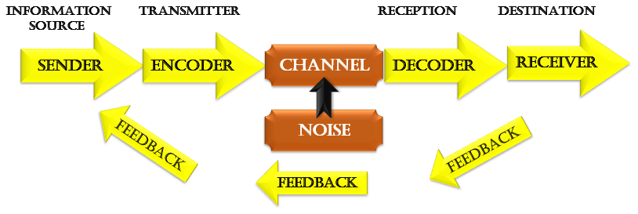

Example:
Maria and Pedro. Pedro works on a building site and Maria is his wife. One day Maria phoned Pedro. "Hello Pedro, when you’re coming home, see if you can get me a chicken "Okay, however, during his call, noise occurred (transmission error)’. When he got home, Pedro took off his boots and coat and went into the kitchen. "Maria, where are you? 'she said. ‘Here – in the sitting room,’ she said. when Pedro went into the sitting room, Maria said, "Where is the chicken?? ’What Chicken?’ asked Pedro, because of transmission errors or noise, Pedro was unable to hear the editor’s messages. The one I asked you to get on your way home. 'OH, no! I thought you said when I come home, I will see you in the kitchen! In this case Maria is the Sender and Pedro is the encored. When noise occurs due to disruption, the channel is represented as the mobile network or noise occurred. While Maria requested the (feedback) and important information was not received.

2.2 Schramm model

Theory:
Information, according to Wilber Schramm, is useless unless and unless it is carefully articulated in words and passed on to others. Coding is essential because it kicks off the dialogue phase by translating thoughts into content. The receiver's primary responsibility as the information is presented is to understand what the speaker is trying to convey (Schramm, 2010). If and until the other person may read or decodes the details on what the sender wants to deliver, communication is irrelevant.
Therefore, the two most critical considerations for effective communication are encoding and decoding, without which knowledge cannot circulate between two individuals. Schramm's model is founded on the same hypothesis as the previous one. According to Schramm's model, the two critical phases of effective communication are encoding and decoding. He often emphasises that communication is not fully until the sender gets feedback from the recipient (Schramm, 2010).

Fig. 2. Schramm model
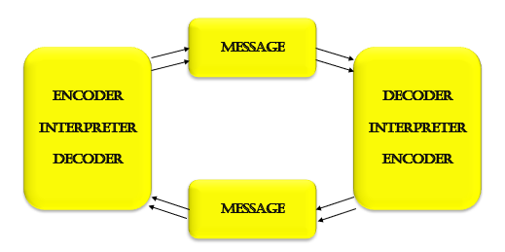

Example:
Consider a person who expresses his thoughts to a friend and receives no response. The communication is not finished; thus, it makes it unsuccessful. Communication, according to Schramm, is a two-way street between the first and second parties.

2.3 Berlo model

Theory:
David Berlo developed the Berlo dialogue model in the 1960s. The SMCR interaction platform is another name for this model. Unlike Aristotle's communication model, which assigns speakers as an essential component, this model argues that the emotional component of the message is an essential component of communication (Berlo, 1974).
In this model, SMCR stands for Source, Message, Channel, and Receiver. It contains the characteristics of each aspect. Sender skills include things like attitude, intelligence, and social system community. The real substance or sense of communication is the vital message. It refers to the configuration, content, message treatment components, and code sent from the sender to the receiver and may take any type, including email, video, or other media (Berlo, 1974). The platform, also known as a channel, is the vehicle by which the message is sent. Various correspondence methods, such as the internet, radio, television, and print, are available depending on the message. The senses of hearing, seeing, touching, smelling, and tasting are all important in the channel. Finally, the receiver is on the other end of the contact chain from the sender. The recipient is the one who decodes and comprehends the message sent by the sender. Many of the variables discussed above, as well as the thinking process, should be in sync with the sender, according to Berlo's correspondence model (Berlo, 1974). Communication will be far more successful as a result of this.

Fig. 3. Berlo model
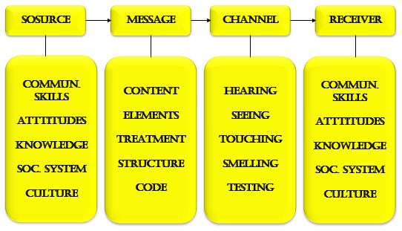

Example:
A lecturer who has an incredible autobiography starts working at a prestigious university located in another ethnographic area of the country. As soon as the first lecture begins, students realize that the lecturer speaks a dialect incomprehensible to them.

3.Communication Skills

3.1 Verbal communication skills – spoken and written.

Theory:
The method of transmitting and receiving messages utilising vocabulary and voice as a sign system is known as verbal communication. As a result, we would be able to grasp natural sound meaning, or the system of phonetic signals, by verbal contact. The elaboration of an idea, which is then dressed in a system of signs, precedes the process of coding the details. The context of the details is known to the recipient during the decoding phase. Presenting a concept and keeping the dialogue going with questions and responses are two ways to talk. The context in which we talk is important. When you write in a way that is suited to your partner's nature, the recipient will immediately see how it can serve them.
Diction, rational accents, speech pace, delay, intonation, word order, and metalanguage are all factors of verbal communication (Mehrabian, 2015).
Verbal contact occurs in a variety of settings and can be divided into two categories: formal and informal. The official communicative domain gains ritual and competence. The official communicative sphere is referred to as the ceremonial communicative sphere, and it is distinguished by clearly identified circumstances in which it is realised, as it is a relatively closed communicative culture with a historically developed and correctly replicated language store. The specialist sector lacks well-defined characteristics and can be diverse in terms of linguistic characteristics. The daily, polite, collegial specialist, and home communicative domains make up the informal communicative domain.

Example:
The operations manager has a meeting with employees from all departments of the company and presents plans and responsibilities at all levels, uses too many technical terms incomprehensible to employees from other departments and the result is a lack of understanding on the part of the audience.

3.2 Non-verbal communication skills

Theory:
Non-verbal communication is that communication, the part of the information transmitted between people that is not expressed in words. That is, it is transmitted on a nonverbal level. Nonverbal communication accounts for most emotional states and expressions. Nonverbal communication can be classified into five dimensions:
Gestures are conditional movements of the hands, fingers, head, representing a large part of non-verbal communication. They may express instruction, invitation, or aggressive intentions. Facial expressions are also non-verbal, expressive conditions of a person's face, including eye contact (Mehrabian, 2015). The condition of the face and eye contact can express approval, provoke attention, be a signal for action, etc. Pantomime represents the expressive movements and position of the body.
The characteristic of non-verbal signs is that to a large extent they are not realized now of their transmission and reception, they do not become a fact of consciousness (Mehrabian, 2015), but they affect the way in which the currently transmitted verbal message is received. Non-verbal communication is a prerequisite for creating one or another attitude to the message and to the sender.

Example:
Pantomime and ballet are excellent examples of non-verbal communication. Through body language, the sender presents his message, which should reach the recipients and thus provoke a certain reaction in his audience.

3.3 Active listening

Theory:
The approach of active listening can be useful in situations other than therapy, such as daily conversations, organised debates, briefings, work, and marriage - in all circumstances in which people communicate. When the burner has a problem or is animated on an object, active listening is useful (Mehrabian, 2015). The listener is interested in either helping people with the dilemma or learning more from the speaker's point of view. Active listening has two main components: first, attempting to break another individual twice, and second, expressing or dropping out when breaking the speaker. Because of this latter feature, the technique is often called "reflective listening." Contemplation is essential, reassuring both the speaker and the audience that the broadcast is heard. Without a connection to either the speaker or the listener, you cannot be sure that direct contact is being established (Mehrabian, 2015). Active listening is a discipline that can be learned.
However, it is more than what the vocabulary of ordinary people suggests; it is more than just "paying attention." The strategy consists of a collection of skills and, even more critically, a mentality. This thinking is motivated by the need to see and understand how another person perceives and understands everything. Many of us who grew up owning a knowledge package believe that most of the planet views the world the way we do. We are surprised to see people acting in an unreasonable way. To build the ability to actively communicate, you must be extremely interested GFM? in seeing the world through the eyes of others. Given the aspiration, it is necessary to learn some, you may have unnatural skills to succeed in technique.

Example: A group of people go to a comedy theatre and show no emotion during the show. They do not smile or laugh, they don't move, they just stand expressionless in the audience, they don't applaud. This has a demotivating effect on actors who try to send a message to their audience, but in this case it fails.

Conclusion

After the presented statements from a theoretical and practical point of view, it can be summarized that communication is a tool that unleashes the potential of each person and allows him to be successful in every area of ​​his life. Effective communication is a key interpersonal skill and learning how to improve it has many benefits. Communication is a two-way process, so improving our skills involves both sending and receiving messages.
The Shannon-Weaver, Schramm and Berlo models visually show exactly how the communication process takes place and what could help or hinder its quality.
Communication is verbal and non-verbal, and part of it is active listening. From the above it becomes clear that the basis of effective communication is the understanding of the process and compliance with the rules to achieve effective communication that saves individuals and businesses time, money, mistakes and leads to success and cohesion. team.

References

- Berlo, D.K. (1974). The process of communication : an introduction to theory and practice. New York, N.Y., Etc.: Holt, Rinehart And Winston.
- Mehrabian, A. (2015). Attitudes inferred from non-verbal and verbal communications. Journal of Verbal Learning and Verbal Behaviour, 6(2), pp.294–295.
- O'Rourke, J. (2015). Effective communication. London Dorling Kindersley Limited.
- Salmon, P. and Young, B. (2011). Creativity in clinical communication: from communication skills to skilled communication. Medical Education, 45(3), pp.217–226.
- Schramm, W. (2010). Mass media and national development : the role of information in the developing countries. Stanford: Stanford University Press.
- Shannon, C.E. and Weaver, W. (1999). The mathematical theory of communication. Urbana: University Of Illinois Press.

