MSC PUBLIC HEALTH AND SOCIAL CARE IN PRACTICE

ASSIGNMENT TITLE: COMPONENT 2 ANALYTICAL REPORT

MODULE NAME: Social Epidemiology and Public Health Development

MODULE CODE: LCHS7000

Programme Name: MSC Public Health and Social Care in Practice

Student Name: Nilesh Ambalal Patil
Student ID: 2523930

Submission Date: 1st May 2026
Lecturer: Itse Olaoye, Brian Mashumba

Institution: University of Wales trinity saint David London Campus
City, Country: London UK

Table of Contents
Task 1: Social Epidemiological Analysis 2
Introduction 2
Contextual Background and Underlying Factors 2
Diseases 2
Social Issues 4
National Response for the Reduction of Health Inequalities 5
Organisation that supports the selected group 5
Conclusion 6
Task 2: Epidemiological Analysis 7
Introduction 7
Main Body 7
Public Health Measures 7
Determinants and Risk Factors 8
Analysing the Epidemiological Studies and Health Needs Assessment 9
Surveillance and Monitoring Systems 10
Impact on Public Health 10
Intervention Programmes and their Evaluation 11
Strengths and Weaknesses of the Epidemiological Approach 11
Conclusion 12
References 13

Task 1: Disability and Health Inequality in the UK: A Social Epidemiological Analysis

Introduction
The chosen target group are the adults with physical disabilities in the UK who tend to experience substantial inequalities in healthcare, defined as unfair and avoidable differences in health outcomes among population groups. Two longitudinal studies have revealed that the acquisition of disability has posed a lasting detrimental impact on the life satisfaction and happiness in British and German citizens (Aitken et al., 2022), revealing the underlying reasons surrounding unequal resource access, healthcare and social participation fuelling these inequalities. People with disabilities have a higher likelihood of facing barriers in accessing healthcare (Kuper et al., 2024), including exclusion and poverty, adding to health risks. As a result, disability tends to become closely associated with broader social determinants, causing higher rates of preventable illness and poorer overall health consequences.

Contextual Background and Underlying Factors

Diseases
1. Higher Prevalence of Type 2 Diabetes among Disabled Adults
This is more prevalent among adults with physical disabilities, mainly due to structural barriers instead of individual lifestyle alone. A 2023 survey found that nearly 37.7% (4 in 10 households with a disabled adult) face food insecurity, compared with 13.3% (1 in 10 households without disability) (Foodfoundation, 2026).
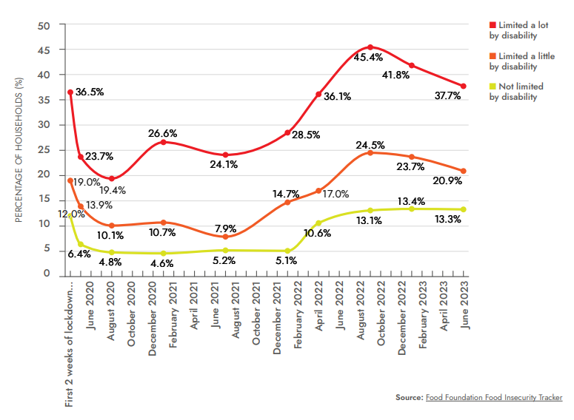
Figure 1: Households that experience food insecurity depending on disability levels
(Source: Food foundation, 2026)
As a result, constrained food choices due to low-income settings combined with limited access to physical activity increase the risk of developing Type 2 diabetes.

2. Increased Rates of Depression and Anxiety among Disabled Adults
Disabled individuals are more prone towards developing these disorders, which reflects ongoing social exclusion rather than clinical vulnerability in a pure sense. Disabled people tend to experience higher rates of violence and crime, which includes domestic and intimate violence, child abuse, bullying and hate crime (Hollomotz et al., 2025), which contribute to chronic psychological stress. Despite the availability of mental health services, appropriate personalisation suited to the individual's needs is lacking. This suggests that current approaches are more focused on treatment instead of addressing underlying social circumstances that affect mental health inequalities.

3. Higher Risk of Obesity among Disabled Adults
Disabled people have claimed to experience overstimulation in exercise facilities, including pools and gyms, which have undermined engagement opportunities and access, and have also referred to physical design barriers in buildings (Ons, 2026). All these aspects have restricted movement and discouraged people from taking part in engaging and physical activities, contributing to obesity by restricting opportunities for maintaining a healthy lifestyle. The food prices have again gone upwards in the UK, which has led to disabled people settling for a poor-quality, affordable diet, containing ultra-processed foods with high unhealthy fats, sugar and salt content (Disabilityrightsuk, 2026), which might seriously worsen health and might increase obesity risks.

Social Issues
1. Barriers to Healthcare Access for Disabled Adults
This remains a major contributor to health inequality for disabled individuals. Communication challenges, physical inaccessibility and absence of appropriate support often lead to delay in diagnosis and treatment, further leading to advanced disease stages and negative outcomes. A 45-year-old disabled man had died after having to wait for 34 hours for an intravenous (IV) antibiotic for a urine infection, which was mainly due to communication difficulties with the staff regarding the treatment needs due to the disability (Ombudsman, 2026). This is an important instance showing the inconsistent implementation of health policies for equal healthcare access.

2. Unemployment and Economic Exclusion among Disabled Adults
Higher unemployment rates among disabled people directly affect health by a reduction in income and limited resource access. It has been observed that disabled people in the UK have a lower likelihood of getting employed as compared to the non-disabled population at all levels of qualification (Gov, 2026).
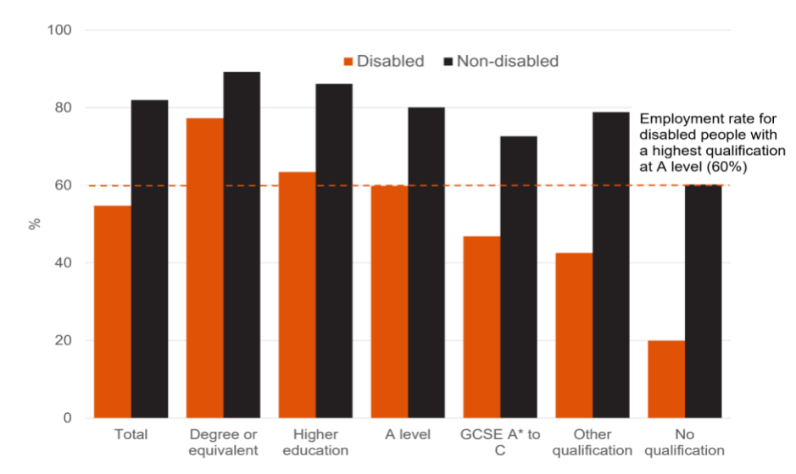
Figure 2: Proportion of people in employment by highest qualification and disability status in the UK
(Source: Gov, 2026)
This demonstrates that economic disadvantage is deeply embedded within systems, instead of being accidental, which restricts healthy living conditions for disabled people and reinforces the existing inequalities, requiring coordinated organisational and policy change.
3. Social Isolation and Loneliness
It has been acknowledged by studies that disabled people in the UK who have alternative communication needs, including assistive technology or sign language, have experienced significant communication barriers while engaging with others, thus feeling isolated and frustrated (Bacon et al., 2023). This lack of social connection is strongly associated with poor physical and mental health outcomes, which adds to the loneliness of these individuals.

National Response for the Reduction of Health Inequalities
The NHS Long-Term Plan prioritised addressing health inequalities, requiring local systems to develop specific plans with measurable mechanisms and goals to help narrow these inequalities in the UK over the next 5 and 10 years (Olivera et al., 2022). However, its impact has been limited by variation in local implementation and an inadequate accessibility focus, which is evident from recent studies. Similarly, employers under the UK Equality Act 2010 were required to provide reasonable adjustments for employees at substantial disadvantage (Davies et al., 2022), which thus aimed to prevent discrimination, yet the effectiveness in practice was reduced by enforcement challenges.

Organisation that supports the selected group
Scope is a leading UK disability charity which works towards the reduction of health inequalities via research, advocacy and direct support services. Scope had launched the Cost of Cuts campaign, which has enabled the organisation to support more than 4,854 individuals, while the petition for the protection of Personal Independent Payment (PIP) obtained 100,000 signatures, prompting the UK government to plan to protect the same, along with scaling back the planned job cuts to 6.5 billion UK pounds from 11 billion UK pounds (Scope, 2026). However, the reliance on firms also highlights the limitations in state provision, since essential support is often delivered via the voluntary sector instead of full integration into public systems.

Conclusion
Health inequalities among adults with physical disabilities are shaped by the interconnection between structural and social factors instead of mere individual conditions. Though the policies and organisations attempt towards addressing these specific issues, ongoing barriers recognised in employment, healthcare access, and social inclusion significantly add to the limitation of progress. Reduction of inequality thus requires sustained structural changes in the UK to help address underlying causes embedded within wider social systems. Future strategies must focus on addressing social determinants of health through inclusive policy design and equitable resource distribution to achieve long-term reduction in health inequalities.

Task 2: Epidemiological Analysis

Introduction
Type 2 Diabetes might be considered to be a long-term chronic condition that prevents the body from effectively using insulin, leading to higher levels of blood glucose and serious complications in health over time. The prevalence of this disease has been rising both across the UK and globally, with certain local areas, including Harrow, showing significantly high rates of occurrences. Type 2 Diabetes (T2D) has been affecting more than 830 million people worldwide (Magomedova, 2025). The importance of this pattern lies in the fact that not all groups are equally affected by this disease, with higher rates seen mostly among people with physical disabilities and those from South Asian communities in Harrow. Comparatively higher rates have been acknowledged among the same set of people with physical disabilities, which suggests Diabetes is closely associated with social and structural inequalities, along with a severe medical problem. In epidemiology, incidence is the number of new cases that occur during a certain time period, whereas prevalence is the total number of instances that exist within a community. These metrics aid in determining the prevalence and extent of Type 2 diabetes. (Nguyen, 2024; Ye et al., 2023).

Main Body

Public Health Measures
Prevention
Prevention strategies focus on decreasing the risk of Type 2 diabetes in Harrow based on early intervention, especially via programmes such as the NHS Diabetes Prevention Programme. Poor diet has been recognised as increasing the risk of Type 2 diabetes (Harrow.moderngov.co.uk, 2026). These initiatives by the government promote lifestyle changes consisting of improved diet and enhanced physical activity. However, effectiveness is highly uneven. For different individuals with physical disabilities, participation is limited because of inaccessible facilities and a lack of tailored support. Additionally, engagement in the South Asian communities remains inconsistent, suggesting different prevention strategies, which are not always culturally adapted. This suggests that prevention for Type 2 diabetes, while well-designed in theory, does not fully reach those most at risk. Type 2 Diabetes (T2D) is featured by elevated blood glucose levels, and is highly related to an increasing risk of developing micro- and macrovascular comorbidities (Hinnen et al., 2023).
Promotion
Health promotion depends on increasing awareness and motivating behaviour change based on campaigns and education. In Harrow, these efforts set an aim to boost understanding of diabetes risk and healthy living. T2D prevention strategies highlight two factors, such as structural context and neoliberal political backgrounds (Barry, 2024). However, people often assume that different individuals have varied resources and control to act on the information. For different disabled individuals who are facing social barriers, this assumption is not always valid. As a result, different promotional strategies may raise awareness; however, they do not necessarily lead to a meaningful change without addressing different underlying inequalities. Population and health strategies to minimise different diseases, such as diabetes, are highly limited and poorly financed (Barry et al., 2023). Targeted community outreach as part of adoption strategies to control Type 2 diabetes helps in creating risk awareness.
Protection
Early diagnosis and lowering complications through screening and clinical interventions are key components of protection methods. Identification of those at risk for Type 2 diabetes in Harrow is mostly dependent on NHS Health Checks and regular blood glucose monitoring (NHS England, 2026; McManus et al., 2022). However, due to obstacles including low awareness and accessibility issues, access to these services is still uneven, especially for people with disabilities and ethnic minorities (Kuper et al., 2024; Harrow.gov.uk, 2026). To enhance early diagnosis and lower the burden of disease, inclusive screening programs must be strengthened (Ahmad et al., 2022).

Determinants and Risk Factors
In Harrow, the risk of type 2 diabetes is shaped by a mix of different factors, such as social, biological, and environmental aspects. With two types of diabetes, additional risks are stroke, heart failure, myocardial infarction, renal replacement therapy, and angina (Harrow.gov.uk, 2026). A huge proportion of the population comes from South Asian backgrounds, which is related to a high metabolic risk. On the other hand, this alone does not reflect on the pattern. T2D is a major chronic disease that spreads across different Western countries, and it is estimated to affect 642 million people worldwide by 2040 (Beulens et al., 2022). The cultural dietary habits, low levels of different physical activities, and declining engagement with preventive healthcare are contributing to maximising risks. Additionally, pockets of deprivation within Harrow have a negative impact on healthcare and healthy food. This highlights that diabetes risk is not simply behaviour, along with different types of living conditions. These factors demonstrate that Type 2 diabetes is strongly influenced by social determinants rather than individual behaviour alone.
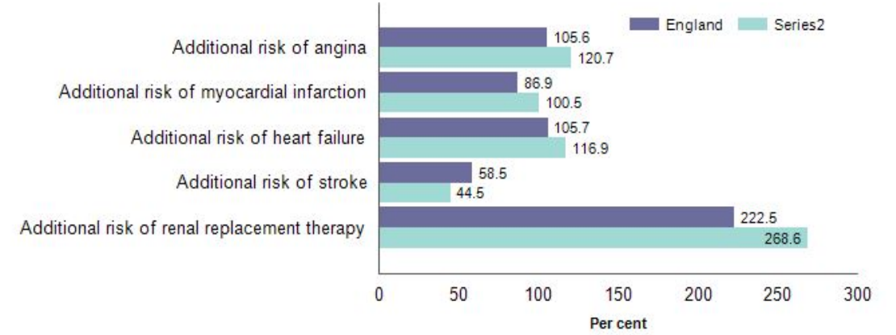
Figure 3: Additional risks associated with Diabetes
(Source: Harrow.gov.uk, 2026)

Analysing the Epidemiological Studies and Health Needs Assessment
Consideration of epidemiological studies, consisting of cross-sectional and cohort research, persistently reflects that type 2 diabetes is more common in ethnic minority groups and among people with existing health conditions or diabetes. Monthly hospital admission rates of the diseases based on the NHS Health Check were designed to tackle, incorporating diabetes, stroke, and heart disease (Nguyen, 2024). Local data from Harrow shows this current trend with higher prevalence in specific communities. Health Needs Assessments (HNAs) support the identification of where services are lacking, especially in relation to early diagnosis and culturally specific care. NHS Diabetes Prevention Programme (DPP) has been acknowledged as a national curriculum, as it targets the adult population to prevent T2D, while it is a joint programme involving Diabetes UK (McManus et al., 2022). Limitations have been found within these studies. The maximum amount of data is aggregated, which may hide differences between different groups, and disability-oriented data is often missing. Therefore, this makes it highly difficult to understand the needs of all subgroups. Though these mechanisms are useful to identify the patterns, the full picture of inequality has not been captured. The improvement in prevention and prognosis of type 2 diabetes mellitus has been based on studying epidemiological characteristics (Ye et al., 2023). This limits the ability to design fully targeted interventions for specific vulnerable groups.

Surveillance and Monitoring Systems
Diabetes is monitored using systems such as NHS Digital, National Database audit, and Outcomes framework in Harrow. According to the National Database Audit, young people who are aged under 40 years old with type 2 diabetes were usually from Asian and mixed ethnic groups in comparison to older people with type 2 diabetes (Digital.nhs.uk, 2026). Therefore, these systems help in tracking prevalence, trends over time, and treatment outcomes, which support local planning. However, those studies emphasise clinical indicators and offer limited insight into social factors such as cultural context or disability. As a result, while surveillance systems are highly crucial for understanding disease patterns, they may not fully focus on the inequalities that impede those patterns. These monitoring systems include sentinel surveillance (data gathered from specific healthcare providers, such as GP practices or hospitals), active surveillance (systematic screening programmes and targeted case finding), and passive surveillance (routine NHS data collection from hospitals and general practice records). Each of these systems makes a unique contribution to the understanding of disease patterns. (Nguyen, 2024)

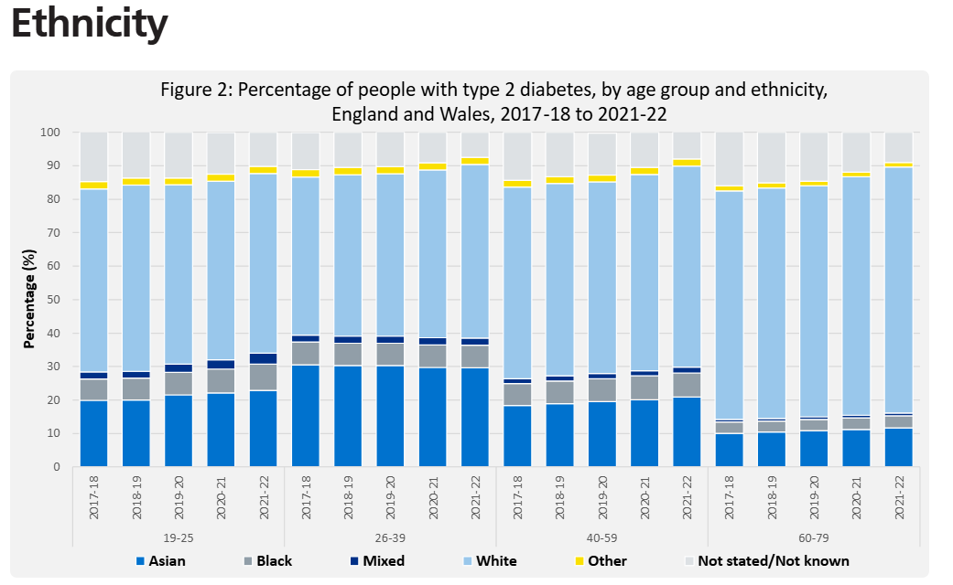
Figure 4: Ethnicity-oriented Diabetes report
(Source: Digital.nhs.uk, 2026)

Impact on Public Health
In Harrow, Type 2 diabetes has both long-term and immediate effects on public health. In short, the disease increases demand for healthcare services and impacts daily quality of life. Type 2 diabetes affects all parts of the body and causes potentially life-threatening complications (Health.harvard.edu, 2026). Over time, different complications are kidney failure, cardiovascular disease, and nerve damage that place an important burden on individuals and the healthcare system. This affects disabled people and those from ethnic minority backgrounds because of delays in diagnosis or treatment. Additionally, this highlights the way diabetes reflects inequality and the worst consequences over time. Different medications to address type 2 diabetes include antidiabetics, lipid-lowering drugs, antihypertensives and antiplatelet agents (Carr et al., 2022).

Intervention Programmes and their Evaluation
An effective approach would involve the targeted interventions, which are both culturally appropriate and accessible for ethnic people or disabled people in Harrow. For example, the community-oriented programmes may offer tailored dietary advice, adapted physical activity options, and multilingual support. Different digital technology-based services offer to set goals of preventing type 2 diabetes under NHS DPP (England.nhs.uk, 2026). Additionally, collaborating with local organisations and primary care services may improve the engagement of patients and enhance trust within communities. Despite advances, substantial barriers have caused the epidemic (Ahmad et al., 2022). While these interventions are required to boost participation, additional resources, along with long-term commitment, are highly required for those people. The success may depend on multiple factors such as design, accessibility, and consistent delivery. Especially, unaddressed more important challenges such as inequality and the gap in access to healthy food have not been evaluated properly, and the application of intervention programmes may be limited. Report highlights weight loss in T2DR programmes was statistically lower in participants of Black and Asian ethnicity, in comparison to Whites in England (Valabhji et al., 2024). This suggests that targeted programmes are highly crucial, which may not work in isolation, and need to be part of a bigger strategy to mitigate the root cause of inequality.

Strengths and Weaknesses of the Epidemiological Approach
Strengths
Epidemiology is crucial for finding patterns of disease and determining which populations are most at risk. In Harrow, it aims to highlight higher diabetes prevalence among specific ethnic groups and individuals with disabilities. This helps evidence-based planning, targeted interventions, and resource allocation. Epidemiology allows different public health professionals to move beyond assumptions and make informed decisions by reflecting on measurable trends. Low-cost behaviour change progress is highly beneficial (McManus et al., 2023).

Weaknesses
Despite its values, epidemiology has significant limitations. Quantitative data often fail to capture different living experiences, especially barriers faced by disabled individuals in accessing care. Additionally, dependence on existing databases may lead to gaps, bias, or underreporting, particularly where disability-oriented information is limited. This means that while epidemiology identifies patterns, it has not explained the underlying reasons. Consequently, it should be complemented with more context-sensitive approaches to fully understand health inequalities. A hypocaloric dietary intervention leads to remission of type 2 diabetes (Sattar et al., 2023).

Conclusion
Overall, this evaluation highlights that Type 2 diabetes emphasises the way health outcomes are powered by structural inequalities in Harrow. Effective response needs to combine epidemiological evidence with targeted, however, inclusive interventions by addressing underlying social determinants. A comprehensive approach combining epidemiological data with social interventions is essential to effectively reduce the burden of Type 2 diabetes. Without addressing inequality, long-term improvements will remain limited.

References

- Bacon, A., Hyland, A., James, S., Martin, N., O’Brien, G., Premkumar, P., Takhar, S. and Wilkinson, P., 2023. Disability, Loneliness and Relationships.
- Davies, J., Heasman, B., Livesey, A., Walker, A., Pellicano, E. and Remington, A., 2022. Autistic adults’ views and experiences of requesting and receiving workplace adjustments in the UK. Plos one, 17(8), p.e0272420.
- Disabilityrightsuk.org, 2026 Disabilityrightsuk.org. Available at: https://www.disabilityrightsuk.org/news/food-insecurity-rises-again?srsltid=AfmBOoqX9wa9quoloJm_MhxH3soKApNlQzGlFONc88ag0R99XJCotsyT (Accessed: 24 April 2026).
- Foodfoundation.org.uk, 2026 Available at: https://foodfoundation.org.uk/sites/default/files/2023-12/Disabilities%20briefing_FINAL.pdf.
- Gov.uk, 2026 The Employment of Disabled People 2024, Gov.uk. Available at: https://www.gov.uk/government/statistics/the-employment-of-disabled-people-2024/the-employment-of-disabled-people-2024.
- Hollomotz, A., Priestley, M., Andre, D., Lavery, B. and Hadi, F., 2025. The lived experience of disabled people in the UK: a review of evidence.
- Kuper, H., Gatta, D.R., Rotenberg, S., Banks, L.M., Smythe, T. and Heydt, P., 2024. Building disability-inclusive health systems. The Lancet Public Health, 9(5), pp.e316-e325.
- Magomedova, A., 2025. The role of socio-economic deprivation in developing of Obesity and Diabetes type 2 among population aged 16 and over in England and Sweden, 2021-2024. Medical Research Archives,[online] 13 (8) [online]
- Olivera, J.N., Ford, J., Sowden, S. and Bambra, C., 2022. Conceptualisation of health inequalities by local healthcare systems: A document analysis. Health & Social Care in the Community, 30(6), pp.e3977-e3984.
- Ombudsman.org.uk, 2026 Hospital treatment delay led to avoidable death of man with disabilities, Ombudsman.org.uk. Parliamentary and Health Service Ombudsman. Available at: https://www.ombudsman.org.uk/news-and-blog/news/hospital-treatment-delay-led-avoidable-death-man-disabilities.
- Ons.gov.uk, 2026 Disabled people’s experiences with activities, goods and services, UK - Office for National Statistics, www.ons.gov.uk. Available at: https://www.ons.gov.uk/peoplepopulationandcommunity/healthandsocialcare/disability/bulletins/disabledpeoplesexperienceswithactivitiesgoodsandservicesuk/februarytomarch2022.
- Scope.org.uk, 2026 Scope. Available at: https://www.scope.org.uk/about-us/our-impact-2024-to-2025.
- Ahmad, E., Lim, S., Lamptey, R., Webb, D.R. and Davies, M.J., 2022. Type 2 diabetes. The Lancet, 400(10365), pp.1803-1820.
- Aitken, Z., Bishop, G.M., Disney, G., Emerson, E. and Kavanagh, A.M., 2022. Disability-related inequalities in health and well-being are mediated by barriers to participation faced by people with disability. A causal mediation analysis. Social Science & Medicine, 315, p.115500.
- Barry, E., 2024. Type 2 diabetes prevention policy and practice: a multimethod qualitative study exploring the perspectives of patients, clinicians, and policy makers (Doctoral dissertation, University of Oxford).
- Barry, E., Greenhalgh, T., Shaw, S. and Papoutsi, C., 2023. Explaining the UK’s ‘high-risk’approach to type 2 diabetes prevention: findings from a qualitative interview study with policy-makers in England. BMJ open, 13(2), p.e066301.
- Beulens, J.W., Pinho, M.G., Abreu, T.C., den Braver, N.R., Lam, T.M., Huss, A., Vlaanderen, J., Sonnenschein, T., Siddiqui, N.Z., Yuan, Z. and Kerckhoffs, J., 2022. Environmental risk factors of type 2 diabetes—an exposome approach. Diabetologia, 65(2), pp.263-274.
- Carr, M.J., Wright, A.K., Leelarathna, L., Thabit, H., Milne, N., Kanumilli, N., Ashcroft, D.M. and Rutter, M.K., 2022. Impact of COVID-19 restrictions on diabetes health checks and prescribing for people with type 2 diabetes: a UK-wide cohort study involving 618 161 people in primary care. BMJ Quality & Safety, 31(7), pp.503-514.
- Digital.nhs.uk, 2026. NHS Digital. (2022). National Diabetes Audit 2021-22, Young People with Type 2 Diabetes - Detailed Analysis Report. [online] Available at: https://digital.nhs.uk/data-and-information/publications/statistical/national-diabetes-audit-yt2/young-people-with-type-2-diabetes-detailed-report-2021-22 [Accessed 24 Apr. 2026].
- England.nhs.uk, 2026. NHS England (2023). NHS Diabetes Prevention Programme (NHS DPP). [online] NHS England. Available at: https://www.england.nhs.uk/diabetes/diabetes-prevention/ [Accessed 24 Apr. 2026].
- Harrow.gov.uk, 2026. PUBLIC HEALTH REPORT. (2023). Available at: https://www.harrow.gov.uk/downloads/file/30091/Harrow_Diabetes_Report_2021_v3.pdf [Accessed 24 Apr. 2026].
- Harrow.moderngov.co.uk, 2026. Harrow Clinical Commissioning Group Title of Meeting : CCG Executive Date of meeting: 21 February 2017 Agenda Item Title: Diabetes Strategy for Harrow Purpose of the report. (2017). Available at: https://harrow.moderngov.co.uk/documents/s142414/Harrow%20Diabetes%20Strategy.pdf [Accessed 24 Apr. 2026].
- Health.harvard.edu, 2026. Lewine, H. (2024). Type 2 Diabetes Mellitus. [online] Harvard Health. Available at: https://www.health.harvard.edu/diseases-and-conditions/type-2-diabetes-mellitus-a-to-z [Accessed 24 Apr. 2026].
- Hinnen, D., Kruger, D. and Magwire, M., 2023. Type 2 diabetes and cardiovascular disease: risk reduction and early intervention. Postgraduate medicine, 135(1), pp.2-12.
- McManus, E., Meacock, R., Parkinson, B. and Sutton, M., 2022. Population level impact of the NHS Diabetes Prevention Programme on incidence of type 2 diabetes in England: an observational study. The Lancet Regional Health–Europe, 19.
- McManus, E., Meacock, R., Parkinson, B. and Sutton, M., 2023. Evaluating the short-term costs and benefits of a nationwide diabetes prevention programme in England: retrospective observational study. Applied health economics and health policy, 21(6), p.891.
- Nguyen, V., 2024. Triangulating epidemiological and data science approaches to evaluate the impact of public health interventions on the prevention of type 2 diabetes (Doctoral dissertation, UCL (University College London)).
- Sattar, N., Welsh, P., Leslie, W.S., Thom, G., McCombie, L., Brosnahan, N., Richardson, J., Gill, J.M., Crawford, L. and Lean, M.E., 2023. Dietary weight-management for type 2 diabetes remissions in South Asians: the South Asian diabetes remission randomised trial for proof-of-concept and feasibility (STANDby). The Lancet Regional Health-Southeast Asia, 9.
- Valabhji, J., Gorton, T., Barron, E., Safazadeh, S., Earnshaw, F., Helm, C., Virr, M., Kernan, J., Crowe, S., Aveyard, P. and Wilding, J., 2024. Early findings from the NHS Type 2 Diabetes Path to Remission Programme: a prospective evaluation of real-world implementation. The Lancet Diabetes & Endocrinology, 12(9), pp.653-663.
- Ye, J., Wu, Y., Yang, S., Zhu, D., Chen, F., Chen, J., Ji, X. and Hou, K., 2023. The global, regional and national burden of type 2 diabetes mellitus in the past, present and future: a systematic analysis of the Global Burden of Disease Study 2019. Frontiers in endocrinology, 14, p.1192629.

