
Assessment 2
Person-centred care for children with cancer
Introduction
This essay will focus on the person-centred care for children suffering from cancer within the health care sector in England. Person-centred care is a way which the people who use the health care sector gets to take part equally in the planning and monitoring of the care process which they are going through. Recently, there have been certain changes in terms of person-centred care. The structure of the current person-centred care includes the development and implementation of various educational programs and health promotion programs. The essay will be describing the way through which person-centred care is applied to take care of the children. Cancer is one of the most serious illnesses that individuals suffer. This can sometimes result in the death of the individual as well. Further, it will also include different theories which are helpful in maintaining this approach in their services.
Person-centred care is one of the efficient systems in the health care sector of England which says that the patients who are using the services have the right to get informed about the steps that have been taken for their treatment (Coulter, 2016).
It is very a very good approach specifically for children with cancer, because it provides opportunities for patients and their families to make their own decisions and choices for their treatment with the support of the specialists.
Children with cancer
Cancer is a serious illness that develops because of abnormal dividing by a group of cells, that cannot be controlled. (Macmillan cancer support, 2021). There are more than 200 types of cancer. In most cases cancer affects adults however, it rarely also affects children. Based on statistics in England ‘1 in every 450 children under 15 or 1900 children per year develop cancer’ (CCLG, 2021). Most common types of children cancer are: (see appendix): Leukaemia, Brain and spinal tumours, lymphomas etc. (CCLG, 2021).
Unfortunately, the percentage of mortality with childhood cancer is high. More than 240 children lose their lives every year. (Children with Cancer UK, 2021). That’s why is very important to have place where children and their families can find good treatment and support. A place like this is one of the biggest hospital in England that focuses on children treatment is Great Ormond Street Hospital (GOSH).
Along with all the other illnesses that they treat - there is a special wards called ‘Giraffe, Lion and Elephant Wards’, that provide diagnoses, monitoring and treatment for children with cancer, leukaemia and tumours. GOSH also provide shared care which means that depends on children’s condition they can stay in the hospital or in their home. In the hospital they have Safari day care that has all facilities that are necessary for children with cancer. (GOSH, 2021).
In these wards a huge multidisciplinary team with a lot of professionals work to help and support the little patients such as: ‘nurses and clinical nurse specialists, haematology consultants, oncology consultants, physiotherapists, pharmacists, healthcare assistants, play specialists and house-keeping staff’ (GOSH, 2021) that provides good care for the children.
Person-centred care allows the patients and their families to create their own daily plan. The plan consists of the patient’s preferences and decisions. The first step is to get up (at a suitable time for the patient), socialise with them, next is to help the patients with their hygiene, daily health check-up, plan their menu together with nutritious benefits, physical activity and social life (with other patients with similar conditions). Person-centred care gives the opportunity for the professionals to help not only with physical well-being but also mental.
The life of the children with cancer and their families revolves between hospitals, nurses, oncologists, chemo or radiotherapy and medication. That’s why is important to care not only for their physical condition but also for their mental well-being. One of biggest benefits of person centre care provided in GOSH is the ability children to receive support and play during their healthcare and treatment. Playing is the way that children explore the world. In GOSH this happens because of the play worker specialists. Playing and having a good time helps the children to recover faster. Play specialists are the people with purple shirts in GOSH that bring fun to the hospital. They are just as important as other healthcare professionals because play specialists give joy to children and replace the focus from their illness to something positive.

Discussion and analysis
Person-centred care was first established in the year 1919. Further, it has helped the patients to get the proper knowledge regarding their treatment. It is composed of 6 Cs which are: care, compassion, competence, communication, courage and commitment. The 6 Cs are the values that help in the foundation of the compassion in practice strategy. This was the national strategy for the nurses and other health care professionals which was decided in the year 2012. Care is the first C in the 6 Cs, which is the core business and helps the organisation to deliver the best service. Compassion on the other hand is the way through which care is given to individuals. The social needs and the expertise is understood with the help of competence. Among the 6 Cs, communication is one of the most important values which encourages individuals to listen properly so that they are able to provide the best service. Further, courage gives the ability to the individuals to do the right thing for taking care of the people. Lastly, commitment is the one that helps in improving the experience of the patients. (NHS, 2020).
There are several benefits that are gained by the individuals who are using the approach of person-centred care. This approach places the patients at the centre of the process. This helps in the promotion of individual health and all the needs of the customers are also met in this way (GOV.UK, 2015). This approach helps in dealing with the exact problem so that the exact treatment is given to the patients which help in the accomplishment of the success in curing the patient. In this system, the patients are able to gain control of their treatment process and this helps in making the patients more confident. Further, they also become conscious about their health and it also gives them the opportunity to communicate with the doctors and share the ideas and the problems which they are facing in their daily lives. Person-centred care, the health care providers are able to show more empathy and positivity to the patients. Further, this flexible approach helps in taking proper care of the patients who are suffering from cancer. With all it benefits this approach has several disadvantages as well. Person-centred care is highly optimistic in nature which might sometimes fail in providing the proper treatment to the patients. This approach is also based on the perspective of human beings which might sometimes fail. Furthermore, when the patients make the decisions alone without the proper advice of the professionals, this might lead to the failure of the complete treatment process. In this approach, different problems might come up as the result of the deeper mental issues for the patients therefore might fail to control the complete process. (Care, 2020). If the patient and their family might fail to understand the exact problems, the complete process might become a failure. Moreover, this approach is not applicable in all the situation. In the case where the patient doesn’t have the mental capacity, there might be a problem making the proper decisions regarding their health. This can be one of the most challenging tasks for the health care professionals and the patients will not be able to make effective decisions in this case. Therefore, it can be said that person-centred care is one of the most efficient systems where the patients are able to gain the proper knowledge regarding their health and they can also make their own decision regarding their treatment. (Clissett, 2021). This also ensures success in the treatment process. Further, this helps in strengthening the health care system in England. However, due to several drawbacks that are posed by this approach might sometimes lead to the failure of the overall treatment. This might even lead to the death of patients. Further, the health care sectors in England also give complete support to this approach but there are several restrictions as well which are forced due to this. (Ross, 2020).
Person centred care revolves around the fact that every person should be given equal amount of health care at times of need. Maintaining the ethical consideration while providing proper health care is also important. Apart from that taking their consent while making decisions regarding their health care is also an important aspect of person-centred care. Person-centred care is directly related to the health care rights that every individual possesses and that can be explained using certain theories. As the Alderfer Theory of Motivation 1969 states that the human needs that are important for person-centred care are relatedness, existence and growth. This contains the basic needs of a human being which helps them understand their rights possessed by them in health care determined by the government of UK. The basic needs include water, food, safety, clothing and health care (Arnold and Boshoff, 2017).
It is important that the ethical considerations are maintained while adapting the methods of person-centred care for the improvement of an individual. This ensures the morals and the values of the people in order to support those certain theories has been proposed. One of which that is based on the theory of Bradshaw’s Taxonomy of Social Needs 1972, explains the fact that social considerations should be followed by the government in order to manage the health and safety measures related to person-centred care. (Bradshow, 2020).
According to Bradshaw, the government bodies should be responsible for making the people aware of the social needs. These needs are the most important aspects in terms of learning ethical principles which give rise to proper health and safety measures.
Person-centred care has certain benefits which helps the individuals to attain proper care in terms of health and safety. One of the most important benefit is the flexibility that it provides in terms of providing the proper care and help the individuals in adapting to the social needs which they deserve. Besides that, it brings out the responsibilities of the government bodies towards the individuals in extreme need of these facilities. This gives rise to satisfaction in terms of mental and physical health. Another benefit is that the individuals are independent to make decisions in terms of their own health care methods. For example, in terms of cancer patients, the consent of the whole family and the patient is taken before conducting any kind of decisions of treatment.
Along with the benefits, person centred care facility also faces some kind of limitations while the process is conducted. One of the most common limitation is the economical limitations faced by this process. Financial problems have consumed mostly every sector and this gives rise to personal and financial costs. Apart from that, some of the groups are not benefitted because this care process does not cover all the concerns at times. Besides that, the condition and the quality of some of the staffs are not entertained under this program. Therefore, at times when the staffs face some serious health problems such as cancer it becomes hard for them to carry on the costs and get proper treatment (Arnolds and Boshoff, 2017).
The person-centred care has been considered at times of serious problems, such as organising intervention for the children with cancer. This is done in order to educate the parents properly so that they get to know about the ways in which they can handle the effected children properly. This is done effectively with the help of Maslow’s Theory of Need 1943 which is a ranked approach to explain the different levels in which the diagnosis can be conducted. (McLeod, 2020). Through this the parents where taught ways through which they can understand the needs of the children who are suffering from the problem. Then the safety measure was explained to the parents which they should follow in order to keep their children safe from certain problems which might affect their health. Furthermore, the explained methods which shows the affection and the love that the children need during this period. The importance of being in a group in order to improve the mental state of the children was also explained. Through this the children would stay motivated and never face mental breakdowns. Finally comes the self-education step where the children will gain the potential to stay strong and recover themselves (Bradshaw, 2020).
Recommendations
The person-centred care in England should take some effective measures so that their services can be improved. Organisations must hire highly qualified professionals who are able to provide a high quality of services to people. They also have effective knowledge through which they are able to provide the best services to the children with cancer. Along with this, the person-centred care in England should not give false hope to the innocent suffering children, because that can reduce the quality of the services. The person-centred care should also clear their descriptions regarding the outcomes of the treatments. So the patients will get a clear concept regarding the treatment provided by the professionals. In addition to this, person-centred care in England has to face the issues of good communication. (Groteclaes, 2020). Therefore, it is recommended that person-centred care must improve its communication through the professionals. That’s why the organisations should use proper tools through which they would be able to communicate with the patients. Moreover, the patients would be able to share their conceptions regarding the cancer treatment and they would also be able to respond to the problems they have been facing while receiving care. Along with this, person-centred care is able to provide the type of treatment that patients have been demanding. The quality of services provided by person-centred care would also be enhanced.
Beside the standard treatment complimentary therapy is also recommended as an alternative approach to medicine and treatment. Complimentary therapy includes a variety of less common medical approaches such as: ‘yoga, meditation, acupuncture, aromatherapy, herbs, homeopathy etc’. (Raby, 2021). Complimentary therapy is recommended because it has many advantages like: stress relief and anxiety help, which convinces a lot of younger patients and their families to choose this approach.

Conclusion
In conclusion, the main focus of this essay has been person-centred care for children with cancer. The proper analysis of the social and health care with the help of this method was also described. The relevancy of person-centred care along with the advantages and the disadvantages has also been explained. Besides that, the use of different theories in order to maintain the effectiveness of this process has been mentioned. Also different theories which can be adapted by the government bodies to provide proper care to the individuals were highlighted. The benefits and limitations of the person-centred care in relation to critical health issues such as children’s cancer were also discussed. Furthermore, this essay has devised the implementation of theories for person-centred care in providing appropriate knowledge in relation to children suffering with cancer. Finally, recommendations were given to help improve the person-centred care, because working with children has many challenges. Therefore, only specialised healthcare workers are suitable for this role.

References
Arnolds, C.A. and Boshoff, C., (2017). ‘Compensation, esteem valence and job performance: an empirical assessment of Alderfer ERG theory. ‘International Journal of Human Resource Management, 13(4), pp.697-719.
Bradshow, J. (2020). Taxonomy of social need. Problems and progress in medical care: essays on current research, 7th series. London: Oxford University Press, pp. 71-82
Children with cancer UK, (2021). Childhood cancer facts and figures. (Available at: https://www.childrenwithcancer.org.uk/childhood-cancer-info/understanding-cancer/childhood-cancer-facts-figures/ (Accessed: 1st September 2021).
Children’s cancer and leukaemia group, (2021) Childhood cancer. Available at: https://www.cclg.org.uk/Childhood-cancer (Accessed: 2nd September 2021).
Clissett, P., (2021). ‘The challenges of achieving person-centred care in acute hospitals: A qualitative study of people with dementia and their families’. International Journal of nursing studies. Vol.50. Issue. (11). pp. 1495-1503. Available at: https://www.sciencedirect.com/science/article/pii/S0020748913000692
Coulter, A., (2016). ‘Person-centred care: what is it and how do we get there?’Future Healthcare Journal. Vol. 3. Issue. (2). pp. 114-116.
Available at: https://www.ncbi.nlm.nih.gov/pmc/articles/PMC6465833/ (Accessed: 1st September 2021).
GOV. UK. (2015). Delivering better integrated care. Available at: https://www.gov.uk/guidance/enabling-integrated-care-in-the-nhs (Accessed: 3rd September 2021).
Great Ormond Street Hospital for Children, (2021). Wards and Departments. Available at: https://www.gosh.nhs.uk/wards-and-departments/ward-and-admissions-information/giraffe-ward/ (Accessed: 3rd September 2021).
Great Ormond Street Hospital for Children, (2021). Who you will meet? Available at: https://www.gosh.nhs.uk/wards-and-departments/ward-and-admissions-information/elephant-ward/ (Accessed 2nd September 2021).
Groteclaes, I., (2020). What are the limitations of person centered therapy?
Available at: https://findanyanswer.com/what-are-the-limitations-of-person-centered-therapy (Accessed: 3rd September 2021).
Macmillan Cancer Support, (2021). Cancer information and support. Available at: https://www.macmillan.org.uk/cancer-information-and-support/worried-about-cancer/what-is-cancer (Accessed: 2nd September 2021).
McLeod, S., (2021). Maslow’s hierarhy of Needs. Symply Psyhology. Available at: https://www.simplypsychology.org/maslow.html (Accessed: 3rd September 2021).
NHS, (2020). Person-centred care. Health Education England. Available at: https://www.hee.nhs.uk/our-work/person-centred-care (Accessed: 2nd September 2021).
Raby, A. (2021). Complementary Therapies. Available at: https://www.bupa.co.uk/health-information/complementary-therapies/complementary-therapies (Accessed: 4th September 2021).
Ross, H., et all. (2015). ‘Understanding and achieving person-centred care: the nurse perspective.’ National Library of Medicine. Vol. 24. Issue. (9-10). pp. 1223-1233. Available at: https://pubmed.ncbi.nlm.nih.gov/25047737/ (Accessed: 2nd September 2021).

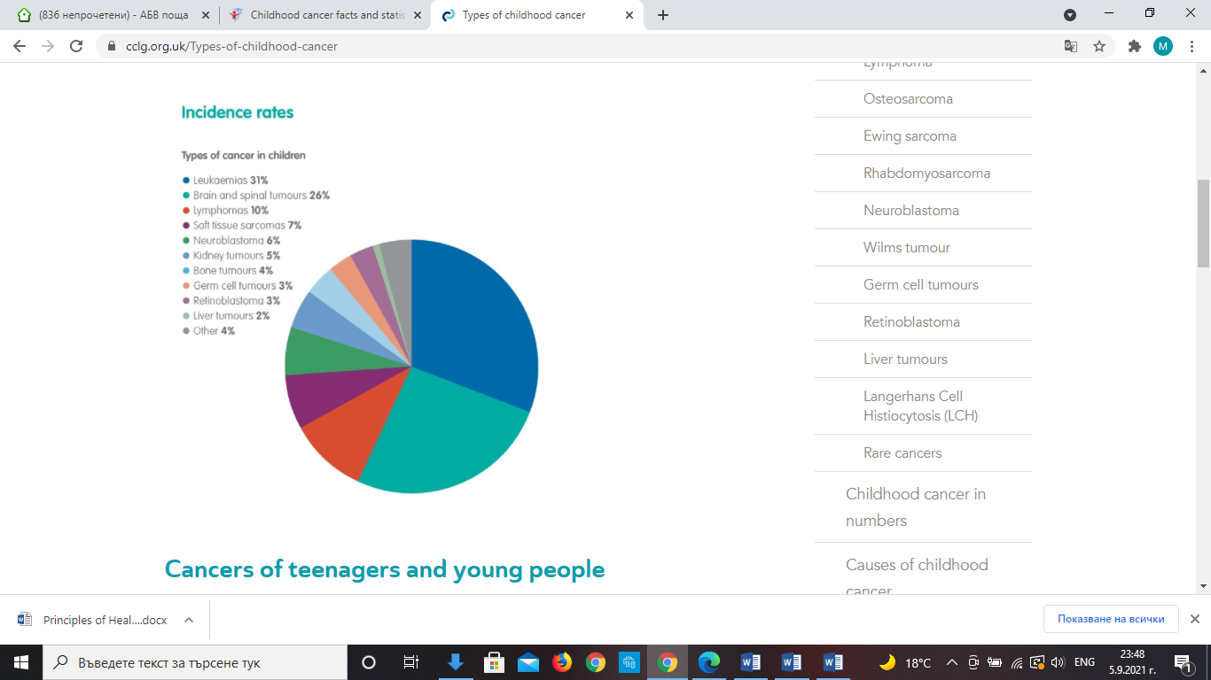
Appendix
Photo credit: Children’s cancer and Leukaemia Group. Available at: https://www.cclg.org.uk/Types-of-childhood-cancer

