An investigation into Higher Education: Exploring the Benefits and Barriers for Adult Learners

Name: Amy Morgan
Student Number: 2319574
Program of Study: BA Business Management
Module: Sustainable Business Dissertation BMSP6018
Tutor: Dr Laura James

Table of Contents
Title 3
Key Questions 4
Background 5
Literature Review 6
Methodology 8
Time scale 10
Reference List 11

Title
What are the benefits and barriers for adult learners going into higher education?

Key Questions

The aim of this research is to explore and critically evaluate the benefits and barriers experienced by adults in higher education.

  - Key Questions
What are the most common barriers faced by adult learners in accessing higher education?
What are the barriers faced by adults completing higher education?
What are the most common benefits of adult learners accessing and completing higher education?
What are the social benefits for adults returning to higher education?

Background
Returning to education after a 20-year gap presents a unique set of challenges and opportunities, as a mature student. I have personally seen how higher education has changed especially with the rise of online learning and the use of digital platforms such as HWB and Moodle. This firsthand experience has created a keen interest in how mature students navigate these changes and what kind of resources work most successfully for them.
This research aims to explore the benefits and barriers faced by mature students pursuing higher education, with an emphasis on how the developments in technology and how their more complexed needs such as flexibility and finances have changed their educational experience.
The study looks at both the motivational factors that encourage mature students and the personal barriers they face. To offer insights that will help improve support services and promote inclusive learning environments. Universities working to accommodate a variety of students and encourage lifelong learning will find value in the findings.

Literature Review

A report by Office for Students (2023) shows that the demographics of higher education students have diversified over the last two decades with more mature students pursuing higher education for personal growth, career progression and adapting to new job markets. The study also draws attention to the barriers mature students encounter such as technological difficulties, lack of flexibility, disabilities, and financial pressures. Resulting in having more complexed needs than younger students.
In the academic year 2021-2022, 2,717,010 students attended university in the UK, 63% of them were mature students (aged twenty-one and over) as shown in the graph below (Universities UK, 2023).
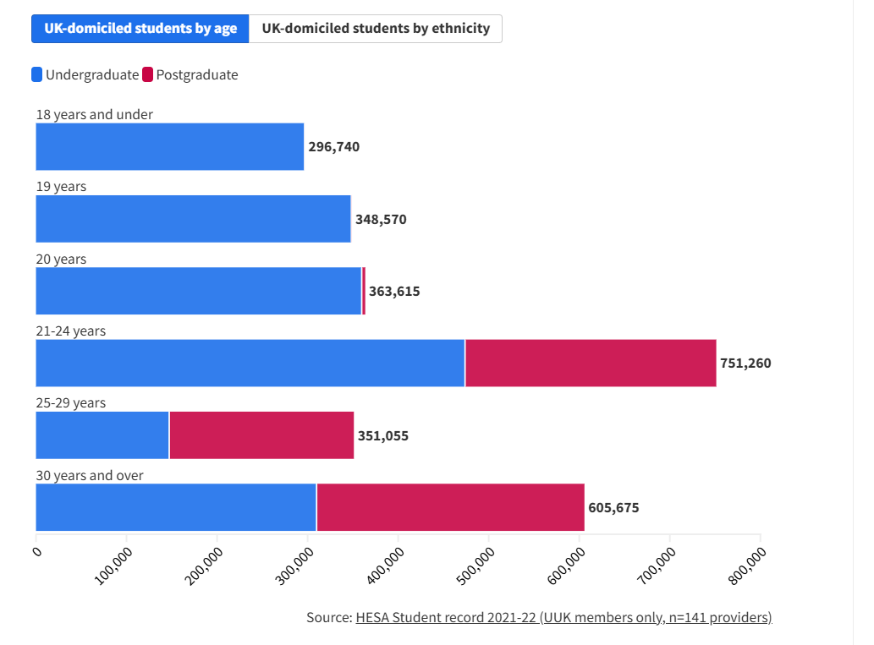
A report by House of Commons Library (2021) reveals that the number of mature students in England fell from more than 400,000 in 2010-2011 to less than 240,000 by 2017-2018 dropping a massive 40% in 7 years. According to HESA (2025) the number of mature students in the UK overall has risen by 308,175 from 2019 to 2024 as shown in the chart below.
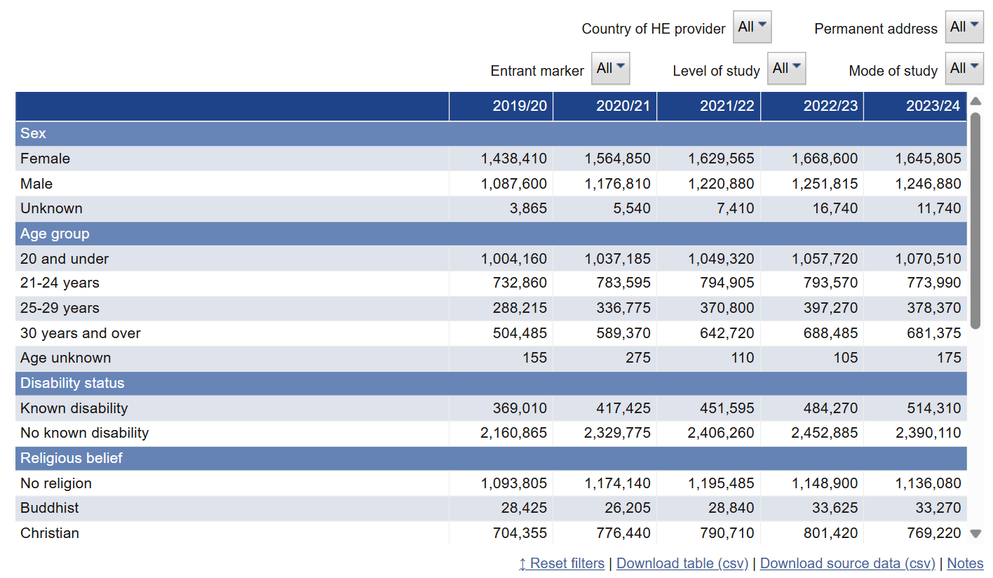
There is a lack of available data on adult learners in Welsh universities, a report by Colegau Cymru (2025) states that the number of full time learners in higher education has stayed quite steady but the number of part time students has fallen by 50,000 (45%) in the last decade this is due to a substantial decrease in funding, grant funding accessible for parttime learners in further education in Wales has been cut by £22 million. Additionally, like Wales there is not a specific data for adult learners in Scotland although the 2022 Scotland Census reveals that about 1.5 million adults have a degree level qualification of higher. Furthermore, the Scottish Government’s Adult Learning Strategy for 2022-2027 reports that in 2020, 324,700 adults aged 16 to 64 had few or no qualifications, highlighting the importance of adult education programs (Scottish Government, 2022).

  - Motivations for Mature Learners
A study published by the Society for Research into Higher Education (2023) finds that motivation varies by age groups. Mature students aged forty and over are more likely to be in the pursuit of their own happiness or lifetime learning goals. Whereas mature students between the ages of 25 – 39 are often driven by career advancement.
A report by the Department for Education (2023) also highlights that career progression, personal development and being a role model for their children are a big motivation for mature students.

  - Barriers to Participation
According to a study by (Smith & Ahmed, 2024) mature students reported that a major barrier they faced going into higher education was financial security, with the high price of tuition and leaving the stability of their paid jobs. Their family commitments being another barrier, many participants found it difficult to manage their academic obligations as well as their childcare responsibilities.

  - Theoretical Framework
Jack Mezirow’s Transformative Learning Theory, which provides insight for recognising how mature students face the difficulties of enrolling in higher education, serves as the foundation for this study. Adult learning involves more than just gaining knowledge, it also entails changing one’s perspective through conversation and critical reflection (Mezirow. 1991).

Methodology
The research paradigm will adopt a subjectivist stance, incorporating an interpretivist epistemology. Accordingly, a qualitative methodology is most appropriate to capture rich data through phenomenological and ethnographic approaches Creswell, J. W., & Poth, C. N. (2016).
Primary data will be collected by myself through semi-structured interviews; they will be undertaken in person or through teams to collect qualitative data regarding the benefits and barriers faced by mature students in higher education. This method enables a greater understanding of the participants, lived experiences, this will be made possible through this approach, which will also provide a broad, detailed investigation of the institutional and personal factors that influence their educational journeys.
Secondary data will be gathered through literature research of pre-existing data within academic articles, reports, statistics, and databases.

Time scale

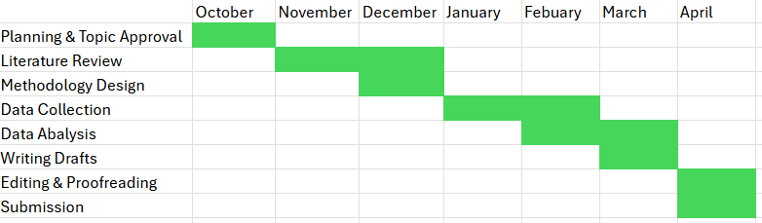

Reference List

Creswell, J. W., & Poth, C. N. (2016). Qualitative inquiry and research design: Choosing among five approaches (4th ed.). Sage publications. https://scholar.google.com/scholar?hl=en&as_sdt=0%2C5&q=Creswell%2C+J.+W.%2C+%26+Poth%2C+C.+N.+%282018%29.+Qualitative+Inquiry+and+Research+Design%3A+Choosing+Among+Five+Approaches+%284th+ed.%29.+SAGE+Publications.&btnG=

Colegau Cymru. (2025). Transforming Adult Education in Wales. https://www.colleges.wales/en/blog/post/transforming-adult-education-in-wales

Department for Education. (2023). Studying part-time: Perspectives of mature students. GOV.UK. https://assets.publishing.service.gov.uk/government/uploads/system/uploads/attachment_data/file/1158990/Studying_part-time_-_perspectives_of_mature_students__May_2023.pdf

Higher Education Statistics Agency. (2025). HE Student Data. https://www.hesa.ac.uk/data-and-analysis/sb271/figure-5

House of Commons Library. (2021). Mature Students in England. https://commonslibrary.parliament.uk/research-briefings/cbp-8809/

Mezirow, J. (1991). Transformative dimensions of adult learning. Jossey-Bass, 350 Sansome Street, San Francisco, CA 94104-1310. https://eric.ed.gov/?id=ED353469

Office for Students. (2023). Improving opportunity and choice for mature students. https://www.officeforstudents.org.uk/publications/improving-opportunity-and-choice-for-mature-students/

Scottish Government. (2022). Adult learning strategy 2022 to 2027. ISBN: 9781802018301. https://www.gov.scot/publications/adult-learning-strategy-scotland-2022-27/pages/3/

Smith, L., & Ahmed, R. (2024). Access to higher education: A case study of mature students in London. Journal of Equity and Social Justice in Education, 3(1), 45-62. https://equity-ed.org/wp-content/uploads/2025/06/JESJE-vol3-2024-art-5.pdf

Society for Research into Higher Education. (2023). Mature student motivation and drop out: Age-related patterns. https://srhe.ac.uk/arc/23/0207.pdf

