Applying a range of critical theories, identify and discuss an artwork of your own choosing.

Chosen artwork: 'cyfarthfa Ironworks Interior at Night', by Penry Williams, 1825

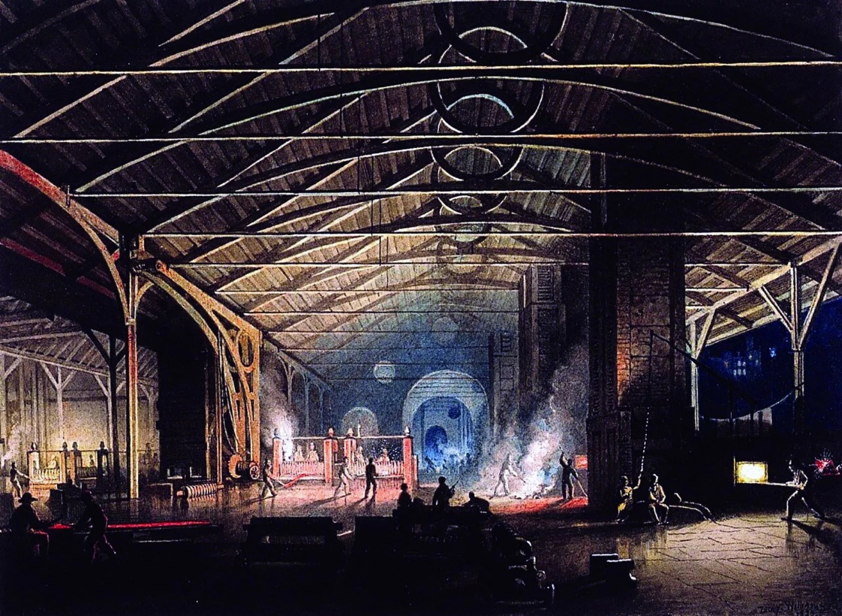

'Cyfarthfa Ironworks Interior at Night’ by Penry Williams was a piece I discovered while doing some artist research and I was instantly drawn to the intricate design of the watercolour painting. His ability to draw the eye to the painting captured my attention. I will be using a range of critical thinking theories to discuss this painting, including semiotics and mediation while supporting my thoughts with context and references. Williams’ use of colour and contrast highlights his admiration of the building and all who occupy it.
Williams used many creative techniques to create his piece such as sing light as an illusion to draw the eyes to the centre of the image, lengthening the building and creating depth. Semiotics are the concept that shapes and images or symbols are messages or represents feelings, objects or ideals. “Semiotics the study of signs and symbols, what they mean, and how they are used” (Cambridge dictionary). It is thought that semiotics are found consistently within art. The book ‘bodies and artefacts: historical materialism of corporeal semiotics’ (Fraccia, 2022) as well as the article ‘shapes: semiotics+symbolism’ (Dailey, 2023) explained semiotics to me very well which has helped me in identifying semiotics in my own pieces of work as well as others.
Circles consistently appear in williams painting and in terms of semiotics one could say they represent the constant circle of life and the working day, with men continuously returning and leaving to work, it could also symbolise the duality of chaos and order that you would expect in the iron works. Furthermore, it could symbolise Williams projections of good and evil within the workforce such as the bosses and employees. The circle is continuous and everlasting, the same was once thought of the iron works and coal mines. Furthermore, the circle is similar to the well known infinity symbol, comprised of two circles conjoined, representing the theory of everlasting life and infinite possibilities and outcomes within life. Another observation is the circles could represent movement such as gears and cogs, as would be associated with the iron works. Furthermore, it is most likely that Williams saw this himself and added the circles to draw the viewers eye to the centre of the painting, his skills at manipulating the viewer into looking where he wishes them too without them noticing. The triangles that are often repeated in Williams’ painting could represent the three concepts of time, past, present and future. It was a common belief that the iron and steelworks would be a needed past of the industrial revolution for many centuries to come which has remained somewhat true.
The use of dramatic lighting and shadows are a form of mediation as the iron works would not have that dark contrasting light in the same way. “Its central idea is that technologies, when they are used, help to shape the relations between human beings and the world.” (Verbeek,2022) The human eye would not perceive the light the same way as is painted by williams. Furthermore, the use of workers in the art is another form of mediation as it is Williams’ own interpretations of the working industrial men and how they would have interacted within their environments. Williams’ painting shows pride for the industry and his documentation of the working men in his painting reflect his admiration for their hard work ethic. His use of the light highlighting the men suggests he wishes the attention to be drawn not them and their daily lives. As well as this the lighting truly highlights that its set at night even if you had no prior knowledge that it was. The shadows creeping up the walls and covering corners of the painting reflect how the lighting at night creates the illusion that everything is larger and grander than it truly is.
One could say his admiration of the working class stemmed from being raised by his stone mason father who would have instilled hard working values within Williams. Williams had painted many paintings based on the industrial scene which shows his passion for the subject, his admiration could be interpreted as manifestos within his work as he depicts hard working men in their daily lives. “His industrial landscapes – one in particular, showing an ironworks at night – were based on sights and scenes around the industrial valleys of Wales.” (Carradice, 2015, BBC article). The quote “an image is a sight that has been recreated or reproduced… which has been detached from the place of time in which it first made its appearance…” (Berger, 1972, page 9) further argues that Williams’ was using his own interpretations of the ironworks to create his artwork, highlighting the key points he believed were important to feature. It seems his belief was that the infostructure was more important than the men, as the details are more defined on the architecture of the building. However, him placing the working men at the centre of the painting highlighted by the only vivid colour contrasts with that. It suggests that both work in harmony, the building and the men are reliant on each other. One without the other wouldn’t work harmoniously, the building allows the men to feed their families and the men keep the building running continuously in good shape.
Williams’ use of colour highlights his interpretation of the ironworks as alive. The use of red in the artwork could be interpreted as personification, with red symbolising life or blood, and the men highlighted in the middle of the painting as the heart of the ironworks, keeping the place beating and operational. The red could also symbolise death or danger as the ironworks would have been a dangerous place to work with furnaces and chimneys to remove poisonous gases from the works. “You can see that the brickwork has literally melted, which gives you an idea of the intense temperatures there would have been in here.” (prior, 2013, BBC article) the concept of danger could have been reflected into Williams’ work using colour. Williams’ use of blue towards the back centre of the painting could represent the contrast between the iron when its heated-up versus when it’s cold. It could also symbolise the sadness that resonated in the ironwork, due to the overworking of the men.
The ironworks was crucial for the working class during the 1700 hundreds to the early 1900s as it provided a means of living and a wage for thousands of people. The scholar journal explains “By 1865, puddled iron output reached 1,200 tons a week and 5,000 employees worked at Cyfartha producing wrought iron bar and railway rail, much of which was exported.” (Smith, Steel Times International; Redhill Vol. 40, Iss. 5, Jul/Aug 2016) this could further point towards his passion for the working class in his paintings.
Williams art medium of choice for this painting is watercolour, a versatile, buildable paint that allows the artist to layer intricate details and great depth. Watercolour was one of the most readily available paints to use and source, within history many people have found their own pigments by foraging or using what they have in the home such as spices or flowers. “Watercolour Painting, also known as Egyptian Art, was painted on papyrus and used in Egyptian art forms during the early twentieth century. Painting religious murals with watercolours began to take root in Asia around 4,000 B.C., and Chinese traditional painting with watercolours developed as a decorative medium until the first century A.D., when the art of painting religious murals began to emerge.” (huckleberry, 2022) Watercolours were most likely all Williams could afford to paint with at the time or due to it being an accessible paint perhaps it was why he favoured watercolours. the detail Williams was able to achieve through this paint choice is incredible and would have required a lot of skill, which he built up while in London for university. Williams’ use of watercolour is what drew me towards him for this essay, as I also primarily use watercolour, and have built my skills in that area over the years.

In conclusion, Williams uses many critical theories within his work perhaps without him realising or intending to do so, the use of repetitive symbols and selective bright colour show how he wishes to draw the human eye inwards. I personally enjoy this artwork for its representation of working class men, as well as his use of dramatic shadows and contrasting colours. This piece can infer a few key messages, as referenced in the introduction Williams’ use of colour to highlight the importance of the working men shows his values as a man who grew up around that environment, as well as his admiration for the men. ‘Cyfarthfa ironworks interior at night’ is a breathtaking, striking piece which highlights the beauty of the working class.

Index

https://www.bbc.co.uk/blogs/wales/entries/a06eff45-3170-4969-b524-25298e5b24aa
https://www.bbc.co.uk/programmes/articles/5tP2c8XvP02Bk6p2m1Pv8mg/sophisticated-radical-and-international-the-story-of-welsh-art
https://www.bbc.co.uk/news/uk-wales-23996472
https://huckleberryfineart.com/a-brief-history-of-watercolor-painting/
https://librarysearch.uwtsd.ac.uk/discovery/fulldisplay?docid=alma99100534100702421&context=L&vid=44WHELF_UWTSD:44WHELF_UWTSD_VU1&lang=en&search_scope=MyInst_and_CI&adaptor=Local%20Search%20Engine&tab=Everything&query=any%2Ccontains%2Csemiotics
https://www.peoplescollection.wales/collections/429934
https://www.proquest.com/docview/1849313201/fulltext/2FFE087153AF44B7PQ/1?accountid=130472&sourcetype=Scholarly%20Journals

