University of Wales Trinity Saint David
School of Engineering
Using a Lean Six Sigma approach for Hot Strip Mill coil presentational quality diversions
Michael Corish
Advanced Manufacturing and Operations
2025



Declaration of Authenticity

‘This thesis is the result of the author’s original research. It has been composed by the author and has not been previously submitted for examination which has led to the award of a degree.’

Signed: Date: 18/05/2025

Table of Contents

1 Abstract 1
2 Aims and Objectives 2
2.1 Project Charter 2
2.2 Scope Statement 3
3 Timing Plan 5
3.1 Gantt Chart 5
4 Research and Literature Review 7
4.1 Lean Methodology 7
4.2 Six Sigma DMAIC 9
4.2.1 Define Phase 9
4.2.2 Measure Phase 9
4.2.3 Analyse Phase 10
4.2.4 Improvement Phase 10
4.2.5 Control Phase 10
4.3 Lean Six Sigma 11
4.4 Hot Rolling Coiling Process 12
5 Work Carried Out 14
5.1 Define 14
5.1.1 Pareto Analysis 14
5.1.2 Problem Statement 16
5.1.3 Voice of the Customer 16
5.1.4 Stakeholder Analysis 17
5.1.5 SIPOC 19
5.1.6 Customer and Quality 20
5.1.7 Customer Release Standards 21
5.2 Measure 23
5.2.1 Measurement System Analysis 23
5.2.2 Data Collection Plan 24
5.2.3 Hot Mill Customer Product Output 25
5.2.4 Tonnage of Diversions by Customer 25
5.2.5 Coil Presentation Annual Cost of Quality 26
5.2.6 Trostre Tail End Diversions by Shift, Gauge and Grade 27
5.2.7 Trostre Tail End Diversions by Coiler and Width 28
5.2.8 Defects Per Million Opportunities and Process Capability 28
5.3 Analysis 30
5.3.1 Graphical Analysis 30
5.3.2 Ishikawa Diagram 32
5.3.3 IBA Analysis 33
5.4 Improve 38
5.4.1 Pinch Roll Auto Gap Adjust Offset 39
5.4.2 Human Machine Interface (HMI) Development 44
5.4.3 Customer Inspection Technology Assistance 45
5.5 Control 48
5.5.1 Statistical Process Control (SPC) Chart 48
5.5.2 Training 49
5.5.3 Standardised Operating Procedure 50
6 Results 51
6.1 Number of Tinplate Tail End Diversions 51
6.2 Costs 52
7 Discussion and Conclusion 54
8 Recommended further work 57
9 References 59

Table of Figures
Figure 1 - Project Charter created to highlight key information on project initiation. 2
Figure 2 - Scope Statement used to clearly define what lies within or outside scope boundaries. 3
Figure 3 - Gantt Chart timing plan used for DMAIC phase task completion 5
Figure 4 - The integration of Lean and Six Sigma methodologies (Márquez, et al., 2020). 10
Figure 5 - Visual representation of the entire hot rolling process in Tata Steel Port Talbot (Tata Steel, 2023). 11
Figure 6 - Visual representation of a Downcoiler process within a Hot Strip Mill (Majumder, et al., 2023). 12
Figure 7 - Pareto analysis of tinplate diversions, highlighting the 'vital few'. 13
Figure 8 - Loose or Damaged Tail Ends diversion Figure 9 - Damaged Coil diversion 14
Figure 10 - Tail End Runoff diversion Figure 11 - Key elements of steel coil product (Dallan, 2016) 14
Figure 12 - Voice of the Customer (VOC) project feedback. 16
Figure 13 - Table detailing information captured during Stakeholder Analysis 17
Figure 14 - Stakeholder matrix of further actions to be taken. 18
Figure 15 - SIPOC diagram of the current steelmaking operations in Tata Steel Port Talbot. 19
Figure 16 - Customer requirements and control measures used within Port Talbot Hot Mill for quality performance 20
Figure 17 - Live feedback of customer specifications such as temperature, width and gauge. 20
Figure 18 - Current customer release standards used within the Pencilmans role of Hot Coil Finishing. 21
Figure 19 - Measurement System Analysis results from trial carried out on Pencilman visual measurements. 22
Figure 20 - Developed data collection plan to initiate the measure phase project. 23
Figure 21 - Number of coils produced for customer by week over data collection period. 24
Figure 22 - Data collection of diverted tonnages by customer and reasons for diversion. 24
Figure 23 - Projected annual costs of good and poor coil presentation quality. 25
Figure 24 - Trostre tail end diversion data against individual shifts. 26
Figure 25 - Grouping of tail end diversion data by gauge. 26
Figure 26 - Tail end diversions by material grade. 26
Figure 27 - Collected data of tail end diversions by Coiler identification 27
Figure 28 - Collected data of tail end diversions against grouped width dimensions 27
Figure 29 - Calculations for determining DPMO and Sigma level 27
Figure 30 - Sigma level conversion table to identify process capability (MoreStream, 2024) 28
Figure 31 - Pie chart displaying number of tail end diversions by Coiler. 29
Figure 32 - Column graph of tinplate tail end diversions against material grade. 30
Figure 33 - Line graph of tinplate tail end diversions by shift rota. 31
Figure 34 - Ishikawa diagram displaying potential root causes associated with tail end quality. 32
Figure 35 - Overview of iba analysis on tinplate tail end run off diversion 33
Figure 36 - Consistent equipment feedback traces of damaged coil and tail end diversions linked to pinch roll slip. 34
Figure 37 - Feedback of operator pinch roll gap intervention to correct mandrel speeds, leading to tail end run off 35
Figure 38 - Trace feedback highlighting low pinch roll gap selection leading to tail end run off 36
Figure 39 - The best practice of tail end control by A rota operators 37
Figure 40 - Requirements for pinch roll auto gap adjust operator offset code. 38
Figure 41 – Coiler 5 auto pinch roll gap adjust offset Functional Block Diagram 39
Figure 42 - Coiler Data Capture and F_TRIG/SEL_DI function purposes. 39
Figure 43 - Pinch roll offset additions, set conditions and screw jack running time limiting towards error proofing 40
Figure 44 - Operator manual intervention logic for offset disabling 40
Figure 45 - Pinch roll slip detection Functional Block Diagram 41
Figure 46 - Setting specific conditions to be met for no pinch roll slip detection and offset enabling. 41
Figure 47 - Pinch roll slip detection timer, RS logic and value conversion for HMI input/output 42
Figure 48 - IBA feedback of offset logic utilisation displaying automatic increase in pinch roll gap for tail ends 43
Figure 49 - Newly developed operator HMI 'Setup Data' screen, highlighting the changes introduced. 44
Figure 50 - Vision technology trace, displaying coil width across full diameter from head end to tail end. 45
Figure 51 - Developed tail end run off inspection page to assist in visual inspection process 46
Figure 52 - C-chart for SPC of tail end diversions post-improvement implementation over 11 week period 47
Figure 53 - Step-by-step auto gap offset procedure for overall SOP. 49
Figure 54 - Results of overall number of tinplate tail end diversions by diversion reasoning 50
Figure 55 - Number of tinplate tail end diversions by shift after improvements 51
Figure 56 - Additional processing cost calculations pre and post improvement application 52
Figure 57 - Screenshot of current measures captured through Coiler traffic light system. 56
Figure 58 - An example of a run chart used within Coiler traffic light system 56

Abstract

The main purpose of this report was to implement a Lean Six Sigma strategy towards improving tinplate tail end quality from Hot Mill operations. The literature review was directed towards Six Sigma and Lean methodologies and their tools, whilst also gathering information on how these approaches are applied together. Applying the DMAIC (Define, Measure, Analyse, Improve and Control) structure created a pre-defined strategy and aligned project structure. The paper defines the project deliverables whilst also identifying the limitations, most notably the non-existent funding available towards process improvements due to current financial uncertainties. The deployment of data software such as Structured Query Language (SQL) and ibaAnalyser shaped the path created, capturing specific data measurements including material grade, strip dimensions and the latter of these data software’s, supplying key process equipment feedback for analysis. Deploying innovative thinking was required to optimise Coiler pinch roll gap control systems through the creation of automated operator offsets and introducing technological assistance to support current quality inspection methods. Although, the developed improvement to operator tail end control may be viewed as ‘unique’, therefore further understanding and control will be essential to identifying potential adverse effects to the process. Overall, the short-term results produced from deploying the LSS strategy towards continuous improvement were promising, however the journey towards the production of sustainable and reliable results required time and continued control.

Aims and Objectives

Project Charter

The project charter was created to highlight key information and provided a shared understanding of the project as a whole. In short, basic information was captured including goals, risks, stakeholders, and diversion type. This information will be considered throughout the measurement and analysis phases of the DMAIC approach.
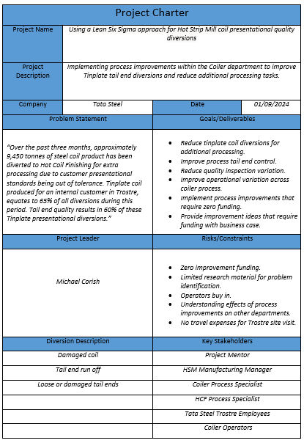

Figure 1 - Project Charter created to highlight key information on project initiation.

Scope Statement

A major determining factor to unsuccessful projects is the lack of understanding or project information at the start of the project. A properly defined project leads to delivering a quality product, cost-effectiveness and within set task time deadlines (Mirza, et al., 2013). The scope statement (Figure 2) defines which areas of the project are within or outside of scope boundaries. These scope boundaries are set by stakeholders that are invested in project outcomes. Through understanding which tasks are achievable and those that are not, will improve efficiency by removing areas of interest that are determined as out of scope. Further areas were documented within the scope statement, such as project objectives and detailing areas associated with risk. Thus, allowing for initial planning to mitigate risks during the project lifecycle.
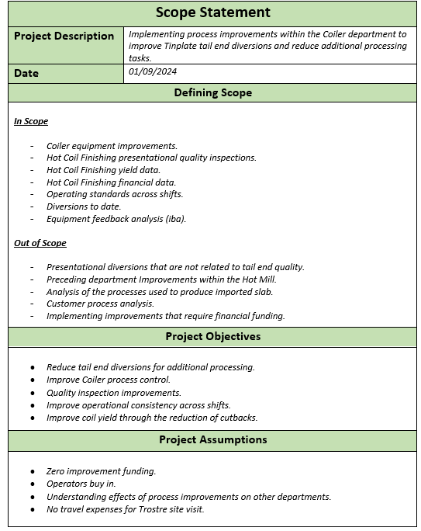

Figure 2 - Scope Statement used to clearly define what lies within or outside scope boundaries.

Timing Plan

(Oburu, 2020) describes time management as the undertaking of planning, scheduling, and exercising conscious control over the amount of time spent on specific activities, leading to enhanced effectiveness, efficiency, or productivity. Selecting the correct method for project time management was essential, ensuring that tasks were accounted for, and scheduled deadlines met before project closure. The DMAIC structure used within Six Sigma methodology created the pathway for planning and scheduling specific activities through the implementation of time management.

Gantt Chart

The Gantt chart was the time management tool selected for project planning (Figure 3), due to its visual simplicity and ability to clearly define specified tasks against timescales. Firstly, an overall duration was outlined from start to project finish, followed by setting the timescales for each DMAIC stage. Thereafter, interpreting and delivering the manageable workload required for specified task completion towards meeting deadlines.
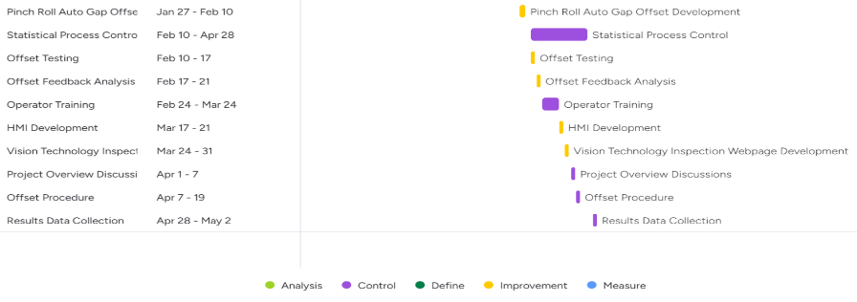
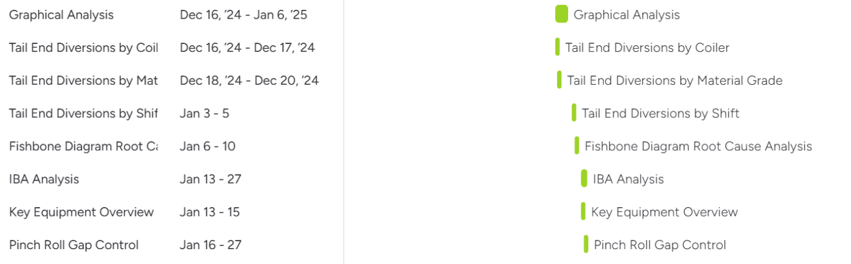
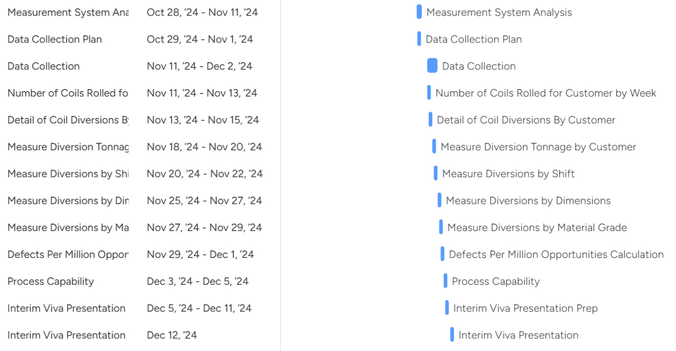
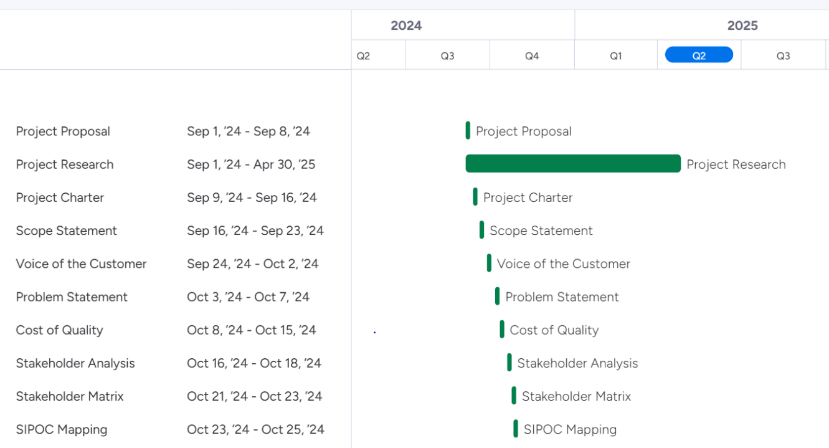

Figure 3 - Gantt Chart timing plan used for DMAIC phase task completion

Research and Literature Review

The research and literature review will provide a baseline of information on the renowned Lean and Six Sigma methodologies, to improve steel manufacturing processes and quality. This review will independently explore Lean and Six Sigma approaches separately, then review the combination of these approaches and the tools used for project outcomes. Also, studying the key principles of the coiling process in steel manufacturing, to provide the reader with the basic knowledge of Coiler operations for future references within this report.

Lean Methodology

(Čiarnienė & Vienažindienė, 2012) suggested that Lean production is a major manufacturing way of thinking that is primarily focused on process improvements that benefit the customer. The main focus is increasing customer value while eliminating process waste including cycle times and resources. (Field, 2000) indicates the development of a production operation that provides responsiveness, flexibility, predictability, and consistency. Further suggesting, this production philosophy creates a continuous improvement workforce driven by output measures that rely on being within customer specifications. The main principles taken from these articles and books were the prominence of customer focused deliverables through Lean application on a production process. Although, (Mostafa, et al., 2013) believes that limited understanding on Lean practices and theories has a prominent impact on obtaining the benefits. Furthermore, (Dutta & Banerjeez, 2014) highlights that the workforce is the driving factor in Lean manufacturing attainability, including employee perception and management influence. The reliance on process knowledge and skills are vital to successfully employing Lean in a manufacturing environment. During Lean implementation multiple tools or methods can be used for successful outcomes such as Ishikawa, Standardised Work and Poka-Yoke. These will be the main Lean tools of focus within this report, so gathering information towards a deeper understanding of these concepts would prove beneficial.

Ishikawa Diagrams

(Ciecińska, 2023) summarises the purpose of the Ishikawa diagram as an analysis tool used for various defects and irregularities, enhancing the possibility to link various effects to a given cause in a universal way. This root cause analysis tool could provide essential information on potential focus areas towards reducing presentational quality defects. Therefore, understanding the layout structure of the diagram would enhance the overall results of application. (Antonelli, et al., 2024) explains the construction of an Ishikawa diagram, as consisting of a horizontal arrow representing the given problem and multiple categories contributing to the effect, creating sub-sections for focus areas that benefit to determining the root cause of the problem.

Standardised Work

(Morrey, et al., 2013) quotes that standardised work documents the current, best practice for carrying out a particular activity/process. Therefore, resulting in a consistent output of high quality product from a consistently performed standard procedure. This will be an essential aspect of this project towards ensuring consistent results across multiple areas such as operator actions, quality inspection methods and process controls. (Pereira, et al., 2016) corroborate this view by highlighting the benefits of standardised work if correctly applied, as establishing a reference point from where to improve process control, variability reduction, stability, and the creation of a platform for learning. However, the implementation of standardised work relies on the employees controlling the process and the management of that process (Gudmundsson, et al., 2004). Furthermore, (Dozuki, 2024) explains that 88% of companies cited low levels of commitment from leadership as a prominent reason for unsuccessful implementation of Standard Work and other lean principles. Therefore, developing a standard working procedure will require commitment from all levels of the organisation to be proved successful.

Poka-Yoke

The Lean tool poka-yoke has multiple definitions when researching literature, although worded differently the key principles remain consistent. (Middleton, 2001) describes poka-yoke as the systematic practice of eradicating errors, by locating their root cause. Whereas, (Shingo, 2021) explains that poka-yoke is a system for error and defect detection, which inspects each individual piece, working predominantly on the operators attention span. To summarise, the main focus for this Lean mechanism would be to improve process output stability through minimising the risk of error.

Six Sigma DMAIC

A Six Sigma project or strategy is characterised by the succession of pre-defined phases, Define, Measure, Analyse, Improve and Control, otherwise known as the DMAIC structure (Barone & Franco, 2012). Whereas (Kwak & Anabri, 2006) define the DMAIC strategy as a closed loop system that removes inefficient steps, focusing on measurements and applied technology towards continuous improvement.

Define Phase

(Smetkowska & Mrugalska, 2018) believe the main purpose of this stage is to verify the relationship between the desired actions to be taken and the business needs of the organisation. Also, ensuring support from management with required resource availability. The misalignment of project tasks and business needs would be detrimental to overall project outcomes, ensuring lines of communication between identified key stakeholders would unify and build a common purpose. Also, (Patil & Inamdar, 2014) highlight critical goals of this phase such as define the problem statement, the customer as well as customer needs, the critical process outputs, the target process and other related business processes, project targets or goals and project boundaries.

Measure Phase

The main focus of the Measure phase is to define the process reference point. While the define phase identifies the initiation of the project, the measure phase aims to define the current state of the process through data collection and determining process capability (Hessing, 2019). Also, (Delgadillo, et al., 2022) believes that the greatest practice is to select and employ performance indicators, allowing for target-oriented analysis where indicators are selected in alignment with project goals and these indicators are used to develop a measurement strategy. Although, (Delgadillo, et al., 2022) insists on performance indicators, within this project capturing the variables of strip steel could be deemed more sufficient in identifying the real root cause during analysis of collected data.

Analyse Phase

The analysis phase of the DMAIC methodology targets the root cause of the problem. Also, developing knowledge on why these defects are occurring, whilst evaluating and identifying opportunities that would have a positive impact on process improvement (Adams, et al., 2003). However, root cause analysis tools are not constricted to be implementation only within the analysis phase. (The Council for Six Sigma Certification, 2018) identifies that the application of root cause analysis tools can be utilised within the define and measure phases, depending on preference. This information allows for increased fluidity in tool implementation across the first three phases of the project cycle, therefore confirming that these can be applied where most useful.

Improvement Phase

(Trimarjoko, et al., 2020) define the improve phase as the selection of improvements that provide best acting alternative measures, reducing the occurrence of the given problem by conducting tests of the actions taken. (Liu, et al., 2023) believes an important process used during the improve phase are designed experiments, which are widely applied within the DMAIC process and deemed extremely important for improvement implementation. Thus, allowing for testing particular process factors and the effect they have on returned results, so the final improvement will be finely tuned when integrated into the process.

Control Phase

Employing statistical tools within the control phase is an integral part of Six Sigma methodology such as control charts (Sarkar, et al., 2014). Also, (Srinivasan, et al., 2016) reiterates this by identifying that developing control charts are the analysis tool to determine improvement results and variation. Whilst also, highlighting the importance of integrating process standardisation through constructing Standard Operating Procedures. To summarise, (Brook, 2017) identifies the aim of control as to ensure implemented solutions become embedded into the process. By achieving this aim, improvements can be sustained long after project closure.

Lean Six Sigma

Lean Six Sigma (LSS) combines the previously mentioned Lean and Six Sigma methodologies through amalgamating tools and techniques from each to achieve desired results. The LSS approach is a structured theory based methodology to improve process standardisation, reduce variation, develop efficient leadership, customer satisfaction and reduce waste (Arcidiacono & Pieroni, 2018) (Snee, 2010). (Arcidiacono, et al., 2017) highlight that the continued success of this methodology in the manufacturing industry has led to further deployment in multiple fields including the service and public administration industries. This confirms the flexibility of this methodologies approach and the successful results that can be obtained from implementing this strategy. (Márquez, et al., 2020) reiterates this, explaining how the relationship of both approaches complete each other by providing enhanced efficiency and helping achieve increased performance faster than utilising an individual isolated methodology. The flow chart below (Figure 4), displays the history of both and how both methodologies were integrated to produce optimal results.
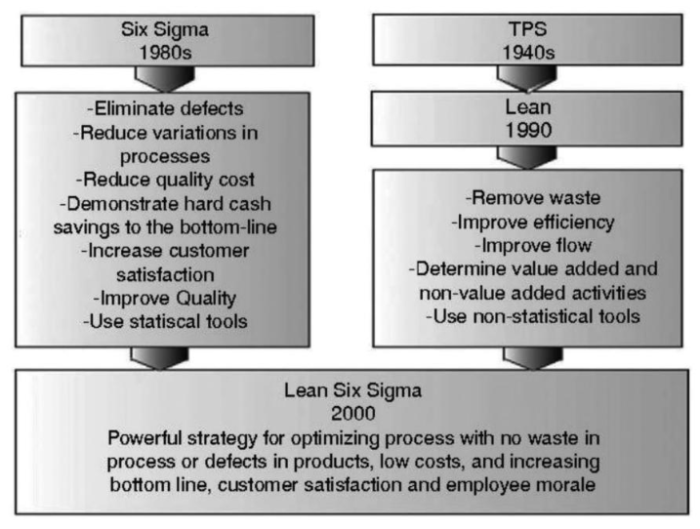

Figure 4 - The integration of Lean and Six Sigma methodologies (Márquez, et al., 2020).

Hot Rolling Coiling Process

An overview of the importance of hot rolling was captured by (Peng, et al., 2014), they indicate that the Hot Mill Process plays an essential role in the industrial field of steel manufacturing. Roughly estimating that 50% of the steel products worldwide, predominantly strip and sheet steel, are produced from Hot Mill processes. The Hot Strip Mill rolling process consists of several sub-processes to convert steel slab into the finished steel coil product. The main sub-processes are re-heating of steel slabs, slab descaling, reducing slab thickness through a roughing mill, reducing strip thickness in the finishing mill, controlled cooling of strip and coiling of the processed strip (Cast Iron Casting Manufacturers & Suppliers - Calmet, 2025) (Figure 5). Although, the basic concepts of Hot Mill steel manufacturing are the same, it is important to note that each are unique and are not entirely identical to each other. Therefore, what may apply to one Hot Mill process could possibly not be applicable to another.
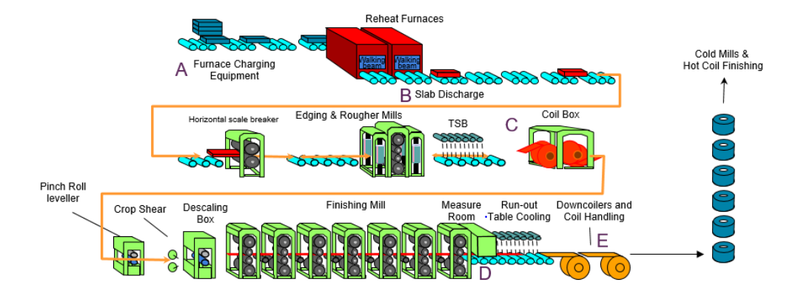
Figure 5 - Visual representation of the entire hot rolling process in Tata Steel Port Talbot (Tata Steel, 2023).

A Downcoiler is used for coiling steel strip delivered from a Finishing Mill, it consists of key process equipment such as side guides, pinch rolls, mandrel, and wrapper rolls (Figure 6). (Choi & Lee, 2009) describes that the main function of the side guides is to direct strip toward the centreline, while the mandrel is primarily used to coil the strip, and the wrapper rolls are used to create head end tension. Although wrapper rolls create initial tension of strip, the pinch rolls are the key tensioning process equipment during the whole coiling process between the mandrel and finishing mill. Pinch rolls are classified by their method of gap control and are primarily hinge or housing types. Both types produce tension by pressing the steel strip between the top and bottom rolls (Lee, 2007). (Majumder, et al., 2023) highlights that the success of coiling largely depends upon the application of the appropriate coiler tension. Also, stating that if the required tension is greater than the capability of the coiler itself, coiling fails to perform properly therefore producing loose laps or loop formation. (Choi & Lee, 2009) believe that coiling technology has seen advancement over the past decades. However, due to the lack of deep understanding on these technologies, redesigning of common coiling procedures have been withdrawn. After review, there must be an importance to understand how this process functions to truly undertake improvements that will remain integrated within the coiling system, ensuring development and sustainability.
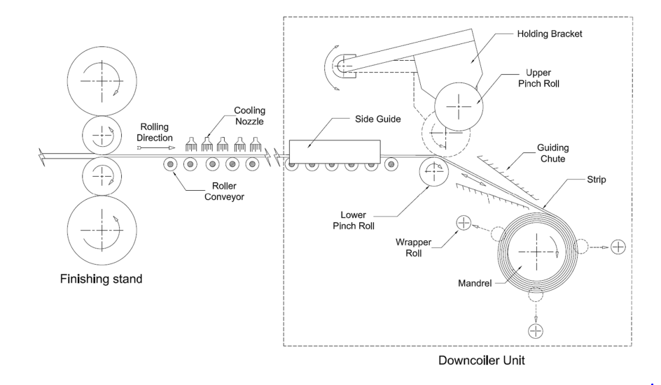

Figure 6 - Visual representation of a Downcoiler process within a Hot Strip Mill (Majumder, et al., 2023).

Work Carried Out

Define

Pareto Analysis

The implementation of Pareto analysis was brought forward due to the number of potential root causes and locations for differing diversion reasons. Determining the ‘vital few’ diversions provided an increased focus to where root causes are emerging and also, developing process improvements that will hopefully deliver an improvement to tinplate presentational quality. After review (Figure 7), the three most frequent diversions (Damaged Coil, Tail End Runoff and Loose or Damaged Tail Ends) are directly linked to tail end quality (outer laps). This information highlighted the Coiler department as an area of focus, due to the areas prominent influence on tail end control. The Telescope diversion was also found to be within the ‘vital few’. However, due to the defect being located at the strip head end (inner laps), this was deemed outside of project scope and therefore, unrelated to the area of study.
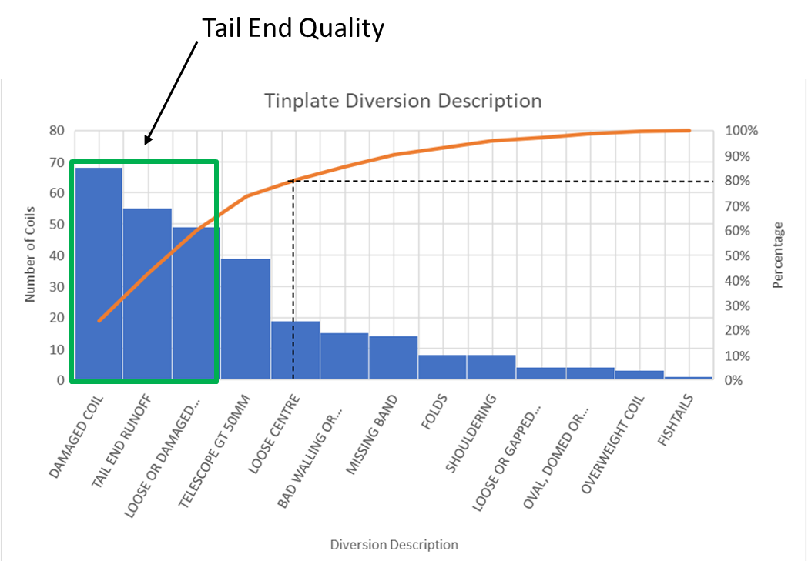

Figure 7 - Pareto analysis of tinplate diversions, highlighting the 'vital few'.
These significant tail end presentational defects are visually displayed in process (Figure 8) (Figure 9) (Figure 10). The location of these defects are based on the outer edges or laps of the manufactured coil product. The coil schematic (Figure 11) indicates the meaning of the term laps and additional key elements to ensure basic understanding.

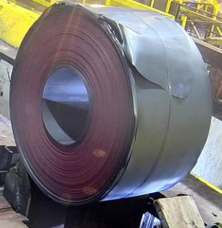
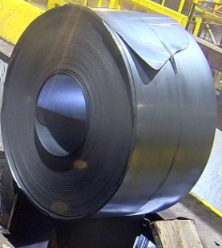
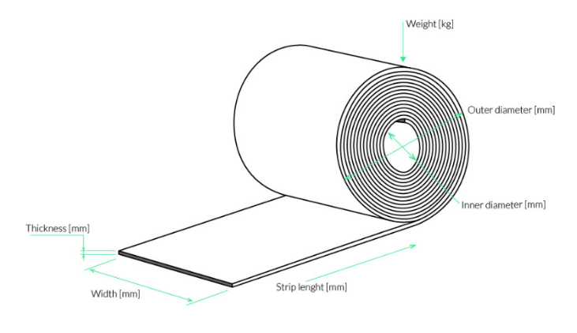
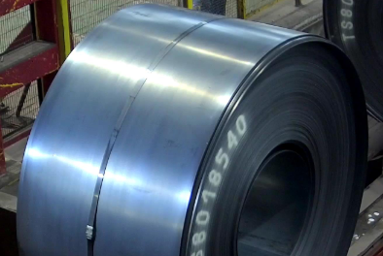
Figure 8 - Loose or Damaged Tail Ends diversion Figure 9 - Damaged Coil diversion
Laps

Figure 10 - Tail End Runoff diversion Figure 11 - Key elements of steel coil product (Dallan, 2016)

Problem Statement

To initialise the beginning of the project, a concise and data driven statement of the diversion problem was developed, otherwise known as the problem statement. The development of this statement was referenced against SMART objectives, ensuring that the statement was Specific, Measurable, Achievable, Relevant and Time-bound. There was an upmost importance that these objectives were met, to ensure the validity of project goals. The problem statement developed for this project is as follows;
“Over the past three months, approximately 9,450 tonnes of steel coil product has been diverted to Hot Coil Finishing for extra processing due to customer presentational standards being out of tolerance. Tinplate coil produced for an internal customer in Trostre, equates to 65% of all diversions during this period. Tail end quality results in 60% of these Tinplate presentational diversions. “

Voice of the Customer

The role of Voice of the Customer (VOC) is to collect, analyse and understand the customers’ needs and expectations. Through applying this at the beginning of the project, provided actionable insights and contributed towards project approval, through identifying customer knowledge of the problem. Therefore, data driven decisions could be made to improve customer satisfaction and enhance the customer’s overall project experience. It was essential to gather the opinions of individuals directly or indirectly affected by the project proposal. Also, collecting feedback from senior management provided an opinion that could be deemed as unbiased (Figure 12).
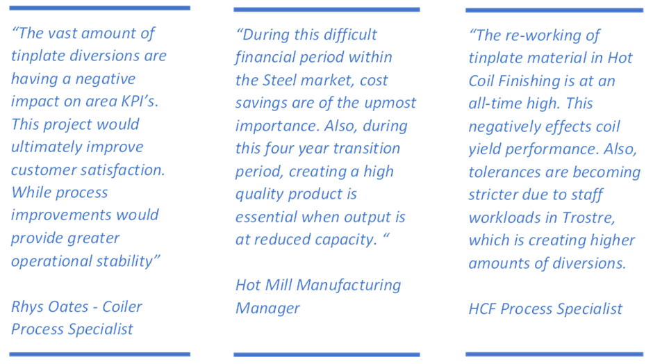
Figure 12 - Voice of the Customer (VOC) project feedback.

Stakeholder Analysis

(Wang, et al., 2012) believes that there is a no overall consensus on the opinion over what exactly stakeholders are. The commonly used definition of a stakeholder was introduced by (Freeman, 2010), who defined stakeholders as “any group or individual who can effect or is affected by the achievement of the firm's objective”. The main purpose of this analysis evaluate and understand stakeholders from the organisations perspective, or to determine their interest or influence on project outcomes (Brugha & Varvasovsky, 2000), and also to utilise feedback on differing stakeholder interests.
Firstly, it was essential to select the key stakeholders who have a direct effect on project outcomes. Stakeholder analysis was used to understand the wants/needs of these selected groups or people, while also capturing their concerns of potential project possibilities. Lastly, grading each individual stakeholder’s interest and influence on the project, helped understand their outlook on project ideas and their input into outcomes. A structured table was created to represent captured information (Figure 13). Also, grouping stakeholders required developing future actions for each during the project lifecycle through creating a stakeholder matrix of influence against interest levels (Figure 14).

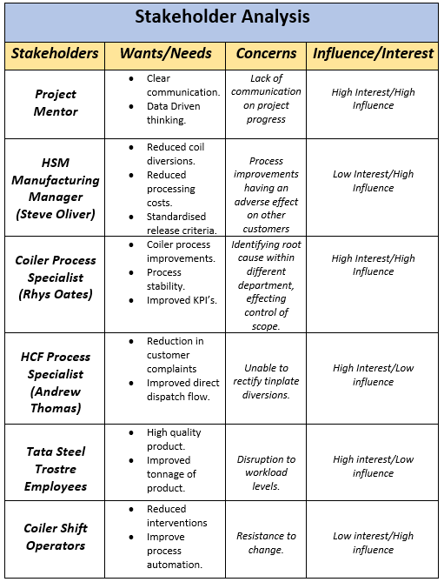
Figure 13 - Table detailing information captured during Stakeholder Analysis

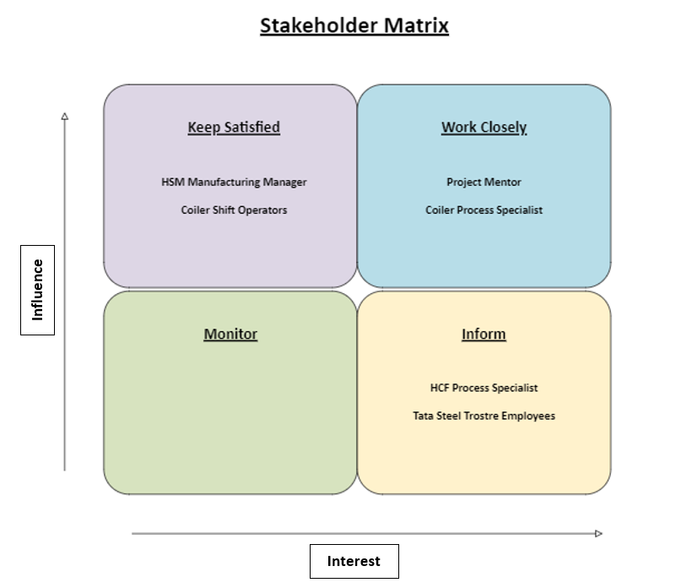

Figure 14 - Stakeholder Matrix of further actions to be taken.

SIPOC

SIPOC diagrams are a Six Sigma tool used for documenting business processes. This tool was used to cover all areas of the plant, providing an overall picture of the steelmaking process in Tata Steel Port Talbot (Figure 15). The SIPOC diagram does not contain detailed information about each individual process, classifying this as a high-level process map (Kothari, 2024).
During the past three months, major changes have been made to Hot Mill slab supply due to the closure of heavy end assets. Therefore, importation of externally produced steel slab requires transportation on a global scale. This has an adverse effect on slab stocks, leading to reduced Hot Mill productivity over the four-year transition period. However, Hot Mill processes such as Reheat Furnaces, Reversing Rougher, Coil Box, Finishing Mill, Downcoilers and Hot Coil Finishing remain operational.
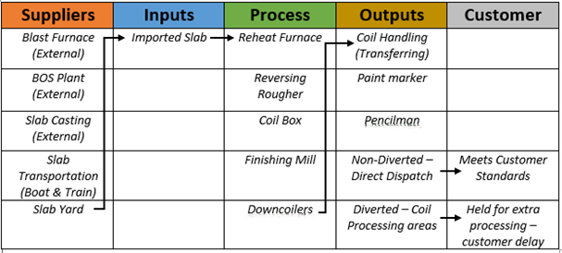

Figure 15 - SIPOC diagram of the current steelmaking operations in Tata Steel Port Talbot.

Customer and Quality

During this current reduced tonnage period sustaining a loyal customer base was essential for Hot Mill sustainability. Although product mix can vary over a weekly period there are majority customers that are consistently rolled through the Hot Mill process. The four main customers of Port Talbot Hot Mill are as follows:
- Cold Mill – CAPL/Shotton/Zodiac – C/CF – 15kt
- Tubes – Corby/Hartlepool – DC/DH – 6kt
- Tinplate – Trostre – T/TS – 6kt
- Llanwern – DL/DD – 6kt
Understanding customer requirements and expectations improves product satisfaction. The customer selects the coil width, gauge and grade required; however, the Hot Mill controls the quality of output. There are multiple requirements that define the level of coil quality. Control measures are implemented for each requirement to ensure quality defects are captured before supplying the customer (Figure 16) (Figure 17).

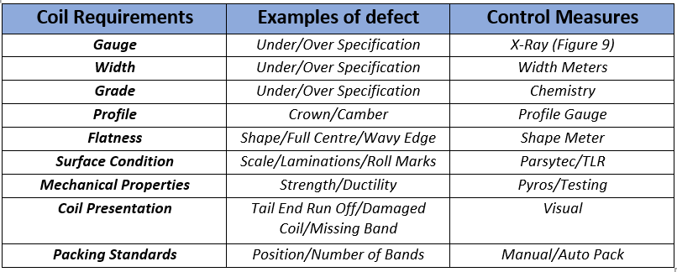
Figure 16 - Customer requirements and control measures used within Port Talbot Hot Mill for quality performance
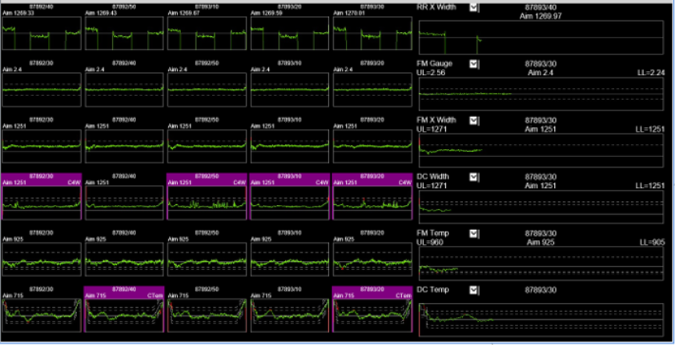

Figure 17 - Live feedback of customer specifications such as temperature, width, and gauge.

Customer Release Standards

Counter measures used to detect coil presentation standards are carried out visually within the Pencilmans role located in the Hot Coil Finishing Department. Each customer’s release standards vary by requirements for own downstream processes. The Pencilman visually compares product standards against pre-determined release standards (Figure 18). Therefore, if standards are perceived to meet required specifications, then coils are transported for direct dispatch to customers. Although, coils deemed to be out of tolerance are diverted to additional processing areas depending on the presentational defect identified.
When comparing Trostre material against alternate customer release standards, there were marginal differences and sufficient leniency of presentational tolerances. Additionally, Trostre has an additional release standard of seven inner and twenty outer laps. Therefore, any defect within these determined areas was not acceptable. The next phase of the project required thorough data collection towards identifying the root causes.
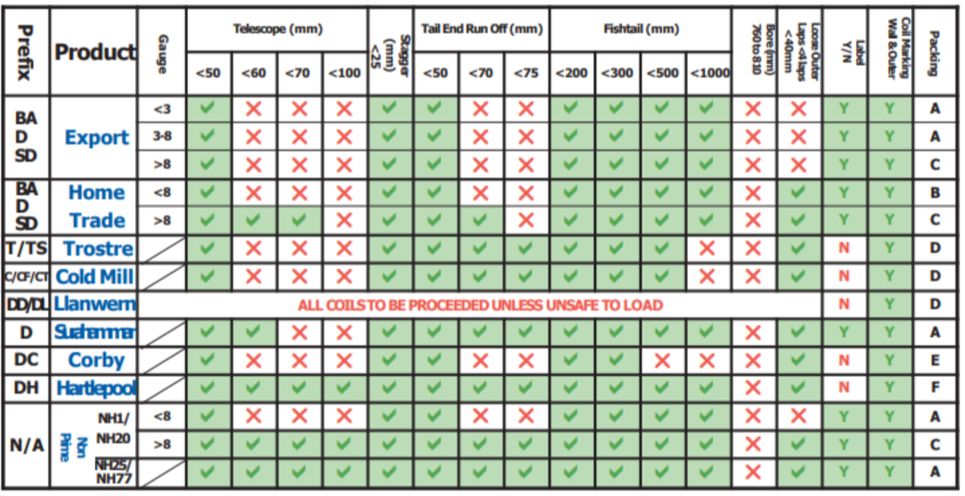

Figure 18 - Current customer release standards used within the Pencilmans role of Hot Coil Finishing.

Measure

Measurement System Analysis

Measurement System Analysis (MSA) was a tool selected to investigate variation in the Pencilmans quality audit procedure. Traditional MSA identifies control through tracking results within specified upper and lower control limits. Although, due to the current quality measurement process and attribute data collection such as determining coils that pass or fail inspection, an interpretation to traditional MSA was necessary.
An uncomplicated trial was selected to measure variability within the current measurement process, by modelling the current process of visual measurements to determine coil quality against customer specifications. The trial required the Pencilman from each shift to determine the length of a 50mm piece of banding wire from eight feet. The collected results were then inputted to visually display the findings in graphical form (Figure 19). The results clearly show the variability within the current measurement system, with only one shift determining the correct length. To improve variability, would require limiting perception from quality inspection methods. Therefore, introducing Coiler process improvements to produce higher quality coil and reduce the need of perception. Also, providing new methods in assisting the Pencilman role with decision making.
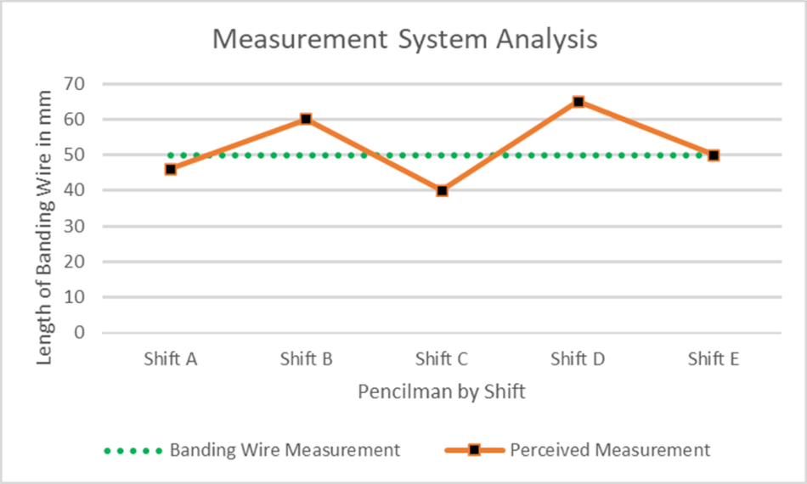

Figure 19 - Measurement System Analysis results from trial carried out on Pencilman visual measurements.

Data Collection Plan

(Taherdoost, 2021) believes that plenty of quality time should be spent in the collection of data to obtain appropriate results otherwise insufficient and inaccurate data prevents decreases accuracy of results. The data collection plan (Figure 20) was developed to guide the data collection process in the correct direction. Through documenting specific questions to be answered, allowed for outcomes to be centred around the given problem affecting process output. Thereafter, areas for data collection provided the scope in which information would be applicable to understanding the root cause. The software of choice for data collection was Structured Query Language (SQL), this created the opportunity to extract required data from Hot Mill databases. Finally, selecting data collection timescales and display formats outlined timing plan requirements and graphical analysis methods.
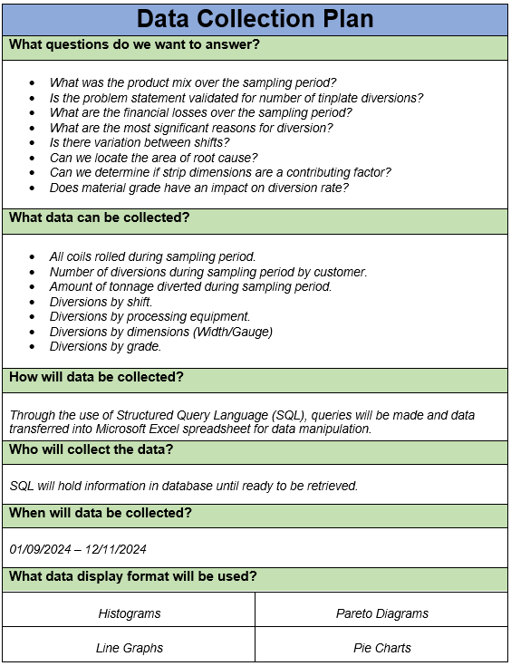

Figure 20 - Developed data collection plan to initiate the measure phase project.

Hot Mill Customer Product Output

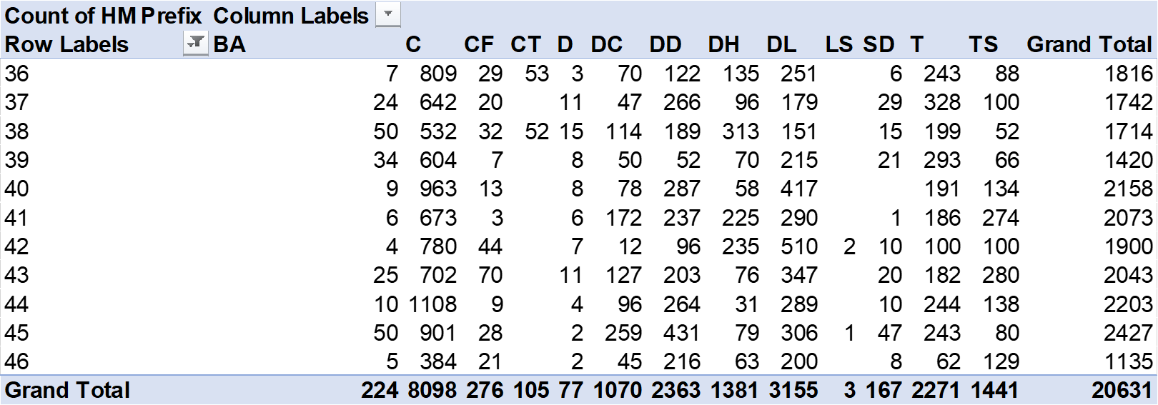
To understand the Hot Mill product mix over the data collection period, the total number of coils rolled through the process were collected (Figure 21). The coil data was filtered by week and customer to determine the amount of coil output per customer. Additionally, the prefix’s used for identifying Trostre products are displayed as T and TS.

Figure 21 - Number of coils produced for customer by week over data collection period.

Tonnage of Diversions by Customer

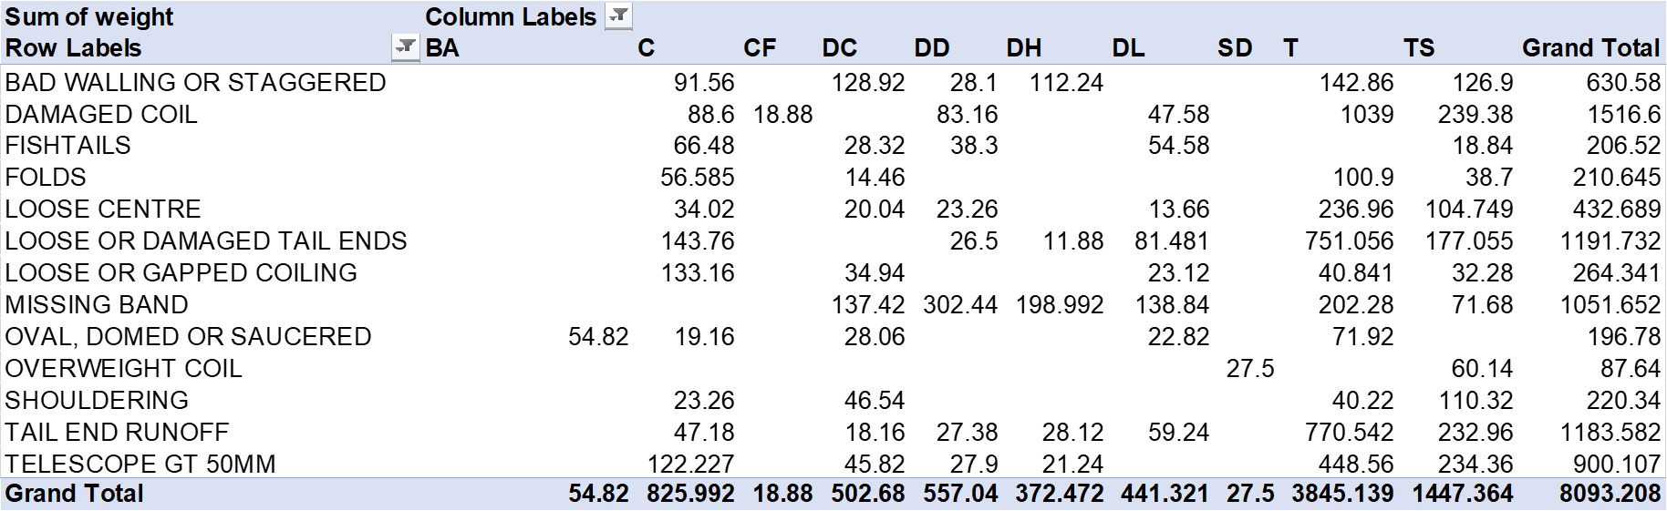
This data set (Figure 22) displays the tonnage rolled over the collection period whilst filtering the results by customer and diversion reasoning. The information was used previously in performing pareto analysis to determine the vital few diversions for coil defect location. Furthermore, the collected data was vital to representing financial losses associated with coil re-work, due to tonnage being the metric determining the overall costs of additional processing.

Figure 22 - Data collection of diverted tonnages by customer and reasons for diversion.

Coil Presentation Annual Cost of Quality

The following calculations (Figure 23) were performed to identify present company costs towards good and poor quality. As previously mentioned, the Pencilman role has been identified as the individual quality measurement system utilised for coil inspection. Therefore, the calculation used for determining good quality costs was uncomplicated, as role salaries across five shifts were combined to provide given result of £200,000. However, Hot Mill processing costs would have provided helpful information in understanding the costs of coil production, but these financials were unattainable.
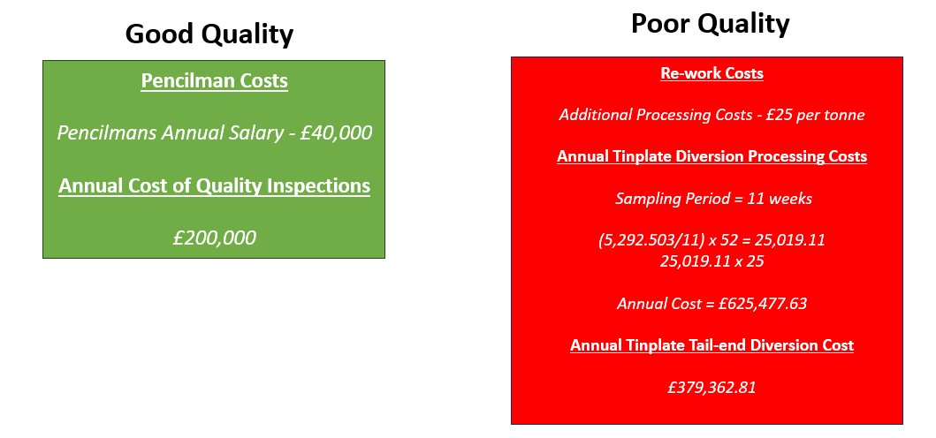
Understanding the financial losses of poor quality required using the data collected for diverted tonnages over the sampling period. The current additional coil processing costs are £25 per tonne. From this information, it was possible to determine the annual costs of re-work for Tinplate material and also, breaking these costs down to identify the costs of tail end diversion re-work. Although, annual financial costs provided were approximations from the 11-week sampling period, determining projected losses if current diversion rates continued.

Figure 23 - Projected annual costs of good and poor coil presentation quality.

Trostre Tail End Diversions by Shift, Gauge and Grade

Breaking down diversions by shift data (Figure 24) was essential in gaining knowledge on process variability between differing operating procedures and Pencilman inspection standards. If there is variation between shifts, analysis would be used to understand what process inputs are being used against quality of output for developing future improvements.
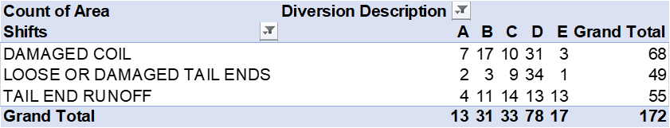
Figure 24 - Trostre tail end diversion data against individual shifts.
Typically Trostre coil is a light gauge product, indicating that strip thickness is always below 3mm unless alternative gauges are selected due to processing department delays. The reason behind collecting gauge diversion data, was determining tail end quality output against specified strip thickness. The data was filtered into gauge groups and tail end diversion reason (Figure 25).
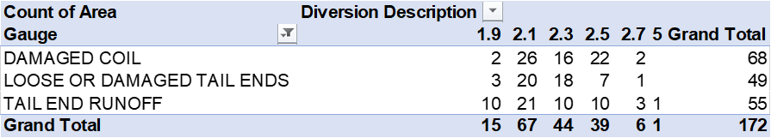

Figure 25 - Grouping of tail end diversion data by gauge.
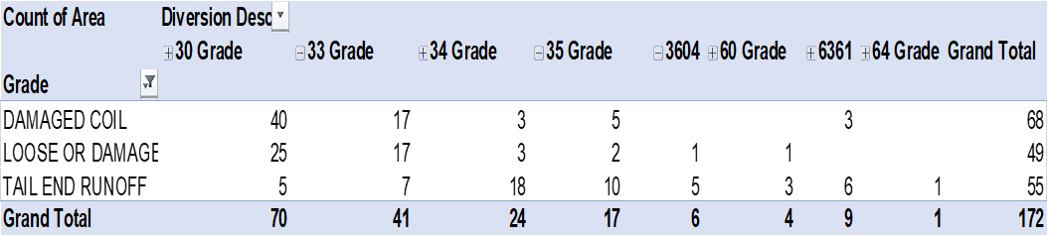
This area of data collection was to understand the effects of material grade on product quality output (Figure 26). Identifying a specific material grade may provide a process capability issue. Although, if diversions are spread across multiple grades, this would indicate standard process equipment weaknesses for tinplate manufacturing.
Figure 26 - Tail end diversions by material grade.

Trostre Tail End Diversions by Coiler and Width

The final groups of data collected were directed towards Coiler identification (Figure 27) and the effects of strip width on tail end diversion numbers (Figure 28). From the data provided, narrower dimensions and Coiler 5 production contributed to greater amounts of diverted material. This information allowed for increased focus for in-depth analysis on the potential causes influencing diversions.
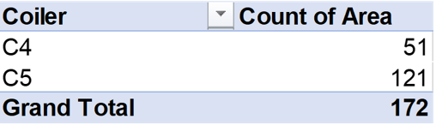

Figure 27 - Collected data of tail end diversions by Coiler identification
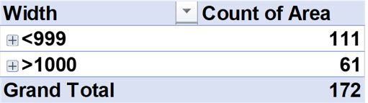

Figure 28 - Collected data of tail end diversions against grouped width dimensions

Defects Per Million Opportunities and Process Capability

The data collected was used to calculate the Defects Per Million Opportunities (DPMO), to understand the Six Sigma level of the company during this current period. From these results, quality and process performance provides a metric to work against once improvements are made. The following calculations (Figure 29) were made to determine sigma levels for all products and Trostre related material:
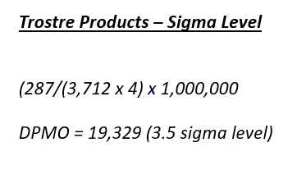
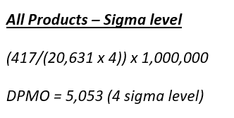
Figure 29 - Calculations for determining DPMO and Sigma level
The results show that DPMO for all products is significantly less compared to DPMO for Trostre products, providing a difference in sigma levels. These results will be used for comparison with data collection after improvements are made. Also, due to the use of attribute data in quality inspection methods with no upper or lower specification limits, these results were used as an alternative for interpreting process capability. The comparison table (Figure 30) identified that current process capability for tinplate material was approximately 1.2 Cpk, indicating that the process was barely capable and required tight control. This highlighted that process improvements were required to improve sigma levels whilst also improving process capability for greater control of quality.
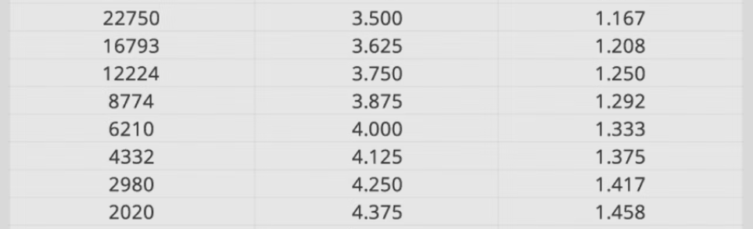
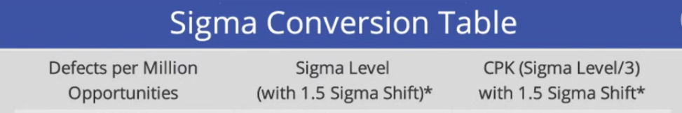

Figure 30 - Sigma level conversion table to identify process capability (MoreStream, 2024)

Analysis

Graphical Analysis

Once the required data had been collected, producing a variety of graphs for data sets was vital to identifying areas of focus towards root cause identification. Through developing these graphical tools, provided greater ease in identifying focus areas rather than analysing large data sets. Thereafter, specifying key variables associated with tail end quality through Ishikawa diagrams, then utilising ibaAnalyser software for equipment feedback and operating procedure analysis, leading to root cause identification and improvement development.

Tail End Diversions by Coiler

Analysing the number of tail end diversions by individual Coiler (C4 & C5), displayed the magnitude in from specific Coiler production (Figure 24). The diversions from C5 stood at 121 coils or approximately 70% over the data collection period compared to 51 coils from C4. Thus, allowing for further questions, such as ‘What are the key differences between C4 and C5?’ and ‘Do equipment set ups differ by individual Coiler when manufacturing the same product?’. By answering these questions would further progress root cause identification.
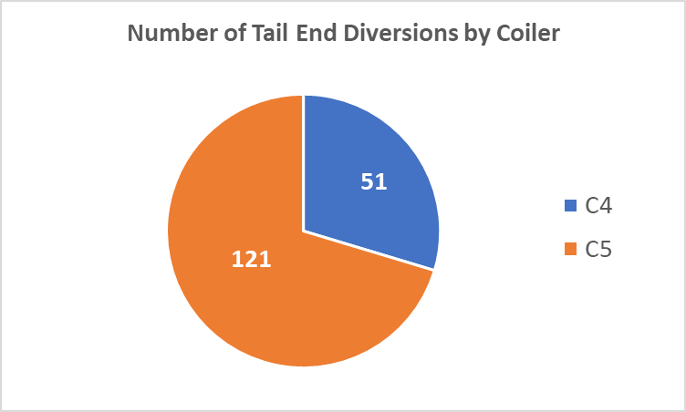

Figure 31 - Pie chart displaying number of tail end diversions by Coiler.

Tail End Diversions by Material Grade

The column graph (Figure 32) displayed the relationship between tinplate steel grade and the diversion reasoning over the data collection period. This information clearly displayed that lower carbon steel such as 30 and 33 grades created higher amounts of damaged coil and damaged tail ends. Whereas tail end runoff diversions are spread across multiple grades, however higher carbon steel such as 34 and 35 grades were the most prominent when interpreting data. The data displayed potentially shows the same root cause affecting Trostre tail end quality. Although not yet proven, outer laps of steel coil being outside requirements has the potential to cause larger amounts of strip damage due to higher levels of ductility and malleability linked to lower carbon content steel. However, higher carbon contents display increased hardness properties, therefore less susceptible to damage but still outside of customer specifications leading to tail end run off diversions. Further analysis would be required to provide validation of this hypothesis.
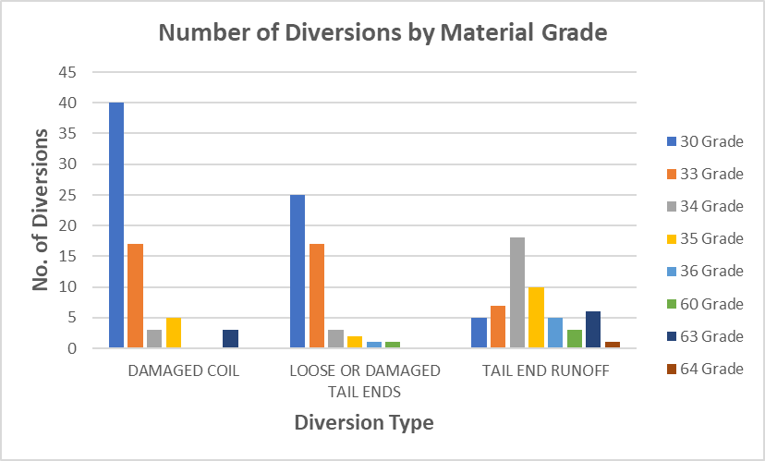

Figure 32 - Column graph of tinplate tail end diversions against material grade.

Tail End Diversions by Shift

From analysing the number of tail end diversions by shift, the graph (Figure 33) displayed the variability in quality of tail end output between shifts. From this information, D rota produced 78 diversions over the 11-week period, considerably higher than the 5-shift average of 33.4 diversions. These results displayed inconsistency across all shifts, requiring operating procedure and set up analysis for coiling tinplate material. Therefore, operating comparisons was required in developing a standard operating procedure that would benefit quality and a standardised output of all operators leading to a reduction in product variability.
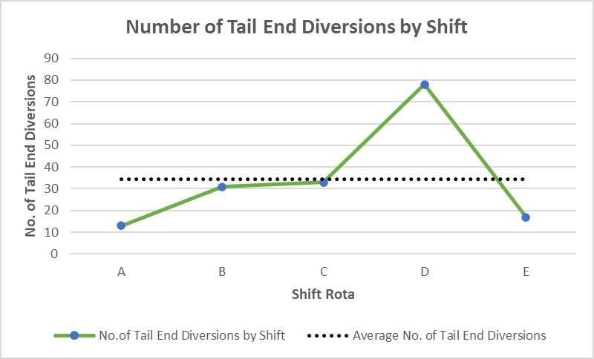

Figure 33 - Line graph of tinplate tail end diversions by shift rota.

Ishikawa Diagram

An Ishikawa diagram (Figure 34) was created to breakdown the potential root causes of poor tinplate tail end quality. These were split into specific categories to capture each area of possible root cause location and provide a visual aid when reviewing causes. From these specified categories, the specific causes linked to each section were derived and recorded within. From reviewing this information, potential root causes can be prioritised for further analysis or eliminated from question. For example, the consistent results in data collection for strip width and thickness variation, allowed for root cause elimination due to tail end diversion figures spread across all measured dimensions of the product.
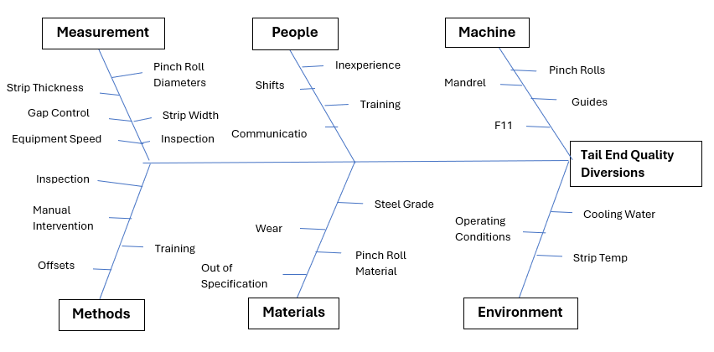
Figure 34 - Ishikawa diagram displaying potential root causes associated with tail end quality.

IBA Analysis

‘ibaAnalyser is a software for offline analysis of data. The software offers database connectivity, enabling database queries to be made to load historic data. The software offers a versatile arsenal of signal processing tools. All signals can be visually represented for the user to study. ‘ (Kurttio, 2023)
ibaAnalyser software allowed for cross referencing of diversion coil identification into the systems historic data search. This granted historic signal analysis of Coiler process equipment when processing tinplate material, allowing for comparison of system requested values (set) and actual recorded values (measured). The main equipment functions that were investigated during analysis included speed, current and gap control. Also, creating an understanding of how operator set ups effect tail end quality and how improvements may be utilised. The following iba analysis reviewed key Coiler process equipment for tail end control which included mandrel, pinch rolls, and side guides.

Key Process Equipment Feedback Overview

The analysis traces below (Figure 35) displayed the behaviour of process equipment on an individual tinplate coil which was diverted for tail end run off. Following video review, this quality defect began once the strip had departed F11, the signal feedback is displayed as the green bar within the traces. Furthermore, the area of concern was highlighted once the strip detection signal of metal in the F11 location was lost. There is an importance to understand the control concept of coiling operations, during the period of metal within F11, the coiler operates in current control. This means that equipment motor current feedback controls operating speeds. As an example, if pinch roll current feedback was lower than the systems set value, then mandrel and pinch roll speeds would also perform under there individually set system values. However, once strip departs F11, these control measures switch from current to speed control. These changes are required due to the volatility of current feedback during the tail end control phase of coiling. After developing an understanding of how these equipment factors and control systems rely on each other during operation, individual analysis on feedback traces for tinplate product was carried out to pinpoint areas for improvement.
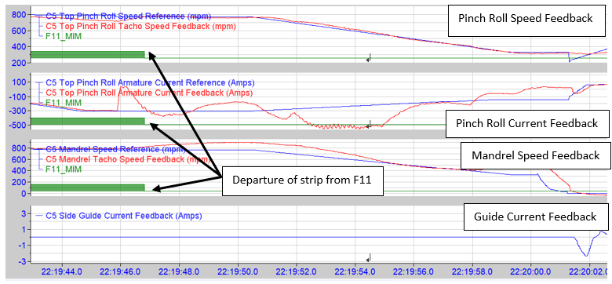
Figure 35 - Overview of iba analysis on tinplate tail end run off

Pinch Roll Gap Control

Through equipment feedback analysis, discoveries were made to the volatility in mandrel speeds depending on pinch roll gap offsets. These offsets determine the gap between top and bottom pinch rolls and therefore, the amount of tension on strip once the tail end has departed the Finishing Mill. Pinch roll gap control has minimal margins for error, usually operating within a 0.1mm range. Anything outside this optimum range can cause adverse effects on tail end strip quality. Also, tinplate coil manufacturing requires running at maximum equipment speeds compared to all other product ranges due to its required metallurgical structure. Therefore, controlling tail ends to a stop whilst using the pinch rolls as a braking system requires an elevated level of control. The following analysis reviewed the contribution of selected pinch roll gaps to tail end quality and the variables that influence end results.
Pinch roll slip is a common term used within the Coiler department. This term means that during coiling operations, the top pinch roll is not contacting the top surface of the strip therefore providing minimal tension during operational performance. Consequently, this causes mandrel speeds to rapidly increase over required values once departing the preceding Finishing Mill stand. Therefore, releasing strip into the coilers at elevated speed, posing potential risk to equipment damage and the coil itself. When analysing damaged coil and damaged tail end diversion coil identification numbers, the inherent feedback traces linked with pinch roll slip were prominent amongst the majority of results.
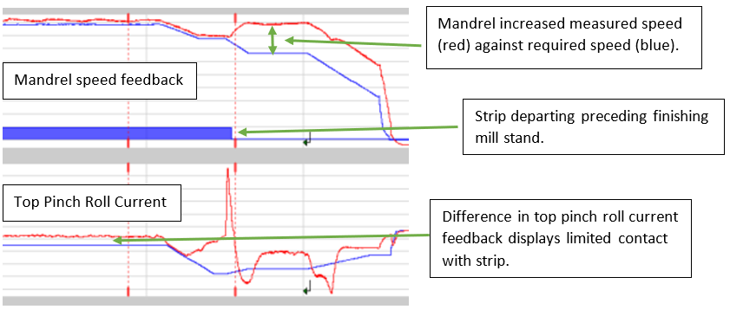
Figure 36 - Consistent equipment feedback traces of damaged coil and tail end diversions linked to pinch roll slip.

The use of operator manual intervention to counteract pinch roll slip for tail end control was also captured during analysis. In short, the operator identified the increase in mandrel speed then decreased the pinch roll gap manually from the operating desk to reduce mandrel speeds to their set value (Figure 37). Although, this intervention predominantly caused negative effects to strip quality. For example, a driver braking a car at high speed has less control of the vehicle when braking suddenly than braking consistently over a longer period. This methodology corresponds with reducing strip speed, these sudden changes in speed were found to be linked to tail end run off diversions. The sudden impact of the pinch roll on steel strip caused outer coil laps to divert away from the coil face.
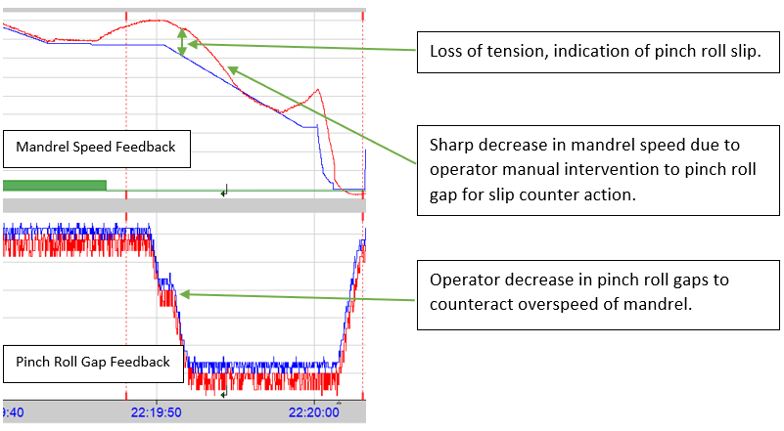
Figure 37 - Feedback of operator pinch roll gap intervention to correct mandrel speeds, leading to tail end run off

After analysing the effects of oversized pinch roll gaps on tail end quality, there also required understanding on the influence of operating with lower pinch roll gap measurements. After review, the reduction in these gaps eliminated pinch roll slip during tail end operations. However due to the volatility of pinch roll gap selection, tail end diversions were still apparent where no manual operator interventions were made (Figure 38). Tail end run off was found to be the most prominent diversion in these cases. The squeezing of strip between top and bottom pinch roll causes the tail ends to track off coil centreline. Therefore, increasing the probability of being outside Trostre quality specification such as the twenty outer laps rule. Also, due to the increased distance of Coiler 5 from Finishing Mill stands compared to Coiler 4, potentially indicates the reason for increased tail end diversions from this specific coiler. This identified that the length of strip once departing the last stand was longer, therefore requiring increased reliance of pinch roll control over time. Therefore, through limited control of tail ends, Coiler 5 produced higher amounts of coil laps off centreline.
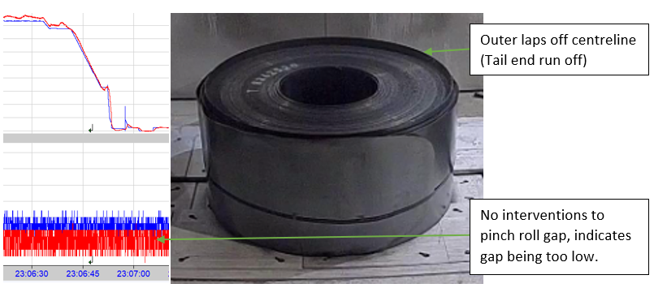
Figure 38 - Trace feedback highlighting low pinch roll gap selection leading to tail end run off

A key aspect of the analysis phase was understanding the operating procedures across all shifts, due to the variability in results during graphical analysis. Over the sampling period results showed that D rota had the highest output of tail end diversions, whilst A rota produced the least. Through the use of ibaAnalyser, there was opportunity to understand operator equipment set ups and any manual interventions used during tinplate coiling. The main difference found on investigation was the manual intervention of pinch roll gaps during tail end sequence of operations. Reviewing A rota trace feedback, discoveries were found on how pinch roll gap offsets were lower than D rota operators for pinch roll slip counteraction. Although, the key aspect of tail end control showed A rota operators increasing pinch roll gaps once strip had departed the Finishing mill stands, therefore relieving strip tension during the braking period and counteracting the probability of tail end run off (Figure 39).

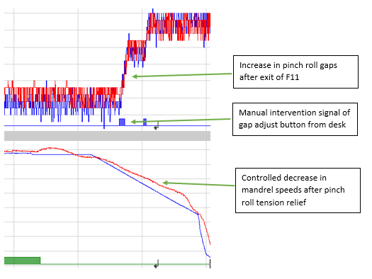

Figure 39 - The best practice of tail end control by A rota operators

Also, another discovery made during key equipment analysis included the utilisation of coiler guides during tail end operations. The analysis displayed high motor currents from guide feedback when adjusting pinch roll gap adjusts, therefore using the guides to maintain tension while relieving the tension produced by pinch rolls. Although, due to the manual intervention required from operators for each coil, these operations were found to be sporadic. Furthermore, the probability of producing diversions will always occur when relying on operators to manually implement these changes for each coil, due to workplace distractions such as training of other personnel and operator interventions to other areas of coiler equipment. Additionally, another variable effecting tail end diversion production through gap adjusting operations was also unearthed such as manual intervention timings. For example, the increasing of pinch roll gaps too early created pinch roll slip and actioning these too late continued causing strip to track off centreline. Therefore to optimise tail end control, standardisation of the best tail end operating procedure was required across all shifts through offset assistance.

Improve

The main focus during this phase of the project required developing improvement ideas that met stakeholder targets and mitigated the risks captured within the project charter. The following improvements were developed through the gathered understanding of information found in root cause analysis, whilst also advancing the coiler process through improvements that required zero company funding due to the current financial environment.

Pinch Roll Auto Gap Adjust Offset

The specific pinch roll gap control procedure utilised for tinplate tail ends produced a consistent output of high quality coil. The aim was to create a standardised procedure through process automation, to reduce variation in diversions across all shifts. To achieve this aim, developing an operator offset into the current control system was required using Functional Block Diagram (FBD) programming. (Duschl, et al., 2015) state that FBD is widely used by software engineers to specify the software part of industrial automation systems. Also, highlighting that its primary concept is data flow from inputs to outputs through function blocks or functions that offer a wide range of signal operations. Before programme development began, the specification of required parameters were collected to ensure desired results (Figure 40).
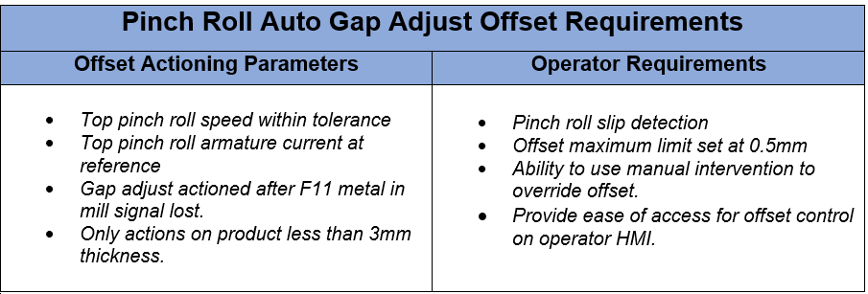
Figure 40 - Requirements for pinch roll auto gap adjust operator offset code.
The Functional Block Diagram (Figure 41) displays the developed program used for the pinch roll auto gap adjust offset on Coiler 5. The diagram accounts for several offset and operator requirements identified in (Figure 40). Also, the key aspects of the program are highlighted in greater detail below, allowing for enhanced understanding on the functions used and how they apply to the process.
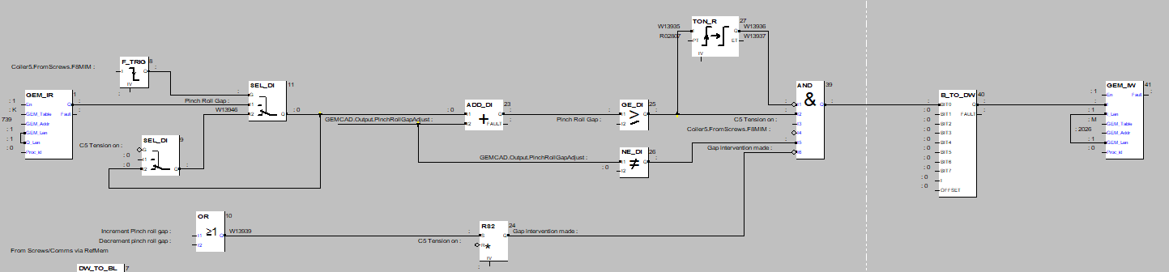
Figure 41 – Coiler 5 auto pinch roll gap adjust offset Functional Block Diagram
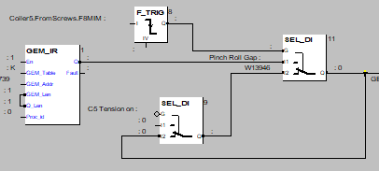
The first phase of the gap adjust program (Figure 42) required capturing the present gaps between top and bottom pinch rolls, this is displayed as GEM_IR inputted into the SEL_DI function. The F_TRIG function block outlines the start signal for pinch roll gap increase on strip tail end, the actioning point within the process for offset utilisation. The primary focus of actioning gap increase at the final finishing mill stand (F11) required alterations on Coiler 5 (C5) during practical testing, due to an issue in offset timing still producing tail end run off. After trialling preceding finishing mill stands, F8 was selected as the optimum actioning point for the C5 program. However, for Coiler 4 (C4), the final stand (F11) was identified as the correct timing. The SEL_DI function requires the F8 metal in mill (F8MIM) and C5 tension on signals to be true for advancing offset programming steps.

Figure 42 - Coiler Data Capture and F_TRIG/SEL_DI function purposes.
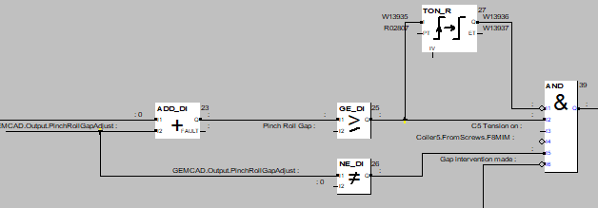
The next phase of programming required setting offset actions and parameters towards offset operation (Figure 43). Firstly, the ADD_DI function block was inserted to add the tail end offset figure selected by the operator to the originally recorded pinch roll gap. Following on, specific conditions were developed to ensure the selected offset was within functional boundaries. GE_DI ensured that the pinch roll gap after operator offset selection was greater than or equal to the originally captured pinch roll gap. Also, NE_DI allowed for offset enabling when the operator selected value was not equal to zero. Finally, error proofing the operation of increasing pinch roll gaps was essential to protecting equipment lifespans and production availability. The TON_R block was inserted to counteract the possibility of pinch roll gaps continuing to increase during tail end operations through implementing a preset timer for gap adjustment operation. Therefore, once the preset time has been met all gap increasing operations will cease, preventing the negative outcomes of failures to stop.

Figure 43 - Pinch roll offset additions, set conditions, and screw jack running time limiting towards error proofing
Additionally, further logic was implemented to allow operators to abort automatic offset operations through manual intervention (Figure 44). The reasons for pinch roll manual intervention include operational abnormalities that are critical to overall process availability. Therefore, introducing this logic into the program, created an escape clause for operators if they were not satisfied with the outcomes of offset enabling.

Figure 44 - Operator manual intervention logic for offset disabling
Following previous analysis, pinch roll slip was a prominent factor when investigating tail end quality diversions. The limited tension produced due to pinch roll gap selection was inherent in the occurrence of slip. Therefore, creating a pinch roll slip detection logic to support the newly developed pinch roll auto gap offset was essential due to the potential impact of decreasing tension from increasing pinch roll gaps. The following program was developed to counteract these differences (Figure 45).
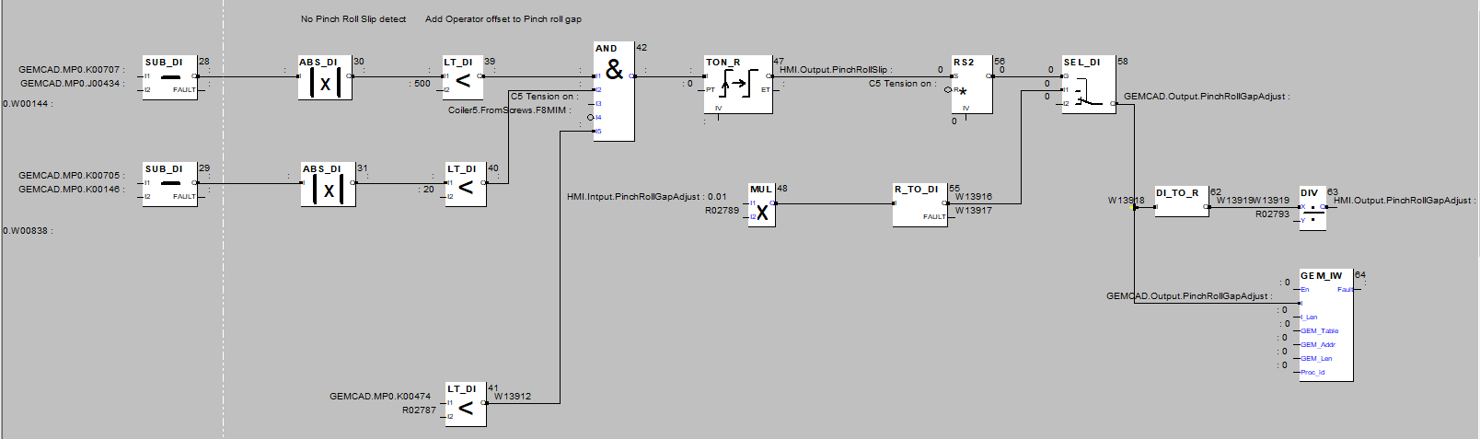
Figure 45 - Pinch roll slip detection Functional Block Diagram
To begin, the process variables that determine pinch roll slip were captured which include top pinch roll speed and current (Figure 46). Through implementing the SUB_DI block, the subtraction of measured value feedback against control system value requirements were calculated to determine the difference of both process variables. Furthermore, the mixture of positive and negative values in these calculations required the ABS_DI block to remove the signs and focus on the absolute value, therefore reducing the complexity of calculations. Also, difference parameters were conditioned within the logic to ensure pinch roll slip was not present during operations. Through applying LT_DI, differences less than 50 m/min for top pinch roll speed and 20 amps for top pinch roll current, safeguards from the consequences of pinch roll slip. However, any calculated value outside these parameters results in offset disabling towards the individual coil, until set up adjustments are applied. The final requirement for offset utilisation requires a strip thickness less than 3mm, due to the association of tail end diversions between 1.9-2.7mm thickness.
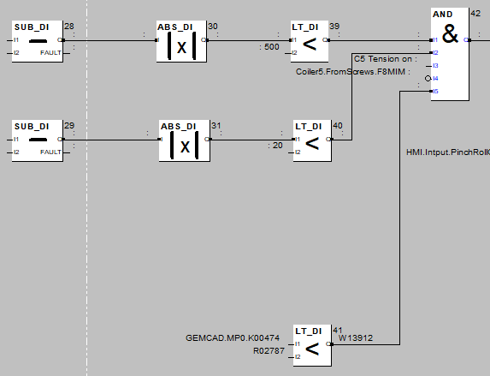
Figure 46 - Setting specific conditions to be met for no pinch roll slip detection and offset enabling.
The next phase of the program (Figure 47) applied TON_R to the previously mentioned pinch roll slip parameters. Through implementing a timer, ensured that calculated values were within set boundaries and no pinch roll slip was present over a consistent period time. This information was then applied to RS logic, therefore if no pinch roll slip was present then the input (S) was derived as true allowing for function output. Therefore, with a true output from RS2 then the input of SEL_DI was used to output the automated pinch roll gap offset. The input identifies the operators offset selection through the control room HMI. Although due to the incremental adjustments made to pinch roll gaps, the control system required integer values, so conversion by the multiplication (MUL) function was essential to producing an output. Therefore, once the offset was outputted, conversion from integer to decimal values by division (DIV) for operator HMI feedback was implemented.
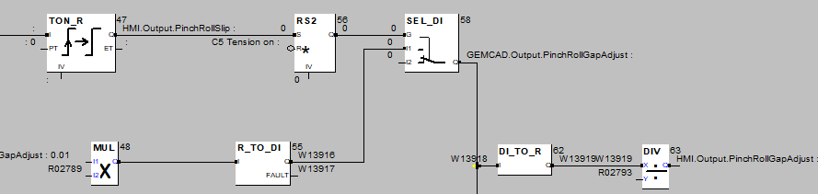

Figure 47 - Pinch roll slip detection timer, RS logic and value conversion for HMI input/output

After testing logic through offline simulation, the offset was enabled for practical testing with Coiler operators. The feedback analysis (Figure 48) outlines the successful operation of automatic pinch roll gap increase for tinplate tail ends through HMI offset selection. The analysis displays the gap increase from 1.15 to 1.35mm after an offset selection of 0.2mm, whilst actioning this increase after the metal in Finishing Mill signal was lost. Also, monitoring mandrel speeds to ensure pinch roll slip detection logic was operating correctly and limiting the adverse effects of mandrel overspeed.
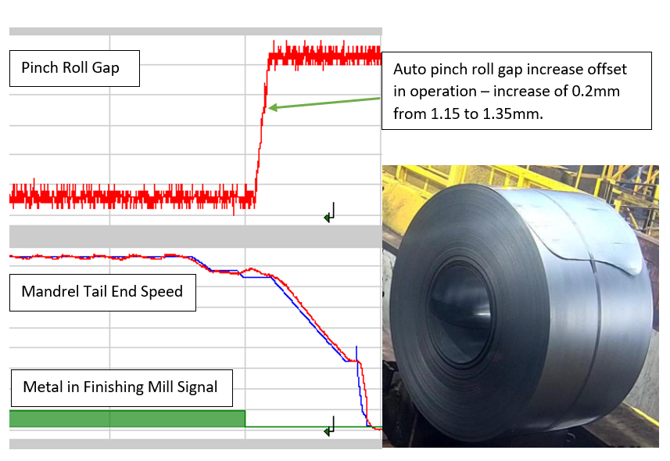

Figure 48 - IBA feedback of offset logic utilisation displaying automatic increase in pinch roll gap for tail ends

Human Machine Interface (HMI) Development

The focus during this stage of improvements was centralising the key coiler equipment offsets to an individual HMI page. Through holding conversations with coiler senior operating employees, decisions were concluded on current offset locations and usability to ensure the newly developed tail end procedure was obtained. During investigation, the most used HMI page for key equipment adjustments was ‘Setup Data’. Although, this operating screen included redundant offset packages such as Pinch Roll Tilt and Mandrel Gear Adjustment, which have been obsolete for several years. Whereas the side guide automatic screw in offset was found to be located within a different operating screen. Following conversations with operators, the location of this offset discourages them from altering guide offsets as often as alternative equipment due to offset accessibility. Therefore, reducing the utilisation of coiler guides during tail end control. The decision was reached to remove the obsolete offset packages within ‘Setup Data’ and replace them with side guide screw in and the newly developed pinch roll auto gap offset (Figure 49).
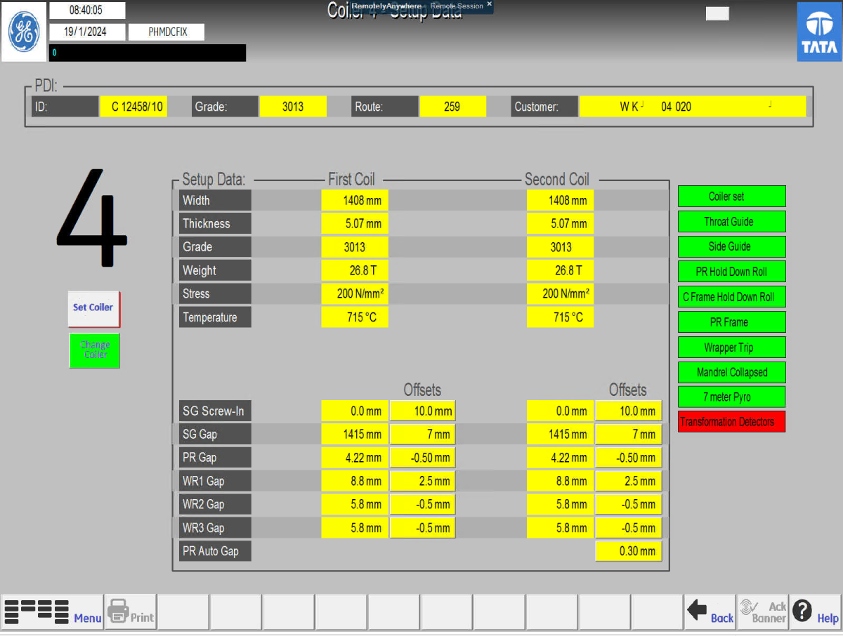
Figure 49 - Newly developed operator HMI 'Setup Data' screen, highlighting the changes introduced.
Although these are only small incremental changes, the Kaizen philosophy highlights that continuous improvement through these small changes can enhance processes towards long term improvements. Also, the benefits of improving the operator workspace included optimising workflow efficiency, improved utilisation of space for visual monitoring, and the influencing of operators to produce key equipment adjustments towards improved quality of coil. Lastly, listening to the operators preference on HMI development created an open line of communication and developed working relationships, producing valuable insights into the current operating environment and where improvements could be achieved.

Customer Inspection Technology Assistance

Due to the financial constraints towards project improvements, alternative approaches were required to assist with coil quality inspections. The following improvement utilises current process technology used to develop coil reports for designated customers. A coil robot marker paints individual coil identification numbers on each coil, although this equipment also uses a profilometer called vision technology to determine coil dimensions. These dimensions are recorded, and traces are produced to display coil width by each lap across the full diameter (Figure 50). Following investigation, the Pencilmans role had no access to these recorded values. Therefore, implementing the vision technology to assist in the roles visual inspections would provide enhanced support in diversion decision making when employed correctly.
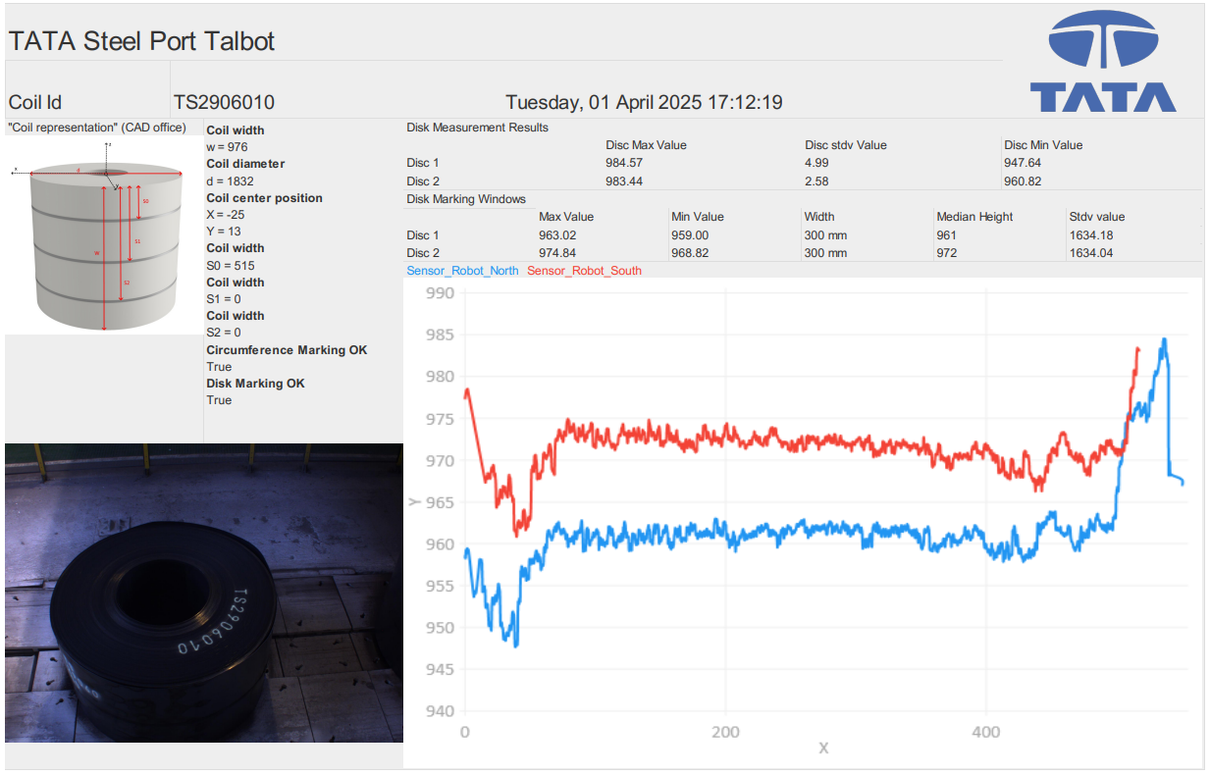

Coil Tail End
Coil Head End

Figure 50 - Vision technology trace, displaying coil width across full diameter from head end to tail end.

The coil tracker (Figure 51) captures information on coil time and date, identification number, gauge, customer, tail end calculation, if the coil was diverted and reasons for that diversion. The tail end calculation simply records the difference between maximum and minimum values on coil tail end traces. The results were then colour coded using a traffic light system to visually assist the Pencilman role, anything below 75mm will be displayed in green, anything within a 10mm range of 75mm displayed as amber and above 85mm as red. Important to note, the vision profile technology would not replace the Pencilmans role but assist in decision making. Also, benefitting with inspection feedback to Coiler operators, allowing for increased efficiency in identifying the problem and introducing the solution through Coiler equipment adjustments.

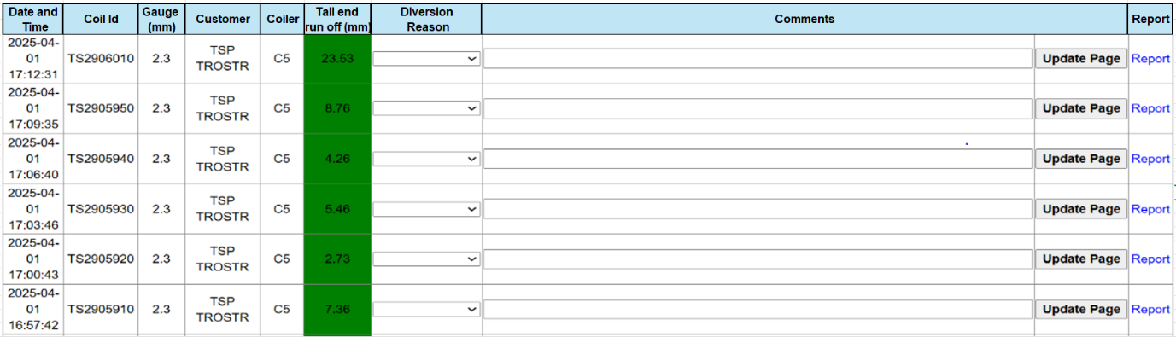
Figure 51 - Developed tail end run off inspection page to assist in visual inspection process

Control

Statistical Process Control (SPC) Chart

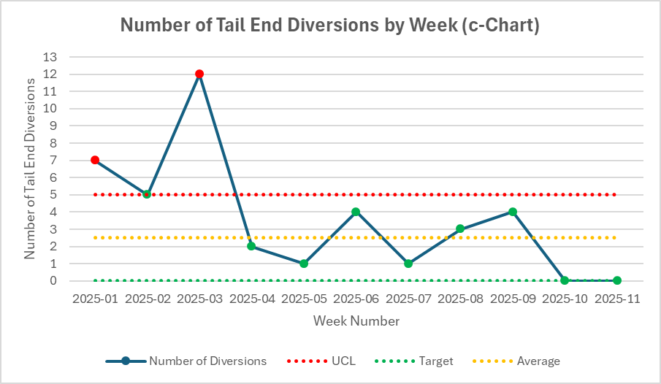
Monitoring variation within the process after improvement implementation was essential to understanding the effects on process outputs and applying corrective actions to control product quality. Therefore, selecting and creating a SPC chart for the number of tail end diversions by week over a 11-week sampling period allowed for variation monitoring. A c-chart was applied to the sample data collected (Figure 52). (Aebtarm & Bouguila, 2011) summarise the c-chart as a tool used to plot attribute data including the number of defects per unit, these are inexpensive and requires no measurement system as it relies on raw count data. Therefore, applying this type of chart to diversion data over a period of time from improvement application contributed to selection reasoning.

Figure 52 - C-chart for SPC of tail end diversions post-improvement implementation over 11-week period

The above chart displayed high variation in the initial stages of improvement application. These erratic data points exhibited special cause variation characteristics, requiring corrective actions to stabilise process output. The program created for the auto pinch roll gap offset required fine tuning to optimise tail end quality. As previously mentioned, the actioning point for pinch roll gap increase required adjustment from the last finishing mill stand (F11) to multiple preceding stands (F8). Also, during week 3, Coiler 5 pinch roll gap adjust drives encountered an issue with blown fuses. Operators manually decreasing pinch roll gaps while the developed program was actioning an increase in gap was the root cause identified. Therefore, the manual intervention of operators to pinch roll gap adjust was applied to disable offset operation and protect gap adjust drives. Once these corrective actions were implemented, results began to improve and remained consistently below the upper control limit (UCL). Although displaying signs of common cause variation around data centreline, the outputs were manageable and trended towards the overall target of zero tail end diversions per week. Therefore, monitoring these outputs and applying counteractive actions supported the journey towards continuous improvement.

Training

The aim of workplace training was to ensure the long-term sustainability of newly introduced operating practices. Training implementation equipped front line employees with the tools and understanding to integrate the new procedures into everyday practice. Firstly, an overview of the project was presented to the Coiler area teams during the fortnightly area meeting. This presentation outlined what, why and how on process improvements, allowing employees to understand the measured data and analysis performed leading to improvement selection.
To embed changes into everyday practice, one-on-one training was performed with Coiler operators and Pencilman staff across all shifts to ensure standard operating procedures were understood. With approximately 14 years’ experience in Coiler operations, allowed myself to personally perform training of operators on procedures, due to the trusted working relationships developed over the past 14 years. Also, selecting the roles and responsibilities of staff, for example, the operator and inspection staff responsibilities including improvement utilisation and reporting, engineering teams for corrective actions and process monitoring for the area process specialist. Outlining these roles, therefore increased the probability of improvement longevity within the process.

Standardised Operating Procedure

To promote standardisation and reduce variation, developing a Standardised Operating Procedure (SOP) was essential to creating a uniformed approach of improvement utilisation across all shifts. The auto pinch roll gap offset procedure (Figure 53), outlines clear to follow instructions to ensure the desired outcome of improved tail end quality. By documenting this procedure, also provides recorded information to new employees and assists in developing skills during on-the-job training. Furthermore, skilled workers could revert to the procedure when encountering issues of their own. This procedure was only a fractional part of the overall SOP, documenting other sections including purpose, roles and responsibilities, materials/equipment, safety considerations and documenting any changes made through document revision. Applying these aspects to one document created standardised working and provided the information required for improvement control and sustainability.
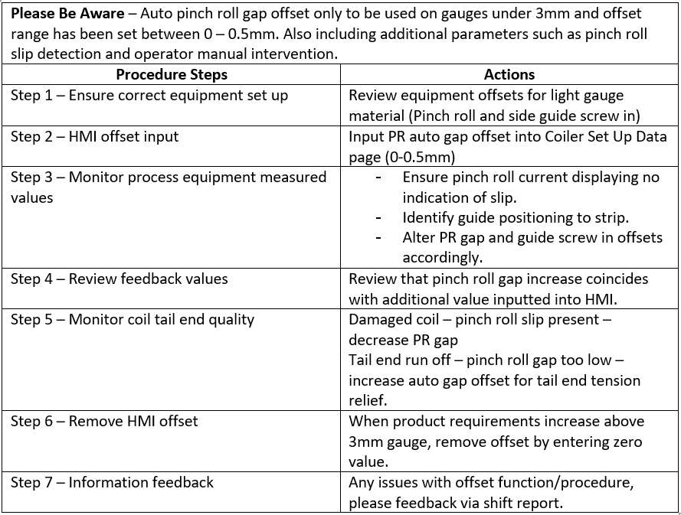

Figure 53 - Step-by-Step auto gap offset procedure for overall SOP.

Results

The results were gathered over a 11-week sampling period after improvements were deemed operational within the process. Ensuring the sampling period was identical to the pre-improvement data collection phase, warranted reliable comparison of results before and after project improvements.

Number of Tinplate Tail End Diversions

The overall number of tinplate tail end diversions (Figure 54) post-improvement stood at 29 coils. This chart displayed the dramatic improvement in Tinplate tail end quality over the selected sampling periods, resulting in an 83% decrease in the overall number of coils diverted for additional processing compared to pre-improvement data. Damaged coil still holds the majority of tail end diversions and could be linked to additional areas of causation.
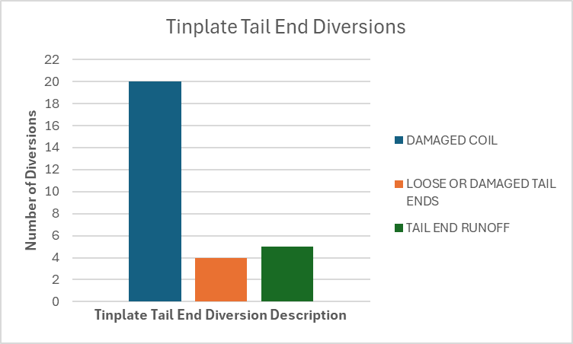

Figure 54 - Results of overall number of tinplate tail end diversions by diversion reasoning
The development of standardised working was the main focus to reduce variation across shifts by aligning operating and inspection practices. The number of tinplate tail end diversions were captured by shift to analyse changes in variation after improvements (Figure 55). The data displays minimal variation between shifts B to E, although shift A produced a sizeable proportion of diversions compared to all other shifts. There are many factors that could contribute to these results, including the special cause variation displayed in control chart development. However, the reliance of operators and inspection staff to follow new procedures could possibly be another contributing factor to variation and demonstrating resistance to change. These findings will require further investigation to understand the reasoning behind the given results.
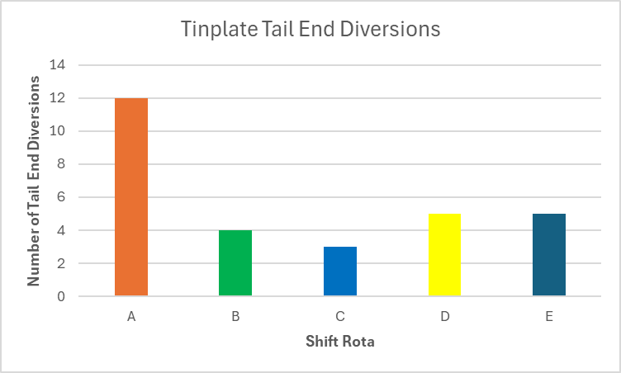

Figure 55 - Number of tinplate tail end diversions by shift after improvements

Costs

The relationship between diversion figures and additional processing costs will always display compatibility. Therefore, from capturing post-improvement diversion results, calculations were completed and comparisons were derived from pre and post improvement costs (Figure 56). Firstly, calculations used during the measure phase of the project identified additional processing costs of £80,260 over the sampling period, compared to recent costs of £13,911. These figures were then manipulated to predict annual company costs of additional processing, displaying substantial predicted savings of £313,651.
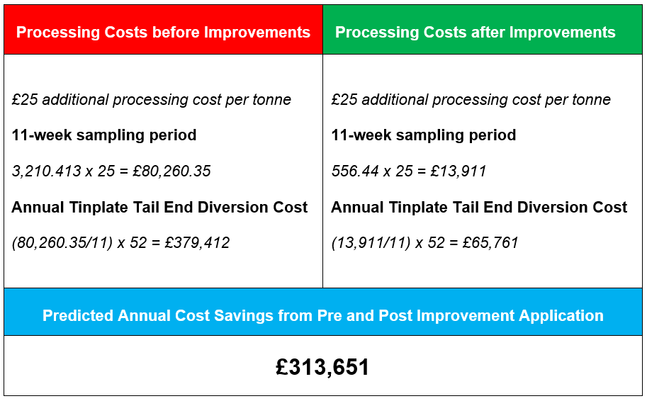

Figure 56 - Additional processing cost calculations pre and post improvement application

Discussion and Conclusion

The aim of this project was to improve tinplate coil presentational quality through reducing tail end diversions for additional processing. The Lean Six Sigma (LSS) strategy selected, provided an aligned project structure to follow and assisted in meeting project deadlines by compartmentalising project phases with DMAIC application. Performing a review on Lean and Six Sigma methodologies, offered foundational evidence and knowledge on the principles from where the project could be developed from. Also, the supporting arguments of LSS from (Arcidiacono & Pieroni, 2018) and (Snee, 2010) towards process standardisation and variation reduction improvements, justified the theory selection and its alignment with project goals.
Both the Define and Measure phases of the project outlined the key information and data collection required to develop understanding on areas of concern and capture data required for analysis. These phases provided the underlying principles that shaped the outcomes of this study including the identification of technological gaps in Pencilman presentational inspection procedures compared to other quality control measures in place. However, conventional Six Sigma statistical analysis tools such as Measurement System Analysis (MSA) required adaptation due to attribute data leading to control limit removal. The alteration of this traditional analysis technique reduces the specificity of data feedback but for the common purpose of identifying variation within the current process, the primary goal was achieved. The utilisation of Structured Query Language (SQL) software for collection of coil data allowed for continuous sampling over the selected 11-week period. Also, providing multiple variables in coil data to enhance the opportunities towards identifying the real root causes.
Graphical analysis on the most prominent areas of measured data collection were performed to gain knowledge on relationships between variables and the diversion outcome. A key insight from this area of study, linked lower carbon steels with coil damage and higher carbon contents with tail end run off. The change in levels of carbon and their effect on presentational defects, therefore implied that the same root cause could potentially be linked to all tail end diversions but producing differing outcomes due to the change in material grade. The relationship between Coiler pinch rolls and their effect on the material grades of steel could be open to further study. Following further analysis, ibaAnalyser software provided real-time and historical process equipment feedback, allowing for operating procedure analysis and the effects of pinch roll gap control on coil presentation and process performance. The volatility in pinch roll gap control was found to be a major contributing factor in effecting tail end quality. The incremental changes to pinch roll gaps produced varying results including pinch roll slip, leading to operator manual intervention causing detrimental effects to coil quality. Also, identifying the best applied operating procedure for tail end control, to develop into standardised work for consistency of output and improved quality, highlighted by (Morrey, et al., 2013).
To redeem the mentioned benefits of standardised work, the primary focus during the improvement stage revolved around developing control systems to assist in operations and inspection. Firstly, the introduction of a pinch roll gap offset was created to gain greater tail end control, through relieving pinch roll strip tension following Finishing Mill departure. The application of Lean principles in Functional Block Diagram (FBD) development were beneficial, towards standardising work and error proofing (poka-yoke). Identifying the potential risks to the process from offset utilisation included pinch roll slip detection, offset limits and gauge restrictions. Although, during offset operational practice, initial variation became evident and required offset disabling through manual intervention to reduce the negative impact on gap adjust drives. The infancy of this offset highlights the possibility for further impacts to the process, due to the unknown effects on Hot Strip Mill operations and the limitations in research to acquire understanding. The financial restrictions associated with this project, led to small changes relating to the kaizen philosophy focusing on technology assistance. In short, HMI development focused on waste elimination through sorting offset screen structure to benefit operators and persuade operator interaction with key tail end control measures. Also, introducing current vision technology to assist in inspection measurement determination. However, these improvements remain heavily reliant on employee buy in and technology interaction. Without these, results may not be maximised to their full potential. Therefore, applying control measures to incorporate training and communicating project decision-making were essential in developing employee relationships and trust with newly launched procedures towards improvement sustainability.
The results collected were measured data gathered over the same 11-week sampling period used during the measurement phase of the project, allowing for stable comparisons of results against previous data. Results post-improvements displayed a substantial 83% decrease in overall tinplate tail end diversion numbers. Furthermore, from this data, projected annual additional processing costs were derived, leading to a predicted £313,651 annual saving. However, the establishment of standardised work was still producing variation in diversion types and shift diversion output. Therefore, increasing the possibilities of further causation in damaged coil diversions and operator resistance to change. Although the results gathered are an exceptional outcome to project improvements, the unknown long-term effects to the process from the unique tail end offset, suggests that continuous monitoring of process data would be advisable to determine further understanding of results.
To conclude, the utilisation of LSS provided the foundations towards project strategy, whilst allowing for the implementation of tools to assist in delivering project goals including standardisation, process control and variation reduction. The financial constraints associated with the project, directed the project journey towards advancing the equipment and technology currently employed to optimise tail end control. The results of which produced substantial improvements in diversion numbers and projected annual savings. Although, limitations are evident and the lack of available research in this area of study, leaves unanswered questions related to long-term sustainability. However, the study exhibits the positive capability of process improvement through equipment optimisation, and the importance of managing change towards continuously improving process outputs.

Recommended further work

Currently, Tata Steel employs a continuous monitoring system for process equipment feedback, otherwise known as the traffic light system (Figure 57). The proposed recommendation involves integrating the tail end diversion run chart and tail end gap control into this system. This will allow implemented improvements to be continuously monitored in an autonomous manner and therefore, limiting the time and resources required towards manually collecting and analysing data.
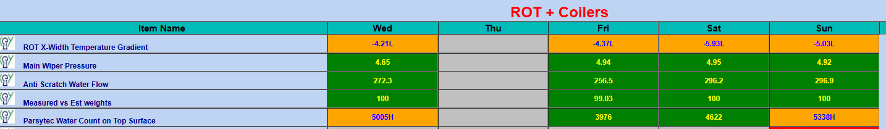
Figure 57 - Screenshot of current measures captured through Coiler traffic light system.
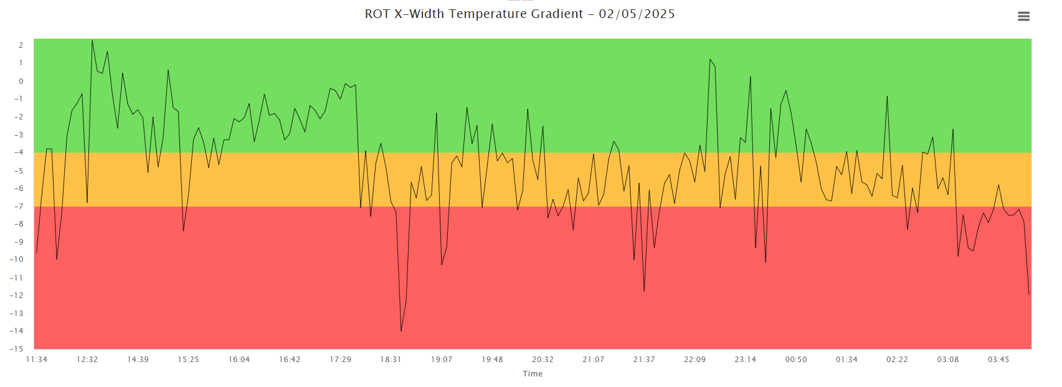
In further detail, selecting the area of interest displays captured results over time (Figure 58). Applying pinch roll tail end gap control, tail end diversion rate and vision technology functionality for monitoring, would provide key information on current and historical measured data for responsible personnel. Therefore, reducing corrective action times and capturing problems before increasing in severity.

Figure 58 - An example of a run chart used within Coiler traffic light system
The introduction of vision technology for tail end quality assistance, provided specified coil profile along the top surface. Although, with the primary focus of this study on tail end quality, there are opportunities to assist in coil head end quality such as telescoping. Therefore, the potential expansion of this technology for diversion detection could provide additional assistance and enhance current inspection procedures with further work.
Lastly, whether the developed auto pinch roll gap offset is deemed counteractive rather than confirmative, there are multiple opportunities for further study on tail end control and pinch roll optimisation within the coiling process. Some of these opportunities include tail end tracking, variation of roll material selection for specific steel grades, and continued research on the effect of pinch roll gap adjustments on strip quality. Overall, undertaking these proposed changes I believe would further advance quality control within hot rolling processes.

References

Adams, C. W., Gupta, P. and Wilson Jr, P. W. (2003) Six Sigma Deployment. Burlington: Elsevier Science.
Aebtarm, S. and Bouguila, N. (2011) An empirical evaluation of attribute control charts for monitoring defects. Expert Systems with Applications, 38(6), pp. 7869-7880.
Antonelli, D., Stadnicka, D. and Litwin, P. (2024) Inclusive manufacturing through the application of lean tools to sustainability issues. Procedia CIRP, Volume 122, pp. 593-598.
Arcidiacono, G., Matt, D. and Rauch, E. (2017) Axiomatic Design of a Framework for the Comprehensive Optimization of Patient Flows in Hospitals. Journal of HealthCare Engineering, pp. 1-9.
Arcidiacono, G. and Pieroni, A. (2018) The Revolution Lean Six Sigma 4.0. International Journal on Advanced Science Engineering Information Technology , 8(1), pp. 141-142.
Barone, S. and Franco, E. L. (2012) Statistical and Managerial Techniques for Six Sigma Methodology: Theory and Application. 1st ed. Palermo: Wiley.
Brook, Q. (2017) Lean Six Sigma Minitab: The Complete Toolbox Guide for Business Improvement. 5th ed. Hampshire: Opex Resources.
Brugha, R. and Varvasovsky, Z. (2000) Stakeholder Analysis: A Review. Health Policy and Planning, 15(3), pp. 239-246.
Cast Iron Casting Manufacturers & Suppliers - Calmet (2025) Main features of a modern hot strip mill.
Available at: https://www.calmet.com/main-features-of-a-modern-hot-strip-mill/
(Accessed 10 March 2025).
Choi, Y.-J. and Lee, M.-C. (2009) A downcoiler simulator for high performance coiling in hot strip mill lines. International Journal of Precision Engineering and Manufacturing, 10(2), pp. 53-61.
Čiarnienė, R. and Vienažindienė, M. (2012) LEAN MANUFACTURING: THEORY AND PRACTICE. ECONOMICS AND MANAGEMENT, 17(2), pp. 726-732.
Ciecińska, B. (2023) Identification of Defects Causes: Ishikawa Diagram and 5 Whys in Theoretical and Practical Terms. 1st ed. Oman: IntechOpen.
Dallan, A. (2016) Coil-fed processing: 4 quick formulas for production planning. Treviso: LinkedIn.
Delgadillo, R. R., Medini, K. and Wuest, T. (2022) A DMAIC Framework to Improve Quality and Sustainability in Additive Manufacturing—A Case Study. Sustainability , 14(1), p. 581.
Dozuki (2024) What's Wrong with Standard Work?.
Available at: https://www.dozuki.com/blog/whats-wrong-with-standard-work#:~:text=Lack%20of%20Leadership%20Support,for%20a%20receptive%20employee%20culture.
(Accessed 19 February 2025).
Duschl, K. C., Gramß, D., Obermeier, M. and Vogel-Heuser, B. (2015) Towards a taxonomy of errors in PLC programming. Cognition, Technology & Work, Volume 17, pp. 417-430.
Dutta, A. B. and Banerjeez, S. (2014) REVIEW OF LEAN MANUFACTURING ISSUES AND CHALLENGES IN MANUFACTURING PROCESS. International Journal of Research in Business Management, 2(4), pp. 27-36.
Field, W. M. (2000) Lean Manufacturing: Tools, Techniques, and How to Use Them. 1st ed. Boca Raton: CRC Press.
Freeman, R. E. (2010) Strategic Management: A Strategic Approach. 1st ed. Pitman : Cambridge University Press.
Gudmundsson, A., Boer, H. & Corso, M. (2004) The implementation process of standardisation. Journal of Manufacturing Technology Management, 15(4), pp. 335-342.
Hessing, T. (2019) Measure Phase (DMAIC).
Available at: https://sixsigmastudyguide.com/measure-phase-dmaic/
(Accessed 26 February 2025).
Kothari, A. (2024) SIPOC Diagram: Definition and Steps. [Online]
Available at: https://tallyfy.com/sipoc-diagram/
(Accessed 14 November 2024).
Kurttio, K. (2023) Condition-based monitoring applied to nitrogen compressor - A Case Study, Gavle: DiVA.
Kwak, Y. H. and Anabri, F. T. (2006) Benefits, obstacles, and future of six sigma approach. Technovation, 26(5), pp. 708-715.
Lee, Y. S. (2007) Effect of Rolling Speed on the Exit Cross Sectional Shape in Rod Rolling Process. International Journal of Precision Engineering and Manufacturing, 8(1), pp. 27-31.
Liu, Y. et al. (2023) Solenoid valves quality improvement based on Six Sigma management. International Journal of Lean Six Sigma, 14(1), pp. 72-93.
Majumder, M. K. et al. (2023) Mathematical Model to Analyze Coiling Feasibility at Downcoiler in Hot Strip Mill. International Journal of Precision Engineering and Manufacturing, Volume 24, pp. 1889-1901.
Márquez, F. P. G., Segovia, I., Bányai, T. and Tamás, P. (2020) Lean Manufacturing and Six Sigma: Behind the Mask. 1st ed. London: IntechOpen.
Middleton, P. (2001) Lean Software Development: two case studies. Software Quality Journal, Volume 9, pp. 241-252.
Mirza, N. M., Pourzolfaghar, Z. and Shahnazari, M. (2013) Significance of Scope in Project Success. Malaysia, Procedia Technology, pp. 722-729.
MoreStream (2024) Six Sigma Conversion Table.
Available at: https://www.moresteam.com/toolbox/six-sigma-conversion-table
(Accessed 1 December 2024).
Morrey, N., Pasquire, C. and Dainty, A. (2013) Developing A Strategy to Enact Lean. Journal of Engineering, Project, and Production Management, 3(1), pp. 35-45.
Mostafa, S., Dumrak, J. and Soltan, H. (2013) A framework for lean manufacturing implementation. Production & Manufacturing Research: An Open Access Journal, Volume 1, pp. 44-64.
Oburu, A. O. (2020) EFFECTIVE PROJECT TIME MANAGEMENT. International Academic Journal of Information Sciences and Project Management, 3(6), pp. 47-55.
Patil, A. B. and Inamdar, K. H. (2014) Process Improvement using DMAIC Approach: Case Study in Downtime Reduction. International Journal of Engineering Research & Technology, 3(3), pp. 1930-1934.
Peng, K. et al. (2014) Strip shape modeling and its setup strategy in hot strip mill process. The International Journal of Advanced Manufacturing Technology , Volume 72, pp. 589-605.
Pereira, A. et al. (2016) Reconfigurable Standardized Work in a Lean Company - a case study. Procedia CIRP, Volume 52, pp. 239-244.
Sarkar, A., Mukhopadhyay, A. R. and Ghosh, S. K. (2014) An outline of the “Control Phase” for implementing Lean Six Sigma. International Journal of Lean Six Sigma, 5(3), pp. 230-252.
Shingo, S. (2021) Zero Quality Control: Source Inspection and the poka-yoke system. s.l.:Routledge.
Smetkowska, M. and Mrugalska, B. (2018) Using Six Sigma DMAIC to Improve the Quality of the Production Process: A Case Study. Procedia - Social and Behavioral Sciences, Volume 238, pp. 590-596.
Snee, R. D. (2010) Lean Six Sigma – getting better all the time. International Journal of Lean Six Sigma, 1(1), pp. 9-29.
Srinivasan, K., Muthu, S., Devadasan, S. R. and Sugumaran, C. (2016) Enhancement of sigma level in the manufacturing of furnace nozzle through DMAIC approach of Six Sigma: a case study. Production planning & control, 27(10), pp. 810-822.
Taherdoost, H. (2021) Data Collection Methods and Tools for Research; A Step-by-Step Guide to Choose Data Collection Technique for Academic and Business Research Projects. International Journal of Academic Research in Management, 10(1), pp. 10-38.
Tata Steel (2023) Hot Rolled Products: Site Orientation. Port Talbot: Tata Steel.
The Council for Six Sigma Certification (2018) Six Sigma: A Complete Step-by-Step Guide. Buffalo: Harmony Living.
Trimarjoko, A., Purba, H. H. and Nindiani, A. (2020) Consistency of DMAIC phases implementation on Six Sigma method in manufacturingand service industry: a literature review. Management and Production Engineering Review, 11(4), pp. 34-45.
Wang, J., Ge, J. and Lu, Q. (2012) 3rd International Conference on System Science, Engineering Design and Manufacturing Informatization. Chengdu, IEEE .

