This essay will critically evaluate the creativity and enterprise skills of the writer, in order to complete this the Entrecomp Framework (Acigalupo et al, 2016) will be used. This essay will also consider how creativity and enterprise skills can be fostered in pupils within the primary school.
The Entrecomp Framework (2016) highlights that fostering enterprise skills in education can help prepare children for the future, it suggests that it is beneficial in developing confidence and determination. In the same way, The World Economic Forum (2016) identifies creativity as a skill needed for future jobs. This importance of creativity and enterprise skills in preparing children for the future is evident in the forthcoming curriculum in wales as highlighted in Successful Futures (2015) indicating their importance. As expressed by Fumoto (2012) creativity which was once a quality attributed to ‘exceptional’ individuals is now considered to be within every individual. However, Ken Robinson (TED, 2007) spotlights that schools educate children out of creativity due to the pressures on schools to produce good test results. Hence, given its importance as expressed by Jones (1972) teachers are responsible for creating the conditions to foster creativity in schools.
Desailly (2012) emphasises that there are many different definitions of creativity, as different people identify different qualities that contribute to being creative. Gardener (1997, cited in Jesson, 2012, p. 8) suggests that creativity means having the ability to ‘solve problems’ and ‘raise new questions’ on the other hand, Wilson (2015) claims creativity is practice which entails using the imagination. Although the National Advisory Committee on Creativity and Cultural Education (NACCCE) who’s report in 1999, was crucial in sending the message of the importance of creativity in education states that creativity is ‘Imaginative activity fashioned to produce outcomes that are both original and of value’. Evidently all ideas of what creativity is, have common factors of creating something original and using the imagination. However, Jalongo (2003, p.218-219) suggests that this definition needs reconsidering in order to consider all aspects of modern research where, as emphasised by Craft, Cremin and Bernard (2008) the process is more valuable to children’s development than the final product being original or of value.
The NACCCE report (1999) identifies that there are two ways of fostering creativity in school. It discusses ‘Teaching Creatively’ and ‘Teaching for Creativity’. Teaching Creatively is described by Jeffrey and Craft (2004, p.80) as the ability to teach in a creative manner, this is about using the teachers use of imaginative approaches. Whereas, teaching for creativity as explained by NACCCE is the ability to support children in believing in their creative abilities and develop the capacities of creativity such as curiosity. As explained by Lin (2011, p. 152) the two practices are linked as teaching for creativity often engages the features of creativity such as the imagination which leads to teaching for creativity.
As Voiced by the Quality Assurance Agency (QAA) (2018) Enterprise Education in summary is about providing children with the capacity to generate ideas and provides them with the knowledge and skills to make them happen. As suggested by Young (2004) the benefit of fostering enterprise skills in school is because it results in an improvement of critical thinking abilities and confidence which aids in risk-taking. As Further emphasised by Hytti (2004, p. 11) these skills are essential in preparing children for life beyond education. In order to help guide progress in enterprise skills educational and work setting can choose to look at the Entrecomp Framework (2016), as expressed in the Framework it aims to ‘establish a bridge between the world of education and work as regards to entrepreneurship as a competence.’ Therefore, contributing to preparing pupils for the world of work.

Evaluation of my creativity
This section of the essay will examine the creativity of the writer. To evaluate the writer’s creativity, the Entrecomp Framework will be used. Visible, in the Entrecomp Framework are 15 competencies which are their ideas of the skills needed to be successful entrepreneurs. In evaluating the writer’s creativity, two competencies have been chosen from the framework as a focus. These are:
- Competence 1.2: Creativity.
- Competence 3.5: Learning through Experience.
Creativity 1.2
Emphasised by Jones (1972) and agreed by Duffy (2006) having creative teachers is essential if we are to foster creative children. Extended by Jalongo (2003), he suggests that teachers who are creatively motivated and persistent with their creativity also foster this attitude in their students.
An aspect of the creativity competence in the Entrecomp Framework looks at being able to develop ideas that are innovative, this is the ability to produce original and new ideas. The writer suggests that being innovative is a strength of theirs due the fact that they are curious to always try new methods of teaching when on practice. Cross et al (2016) explains that curiosity is a drive form within which increases the desire for an individual to explore or find out about an object or subject. As indicated by Stenger (2014) this is a beneficial quality for a teacher as it leads individuals to seek answers. Appendix 1 indicates that the writer can use research to seek and explore new methods or answers in order to inform their practice, which as shown by feedback in Appendix 1 positively impacts their teaching. This is as researching effective methods allows them to discover innovative techniques to use in the classroom. This is important as Zeichner (2003) suggests teacher research results in a higher quality of learning. However, the writer considers being innovative in the classroom as strength, they recognise that sometimes confidence can be a factor which limits their innovativeness due to the worry of the opinions of others if the method is to fail. This is a worry indicated by Beetlestone (1998) and Jones and Wyse (2004) confidence is essential for a teacher, a teacher that is not confident in being innovative will discourage innovation in their students.
Another aspect of the creativity competence is the ability to be able to ‘assemble, test and refine’ prototypes. Csikszwntmihalyi (2013) acknowledges to be able to refine and reflection is important. Indicated in Appendix 2, the writer is successfully able to reflect on their mistakes, or what did not go well within a lesson or about a product. However, as emphasised by Hartford and MacRuairc (2008), agreed by the Cambridge Assessment Website (2018) people are usually good at identifying what went wrong, although often they do not identify practical steps that will move them forwards. An example of this on teaching experience could be when a resource was made which in practice was unsuccessful in fully supporting the needs of the learner. Although it was identified the resource was not successful, steps to move forward were not educated and were not practiced; therefore, there was no progression from the mistake. This indicates a weakness is being able to identify how to refine a product. In order, to improve the way feedback is used to inform future practice the writer will consider using short term goals, which would aid in tackling small parts of the problem, in order to reach the long-term goal. Learners being able to develop multiple ideas is an aspect of the creativity competence of the framework. The writer believes that this is a weakness, this is as Tapinos (2016, p. 1406) suggests that a barrier to teacher creative thinking, which includes the ability to be able to develop multiple ideas is the fact that teacher training and the education system limits what we believe we can and can’t do in our practice. In this way we are less able to have complete freedom over or ideas. The ability to be able to develop multiple ideas in response to one task as stated by Guilford (1967, cited in Berlin, Tavani and Beasancon, 2015) is called divergent thinking. Spencer (2018) suggests that this can be developed by practicing tasks which encourage thinking in multiple ways to produce a variety of answers, by carrying this out the writer may improve their ability to develop multiple ideas. By identifying the strengths and weaknesses of the Creativity, it can be concluded that the writer is at the intermediate level of creativity. As shown in Appendix 3, the skills that the writer can perform are highlighted on the progression framework. For the writer, although the majority of the skills are level 4, due to their weakness of not being able to produce and therefore experiment with a variety of techniques for the ‘Develop Ideas’ column this has been evaluated at a level 3. To improve this as expressed in the previous paragraph, the writer can practise activities which encourage divergent thinking.

Learning Through Experience: 3.5
The Entrecomp Framework also displays ‘Learning Through Experience’ as one of its competencies. Handyani (date unknown) suggests that Learning through experience, is about hand-on work, where individuals learn by doing. Boud, Keough and Walker (2005) emphasises that this is beneficial in gaining and using learnt skills in a practical setting, this is beneficial as teachers are able to practice and refine skills, acknowledging what works and what needs improvement in practice.
Leading on from consulting others about making effective future recommendations, the Learning through experience competence suggests that the individual must be effective in learning with others, Vygotsky (1962) suggests that we learn when we interact with others, therefore as Gu and Day (2007, p. 1313) emphasise it is beneficial for schools to be places where teachers engage in intellectual work, therefore learn together, in line with this an Estyn report highlights that teachers who work together well, create a positive environment where learning is fun. Appendix 4 identifies feedback from a mentor of the writers. It suggests that the writer can engage in professional conversations with staff and as a result learn from them, experience in school identifies that this was a very engaging and valuable way to learn information about the running of a school and one which was a strength for the writer, in agreement, Vogt (2002) suggests that being able to communicate effectively with other members of staff is an essential tool for learning with others. Learning from failures is a part of the ‘Learning through Experience’ competence. Wilson (2015) highlights that creative teachers actively take risks, Craft (1999) agrees and suggests that it is important that children witness teachers taking risks. In order to learn from experience teachers must take risks, this is a weakness indicated by the writer, due to the fact that the problem with taking risks is that it may lead to failure; this has often been something that has limited their success in tasks. Murray (2019) suggests that to learn from failure it is important to think about how to improve from the mistake and be confident that mistakes help us improve. Dweck (2008) talks about a growth mindset which is surrounded by the ability to believe that you can improve, in order to improve this Gerstein (2015) suggests that we can thinking about the what we can do, instead of what we can’t do in challenging times. To encourage learning from failure and having a growth mindset, writing down strengths can be something the writer can do in order to learn from failures. As highlighted in Appendix 5 the writer has evaluated that taking in to consideration the strengths and weakness about learning through experience, it is concluded that in aspects of this competence she reaches a level 3. Taking in the suggestions in order to improve would allow the writer to move on to level 4.

Fostering Children’s Creativity
As highlighted by Latham (TES, 2018) fostering creative skills I children such as by encouraging risk taking and exploration can aid in helping children gain a deeper understanding of subjects, Geist and Hon (2009) delve deeper in to this suggesting that this is due to the fact that engages all of our senses. Teaching Creatively, is beneficial in providing different ways to access the curriculum, which can suit the needs of all children, as recognised by DeBono, children have ways in which they learn best and teaching creatively can help in catering to this.
Encouraging divergent thinking can help enhance children’s creativity. As explained by Guilford (1967, cited in Berlin, Tavani and Beascon, 2015) divergent thinking is the ‘cognitive ability to produce numerous responses in various directions for one task’. The Torrence Test as discussed in Thorne (2007) which tested for creative abilities, identified Fluence- the ability to produce many ideas, as one of the essential qualities in a creative person, hence the importance of encouraging divergent thinking to foster children’s creativity. The QAA (2018) also identified the ability to produce many ideas as a skill learned in enterprise education. Spencer (2018) suggests that divergent thinking can be fostered by providing children with opportunities to participate in activities which require multiple responses. However, Gu and Day (2007) identifies that these activities require risky thinking from children which goes against their instincts, it is for this reason that Ucas and Acar (2018) promote that teachers should encourage and demonstrate open-mindedness and value all answers from pupils. Although, Schuster (1984) identifies that often teacher do not value children answers, and the limitation of children’s divergent thinking is that they are bound by the pressure from their teachers to producing answers which are right. As indicated in research by Opezzo and Schwartz (2014), walking in particular encouraged divergent thinking due to its effects on the brain. Therefore, in order to encourage divergent thinking teachers could incorporate walking in to their lessons when expecting children to be divergent thinkers. However, when using divergent thinking children often have to move on to use convergent thinking in order to narrow down their answers, to produce a final one. Pakizer (2016) describes convergent thinking as the ability to narrow down answers. As suggested by Jesson (2012) Teachers need to provide time for children to digest and think about their answers in order to filter their divergent answer, but as Jesson spotlights, teacher do not always give children this time which can inhibit the ability to perform this task. Collard (date unknown, cited in Manichander, 2016, p. 154) Suggests that creative skills should include five major areas. He shows that one of these is resiliency. In a Welsh Government document (2010) it suggests that resilience is the ability for an individual to ‘bounce back’ after failure, in other words their inner drive to continue doing something even if they have failed. As expressed by Craft (1999) a benefit of fostering creativity is providing children with a tool to express oneself, however she spotlights that this includes taking risks, in line with this indicated by the Entrecomp Framework (2016), being able to reflect on failures and move forward is an essential part of creativity. Hence, the importance of building resilience in order to foster creativity. Symmonds (2015) suggests that in order to develop resilience teachers can aid in giving children responsibility in the classroom, this will allow them to explore and take responsibility for their actions and even decide on risks. However, Craft, Cremin, Hay and Clack (2014, p. 17) also within Successful Futures (2015) it suggests that teachers should encourage appropriate risks. The Welsh Government (2010) also suggest that building resilience includes promoting children’s self-esteem, this can be done through providing positive feedback. If fostering creativity is about encouraging self-esteem it is important that we look at how we assess creativity. As expressed by Jones (1972) in assessing creativity children whose thoughts are different from others need to be supported in order to maintain their confidence, keeping this in mind, Fisher and Williams (2009) talk about an example of assessing creativity in one school, where student and teacher agree on the strengths and weaknesses of their work and what it is important to see; this acknowledges that creative work is individual and from an individual perspective. However, as indicated by Sommer and Sommer, assessment in this way is difficult in schools as teachers in some schools are bound by Summative assessment, this is a barrier for teachers who aim to foster creativity in schools.
As previously explained by Cross et al. (2016) curiosity is an inner drive which encourages an individual to explore, as expressed by Duffy (2000) along with promoting the ability to explore, through exploration curiosity therefore results in children developing a greater understanding of the world around them. Hetland (2013, p. 67) explains that creativity, does not help in constructing knowledge, suggesting that if education is knowledge focused we will fail to foster a well-rounded pupil. It can be argued that as creativity involves curiosity which leads to understand their world better, knowledge and creativity are able to assist in gaining a deeper level of knowledge. Explained by Griffiths and Burnes (2013), teachers can ignite curiosity by asking questions. Fisher and William (2009) highlight that through this teacher can help guide in children connecting their knowledge to find answers. As stated by Beetlestone (1998) proposing children with questions to answer can engage their natural curiosity to learn. This is agreed by a scenario on teaching experience where engaging curiosity and increasing motivation to learn was gained by proposing questions at the start of the lesson. In this self-directed learning, children were able to assemble knowledge themselves. However, Estyn’s 2017-2018 report suggest that in half of schools, children’s ability to independently problem solve needs improvement, this demonstrates that not all schools are taking in to consideration the benefits of learning creative and enterprise skills. Found in an observation of a school by Jeffrey and Woods (2003) teachers adapt to using the outdoor environment in order to engage children in exploration due to ignited curiosity. This view is shared by Fumoto (2012) who says that it may influence children use materials or their creative thought, creating a greater variety of creative responses.
Collard (date unknow, cited in Manichander, 2016, p. 154) also suggests that collaboration is a key skill in developing creativity. Estyn Good Practice (2016), identifies that this collaboration should not only be students collaborating, but student- teacher collaboration where student’s interests are used in order to motivate learners. In practices where learning Is learner-centered, Andragogy is taking place. Estyn suggest that this is good practice, when considering as stated in their 2016-2017 annual report, schools in which there are short comings display over-directed learning.
Conclusion
A view established throughout this essay can be said to be that creativity and enterprise skills and essential for pupils and teachers. For pupils, fostering creativity and enterprise skills within the primary classroom as emphasised in Successful Futures will be essential to aiding them in preparing for the world of work. In evaluating creativity, it is of the writer’s opinion that it has aided in identifying steps for future development in this area such as to practise divergent thinking in order to be able to have more creative thoughts also, to add more effort in to using research to make failures in to successes. However, it should be noted that it is the view of the writer that the Entrecomp framework is difficult to understand, and considering it is trying to bridge a gap with the world of education, some of the strands would be hard to implement in an educational setting. With this in mind, noted in the framework states that it has yet to be tested in educational settings. When considering fostering children’s creativity, research within this essay has identified that teachers heavily influence this in schools. Despite as indicated in previous paragraphs that a drive towards good results in schools, means teachers limit creativity. The importance of developing skills such as creative through which aids in problem solving and creativity which gives children a means to express themselves, should not be underestimated as valuable tools to increase children’s emotional well-being and attainment.

Appendix 1
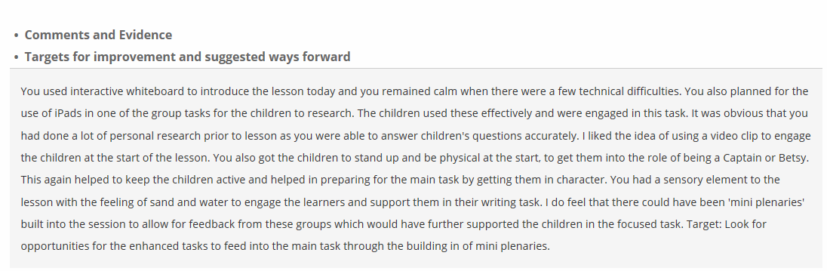

Appendix 2
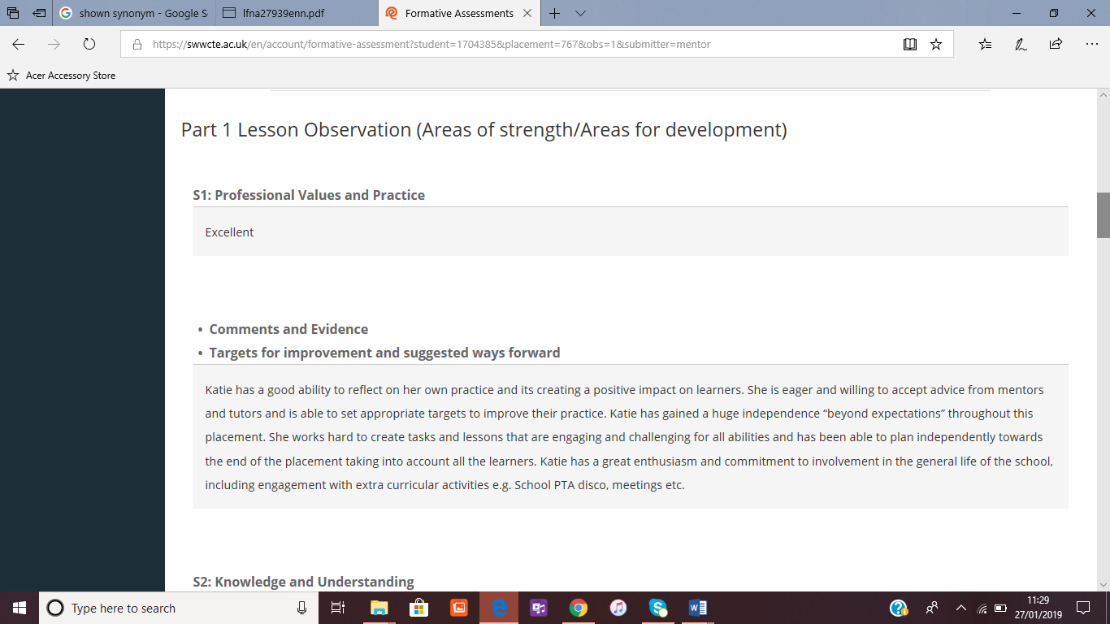

Appendix 3 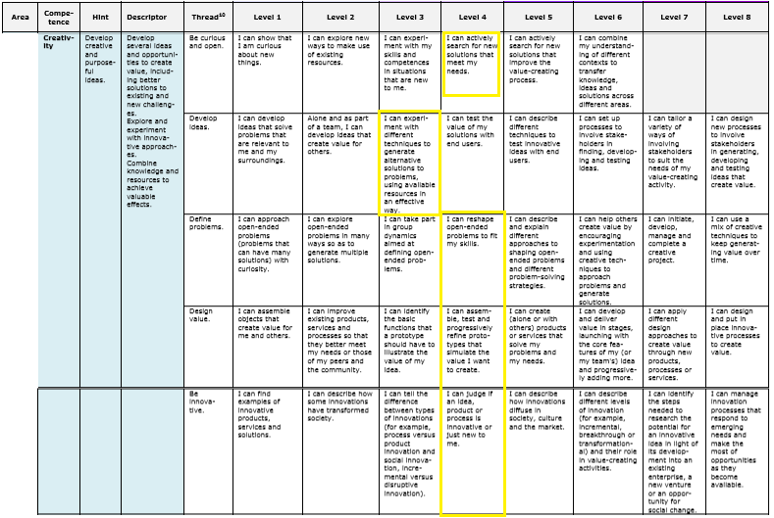

Appendix 4

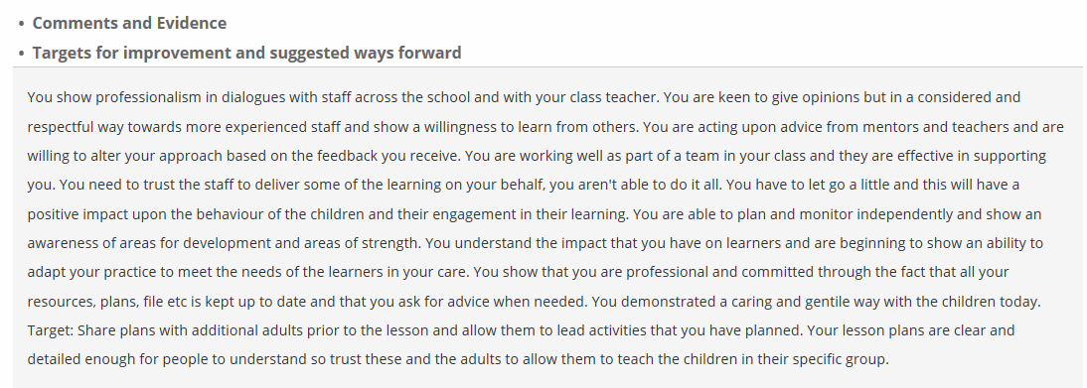

Appendix 5

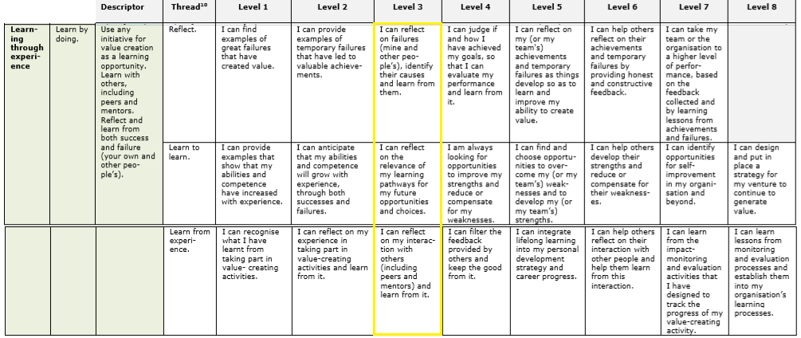
Reference List

Acigalupo, M. et al. (2016) Entrecomp: The Entrepreneurship Competence Framework. Available at: http://publications.jrc.ec.europa.eu/repository/bitstream/JRC101581/lfna27939enn.pdf (Accessed: 18th January 2018).

Beetlestone, F. (1998) Creative children, imaginative teaching. Buckingham: Open University Press.

Berlin, N., Tavani, J. and Beasancon, M. (2015) An Exploratory Study of Creativity, Personality and Schooling Achievement.

Boud, D., Walker, D and Keogh, R. (2015) Reflection: Turning Experience in to Learning. Oxon: Routledge.

Cambridge Assessment International Education (2019) Getting Started with Reflective Practice. Available at: https://www.cambridge-community.org.uk/professional-development/gswrp/index.html (Accessed: 19th January 2018).

Craft, A., Cremin, T. and Burnard, P. (2008) Creative Learning 3-11: and how we document it. Staffordshire: Trentham Books Limited.

Craft, A., Cremin, T., Hay, P., and Clack, J. (2014) ‘Creative Primary Schools: Developing and Maintaining Pedagogy for Creativity’ Ethnography and Education, 9, pp. 16-34.
Cross et al. (2016) Curious Learners in Primary Maths, Science, Computing and DT. London: SAGE.

Csikszwntmihalyi, M. (2013) Creativity: the psychology of discovery and invention. New York: Harper Perennial Modern Classics.

Desailly, J. (2012). Creativity in the primary classroom. London: SAGE.

DOI: http://dx.doi.org/10.1080/17457823.2013.828474
Duffy, B. (2000) Supporting Creativity and Imagination in the Early Years. Buckingham: Open University Press.
Duffy, B. (2006) Supporting Creativity and Imagination in the Early Years. Buckingham: Open University Press.

Estyn (2016) Good Practice: A collaborative Approach to Creative Activities. Available at: https://www.estyn.gov.wales/effective-practice/collaborative-approach-developing-creative-activities . (Accessed: 26th January 2019).

Estyn (2017) The Annual Report of Her Majesty's Chief Inspector of Education and Training in Wales 2016-2017. Cardiff: Estyn.

Estyn (2018) The Annual Report of Her Majesty's Chief Inspector of Education and Training in Wales 2017-2018. Cardiff: Estyn.

Fisher, R. and Williams, M. (2009) Unlocking Creativity: Teaching Across the Curriculum. Oxon: Routledge.

Fumoto, H. (2012) Young children’s creative thinking. London: SAGE.

Geist, E. and Hohn, J. (2009) ‘Encouraging Creativity in the Face of Administrative Convenience: How Our Schools Discourage Divergent Thinking. Education. 130(1), pp. 141-150.

Griffith, A. and Burnes, M. (2013) Teach Primary: Building Curiosity in the Primary Classroom. Available at: https://www.teachprimary.com/learning_resources/view/building-curiosity-in-the-primary-classroom (Accessed: 26th January 2019).

Gu, Q. and Day, C. (2007) ‘Teacher Resilience: A Necessary Condition for Effectiveness.’ Teaching and Teacher Education: An international Journal of Research and Studies. 23(8), pp. 1302-1216. DOI: https://doi.org/10.1016/j.tate.2006.06.006

Harford, J. and MacRuairc, G. (2007) ‘Engaging students in meaningful reflective practice’ Teacher and Teacher Education. Available at: http://eprints.teachingandlearning.ie/2428/1/Harford%20and%20MacRuairc%202008.pdf (Accessed: 19th January 2018).

Hytti, U. (2004) ‘What is Enterprise Education? An Analysis of the Objectives and Methods of Enterprise Education Programmes in Four European Countries.’ Education and Training, 46(1), pp. 11-23. DOI: 10.1108/00400910410518188.

Jeffrey, B. and Craft, A. (2004) ‘Teaching Creatively and Teaching for Creativity: distinctions and relationships’ Educational Studies, 30(1), pp. 77-87. DOI: https://doi.org/10.1080/0305569032000159750

Jeffrey, B. and Woods, P. (2003) The Creative School: A Framework for success, quality and effectiveness. London: Routledge.

Jesson, J. (2012) Developing Creativity in the Primary School. Berkshire: Open University Press

Jesson, J. (2012) Developing Creativity in the Primary School. Berkshire: Open University Press.

Jones, R. and Wyse, D. (2004) Creativity in the primary curriculum. London: David Fulton Publishers.
Jones, T. (1972) Creative Learning in Perspective. London: University of London Press Ltd.

L, Hetland (2013) ‘Connecting Creativity to Understanding.’ Educational Leadership, 70(5), pp. 65-70.

Lin, Y. (2011) ‘Fostering Creativity through Education—A Conceptual Framework of Creative Pedagogy’ Creative Education, 2(3), pp. 149-155. DOI: :10.4236/ce.2011.23021

Manichander, T (Date Unknown) Advanced Educational Psychology. Publisher and Place unknown.

National Advisory Committee on Creative and Cultural Education. (1999) All our Futures: Creativity, Culture and Education. Great Britain: Department for Education and Employment.

Noodle (2015) Cultivate a Growth Mindset with these 6 Strategies. Available at: https://www.noodle.com/articles/these-6-strategies-will-promote-a-growth-mindset-in-your-kid (Accessed: 25th January 2019).
Oppezzo, M. and Schwartz, D. (2014) ‘Give Your Ideas Some Legs: The Positive Effect of Walking on Creative Thinking.’ Journal of Experimental Psychology: Learning, Memory, and Cognition. 40(4), pp. 1142–1152. DOI: 0 http://dx.doi.org/10.1037/a0036577

Pakizer (2016) SimpleK12: Divergent and Convergent Thinking-Getting Outside the Box. [Article] Available at: https://www.simplek12.com/learning-theories-strategies/divergent-and-convergent-thinking/ (Accessed: 15th January 2018).

Quality Assurance Agency for Higher Education (2018) Enterprise and Entrepreneurship Education: Guidance for UK Higher Education Providers. Available at: https://www.qaa.ac.uk/docs/qaas/enhancement-and-development/enterprise-and-entrpreneurship-education-2018.pdf?sfvrsn=15f1f981_8 (Accessed: 11th January 2019).

Schuster, E. (1984) ‘An Opportunity for Divergent Thinking in the Classroom: Students against the Text. Gifted Child Today. 7(5), pp.30-33. DOI: https://doi.org/10.1177/107621758400700511

Spencer, J. (2018) John Spencer. [Article] Available at: http://www.spencerauthor.com/divergent-thinking/ (Accessed: 15th January 2018).

Stenger, M. (2014) Edutopia: Why Curiosity Enhances Learning. Available at: https://www.edutopia.org/blog/why-curiosity-enhances-learning-marianne-stenger (Accessed: 19th January 2018).

Successful Futures: Independent Review of Curriculum and Assessment Arrangements in Wales. (2015). [online] Professor Graham Donaldson. Available at: https://www.nasuwt.org.uk/asset/A788604C-3046-4005-A1EA0EAFF023E0DD/ (Accessed: 11th January 2018).

Symonds, J. (2015) Understanding School Transition: What happens to children and how to help them. Oxon: Routledge

Tapinos, E. (2016) ‘The Limitations Impacting Teachers’ Understanding of Creative Thinking.’ Creative Education, 7, pp. 1404-1409. DOI: 10.4236/ce.2016.710145

TeachHub.com (2019) Teaching Strategies: Let students Learn from Failure. Available at: http://www.teachhub.com/teaching-strategies-let-students-learn-failure (Accessed: 25th January 2019).

TED: Sir Ken Robinson ‘Do Schools Kill Creativity?’ (2007) YouTube [Video]. Available at: https://www.youtube.com/watch?v=iG9CE55wbtY (Accessed: 18th January 2019).

TES (2018) What is Creativity and Why does it Matter? Available at: https://www.tes.com/news/what-creativity-and-why-does-it-matter (Accessed: 24th January 2019).

Thorne, K. (2007) Essential creativity in the classroom inspiring kids, London: Routledge

Vogt, F. (2002) ‘Teacher teamwork-supportive cultures and coercive policies?’, Annual Conference of the British Educational Research Association. University of Exeter, England. Available at: http://www.leeds.ac.uk/educol/documents/00002159.htm (Accessed: 18th January 2018).

Welsh Government (2010) Thinking positively Emotional health and well-being in schools and Early Years settings. Cardiff: Welsh Assembly Government.

Wilson, A. (2015) Creativity in Primary Education 3rd Ed. London: Learning Matters.

Wilson, A. (2015) Creativity in Primary Education 3rd Ed. London: Learning Matters.

World Economic Forum (2015) New Vision for Education: Unlocking the Potential of Technology. Available at: http://www3.weforum.org/docs/WEFUSA_NewVisionforEducation_Report2015.pdf (Accessed: 21st January 2019).

Zeichner, K. (2003) ‘Teacher research as professional development for P-12 educators in the USA’ Education Action Research. 11(2), pp. 301-326. DOI: 10.1080/096507903002002

Ucas, S. and Acar, I (2018) ‘Teachers’ innovativeness and Teaching Approach: The mediating role of creative classroom behaviours. Social Behaviour and Personality. 46(10), pp. 1697-1711. DOI: doi.org/10.2224/sbp.7100

