

Postgraduate/Distance Learning
Assignment coversheet & feedback form

THIS SHEET MUST BE THE FIRST PAGE OF THE ASSIGNMENT YOU ARE SUBMITTING (DO NOT SEND AS A SEPARATE FILE)

For completion by the student:
Student Name: Ling Duong

Student University Email: 2221051@student.uwtsd.ac.uk

Module code:  HPCA7015  Module title:  Foundations in Cultural Astronomy and Astrology | Student ID number:  2221051 |  |  | Educational support needs:  Yes
Assignment title:
A 3,500 word essay written on a topic within the subject area

Assignment due date: 3th January 2023
This assignment is for the 1st
module of the degree
I confirm that this is my original work and that I have adhered to the University policy on plagiarism.
Signed: Ling Duong
Email submission:if you are submitting this form via email, please tick this box □
(as a substitute for your signature) to confirm that you agree to the above declaration.
Assignment Mark
1st Marker’s Provisional mark
2nd Marker’s/Moderator’s provisional mark
External Examiner’s mark (if relevant)
Final Mark

NB. All marks are provisional until confirmed by the Final Examination Board.

For completion by Marker 1 :
Comments:

Marker’s signature: |  |  | Date:
For completion by Marker 2/Moderator:

Comments:

Marker’s Signature: |  | Date:
External Examiner’s comments (if relevant)

External Examiner’s Signature: |  | Date:

Are perceptions of the cosmos culturally conditioned?
Word Count: 3523

Introduction:

The focus on this paper examines whether cosmologies arise out of cultural behaviour and assumptions, or whether they have some essential reality. I will explore three key cosmological viewpoints of Plato, Taoism and Alchemy within the culture of western sacred architecture, namely churches and cathedrals. I will examine the question through a series of primary and secondary sources. As well as to investigate why they were designed in this matter and to understand the symbolism behind their aesthetics.

The Author:

The subject area holds great interest to me. As my research question: ‘How does the harmonic design of nature and oneness, be used as an art based health intervention for mental health and wellbeing?’ relies on understanding the cosmology and culture within the patients’ region, in order to procced with the correct method of rehabilitation. As an artist who was originally trained in animation. We were expected to work commercially upon graduation. As I took on projects in advertising, television and film. I started to question the output of some of the projects and the consequences it might have on society. This led me to question the responsibility of the artist and the ethics one is putting into the culture. From a personal perspective, understanding one’s identity and culture is important because as someone who is of Chinese-Vietnamese heritage and born in the city of London, United Kingdom. The benefits of being bought up this way is the expended worldview and open mindedness of other cultures. I hope this paper leads me to understand how ancient craftspeople were trained, in relation to traditional cosmology and how to imply this to my own practice, for the greater whole.

What is Traditional Cosmology?

‘It is not without reason that Hawking said: ‘It is difficult to discuss the beginning of the universe without mentioning the concept of god.’ When one is dealing with traditional cosmologies, there is no avoiding the subject of religion and the divine. Traditional cosmology in the west has its origins in Greece. According to the ‘Greek and English lexicon to the New Testament’ book by John, Major and Rose, the meaning of cosmos comes from the Greek definition of Kósmos. It has two meanings, one to set in order and one of adornment. The dictionary gives an explanation by Aristotle: ‘A system composed of the heaven and the earth, and of the beings contained in them; otherwise, the order and beautiful arrangement of the universe is called κόσμος (Kósmos).’

Nicholas Campion’s book ‘A History of Western Astrology’ states by the beginning of the fourth century BCE, Plato was the forefront of Greek philosophy and held the foundations of European cosmology until the time of Galileo in 1609. Plato was born in Greece around the year 428 BCE. The School of Athens, also called Plato’s Academy had a far-reaching influence on Islamic and Christian thought. His student Aristotle, as directly quoted in John et al book, was as prominent of a figure as Plato respectively. Like Pythagoras, he believed all is number and that the cosmos was interconnected as a harmonic, mathematical, geometric, musical order. Within the cosmos, exists two orders of things, the ‘being’ and the ‘becoming’. God, the creator of all things lives in the being, as an eternal, unchanging, perfect and true architype. When God starts to move, becoming is born as the cosmos, an imperfect copy of being, but still carry its essence. It is ever changing; its life is measured by time. This is the duality that holds the universe in place. The unchanging invisible world and the changeable visible world.

Compared to Plato, Chinese cosmology also holds similarities on how the universe was made, the canon of Taoism ‘Tao Te Ching’, was translated by Benjamin Hoff and originally written by Lao Tzu. Hoff commentates that Lao Tzu is the founder of Taoism and was born during 475-300 BCE, the warring state period of the Chou Dynasty. A former record keeper of the royal library of Luoyang. He has crossed paths with Confucius, who is known for his philosophy on a state level. Legend has it that a border keeper recognised him and asked Lao Tzu to write down some thoughts so he can be enlightened by it. He then wrote a book, comprised of two parts and about five thousand words. He suddenly departed, nowhere to be seen and that become the ‘Tao Te Ching’. Historian Sima Qian, in his ‘Records of the Grand Historian’ 100 BCE wrote the earliest accounts of Lao Tzu. Hoff speculates on the legitimacy of Lao Tzu as a person, Lao Tzu literally means ‘Old Master (老子) and his actual name Lǐ Ěr (李耳) given by Historian Sima Qian translates as Long Ears. In East Asian culture, long ears symbolise wisdom, so this name could be a pseudonym too.
The Way:

The Way That Can Be Followed
Is not The Eternal Way.
The Name That Can Be Named
Is not The Eternal Name.

Without-Name is The Origin
Of Heaven and Earth.
Has-Name is The Mother
Of Every Earthly Being.

Consistently desire Without-Form
In order to study its mysteries.
Consistently desire Has-Form
In order to study its frontiers.

The previous two are the same energy,
But have different designations.
When those are joined, that is called
Growing darkness—
Darkness of ever-increasing darkness;
Many-mysteries’ gateway.

Due to the pictogram nature of the Chinese written language, one Chinese character (or word) can have more than one meaning. Hoff gives further explanation to the poem: ‘Without-Form (wu, literally “non-being”) in the third stanza is the invisible Way of Heaven. Has-Form (yu, literally “being”) is the visible-in-its-manifestations Valley Spirit.’ Paul J. Lin, another author who translates the text with Wang Pi’s commentary states that the Chinese characters: ‘The Origin and ‘The Mother’ could be translated as ‘Non-Being’ (無) and ‘Being’ (有).’ As seen from this viewpoint, it is comparable to say that Taoism and Plato’s cosmology could be expressing something of the same essence or reality. The I-Ching, one of the oldest cosmological text, complements this duality through its hexagrams. The translated version of Richard Wilhelm’s book shows the creative as six unbroken lines (䷀). It is the image of heaven and is metaphysically represented as Yang, the masculine energy: active, strong and light-giving. While the receptive with its six broken lines (䷁), represents the Earth, the dark, yielding feminine qualities of Yin. In part two of its great commentary section, it gives an example of Plato’s visible and invisible world analogy. The above form, which refers to itself as the Tao of heaven and entelechy, transcends down to the visible world and acts upon it as a form of images and ideas. Then materialises itself as a spatial object with corporeal limitations, but to truly understand it, one needs have an understanding of Tao’s existence. This definition is also similar to Western Alchemy. One of the best introductions to the subject area is Titus Burckhardt book ‘Alchemy’, he explains the foundation of the royal art via ‘The Emerald Tablet’ attributed to Hermes Tristmegistus ‘In truth certainly and without doubt, whatever is below is like that which is above, and whatever is above is like that which is below, to accomplish the miracles of one thing.’ Burckhardt explains in the hermetic tradition, this mirror-like inversion of one another can also be seen as the macrocosm and microcosm analogy. Humans are a reflection of the world and thus, the cosmos. It’s origin, divine with pure spirit and intellect. He explains that the intellect is not the exact substance of God, but it still shines its essence like the radiance of the sun. This goes back to the Plato expression of ‘Becoming’ and the qualities of Yin of materialising into form. Nasr states similar metaphysical principles. He quotes Rūmī: ‘In form you are microcosm, in reality the macrocosm.’

What is Culture?

English Collins dictionary definition of the word culture was described as the ideas and customs within a particular society or civilisation. In Terry Eagleton book ‘The Idea of Culture’, he takes us one step back and etymologically refers to it as a concept which came out of nature. The word ‘coulter’ has origins to the word ‘culture’ and it describes a vertically mounted sharp-edged blade, which is attached to a ploughshare to cultivate the land. If one analyses the word ‘cultivate’, it means to develop and grow, not just in terms of crops, but as an attribute to refine the way one behaves or to improve a skill or image. Eagleton refers to this recent development as ‘cultural materialism.’ It is taken out of its rural context and been replaced to refer to the arts, a totally man-made artefact as a means to transpose and effect the spirit. The word ‘culture’ also has roots to the Latin words ‘cultus’ and ‘colere’, both seem to share the meaning of worship or to protect in a religious, divine context. High culture or the traditions of the people could be seen as ‘cultural truths’ and revered as something that is sacred. ‘Nature produces culture which changes nature.’ Eagleton suggests that culture is also a means to self-cultivate oneself and to discipline it. From a Western alchemy standpoint, this could be a method in doing so, as it describes itself as the transmutation of the soul. A ‘transmutation of the base metals of lead into the noble metals of gold and silver.’ This is a metaphysical analogy, as a means to purify the soul. ‘The purity of the symbol man must be regained, before the human form can be reassumed into its infinite and divine archetype.’ Burckhardt highlights that alchemical expressions were adopted by Christianity and Islam. The story of the fall of Adam can also be seen as an allegory to regain the original mobility of human nature.

Eagleton argues that refining oneself could not be done alone and a state or education system needs to collectively nurture the right social conditions within a society to flourish. Rudolf Wittkower’s book ‘Architectural Principles in the Age of Humanism’ provides an answer through the lens of art and sacred architecture. Wittknower quotes that the Italian ‘Renaissance (14th-17th century) conception of the perfect church is rooted in Plato’s cosmology.’ Wittknower further describes that the ‘closely related ideas which had their roots in antiquity and belonged to the undisputed tenets of mediaeval philosophy and theology, acquired new life in the Renaissance.’ Wittknower quotes this as the Quadrivium, which consists of: Geometry, Music, Arithmetic and Astronomy. Combined with the Trivium: Rhetoric, Grammar and Logic. Together, they are called the seven liberal arts. Campion mentions that classical astronomy used to be one subject until the separation in the seventeenth century ‘there were two forms of astronomy, one which dealt with the movement of the stars, the other (which we would call astrology) with their effects or significance.’

The Platonic theory of universal harmony lies in the basis of the square and the circle. In the Chinese cosmology of the I-Ching, Wilheim states that symbolically, the circle represents the heavens and the square represents the earth. What is more interesting is that when you dissect the square into a single straight line, this has the metaphysical masculine qualities of the creative. When you do this to the circle, it creates a curve and that is the qualities of the feminine receptive (see image 01). When the square forms the three-dimensional shape of a cube and vice versa with a circle transforming into a sphere. This still sits within the laws of the creative and the receptive. Like the Yin-Yang symbol, both hold each other’s cosmological characteristics.

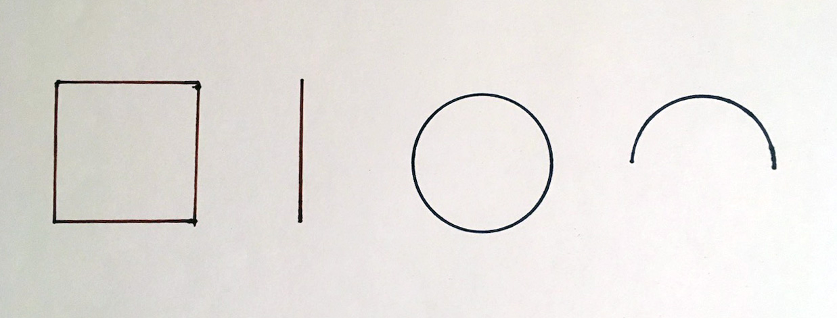
Image 01: Square and Circle example. Drawing: Ling Duong.

This is comparable to the Platonic tradition, in Rudolf Aller’s book ‘Microcosmus’. The Vitruvian figure inscribed in a square and a circle became the symbol of the mathematical sympathy between microcosm and macrocosm.’ ‘Leon Battista Alberti’, an Italian architectural polymath from the book ‘De re aedificatoria’ written in 1450, states that the ‘lines and figures pertaining to music and geometry so that everywhere the education of the mind is stimulated.’ Alberti’s definition is similar to the Yin-Yang example given previously. In other words, he hopes that every corner and form within the building communicates to the cosmological (Platonic) essences in which he has applied. This is of course amplified when Wittkower explains that creating buildings using the methods of ‘music and geometry are fundamentally one and the same; that music is geometry translated into sound, and that in music the very same harmonies are audible which inform the geometry of the building.’ A good example to see this as the properties of water, in its solid form, it becomes ice. When it liquefies, it becomes water and when it comes a gas, it is like the clouds. Robert Lawlor book ‘Sacred Geometry’ notes that ‘geometry is the language recommended by Plato as the clearest model by which to describe this metaphysical realm.’

In 1992, the ‘Traditional Cosmology Society’ based in the ‘University of Edinburgh’ produced a book called ‘Sacred Architecture in the Traditions of India, China, Judaism and Islam.’ Edited by Emily Lyle, a group of scholars were investigating how cosmological symbolism was expressed in the sacred architecture of temples and shrines of different cultures from around the world. They too noted that in a number of their studies, the buildings reflected the human form as the image of God. Burckhardt addressed this as the divine archetype. Plato and the Neo-Platonists, as previously stated in the traditional cosmology section, believed that the universe was interconnected as a harmonic, mathematical, geometric, musical order. Wittknower implies that if this is truly the order of the cosmos. Then our very souls, along with the stars, planets and the life forms of Earth would have been made of its essence. If the church was built correctly to this mathematical harmonic standard. One’s soul will be able tell us if the balance was true, because one’s instinct would be able to tell ‘without rational analysis, when the building we are in partakes of the vital force which lies behind all matter and binds the universe together.’ Up until now, the educational system of the liberal arts has given an example of what high culture should involve. Artefacts of how to not only express human nature, but also to transcend the cosmic origins for when it came.

Conclusion

The aim of this research was to examine whether cosmologies arise out of cultural behaviour and assumptions, or whether they have some essential reality. The previous sections have reviewed the three key cosmological viewpoints of Plato, Taoism and Alchemy, it has shown that there is indeed a similar underlining essence. As a summary, the macrocosm represents the eternal, nature of reality and the microcosm materialises it in form, as a mirror within us and the culture one creates. Both Platonism and Taoism represent the square and circle as heaven and earth, being and becoming (see image 02). These cosmologies were communicated within the culture of church architecture as actual practice. The difference to whatever the cosmos is culturally conditioned or not, comes from the standpoint of your intentions when making the artefact. Whatever it is from a popular culture or high culture perspective. Wittkower believes that one needs to be educated or culturally conditioned to follow the harmonic rules and apply these geometric proportions properly. He states that anyone who ‘transgress this rule would create a monster, he would break and violate the natural laws.’ Burckhardt has a more practical take on the matter. He suggests that it ‘is true the intellect has direct and immediate knowledge of itself, but this knowledge lies beyond the world of distinctions, so that, from the point of view of distinctive perception (divided as it is into object and subject), it seems non-existent.’ In other words, when God created the universe, his entire physical presence left, it is not in this realm anymore. That’s why it needs to be called upon and attained. Burckhardt is frank that the other alchemist authors such as Artephius, Synesios and Geber all suggest that alchemy was not meant for everyone and they will by all means hide it in riddles, so anyone unworthy cannot misuse its power. One could argue that the patterns found in nature is in all cultures and that within itself stays true; but how can one notice something which you have no idea what to look for? Lawlor states that:

Modern thought has difficult access to the concept of the archetypal because European languages require that verbs or action words be associated with nouns. We therefore have no linguistic forms with which to image a process or activity that has no material carrier.

Lugwig Wittgenstein quotes that ‘the limits of my language are the limits of my world.’ Humans are interlinked to experience and perceptions; but the cultural conditioning of the language can affect the outcomes to describe it. The essential reality is our perception and world is in content change, it is a relationship which is interrelated, cannot be categorised; but can be represented in ideas, forms and symbols, hence maintains the harmony in the realm which we live.

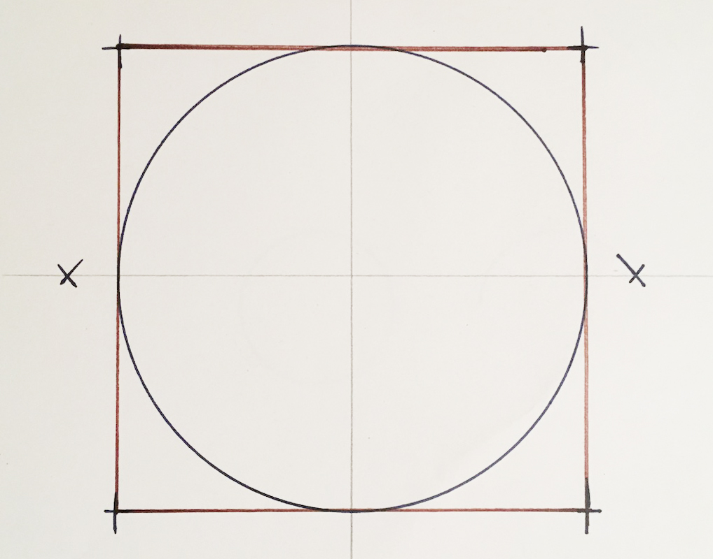
Image 02: Heaven in Earth, drawing with compass: Ling Duong.

Bibliography
Aller, Rudolf. “Microcosmus: From Anaximandros to Paracelsus.” JSTOR, Cambridge University Press, 1944, [www-jstor-org.ezproxy.uwtsd.ac.uk/stable/pdf/27830052.pdf?refreqid=excelsior%3A1fb0fc7461c8e0c6cbf35510006358a1&ab_segments=&origin=&acceptTC=1] Accessed 27 Dec. 2022.

Burckhardt, Titus, and William Stoddart. Alchemy: Science of the Cosmos, Science of the Soul. Shaftesbury, Element Books, 1986.

Campion, Nicholas. A History of Western Astrology. Volume I: The Ancient World. London, Hambledon Continuum, 2008.

Campion, Nicholas. Astrology and Cosmology in the World’s Religions. New York, New York University Press, 2012.

Collins Gem English Dictionary. Glasgow, Harpercollins, 2001.

Eagleton, Terry. The Idea of Culture. Eighth Edition ed., Blackwell Publishing, 2005.

Lyle, Emily. Sacred Architecture in the Traditions of India, China, Judaism and Islam. Edinburgh University Press, 1992.

Ferguson, Kitty. The Fire in the Equations: Science, Religion, and the Search for God. Eerdmans Publishing Company, 1994.

Hoff, Benjamin, and Lao Tzu. The Eternal Tao Te Ching : The Philosophical Masterwork of Taoism and Its Relevance Today. New York, Abrams, 2021.

McManus, Denis, and Ludwig Wittgenstein. The Enchantment of Words: Wittgenstein’s Tractatus Logico-Philosophicus. Clarendon Press, 29 Apr. 2010.

Parkhurst, John, et al. A Greek and English Lexicon to the New Testament. HathiTrust, London, Longman, 1845, [babel.hathitrust.org/cgi/pt?id=uc1.31175002230723&view=1up&seq=437] Accessed 28 Dec. 2022.

Paul J Lin, et al. A Translation of Lao Tzu’s Tao Te Ching and Wang Pi’s Commentary. Ann Arbor, Center For Chinese Studies, University Of Michigan, 1977.

Lawlor, Robert. Sacred Geometry : Philosophy and Practice. London, Thames & Hudson, 1982.
‌
Wilhelm, Richard. I Ching or Book of Changes. London, UK, Penguin Books, 1989.

Wittkower, Rudolf. Architectural Principles in the Age of Humanism. St Martins Press, 1988.
‌

Ferguson, Kitty. The Fire in the Equations : Science, Religion, and the Search for God. Eerdmans Publishing Company, 1994, p.86
Parkhurst, John, et al. A Greek and English Lexicon to the New Testament. London, Longman & Co, 1845, p.437
Parkhurst, John, et al. A Greek and English Lexicon to the New Testament. London, Longman & Co, 1845, p.438
Campion, Nicholas. A History of Western Astrology. Volume I: The Ancient World. London, Hambledon Continuum, 2008, p.149-157
Hoff, Benjamin, and Lao Tzu. The Eternal Tao Te Ching : The Philosophical Masterwork of Taoism and Its Relevance Today. New York, Abrams, 2021, p.13-14
Hoff, Benjamin, and Lao Tzu. The Eternal Tao Te Ching : The Philosophical Masterwork of Taoism and Its Relevance Today. New York, Abrams, 2021, p.14-15
Hoff, Benjamin, and Lao Tzu. The Eternal Tao Te Ching: The Philosophical Masterwork of Taoism and Its Relevance Today. New York, Abrams, 2021, p.23
Hoff, Benjamin, and Lao Tzu. The Eternal Tao Te Ching: The Philosophical Masterwork of Taoism and Its Relevance Today. New York, Abrams, 2021, p.134
Paul J Lin, et al. A Translation of Lao Tzu’s Tao Te Ching and Wang Pi’s Commentary. Ann Arbor, Center For Chinese Studies, University Of Michigan, 1977, p.4
Wilhelm, Richard. I Ching or Book of Changes. London, UK, Penguin Books, 1989, p.3-15
Burckhardt, Titus, and William Stoddart. Alchemy: Science of the Cosmos, Science of the Soul. Shaftesbury, Element Books, 1986, p.196-197.
Burckhardt, Titus, and William Stoddart. Alchemy: Science of the Cosmos, Science of the Soul. Shaftesbury, Element Books, 1986, p.34-35
Seyyed Hossein Nasr, Need for a Sacred Science, State University of New York Press, 2013, p. 19.
Collins Gem English Dictionary. Glasgow, Harpercollins, 2001, p.130.
Eagleton, Terry. The Idea of Culture. Eighth Edition., Blackwell Publishing, 2005, p.1
Collins Gem English Dictionary. Glasgow, Harpercollins, 2001, p.130.
Eagleton, Terry. The Idea of Culture. Eighth Edition., Blackwell Publishing, 2005, p.1
Eagleton, Terry. The Idea of Culture. Eighth Edition., Blackwell Publishing, 2005, p.3
Eagleton, Terry. The Idea of Culture. Eighth Edition., Blackwell Publishing, 2005, p.6
Burckhardt, Titus, and William Stoddart. Alchemy: Science of the Cosmos, Science of the Soul. Shaftesbury, Element Books, 1986, p.23
Burckhardt, Titus, and William Stoddart. Alchemy: Science of the Cosmos, Science of the Soul. Shaftesbury, Element Books, 1986, p.26
Burckhardt, Titus, and William Stoddart. Alchemy: Science of the Cosmos, Science of the Soul. Shaftesbury, Element Books, 1986, p.25
Eagleton, Terry. The Idea of Culture. Eighth Edition., Blackwell Publishing, 2005, p.10
Wittkower, Rudolf. Architectural Principles in the Age of Humanism. St Martins Press, 1988, p.32
Wittkower, Rudolf. Architectural Principles in the Age of Humanism. St Martins Press, 1988, p.39
Wittkower, Rudolf. Architectural Principles in the Age of Humanism. St Martins Press, 1988, p.113
Campion, Nicholas. A History of Western Astrology. Volume I: The Ancient World. London, Hambledon Continuum, 2008, in Introduction, x
Wilhelm, Richard. I Ching or Book of Changes. London, UK, Penguin Books, 1989, p.13-14
Aller, Rudolf. “Microcosmus: From Anaximandros to Paracelsus.” JSTOR, Cambridge University Press, 1944, in Traditio, II.
Wittkower, Rudolf. Architectural Principles in the Age of Humanism. St Martins Press, 1988, p.19
Wittkower, Rudolf. Architectural Principles in the Age of Humanism. St Martins Press, 1988, p.19
Lawlor, Robert. Sacred Geometry: Philosophy and Practice. London, Thames & Hudson, 1982, p.9
Lyle, Emily. Sacred Architecture in the Traditions of India, China, Judaism and Islam. Edinburgh University Press, 1992, p.2-5.
Wittkower, Rudolf. Architectural Principles in the Age of Humanism. St Martins Press, 1988, p.38
Wittkower, Rudolf. Architectural Principles in the Age of Humanism. St Martins Press, 1988, p.38
Wittkower, Rudolf. Architectural Principles in the Age of Humanism. St Martins Press, 1988, p.138
Burckhardt, Titus, and William Stoddart. Alchemy: Science of the Cosmos, Science of the Soul. Shaftesbury, Element Books, 1986, p.35
Burckhardt, Titus, and William Stoddart. Alchemy: Science of the Cosmos, Science of the Soul. Shaftesbury, Element Books, 1986, p.29
Lawlor, Robert. Sacred Geometry : Philosophy and Practice. London, Thames & Hudson, 1982, p.8 ‌
McManus, Denis, and Ludwig Wittgenstein. The Enchantment of Words: Wittgenstein’s Tractatus Logico-Philosophicus. Clarendon Press, 29 Apr. 2010, p.218

