James Fitches
2217780
Applied Computing/Software Engineering
L4: DATABASE
CONCEPTS
Assignment

Table of Contents
Abstract. 2
Introduction. 3
Tables 4
Branch 4
Department 4
Employee 4
Event 5
Customer 5
Supplier 5
Invoice 6
InvoiceItem 6
Entity Relationship Diagram 7
Conclusion. 8
References. 9
Abbreviations. 10

Introduction

To explain…

Tables

Branch

Field | Type | Length | Index
Id | Int (Auto) |  | PK
Name | VarChar | 128
Address1 | VarChar | 255
Address2 | VarChar | 255
Town | VarChar | 128
County | VarChar | 128
Postcode | VarChar | 7
TelNo | VarChar | 15

Department

Field | Type | Length | Index
Id | Int (Auto) |  | PK
BranchId | Int |  | FK
Name | VarChar | 128

Employee

Field | Type | Length | Index
Id | Int (Auto) |  | PK
DeptId | Int |  | FK
Forename | VarChar | 128
Surname | VarChar | 128
Address1 | VarChar | 255
Address2 | VarChar | 255
Town | VarChar | 128
County | VarChar | 128
Postcode | VarChar | 7
HomeNo | VarChar | 15
MobileNo | VarChar | 15
NINo | VarChar | 9
Position | VarChar | 128
StartDate | Date
Salary | Decimal | 10,2

Event

Field | Type | Length | Index
Id | Int (Auto) |  | PK
BranchId | Int |  | FK
CustomerId | Int |  | FK
Venue | VarChar | 255
Description | VarChar | 255
Rooms | Int
StartDate | Date
EndDate | Date
Rate | Decimal | 10,2

Customer

Field | Type | Length | Index
Id | Int (Auto) |  | PK
Forename | VarChar | 128
Surname | VarChar | 128
Company | VarChar | 255
Address1 | VarChar | 255
Address2 | VarChar | 255
Town | VarChar | 128
County | VarChar | 128
Postcode | VarChar | 7
WorkNo | VarChar | 15
MobileNo | VarChar | 15
Email | VarChar | 255

Supplier

Field | Type | Length | Index
Id | Int (Auto) |  | PK
Name | VarChar | 128
Address1 | VarChar | 255
Address2 | VarChar | 255
Town | VarChar | 128
County | VarChar | 128
Postcode | VarChar | 7
WorkNo | VarChar | 15
MobileNo | VarChar | 15
Email | VarChar | 255

Invoice

Field | Type | Length | Index
Id | Int (Auto) |  | PK
SupplierId | Int |  | FK
CustomerId | Int |  | FK
DepartmentId | Int |  | FK
InvoiceDate | Date
DueDate | Date
Reference | VarChar | 128
Net | Decimal | 10,2
VAT | Decimal | 10,2
Total | Decimal | 10,2

InvoiceItem

Field | Type | Length | Index
Id | Int (Auto) |  | PK
InvoiceId | Int |  | FK
Description | VarChar | 255
Quantity | Int
UnitPrice | Decimal | 10,2
Total | Decimal | 10,2

Entity Relationship Diagram

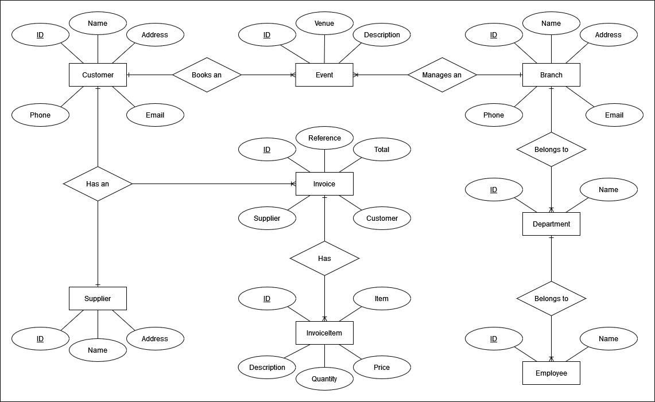

Forms

Blah.

Reports

References

[1] , "", [Online] Available: [Accessed 99/99/2023]

Abbreviations

Abbr. – Abbreviation

