LECTURER: SUJEEWA HERATH
STUDENT: COSTEL ANDONE(2027240)
MANAGING PROJECTS IN THE WORKPLACE
MODULE CODE: BMSW5104

Solar Power Company

Project Plan

Contents
Solar Power Company 1
Project Plan 1
Executive Summary 3
Introduction 3
The company 3
The Generic Project Cycle 3
Gantt chart 4
Initiation 5
Vision 5
Future Scope 5
Strategy. Organization and Management 8
Planning 8
Financing Plan and Profitability 8
Risk 8
The team of contractors 9
There aren't many large retailers for certain goods. The proposed organization's structure gives it greater negotiating leverage with key suppliers than many individual operators do. It is to be expected that these important vendors would combine more and more over time. 9
Numerous little sellers in the area sell additional goods. 9
Executing 9
Product and service planning 9
Permits , legal requirements and environmental issues 10
Closure 11
Projections and Financial Analysis 11
The investment as a whole is the subject of the financial analysis. 11
Conclusion 12
References 12

Executive Summary
This Solar Power Company project (SPCP) is intended to be both technically and financially feasible, as well as advantageous for investors, customers, employees, the general public, and the environment.

Introduction
This report is about the establishment of a Solar Energy Installations and Systems company. The generic project cycle will be used in this report, to see the structure of the breakdown of the activity, the scope, the allocation of resources, the involvement of the interested parties as well as the results of the project.

The company
Company will start working on implementing the plan to build a photovoltaic power plant. Despite the fact that the entire investment is based on the idea of photovoltaic solar panels covering costs and liabilities in the long run and generating a profit, it is still worth mentioning that an additional flow of money from elevated structures, specifically the items on which photovoltaic solar panels will be installed, may be anticipated.

The Generic Project Cycle
The life cycle of the project, the order of phases showing the steps that a project follows. These steps are as follows: initiation followed by planning, then execution and finally closure (Fig 1) .
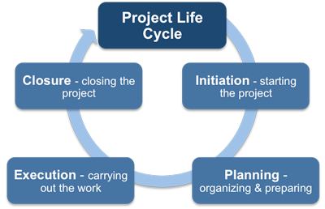
Figure: 1. Phases in the Project Life Cycle
Source: http://www.free-management-ebooks.com/faqpm/principles-08.htm

Each phase in the project is made up of discrete activities, and each of them has associated guidelines and a definition. Depending on the scope of the project, the number of activities will be decided.
We will take as an example a simpler project, it will have only a few activities, but more complex projects will definitely have hundreds or even thousands of separate or individual activities.

Gantt chart
A Gantt chart, a project management tool, is used to represent a project plan. A left-side task list and a right-side timeline with work-scheduling bars make up its typical two components.

 | APR | MAY | JUNE | JUL | AUG
Vision and future scope
Objectives and services
The team of contractors

Permits, environmental issues

Cost of services
Solar Energy System Installations

Projections and Financial Analysis
Finalize plan and Stakeholders

Figure 3: Gantt chart.

Gantt charts are useful for visualising the numerous tasks and projects that are carried out concurrently inside an organisation as well as their current status. Management uses them to plan and schedule these projects in order to distribute resources efficiently and to ensure that higher priority projects are completed before lower priority ones.

Initiation

Vision
There is a lot of potential in this modern world. A very large part of people are educated and technological and scientific knowledge offers solutions for
world problems. The biggest aid in the world at the present time is the responsibility of businesses, which helps to initiate and progress, and the subject of solar energy is a high priority.

Future Scope
Energy security, affordability, and availability are crucial for socioeconomic growth. By utilising it, we may improve our everyday lives. To assure energy security in the near future, we have tried to concentrate on alternative uses of solar energy in this essay. Our irrigation problem can be resolved, and a DC grid powered by solar PV will guarantee a higher quality of life for rural residents. For lowering the use of natural gas and the burning of wood fuel, solar cooking can be a practical solution for both rural and urban areas. In order to solve our energy and gas crises and preserve a green environment for future generations, we must secure these great possibilities.

Goals and Objectives
The objectives of this project for Solar Power Company project (SPCP)are to be a successful organisation to carry out these SPCP activities and to accomplish so in a way that the organisation is.

Products and services
The business will create electrical energy using renewable resources.
Distributors of electrical energy in UK sell this energy separately from that derived from fossil sources. These businesses are already on the market, but since the process is just starting out, we can anticipate that the supply will increase. In order for consumers to receive satisfactory results, society as a whole to have a positive impact, and investors to have a low risk and safe investment opportunity, a business must be financially viable and successful.

Stakeholders
Project developers, installation businesses, component producers, and other trade labourers including roofers, HVAC installers, and electricians are some of the stakeholders in the solar sector. These businesses may have a local base or an interest in growing inside the neighbourhood.

The Opportunity Investment
Policymakers in the US and elsewhere are turning to the energy sector to be the driver of future development as it is a significant area for investment. The installation of solar energy systems and energy efficiency retrofits are becoming more and more appealing due to the fundamental economics of energy and technological advancements. This area of the energy market is where SPCP is best positioned to expand.
Sector analyses highlight this market segment's enormous potential. Long-term investments have been made in the sector by Warren Buffett and other well-known investors.
However, the studies do not address why the expansion of that industry has been so sluggish in comparison to its potential. According to our financial study, this is due to a mismatch between the consumer's needs and the organisational structure of the system and finance suppliers. This limitation is addressed by the SPCP project.

Solar Energy System Installations
The following graph illustrates the rapid growth of the global market for solar energy systems. The market for solar energy was valued at US$ 197.23 billion in 2021 and is anticipated to increase to US$ 368.63 billion by 2030, with a predicted CAGR of 7.2% during that period.
Solar energy is the radiant energy that the sun emits and may be harnessed by a variety of technologies, including photovoltaic cells, solar heating, and more. It is a viable source of renewable energy that effectively combats both rising greenhouse emigrations and global warming (Fig: 2).
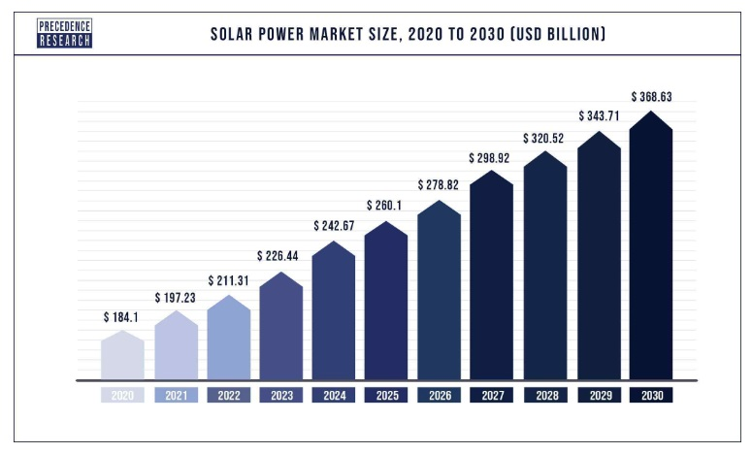
Figure 2. Solar Market size ,2020 to 2030.
Source: https://www.precedenceresearch.com/solar-power-market

A renaissance in solar energy is driving the faster-than-expected growth of the world's renewable electricity supply, which might increase by 50% in the next five years. The IEA discovered that the number of solar, wind, and hydropower projects is growing at its quickest rate in four years. According to the most recent projection, the global solar capacity might expand by 600 GW by 2024, more than double Japan's installed total energy capacity. The overall amount of renewable electricity is anticipated to increase by 1,200 GW over the course of the next five years, which is equal to the US's entire installed capacity.

Strategy. Organization and Management
In light of this, SPCP 's goal is to build upon what already exists as much as possible rather than starting from scratch. The project's operational level is handled by existing contractors, but they are constrained by convoluted incentives, laws, and paperwork.
The approach recognises the unique assets of this neighbourhood, such as the contribution of local companies to neighbourhood development, and takes into account the fragmented nature of the contracting market.
In addition, the project is structured so that units dealing with the major challenges of finance, negotiating incentive possibilities, assuring good structure, and maintaining control quality are responsible for handling these difficulties: a "holding" company with a funding division, and b" a management project and monitoring division.

Planning

Financing Plan and Profitability
The proposed financing is a $25 million loan instrument with a 15-year repayment period and an effective interest rate of 4% annually.
According to the base case, this money will allow the SPCP project to start turning a profit in Year 3 and continue to do so moving forward.
Long before the loan's maturity, repayment will be available.

Risk
The financial and economic risk is minimal compared to the other standard company hazards. Future increased prices for fossil fuel-based energy make the SPCP project more attractive, not less, and technological trends should increase the profitability of this area of the energy sector, not decrease it.

The team of contractors
A marketing team for an organisation will be concerned with anything that pertains to market research and claims.
All base teams are well known in the industry for their local community energy systems and longer-range movement for medium and sustainability. There are plenty of people available for hire, but the key is having a product or service to sell, as well as the client's ability to fund the project.

Equipment for entrepreneurs
A preliminary selection of contractors willing to work on projects has already been made. These are business owners and subcontractors who have already made money working with the base management.
Numerous independent business owners who are qualified to carry out the necessary tasks exist.

The team of suppliers

There aren't many large retailers for certain goods. The proposed organization's structure gives it greater negotiating leverage with key suppliers than many individual operators do. It is to be expected that these important vendors would combine more and more over time.

Numerous little sellers in the area sell additional goods.
In order to cut expenses while improving quality, the corporation will diversify its purchasing strategies

Executing

Product and service planning
Birmingham is the site of the land where the PV power plant will be built. The location of the land is The land's surface size is 93.000 m2, and it is situated in a sizable area free of forests (Fig: 3).
The area is ideal for building a PV power plant since it has mild winters with less snow, which makes it easier to produce energy when the modules are covered in snow in other locations. Additionally, the area receives the same amount of solar radiation (1326 kWh/m2) as the coastal regions of the UK, which are subject to the greatest solar radiation in the country; the summer temperatures are also a little lower than in coastal areas, which makes the modules more efficient because their utilisation rate is lower during heating.
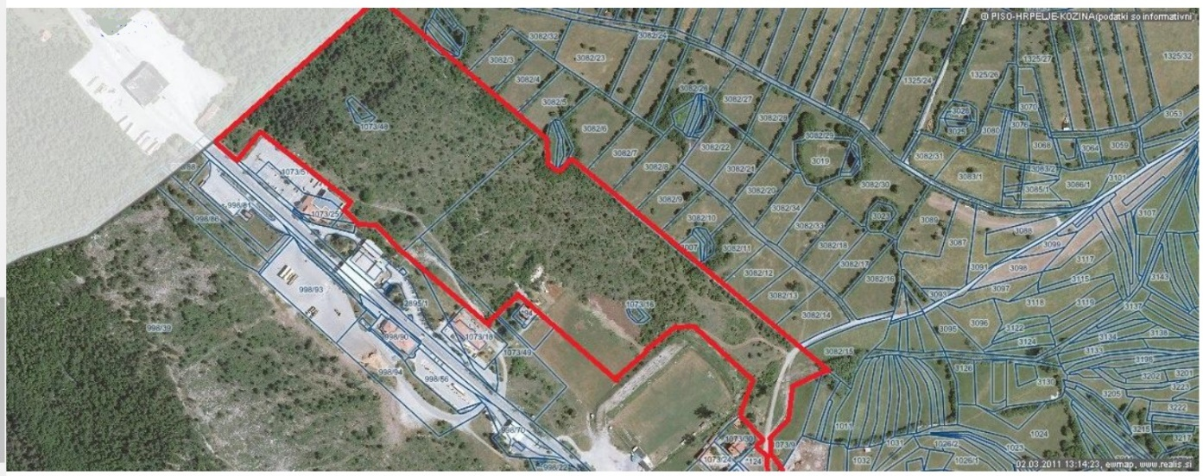
Figure : 3

Permits , legal requirements and environmental issues
The procedure of getting a construction permit resulted in the acquisition of all necessary permits and other requirements, which were also resolved. Until the collective charge is paid, the construction permission is temporarily on hold. When this price is paid, the construction permit will be fully valid legally and there won't be any more barriers to getting started.
We also have permission to connect to the national power grid.

General time-table
Construction can start if the collective fee is paid. From the start of construction until completion (on a turn-key basis), 3–4 months are anticipated.

Risks
Vandalism, force majeure, or weather-related panel destruction
In the event that a panel is destroyed due to weather, a force majeure event, or vandalism, which results in decreased electrical energy production, we will have an insurance contract with the insurance company that also offers reimbursement for the lost inflow due to decreased electrical energy production. This contract will ensure that we are able to achieve the planned revenues.

Damage power plant's panels and other parts
According to the comprehensive warranty, damaged panels and other parts are replaced or fixed. Due to the size of the PV power plant, such faults should typically only happen infrequently and should only result in damage to a small portion of the components or panels, not significantly affecting the generation of electrical energy.
It is possible for some unanticipated events to occur throughout the operation, but they won't have a significant impact on the business's operations because their origin is unrelated to the company.
The PV power plant is adequately insured against any event of loss and damage, and the agreement for a fixed FIT rate is made for a 15-year period, so the guaranteed FIT rate cannot be changed .

Closure

Projections and Financial Analysis

The financial statement set that follows gives a five-year overview of the precise calculations that illustrate how the SPCP programme might work .
This is a base case that illustrates how the suggested technique could result in a fundamentally solid financial condition. The highlights are as follows:
A project that instals 1.2 MW of solar energy systems annually will be funded with a $25 million finance that will be made up of three tranches: $5 million in the first year, $10 million in the second year, and $10 million in the third year.

The investment as a whole is the subject of the financial analysis.

We chose the COSTA EPC company TEP Invest d.o.o. to build the power plant from start to finish. This business has extensive industry knowledge and is familiar with all relevant local laws and regulations. We also got to the conclusion that they can provide the greatest components at the best costs.
Warehouses: cash flow and balance
In charge of managing the warehouses is ANDO Project d.o.o. This company will manage the administrative tasks required for warehousing, ensure that the warehouses are well stocked, handle the structures that contain the storing materials, and supervise and keep an eye on both the structures and the materials.
It is obvious that the investment in the PV power plant pays for itself, and the warehousing provides an additional assurance that the annuities will be paid off on schedule.
The ANDO Project company has already made provisional arrangements for the rental of warehouses with logistical firms.

Conclusion
The provision of electric energy for the fulfilment of rural and municipal lighting needs may have other beneficial effects, such as enhancing life quality and expanding revenue and employment opportunities. Therefore, using solar energy to electrify rural areas is a good example for users because it liberates them from system management duties. The system's overall collapse was prevented by including the local community in administration. Solar energy system demonstrations were successful in generating interest among rural residents and were noted and requested from other locations.

References

Anbari, F.T., Carayannis, E.G. and Voetsch, R.J., 2008. Post-project reviews as a key project management competence. Technovation, 28(10), pp.633-643.
Barad, M. and Raz, T., 2000. Contribution of quality management tools and practices to project management performance. International Journal of Quality & Reliability Management.
Barad, M. and Raz, T., 2000. Contribution of quality management tools and practices to project management performance. International Journal of Quality & Reliability Management.
Heracleous, L., 2003. Strategy and organization: Realizing strategic management. Cambridge University Press.
Imran, M.K., Rehman, C.A., Aslam, U. and Bilal, A.R., 2016. What’s organization knowledge management strategy for successful change implementation?. Journal of Organizational Change Management.
Labuschagne, C. and Brent, A.C., 2005. Sustainable project life cycle management: the need to integrate life cycles in the manufacturing sector. International journal of project management, 23(2), pp.159-168.
Nový, M., Nováková, J. and Waldhans, M., 2012. Project management in building industry management. Acta Universitatis Agriculturae et Silviculturae Mendelianae Brunensis, 60(7), pp.189-198.
Pettigrew, A.M., Thomas, H. and Whittington, R. eds., 2006. Handbook of strategy and management. Sage.
Qureshi, T.M., Warraich, A.S. and Hijazi, S.T., 2009. Significance of project management performance assessment (PMPA) model. International Journal of Project Management, 27(4), pp.378-388.
Shenhar, A.J., Dvir, D., Levy, O. and Maltz, A.C., 2001. Project success: a multidimensional strategic concept. Long range planning, 34(6), pp.699-725.
Thomke, S.H., 2003. Experimentation matters: unlocking the potential of new technologies for innovation. Harvard Business Press.
Turner, J.R., 2009. Handbook of project-based management: Leading strategic change in organizations. McGraw-Hill Education.

