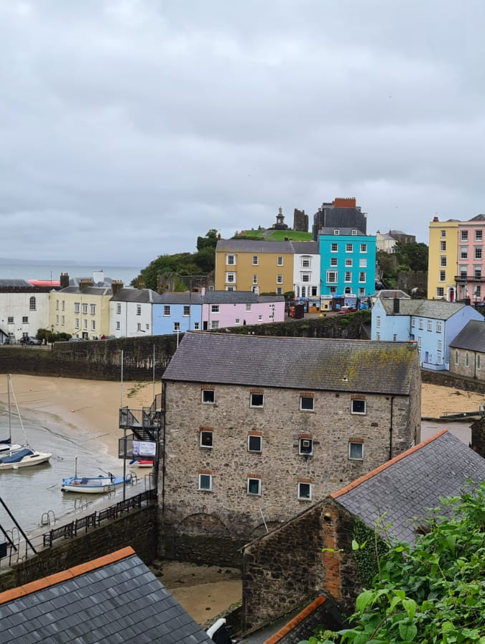  Figure 1Tenby buildings, Cleo Harris, 2021  Using one of the establishments visited how easy is it to gain a sense of what constitutes Welsh culture?  Exploration of Heritage and culture in Tenby | Abstract  This report is investigating the history of Tenby and how the town represents its heritage and how this effects the perceptions of the Welsh culture in the local area.  Cleo Joanna Harris (2004275)

Introduction
Through exploring the town of Tenby, the history of the town area also investigating the towns architectural history, this report will analyse the cultural expressions of the town and how Tenby presents a certain type of Welshness in an area often considered to be lacking Welsh culture and authenticity. It’s by looking into how the town council, national park and businesses of the town present the heritage of Tenby to itinerate, one off tourists to the local area. This report will also explore aspects of what it means to be representing Welsh Heritage, and the expectations of visitors coming to Wales in contrast to people local to the area.

Brief History of Tenby

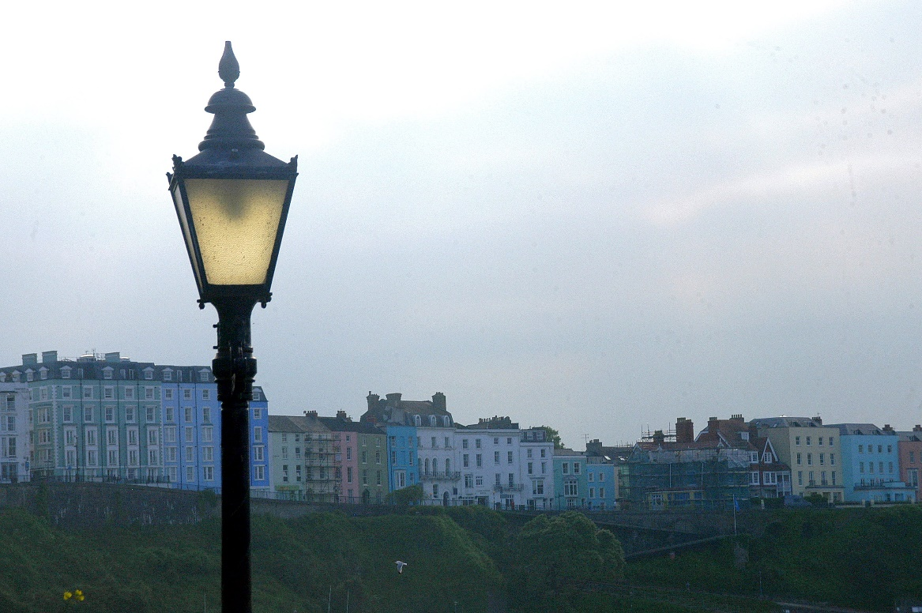
Figure 1Tenby Buildings, Tim Burton, Cleo Harris, 2018

It’s possible to witness the different stages of Tenby’s life through looking closely at the layout of the main town itself. Stone walls still stand today, and medieval buildings stand nestled amongst the pastel hotels and 20th century architecture.

The Town of Tenby in south Pembrokeshire, is a popular tourist destination, promising golden sands and a classic seaside resort experience. With brightly coloured buildings and shops harking back to the Victorian era. Though unlike many seaside resorts of Britain today, Tenby was not purpose made for the enjoyment of its visitors but instead has been the site of a much older town, with a settlement existing on the site from dark ages. Since the 9th century visitors to the town have taken not of the towns connection to the sea and the maritime industry. An anonymous poet wrote:

“ Addfwyn gaer y sydd ar lydan lyn
Dinas diachor, môr o’i chylchyn”

(A splendid Fortress, stands by the wide ocean
A sturdy stronghold, enriched by the sea,) “
(Jenkins, 2016)
It’s the sea that connects each aspect of Tenby’s history. From the Norman settlement and building of the town walls, that soon replaced the fortress discussed in the above poem. To the medieval harbour built in the 1300’s and the coal and lime exports up to the 19th century and to the leisure resort of the Georgian and Victorian era that can still be seen today.

During the medieval period many notable merchants settled in the town, profiting off the import of French wines. The Tenby Merchants House on Quey Hill has been re-created to express the life of the wealthy merchants during the 1500’s. with the towns situation on the coast smuggling gained a small foothold in the town, bringing wealth to the merchants, also the import and export of legal and illegal goods, the fishing industry of Tenby continued to be profitable. An abundance of fish such as herrings and oysters where commonplace off the shores of Cauldey island and would provide food for the town and surrounding areas. (Vousden & Groom, 2019)

The coal trade in Tenby was thriving along with the fishing industry, up until the late 18th century with 30% of the coal export in Pembrokeshire (Jenkins, 2016)The translation being the town of little fishes. Nearby towns such as Saundersfoot also took part in this industry and continued with their exports into the 20th century and, consequently, due to the increase of visitors in Tenby and the rapid development in tourism, colliers where not as welcome in the town.

Tenby re-invented itself as a seaside resort during the 19th century and to this day the tourist industry of the town draws thousands of visitors each month. It was in the 1830’s that a twice weekly steam packet from Bristol would make it way to the town. And with the arrival of the train in the 1860’s the tourism industry was booming. Bandstands, Theatres and hotels soon dominated the towns landscape and anything that could draw visitors to the area during this time the fishing industry continued with its steady presence in the town.

Tenby Today
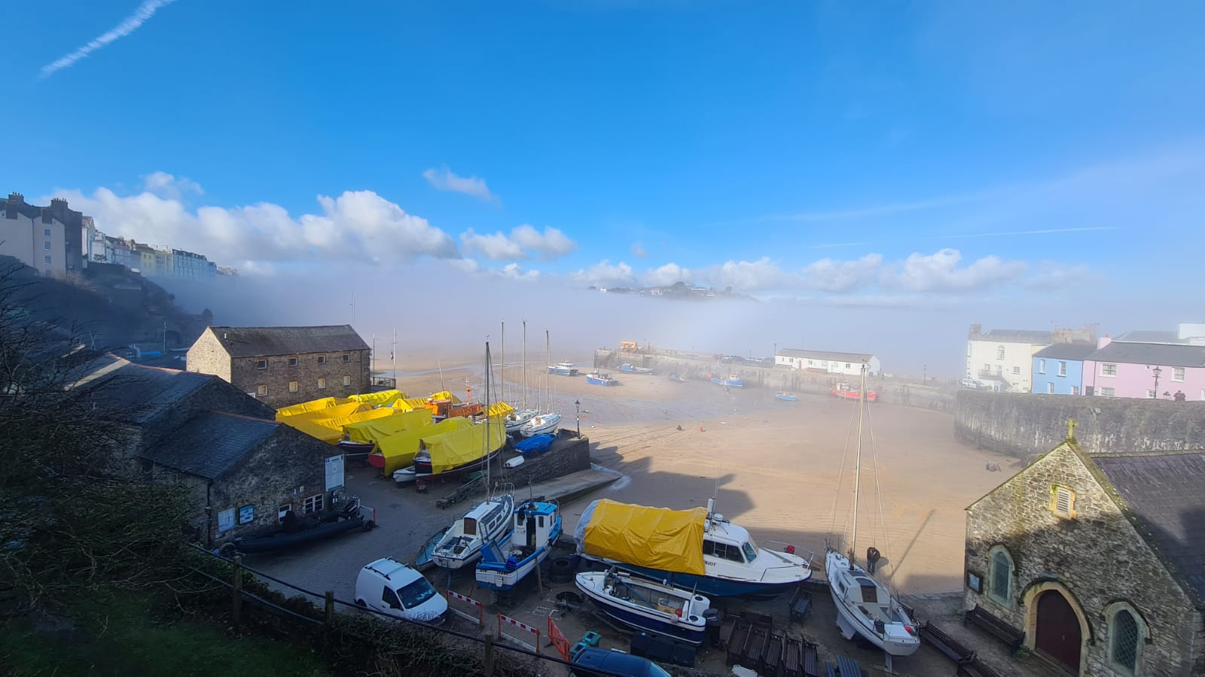
Figure 2 Tenby Buildings, Cleo Harris, 2021

Today Tenby still relies on the attractions of the old resort and continues to draw hundreds of thousands of visitors to Pembrokeshire each year. There is a large emphasis on the seaside aesthetic of the town that is seen in many of the shops, such as Lollies sweetshop and old-style store on the sea front selling Welsh chocolate and old-style sweets. Tourism constitutes a large portion of the local Pembrokeshire economy and the local development plan for tourism 2019 and visit Wales states that Tenby visitor attractions such as Cauldey island and the Tudor merchants house brought over 75,000 visitors to the area (Pembrokeshire County Council, 2019). The vibrant pastel buildings and promises of seaside adventure continues to draw tourist by the hundreds of thousands. Winding streets lined with modern restaurants, ice-cream shops, pubs and fish and chip takeaways, offer visitors everything they could need when visiting the town during the summer holidays.

Fishing in Tenby continues to be culturally relevant today, with many restaurants and caffes in the town offering fresh authentic Tenby caught shellfish, cockles, and fish as part of their menu. simply seafood is one such example, selling produce straight from the harbour. While the fishing boats are still present in the harbour today much of the less appealing aspects of the fishing industry have been moved away from the harbour area itself and can be found on the outskirts of town such as lower park road.

Little England is the name often given to the area of south Pembrokeshire below the Landsker line. This title came to be as a result of the Norman conquest of Wales and was in reference to the influx of English and Flemish residence to the area. (Austin, 2005) Today the title also refers to the language difference between the north and south of Pembrokeshire, with the Welsh language having a much smaller foothold in the south than the rest of the county. Little England is commonly used by locals to refer to the tourist towns and the increasing number of second homeowners in many seaside areas.

What is Welsh culture?

Many businesses in Tenby present themselves as being authentically Welsh, selling a variety of produce (fresh baked goods, t-shirts, printed memorabilia, etc) It’s images off love spoons, dragons, mountains and women dressed in tall black hats that first comes to mind when thinking of “Welsh culture” and it’s these images of Welshness that are often emphasised for those visiting anywhere in the country. But what exactly constitutes Welsh culture? Is it the often over manufactured souvenirs found in gift shops, people living in the countryside, farming or working with the land? There are many practices within Welsh society today, such as the school eisteddfodau, that are practised across the country, experiences that every child growing up in the country will have participated in. The Welsh language also is a facet of Welshness that is present across the board in every school and is often the defining characteristic of Authentic Welsh culture.

Regarding the town of Tenby, what then is Welsh culture? The language of the area is predominantly English, the stereotypical Welsh heritage items (such as the previously mentioned love-spoons) has historically been cushioned beneath the English and Flemish cultures of the settling migrants to the areas.

Merfyn Jones writes “Welsh identities, it would appear are plentiful, but Welsh identity to be embraced by all or by a majoritarian current, is providing to be harder to come by” (Jones, 1992) It’s this idea of no fully homogonous Welsh culture that is doubly relevant to many of the towns in south Pembrokeshire where the typical idea of a Welsh connection is even more intangible.

Presentation of cultural heritage in Tenby

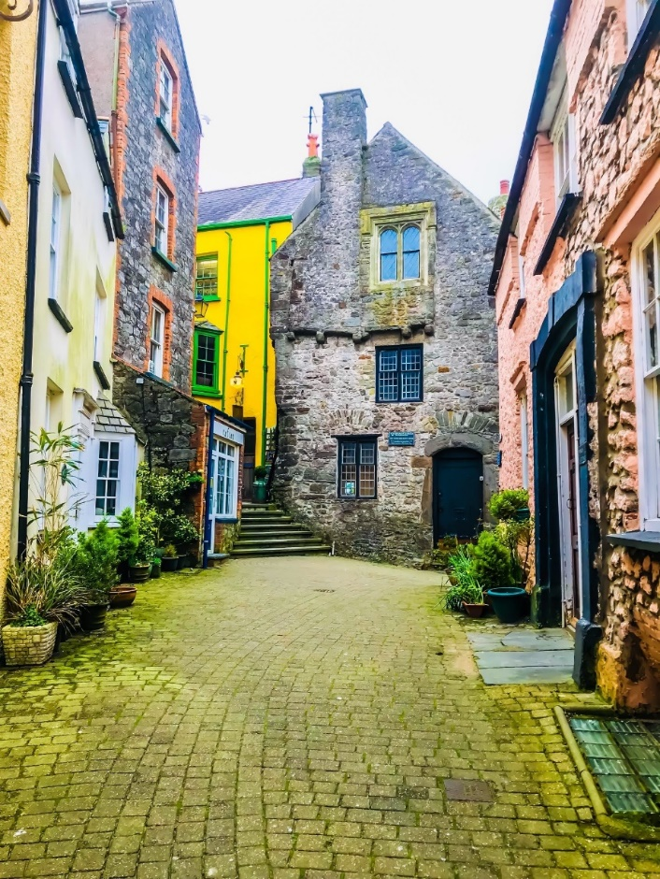
Figure 2 Tenby Merchants house, Tim Burton, 2018

Signage is a large part of how the town of Tenby goes about displaying its heritage to visitors. It’s not a single organisation that controls the outward presentation of the town’s heritage but instead a multitude of groups, such as the town council. County council. The national park authority. CADW, individual businesses in the town, and organisations such as the Walled Towns Friendship Circle and Tenby walled town Residents’ Association.
There are many blue plaques marking the residence or visits of famous individuals to Tenby over the years, Beatrix Potter, Dylan Thomas and Roald Dhal each have blue plaques referencing their visits to the town. It’s important to note that these blue plaques do not give a great deal off information to visitors who notice their placement on buildings, merely stating a name and date and a sentence or two on the individual mentioned. Yet the placement of these plaques in the first place gives insight into how the town is using the appeal of fame to draw visitors to the area.

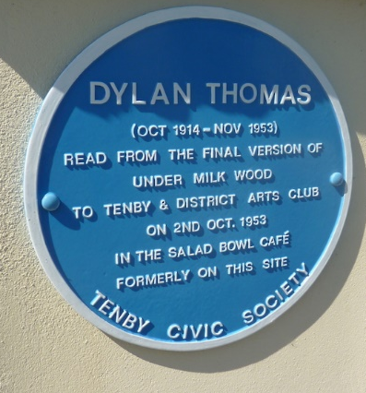
Figure 3Dylan Thomas, Tenby Museum,2015
Tenby has a strong emphasis on situating itself into an already widely known narrative. A lord nelson statue sits proudly in the town in view of a Napoleonic fort on Catherine’s Island. The use of blue plaques stating the ties to people of note, also the generally focus on the popular narratives of pirates and smuggling, and its development as a Norman settlement and then its later re-invention as a seaside resort. The focus of the history, as presented by the town, does little to represent the Welsh culture of the area. Instead aligning itself with a more English expression of history, whereas elsewhere in the local area (Carew Tidal Mill as one example) may focus more on the local history, without such an emphasis on a wider British narrative. This is a theme that runs throughout how the town chooses to present itself to visitors.

The draw of tourism to Tenby determines the focus of the heritage that is obviously presented to the public. With tourism in the year 2019 £589,945,000 contributing to the local economy (Visit Pembrokeshire, 2019)This impact can be seen with the popular activities such as ghost walks throughout the town at night and how these tours exclusively use the main streets, not venturing away from the usual tourist hotspots of the town.

Along with the standard fish and chip shops found in every seaside town. There are many restaurants and caffe’s selling traditional Welsh dishes such as Welsh cawl, and fresh bread. This expression of Welsh culture is only rivalled using locally sourced fish from the town’s fishermen, still present and working in the harbour today. The focus on the importance of tourism in the area has resulted in much of the less appealing aspects of the fishing industry being moved to the outskirts of town. It’s this displacement of industry, residents and the industry’s aspects of day to day living in Tenby to the outskirts of town that often clashes with the typical view of Tenby that is offered up to visitors. Restaurants often offer Typically Welsh products to visitors, emphasizing the Welsh culture of the area yet do not take the same care to introduce local cultural dishes with the same enthusiasm. It’s unlikely that dishes culturally relevant to South Pembrokeshire, like that of leaky porridge, would be served.

Tenby museum is one if the oldest independent museums in Wales, and has been run since the 1878, and claims to “preserve and promote the history of the town, giving a sense of place and heritage to both the local person and the visitor.” (Tenby Museum & Art Gallery, 2021) the museum while it maintains a much more varied collection of local artifacts with relevance to those living in the area, they also feed into Tenby’s overall appeal of pastel buildings of the sea front, in its art gallery, something echoed in many of the souvenir shops around town and enforced by the town council in the fact to change a colour of a seafront building planning permission to do so is required.

To many local people it’s the fabrication of Welsh culture aimed at itinerant one-time visitors, not just in the food industry of the town, but in businesses and national park attractions, that has led to a disconnect between locals of the area and the town of Tenby itself. Many of whom would only visit the town during winter to make use of the many pubs and leisure activities that are often too crowded to fully appreciate, the culture presented in This sentiment has been expressed by the Tenby walled town Residents’ Association in a report to parliament stating “…client base promoted a "cheap and cheerful" holiday, a by-product being to establish a culture that Tenby was an ideal place for excessive drinking and more recently as a stag and hen party resort.” (Walker, 2004) emphasising that to a local resident, the culture represented in Tenby may feel fabricated and unauthentic, aimed towards easy leisure and not towards promoting local Welsh culture.

Conclusion

Though Tenby has a vast and important history, the town focuses’ its tangible heritage on exploring the aspects of its history most appealing to the visitor. There are two different cultures present in the town, that of the yearly visitor and that of the local.
Welsh culture is not widely represented in Tenby because of the narrative driven and insular expression of culture that the town presents. it is important to not that despite Tenby situating itself into a wider British narrative, whilst at the same time distancing itself from the local south Pembrokeshire narrative the culture presented is much more akin to an English town despite the emphasis on stereotypical cultural experiences. It is in the intangible heritage of the town, the hidden heritage, behind the council enforced pastel colours that is more closely related to a more authentic cultural understanding of the town.

Bibliography
Austin, D., 2005. Little England Beyond Wales: Re-defining the Myth. Landscapes, pp. 30 - 62.
Heeley, J., 1981. Planning for Tourism in Britain: An Historical Perspective. The Town Planning Review, 52(1), pp. 61-79.
Jenkins, G. J., 2016. Pembrokeshire: its present and its past explored. Llanwrst: Gwasg Carreg Gwalch.
Jones, M., 1992. Beyond Identity? The Reconstruction of the Welsh. Journal of British Studies, 31(4), pp. 330-357.
Lilley, K. & Hubbard, P., 2000. Selling the Past: Heritage-tourism and Place Identity in Stratford-upon-Avon. Geography, 85(3), pp. 221-232.
Pembrokeshire County Council, 2019. Background Paper for Local Development Plan 2: Tourism, s.l.: Pembrokeshire County Council.
Tenby Museum & Art Gallery, 2021. Tenby Museum and Art Gallery. [Online]
Available at: http://www.tenbymuseum.org.uk/
[Accessed 7 october 2021].
Visit Pembrokeshire, 2019. Economic Impact of Tourism. s.l.:Destination Research.
Vousden, N. & Groom, D., 2019. Such Store of Fishe as Pleased God to Send. In: Wales and the Sea: 10,000 Years of Welsh Maritime History. s.l.:Y Lolfa, pp. 150 - 155.
Walker, R., 2004. Parliment. [Online]
Available at: https://publications.parliament.uk/pa/cm200405/cmselect/cmwelaf/46/46we31.htm
[Accessed 10 10 2021].

