INTRODUCTION
The marketing is everything (McKenna,1991) famous publication on the Harvard business review in February of 1991 change the definition of market in a simple word “everything”.
Nowadays we live in a market society which it is always changing trends, habits and the way to market which is definitely going backwards where is the final consumer deciding how to direct the market, and a continuous share of information that reach us h24 through our phones.
“The 1990s will belong to the customer. And that is great news for the marketer.
Technology is transforming choice, and the choice is transforming the marketplace.” (McKenna, 1991)
A radical transformation with an almost invisible difference between goods and commodities, Yanis Varoufakis explains how in thousand of year we have arrived at where in economic speaking the human labour is no longer a good but a commodity on the market, as raw materials and land, making the society part of the market and not vice versa (Varofakis,2013).
Given few words on what is the main ingredient of my report I will now move the attention on the most important tool on how to keep control of the broad amount of information the market is throwing to companies, evaluating its effectiveness within the hospitality industry and a closer view at the relationship with information, communication and marketing.

MARKETING INFORMATION SYSTEM
The right product, in the right place, at the right time and at the right price.
There it is what everyone wants to achieve, but needs a solid path of research, investment and gather based on the flow of information on the market. more precisely we are speaking of a systematic collection, analysis, interpretation, storage and dissemination of the market information, from both the internal and external sources, to the marketers on a regular and continuous basis. (business jargons,2019)
The marketing information system is divided into four fundamentals;
- Internal records
- Marketing intelligence
- Marketing research
- Marketing decision support

Internal records represent every information related to the inside of the company, every number the company produce or spent, inventory or customer database. The data are usually stored in power software where the marketers can dig and analyse anytime.

Marketing intelligence on the opposite is focused on the marketing environment, and highly recommended to work deeply on this point being part of factors like market trends, competitors’ numbers, customer needs and wants, new products in the market, promotion and strategy of the competitors.

Marketing research is the topic of the MIS is the practical interpretation of the information gathered and analysing the environment on the base of two data:
- Primary data (word of mouth, questionnaires, interviews...)
- Secondary data (books, trade journals, government, bought from an external company...)

Marketing decision support as per name is the technological help that rescues the marketers from the huge amount of information obtained and helps balance the strategy with the findings.

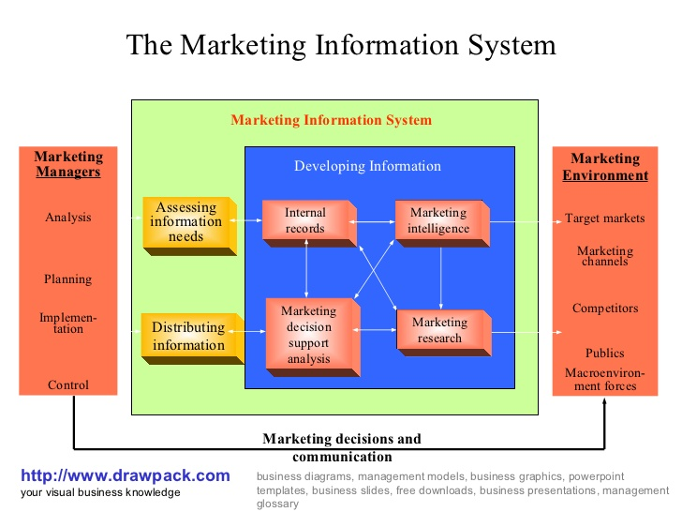

Every company which aims to a competitive marketing strategy needs a serious approach to the MIS and remember that a good one follows a few topic points:
- Continuous system
- Technological presence
- Accuracy
- Market complete overview
- Problem-solving
- Timing advantage

MARRIOTT
Marriott today is one of the biggest colossal of the hospitality industry comprising 30 different brands from luxury to economy scale, been on the market since 1927 with 1.2million rooms spread all over the world. (USA Today,2018)

Information GATHERING
The importance of gathering information is the base of the entire process and according to this article in 1997 Marriott decided to invest 100 million dollars in new technological systems giving a clear advantage on the market (CIO from idg, 2019) with internal developing and featuring with other companies as MICROS Systems, Inc. a leading provider of information technology solutions for the hospitality and retail industries(Cision pr newswire,2019) in the 2013, connecting all the North America, with a central system of gathering information and obviously improving the technological service. CIO Magazine named Marriott International to its Top 100 list for the fifth time. Marriott is the only hotel on the list, which recognizes organizations for excellence in information technology. (Lodging Hospitality, 2004) Gathering information of the company is focused in every department reaching any kind of product that can be stored, simple as recipes, elaborating a proper system of control over the menu, food cost, inventory and seasonality of the ingredients, accessible from the whole management team and translated in several different languages. Everything connects to increase the productivity, drive sales, customers satisfaction and an unmissable boost of profits

COMMUNICATION
MIS, as we said, is a basic point for the right overview of every company and the right utilize can absolutely be profitable, but not always willing to positive ends, as a next step I would like to highlight how miscommunication can create unbelievable gaps, not just within the MIS but also huge leaks in the company.
In the November of the last year has been published on the New York Time “Marriott Hacking Exposes Data of Up to 500 Million Guests" starting in 2014 the Starwood's booking database has been hacked stealing names, addresses, phone numbers, birth dates, email addresses and encrypted credit card details. (New York Times,2018)
Bringing one of the darkest sides of the MIS to reality with a massive lack of internal communication, but the counter-response of the company is not late to come and where they lacked within the company, they did not with their customer promptly creating a connect website with help assistance in every country.
In conclusion thanks to what happened, it teaches us how the communication between customer and company is a fundamental in the industry e improve their loyalty.

MARKETING
Success is never final. (The Spirit to Serve,2000) and to keep it going you need a strong marketing strategy and a strong strategy come from a strong MIS. I would like to list three points that I personally think are vital for a strong marketing strategy in the hospitality industry:
- Creativity, the research of new concept in the market will give to the company an exclusivity and an automatic advertisement.

- Technology, according to Michael Wright, Content Marketing Director at ConfidentWriters, content is king on websites of all kinds, and this is also true for hospitality home sites. (Hospitalitynet.org, 2019) as we have seen in the rest of the report technology is the base of any type of information’s spread or gather.

- Loyalty, in an industry where the amount of businesses is massive, personalization of social media and email content experiences for customers are part of making customers remember the business

TUCH OF MARKETING MIX
We started with a precise sentence, The right product, in the right place, at the right time and at the right price, and here again almost at the end of the cycle with a final strategy to accomplish it. Marketing Mix has born to give the right direction to your product in a determinate marketing segment, following four key points, or also called 4P’s:
- Product
- Place
- Promotion
- Price
With an implement of another three when we speak about a service-based company
- People
- Process
- Physical evidence
Given the 7P’s we need to move our attention also to the customer point of view been express from the 4C’s
- Customer needs and wants
- Cost to the customer
- Convenience
- Communication

CONCLUSION
We started with a quick description of marketing and we have done all the way down to the marketing mix, a guideline that hopefully should lead your company to a winning presence on the market, but as I like to highlight the success is never the last objective and to catch the right marketing strategy you need a lot of work, as we have seen the MIS has bright sides but also several liabilities. A strong company is also made from a firm management team that knows how to handle all the information emanated from the MIS and take wise decisions.
Marriott is for sure one of the best example on the market of a company that even in his worst years is always working hard to get better, training and taking care of is management teams that reflex on his thousands of employees and in final good faith on his customers.
"We have realized for a long time that you can't have a service business with a lot of employees without having people who know how to manage. So, we have been teaching our management about how to manage, as well as our employees how to take care of their jobs. Good management and trained personnel are the most important factors in our business." (The Spirit to Serve,2000)Another tip from the book of J.W. Marriott that inspire all his employees, and you can also find it in every room of the Marriott group, it inspired even me keeping in mind the very little where he started and the giant goals he achieved with his business.
I am slowly learning that marketing is a cruel world where there are a lot of rules and much less possibility of the good result even following them, but I am amazed of what you can build with effort and dedication.

REFERENCES

