Commentary on an image:
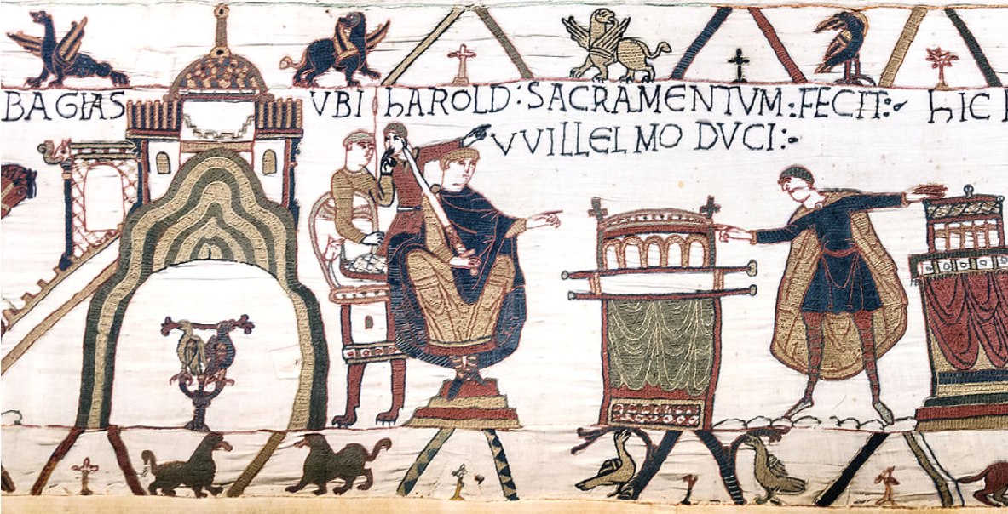
(1250 words)

The above image from the Bayeux Tapestry depicts Duke Harold Godwinson swearing an oath to Duke William of Normandy. This image depicts Harold as a double dealer who broke his oath in which he promised the Duke of Normandy the throne of England when King Edward the Confessor died.
The most likely audience for the Bayeux Tapestry would have been all classes in varying ways. A tapestry of grand design would generally be reserved for the nobility; however, it is easy for the lower classes to understand and follow the story. This may have helped to solidify Duke William of Normandy’s legitimacy of action and increase the support for his conquest throughout the country.
It is uncertain who commissioned the Bayeux Tapestry, although it is suggested by various historians that the most likely person was Duke William of Normandy’s half-brother Bishop Odo of Bayeux. A major reason for the assumption that Bishop Odo commissioned the embroidery is that he appears to play a disproportionately large role in the representation of the Battle of Hastings and the planning beforehand. This opinion is repeated throughout many modern statements about the Bayeux Tapestry which state that it sometimes feels as if the makers were going out of their way to increase and draw attention to Odo’s contribution to the success of the Norman Conquest of England.
In 1064 Duke Harold was shipwrecked at Ponthieu near Normandy and taken in by Duke William. There is mention of Harold being taken captive by Count Guy I of Ponthieu before Duke William intervened, but this is questionable. Harold remained in Normandy as a guest or hostage of William in which time it is claimed Harold swore an oath regarding the crown of England. It is suggested that Harold was in France to negotiate the release of his brother and nephew who were imprisoned by Duke William or, if some Norman literature is to be believed, his brother and nephew were hostages to ensure a previous oath was upheld. However, in modern text it states that when Duke William visited England Harold’s brother was in exile therefore, he could not have been taken as a hostage.
One criticism of the Bayeux Tapestry is that it only shows the Norman perspective of the events leading up to the Norman Conquest of England therefore, it paints the Normans in a very positive light and attempts to legitimise all of their actions leading up to the Battle of Hastings. The Norman reasoning for the conquest is based solely on a claim that Duke William was named as Edward the Confessors heir and supported by an oath from Harold however, there is no concrete proof of any oath and Edward would not have been able to solely appoint his heir without the agreement of his witan.
Even if an oath was sworn by Harold, we do not know whether Harold was under duress or in fear of William if he did not agree. Even though he was supposedly a guest, he did not seem to have been able to choose when he left. It is often worded as the Duke letting Harold go making it appear that Harold was being held, at least in part, against his will. Harold also did not have authority to offer the English crown as he was only the brother in law of the King, the decision had to be made by a consensus within the witan. It could therefore be assumed that the oath or agreement made was Harold’s support for the Duke’s claim not his assurance that he himself would hand Duke William the crown.
The Duke’s claim was weak, not based on blood or right but on the word of a monarch and later the support of the Pope. He did not have Anglo-Saxon blood that tied him to England which was a common target for raids and attempted invasions by others, including Vikings and Norse men, the ancestors of the Normans and the Duke himself.
There is mention of the Norman Duke visiting England previous to Harold’s apparent oath and a possible agreement taking place at this time. ‘If Duke William came to England in 1051 or 1052 he came at the moment when…‘the Norman party were in the full swing of power’ and Earl Godwin and his sons in exile. A promise of the succession to Duke William would thus have been made at this time by King Edward and witan, the most influential of whom were foreigners who a year later had been disgraced and exiled. Was it likely that William and his supporters would later base their claim to the English throne on the act of these discredited foreigners…’ (Oleson, T. J., 1957). Earl Godwin was Harold Godwinson’s father meaning when the first possible promise took place the man who would become key to William’s claim was not even present in the country and had no connection to the decision. The decision would also have had to be made by the witan who later chose Harold as king, if the witan had named William as successor there is little reason why they would have not honoured that and brought William over from Normandy as soon as Edward the Confessor died. It would not help Duke William to place his whole claim on the words of discredited members of the witan.
There are texts written from the Norman point of view which tell a very different story to the commonly accepted and Anglo-Saxon written version of events. ‘About the same time, Edward, king of the English, who had already appointed William as his heir, and who held him in the same affection as a brother or son, gave more serious evidence of his intentions then before…In order to confirm his promise by an oath, Edward sent to William Harold, the most prominent of his subjects in wealth, honour and power, and whose brother and nephew had already been given as hostages to ensure this succession.’ (Poitiers, W). This passage has many inaccuracies due to William of Poitiers making sure to display the Normans in a favourable light. There is mention of Harold’s brother and nephew being held as hostages to ensure succession. This goes against the more likely scenario that they had been taken as hostages for a completely unrelated reason and if the succession was already approved by Edward the Confessor and his witan then why would he need to take any hostages.
Another text from the Norman point of view is the Gesta Normannorum which states as follows. "Edward, king of the English, by the will of God having no heir, had in the past sent Robert, archbishop of Canterbury to the duke, to appoint him heir to the kingdom given to him by God. But he also, at a later date, sent to him Harold, the greatest of all earls in his realm in wealth, honour, and power, that he should swear fealty to the duke concerning his crown and, according to the Christian custom, pledge it with oaths." (Jumieges, W., 1070). William of Jumieges talks about the archbishop of Canterbury being sent to appoint Duke William as heir. This decision would be made by the witan and the archbishop of Canterbury is not mentioned in other Norman or Anglo-Saxon texts. There is no reason why Harold would be sent specifically to swear oaths of fealty. If Duke William was the heir, he would need the support of all the members of the witan when he came to power and if they had appointed him then their support would already be there.
In conclusion, this section of the Bayeux Tapestry is questionable in accuracy, there is a lack of documents that support this meeting and no proof of an oath ever being sworn by Harold. This piece could be propaganda based on limited accuracy of an agreement made under duress whilst Harold was in Normandy. It is a Norman source, so it is attempting to legitimise the Norman conquest and the actions afterwards. Many of the Norman sources heavily focus on the idea of the oath as the reason for the Norman action at Hastings and the connection between Duke William and Edward the Confessor by comparing them to family members.

Bibliography/Reference list
Bayeux Museum. Tapestry or Embroidery? [online] Available at: <https://www.bayeuxmuseum.com/en/the-bayeux-tapestry/discover-the-bayeux-tapestry/tapestry-or-embroidery/> [Accessed 17 April 2021].
History Extra. The Bayeux Tapestry: what is it, why was it made and what story does it tell? [online] Available at: <https://www.historyextra.com/period/norman/5-bayeux-tapestry-facts-what-is-it-why-was-it-made-and-what-story-does-it-tell/> [Accessed 18 April 2021].
Jumieges, W., 1070. The Gesta Normannorum Ducum. Available at: <https://penelope.uchicago.edu/~grout/encyclopaedia_romana/britannia/anglo-saxon/hastings/forsworn.html> [Accessed 18 April 2021].
Normandy Then and Now, 2017. When Harold Met William In 1064; A Tale Of Quicksand And Cunning. [online] Available at: <https://www.normandythenandnow.com/when-harold-met-william-in-106 4/> [Accessed 17 April 2021].
Oleson, T. J., 1957. Edward the Confessor's Promise of the Throne to Duke William of Normandy. [e-journal] Oxford: Oxford University Press. Available through: JSTOR <https://www-jstor-org.ezproxy.uwtsd.ac.uk/stable/558704?seq=2#metadata_info_tab_contents> [Accessed 18 April 2021].
Poitiers, W. Gesta Willelmi. [pdf] Available at: <https://moodle.uwtsd.ac.uk/pluginfile.php/489282/mod_resource/content/0/Gesta%20Willelmi.pdf> [Accessed 20 April 2021].

