Module Code: ACCA7022
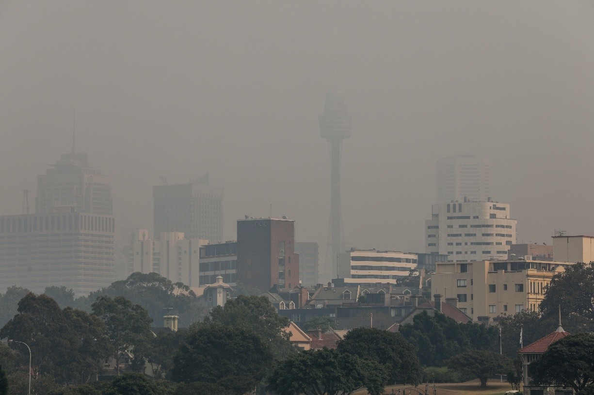
Data Analysis
Lecturer: Dr. Aliyu Sambo
Advanced Statistical Programming
Iftekhar Rashid
Student no. 2215602
Contents
Introduction 2
Visualisations 2
Critical Thinking and Evaluation 4
Challenges and Learning 5
Improvements for Future Work 6
Use of Generative AI 6
Conclusion 6

Reflective Summary

Introduction
This project helped me develop a clear understanding of how to analyse real-world environmental data using R. I worked with the AirQualityUCI dataset, which includes hourly measurements of pollutants and weather variables. My approach started with importing the dataset, checking its structure, and cleaning the data before starting the analysis. This step was very important because the dataset contained missing values coded as -200. I replaced these values with NA so that R could correctly handle missing data in calculations and statistical tests. I also created a DateTime variable by combining the Date and Time columns, which made it easier to analyse patterns over time.

Visualisations
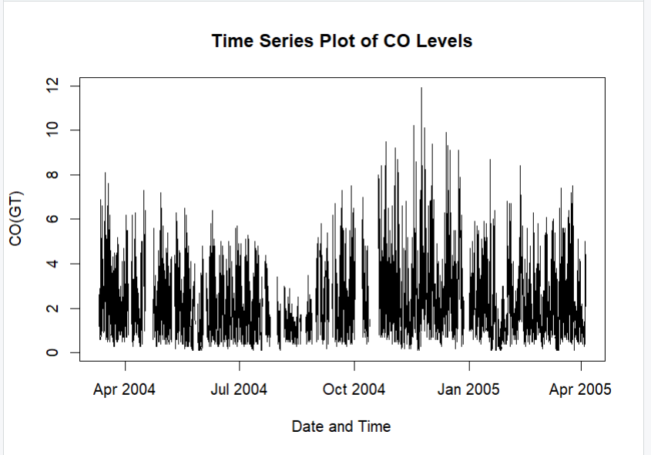
Visualisation played a key role in this project because it helped me understand the data and communicate the results clearly. I used a time series plot to examine how carbon monoxide (CO) levels changed over time. This was a suitable choice because the data was collected hourly, so time-based visualisation allowed me to observe trends and fluctuations more effectively.
Figure 1:Time series plot of CO levels over time

This plot helped me identify how CO levels increased and decreased during different periods. I also created a similar plot for nitrogen dioxide (NO2) to compare patterns between pollutants.
I then used scatterplots to explore relationships between variables. For example, I plotted CO against temperature to examine whether there was any relationship between pollution and weather conditions.
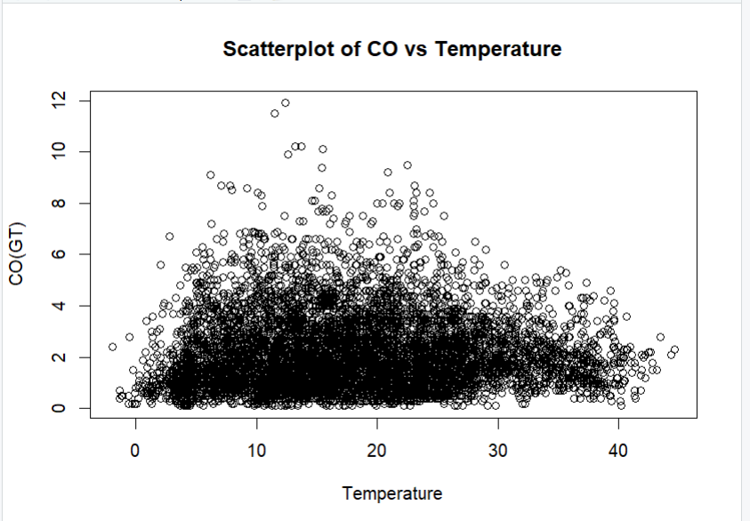
Figure 2:Scatterplot of CO levels against temperature
Scatterplots were useful because they clearly showed whether variables were related or not. From this, I could visually assess whether higher temperatures were linked to higher or lower pollution levels.
To support the visual findings, I also carried out correlation analysis between pollutants such as CO, NO2, and benzene. The correlation matrix showed a strong positive relationship between CO and benzene. This suggests that these pollutants may come from similar sources, such as traffic emissions or industrial activities. However, one limitation of correlation is that it does not show cause and effect, so the results need to be interpreted carefully.
In addition, I used a boxplot to compare CO levels across different seasons.
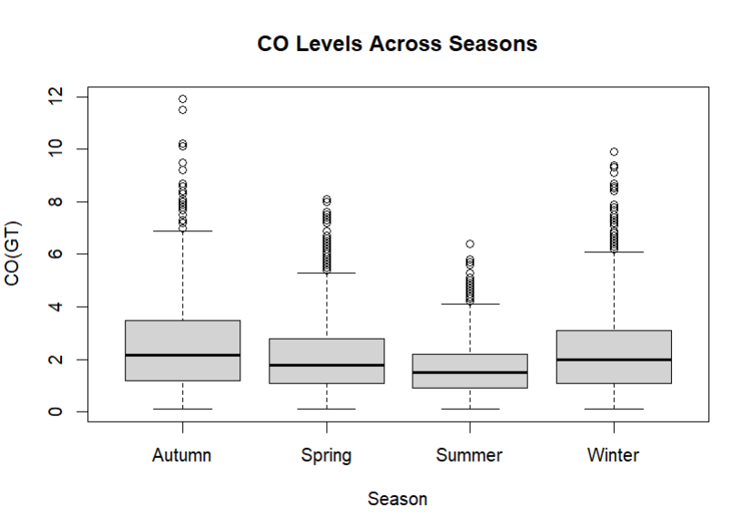
Figure 3:Boxplot of CO levels across seasons
This visualisation helped me compare groups and understand how pollution levels varied across winter, spring, summer, and autumn (see Appendix A). Boxplots are useful because they show the distribution of data and highlight differences between groups.

Critical Thinking and Evaluation
Although the analysis identified useful patterns, several limitations should be considered. The dataset contained many missing values, which were replaced with NA. While this allowed the analysis to proceed, it may have reduced the accuracy of the results, meaning the findings may not fully reflect real conditions.
The correlation analysis showed strong relationships between pollutants such as CO and benzene; however, correlation does not imply causation. These relationships may be influenced by external factors such as traffic or industrial activity, so the results should be interpreted with caution.
The t-test and ANOVA were appropriate methods for comparing groups, but their assumptions (normality and equal variance) were not tested, which may reduce the reliability and validity of the results. In addition, ANOVA does not identify which specific groups differ, and a post-hoc test would be needed for deeper analysis.
Finally, while basic visualisations were useful, more advanced techniques such as heatmaps or correlograms could provide a clearer understanding of relationships between variables. Overall, future work could improve the analysis by testing assumptions and using more advanced methods.

Challenges and Learning
One of the main challenges was importing the dataset correctly, as it was initially read as a single column due to formatting issues. This made analysis difficult and caused errors, but the problem was resolved by checking the data structure using functions such as str() and head().
Another challenge was creating the DateTime variable and extracting seasonal information, where small formatting errors led to missing values. This highlighted the importance of systematic checking and validation throughout the analysis process.
Through this project, I developed a stronger understanding of data cleaning and preparation, which are essential for accurate analysis. I also improved my ability to select appropriate statistical methods. For example, I used a t-test for comparing two groups and ANOVA for multiple groups. However, I learned that these tests rely on assumptions, such as normal distribution and equal variance, which should be considered when interpreting results.

Improvements for Future Work
If I were to improve this work in the future, I would include more advanced visualisations such as correlation heatmaps to better present relationships between variables. I would also carry out post-hoc tests after ANOVA to identify which specific groups are significantly different.
In addition, I would improve the organisation of the code by using functions and clearer structure, which would make the analysis easier to maintain and reuse.

Use of Generative AI
Generative AI was used as a support tool during this project to help understand coding errors and guide the analysis process. However, all code was tested, verified, and interpreted independently to ensure accuracy and understanding.

Conclusion
Overall, this project improved my understanding of data analysis in R, including data cleaning, visualisation, and statistical testing. It also helped me develop problem-solving skills and confidence in analysing real-world datasets.

