Title Page

Student Name: | Simon Berjawi
Student Number: | 1910916
Module No: | BMSK4006
Module Title: | Managing Enterprise in the 21st Century

THE IMPERIAL CAFE

Table of Contents
Executive Summary 4
Business Overview 5
Markets and Competition 6
Target Markets 6
Competition 6
Sales and Marketing 7
Product Positioning 7
Marketing 7
Sales 7
Management 8
Key Personnel 8
Advisors and support services 8
Operations 8
Premises and Equipment 8
Premises 9
Employees 10
Suppliers 10
Insurance 10
Financial Forecast 12
Sales 12
Cashflow 13
Profitability 13
Financing 13
Appendix………………………………………………………………………………………… 14

Executive Summary
To Summarize, this is a plan for an imperialist themed café on Albany road in Cardiff. Like many cafes it will serve a variety of hot and cold drinks, along with a selection of hot and cold food you would generally expect to find in a café. My business will provide a fun, interesting ambience, theme and décor for people to enjoy socially, or for students to study etc.
My target market is primarily going to be passing foot traffic along with a marketing campaign targeting students, pop culture fans and gamers.
I will be marketing my business in a variety of ways. Primarily online through social media, as well as purchasing spots on local radio and newspapers.
My business will consist of myself 3 Baristas 3 serving staff and a cleaner.
My financial forecasts can be found below, where I will show I plan to generate an annual turnover in the region of £500,000.00 per year with a profit in the region of £350,000.00 per year. My exact figures can be found in my cashflow prediction.
In order to finance this venture, I will be using my inheritance of £100,000.00 to cover all start up costs from premises to equipment and stock, and everything in between. A full breakdown of my start-up costs and expenditures can be found in the appendix, along with a breakdown of my annual running costs.

Business Overview

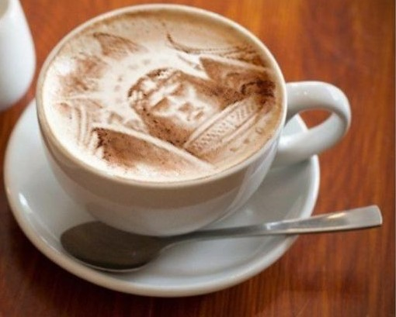

This is a plan for a sole proprietorship, Café style business intended to cater primarily to students and would also attract fans of both real and fictional pop culture empires looking for an interesting and imperialistically ambient environment to relax and enjoy lunch, or just chat over coffee. This business would provide them a place to both relax and study in both a fun and interesting decor. The unique feature of this café would be that it has an imperialistic theme derived from multiple empires both real and fictional, such as Star Wars and the Warhammer 40k universe to name a couple, along with several real world empires such as the Greek, Roman and British empires. The business would provide free Wi-Fi for them to be able to study, as well as serve a variety of food and beverages at reasonable prices. The primary beverages would be tea, coffee or regular cold drinks such as Coca Cola, served again with an imperial theme, for example cinnamon or cocoa sprinkled through a stencil over coffee for example , the resultant coffee then showing a picture of one of a choice of emperors from history or fictional pop culture. The food would consist of your expected café foods such as sandwiches, scones and baked goods like pastries and also ice cream, and the type of thing you would generally expect from a classic English tea-room, all served with a fun and or educational imperialist twist. I came up with this idea as I am a huge coffee drinker and lover of cafes myself, and I base my patronage on the ambience, décor and interesting features of a coffee room or café. I have not seen any cafes operating with this kind of fun educational theme, and since empires of all kinds, both real and fictional have always interested and entertained me , I feel I can bring all this together to create an environment that would appeal to the younger to middle aged generations , aged primarily 18-44 who are these days well versed in pop culture, but with a relaxed environment that would easily attract people passing by, or even older generations who’s curiosity would be aroused by the décor and theme. I would also invite certain clubs of a similar theme, be it comic books or pop culture gamers to use the business as a meeting place/clubhouse on certain days , where they can meet to discuss their favourite empires and comic books and games, with a club discount on food and drink available to them. Any finance I raise will be used to pay for the premises, décor, utilities, amenities, marketing, staff and stock necessary to bring this business to life, with any profits generated being initially reinvested into the business.

Markets and Competition

Target Markets

My target market is very broad. By locating my premises near to a University in a city, I will be targeting passing foot traffic, students, comic book fans, gamers and locals who want to study in peace or just relax and chat. I would also be targeting lovers of pop culture universes and comic books featuring empires. The main age bracket for students being 18-24. The comic book and pop culture markets are much broader with an age bracket primarily 18-44 (Appendix 1a) with some older fans as well. I would also pick up trade from locals who also enjoy a pleasant coffee room to meet and chat. This is a café that would appeal to everybody.

My main targets are:

Passers by

Students

Gamers

Pop culture fans

Comic book fans

Coffee lovers

Competition

My main competitors are going to be the big franchises, such as Costa Coffee and Starbucks. While they do currently dominate the market , worldcoffeeportal.com released an analysis on 12 February 2020 shows that UK market leader costa coffee (purchased by coca cola for £3.9Billion as of January 2019) opened 60% fewer stores in 2019 than in 2018, while Starbucks opened just 3 net new stores in 2019.

World Coffee portal also went on to say “The consequences of Brexit on investment and staff recruitment, coupled with a 6.2% National Living Wage increase and the rising cost of property could all converge to impede café segment performance in 2020. This concern is reflected among industry leaders surveyed by World Coffee Portal, who cited the cost of property, staffing, and the impact of Brexit as their three toughest challenges”.

Meanwhile, “The Rise of Independents UK 2019”, which is World Coffee Portal’s first dedicated report on the UK’s independent coffee shop segment, reveals 7,022 independent cafés operating in the UK, with an estimated value of £2.4bn. (appendix 1b)
The report shows a 4% annual outlet growth for UK independents over the last 12 months, with an estimated 260+ net new sites. The report also forecasts the segment will grow to 8,000 outlets by 2024, growing at 3% Compound Annual Growth Rate.
Allegra estimates UK independents serve more than 10.5 million cups of coffee each week (approximately 1496 cups per independent store per week).

This shows that the demand for quality coffee from an independent business is growing in comparison to the demand for convenient coffee, and that is what my establishment will be providing. Reasonably priced, quality coffee with a unique décor and ambience.

Sales and Marketing

Product Positioning

My product positioning strategy would be a neutral pricing strategy. I would be pricing my products and services at a similar level to my competition. Setting a low price would make my customers question quality, and a high price would scare them away before they made a purchase. A neutral pricing strategy will not do either of these things, and the food, beverage and service quality, alongside the unique theme, prime location, ambience and décor will generate repeat custom.

Marketing

My main approach to marketing to begin will be a Social media campaign, targeting many local pages on Facebook, Instagram etc, and reaching out to interested hobby communities. I would also do a flyer campaign of 1000 flyers delivered locally by hand, alongside putting multiple adverts in several local newspapers. I will also be contacting several local clubs and communities directly, through face to face meetings, telephone calls and email to offer their clubs use of the premises on certain days for their recreational use at a discounted rate. For example, Magic the Gathering (MTG) is a hugely popular trading card game in pop culture. it has a huge crossover with fan bases from Star Wars, Warhammer 40k and comic books. Many of those who are members of these fan bases are also students, or of student age. A portion of the premises can easily accommodate them once or twice a week to play card games while I generate revenue from their custom.

My initial budget for marketing is £3000, with a further monthly marketing spend of £500 to maintain a presence on radio, social media and other avenues.

Sales

Sales will be over the counter sales. Primarily coffee, tea and beverages of this nature, with cakes, sandwiches, ice cream and other café foods, for this of course we will require an A3 licence so that food can be consumed on the premises. These are available from our local council. We will also be doing some Mug and T-Shirt branded merchandise sales to increase our market visibility and generate brand recognition.

Management

Key Personnel

The key personnel of the business would include myself as the proprietor and general manager, 1 manager, 3 Baristas, 3 serving staff and a cleaner.

I would be responsible for literally everything as the proprietor. I will do the initial recruiting interviewing and hiring of staff. I would be responsible for keeping all licences up to date, paying for the premises, paying the overhead costs, ensuring stock is replenished on both a weekly and ad hoc basis, ensuring payroll is conducted and paying the taxes incurred by the business. I would be responsible for ensuring the I.T requirements and I.T maintenance of the business are met and monitoring profit or loss and acting on these appropriately.

The manager would be responsible in my absence for the day to day running of the establishment. His job would be to organise the staff rotas, manage stock control, recruiting, interviewing and or dismissing staff, conducting disciplinaries when required, managing customer complaints, and ensuring cleanliness and quality control. On certain days dependant on shift rotation, he would also be responsible for the opening and or closing of the business, ensuring all tills are cashed up correctly and any repairs or maintenance are either fixed or reported to me to arrange for their repair.

The Baristas/serving staff duties would include making the food and beverages, serving customers and taking payments, bringing the orders to the customers tables, cleaning of the establishment and associated equipment, both front and back of house and ensuring the needs of the customers are met as the business requires.

The cleaner will do a thorough front of house clean for 2 hours each day after we stop serving, with a possible increase in duties and hours as the business requires.

Advisors and support services

I will have an accountancy firm to do the book-keeping. Having reviewed accountancy charges for small businesses online, the average cost for a small business is between £800 -£1200 for per annum for end of year accounts and corporation tax return. I will add this to the cashflow projection at the higher end of the estimate (£1200) at a cost of £100 pcm.

Operations

Premises, Equipment and marketing

Office computer £3000

Office supplies £500

Décor and refurbishment budget. Inc air conditioning, flooring and ceiling £35,000

Automatic drip coffee maker – Bonavista BV1900TS 8-cup coffee maker £140

Commercial Espresso machine – La Pavoni BAR-T 2V-R Commercial 2 Group Volumetric Espresso Machine RED, 14L Boiler Water Capacity, Electronic Automatic Water Level £5,500.00 inc shipping

Industrial coffee grinder – Baratza CD Electric Coffee Grinder with Ceramic Quern Forte-AP (All Purpose) grey £785.49 inc. Shipping

Water filtration system (To comply with SCA brewing standards for water) – Brita Purity Quell ST 1200 Filter System with Digital Display (Large Beverge Equipment) £839.99 inc. VAT

Refrigeration system – Serve over Deli counter, curved glass front. Width 1980mm, Adexa BSS1811RGA £1366.80 inc. delivery from Adexa Direct

Refrigeration system – Commercial Refrigerator Upright cabinet 1200 litres, Stainless steel twin door GN21/1 Fan assisted cooling, Adexa R1200S. £994.80 inc. VAT from Adexa Direct

Containers, pumps and assorted miscellaneous - £2000

Modena TTC Rotary Conveyor Toaster for bread bagels and muffins and speciality breads. £359.99 from easy equipment

Security system – comprehensive 1b-100 wireless perimeter alarm with h/d gsm auto dialler- £906.61 inc. delivery from Ultra Secure direct

Shelving - £500 approx

Commercial Freezer (back of house) – Arctic air AF49-2 door reach in freezer £2150.00

Freezer for ice cream (front of house) – HBD-12 Dipping cabinet with LED interior lighting £2,150.00

3 industrial blenders £322 each from E-Catering (£966 total)

Cloud based POS system and related hardware £450

Cash till £1500

Commercial Dishwasher £2499.99

Crockery £1000

Signage £500

Equipment, refurbishment and décor Total= £63,109.67

Initial stock purchase £3000

Marketing- £3000 initially, to cover the cost of posting adverts, on radio, and online, creating flyers and use of social media.

Total including marketing and stock £69,109.67

Premises

The 3 premises I have found that I feel are most suitable are…

108 Albany road Cardiff CF24 3RT -£19,500 per annum 900 square foot downstairs with 2 floors above comprising 6 rooms and a bathroom. Whole 3 storey property available for lease.

80 Tudor street Cardiff CF11 6AL 23,200.00 per annum (David’s homes estate agency) 1,115 sq ft

And 63-65 Whitchurch road Cardiff CF14 3JP - £22,500.00 per annum (Fletcher Morgan Properties) 900 square feet.

I feel these properties, given their size and location, can hold comfortable seating for 35-50 guests.

Out of the 3 of the options I have selected, I will select the Albany road venue. Despite being slightly smaller at 900 square feet downstairs, the opportunity for profit generated to be used to turn the upstairs portions into further seating areas is fantastic, its location on a high street near to Cardiff university will give it much better positioning to attracting passing custom, as well as being in a great location to bring in the demographics I mentioned earlier. It is also the least expensive of all 3, with a much higher footfall than the others. I will take into account the Band D council tax for Albany Road at a rate of £1270 per annum as quoted by Cardiff county council in my cashflow projection.

Employees

I will require 6 staff.

Myself as General manager - £30k per annum - £2500 pcm

2 Baristas full time 35 hours per week £8.80 per hour 1 for AM shift, 1 for PM shift £616 per week -£2669.35 pcm

1 Barista part time for cover 20 hours per week £8.80 per hour £176 per week - £762.67 pcm

2 serving/waiting staff full time 35 hours per week. £8.61 per hour, 1 for AM shift, 1 for PM shift £602.7 per week - £2611.70 pcm

1 serving/waiting staff part time for cover 20 hours per week £8.61 per hour £172.2 per week - £746.20 pcm

1 cleaner part time 10 hours per week £8.61 per hour £86.10 per week - £373.10 pcm

Total staffing cost pcm - £9663.02

Suppliers

My primary supplier will be NISBETS (Nisbets.co.uk). With over 30,000 products, both consumable and re-usable, and free delivery, they provide literally everything a café requires at extremely good wholesale prices. From disposable coffee cups to a variety of fresh coffee beans and syrups, with a wide range of other products, they are specifically geared to provide a café with everything it needs. They are very positively reviewed on-line and I am confident they will be perfect to supply my company. we will manage any supplier price increases accordingly, and if for some reason they were to go out of business, there are other local companies we can use to replace them. Companies like Coffee pro and coffee supplies direct offer competitive wholesale prices on a wide range of equipment, consumables and other café related goods. They advise a £3000 initial stock purchase, inclusive of all syrups, coffee beans, teas, disposables like takeaway cups and napkins and other sundry items, with an estimated monthly replenishment cost of £1000.

Insurance Zurich have quoted me £2861.88 per annum, or 10 monthly payments of £321.96 for the following insurances combined. £2,000,000 public liability insurance. £10,000,000 employers’ liability £50,000 contents insurance £25,000 stock insurance £100,000 legal expenses insurance £1,000,000 business turnover protection £50,000 tenants improvements insurance Personal accident cover

Licenses I have contacted Cardiff council by phone who have informed me that the cost of an A3 Licence for a venue serving hot and cold food and drink for consumption on and off the premises ranges from £100-£1905 depending on the fee band of the venue. Unfortunately I could not get a direct quote from them with regard to my particular choice of venue and type of establishment without making an actual application as they need to send someone out to inspect the premises and carry out their own assessment. For the purposes of this assignment, I will factor in a cost at the higher end of the estimate (£1500) and add this to my cash flow prediction.

Financial Forecast

Sales

I am basing this projection on an average daily footfall for Albany road of 25,000 per day. I contacted several companies already operating on Albany road and spoke to the managers of Sainsburys, Tesco metro and coffee #1, who informed me that Albany road has an average footfall of at least 25,000 per day. I am giving myself a pessimistic projection of only getting 1% of the passing footfall into my doors, which still shows a potential revenue of £522,750 in the first year taking into account research from Statista.com also shows the average coffee shop spend for a takeaway customer is £3.50 with sit down customers spending a little more at around £7.50.

Cashflow

This first year cashflow projection is based on a pessimistic 1% of the Albany road footfall making it through my business’s doors. I would rather under-estimate my custom than over-estimate.

Profitability

By looking at the cash flow prediction sheet, and taking into account all the outgoings and expenditures I expect to incur, and subtract that from my projected sales, I hope to generate £522,750 in sales with £354,576 profit in the first year at a rate of £29,548 profit in each calendar month.

Financing
For the purposes of this business plan, I am going to base my financing on the receipt of a £100,000.00 inheritance.
This will be the budget upon which I will finance my business.
This initial £100,000.00 will finance and cover all my foreseeable start up costs and fees. A breakdown of which can be found in appendix 1C, with a breakdown of all annual expenses in appendix 1D.

Appendix
1a. 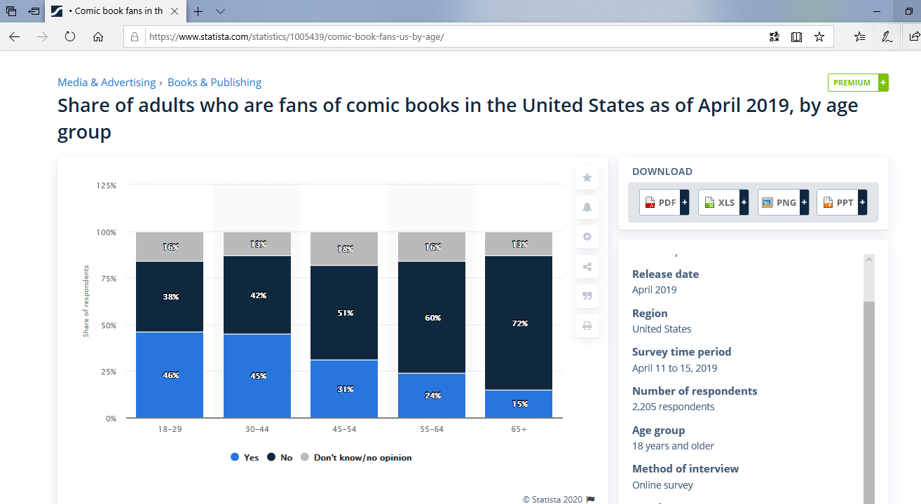

1b, 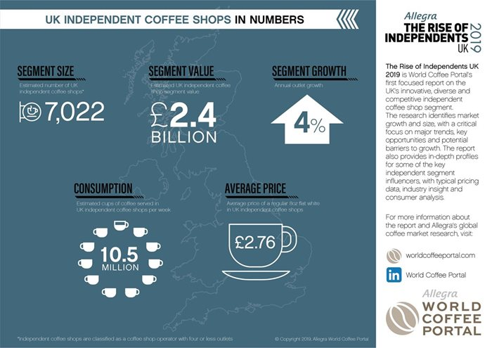

1c,
Start-up costs breakdown from initial budget of £100,000.00

Premises initial rent | £1625
Premises refurbishment | £35,000.00
Initial Stock purchase | £3,000
A3 business Licence | £1500
All equipment | £28,109.67
Advertising/marketing | £3000
Total | £72,234.67
Available cash after all deductions | £27,765.33

1d, breakdown of costs per year
Rent | £19,500
Gas | £2400
Electric | £4,800
Water | £450
Annual water service charge | £131.95
Annual A3 business licence | £1500
Council tax | £1270
Insurance | £3220
Stock | £12,000
Telephone and WIFI | £599
Advertising and marketing | £6000
Wages | £115,956.24
Accountant fee | £1200
Total annual costs | £169,026.71

Gas/Electric- estimates from SWALEC
Water- estimate from Welsh Water
Phone and WIFI quote from BT

