Module name: Managing People
Module code: LCBB5004_BIRM
Student Name: Petar Artyuhov
Student ID: 2123090
Lecturer name: Abdi Rahman

Table of Contents
Introduction 3
The benefit of implementing flexible working strategies into Vodafone 3
Describe processes that should be considered to implement flexible working 5
Evaluating strategies to promote employee engagement during the implementation phase of flexible working 6
Describing ways for Vodafone to evaluate employee value proposition to implement a pay structure 9
Conclusion 10
Reference list 11

Introduction
Covid 19 has changed the working structure for business organisations from a different perspective. As employees in the workplace of Vodafone have not been able to come to the office, the company has provided flexible working time with work from home based structure. Therefore, the organisation faced some critical issues as the employees have not been accommodated with the flexible working hours in previous. In this article, the ways Vodafone has established flexible working modes for employees will be discussed. The research also includes the related strategies that have been used by the company to make the workflow constant from the employees' end.

The benefit of implementing flexible working strategies into Vodafone
Implementing a flexible working structure in the workplace has an excellent opportunity to increase the working engagement of the employees. Vodafone has implemented flexible working strategies to develop employee efficiency by taking major responsibility through finishing the task within the deadline. Secondary information concludes that new job roles for 3000 employees have increased in the telecommunication industry (BBC, 2022a). This industry example draws the propensity of flexible work arrangements during the COVID-19 pandemic. The organisation has organised a time-based working strategy for the employees where employees are required to work for 3 hours with no break; after 3 hours, they can get a long break and return for their remaining 3 hours within the day. The flexible working time provided by the company has more operational support by the team members, where the team leader has monitored the employees' working time. The team leader has instructed not to take breaks for more than 2 employees in the same time period. Therefore it has been fruitful for the employees when the other team members have fulfilled their unavailability. As the team members at Vodafone are quite transparent in their job, it has been found that the flexible working strategies have increased the cooperative working environment among the team members. Moloney (2021), in the news article, mentioned that Vodafone has planned to incorporate a new 60-40 hybrid working model to facilitate employees' working by splitting time between the office and remote working. This evidence-based information gives insight into the rational decision-making of Vodafone UK to improve employees' work performance per their own preferences. In this way, employees are satisfied with the flexible work arrangements, which uplifts revenue during the COVID-19 pandemic. In order to support this statement, Taylor (2023a) discovered that Vodafone UK acquired more outstanding revenue management in 2020 and the next few years. Thus, the COVID-19 pandemic did not restrict Vodafone from facing financial constraints and employee layoff issues, as the flexible work arrangements created potential benefits on employee work performance.
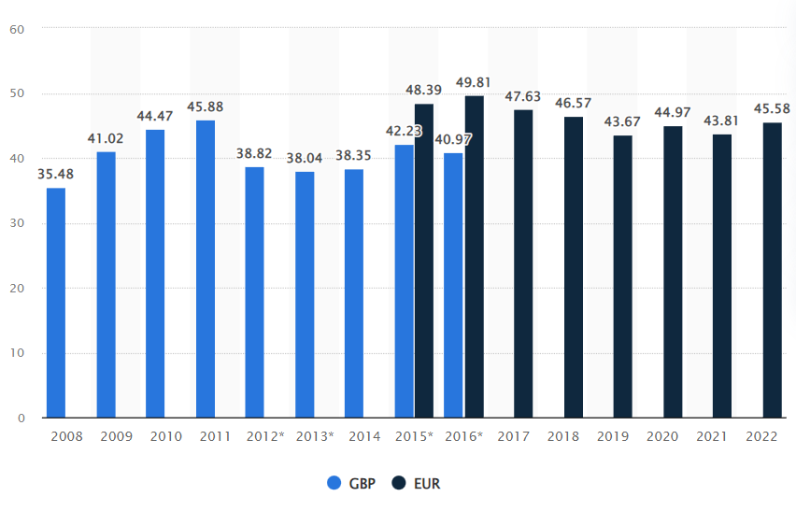
Figure 1: Revenue of the Vodafone
(Source: Taylor, 2023a)
In developing the employees' working efficiency, a flexible working strategy has the potential to develop technical knowledge among the employees through which employees have become digital experts. Vodafone provides telecommunication services to ensure business continuity during the global pandemic (Acciarini et al. 2021). The flexible working mode has a supportive backup to the employees for which employee motivation has been prioritised by the company, which has helped the organisation to increase employee engagement. A flexible working strategy has also helped employees continue working from home, improving their working engagement in Vodafone. Therefore the organisation has enhanced their digital revolution by focusing on and enhancing its flexible working strategy. Apart from this, there are other significant benefits of implementing flexible work arrangements for Vodafone employees. For instance, flexible work arrangements or hybrid working models benefit employees of Vodafone by ensuring well-being, reduce work stress and transportation costs (Moloney, 2021). In relation to this statement, it is worth supporting the decision of Vodafone to offer the ‘work-from-home’ initiatives for increasing employee work satisfaction, enhancing job performance and improving well-being.

Describe processes that should be considered to implement flexible working.
A flexible working strategy has an excellent capability of providing effective working engagement from the employee's perspective. Vodafone has considered Virgin media O2, TalkTalk and Sky to expand broadband connectivity in the UK with a 5G network which has increased the challenging working environment among the employees (BBC, 2022b). Therefore it has been considered by Vodafone to improve their positive employee effect in the workplace to increase their productivity and motivation and output. There are several processes in the workplace through which Vodafone has implemented flexible strategies in the workplace such as
Establishing innovative technology in the work
Developing a flexible working strategy requires technological solid support from the organisation with a stable internet connection. Intercom telecommunication technology and Zoom application for group meetings are the main platforms through which employees have established a collaborative working environment. As mentioned by Chadee et al. (2021), zoom and skype are such digital-centric or connectivity-oriented technologies that are useful for companies to carry out work-from-home initiatives. This statement indicates that helping employees work digitally is a crucial way to facilitate work arrangements.
Using those applications, Vodafone employees have improved their connection with the higher authority of the organisation, where the company has continuous employee engagement to maintain the workflow of the business.
Enhancing flexible working with company culture
Vodafone maintained a strict office culture before the global pandemic Covid-19 appearance. Flexible employee arrangements can enhance employee performances that boost their productivity in the workplace (Ramakrishnan and Arokiasamy, 2019). Therefore the organisation has scheduled some time zones where employees can join to do their work. One working session in the morning period and one in the evening period. In that way, the company has enhanced their flexible working strategy to increase workforce consistency. Capitalising on inherent resources and supportive work systems increased the propensity of flexible work arrangements for Vodafone to ameliorate employees' work performance during the reign of the COVID-19 pandemic. The relevance of this statement can be supported by evidence-based research finding when Sweney (2022), in the news article, mentioned that Vodafone had associated itself with a range of deals that include a takeover or merger with Three UK and counterparts in Italy, Spain and Germany. In conceptualising this evidence-based qualitative research finding, Vodafone harnessed technological equipment, resources, human resources and other inherent technologies by strengthening strategic alliances. In this way, Vodafone never faced shortage or resource deficiency challenges with the support of long-term digital workplace culture in the COVID-19 pandemic crisis environment.
Virtual meetings
Vodafone has regulated two working structures in their company one is regular strict office timing and the second is flexible working time. Employees are not required to choose a flexible working structure if they do not want to. Employees choose flexible working strategies to increase employee efficiency and serve better productivity. It has improved the potential growth of the employee through effective workforce contribution.

Evaluating strategies to promote employee engagement during the implementation phase of flexible working
Vodafone has concentrated on maximising employee engagement during the Global pandemic Covid-19. Developing comfortable working conditions helps employees to manage work-family conflict (Gunaprasida and Wibowo, 2019). Therefore the organisation has followed several employee engagement strategies to improve its capabilities in developing flexible working policies. The strategies are meant to enhance the working effectiveness of the employee through which the company has focused on employee engagement based upon
Taking a survey on the employee productivity strategy
The management board of the company has focused on employee effectiveness in the organisation to identify employee contributions in the workplace. Through employee surveys, the company has evaluated the ways by which Vodafone has measured employee efficiency and their skill in the workplace. It presents employee engagement in the workplace by evaluating their time limit in the workplace and following their way of finishing the task. However, Vodafone's employees faced technological challenges and miscommunication while working in a remote environment. Lack of time management efficiency and poor leadership challenges hampered Vodafone's employee performance during the COVID-19 pandemic.
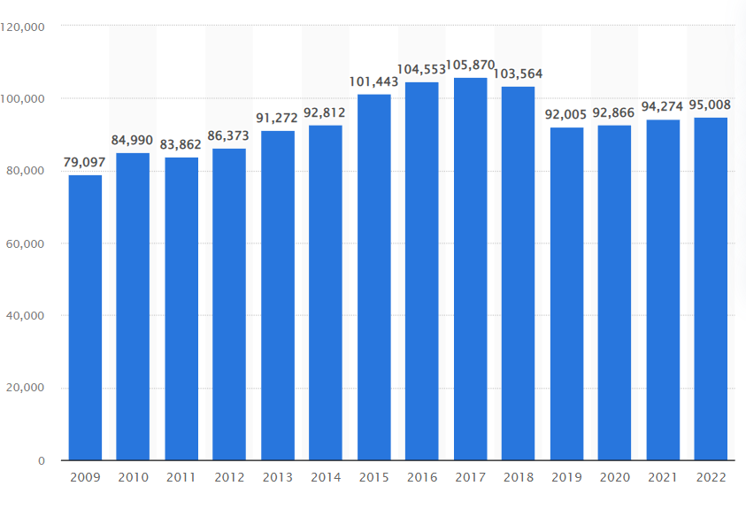
Figure 2: Average Employee Number of Vodafone
(Source: Taylor, 2023b)
However, managers and chief executives provided training sessions to employees to intensify work satisfaction. This strategy worked well for Vodafone when Taylor (2023b) claimed that Vodafone acquired more employees in 2020 and 2021 as compared to the pre-pandemic year, such as 2019 (Figure Shown Above). In this way, the Covid-19 pandemic did not create any employee layoff challenges for Vodafone.
Providing growth opportunities through craving out the career paths strategy
The organisation has provided effective training sessions through Zoom meetings during the Covid 19 period. Employees' personal life can be influenced by job satisfaction through the practice of a flexible working structure (Neirotti et al. 2019). It has increased the technological skill of the employees. Therefore developing technical skills, the employees have become highly capable of continuing their work from home using an internet connection. Providing opportunities for professional career growth by giving promotions has increased employee engagement in the organisation. Growth opportunity is one of the important elements in employee engagement as described by the Deloitte model (Oktanofa et al., 2022). According to this model, organisations should develop a culture of learning and support so that employees can get the opportunity to grow in their careers. Therefore, training employees to make them learn new skills, and also promoting employees to higher work positions can help them to increase their potential and proceed to career growth.
Recognising the top performance strategy
Following the monthly working sheet of each employee, it has helped the organisation to identify the employee who has given 100% effort for the company. Working engagement in the organisation can be increased by recognising high-performing employees based on their working activities in the workplace and rewarding them. Reward and recognition in the workplace are the vital ‘Self-Esteem’ needs of employees as described by Maslow’s Hierarchy of Needs theory. This theory shows five categories of human needs in a hierarchical order and it can be applied to understand work-related needs as well. This theory considers ‘Self-Esteem’ needs as higher-order needs which are placed at the second-highest level of the pyramid (Cote, 2019). Employees' self-esteem needs are required to be fulfilled by the organisation to make them fully engaged (Figure 3) (Akhir et al., 2018). The reinforcement theory of B.F. Skinner also emphasises recognition programs as important to increase employee engagement because their positive behaviour gets reinforced (Cote, 2019).
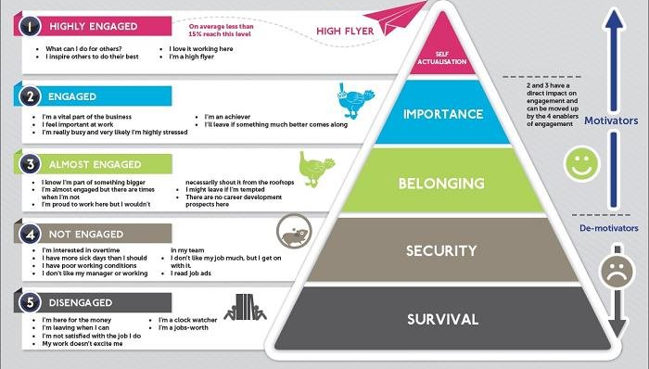
Figure 3: Maslow’s Hierarchy of Needs theory applied to employee engagement
(Source: Akhir et al., 2018)

Describing ways for Vodafone to evaluate employee value proposition to implement a pay structure
In order to develop the employee value position, the company has implemented pay over extra night shifts and pay over extra work. By providing individual safety and data privacy Vodafone has provided ethical support during the global COVID-19 pandemic (Lourenco et al. 2021). Following employee engagement in the organisation, it has been identified that the organisation has focused on developing employee motivation based on their work. Therefore the company has improved their payment structure to increase employee interest in the workplace. Therefore the company has enabled their flexible working structure in the company. Conducting a payment structure for extra night shifts and extra working time, the organisation has provided an extra monetary bonus at the end of every month. Vodafone has presented that Covid 19 has increased gender inequalities in the industrial landscape (Caselli et al. 2021). Therefore the organisation has evaluated the employee performance every month. Following employee performances, the company has provided extra night shift offerings to all the employees in different departments. T-Mobile US is developing a transformative 5G network in Europe and has developed its employee efficiency to provide the best possible service in Germany and Netherlands (Forbes, 2023). During the global pandemic of Covid-19, employees have faced critical problems adjusting to remote working situations with the lower pay structure. Therefore Vodafone has considered employee motivation by enhancing their monetary support. For this reason, the organisation has improvised their pay structure during the pandemic to increase employee engagement through a flexible working structure.

Conclusion
Considering the whole article, the above discussion has provided the benefits of implementing flexible working strategies. During the global COVID-19 pandemic, people have struggled a lot, which has impacted their working life on a serious note. Therefore Vodafone has provided a flexible working structure by considering the employees' request to handle the workload during the pandemic. The company has also implemented a grade pay structure by measuring the weekly working engagement of the employee. The employees of the company have faced a massive problem in their office. Therefore flexible working structure with a work-from-home-based framework, including an effective pay structure, has given the employee survival support during the pandemic.

Reference list
Acciarini, C., Boccardelli, P. and Vitale, M., 2021. Resilient companies in the time of Covid-19 pandemic: a case study approach. Journal of Entrepreneurship and Public Policy, 10(3), pp.336-351.
Akhir, R.M., Ahmad, S.N.B., Ahmad, H. and Hashim, N.A., 2018. Staying or Leaving? The influence of employees’ engagement towards turnover decision among employees of a semi-government organization in Malaysia. American Journal of Social Sciences and Humanities, 3(1), pp.55-62.
BBC, 2022a. Openreach creates 4,000 jobs for broadband rollout | BBC News. [online] BBC. Available from: <https://www.bbc.com/news/business-60326858> [Accessed 22 March 2023].
BBC, 2022b. Vodafone and three in merger talks | BBC News. [online] BBC. Available from: <https://www.bbc.com/news/technology-63118990> [Accessed 22 March 2023].
Caselli, F., Grigoli, F., Sandri, D. and Spilimbergo, A., 2021. Mobility under the COVID-19 pandemic: Asymmetric effects across gender and age. IMF Economic Review, pp.1-34.
Chadee, D., Ren, S. and Tang, G., 2021. Is digital technology the magic bullet for performing work at home? Lessons learned for post COVID-19 recovery in hospitality management. International Journal of Hospitality Management, 92, p.102718.
Cote, R., 2019. Motivating Multigenerational Employees: Is There a Difference?. Journal of Leadership, Accountability and Ethics, 16(2), pp.15-29.
Forbes, 2023. T-Mobile | Company Overview & News | Forbes. [online] Forbes Magazine. Available from: <https://www.forbes.com/companies/t-mobile/?sh=2c07f2893fb4> [Accessed 22 March 2023].
Gunaprasida, N. and Wibowo, A., 2019. The effect of work-family conflict and flexible work arrangement on turnover intention: do female and male employees differ?. Jurnal Siasat Bisnis, pp.27-36.
Lourenco, P.R., Kaur, G., Allison, M. and Evetts, T., 2021. Data sharing and collaborations with Telco data during the COVID-19 pandemic: A Vodafone case study. Data & Policy, 3, p.e33.
Moloney, M. 2021. Vodafone to introduce 60-40 hybrid model for remote and office working | Newstalk. [online] Newstalk. Available from: <https://www.newstalk.com/news/vodafone-to-introduce-60-40-hybrid-model-for-remote-and-office-working-1164366> [Accessed 22 March 2023].
Neirotti, P., Raguseo, E. and Gastaldi, L., 2019. Designing flexible work practices for job satisfaction: the relation between job characteristics and work disaggregation in different types of work arrangements. New technology, work and employment, 34(2), pp.116-138.
Oktanofa, A.K., Arliawan, F.A. and Gustomo, A., 2022. Measuring and Improving Employee Engagement (A Study in PT. Svara Inovasi Indonesia). IPTEK Journal of Proceedings Series, (1), pp.425-431.
Ramakrishnan, S. and Arokiasamy, L., 2019. Flexible working arrangements in Malaysia; A study of employee's performance on white collar employees. Global Business and Management Research, 11(1), pp.551-559.
Sweney, M. 2022. Vodafone confirms consolidation talks with European rivals | The Guardian. [online] Guardian News and Media. Available from: <https://www.theguardian.com/business/2022/feb/02/vodafone-confirms-consolidation-talks-european-rivals-takeover-merger> [Accessed 22 March 2023].
Taylor, P. 2023a. Vodafone Group Revenue 2008-2022 | Statista. [online] Statista. Available from: <https://www.statista.com/statistics/241610/revenue-of-vodafone-since-2008/> [Accessed 22 March 2023].
Taylor, P. 2023b. Vodafone employees worldwide 2009-2022 | Statista. [online] Statista. Available from:<https://www.statista.com/statistics/218819/vodafone-employees-worldwide-since-2009/>[Accessed 22 March 2023].

