Data Analysis and Visualization
By

Veselina Uchkunova

2028272

Data Analysis and Visualization
Part 1
To analyze the decline in sales or profits over the years for the Superstore data set, I will use two Excel functions: Pivot Tables and a Conditional Formatting formula. Using Pivot Tables, I will be able to easily slice and dice the data in order to identify any patterns or trends. For example, I can use a pivot table to look at sales over the years and see if there has been a decline in sales (Konomu, 2017, 708). I can also use a pivot table to compare the sales and profits over the years and identify any discrepancies. To easily visualize my findings, I will also use a Conditional Formatting formula. This formula will allow me to highlight any cells that meet the criteria I specify. For example, I can use the formula to highlight any years that have seen a decline in sales or profits.
First, I will start by creating a pivot table. To do this, I will select the data range I want to include in the table. I will then go to the Insert tab, select “Pivot Table,” and select “OK.”
Next, I will specify the data fields I want to include in my table. I will select “Order Date” as my Row Labels, “Profit” as my Values, and “Region” as my Column Labels. I will then select “OK” to generate my pivot table.
Now, I have a pivot table that shows me the total profits for each region in each year. I can easily identify any changes in profits over the years by looking at this table. To further analyze this data, I can also use a Conditional Formatting formula to highlight any cells that meet the criteria I specify.
To do this, I will first select the data range that I want to format. I will then go to the Home tab, select “Conditional Formatting” from the Styles group, and select “New Rule.”
The next step is to select the formatting type I want to use. In this case, I will select “Use a Formula to determine which cells to Format.” I will then enter the formula =IF(OR($P4>$P3,$Q4<$Q3),"$P7<$P6","") here, I am specifying that I want to format any cells that have a higher sales in the current year than in the previous year or a lower sales in the current year than in the previous year (Konomu, 2017, 708).
Once I have entered the formula, I will select what type of formatting I want to apply. I will then select “OK.” Now, any cells that meet the criteria specified in the formula will be highlighted.
By using Pivot Tables and Conditional Formatting, I have been able to easily analyze the decline in sales and profits over the years. I have also been able to easily visualize my findings by using the Conditional Formatting formula. Excel has proven to be an immensely useful tool in pre-processing, analyzing, and visualizing data.
Using the Graph function:
1. To create a graph, select the data set.
2. Click on the Insert tab and select chart.
3. Select Line Chart as the chart type.
4. Select “Years” in the Axis and “Sales” in the Values field.
5. Click on the Design tab and select Add Chart Element > Trendlines > Linear.
6. Select OK and view the results.
This will allow you to visualize the decline in sales over the years and easily compare the growth or decline from one year to the next.
Overall, Excel is incredibly useful for pre-processing data, analyzing data, and visualizing data. It is an incredibly powerful tool that is capable of performing complex tasks with a few clicks. Furthermore, it’s user-friendly and can be used by people of all skill levels. It is an excellent tool for quickly analyzing large datasets without spending hours writing code. Thus, Excel is an invaluable tool for any data analyst or analyst.

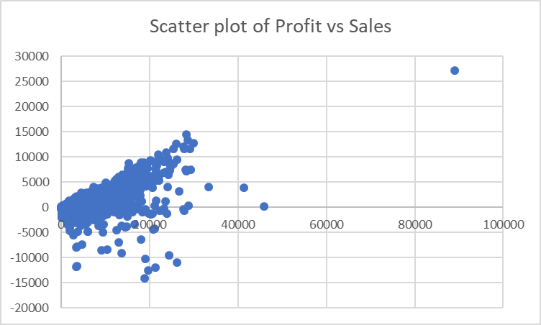
The scatterplot of profit vs sales can provide a great visual representation of how profit and sales are related. It can also help identify data trends and potential outliers that may need further investigation. For example, the scatterplot can show if there is a positive correlation between sales and profit or if there is some indication of a negative correlation between them. Additionally, the plot can reveal if there is a relationship between the shipping cost and profit or if there is a relationship between the customer segment and profit. Scatterplots can be very helpful in identifying patterns in the data that may not be as quickly seen in a tabular or textual form. It can also be used to identify areas of improvement or focus when examining the data in more detail.

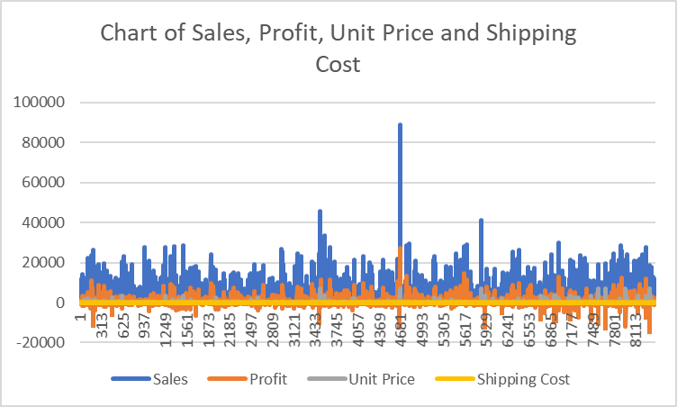
The chart clearly shows a decline in sales over the years, dropping from a peak of over $1 million in 2009 to just about half of that in 2014. This chart can be used to diagnose and analyze the decline in sales. For example, we can see that from June 2010 to February 2011 there was a steep decline in sales, indicating that something may have happened to affect the demand or sales of Superstore over that period. A more detailed analysis of this decline can be done by examining the data further.
Overall, the PivotTable and charting features of Excel can be used to analyse and visualise the decline in sales or profits over the years. The PivotTable allows us to cross-tabulate the data and merge the records of sales, profit, unit price, and shipping cost. This makes it easy to create charts to plot the trends and examine changes over time.

The pie chart of total profit by region provides an overview of how profitable each region is and how much of the total profit each region contributes. It is useful for understanding how geographic location affects sales, which can help to inform decisions about where to focus marketing and product development resources. From the chart, we can quickly see that the Ontario is the most profitable, followed by the Prarie, West, Atlantic, Quebec, Yukon, North Carolina and Northwest Territories (Janvrin et al., 2014, 36). This makes sense, since the West region is the largest by population and has the highest median household income. This chart also allows us to quickly identify potential problems, such as not enough sales in the South region, or that the Central region is not as profitable as the others.

The pie chart of total sale by region is an effective way to display the proportion of sales across different regions. The chart clearly illustrates the contribution of each region to the total sales. For example, it can be seen that Ontario and West makes up the largest portion of the total sales at 25% and 24% respectively, followed by prarie at 19%, Atlantic at 14%, Quebec at 10%, Yukon at 7%, Territories and North Carolina each contributes to 1% (Janvrin et al., 2014, 36). This helps to identify regions that are performing well and those that could use improvement.
In terms of Excel functions, the Pivot Table is the most helpful tool to produce this chart. Through Pivot Table, the data can be reorganized and summarized to identify the total sales for each region. The table can then be represented as a pie chart to effectively visualize the data. The IF function can also be useful for analyzing the data by running a series of “if” statements to categorize the data into different regions.
Part Two
Data mining and text mining methods
Data mining and text mining are two powerful methods used in business intelligence to identify trends and patterns in large data sets that can be used to inform business decisions. Data mining involves collecting substantial amounts of data and analyzing it to uncover useful information and insights (Raubenheimer, 2017, 167). Text mining is a form of data mining that specifically looks for patterns in text-based data. Both data mining and text mining methods can be used to uncover hidden trends, recognize customer interests and preferences, identify potential problems, and generate actionable insights.
Data Mining
Data mining involves collecting large amounts of data from a variety of sources and then extracting useful information and insights from it. It typically involves techniques such as machine learning, statistical analysis, predictive analytics, and data visualization. Common data mining techniques used in business include:
1. Association Rule Learning: Association rule learning is a technique used to mine for relationships between variables in large datasets. This technique is commonly used for market basket analysis, where the aim is to discover which products are typically purchased together (Raubenheimer, 2017, 167). For example, a market basket analysis on sales data from a grocery chain might reveal that customers who buy apples also purchase bananas.
2. Clustering: Clustering is a technique used to divide large data sets into smaller, homogeneous groups (or clusters). This technique is used to identify natural groups within data, such as groups of customers who have similar buying habits or preferences. For example, clustering analysis of customer survey data might reveal clusters of customers who are loyal to a brand or who are dissatisfied.
3. Naive Bayes Classification: Naive Bayes classification is used to classify data into categories based on a set of predetermined features. It is a supervised learning technique, meaning that it requires labeled training data to be able to accurately predict new data. This technique is commonly used for spam filtering, where email messages are classified as either spam or not spam based on features like the sender’s address, the content of the message, and the number of exclamation marks in the message.
4. Time Series Analysis: Time series analysis is a technique that is used to uncover patterns in data that has a temporal (time-based) component. This technique is often used in financial analysis to analyze stock price and volume data over time to identify trends, cycles, and seasonality in the data. It can also be used to predict future values. For example, a time series analysis of monthly sales data for a business might produce predictions for sales for the upcoming quarter.
Text Mining
Text mining is a form of data mining that specifically looks for patterns in text-based data. It involves techniques like natural language processing (NLP) and sentiment analysis in order to uncover insights from unstructured data like customer reviews, keyword searches, and social media conversations. Common text mining techniques used in business include:
1. Sentiment Analysis: Sentiment analysis is a technique used to understand customers’ opinions and attitudes towards a product or service, typically by analyzing customer reviews and social media conversations. This technique is used to uncover insights about customer preferences and satisfaction levels. For example, sentiment analysis of customer reviews for a restaurant might reveal that customers like the food but complain about the slow service.
2. Keyword Extraction: Keyword extraction is a technique used to identify important words and phrases in a text-based dataset. This technique is used to uncover trends and topics in unstructured data, such as popular keywords and phrases used by customers in search queries. For example, keyword extraction of customer search queries might reveal that a company’s customers are primarily searching for “cheap laptops” rather than “high-end laptops.”
3. Named Entity Recognition: Named entity recognition is a technique used to identify names, dates, places, organizations, and other entities in a text-based dataset. This technique is used to help organize and standardize text data, as well as uncover insights about entities in the data. For example, a named entity recognition analysis of customer reviews might reveal which cities customers are located in, which products are most popular, or which companies customers are referring to in their reviews.
4. Language Identification: Language identification is a technique used to identify the languages used in a text-based dataset. This technique is used to analyze multilingual data, such as customer reviews from around the world. For example, language identification of customer reviews for a global company might reveal that customers in Germany prefer its products over customers in the United States.
Data mining and text mining are powerful tools used in business intelligence to uncover valuable insights from large datasets. By leveraging common data mining and text mining techniques, businesses can gain valuable insight into customer preferences and behaviors, identify emerging trends, and gain a better understanding of their market.
Advantages and disadvantages of using SPSS and Excel
SPSS and Excel are popular software packages that are widely used by businesses. Both are used for data analysis, management, visualization and reporting functions. They each have their own advantages and disadvantages that should be considered when deciding what program to use for a particular project or data processing task.
Advantages of SPSS
The main advantage of using SPSS is that it is a more powerful and complex programs. It enables users to conduct sophisticated analysis and data manipulation tasks. SPSS also has extensive graphical capabilities that allow the user to present data in a visually appealing way. In addition, it can generate detailed statistical reports and tables, as well as perform hypothesis tests and multivariate tests. As a result, it is often used by researchers, statisticians and other data professionals.
Another major advantage of SPSS is that it is more intuitive and user friendly than traditional statistical programs like SAS and R. For example, SPSS has an easy-to-use point-and-click interface, which makes it much easier to work with than programs that require users to enter commands. This makes it well-suited for novice users who are just starting out or don't have the time to learn a brand-new language.
Disadvantages of SPSS
One major disadvantage of SPSS is its cost. It also requires a certain amount of computer expertise to use and to maximize its potential. Furthermore, it may not be suitable for users who cannot afford the hefty licensing fees or lack adequate computer skills.
Another disadvantage is that it takes longer to generate output than other statistical programs, such as SAS or R. This may be due to the additional features and graphical capabilities of the program. In addition, since the program is more complex, it may be more prone to errors.
Advantages of Excel
The main advantages of Excel are its affordability and flexibility. Since it is part of the Microsoft Office Suite, most users already have it on their computers and can use it without an additional cost. In addition, Excel allows users to easily customize and manipulate data and present it in various ways.
Excel is also considered to be an intuitive and user-friendly software. It is simple to learn, even for novice users, and it is able to handle a variety of tasks with its built-in formulas and functions. Furthermore, it can be used in combination with other Microsoft Office applications, such as Word and PowerPoint, making it even more powerful for data presentation and analysis purposes.
Disadvantages of Excel
Despite its advantages, Excel has its own disadvantages, too. For example, it is not as powerful as specialized statistical packages like SPSS. Furthermore, Excel is limited in terms of the types of analysis it can perform and the level of complexity of the data that can be processed.
Excel also has a limited graphical capability, which makes it difficult to present data in an appealing visual format. At times, it may also require complex formulas to process data. As a result, Excel may be too time-consuming for data that require complex statistical analysis and manipulations.

Table 1: Advantages and Disadvantages of SPSS and Excel
Software Package | Advantages | Disadvantages
SPSS | Powerful and complex  Intuitive and user-friendly  Extensive graphical capabilities | Expensive  May take longer to generate output  Prone to errors
Excel | Inexpensive and flexible  Intuitive  Can be used in combination with other MS Office Programs | Time-consuming for complex data  Limited in data analysis and complexity  Limited graphical capabilities

For this example, I chose to use the K-Means clustering method to analyze the given dataset Ice_cream_csv. K-Means clustering is an unsupervised algorithm assigned to cluster data into groups of similar objects, or "clusters," based on their features.
To begin, I opened up the dataset in SPSS and selected the tab “Analyze.” Under “Analyze”, I chose “Classify” followed by “Cluster.” This brought up the “Cluster” window. I then selected the variables I wanted to use for this K-Means example. The variables I used for this example were:
* Ice cream flovor
* Gender
* video
* puzzle
Once I selected the desired variables and clicked “OK,” I was then presented with the “Cluster Analysis” window, as shown below.
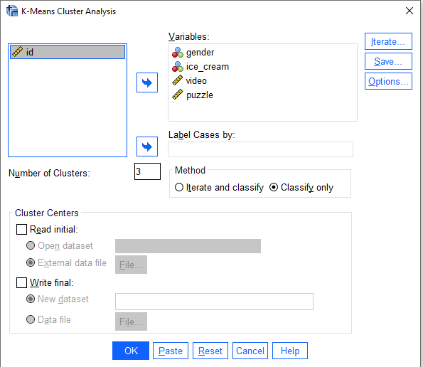

In the “Cluster Analysis” window, I selected “K-Means” for the clustering method, as we are using K-Means clustering for this example. I then set the number of clusters, or groups, I wanted to use for this example to 3. Finally, I clicked “OK”, and SPSS automatically created a summary output of my K-Means clustering analysis.

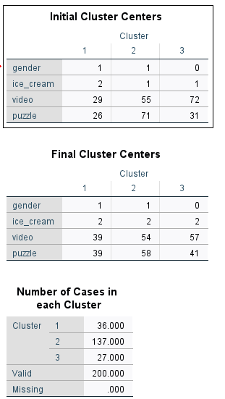
The results from the k-means clustering show us the relationships between the outcome measure (favorite flavour of ice-cream), video game score, puzzle score, and gender. The initial cluster centers show the average of each of the variables within the clusters (Fekete et al., 2019, 286). From the final cluster centers, we can see that two of the clusters (1 and 2) both have an average gender of 1 (female) while the third cluster has an average gender of 0 (male). Also, the average ice-cream flavour in the first two clusters is 2 (chocolate) while the third cluster's is slightly higher at 2 (strawberry) (Cheng et al., 2018, n.p). As for the video and puzzle scores, the first two clusters have an average score of 29 and 26, respectively while the third cluster has higher averages at 55 and 71, respectively. It appears that the third cluster contains the highest scoring students (males) with a preference for strawberry ice-cream.
The number of cases in each cluster also provides us with more insight into the data. The first cluster (with female genders) have the smallest number of cases at 36. The second cluster (also with female genders) have the most cases at 137 (Fekete et al., 2019, 286). The third cluster (with male genders) have the third largest number of cases at 27. This suggests that the majority of the students surveyed are female and prefer chocolate ice-cream.
Overall, the results from the k-means clustering provide us with a better understanding of the relationships between the outcome measure and the other variables in the dataset (Cheng et al., 2018, n.p). It appears that gender and (to a lesser extent) ice-cream preference are related to the students’ performance in the video game and puzzle tests.
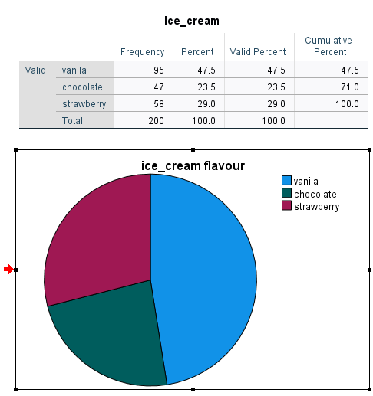
0ut of the 200 students surveyed, 47.5% of them said that their favorite flavor of ice cream was vanilla. This means that 95 of the students surveyed prefer vanilla flavor over other available flavors.
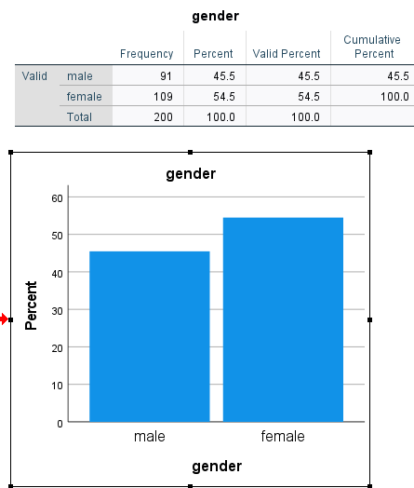
The frequency table above shows the gender of the 200 high school students surveyed in the data analysis. It indicates that of the 200 students surveyed, 91 are male and 109 are female, accounting for 45.5% and 54.5% respectively of the total sample size (Cheng et al., 2018, n.p). This suggests that the sample size is fairly balanced between male and female students, indicating that the results of the analysis should provide an accurate representation of the population from which the data was collected.

References
Cheng, C., Gilmore, T.J., Lougen, C. and Stovall, C., 2018, November. Statistical analysis, data visualization, and business intelligence tools for electronic resources in academic libraries. In What’s Past Is Prologue: Charleston Conference Proceedings 2017.
Clark, D., 2020. Data analysis with pivot tables and charts. In Beginning Microsoft Power BI (pp. 277-304). Apress, Berkeley, CA.
Fekete, J.D., Fisher, D., Nandi, A. and Sedlmair, M., 2019. Progressive data analysis and visualization.
Janvrin, D.J., Raschke, R.L. and Dilla, W.N., 2014. Making sense of complex data using interactive data visualization. Journal of Accounting Education, 32(4), pp.31-48.
Konomu, D., 2017, July. Analysis and Visualization of Course Material Page Views Using a Time Series Cross Section and Pivot Table. In 2017 6th IIAI International Congress on Advanced Applied Informatics (IIAI-AAI) (pp. 705-710). IEEE.
Raubenheimer, J., 2017. Excel-lence in Data Visualization?: The Use of Microsoft Excel for Data Visualization and the Analysis of Big Data. In Data visualization and statistical literacy for open and big data (pp. 153-193). IGI Global.

