  Component One: Student Journal (learning log) 750 words +/- 10%  Contribution to Overall Module Assessment: 25% | Student No: | 2206217
 | Module Title: | Operating Hotel Facilities
 | Module Code: | BMIH4006
 | Lecturer: | Lisa Bassler
Description
As a component of my internship in maintenance, I was responsible for a wide range of tasks that ensured the property's guest apartments alongside public spaces were always organized alongside tidy (Bridger, 2018). Sweeping, scrubbing, restocking facilities, and making sure every single space was clean were all part of the job description. Furthermore, I helped maintain the storage trolleys organized alongside restocking goods when they were low.

Feelings
Upon first impression, I was quite interested in finding out how the cleaning staff operated. However, as I got more involved with my duties, I started becoming stressed out by the enormous amount of work along with the rapid speed of the work (Casado, 2012). Particularly throughout busy periods whenever numerous apartments demanded cleaning at once, I had trouble keeping pace with each employment expectation.

Evaluation
Staffing issues in the cleaning section were among the most significant obstacles I faced throughout the time I was there. It seems obvious because the current department employees remained extremely busy alongside underappreciated, frequently taking on extra tasks to make up for the shortage of personnel (Cottrell, 2019). Because of scheduling limitations, several spaces were not vacuumed sufficiently, which greatly affected the level of hospitality presented to visitors. The meticulousness that is expected in housekeeping duties also took me by unexpectedly. To ensure that tourists received pleasant along with sanitary remains, it was necessary to disinfect all surfaces, crevices, alongside corners thoroughly (Fallon and Rutherford, 2010). The significance of being meticulous alongside exacting in upholding cleaning requirements was brought into focus by these components of the work.
Analysis
I was able to identify my capabilities and opportunities for growth after reviewing my work in housekeeping. The organization as a whole benefited from my strengths in communicating among coworkers as well as establishing priorities according to importance. To be extremely productive even when personality is of the essence, I knew I had to concentrate on my resource capacity for leadership (Ferdinand and Kitchin, 2017). Regarding resolving issues, I discovered that I could swiftly adjust to unforeseen obstacles like a lack of materials for cleaning or broken machinery.

Conclusion
The maintenance staff's important function in guaranteeing customers' happiness was illuminated by my work assignment. A customer's impression of the power source lodging establishment is heavily impacted by the room's hygiene and quality appearance, rendering it an essential part of the visitor's engagement (Johnston and Shulver, 2012). The unacknowledged achievements of cleaning personnel in the tourism business are truly remarkable, which is why I now have a deeper respect for such tireless efforts. Additionally, I learned that efficient supervision alongside the deployment of resources is critical to maximizing organizational effectiveness (Leiter and Bakker, 2010). The maintenance agency's problems pointed to longer fundamental difficulties in the hotel’s organizational organization, therefore it was necessary to take pre-emptive steps to solve employees alongside simplifying operations.

Action Plan
I intend to continue climbing the ladder of success in the restaurant production hotel sector by honing my domestic expertise. I intend to do the following to fix the problem domains:
1. Enhance Time Management Skills: When it comes to completing commitments
alongside producing high-quality employment, I know that effective organization of
time is crucial (Mullins and Doss or, 2013). Some of the tactics I want to employ include making checklists of tasks every day and using time-blocking methods to give every assignment the attention it deserves.
2. Seek Additional Training and Certification: I intend to aggressively pursue
chances for further education along with accreditation to raise my level of
competence in housework process management methods (Quick, 2020). I am devoted to furthering my education while remaining abreast of developments in my field by enrolling in relevant internet via internet, meetings, including conferences.
3. Raise Awareness for the Need for More Personnel: Because I care about the happiness of the cleaning crew and the contentment of our customers, I am going to advocate for higher numbers of employees in that section (Raghubalan and
Raghubalan, 2016). To address the everyday issues that the group is facing because of insufficient hiring, I am going to aggressively voice my problems with leadership and provide backed by research observations.
4. Continuous Feedback and Growth: I know that it is important to get suggestions
from people in charge alongside coworkers to figure out where I can develop
(Rogers, 2008). I promise to make it a point to ask regarding and consider criticisms of my work, as well as recommendations for how to develop. My eagerness to learn alongside grow as an individual in addition to an employee is indicative of my drive for success alongside my desire to make a difference in the lodging business.

Component Two: Health and Safety Guide
Contribution to Overall Module Assessment: 25%

Health and Safety Guide for Room Cleaning in the Housekeeping Department
Premier Inn Southampton Airport

In order to guarantee the wellness alongside security of those who work for us, it is critical that the cleaning division adheres to strict safety protocols (Sharma and Singh, 2019). The purpose of this manual is to provide a framework for secure apartment rooms by outlining the measures to take, and the processes to follow, including the tools to have on hand.
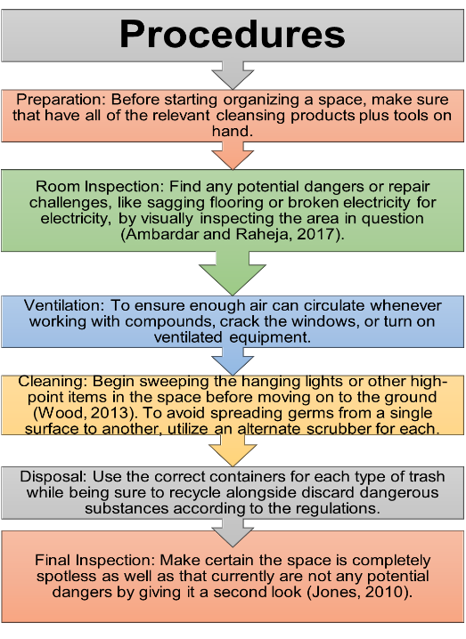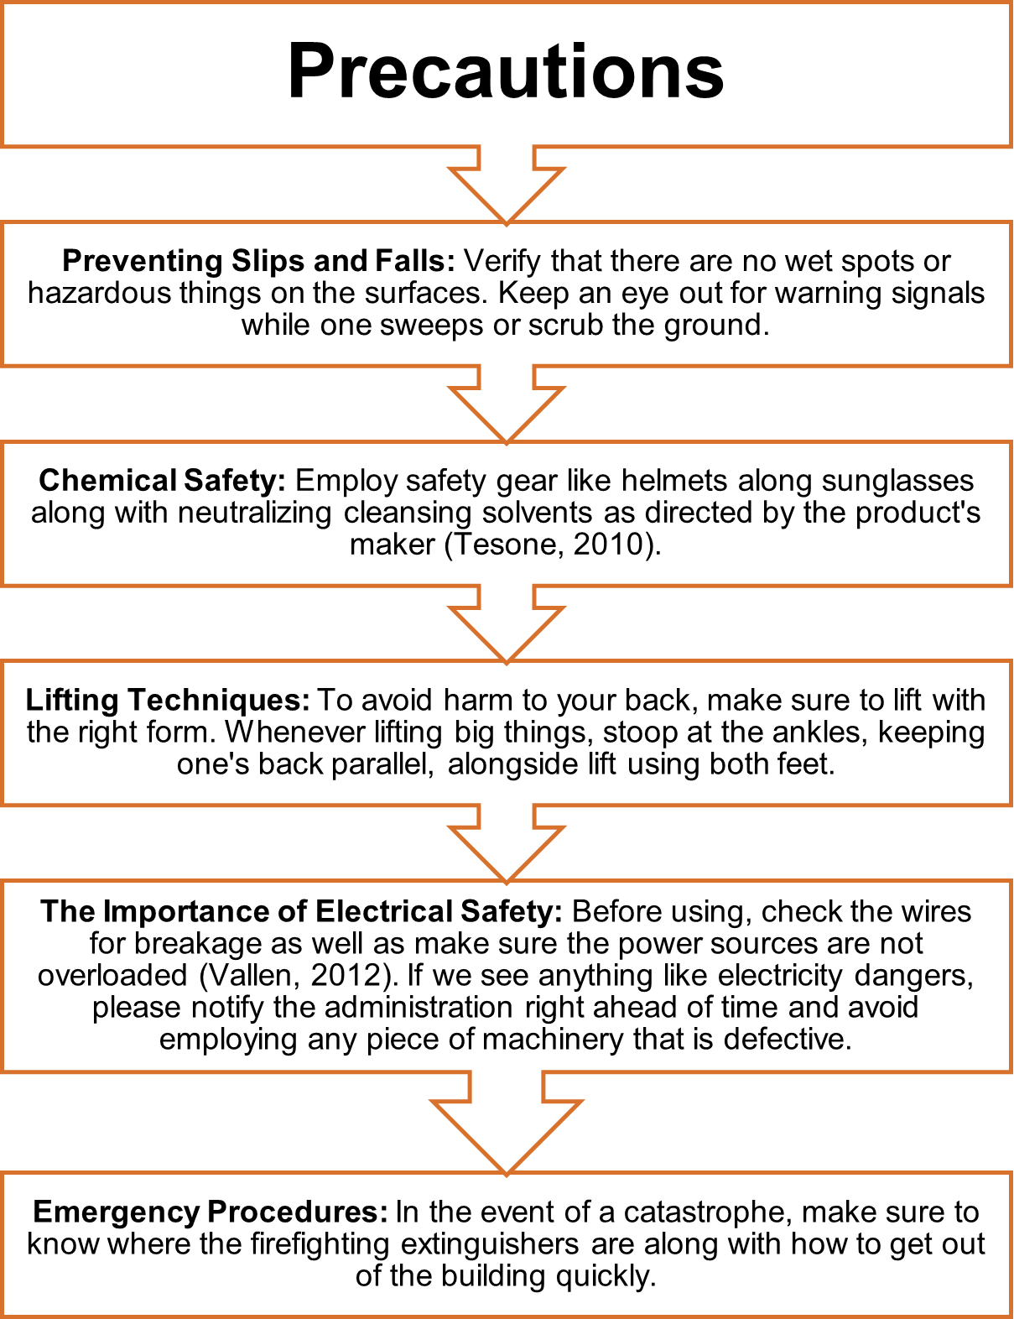
 Equipment


Hazard Mitigation
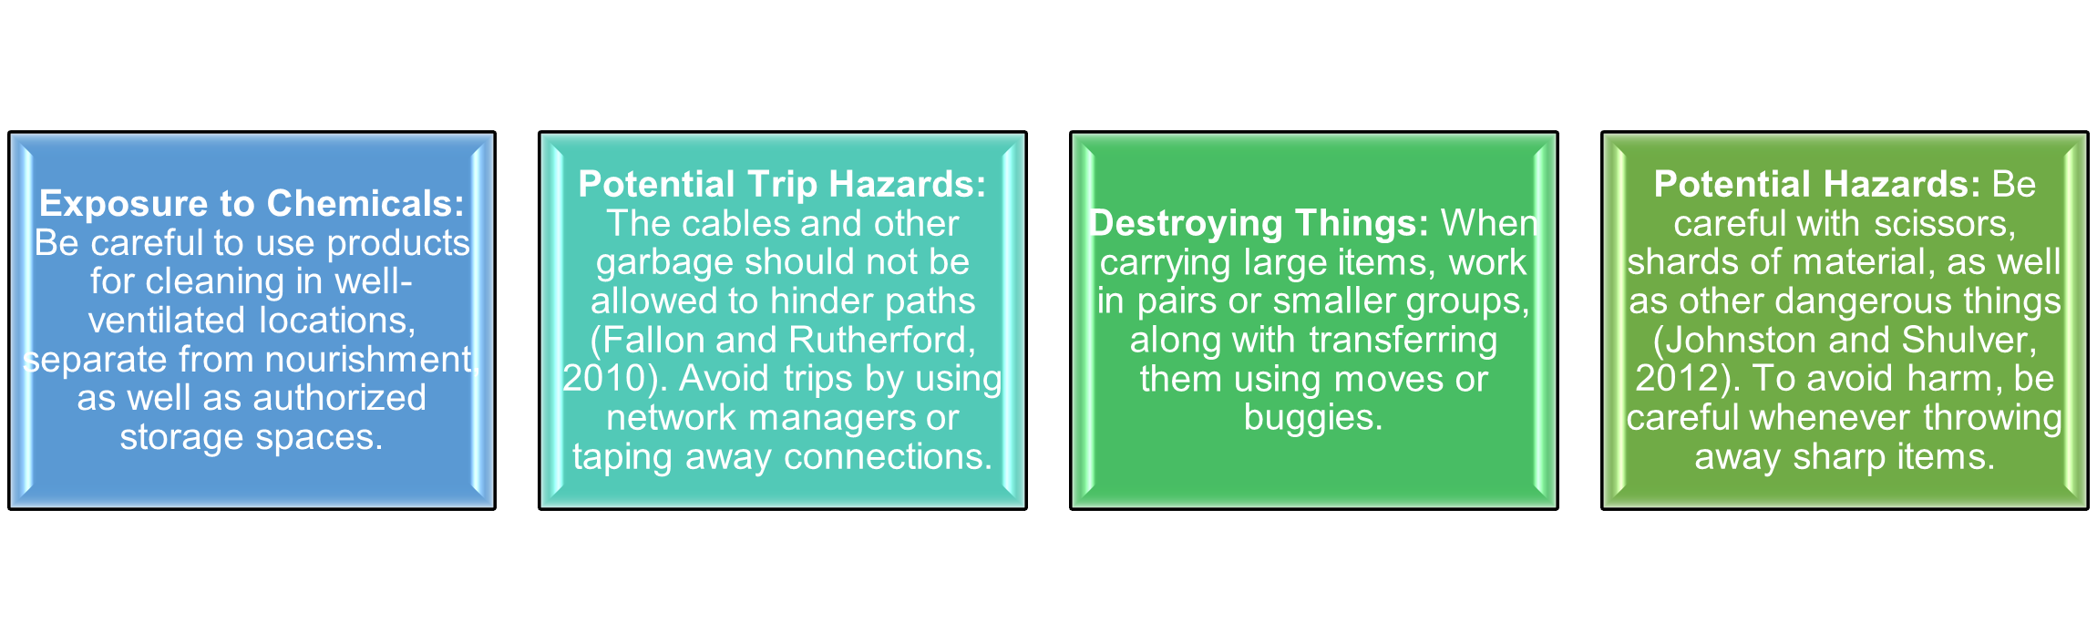
Professional housekeeping workers can function in an atmosphere free from harm according to the rules laid down throughout that security while security manual. These will allow them to wipe down rooms without fear of harm coming to them. To maintain the safeguarding of security and constantly guarantee conformity it is vital to regularly teach along with reinforcing those roles.

Reference List

Ambardar, A. and Raheja, K. (2017) Occupational Safety and Health of Hotel Housekeeping Employees: A Comparative Study. International Journal of Hospitality & Tourism Systems, 10(2).
Bridger, E. (2018) Employee engagement: a practical introduction. 2nd ed. HR Fundamentals. London: CIPD and Kogan Page.
Casado, M. (2012) Housekeeping Management. London: Wiley.
Cottrell, S. (2019) The Study Skills Handbook. 5th ed. London: Red Globe Press.
Fallon, M. and Rutherford, D. (2010) Hotel Management and Operations. London: Pearson.
Ferdinand, N., and Kitchin, P. (2017) Events Management - An International Approach. 2nd ed. London: SAGE Publications Ltd.
Johnston, R., Clark, G. and Shulver, M. (2012) Service Operations Management. London: Pearson.
Jones, T. (2010) Professional Management Housekeeping Operations. London: Wiley.
Leiter, M. P., and Bakker, A. B. (2010) Work Engagement: A Handbook of Essential
Theory and Research. Hove [England]: Psychology Press.
Mullins, L. and Desser, P. (2013) Hospitality Management and Organisational Behaviour. 5th ed. Harlow: Pearson.
Quick, L. (2020) Managing Events. Real Challenges, Real Outcomes. London: SAGE Publications Ltd.
Raghubalan, G. and Raghubalan, S. (2016) Hotel Housekeeping - Operations And
Management. 3rd ed. India: Oxford University Press.
Rogers, T. (2008) Conferences and conventions a global industry (2nd ed., Events
management series). Oxford; Boston: Butterworth-Heinemann.
Sharma, N., Chaudhary, N. and Singh, V. (2019) Management Techniques for Employee Engagement In Contemporary Organizations. Hershey, Pennsylvania: IGI Global.
Tesone, D. (2010) Principles of Management For The Hospitality Industry. 1st ed. London: Routledge.
Vallen, G. and Vallen, J. (2012) Managing Hotel Operations. London: Pearson.
Wood, R. (2013) Key Concepts in Hospitality Management. London: Sage.

