Iwan Williams (1901752)
Engineering science 2 (M4X00386)
Examination answers
Date: 6/5/2020
Starting time: 13:00
Question 1
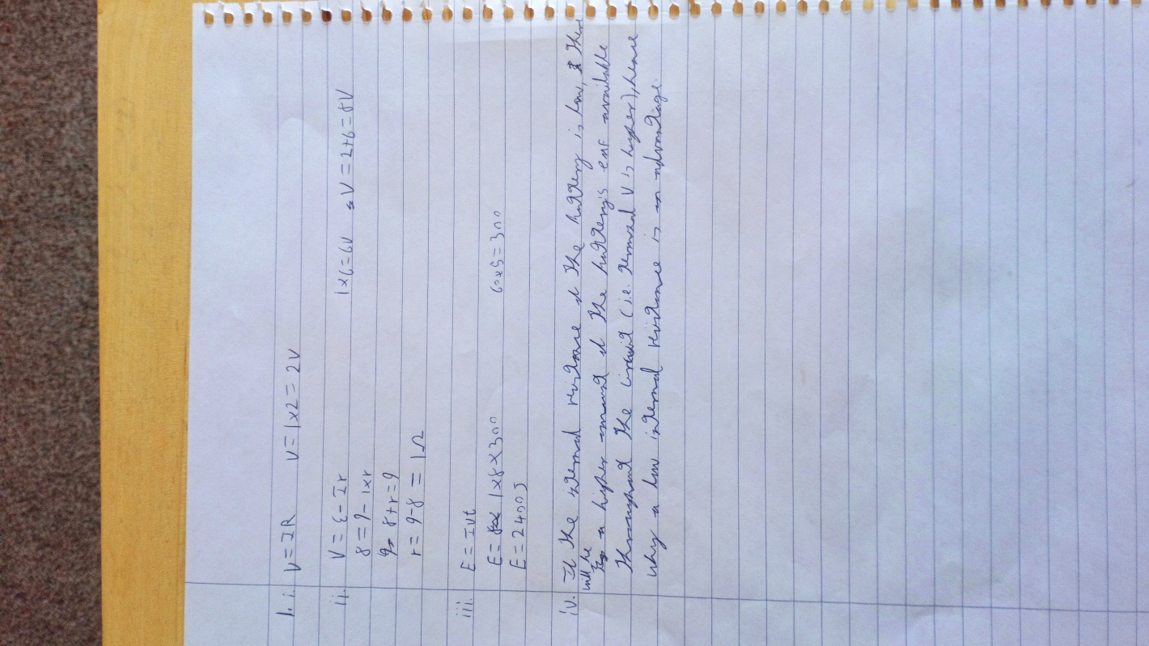

Question 2
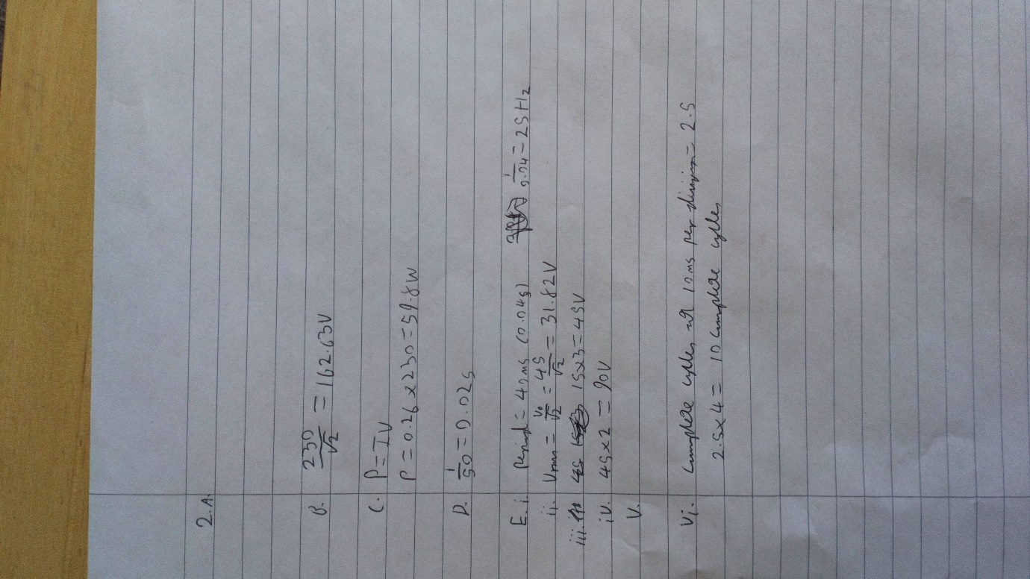

Question 3
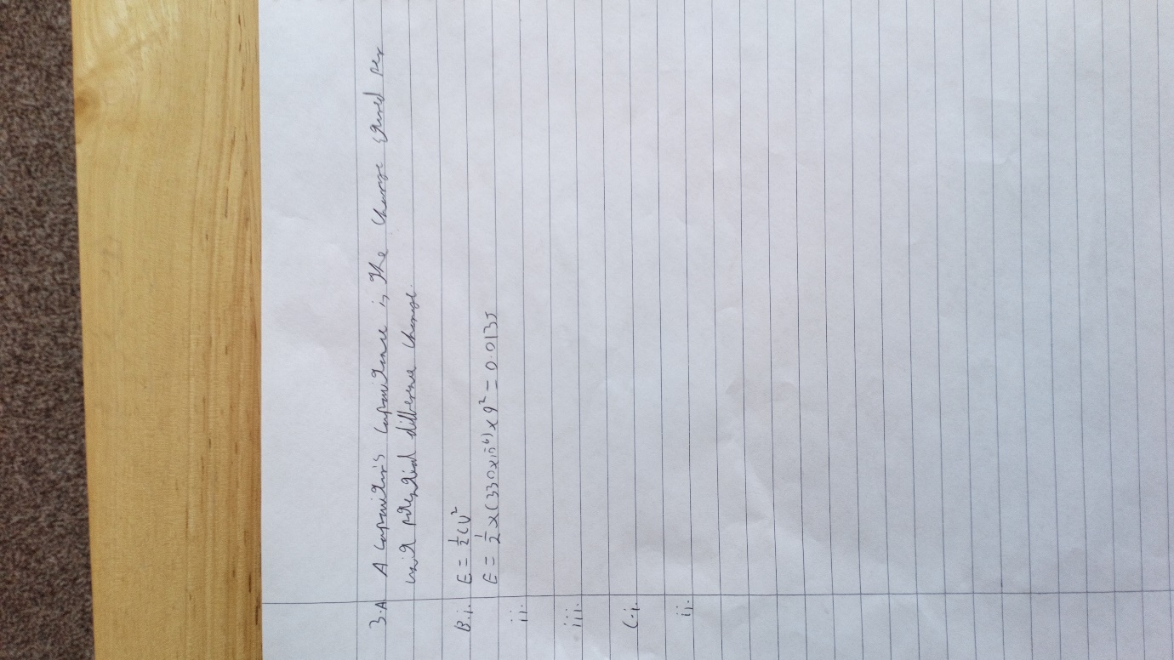

Question 4


