Nathan J Morris

The following report will identify, discuss and evaluate the resources which are critical to a construction project
The project will include an attached Gantt chart and highlight how a delay to a construction project can be resolved.

Report
The project is based on the Canolfan Gwili Centre in Hendy, Carmarthenshire, planning ref no. S/36546. Work started on 16/9/24 and is due to complete on 24/10/25.

Contents
Introduction 2
Overview of the Canolfan Gwili Construction project 2
Resources critical to the construction project 3
How these resources are monitored and controlled 4
How a delay to the project can be resolved 5
Delay Option 1 6
Delay Option 2 6
Appendix 8
Table 1 - Resource task sheet with costs 8
Appendix A 10
Appendix B 10
Appendix C 11
References 12

Word count - 1386

Introduction

Housing construction projects are complicated, they require meticulous planning and resource management. The success of such project’s centres on the effective allocation and monitoring of critical resources, including labour, materials, finances, technology, and time (Chin, 2015). This report identifies, discusses, and evaluates these resources while exploring mechanisms for project control and delay resolution.

Overview of the Canolfan Gwili Construction project

Below is a summary via screen shots of the Microsoft project Gantt chart which has been used to create a detailed work breakdown of the construction project. The full Gantt chart will be submitted separately.

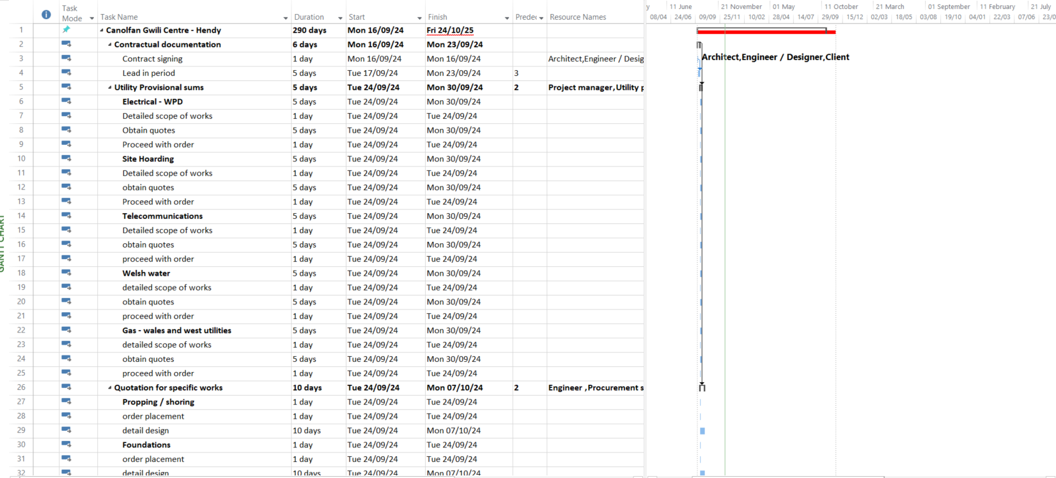
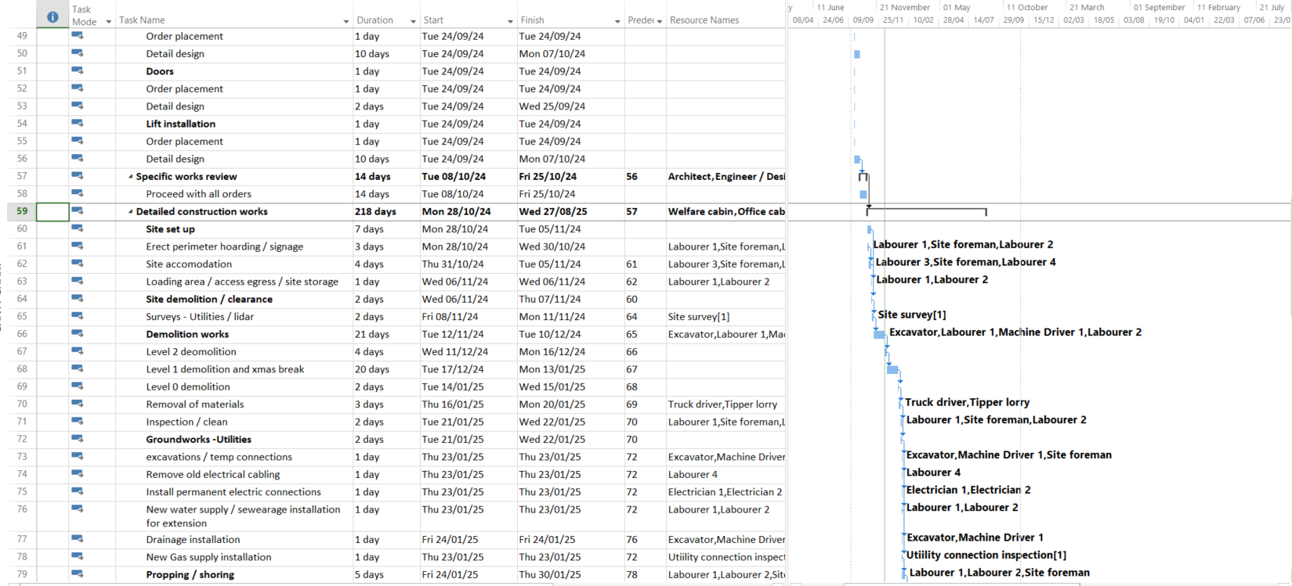
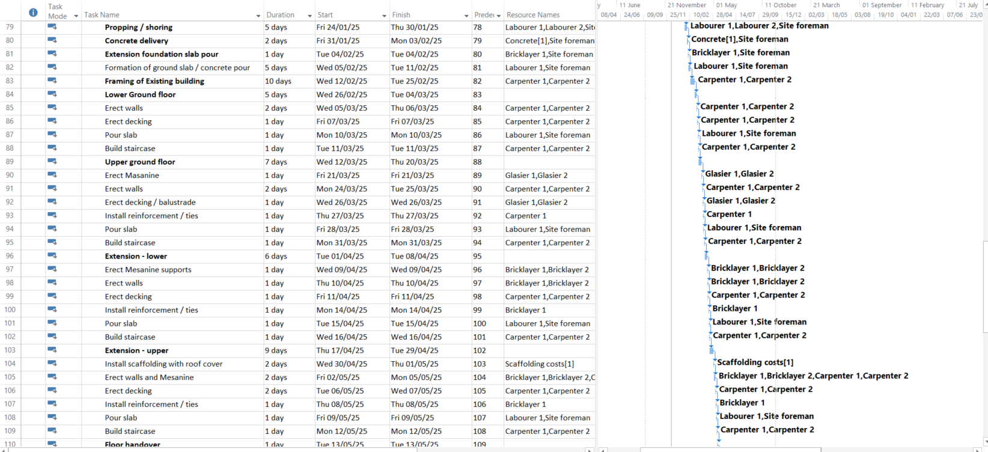
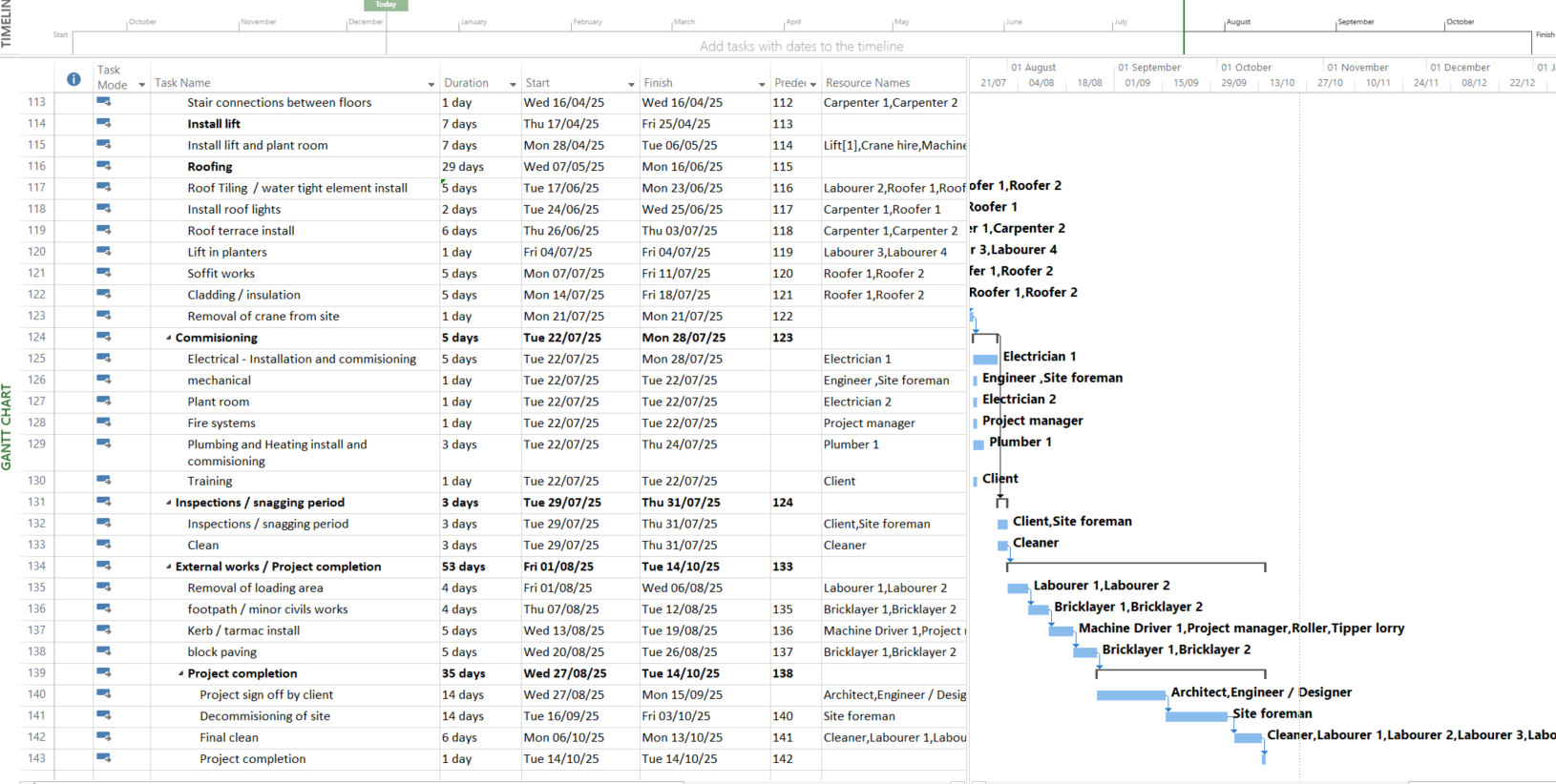
Figure 1 – Project Gantt chart (Carmarthenshire council, 2024).

Resources critical to the construction project

There are many resources that can be deemed critical to a construction project, however certain resources will be of a higher importance than others (Gould, 2008). Resources commonly used in construction projects like this one are:

Materials – These include things such as bricks, cement, concrete, steel, reinforcement bars, timber, tiles, glass and paint. These are critical resources for the physical structure of the building. Some key considerations with these material resources can include their availability, quality and cost, all of which are essential in ensuring a timely completion of the project.

Labour – A skilled and unskilled workforce is another key resource for a construction project and will include Architects, Engineers, Electricians, Plumbers, Carpenters, Bricklayers, Labourers, site foreman, machine drivers and cleaners. Some key considerations with regards to Labour is their availability, skill level and wages as unavailable or low-quality staff can impact on the project’s delivery (Walker, 2022).

Equipment – Construction equipment / machinery will include things like excavators, dumpers, cranes, concrete mixers, small tools and vehicles. These types of equipment are critical to completing tasks more efficiently and it is essential that these pieces of equipment or machinery are available when needed and in good working order to prevent breakdowns and delays.

Financial resources – Construction projects are very expensive and require a large investment for the above resources as well as unforeseen costs which will inevitably occur. It is critical therefore that these costs are accounted for as best as possible prior to beginning the project as well as allocating funds for unexpected costs and ensuring prompt payment to suppliers and workers to minimise any project disruption.

Time – Time is extremely important, as delays can incur large financial costs as well as disgruntled stakeholders who may be relying on the project to be completed by a certain date. This resource is where project timelines, Gantt charts and realistic schedules are drawn up and monitored throughout to identify any issues, show critical path activities and ensure the project remains on track. If any delays are identified, regular monitoring through the above methods can aim to minimise further delays / claw back any lost time.

How these resources are monitored and controlled

Materials – These can be monitored and tracked by regular accurate inventory management, this will ensure no unforeseen material shortages or excess waste occurs. Good co-ordination and communication through suppliers will also ensure timely deliveries and a reliable supply of good quality materials, and any unsatisfactory materials which don’t meet specification are replaced immediately. (Gould, 2008).

Labour – Allocating tasks to the appropriate number of workers is essential as under-utilising resources can lead to slow progress. Employing competent workers with the right skillset will also ensure tasks are completed correctly and avoiding errors. Appropriately trained staff with regular assessments will also ensure tasks are completed safely and correctly, minimising accidents and injuries (Burns, 2024).

Equipment – Monitoring the use and allocation of machinery and equipment through tracking, rent v purchase analysis and utilisation tracking will allow for a smoother project, as machinery on hire for longer than necessary will add additional financial costs and machinery not being available when needed can cause unwanted delays (Walker, 2022).

Financial resources – Regular budget tracking using spreadsheets or Gantt charts can track expected vs actual costs, prompting a change in how the project is running if required. Regular audits and stakeholder meetings will also assist with tracking the financial impact of the project throughout its construction.

Time – Time management is extremely important and can be tracked via Gantt charts or other project management software to identify exactly where the project is compared to where it was supposed to be. This can be achieved through critical path analysis to see if there will be any impact to the project’s deadline allowing quick decision making to reduce the impact of any delays.

How a delay to the project can be resolved

There are many ways a project can be delayed, material shortages, labour issues, equipment failures, weather conditions, financial problems or even global pandemics such as Covid 19. It is how we resolve these delays which will lead to a successful project completion (Burns, 2024).
Although there are many ways a project can be delayed, not all delays are equal. For example, if a particular colour paint is no longer available there will usually be another similar colour we can use, where if a bespoke lift company suddenly goes bankrupt, it becomes a lot more difficult to find a replacement, and if a replacement is found, the cost / time in which they can assist will usually lead to a significant delay.
It is critical that projects are monitored closely and updated regularly via things like Gantt charts to allow any delays to be identified early on and solutions proposed. There are usually a few options when a delay is identified, is it possible to find another supplier? If not, is there any float in the project to absorb the delay? Or is there anywhere else in the project a delay can be recouped (Chin, 2015).
In the example below, the bespoke lift company used in the Canolfan Gwili centre has incorrectly measured the lift for the cricket club. It has stated that it will take a minimum of four weeks to rectify the issue, therefore impacting the completion date of the project.
There are a few ways that this delay could be rectified.

Delay Option 1
The first option is do nothing and accept that the project will be delayed and look to recoup any costs for this delay from the Lift company. This would be done through the procurement specialist where the contract (Usually the NEC – New engineering contract) which is widely used in construction, manages the delay via its compensation event mechanism under the clause 60.1 (Planning, 2024). The process for this type of delay would be the contractor notifying the project manager (PM) of the delay via the early warning clause 16 mechanism (Planning, 2024), the PM assessing the impacts of this delay on the project, the contractor would then issue an updated programme and any delay mitigation measures and the PM then evaluating this and enforcing any penalties on the contractor specified within the contract. An example of the do-nothing approach can be seen below and pushes the completion date back from the 24/10/25 to 03/12/25 as seen in figure 2 below.
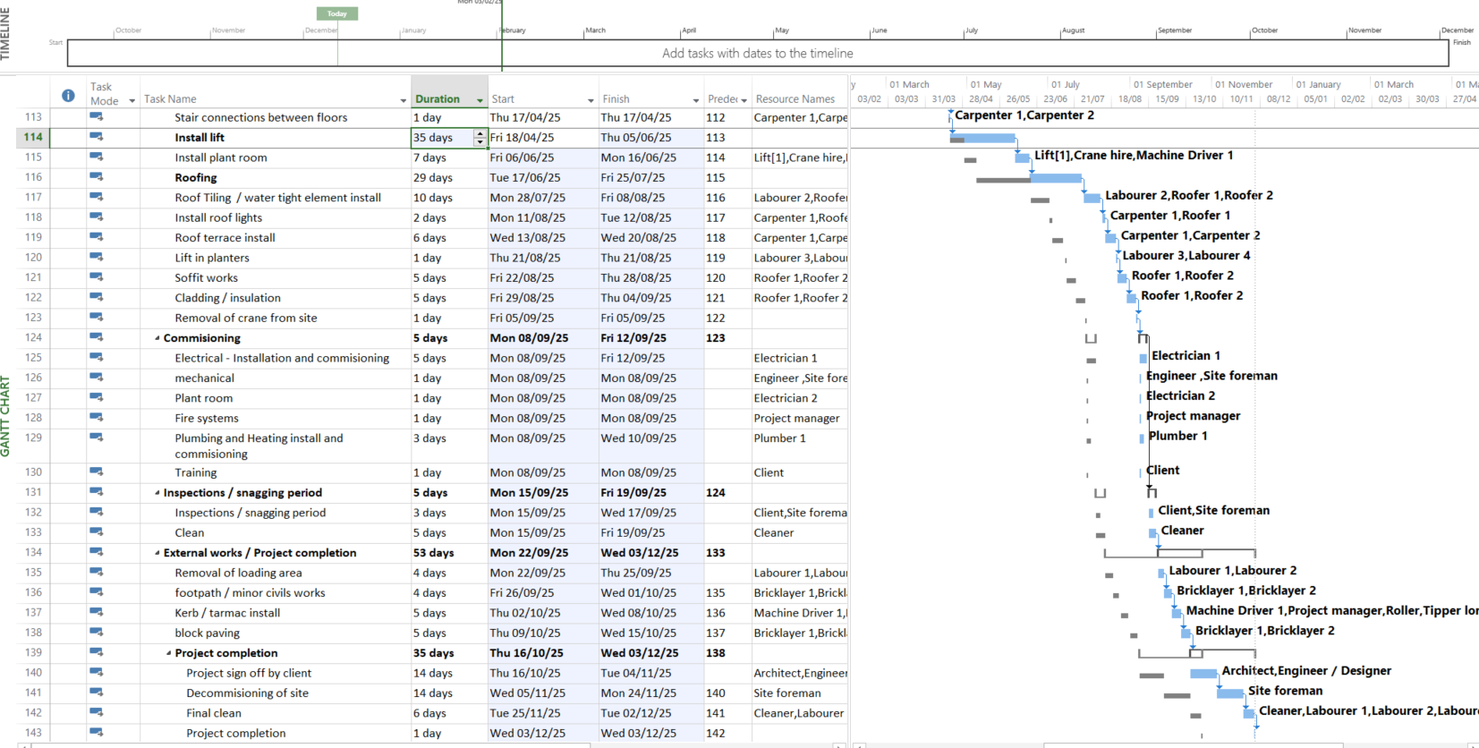

Delay Option 2

Another option to rectify this delay could be to reduce time on other tasks by allocating additional resources, in the example below additional resources were allocated to numerous tasks such as groundworks and roofing to claw back additional time. This obviously adds to the total cost of the project and could be reclaimed through the NEC contract, but if the additional cost is less important than the deadline it is another option to recoup some lost time.

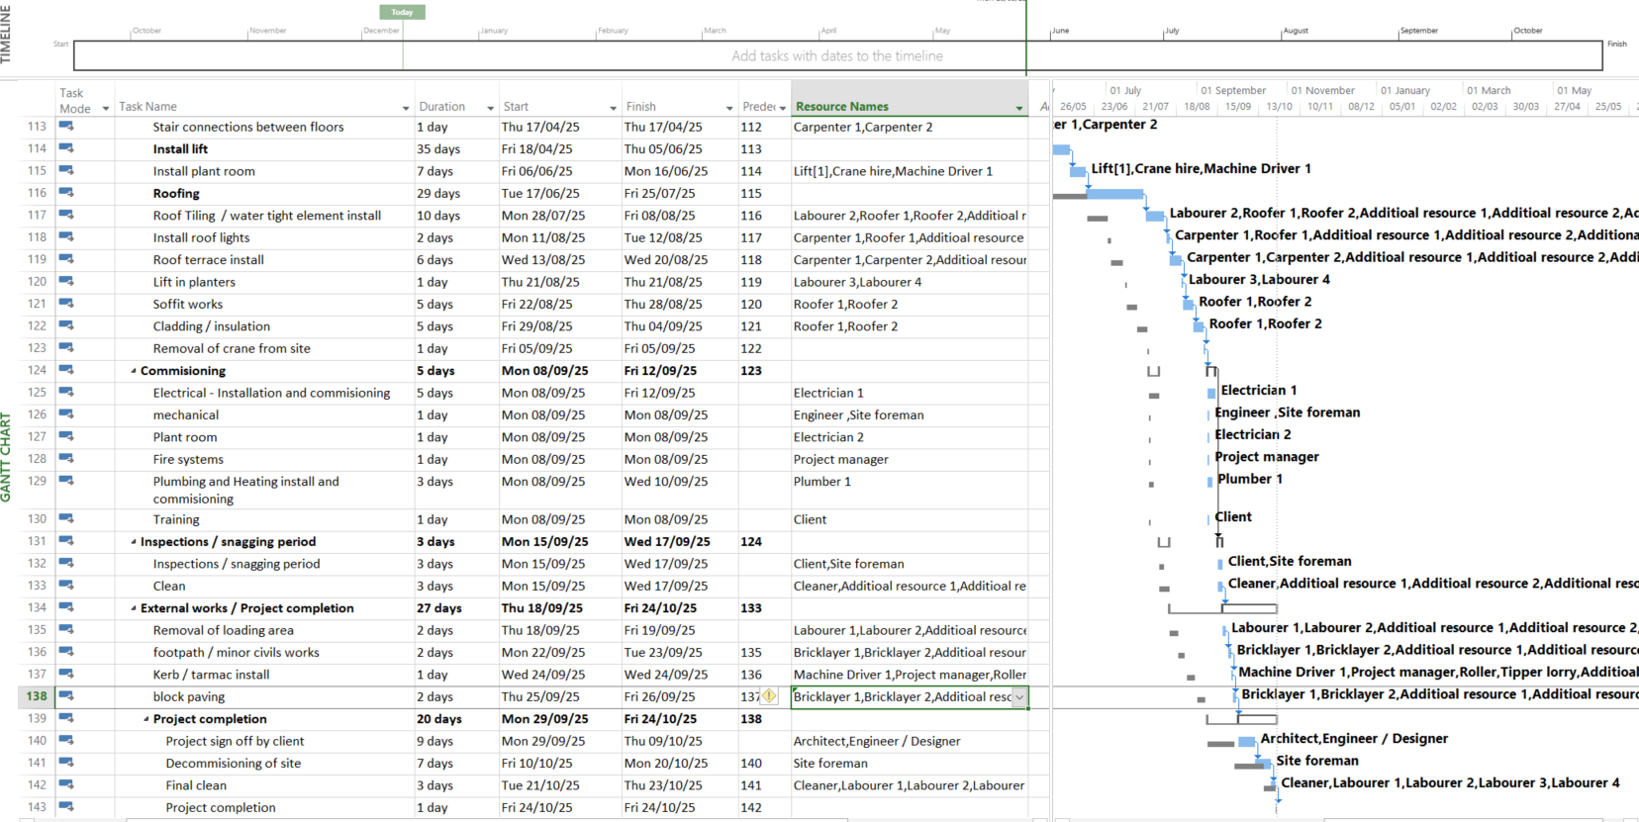
Additional resource

Delays in a construction project are inevitable, whether that is delays in materials, workforce, weather or unprecedented events like Covid 19. It is how we manage these delays that is key to a project’s success (Burns, 2024). It is essential to closely monitor the project through means such as Gantt charts or critical path analysis and hold regular reviews / team meetings of the projects progress to help minimise these delays and identify any potential issues early on to enable these issues to be resolved as quickly as possible.
As mentioned above, some delays are much easier to resolve than others, but early identification of any potential delay and clear well-defined NEC contract gives the project team a much better chance of minimising the potential impact and minimising any potential delay.

Appendix

Table 1 - Resource task sheet with costs

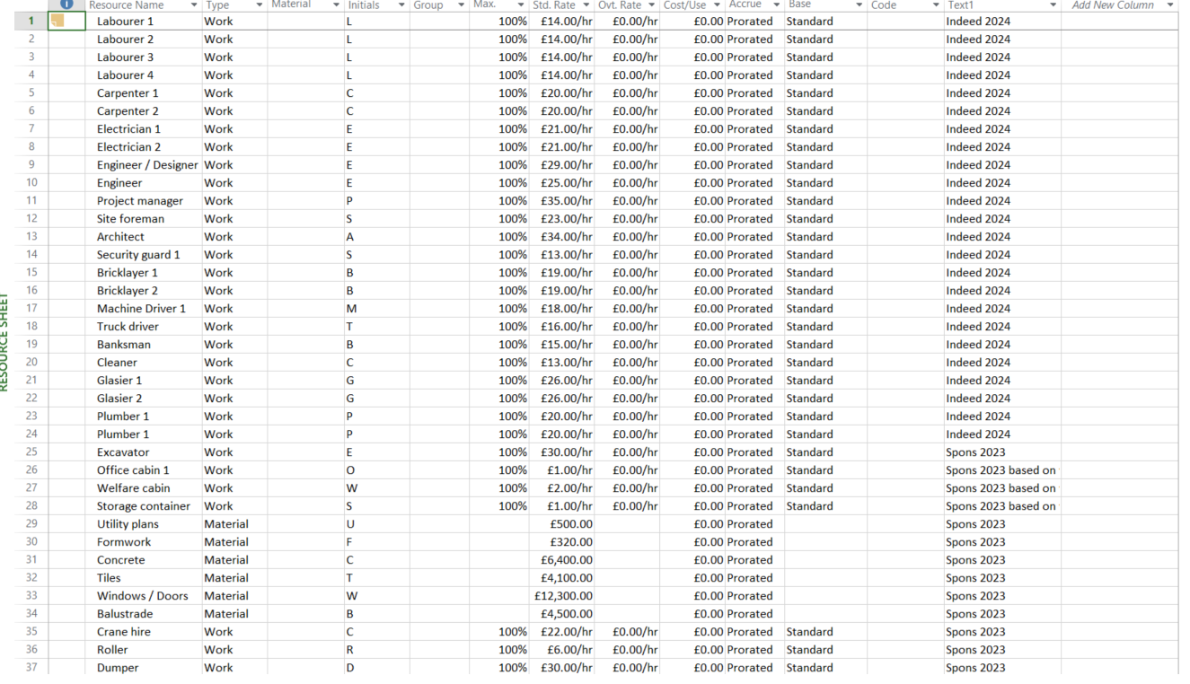

Table 1 – Resource task sheet with costs (Indeed, 2024).

Appendix A
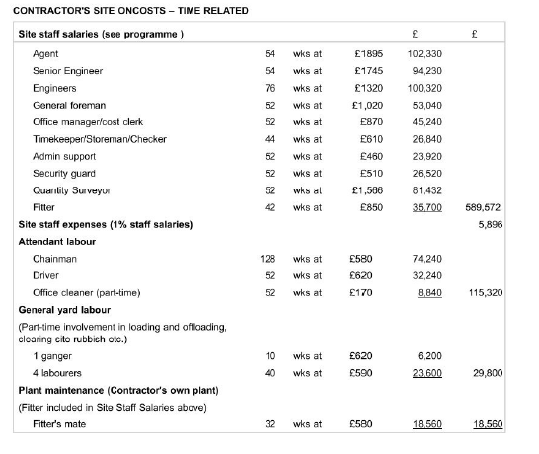
Appendix A – Sample of contractor labour costs per job role (Aecom, 2023)

Appendix B
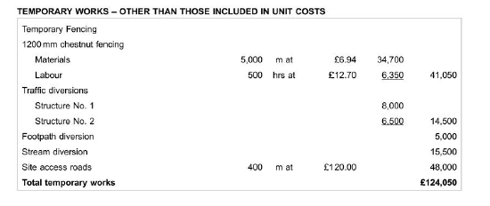
Appendix B – Sample of Temporary works costs (Aecom, 2023).

Appendix C

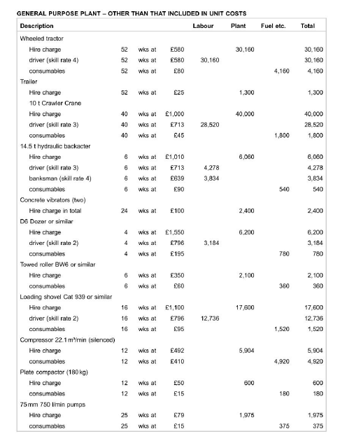
Appendix C – Sample of General purpose plant costs per (Aecom, 2023).

References

Aecom, 2023. Spons. 148 ed. Oxford: CRC Press.
Burns, J., 2024. Corner stone projects. [Online]
Available at: https://www.cornerstoneprojects.co.uk/blog/delays-in-the-construction-industry-our-2022-survey-results-and-how-they-compare-to-2016/#:~:text=This%20means%20that%20supply%20shortages,lead%20to%20delays%20in%20projects.
Carmarthenshire council, 2024. The Planning portal. [Online]
Available at: https://www.carmarthenshire.gov.wales/council-services/planning/search-for-a-planning-application
[Accessed 9 12 2024].
Chin, A. R. A. H., 2015. The Practice of Time Management on Construction Projects. Procedia Engineering, pp. 32-39.
Gould, F. a. J. N., 2008. Construction project management. United kingdom: Pearson education ltd.
Indeed, 2024. Indeed salary guides. [Online]
Available at: https://uk.indeed.com/career/carpenter/salaries/Wales.
[Accessed 4 12 2024].

Indeed, 2024. Indeed salary guides. [Online]
Available at: https://uk.indeed.com/career/carpenter/salaries/Wales.
[Accessed 4 12 2024].
Indeed, 2024. Indeed salary guides. [Online]
Available at: https://uk.indeed.com/career/electrician/salaries/Wales.
[Accessed 4 12 2024].
Indeed, 2024. Indeed salary guides. [Online]
Available at: https://uk.indeed.com/career/carpenter/salaries/Wales.
[Accessed 4 12 2024].
Indeed, 2024. Indeed salary guides. [Online]
Available at: https://uk.indeed.com/career/electrician/salaries/Wales.
[Accessed 4 12 2024].
Indeed, 2024. Indeed salary guides. [Online]
Available at: https://uk.indeed.com/career/labourer/salaries/Wales.
[Accessed 4 12 2024].
Indeed, 2024. Indeed salary guides. [Online]
Available at: https://uk.indeed.com/career/architect/salaries/Wales.
[Accessed 4 12 2024].
Indeed, 2024. Indeed salary guides. [Online]
Available at: https://uk.indeed.com/career/engineer/salaries/Wales.
[Accessed 4 12 2024].
Indeed, 2024. Indeed salary guides. [Online]
Available at: https://uk.indeed.com/career/projectmanager/salaries/Wales.
[Accessed 4 12 2024].
Indeed, 2024. Indeed salary guides. [Online]
Available at: https://uk.indeed.com/career/designer/salaries/Wales.
[Accessed 4 12 2024].
Indeed, 2024. Indeed salary guides. [Online]
Available at: https://uk.indeed.com/career/siteforeman/salaries/Wales.
[Accessed 4 12 2024].
Indeed, 2024. Indeed salary guides. [Online]
Available at: https://uk.indeed.com/career/securityguard/salaries/Wales.
[Accessed 4 12 2024].
Indeed, 2024. Indeed salary guides. [Online]
Available at: https://uk.indeed.com/career/bricklayer/salaries/Wales.
[Accessed 4 12 2024].
Indeed, 2024. Indeed salary guides. [Online]
Available at: https://uk.indeed.com/career/roofer/salaries/Wales.
[Accessed 4 12 2024].
Indeed, 2024. Indeed salary guides. [Online]
Available at: https://uk.indeed.com/career/Glasier/salaries/Wales.
[Accessed 4 12 2024].
Indeed, 2024. Indeed salary guides. [Online]
Available at: https://uk.indeed.com/career/machinedriver/salaries/Wales.
[Accessed 4 12 2024].
Indeed, 2024. Indeed salary guides. [Online]
Available at: https://uk.indeed.com/career/banksman/salaries/Wales.
[Accessed 4 12 2024].
Indeed, 2024. Indeed salary guides. [Online]
Available at: https://uk.indeed.com/career/procurementspecialist/salaries/Wales.
[Accessed 4 12 2024].

Planning, G., 2024. NEC guidance - Clause 16. [Online]
Available at: https://gmhplanning.co.uk/nec-guidance-notes/nec-ecc-clause-16-early-warnings/.
Planning, G., 2024. NEC Guidance - Clause 60.1. [Online]
Available at: https://gmhplanning.co.uk/nec-guidance-notes/ecc-clause-60-1-compensation-events/
Talent.com, 2024. Salary Guides. [Online]. Available at: https://uk.talent.com/salary?job=procurement+specialist#:~:text=The%20average%20procurement%20specialist%20salary%20in%20the%20United%20Kingdom%20is,to%20%C2%A355%2C542%20per%20year. [Accessed 4 12 2024].
Walker, A., 2022. Project Management in Construction. Chichester: Wiley - blackwell.

