LCBB5010
Management Accounting for Managers
Individual Report

Tesco Management Accounting Report

Module Name: BA Management Accounting for Managers
Module Code: LCBB5010
Assignment: Individual Report
Lecturer: Mudassar Hasan
Student: 2329070

Table of Contents
1. Introduction 3
2. Cost Analysis and Business Model 3
2.1 Tesco’s Revenue Model 3
2.2 Key Cost Structures 4
3. Budgeting and Financial Planning 5
3.1 Role of Budgeting in Tesco’s Operations 5
3.2 Operating Expense Trends 5
3.3 Management Decisions Influencing Financial Planning 5
4. Performance Measurement and Decision‑Making (≈350 Words) 6
4.1 Key Financial and Non‑Financial KPIs Identified 6
4.2 Analysis of Strategic Decisions Based on KPIs 7
4.2.1 Driving Revenue Growth through Value and Service Initiatives 7
4.2.2 Profit Margin Optimisation and Operational Efficiency 7
4.2.3 Enhancing Shareholder Returns 7
4.2.4 Competitive Positioning in the UK Market 7
4.2.5 Customer Satisfaction Focus 7
5. Sustainability and Ethical Considerations 8
5.1 Sustainability in Financial Decision‑Making 8
5.2 Ethical Considerations in Cost Management and Pricing 9
6. Conclusion and Recommendations 9
6.1 Recommendations 9
References 11

1. Introduction
Tesco is a global retailer in the general merchandise and grocery markets with one of the largest operations worldwide. Tesco was launched in the year 1919 and it has millions of customers in the UK and other foreign markets (Tesco, 2025). The company has various products in which it deals in both physical stores and online which include food, attires, electronics and home products. Tesco enjoys an excellent presence in the retailing industry, boasting of over 3,400 stores worldwide, and having over 330,000 employees. Management accounting plays an important role in assisting the decision making process in Tesco. It helps the company to compare its financial performance, costs and future planning. Tesco uses management accounting instruments such as budgeting, cost analysis, and performance measurement to ensure effective distribution of its resources and strategic decision making in such a way that it can stay competitive and capable of response to the market requirements.

2. Cost Analysis and Business Model

2.1 Tesco’s Revenue Model
Tesco acquires most of its income by way of retailing the groceries, general goods and fuels in its chain of stores both in the United Kingdom and internationally. Regarding the year 2024-2025, the annual report shows that the group has reported a total revenue amounting to £69.9 billion, with the sub-core of the revenues base being generated by the sale of the grocery and non-food products (Tesco Plc, 2025). The Tesco revenues are centered predominately on the core business; that is, mega-supermarkets, convenience stores, and online grocery service. The online services have gained even greater importance; the Tesco online channel grows the sales on top of the revenue in-store, supporting the consumer acquisition and delivery. Besides, Tesco also earns less but still substantial income on such services as Tesco Mobile and Tesco Bank but the latter is undergoing the process of strategic restructuring in recent results. These are diversified sources of revenues that characterise the source of Tesco due to the possession of steady cash flows and investments in customer value undertakings.
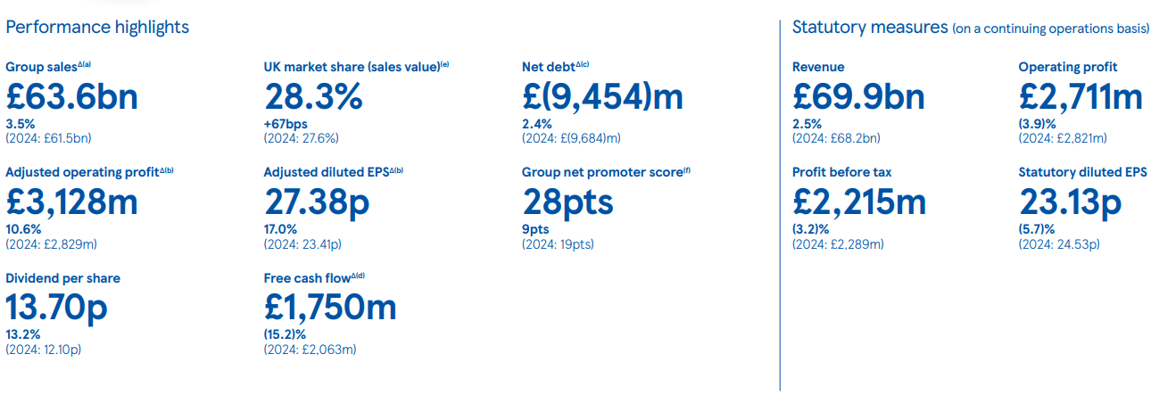
Figure 1: Overall Performance of the year 2024-2025
(Source: Tesco Plc, 2025)

2.2 Key Cost Structures
The Tesco cost structure is made of the fixed and variable costs which are monitored by the management accountants to aid the making of an efficient decision; Fixed Costs are the costs that are not directly proportional to the sales volume. These would include store rent and property cost of Tesco with such large number of stores, the cost of salaried management and head office employees, depreciation of distribution centres and information technology infrastructure as well as long term contract to provide logistics and supply chain facilities (Li and Zeng, 2024). These expenses are relatively fixed regardless of any variations in the revenues during a financial year.
Variable costs change with business activity. In the case of Tesco, some of the important variable costs are Cost of Goods Sold (COGS) which is the purchase cost of inventory that has been sold in the period and in the recent financial year, this expenditure was more than £63.8 billion (Tesco Plc, 2025). The other variable costs are hourly labour costs incurred during the operations of the stores, the fuel costs related to sales undertakings, seasoned promotions and logistics costs that fluctuate with the volume of distribution. Tesco is a proactive business that negotiates with suppliers, implements efficiency programs and manages inventory optimisation strategies, which safeguard its margins and react to the competition (Meng, 2024). Good cost classification will help Tesco to have the management accounting teams to study profitability by product line, predict future costs, and assist in decision making like choice in pricing strategy, cost reduction campaign, and priority in investment.

3. Budgeting and Financial Planning

3.1 Role of Budgeting in Tesco’s Operations
Budgeting at Tesco falls under Tesco financial management framework which helps Tesco in planning budgeting, control and optimisation of resources distribution in its large UK and international operations. Annual budgets combined with periodic forecasting and strategic investment plans allow Tesco to predict its future revenues and expenditures, create the target levels of sales and costs in the future, and assist them in making board or divisional decisions (Joannides de Lautour, 2018). The idea of budgeting assists Tesco to align its operational activities to have the ability to strategically achieve its long term strategic goals, such as being competitive in terms of prices, investing in digital and supply chain betterment, and giving shareholders value. Company budgeting also helps in cash flow management since it enables the company to be liquidated to facilitate investments like stores refurbishment or improvement of the technological infrastructure and help them to maintain the appropriate working capital levels (Jain, 2024). It is a type of financial planning that enables Tesco to react quickly to the changes and cost pressures in the market, and pursue expansion in the same breath.

3.2 Operating Expense Trends
According to the Tesco Annual Report 2025, the total revenues of the retailer were approximately about £69.9billion in February 2025, which was slightly higher than it was the previous year, which meant that people continued to demand the groceries and other retail products (Tesco Plc, 2025). Even though the headline revenue growth was made, the operating profit dynamics affected the entire change in the costs and the group adjusted the profit guidance to the current period due to the changes in competitive pricing and costs. According to the preliminary 2024/25 results, operating profit has risen to £3.12 billion which is by 10.9% higher than the previous year, though Tesco is projecting its operating profit to fall a little bit between £2.7 billion-£3.0 billion, as the firm continues to record fluctuating cost operation and market forces.

3.3 Management Decisions Influencing Financial Planning
The budgeting decisions made by Tesco have internal and external effects. The management of Tesco introduced the "Save to Invest" programme internally and aimed to achieve substantial cost (approximately £510 million) reductions (according to its current financial performance) by means of optimisation of its supply chain, cutting overhead-related costs, and minimisation of operational costs (Tesco Plc, 2025). These are the internal choices that Tesco has in its budgeting interest in enhancing its margin but without compromising its competitive prices. On the external front, Tesco is reacting to macroeconomic pressures like inflationary pressures, wage pressures and costs of regulation (e.g., national insurance and packaging levies) which have a direct effect on the cost of operation (Hoggan, 2024). The management has managed to re-align the plans to contain affordability to its customers plus ensuring control of costs such as strategic price investments to defend its market share and ensure customer value is maintained without reducing profitability. This internal cost management coupled with responsive planning to market changes demonstrates that budgeting helps Tesco to make it through a competitive world of retailing products.

4. Performance Measurement and Decision‑Making (≈350 Words)

4.1 Key Financial and Non‑Financial KPIs Identified
Based on the Annual Report 2025 of Tesco, a number of key performance indicators (KPIs) are disclosed that aid in determining performance and making strategic decisions:
Type of KPI | KPI | Value | Description
Financial KPI | Group Sales | £63.6 billion | Total revenue for the financial year, reflecting growth in sales.
Financial KPI | Adjusted Operating Profit | £3,128 million | Operating profit, indicating the profitability of core operations.
Financial KPI | Dividend Per Share | 13.70 pence | Reflects the cash return to shareholders.
Non-Financial KPI | UK Market Share (sales value) | 28.3% | Market share in the UK, indicating competitive positioning.
Non-Financial KPI | Group Net Promoter Score (NPS) | 28 points | Measure of customer satisfaction, higher scores reflect loyalty.
Table 1: Financial and Non-Financial KPIs
(Source: Tesco Plc, 2025)

4.2 Analysis of Strategic Decisions Based on KPIs

4.2.1 Driving Revenue Growth through Value and Service Initiatives
The growth in Group Sales indicates that Tesco focuses on providing value and quality to its customers through investment in low-price guarantee, Clubcard Price savings, and availability of products to customers (Tesco, 2024). These activities were explicitly correlated with sales growth by the management as it realised that competitive pricing and quality of products were key drivers of volume particularly in the periods of inflation.

4.2.2 Profit Margin Optimisation and Operational Efficiency
It is notable that the Adjusted Operating Profit has increased significantly; this testifies to the focus that Tesco has given to the cost control and productivity (Tesco, 2025). The strategic responses that encompass, but are not limited to Save to Invest programme, rise in logistics efficiencies and supply chain optimisation are all strategic responses founded on profitability KPIs, which would ensure Tesco protects its margins without risking investment on value propositions.

4.2.3 Enhancing Shareholder Returns
Dividend Per Share growth is a sign of the involvement of the management in returning to the investors. This KPI will have an impact on the retained earnings budget and cash flow budget allocation in which Tesco has been forced to balance between investing to grow and a consistent dividend policy that will attract long term shareholders (Gan and Yan, 2023).

4.2.4 Competitive Positioning in the UK Market
The growth of the UK Market Share is an indicator that helps in decision making of pricing structure and promotions. As the market share has been highest in years, Tesco has utilised competitive knowledge in balancing price investments against profitability pressures, particularly in the light of cutthroat discounting by competitors (Creery, 2025).

4.2.5 Customer Satisfaction Focus
The rise in Group NPS has influenced the strategic agenda concerning customer experience, digital, and store innovations (e.g., the extension of the Tesco Whoosh delivery service). High NPS assists in decision-making on resource allocation in customer service improvements, loyalty programmes as well as digital infrastructure (Ziliani and Ieva, 2025).
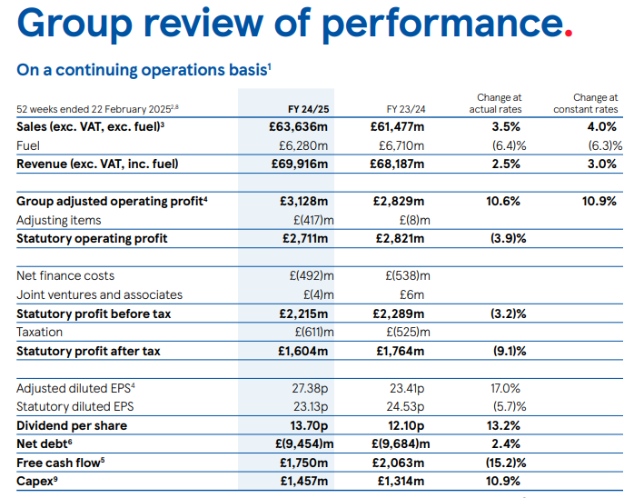
Figure 2: Review of Performance
(Source: Tesco Plc, 2025)

5. Sustainability and Ethical Considerations

5.1 Sustainability in Financial Decision‑Making
Tesco has incorporated the element of sustainability in its financial decision making by inclusion of green initiatives in its operations. The company has been investing in achieving the net-zero emission level by the year 2050 and is also working on the control of the carbon emission in the supply chain and operations (McLauchlan, 2020). Tesco financial strategy is investing finance on sustainable sourcing activities e.g. by providing funds to change to sustainable agriculture and renewable energy source in its stores and distribution centres. Investments are also done further in the reduction of waste and increased levels of recycling more particularly in the packaging. Tesco has ensured that it has decreased its Scope 1 and Scope 2 greenhouse gas (GHG) emissions across the Group by 65 percent, which is higher than its December 2025 target of 60 percent (Tesco, 2025).

5.2 Ethical Considerations in Cost Management and Pricing
Cost management and pricing are the Tesco strategies that are directed towards ethical considerations. The company believes in ensuring that its employees receive fair wages, as it will offer competitive wages and benefits especially at the frontline retail employee base (Tesco PLC, 2025). This coincides with the commitment of Tesco under Fair Pay whereby workers are paid fairly in accordance with national standards and living wage. Tesco has been focused in terms of pricing and it has offered affordable products to its customers and this is under its Clubcard loyalty programme (Azan and Karimah, 2022). This will make sure that customers are able to avail discounts on basic items. Also, Tesco has been keen on assessing the environmental footprint of its pricing policies and lowers the prices of suppliers of materials who choose to produce sustainably. This balances the competitive pricing, sustainability-friendly producers, and the requirement of consumers on products that are eco-friendly.

6. Conclusion and Recommendations
This report has outlined the key performance indicators of the recent financial performance of Tesco that highlighted its strong revenue growth, operating efficiencies, and the commitment to sustainability. Budgeting and financial planning have been well applied at Tesco thus enabling the company to manage its spending and to invest in its customers and sustainability. The engagement of the company in fair wages and environmental impact of its cost management policies and prices depict a strong ethical conduct.

6.1 Recommendations
- Enhance Cost Management through Digitalisation: Tesco should allocate greater funds to artificial intelligence-based supply chain analytics to improve cost, efficiency, and waste minimisation, in particular in such areas of the supply chain as inventory management and logistics (Goswani et al., 2025).
- Focus on Long-Term Sustainability: The sustainable sourcing and friendly programs are to be continued and the consistency of the financial goals and the environmental ones should be maintained to make firm resilient in the long run (Shewmake et al., 2019).
The practices will boost the financial stability of Tesco, its competitive edge, and sustainability objectives.

References
Azan, M.E.M. and Karimah, W.N. (2022) ‘The relationship between customer loyalty program and customer retention at Tesco’, Research in Management of Technology and Business, 3(2), pp. 174–184.
Creery, J. (2025) ‘Tesco lifts outlook as grocer gains ground against rivals’, Bloomberg. [online] Available at: https://www.bloomberg.com/news/articles/2025-10-02/tesco-lifts-profit-outlook-as-grocer-gains-ground-against-rivals (Accessed: 1 February 2026).
Gan, W. and Yan, C. (2023) ‘Financial analysis and development study of Tesco PLC’, Highlights in Business, Economics and Management, 10(2), pp. 167–172. https://doi.org/10.54097/hbem.v10i.8035 (Accessed: 1 February 2026).
Goswami, S.S., Mondal, S., Sarkar, S., Gupta, K.K., Sahoo, S.K. and Halder, R. (2025) ‘Artificial intelligence-enabled supply chain management: Unlocking new opportunities and challenges’, in Artificial intelligence and applications, Vol. 3, No. 1, pp. 110–121.
Hoggan, K. (2024) ‘Tesco says price pressures easing as profits soar’, BBC News, 10 April. [online] Available at: https://www.bbc.com/news/business-68776913 (Accessed: 1 February 2026).
Jain, Y.K. (2024) Financial management and market dynamics. Xoffencerpublication.
Joannidès de Lautour, V. (2018) ‘Strategic planning and forecasting’, in Strategic management accounting, Volume I: Aligning strategy, operations and finance. Cham: Springer International Publishing, pp. 133–215.
Li, L. and Zeng, J.H. (2024) ‘Strategic analysis of Tesco’s international purchasing and supply chain management: challenges, opportunities, and future directions’, International Journal of Science and Business, 35(1), pp. 132–143.
McLauchlan, A. (2020) Managing climate risk: Reducing emissions and achieving net zero targets.
Meng, S. (2024) ‘Operation management of grocery retailer in the UK: A case of Tesco’, Pacific International Journal, 7(2), pp. 136–142.
Shewmake, T., Siegel, A. and Hiatt, E. (2019) ‘The history and progression of sustainability programs in the retail industry’, in Channel strategies and marketing mix in a connected world. Cham: Springer International Publishing, pp. 247–274.
Tesco (2024) Preliminary results 2023/24. [online] Tesco PLC. Available at: https://www.tescoplc.com/preliminary-results-202324/ (Accessed: 1 February 2026).
Tesco (2025) About us. [online] Tesco PLC. Available at: https://www.tescoplc.com/about (Accessed: 1 February 2026).
Tesco (2025) Interim results trading statement 2025/26. [online] Tesco PLC. Available at: https://www.tescoplc.com/interim-results-trading-statement-202526/ (Accessed: 1 February 2026).
Tesco (2025) Making a positive impact. [online] Tesco PLC. Available at: https://www.tescoplc.com/media/wvkj1yic/tesco-sustainability-report-2025.pdf (Accessed: 1 February 2026).
Tesco PLC (2025) Reward and benefits. [online] Tesco PLC. Available at: https://www.tescoplc.com/sustainability/colleagues/reward-benefits (Accessed: 1 February 2026).
Tesco PLC (2025) Tesco PLC annual report and financial statements. [online] Available at: https://www.tescoplc.com/media/ky0bfwpo/tesco_ar25_interactive.pdf (Accessed: 1 February 2026).
Ziliani, C. and Ieva, M. (2025) Loyalty management: Driving engagement with loyalty programs and customer experience. Abingdon: Taylor & Francis. (Accessed: 1 February 2026).

