

Student name: Flor de Maria de Killick
Student ID: 2124309

Module name: Introduction to Physiology
Module code: BMHP5003
Lecturer name: Olusegun Awolaran

Assessment: Component 2

Topic: Cirrhosis of the Liver
Table of Content
Introduction……………………………….... Page 3
Anatomy and Physiology………………… Page 4
Health and Lifestyle routine measures…. Page 8
Health and Social Care practice…………. Page 10
Recommendations………………………… Page 13
Conclusion…………………………………. Page 15
References…………………………………. Page 16

- Introduction
Cirrhosis is a liver disease that develops over time, usually due to chronic liver injury, which causes the appearance of liver fibrosis. Fibrosis disrupts all liver functions and results in structural changes that lead to portal hypertension. This disease is initially asymptomatic until cirrhosis develops, and the more common complications of this disease are portal hypertension and intestinal microbial translocation in cirrhotic patients, which can lead to spontaneous bacterial peritonitis and hepatic encephalopathy. (Fred F, 2015, p, 925-937). Cirrhosis is an advanced stage of liver disease caused by years of alcohol consumption. It is also caused by hepatitis B and C, non-alcoholic fatty liver disease, autoimmune hepatitis, inflammation of the gallbladder, some hereditary conditions, and the long-term use of certain medications. (NHS, 2020). In the United Kingdom, liver cirrhosis is still common; in 2019, 18,047 men and 11,596 women per 100,000 UK population had liver cirrhosis or another chronic liver disease, but men have a much higher rate of this disease. (Stewart, 2021).

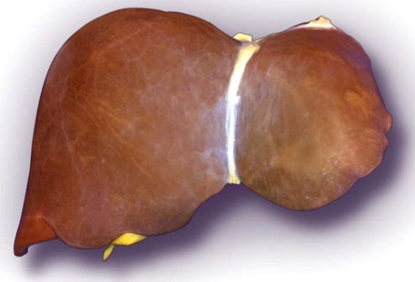
Normal liver

(AASLD, 2013)

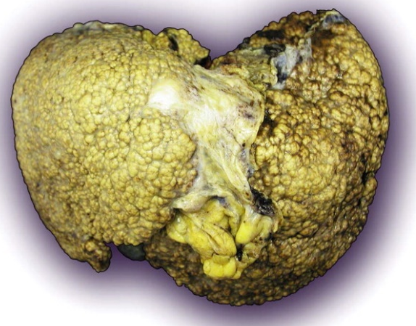
Liver cirrhosis

(AASLD, 2013)

- Liver Anatomy
The liver is a dark reddish-brown organ weighing 1.36 kilograms and conical in shape. It is in the upper right part of the abdomen, above the stomach and below the diaphragm, near the intestines, and the tip of the cone runs down to the right kidney. The liver is one of the largest organs in the body, occupying most of the abdominal cavity. Furthermore, the liver is divided into two large lobes, each of which has eight segments, and these have 1,000 smaller lobes. (Johns Hopkins, 2023).
The liver is made of soft epithelial tissue and is surrounded by a connective tissue capsule. The peritoneum of the abdominal cavity lines and reinforces this capsule, which helps protect and retain the liver in the abdomen. There are four places where the peritoneum and liver are connected: the coronary ligament, the right and left triangular ligaments, and the falciform ligament. The liver also has four distinct lobes: left, right, caudate, and quadrate. (I, Innerbody, 2023).
Hepatocytes are the most abundant liver cells, accounting for 90% of all liver cells; all these cells are similar and are organised into groups called lobules. Those cells have various functions, but each of them performs different jobs in the liver. Each lobe revolves around a central vein. Strips of hepatocytes extend from this central vein like the spokes of a wheel. On the outside of each lobe, both the portal vein and the hepatic artery have branches. In addition, the liver has approximately one billion sinusoids that are lined with endothelial cell tissue. Kuffer cells, Pitt cells, and hepatic stellar cells, or fat cells, are also found in the sinusoids. (The Hepatitis C Trust, 2023).

Anatomy of the Liver
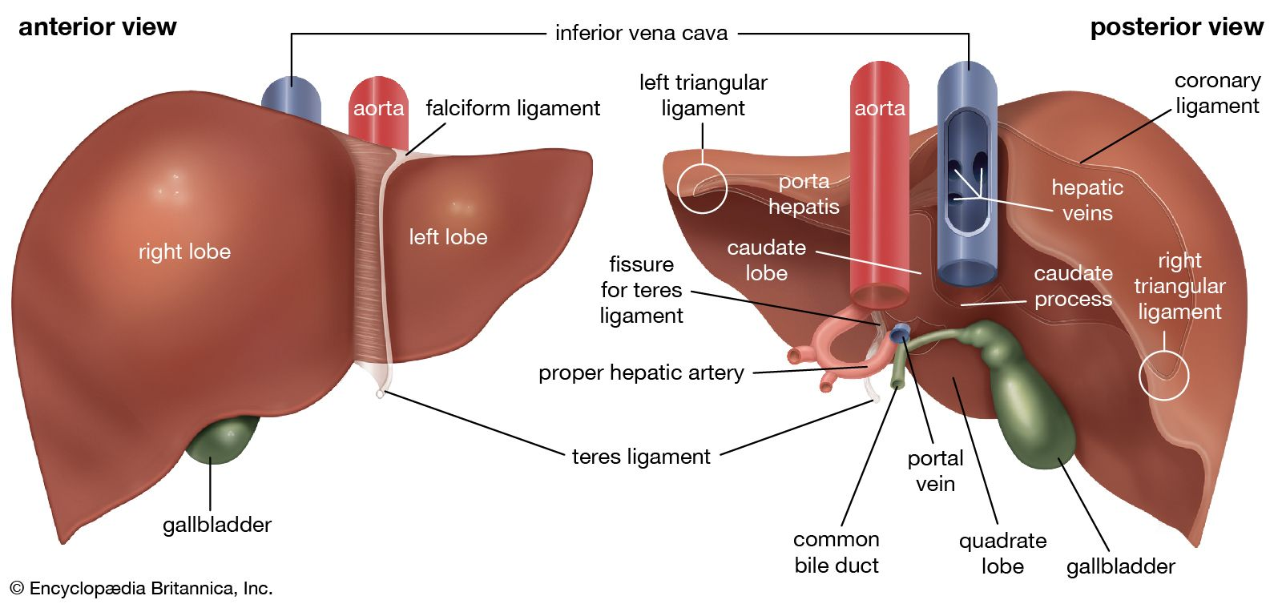

(Britannica, 2023)

Inside the liver
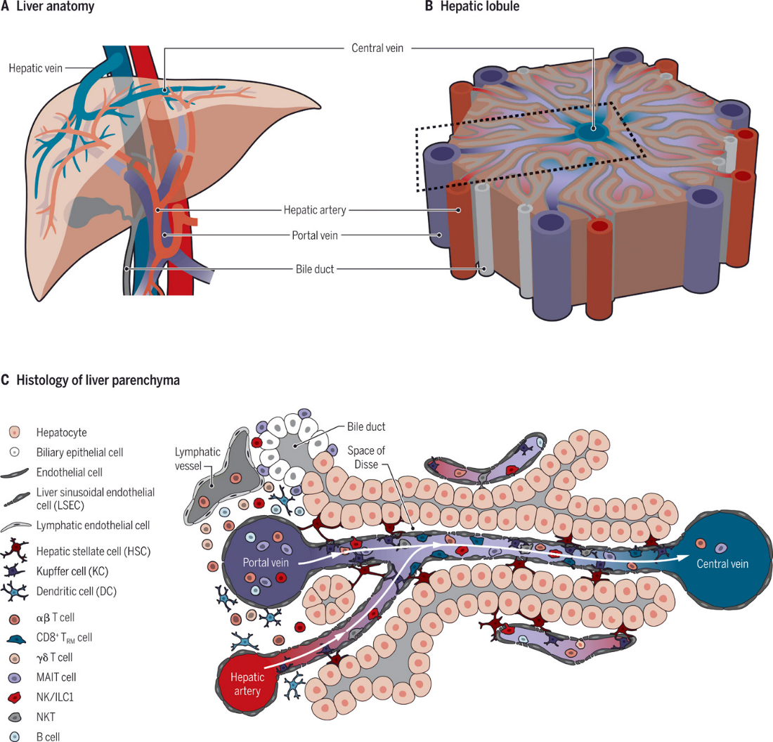

(Science Immunology, 2020)
  - Physiology of liver
The liver has more than 500 vital functions to keep the body healthy, including the production of essential nutrients, the control of blood sugar levels, and the removal of wastes and foreign substances from the bloodstream. The liver has several important functions, including the production of albumin proteins, which ensure that fluids from the bloodstream do not leak into surrounding tissue, and the transport of hormones, vitamins, and enzymes throughout the body. In addition, the liver produces bile fluid, which is used in the small intestine for fat digestion and absorption. It also filters blood as it travels from the stomach and intestines to the liver, removing toxins and other potentially harmful substances. It regulates amino acid levels in the bloodstream, as well as blood clotting and infection resistance, by removing bacteria from the bloodstream during filtration. (Columbia Surgery, 2023).

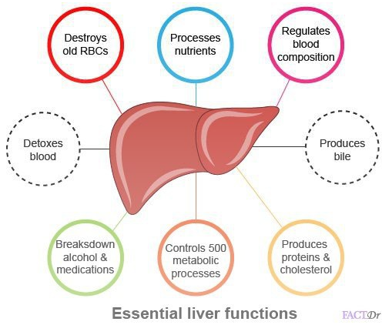

(Schilling, 2023)

- Health and Lifestyle routine measures

In the United Kingdom, liver disease is the leading cause of death among people aged 35 to 49. Since 1970, deaths from liver diseases have increased by 400%. This disease, which is the third leading cause of premature death in the UK, kills more than 40 people every day. 90% of liver diseases can now be avoided. However, three-quarters of people are diagnosed at a late stage, when lifestyle changes or interventions are no longer possible. References

Statistics
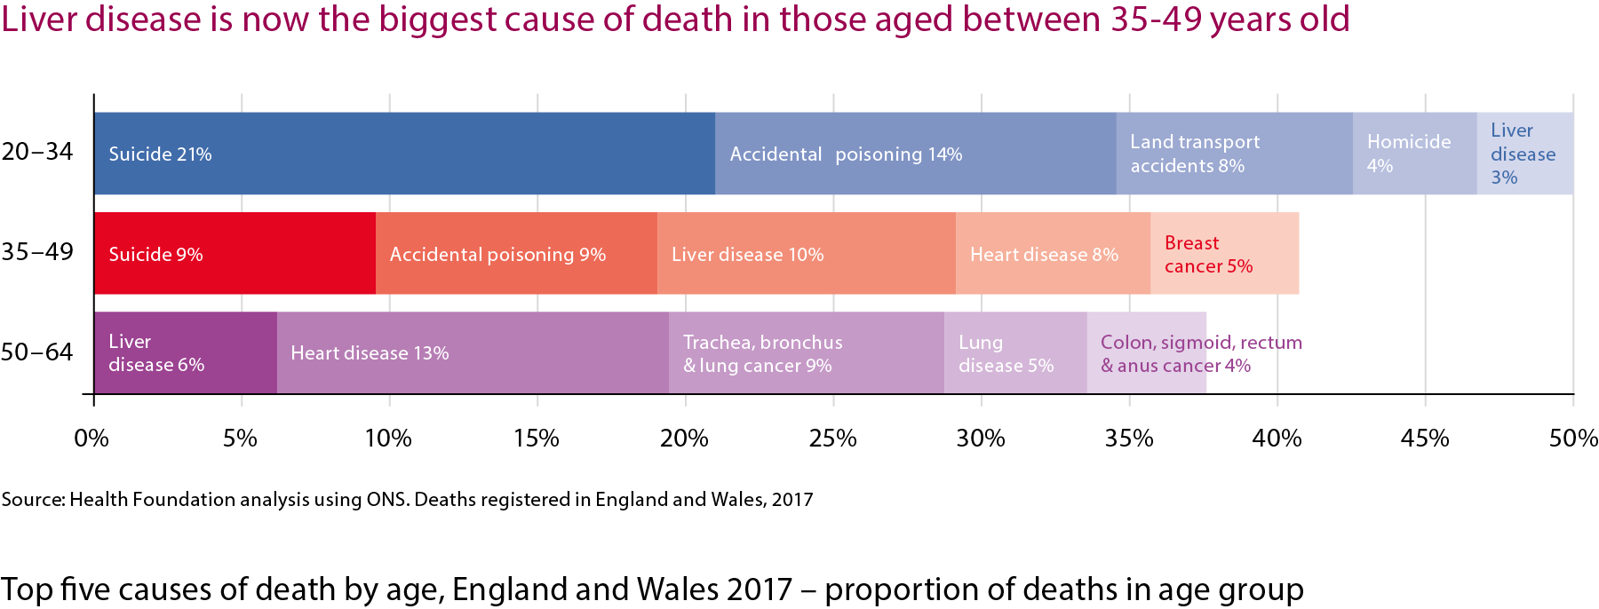

(British Liver Trust, 2023)

Unhealthy habits and lifestyles, such as alcohol consumption, contribute to the prevalence of liver cirrhosis in the population. As a result, alcohol is the main cause of this disease and accounts for 60% of all liver diseases. Each year, approximately 7,700 people die because of alcohol-related liver disease. People in the poorest areas are up to six times more likely than people in the wealthiest areas to die from alcohol-related liver disease. Also, the fatty liver disease causes liver cirrhosis; 63% of UK adults are classified as overweight or obese, and an estimated 1 in 3 have early-stage, non-alcohol-related fatty liver disease. Exercise improves the quality of life, but there may be resilience to the disease, so doctors must talk to their patients about their weight more seriously. According to experts, fatty liver disease will become the leading cause of end-stage liver disease and liver transplantation over the next decade. Cirrhosis can also be caused by viral hepatitis. Discuss each cause of the disease in a paragraph It is estimated that 143,000 people, some of them due to drug use, are carriers of the hepatitis C virus, and 180,000 people have chronic hepatitis B. In addition, about 6,000 people have been diagnosed with primary liver cancer, the most common of which is hepatocellular carcinoma. References
Many of these people will have advanced liver disease. Liver cancer is the leading cause of death in the UK. Only 13% of people with primary liver cancer live longer than five years. (British Liver Trust, 2023). Medications such as anabolic steroids taken by athletes and the dependent use of acetaminophen can cause liver damage. Also, excess cholesterol in the body can lead to non-alcoholic fatty liver disease. Diabetes, according to the Mayo Clinic, increases the risk of developing non-alcoholic liver problems. This is a condition in which too much fat is stored in the liver despite consuming little or no alcohol. Elevated liver enzymes, cirrhosis, fatty liver disease, acute liver failure, and other liver disorders are common in people with type 2 diabetes. A family history of liver problems increases the chance of some family members developing this disease. (Frank. 2020).

- Health and Social Care practice
The British Liver Trust has launched a national campaign called "Love your liver!" to raise awareness about liver health and provide people with the tools they need to keep their livers healthy. The organisation provides information, support, and a free online evaluation to anyone suffering from or seeking advice on prevention. So, the objective of this campaign will be to educate people on how to prevent the disease; for example, 9 out of 10 cases could be avoided. In addition, they will allow people to have the opportunity to participate in the campaign so they can advise other people on how to take care of their liver. Throughout the campaign, educational materials on how to start taking care of the liver will be distributed. For starters, alcohol should be avoided or consumed in moderation, as excessive consumption causes liver damage. As a result, men and women must limit their weekly alcohol intake to 14 units. Give your liver regular rest by abstaining from alcohol two to three days a week. The graph below contains information on how to start reducing your alcohol intake. We must consume a balanced diet and engage in sports or other activities to avoid getting a fatty liver. NAFLD, or non-alcohol-related fatty liver disease, is considered to afflict one in every five adults in the UK. To lower the chance of having this condition, we must maintain a healthy weight. Below, you can watch a video about the stages of NAFLD and some graphics detailing how to lower risk by eating a healthy, balanced diet. (British Liver Trust, 2018).
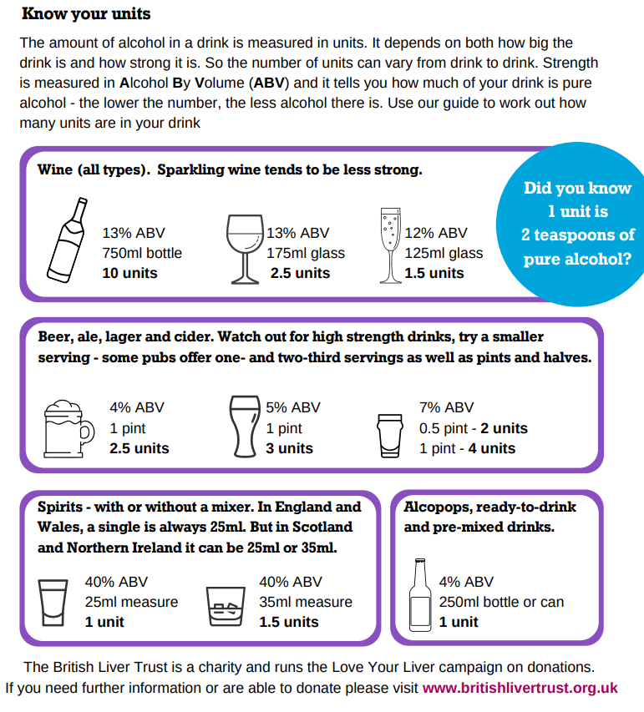

(British Liver Trust, 2018)
Eating well for a healthy liver
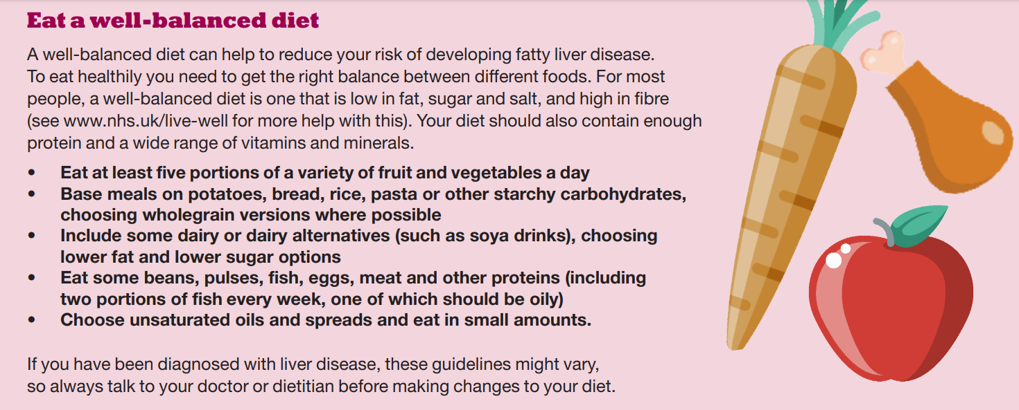

(British Liver Trust, 2018)

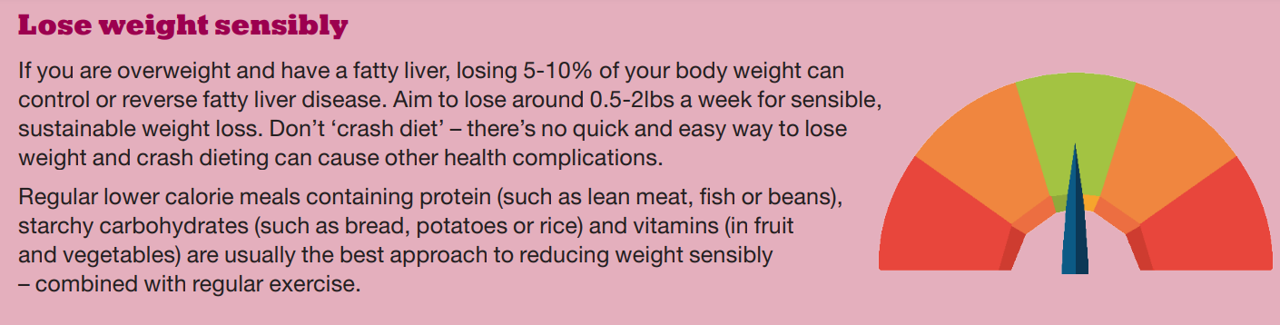

(British Liver Trust, 2018)

Viral hepatitis also causes cirrhosis, with hepatitis A, B, and C being the most common. Hepatitis A does not cause lasting liver damage, and people recover, but hepatitis B and C can cause liver disease and even liver cancer if left untreated. People should never share razors, nail clippers, or toothbrushes; they should cover wounds when playing sports. Use only licenced tattoo and piercing studios, and make sure all equipment used has been sterilised. They should also use condoms during sex. If you think you've been exposed to viral hepatitis, ask your GP or sexual health clinic for a simple blood test.
The campaign is for the public, but especially for people who want more information about the health of their liver or who are concerned about the risk of developing liver disease. The British Liver Trust also organises the "Love Your Liver Roadshow,", which tours England, Northern Ireland, Scotland, and Wales to help people learn about the health of their livers. They perform free liver scans with a non-invasive Fibro Scan device, performed by liver specialist nurses. They also have the advice of expert health professionals.

- Recommendations
To eat healthily, it is necessary to achieve the right balance between different foods. The Eatwell Guide, developed by Public Health England, is below. You It will give you an idea of how much you should eat from each food group to maintain a good balance. For example, starchy foods should make up about a third of the meal we eat, as should fruits and vegetables. (British Liver Trust 2017)

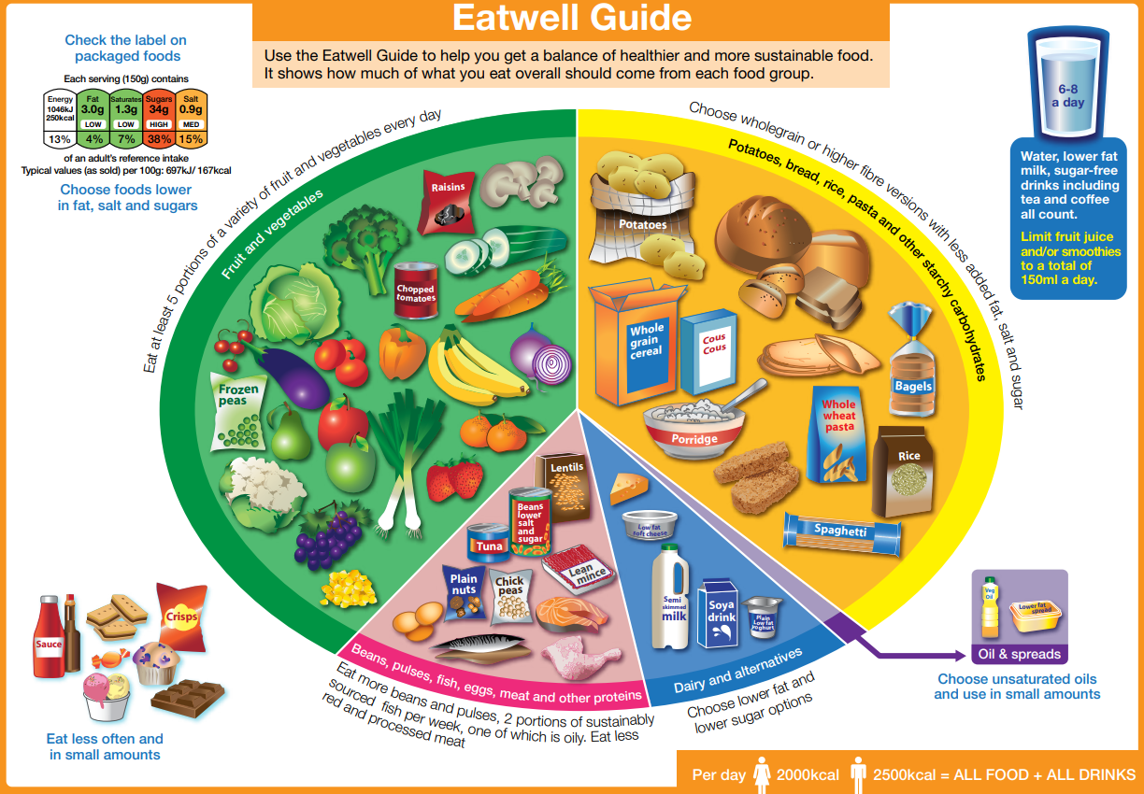

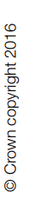

(British Liver Trust 2017)

Cirrhosis patients must modify their lifestyle to maintain their health and reduce the risk of developing new diseases. These are some examples:
- Quit smoking.
- Avoid drinking alcohol completely, as it hastens the progression of the condition.
- Exercises will help you recover from muscle loss and will also help you lose weight.
- To reduce your chances of contracting an infection, practise good hygiene.
- Consult your doctor about any vaccinations you might require, such as the annual flu shot or travel vaccinations.
- If you are taking prescription or over-the-counter medications, you should consult your doctor or pharmacist because liver disease can affect how your body processes some medications.
Dietary modifications
- Most people with cirrhosis are malnourished, so they need to eat a healthy, balanced diet rich in fruits and vegetables to ensure they get all the nutrients they need.
- Eating a little salt in your diet will help reduce fluid buildup in your legs, feet, and abdomen.
- Increase the consumption of calories and protein.
- Eating small, nutritious snacks between meals (3–4 servings per day instead of 1-2 large meals) may be beneficial. (NHS, 2020).

- Conclusion
This report has greatly improved my understanding of liver disease. Now I know where the liver is and what its functions are. People who lead an unhealthy lifestyle can develop life-threatening cirrhosis of the liver. However, thanks to the non-profit British Liver Trust, which campaigns to prevent and diagnose liver disease, the rate of the disease is falling. Also, if people follow the recommendations, they can live a higher-quality life.

- References

- https://www.nhs.uk/conditions/cirrhosis/
- https://www.hopkinsmedicine.org/health/conditions-and-diseases/liver-anatomy-and-functions
- https://www.innerbody.com/image_digeov/card10-new2.html
- http://hepctrust.org.uk/information/liver/inside-liver#:~:text=The%20most%20common%20cells%20of,functions%20which%20the%20liver%20performs.
- https://www.tandfonline.com/doi/abs/10.1185/03007995.2015.1021905
- https://link.springer.com/chapter/10.1007/978-3-030-51331-3_2
- https://britishlivertrust.org.uk/about-us/media-centre/statistics/
- https://www.walkinlab.com/blog/lifestyle-choices-might-put-risk-liver-disease/
- https://britishlivertrust.org.uk/information-and-support/love-your-liver/
- https://britishlivertrust.org.uk/british-liver-trust-taking-launches-national-campaign-to-tackle-liver-disease-stigma/
- https://www.nhs.uk/conditions/cirrhosis/treatment/
- https://columbiasurgery.org/liver/liver-and-its-functions
- https://www.hopkinsmedicine.org/health/conditions-and-diseases/liver-anatomy-and-functions
- http://hepctrust.org.uk/information/liver/inside-liver
- https://www.statista.com/statistics/1036415/prevalence-of-cirrhosis-in-the-uk-by-gender/#:~:text=In%202019%2C%20approximately%2018%2C047%20men,a%20lot%20higher%20in%20males.

