LEVEL 5 ASSESSMENT INFORMATION
Detailed information about the assessment’s specification:
Student Name: | Alexandru-Teodor Ichim | Student ID: | 2323396
Programme: | BSC Applied Computing | Module: | Changemakers: Creativity and  Value Creation (ACCA5033_LON)
Module code: | ACCA5033 | Internal Verifier: | Dr Sana Jokhio
Lecturer: | Dr.Fahad Ahmad | Word count  (or equivalent): | 2500 Words equivalent
Assessment Title: | Assignment 1: Innovation  &Research. | Return date of all the marks & written feedback: | Thursday, 22nd January 2026
Submission deadline: | Monday, 15 December 2025 | Student email: | 2323396@student.uwtsd.ac.uk
Submission method: | Turnitin
Assessment Number: | Assessment 2

Task 1 - documenting import rank including presenting the project scope purpose and aim in terms of product development and elements of gaming development which I have introduced and presented so far with involvement of screenshots of file management and step-by-step production and development of frequently sequential modes for the game.
Q1. My main aim scope and target of this project is the game developers and gamers which love playing voxel games which on this is my project about and it is developing computational thinking which is a very innovative thinking and it is developing coding programming and usually has in gaming to develop step by step solutions and resolving problems and creating mini projects in a team utilizing game modules and in case of clone craft tool it is game world which is inspired from the famous game Minecraft from mojang which I will explain in a following sentences as it is coming from a very popular tech company. The project it is developed on the lua programming objects and languages including coding and programming which is a free source open code programming language which can be utilized in any way without warranty as the condition says and for non-commercial purposes and therefore this is why the project is free and this available to the public and involving that the fact is very easy to modify and do it the way you want but I finalized it this way as I have inspired myself from other Android games popular on Android applications site and mobile stores. The project it is also aiming to make connections with people as well by joining the servers and it is based on the fact that it is possible to access it by the engine and be opened and played on a mobile iOS computer any operating system and so on, and disinvolves installing first the mine test engine from mine t e s t dot org or the forums as well for mine test which provides you with additional modes and I don't including supplements you can customize and you can make it personalized and feeling free of developing new abilities in programming and coding in the lower programming language. You can even try to learn and use a l u a editor which develops you new skills and abilities to deal with such projects. Myself I have utilized notepad to start with the coding which is a good step as it is developing computational thinking which is very easy to understand for example a registering items and proposing new objects in the game and involving developing it with the new files and spreading it with adding more codes to it and they think it on a framework which is a API lua file. The technologies I have utilized are mainly the file explorer which is a fire system via windows and can we even utilized via Android involving third party apps from the mobile stores and this is utilized to make a file system for the game which is beginning with folders and files and I have utilized all the formats and to edit them I have either utilized paint which is a program in windows and even online to edit pictures and images and making them small nice and tidy and also I have utilized notepad to edit and program code and verify code as well by myself step by step and involving lua editor manager which can be utilized to run a code and tell if it's any errors and check the debug error log. I have also utilized lucid chart which is a program to make the Erd chart or the flowchart which portrays below as a screenshot which is to be following that the file system is neatly and manage properly and it began with the menu which are files to be utilized in the main menu of the game and going back to the mods which are files to actually make the game and this ranges from the components of the game which are by default and others such as in-game armor that bones crafting default things to paint and the utilize in the game all the way to vessels extra panes, wall and the screwdriver even though develop x y z thinking within the game and make it easy with programming.

- I have utilized the online software to make a gun chart which will be shown in the following moments which is REPSONA, and it involves even portraying the whole project which is management Grant chart project step by step measures and steps involved creating the project timeline schedule and planning and even a task manager for the project.
- I have also attempted Microsoft task manager to make the project and stop the unnecessary applications to run in the background so I can make it faster reliable safe and secure and runs mostly and for quickly.
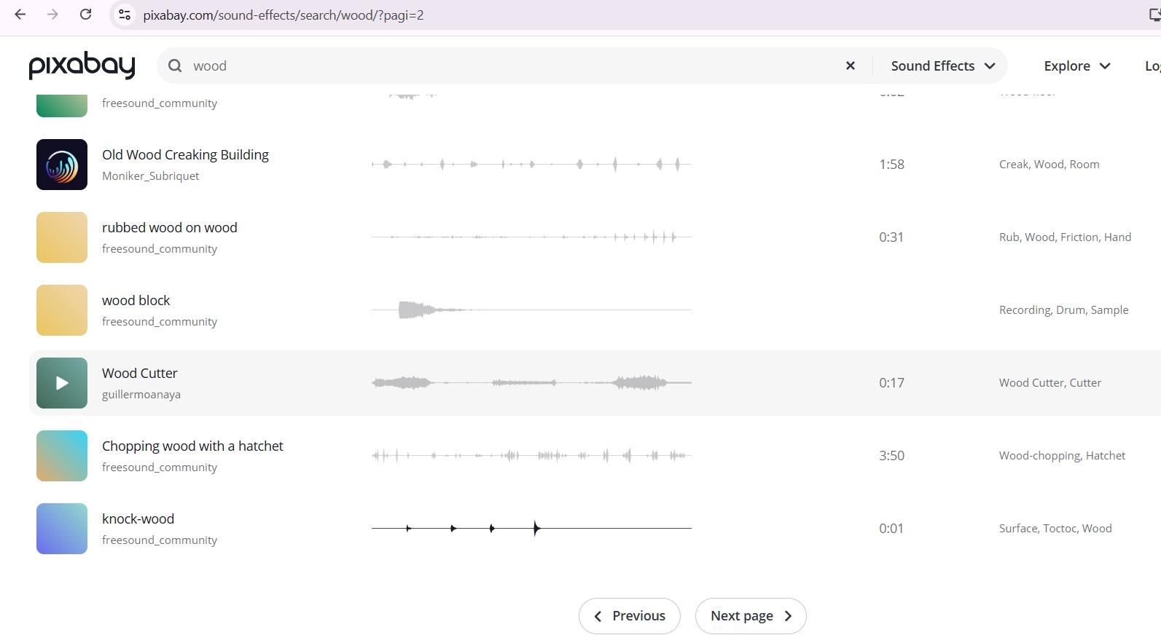
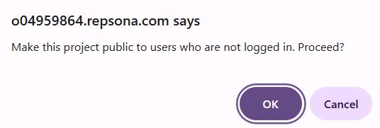
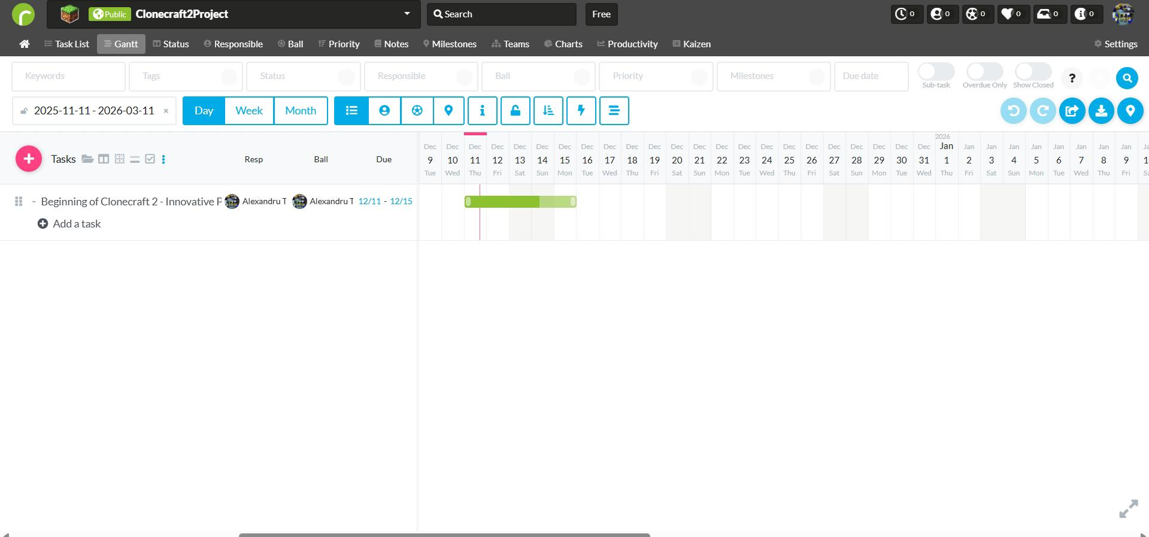
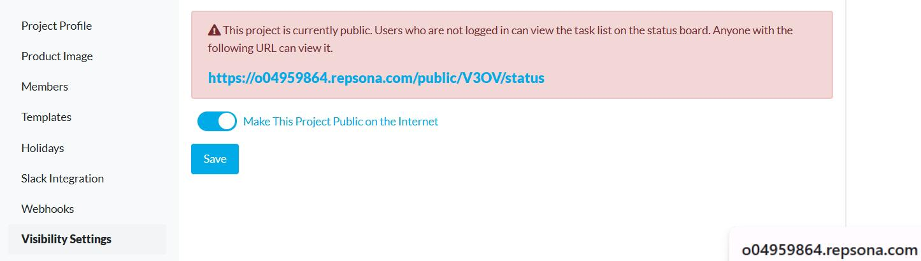
Q2. Here is how I have made the project design public utilizing a software program online service called repsona, and it has features such as grandchild with day week and months and to add new features and also new tabs with selections which involves share download, the weekdays ball priority milestones status keywords and tags and involving dates which are arranging from 2025 to 2026. To make the sounding of the game I have utilized a website called pixabay where do you find public license 3 and open source audio files which you can implement in the clone craft product and let's again make use of them when you run it on your computer or operating system. Afterwards the repsona website ask me if I want to publish the project and I clicked on yes.
Here it is the Erd chart below which portrays the file system of the game and its structure file structure and step by step file modifications and possible outcomes:
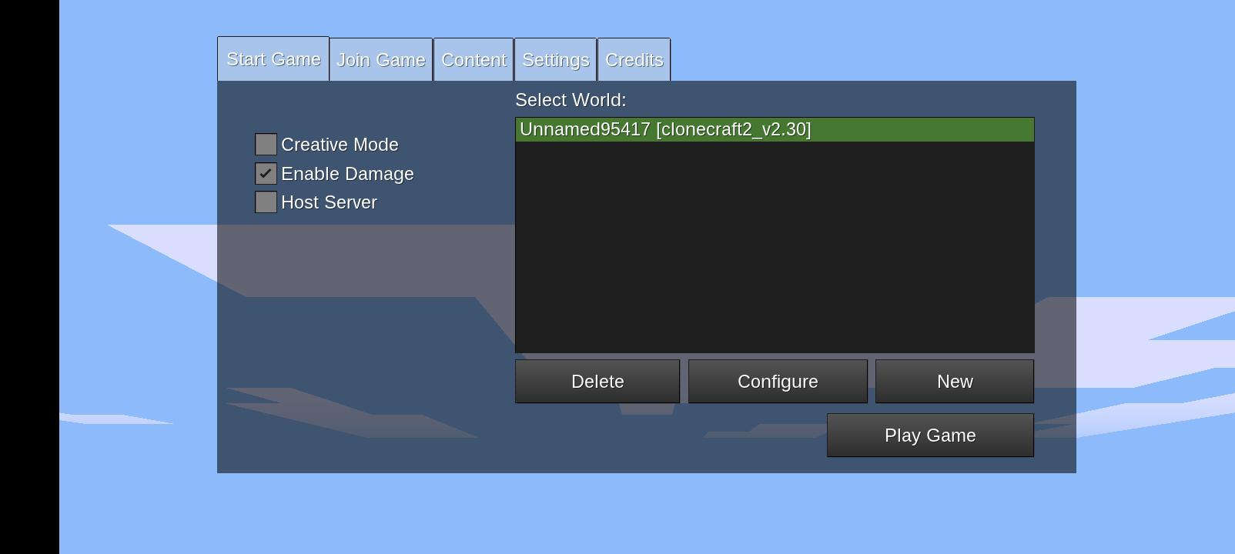
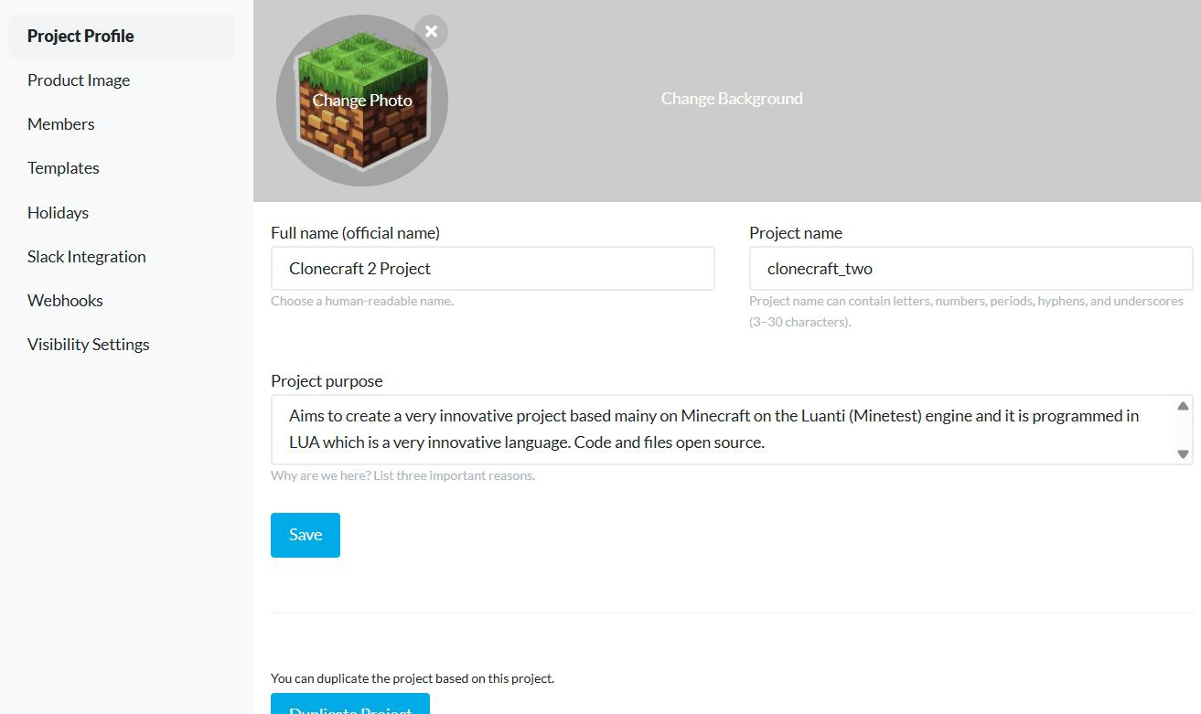
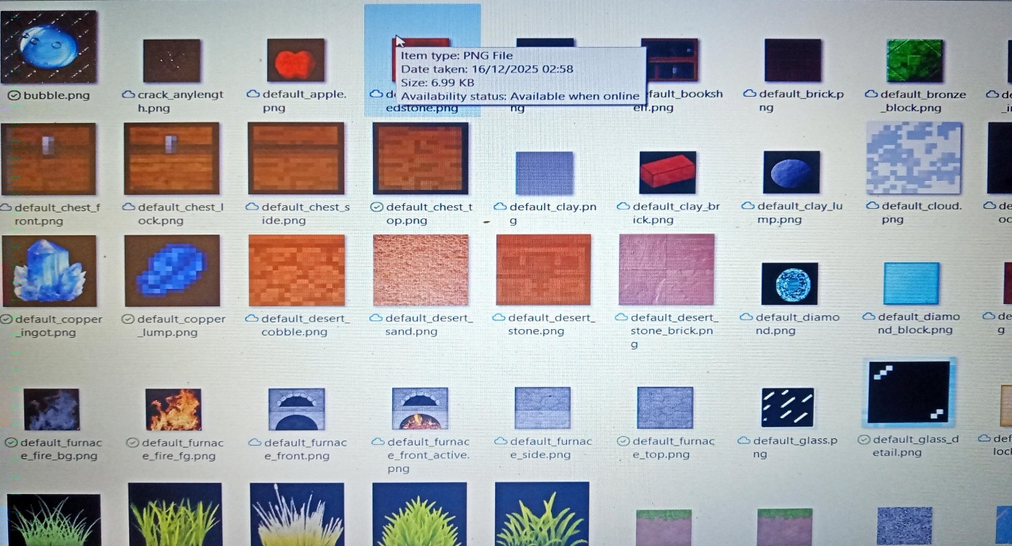

This screenshots portray the file types utilized in the actual and current project which are png dxt ogg text files sound files which have been used throughout the project and which consists of making the project running smoothly and securely. This is actual skeleton and main core of the project which is vital as it is having these attributes and properties to make it run with safety and security.

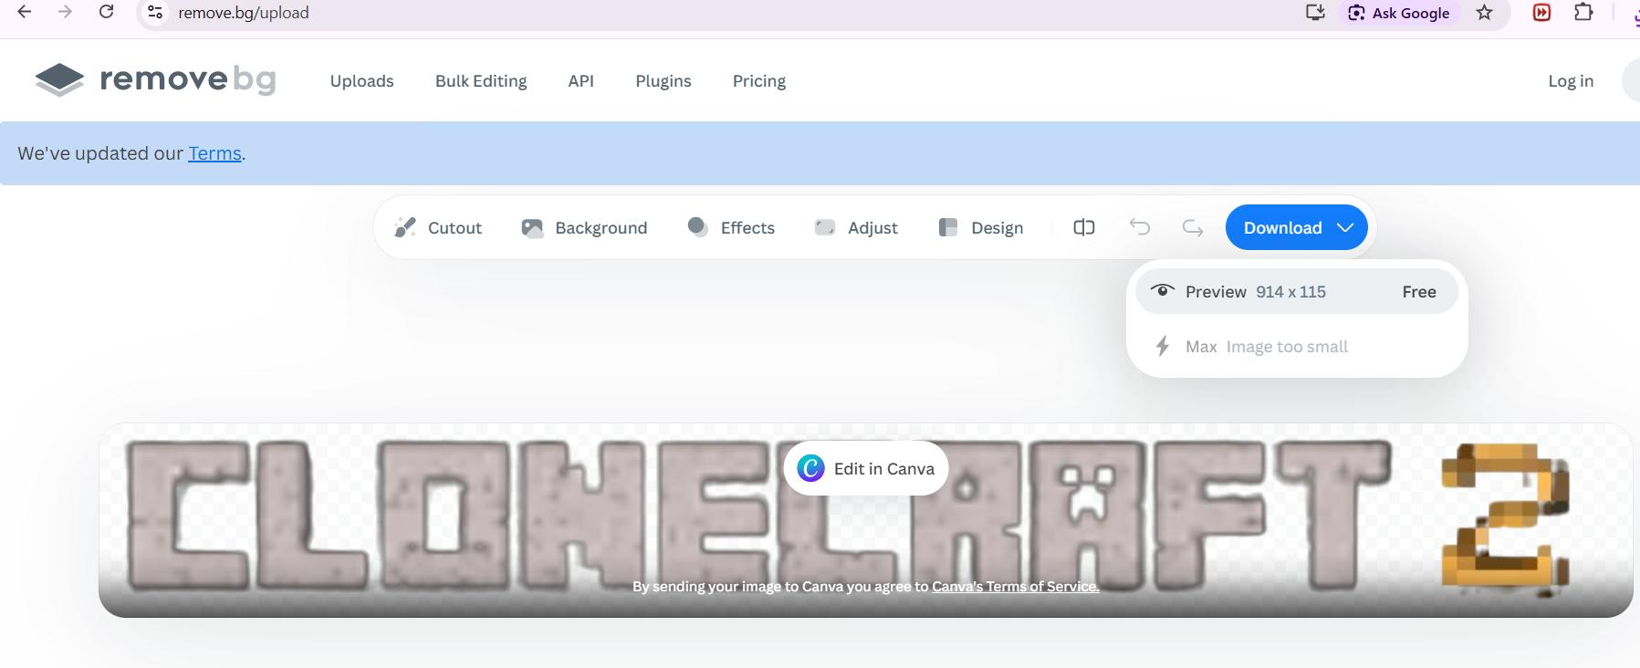
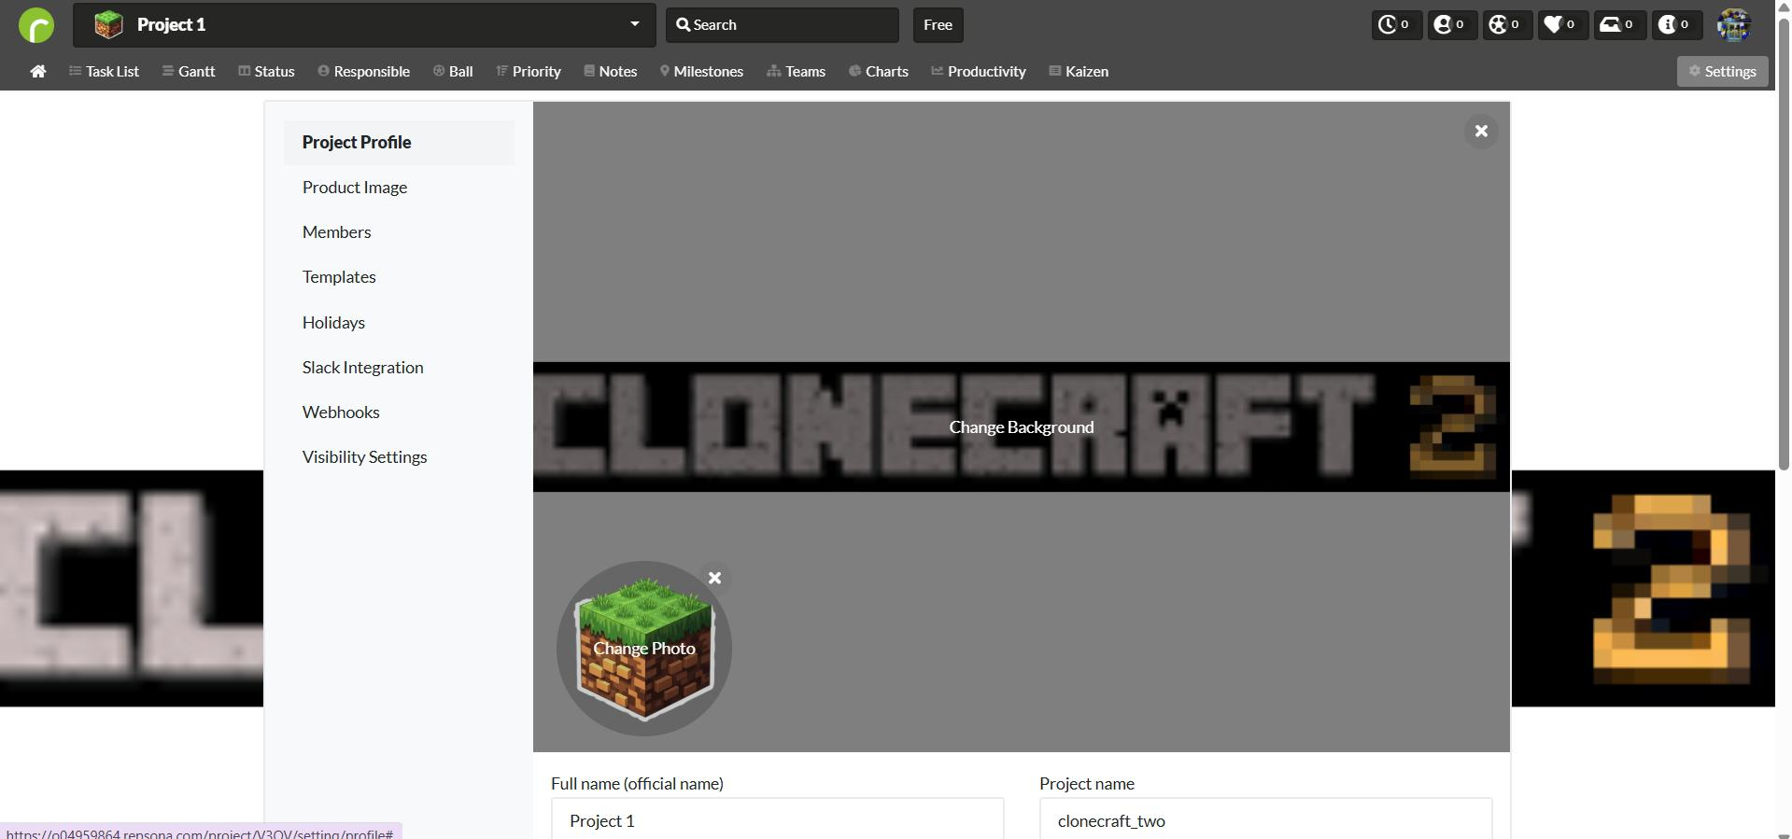
the following screenshots portray the image editor which is background remover which allows me to do the logo of the project and portraying the simplicity and there is ability of the project and has functionality such as upload bulk editing API plugins and even to upgrade but the basic editor is just enough to make the project realized and then done on time

The following screenshot portrait the r e p s o n a application which portrays the project with its background and icon and involving the project profile which has an immense impact and emphasizing on other image including its members the definition of the template the seasonal holidays when the project is of air the stock integration and helping with blending and the web hooks and the settings of viewing and visibility.

Following this the max screenshot will portray the project
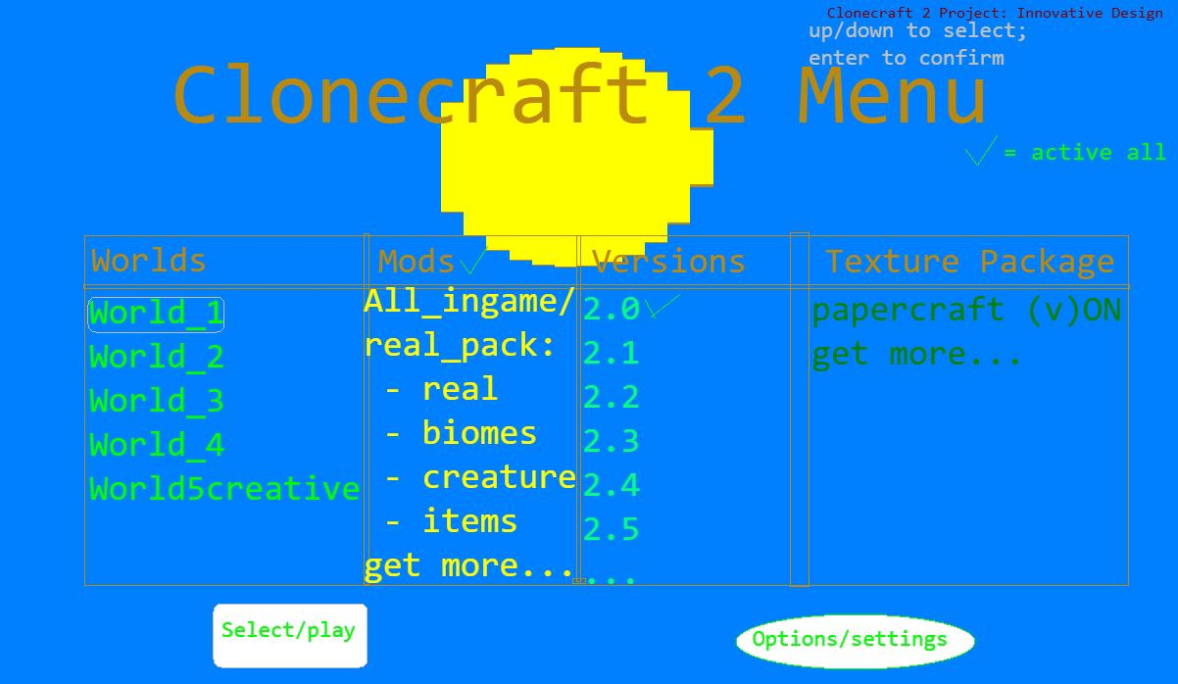

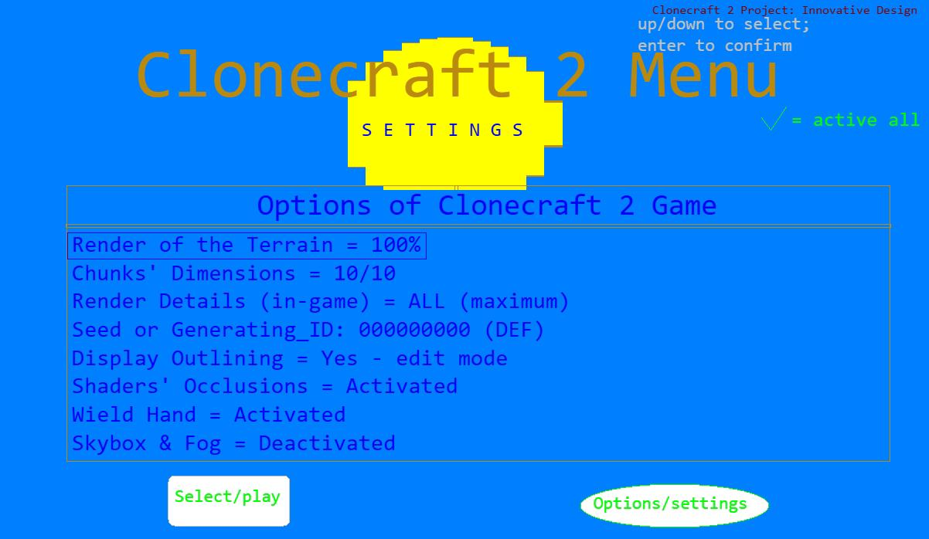

Hear the following captures portray is a storyboard and the sketching of the project including how it should work and it should function in a well presentable manner including its menu and objects within the game and the options and the user interface which has been realized in Microsoft paint.
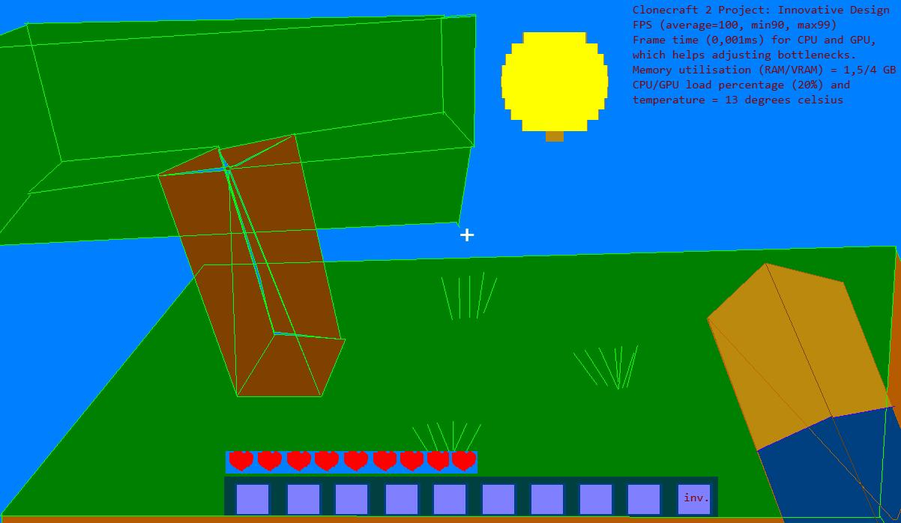
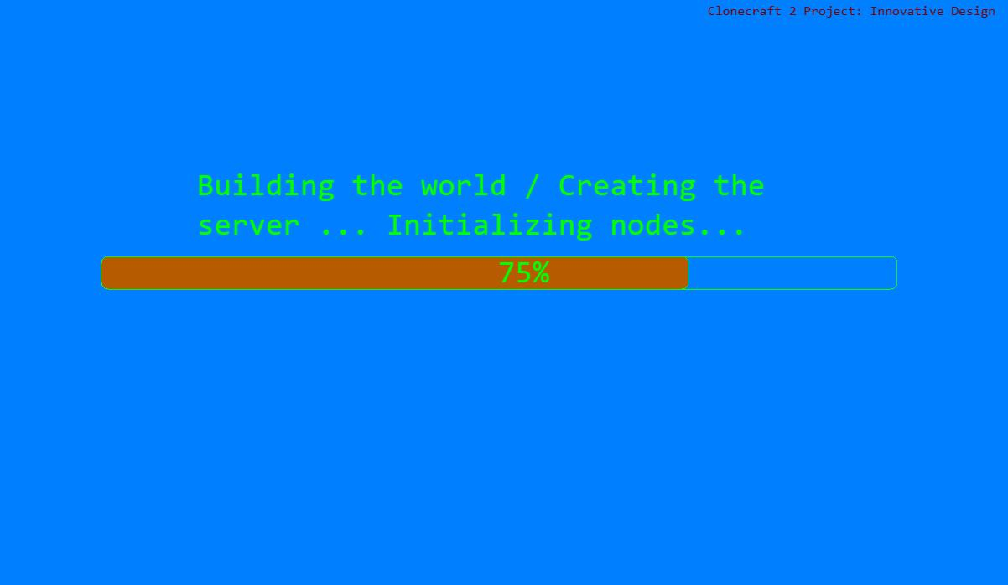

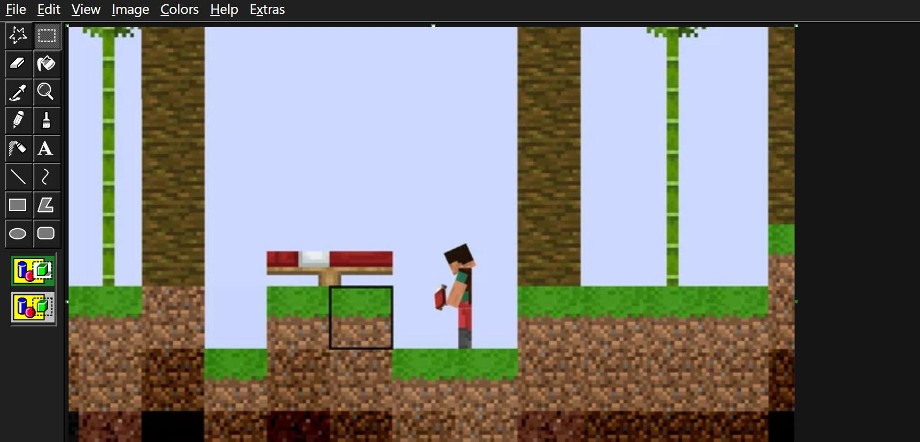

Take a screenshot above it is portraying the to the variant of the project which is inspired from a Minecraft paper online game and it is a skeleton template of helping out developing the project and taking this step by step forward with the design and implementation of it

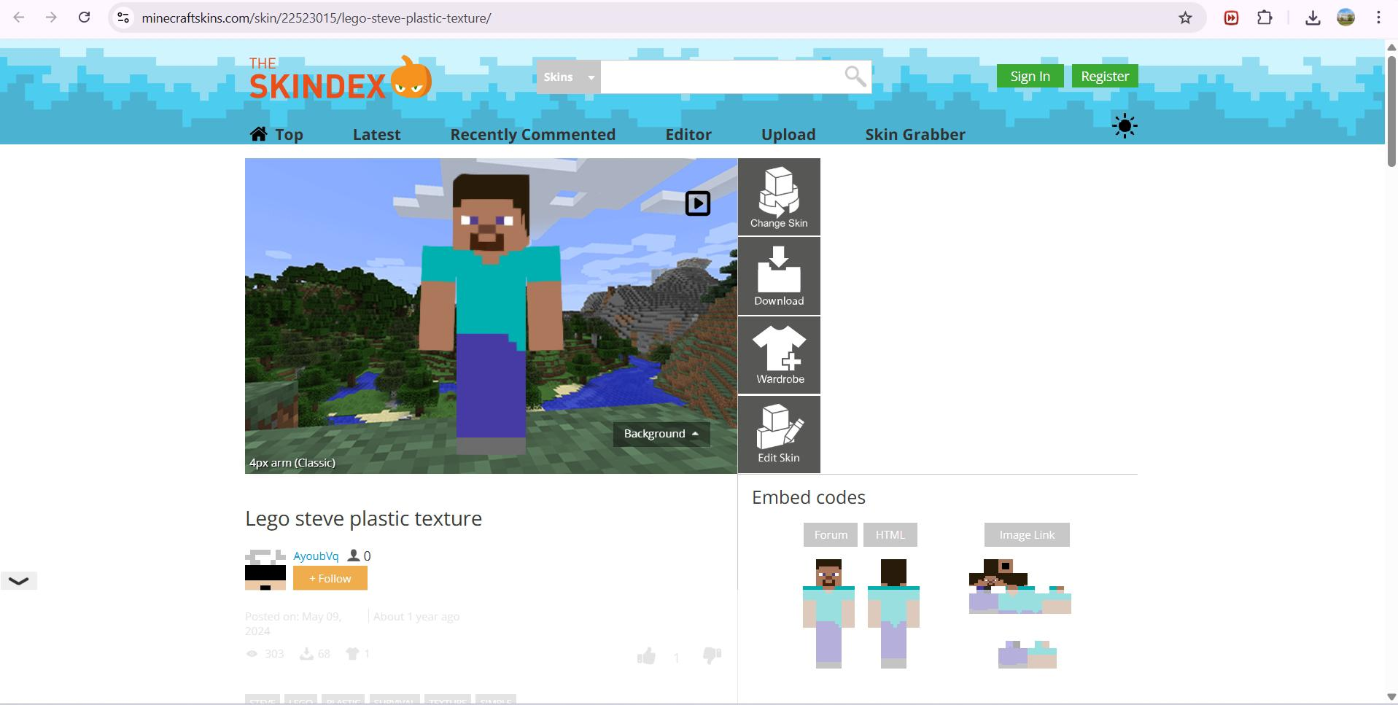
In the screenshot about is the skin index website which I have utilized the skin to put the main default character of the project which is very innovative idea as it is portraying the core values of voxel game and developing step by step
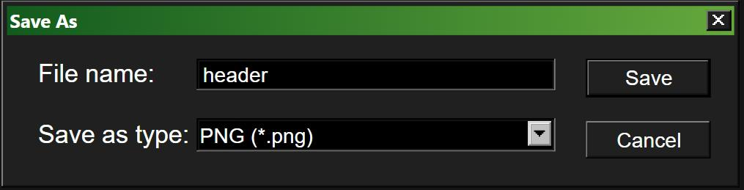
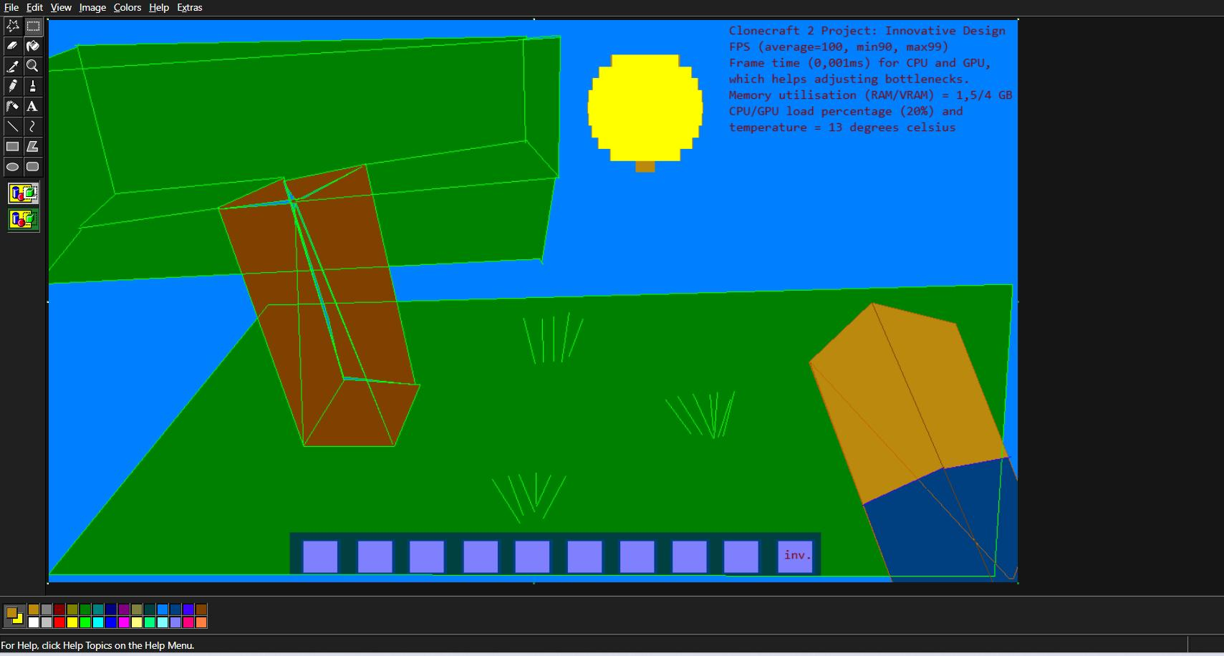
in the screenshot above it is presented the paint which is the Microsoft paint interface of saving us the files this is an example of only the header which I have designed in the max of paint online version of it and continue it and blending it with file directory management and structure with implementation and compilation.
Screenshot about portraits the final variant of the game how it will do around if it will be on the computer as according to run it on my phone at the moment because the phone resources don’t permit at the moment.

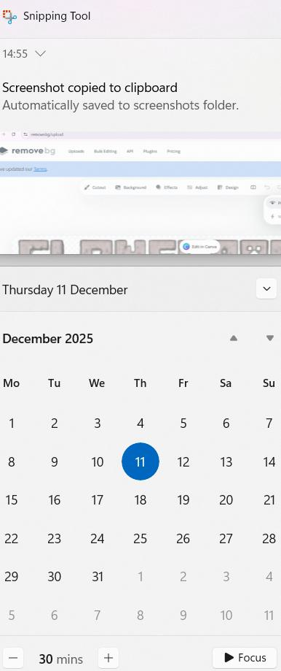
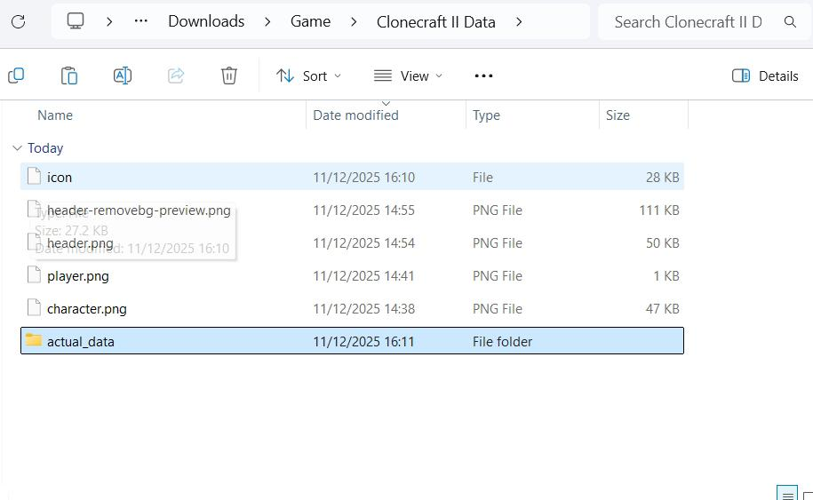
The screenshot below it portrays the project time management and scheduling including the calendar on how it should be terminated and focused on including the date in December and logo of the project.

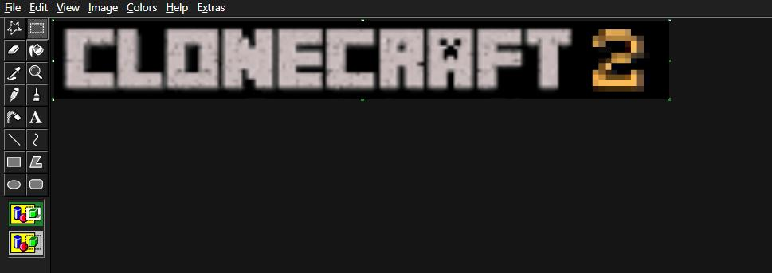

The screenshot about portrays that logo of the clone craft project which is very initiative and made in innovative application paint and very intuitive design and interface utilizing options such as file edit view image colors help and extras and shaping up taking a shape brushing tidy up and making it soft.
The following screenshot presents the beginnings of the project in the software management application in r e p s o n a And how it also works with the phone as it is installed and compatible with mine test engine which is ready and go to be executed.

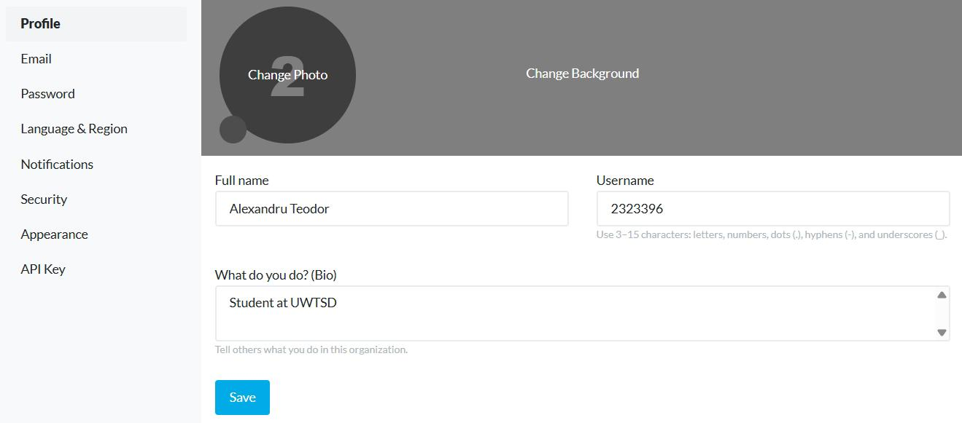
this is the mobile version of the mind test engine which is portraying start game join game settings credits and involving modes like creative mode enable damage and post server and functionalities exactly what needed for projects such as delete configure world new world and play the game including options.

Task 2 - documentation about the mojang tech gaming company
Here it is some brief information about the mojang tech company which is intended for gamers and those who play Minecraft and intended to make computational skills and gaming skills including analyzing and developing abilities.
Marjung ab is just where this company which was originally founded and embedded and created as more than studios which is intended to make gaming elements and items and products which are intended for gamers and those fascinate in gaming even YouTubers and involving innovative elements created in scripts. One of the major products created by this company is Minecraft which is greater and created in c++ . Comparison with mine test this product runs in Minecraft launcher on desktop and computer and in an Android it is the pocket edition version of the application. Here is a brief and detailed analysis of the project which is more than a b attack company which is intended for gaming and computer skills and this isn't thinking if we analyze it step by step:

We are going to use the pattern and a model which is called p e s t and swot to break down and see the components of the company in analytical mode.

We are going to be assisted by this models and evaluate the company step by step and see advantages and disadvantages and ups and downs and even strength and weaknesses and even opportunities and attacks on the company.

Recognition of the brand globally and making it aware and involving the popularity and acknowledgement of it which is mojang ab. Minecraft is a world-based and recognized brand and very attractive as it is a property by mojang and on diet involving a decade of the development and great luck which are very huge community life and other and huge impact on the nature of the cultural world.

Mojanb AB has gained a lot of money which consists of millions of Euros in revenue sometimes because of selling its final product Minecraft and it is available on all the platforms Windows as well as Android PS4 and others including all devices.

This is to make sure that it has a huge sustainability and long-term effect and also it is lasting a lot longer and it is getting support and appreciation from the public and also by buying the game and the company is also used in educational settings which is having the product called Minecraft education.

Strong financial balance and establishment which is very important in the company such as mojang ab as it is selling its introduct and making a positive revenue market profit and it is widely spread across Europe and all the continents as it is based in Sweden and it started off as a simple voxel game development which first started as infiniminer.

The structure of the company should be the following manager chief had executed small manager developer front and developer back and developer project manager code instructor company shift executive director in emergency situations and duty manager all these positions help build up the company and make the stability of the financial situation and evolving very easy and safely including the smalls transition within the market budget area.

W for S(WOT).
Weaknesses of the company would include that not everybody can afford the game and it may lose revenue and also that the game is not directly modded as in case of the mind test engine and involving that you need a special program to edit the code. But the editing of the code is very difficult as it is not permitted as it is intellectual property of mojang ab.

Whereas in the other engine such as the mine test engine the code is open source and without warranty and it can be edited and distributed at any time as long as it is for not commercial purposes.

At some point in the company life it had to sell its end products to Microsoft which lost a lot of revenue money and transferred all the activities to Microsoft and this means that the developers Marcus and Jeb how to go through a marketing loss journey and cease the management of the company.

The other worries for the company would be the competition with others which may and weaken the company and make it harder for them to evolve and even lose the revenue and market expense and budget as well.

And another Downside of the company is that it has a few headquarters it's not headquartered everywhere in Europe as it has a few branches in England as well which is Minecraft experience in Canada water.
It is also supports augmented reality which you can play your game like in real life you would play and you would implement Minecraft features in real life and also experience Minecraft with your own hands and virtual headset as it is of one of the primary experiences at the people take about the mojang ab Minecraft product. But another disadvantage is that reality is not available in any country due to its restrictions and limitations.

Conclusion
Mojang ab company is a company which is intended for gamers and to develop their computational skills including the gaming facilities and also the YouTubers who are fascinated in Minecraft and other gaming industries such as Scrolls and Minecraft education and also helping school students learns from Minecraft coding and programming in c++.
References
[1] F. DALLAN. F. DALLAN. A study on virtual environment distribution. A study on virtual environment distribution. 2024. .
[2] J. Steghöfer and H. Burden. J. Steghöfer and H. Burden. One block on top of the other: Using minetest to teach scrum. One block on top of the other: Using minetest to teach scrum. Presented at Proceedings of the ACM/IEEE 44th International Conference on Software Engineering: Software Engineering Education and Training. Presented at Proceedings of the ACM/IEEE 44th International Conference on Software Engineering: Software Engineering Education and Training. 2022, .
[3] M. Goutier, C. Diebel, M. Adam and A. Benlian. M. Goutier, C. Diebel, M. Adam and A. Benlian. Immersive experiments… and how minetest can enable it. Immersive experiments… and how minetest can enable it. 2025. .
[4] M. Sapkota. M. Sapkota. Improve the energy consumption of CPU in mine test game. Improve the energy consumption of CPU in mine test game. .
[5] R. Bucnaru and E. N. Croitoru. R. Bucnaru and E. N. Croitoru. Aesthetic evolution of target 3D volumes in minecraft. Aesthetic evolution of target 3D volumes in minecraft. Presented at 2023 25th International Symposium on Symbolic and Numeric Algorithms for Scientific Computing (SYNASC). Presented at 2023 25th International Symposium on Symbolic and Numeric Algorithms for Scientific Computing (SYNASC). 2023, .
[6] F. Lecordix, R. Laouar and T. Szanto. F. Lecordix, R. Laouar and T. Szanto. Simulations in the minetest video game (luanti) for sustainable development themes. Simulations in the minetest video game (luanti) for sustainable development themes. Presented at Proceedings of the ICA. Presented at Proceedings of the ICA. 2025, .
[7] N. Höglund. N. Höglund. Digital distribution of video games for PC: A SWOT analysis. Digital distribution of video games for PC: A SWOT analysis. 2014. .
[8] S. Lin. S. Lin. Ready player Green–A case study of sustainability in the swedish games industry. Ready player Green–A case study of sustainability in the swedish games industry. 2022. .

