EYST FUNDRAISING AND WELL-BEING PROJECT
REPORT

Assignment 1: Report Project
Moodle Code: BMSW5009
Moodle Name: Managing Projects in the Organisation
Student ID: 2123934
Student Name: Abibat Ayinke Bammeke
Lecturer: Giulia Chifari
Submission Deadline: 03rd July 2026
Word Count: 1956

Executive Summary
This report critically evaluates the planning, delivery, and closure of a group fundraising and well-being event organised to support EYST Wales. The project aimed to raise funds for the charity while promoting kindness and awareness of well-being within the university community. It assesses scope definition, task breakdown, scheduling, risk management, stakeholder analysis, communication planning, monitoring, and evaluation across the project lifecycle. The event was delivered successfully, raising £115.50 and receiving positive feedback via the QR code. However, informal coordination, limited feedback responses, and insufficiently detailed progress monitoring reduced project control and the evidence available for evaluating results. The report recommends clearer accountability, formal risk reviews, stronger feedback collection, and a lessons-learned log to improve future projects.

Contents

Executive summary ……………………………………………………………………
- Introduction ………………………………………………………………………...
- Findings …………………………………………………………………………….
  - Critical discussion of project management tools and techniques in general ….
  - Critical discussion of how those tools were used in the project ………………
  - Communication and stakeholders ………………………………….…
- Conclusion ………………………………………………………………………….
- Future improvement ………………………………………………….…………….
References ……………………………………………………………………………...
Appendices …………………………………………………………………………….

- Introduction
The EYST Wales fundraising and well-being event was a university-based project combing a bake sale of cultural desserts, a well-being information corner, promotional activity, and QR-code feedback survey. Its aim was to raise funds for EYST Wales while encouraging kindness and awareness of emotional well-being among students and staff. Its objectives were to obtain university approval, satisfy food-safety, and allergen requirements, promote the event, coordinate preparation and delivery, collect participant feedback, and donate the money raised.

Projects are temporary undertakings requiring coordinated people, time, and resources to deliver a defined outcome (Meredith and Mantel, 2009). Consequently, success cannot be judged only by completing activities. It also depends on whether decisions remain aligned with objectives and stakeholder expectations. Heagney (2016) identifies collaborative planning as central to this alignment, while Clegg et al. (2020) argue that projects should be assessed by the value they create for stakeholders. This project evaluates the project across initiation, planning, implementation, monitoring, evaluation, and closure. It critically considers the tools used, the decisions they supported, their limits, stakeholder communication, and improvements for similar future projects.

- Findings
  - Critical discussion of project management tools and techniques in general
Project management tools add value when they inform decisions rather than simply create documentation. Scope definition identifies the intended deliverables, included work and boundaries of responsibility. Haniff and Salama (2016) describe scope as a baseline for planning and control. Therefore, it is particularly important in a short event where broad ambitions can exceed a team’s competence and time. Its limitation is consequential when scope lacks measurable criteria, teams can complete visible activities but still lack evidence that the intended result was achieved.

A Work Breakdown Structure (WBS) decomposes a project into deliverables and work packages. Wysocki (2014) presents this as a means of making complex work manageable, while Heerkens (2015) emphasises that tasks need clear responsibility. The WBS can expose overlooked work, such as compliance checks, closure, and support resource allocation. However, it does not show task timing and actual completion. If ownership and completion criteria are absent, the tool identifies work without making any individual accountable for ensuring that work is finished to the required standard.

A Gantt chart complements the WBS by showing sequence, timing, milestones, and dependencies. Kidston et al. (2015) connect planning, scheduling, monitoring, and control with managing time, cost, and risk. A current schedule can reveal slippage early enough for corrective action. In contrast, a high-level chart can create false assurance because it cannot show whether a prerequisite has delayed the tasks that depend on it. Hollister (2017) notes that simple planning tools can help inexperienced teams organise work, but simplification becomes a weakness when it excludes information needed for control.

Risk management is similarly preventative. Reiss (2015) argues that project teams should anticipate problems before they disrupt delivery. A formal register enables risks to be prioritised by likelihood and impact, assigned to owners, and reviewed. Informal discussion alone may recognise hazards but cannot reliably record actions or determine whether mitigation remains effective. Finally, monitoring and evaluation should combine operational measures with stakeholder evidence. Gibbs’ (1988) cycle is useful because it moves teams beyond description to analyse causes and plan action. These tools are most effective when connected because the scope provides criteria, the WBS defines work, the schedule controls timing, risks shape decisions, and evaluation informs future practice.

  - Critical Discussion of How Those Tools Were Used in the Project
The group converted its initial idea into an event with a defined beneficiary, deliverables, and compliance tasks. Scope included communication with EYST Wales and university operations staff, event approval, food safety, allergen information, promotion, dessert preparation, the well-being area, feedback, and closure. This made safety and approval work visible. It supported the decision to provide ingredient and allergen information before delivery, reducing the possibility that attendees would make food choices without adequate information.

However, the scope lacked explicit exclusions and sufficient precise success measures. Promoting well-being was an appropriate aim but not, by itself, an observable result. The availability project documentation does not show predetermined targets for attendance, interactions with the well-being information area or completed feedback forms. As a result, evaluation could confirm that an event occurred and that some participants responded positively, but it could not establish the wider awareness impact. Clegg et al. (2020) emphasise value creation because a clearer distinction between the direct financial value for EYST Wales and the intended awareness value for students would have provided a more defensible basis for judging success.

The WBS identified project definition, stakeholder contact, approval and food-safety documentation, promotion, dessert preparation, the well-being corner, delivery, feedback, and donation (see Appendix C). Its contribution was to ensure that compliance-related tasks were not overshadowed by visible preparations. This was appropriate because a food event can appear ready while failing to meet safety requirements. Nevertheless, the WBS did not consistently specify owners and resources. “Prepare desserts,” for example, could have been divided into recipe selection, ingredient purchase, allergen verification, label production, and safe display. The consequence of this limited detail was reduced accountability because if a task had been incomplete, the team would have had less clarity about who should act and what completion should look like.

The group used a weekly Gantt-style schedule to sequence planning, approval, promotion, preparation, delivery, feedback, and closure (see Appendix D). It helped place approval and food-safety work before food preparation, reducing the risk of investing resources in an unauthorised event. Yet it was a high-level task table rather than a fully controlled Gantt chart. Exact dates, durations, critical dependencies, task owners, and planned-versus-actual progress were absent. University approval was a critical dependency because a delay could have compressed labelling and preparation work. Because this relationship was not visible through updated status information, the schedule had limited capacity to support early escalation. It coordinated initial activity but did not provide robust control during implementation.

Risk awareness was a practical strength. The project team considered food safety, allergens, and university approval, and displayed ingredient and allergen information at the event. These actions reduced foreseeable harm and supported participant confidence. They show that risk considerations influenced delivery decisions, rather than being treated as theoretical requirements. However, the project materials reviewed do not show an operational risk register used during delivery to record likelihood, impact, controls, and owners. This constrained the team’s ability to prioritise non-safety risks such as poor attendance, insufficient supplies, and low survey participation (see Appendix E). The project therefore mitigated obvious hazards but did not apply the systematic, review-based control process advocated by Reiss (2015).

Monitoring and evaluation generated mixed evidence. The event raised £115.50 for EYST Wales, showing achievement of the fundraising outcome (see Appendix F). Three respondents gave the QR survey an average could not reliably represent all attendees or explain which elements were most valuable. This limitation affected future decision-making because the project group could not determine whether promotion reached the intended audience, whether the well-being area influenced awareness. The project therefore succeeded operationally, but its limited evaluation evidence weakened claims about broader stakeholder impact.

  - Communication and stakeholders
Stakeholder analysis identified groups whose approval, participation could affect delivery. The university operations team and EYST Wales were high-power, high-interest stakeholders, while students and staff were the main audience with high interest but lower formal authority. NHS England and NHS Improvement (n.d.) state that analysis should guide the time and resources allocated to sustaining stakeholder involvement. In this project, analysis informed the choice of communication channels, but it was not fully converted into a documented engagement schedule.

Email was suitable for university operations staff because it created a record of approval requests, safety requirements, and responses. This strengthened accountability by retaining compliance information. However, a named contact owner and internal approval milestone would have made the communication more reliable. Without them, an unresolved request could have delayed dependent work without prompt escalation.

EYST Wales was engaged as the beneficiary and received the donation outcome, yet the evidence does not show a planned frequency of updates for the charity to influence success criteria. This matters because engagement can improve decision quality by incorporating beneficiary expectations. The Project Management Institute (2021) frames stakeholder engagement as an ongoing management activity. More structured contact could have clarified how the charity wished to be represented and what closure information it required.

Posters, LinkedIn promotion, and word-of-mouth were proportionate, low-cost methods for students and staff. Their weakness was evaluative because the promotion methods did not generate measurable evidence of reach and attendance conversion. A registration process, QR-coded promotion link would have transformed awareness activity into usable evidence. Internally, reliance on WhatsApp and face-to-face discussion supported rapid coordination but did not provide a durable decision trail. Without a shared task tracker, this could leave responsibilities unclear, make follow-up dependent on memory, and reduce the team’s ability to demonstrate how decisions were reached (Project Management Institute, 2021).

- Conclusion
The EYST Wales project delivered its professional objective as it ran the planned event, addressed important food-safety requirements, and raised £115.50 for charity. Scope definition, task breakdown, sequencing, and stakeholder communication were adequate for practical execution overall, particularly because approval and allergen requirements were identified early. However, the tools were less mature as mechanisms for control. The WBS identified work but did not consistently allocate ownership because the schedule provided sequence but not updated dependency information, and risks were recognised without a formal register. Similarly, positive feedback was obtained but was too limited to demonstrate the event’s wider well-being impact. The project was therefore successful in delivery, but less robust in monitoring, evidence-based evaluation, and organisational learning. The central lesson is that tools create their greatest value when their outputs are integrated because scope produces measurable criteria, tasks have owners, schedules are updated, risks are reviewed, and evaluation informs future decisions.
- Future improvement
Future events should begin with a concise project-control pack containing a measurable scope, task-owner WBS, dependency-based schedule, and risk register. This would close the gap between planning activity and control by specifying what must be delivered, who owns it, when it is due and what evidence demonstrates completion. Kidston et al. (2015) support this integration of planning, scheduling, and monitoring as a basis for controlling time, cost, and task.

The risk register should be reviewed weekly. Alongside food-related risks, it should capture approval delays, supply shortages, low attendance, and limited feedback response. Each risk should have a likelihood, impact, mitigation, owner, and review date. This would enable prioritised action before issues threaten the event rather than reliance on informal reminders.

Communication should be structured according to stakeholder need. A named university contact should maintain the approval trail since EYST Wales should receive agreed progress and closure updates. However, the project team should use a shared tracker alongside WhatsApp. Promotional effectiveness should be measured through QR links and registrations while enabling them to redirect effort to channels that generate participation.

Finally, the evaluation should use multiple feedback points, direct prompts, and open questions. A lessons-learned log should be maintained during delivery, not created only at closure. Applying Gibbs’ (1988) cycle would enable the team to describe events, assess effects, analyse causes, and assign actions. This would turn a successful one-off activity into evidence for more reliable future project decisions.

Reference
Clegg, S.R., Skyttermoen, T., and Vaagaasar, A.L. (2020) Project Management: A Value Creation Approach. London: SAGE Publications.

Gibbs, G. (1988) Learning by Doing: A Guide to Teaching and Learning Methods. Oxford: Further Education Unit, Oxford Polytechnic.

Haniff, A. and Salama, M. (eds.) (2016) Project Management. Oxford: Goodfellow Publishers.

Heagney, J., (2016). Fundamentals of project management. Fifth edition. New York: AMACOM.

Heerkens, G. (2015) Project management. A Briefcase Book. New York: McGraw-Hill.

Hollister, S. (2017) Project Management: A Quick Start Beginners Guide for Easily Managing Projects the right way. North Charleston, SC: CreateSpace Independent Publishing Platform.

Kidston, P., Haward, K. & Association for Project Management, (2015). Planning, scheduling, monitoring, and control: the practical project management of time, cost, and risk. Buckinghamshire: Association For Project Management.

Meredith, J.R. & Mantel, S.J. (2009) Project Management: A Managerial Approach. Seventh edition. Hoboken, NJ: John Wiley & Sons

NHS England and NHS Improvement (n.d.) Stakeholder Analysis: Quality, Service Improvement, and Redesign Tools. London: NHS England and NHS Improvement.

Project Management Institute (2021) A Guide to Project Management Body of Knowledge (PMBOK® Guide) and The Standard for Project Management. Seventh edition. Newtown Square, PA: Project Management Institute.

Reiss, G. (2015). Project Management Demystified. London: Routledge.

Wysocki, R.K. (2014) Effective project management: Traditional, Agile, Extreme. Seventh edition. Indianapolis: John Wiley & Sons.

Appendices
Appendix A: Project Quad Chart
Project title: EYST Wales Fundraising and Well-being Project
Project aim:
To raise funds for EYST Wales while promoting kindness and emotional well-being within the university community.
Project objectives:
- To obtain university approval for the event.
- To meet food-safety and allergen requirements.
- To promote the event to students and staff.
- To deliver a fundraising bake sale and well-being activity.
- To collect participant feedback and donate funds to EYST Wales.
Main deliverables:
- Cultural dessert bake sale
- Well-being information corner
- Promotional posters and LinkedIn promotion
- Allergen and ingredient information
- QR-code feedback survey
- Donation to EYST Wales.
Appendix B: Retrospective Stakeholder Analysis Used for This Report
Stakeholder | Internal/External | Power | Interest | Engagement and communication method
EYST Wales | External | High | High | Email updates, confirmation of donation, and project outcome.
University operations team | Internal | High | High | Formal email, approval requests, and food-safety information.
Project team | Internal | High | High | WhatsApp, face-to-face, meetings, and shared task planning.
Students and staff | Internal | Medium | High | Posters, LinkedIn promotion, and word-of-mouth.
Event attendees | External | Low | High | Event information, allergen labels, and QR-code feedback

Appendix C: Reconstructed Work Breakdown Structure Based on Group Project Records
- Project initiation
  - Agree event idea
  - Define aim and objectives
  - Identify stakeholders
  - Contact EYST Wales

- Planning and compliance
  - Obtain university approval
  - Complete food-safety requirements
  - Prepare allergen and ingredient information
  - Allocate team responsibilities

- Promotion
  - Design posters.
  - Prepare LinkedIn advertisement
  - Promote through word of mouth

- Event preparation
  - Select and prepare cultural desserts
  - Organise event table and materials
  - Prepare well-being information corner

- Delivery and closure
  - Deliver fundraising event
  - Collect QR-code feedback
  - Record funds raised
  - Donate funds to EYST Wales
  - Complete lessons learned review

Appendix D: Project Gantt Chart
Activity | Week 1 | Week 2 | Week 3 | Week 4
Planning, team discussion, and project idea
Defining aims, objectives, and scope
Contacting the University operations team and EYST Wales charity
Completing disclaimer forms and food safety requirements
Creating WBS and Gantt Chart tools
Designing posters and LinkedIn advertisements
Preparing the ingredients list and desserts
Organising a well-being corner
Delivering a fundraising event
Collecting feedback and evaluating results
Donating to EYST charity and the closure of the project

Appendix E: Proposed Risk Register for Future EYST-Style Events.
Risk | Likelihood | Impact | Mitigating action | Responsible person
Food allergies | Medium | High | Provide full ingredient allergen information | Food-safety lead
Food-safety issue | Low | High | Follow university requirements and ensure safe preparation | Food-safety lead
Delay in university approval | Medium | High | Contact the operations team early and follow up by email | University contact lead
Low attendance | Medium | Medium | Use posters, LinkedIn, and word-of-mouth promotion | Promotion lead
Insufficient ingredients | Low | Medium | Prepare a purchase list and obtain supplies early | Preparation lead
Low feedback response | High | Medium | Display QR-codes clearly and invite attendees to complete survey | Evaluation lead
The risk register was developed retrospectively from the group’s project experience and is proposed as an improvement for future events.

Appendix F: Event Evaluation Evidence
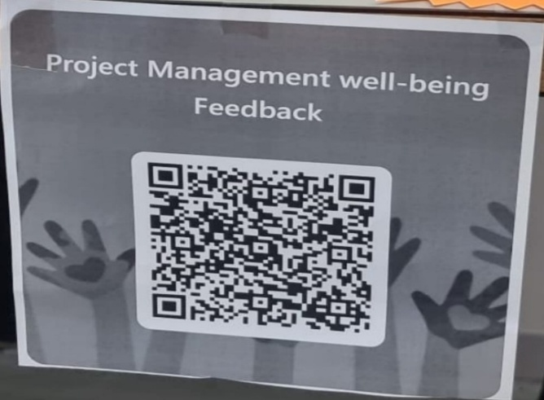 | 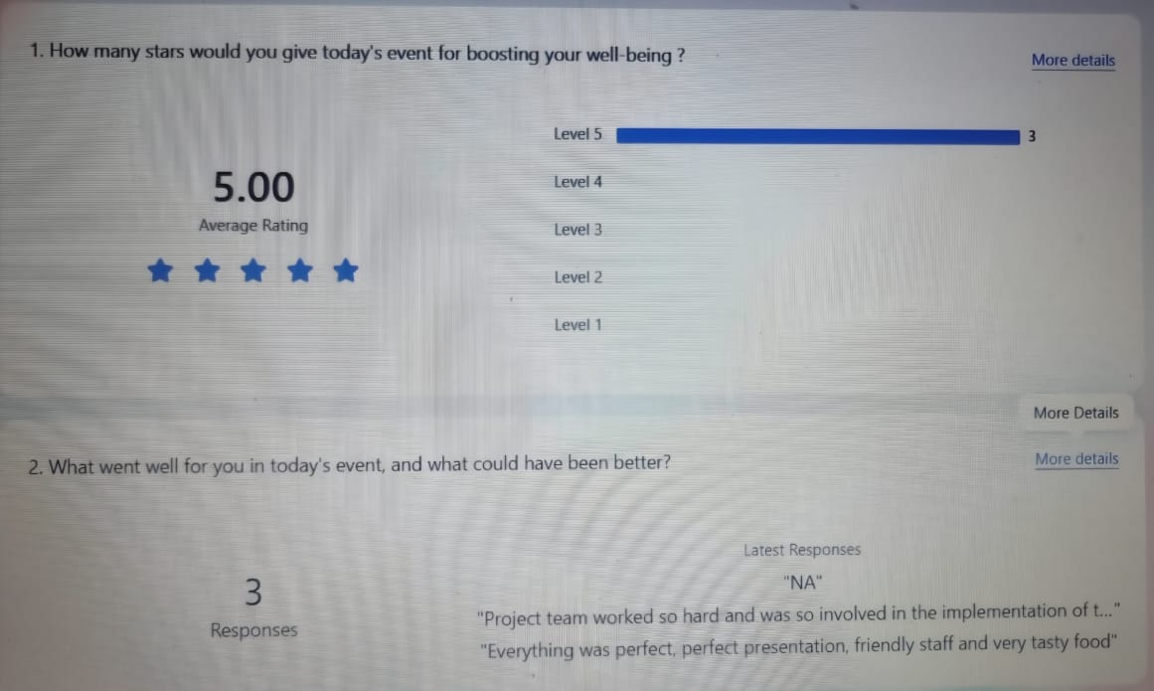
QR code | Feedback
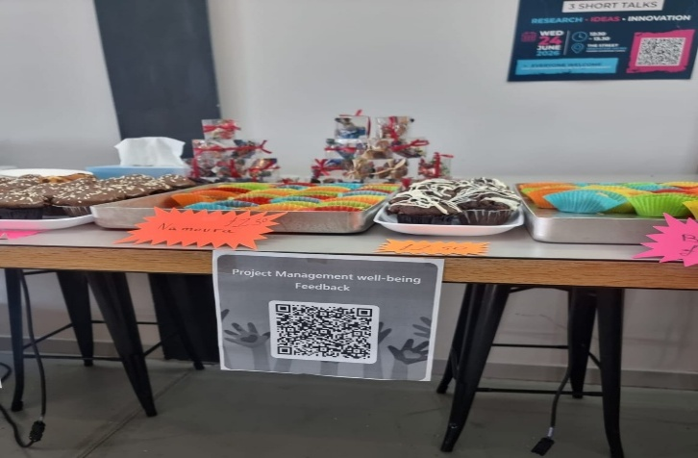 | 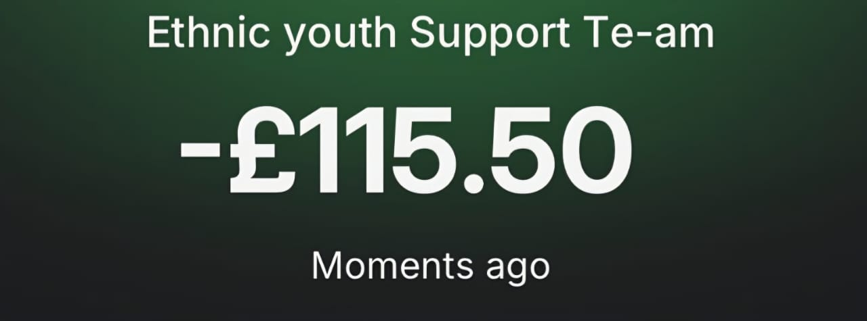
Events table | 115.50 pounds

The fundraising event raised £115.50 for EYST Wales. Three participants completed the QR-code feedback survey and gave an average rating of 5. The feedback was positive, but the small number of responses means that it should be treated as indicative rather than representative of all attendees.

Appendix G: Lessons Learned Log
Observation | Lesson learned | Improvement for future project | Responsible role
WhatsApp communication was quick, but decisions could be missed | Informal communication needs a formal record | Use a shared task tracker alongside WhatsApp | Project team
Only three feedback responses were received | Evaluation needs a larger sample | Encourage survey completion during the event and offer more than one feedback method | Evaluation lead
Food-allergy information required careful preparation | Food-related risks should be identified early | Create a formal risk register at initiation | Food-safety lead
Weekly schedule did not show detailed owners | Planning needs clearer accountability | Use a detailed Gantt Chart with named task owners and exact deadlines | Project manager
University approval was essential before event delivery | Approval is a critical dependency | Set internal approval deadlines and follow up formally | University contact lead

