BsC Cloud Computing
ACCC4004
Information Engineering
Zeyneb Arif
1813730

In first picture it is showing Data Flow Diagram(DFD). I started with process about the business. I complete with Data store then I finished with Dataflow.
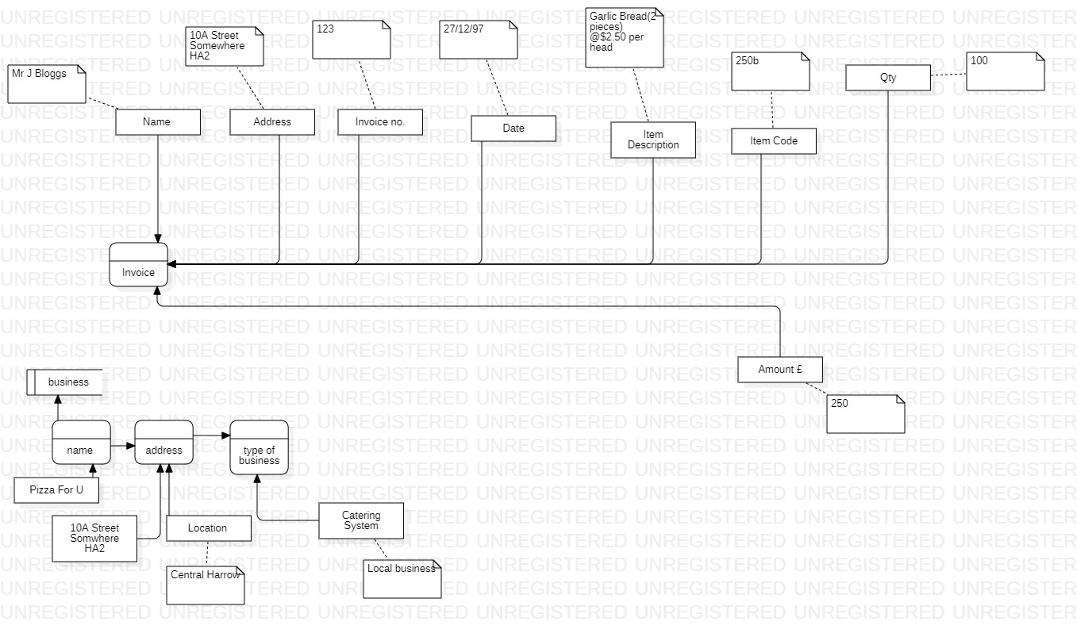

In second picture I complete with Entity Relationship Diagram (ERD). I tried to designed basic relationship.



