

Managing Enterprise in the 21st Century

Business Plan
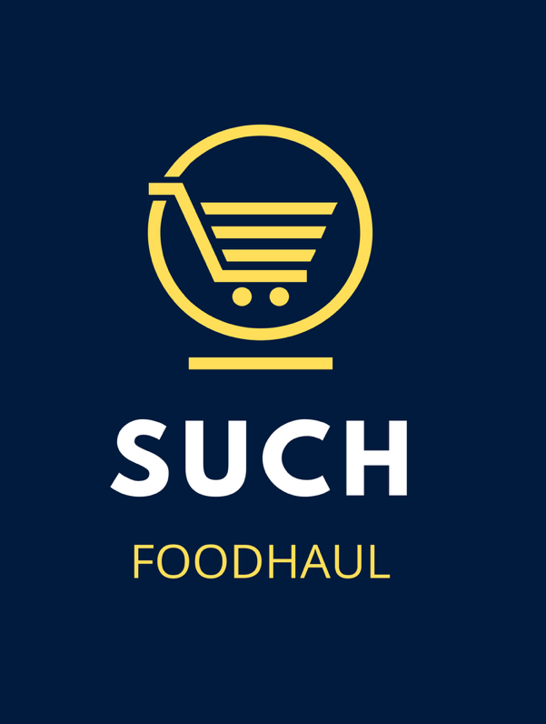

Submission date: 8th March 2026
Lecturer: Charles Obinwa
Student: Ricses Martinez Dacuyan
ID number: 2438233

Table of Contents
Executive Summary 2
Business Concept 2
Business Description / Product Description 3
Business Objectives (SMART Objectives) 3
Short-Term Objectives (less than a year) 3
Long-Term Objectives (More than a year) 3
Market Analysis and Marketing Plan 3
Market Analysis (Competitors, Customers, Target Groups) 4
PESTEL Analysis 5
SWOT Analysis 6
Marketing Mix (4Ps) 6
Management Team and Legal Format 7
Key Milestones 8
Financial Plan (One Year) 9
Sources of Finance 9
Cash Flow Forecast 9
Break Even Analysis 11
Reference List 11
Appendices: 12

Executive Summary
The Smart Urban Convenience Hub (SUCH) is a hybrid retail and service concept designed for high footfall locations such as Oxford Street, London. The business integrates healthy grab-and-go food, grocery, and assisted shopping services within a single, accessible physical store supported by digital ordering and local delivery. The concept responds to evolving urban consumer behaviour, the growing and ageing population in the UK, and increasing demand for convenience, health-focused products, and inclusive retail environments.

Business Concept
A tech-enabled convenience hub offering healthy grab-and-go food, essential items, and assisted shopping services, designed for young professionals, elderly customers, and tourists in a high-footfall Oxford Street retail environment.

Business Description / Product Description
The Business Integrates healthy grab-and-go food, grocery, and assisted shopping services within a single, accessible physical store supported by digital ordering and local delivery. The concept responds to evolving urban consumer behaviour, the growing and ageing population in the UK, and increasing demand convenience, health-focused products, and inclusive retail environments. The core product offering will include freshly prepared meals, barista beverages, diabetic-friendly snacks, and curated range of high -demand convenience items such as travel essentials and household basics.

Business Objectives (SMART Objectives)
The SUCH will use this to guide its strategic development and operational performance. These objectives focus on establishing the business successfully within Oxford Street while ensuring sustainable growth and strong customer engagement.

Short-Term Objectives (less than a year)
- Establish and launch the business within 6 months securing a retail location on or near Oxford Street and completing all necessary licensing, Staffing, and operational setup
- Achieve an average of 150-200 daily transactions within the first 12 months through strong footfall engagement, marketing campaigns, and partnership with nearby offices and tourists’ groups.
- Build brand awareness and customer loyalty by reaching at least 1,500 social media followers and 500 repeat customers within first year

Long-Term Objectives (More than a year)
- Increase annual revenue by 20-25% within the first 3 years through expanded product offerings, delivery services, and subscription options for elderly customers.
- Establish the SUCH as a recognised brand in urban convenience retail 2030, focusing on accessibility, healthy grab-and-go food and inclusive customer service
- Maintain high service standards achieving at least 90% customer satisfaction ratings through feedback surveys and online reviews.

Market Analysis and Marketing Plan

Market Analysis (Competitors, Customers, Target Groups)

Marketing Approach
The SUCH targets a diverse urban customer, an effective marketing approach focuses on creating value and building strong customer relationship to drive long-term success (Kotler and Armstrong, 2018).
Instructions:
- Market Segmentation
  - Segmenting the market based on demographic, geographic, and behavioural factors. Demographically, the business focuses on two key age groups: young adults aged 18-35, including students and working professionals, and older adults aged 60 and above who require accessible and convenient shopping solutions. Behaviourally, the target customers are convenience-driven, time-sensitive, and increasingly health-conscious. And geographically, the business is strategically located on Oxford Street, London, considered as Europe’s busiest shopping street, with significantly higher footfall compared to other major retail destinations such as Madrid and Milan (BNP Paribas Real Estate, 2022).
- Targeting
  - The primary target market consists of young professionals and students who require quick, healthy, and convenient food retail options due to their busy lifestyles. This group is highly engaged with digital platforms and values speed, efficiency, and mobile ordering capabilities
- Positioning
  - The unique value proposition lies in its dual focus on speed and accessibility. It offers high-quality grab-and-go meals for busy individuals while also providing human-centred services tailored to elderly customers. The brand aims to be perceived as reliable, efficient, and inclusive, bridging the gap between traditional convenience stores and modern digital retail solutions.
- Reaching Your Audience
  - Channels and Tactics: Utilising a multi-channel marketing strategy to effectively reach its target audience. Social Media Platforms such as Instagram and TikTok for younger customers through visually appealing food content promotions with the aid of influencer collaborations. The elderly age-group would be more addressed in traditional way such as in-store assistance and word-of-mouth marketing. Clear signage and accessible communication will also play a key role in attracting this segment.
  - Promotion Strategy: Will focus on both digital and physical engagement. Introductory offers, meal deals, and loyalty rewards will be used to attract and retain customers. User-generated content and online reviews will be encouraged to enhance brand credibility.

PESTEL Analysis
The external environment plays a critical role in shaping business strategy, as organisations must respond to political, economic, social, technological, legal and environmental factors (Johnson et al., 2017).
Political
The Business must comply with UK regulations including food safety, employment law, and local council licensing. Trade policies may affect imported goods costs. London-specific regulations on waste and operations also apply. Political stability supports business growth, although future policy changes may influence operational costs and regulatory requirements.

Economic
Economic conditions such as inflation and rising living costs may reduce consumer spending. However, demand for convenient and affordable food remains strong in busy locations like Oxford Street. High rent and labour costs are significant challenges, but strong footfall and tourism provide consistent revenue opportunities.

Social
Growing demand for convenience, speed, and healthier food supports the business concept. The UK’s ageing population increases the need for accessible retail services. Consumers are also more socially conscious, valuing inclusivity and customer experience. Urban lifestyles continue to drive demand for efficient, grab-and-go retail solutions. Consumer demand for convenience and healthier options influenced by social and behavioural trends (Kotler and Keller, 2016)

Technological
Technology enables digital ordering, contactless payments, and efficient inventory systems, enhancing customer experience and operations. However, reliance ton technology may exclude some elderly customers. Continuous investments in updated system is required to remain competitive, increasing operational costs but improving efficiency and service delivery.

Legal
The business must adhere to food hygiene laws, health and safety regulations and GDPR requirements. Compliance is essential to avoid fines and reputational damage. Licensing and inspections will be necessary for food operations, while labour laws will directly impact staffing practices and operational costs.

Environmental
Requires the business to reduce waste, use sustainable packaging, and manage energy consumption. Climate change may impact supply chains, especially fresh produce. Adopting environmentally friendly practices can enhance brand image and meet increasing customer expectations for sustainability in retail and food services.

SWOT Analysis

Strengths | Weaknesses
-Dual-market appeal  -High Footfall Location  -Health positioning  -Accessibility focus | -Staffing costs
Opportunities | Threats
-Ageing UK population  -Corporate partnerships  -Delivery expansion  -Private Label healthy range | -Tesco express / Sainsbury’s Local  -Rising costs  -Economic slowdown  -Strong competition  -High Oxford Street rent

Marketing Mix (4Ps)
Product
The SUCH offers healthy grab-and-go meals, beverages, and essential daily items. It differentiates itself through diabetic-friendly options and elderly-focused services, including assisted shopping, accessible layouts, and clear product information to enhance inclusivity and convenience.
Price
A competitive, value-based pricing strategy will be adopted, aligning with local convenience retailers while reflecting the premium Oxford Street location. Meal deals, bundle offers, and loyalty schemes will encourage repeat purchase while maintaining affordability and supporting profitability.
Place
Located on Oxford Street, the business will benefit from the natural high-footfall, tourism and nearby offices. The store serves as the primary sales channel, supported by click-and-collect and local delivery, ensuring accessibility, convenience, and wider customer reach.
Promotion
Promotion will combine both digital and traditional methods, including social media marketing and loyalty programmes. Partnership with local businesses and hotels, alongside in-store engagement and word-of-mouth, will enhance visibility and attract diverse customer segments.

Management Team and Legal Format

Legal format
SUCH will operate as a Private Limited Company (Ltd) to ensure appropriate legal protection and support future business growth. The structure provides limited liability, meaning the owners’ personal assets are protected from business debts and legal claims, which is particularly important for a high-footfall retail and food operation on Oxford Street. The Ltd. format also enhances commercial credibility with landlords, suppliers, and potential partners, strengthening the business’s professional positioning within the competitive Central London market. Furthermore, operating as a limited company supports scalability, enabling the business to expand to multiple locations, attract investment, and implement structured governance as it grows.

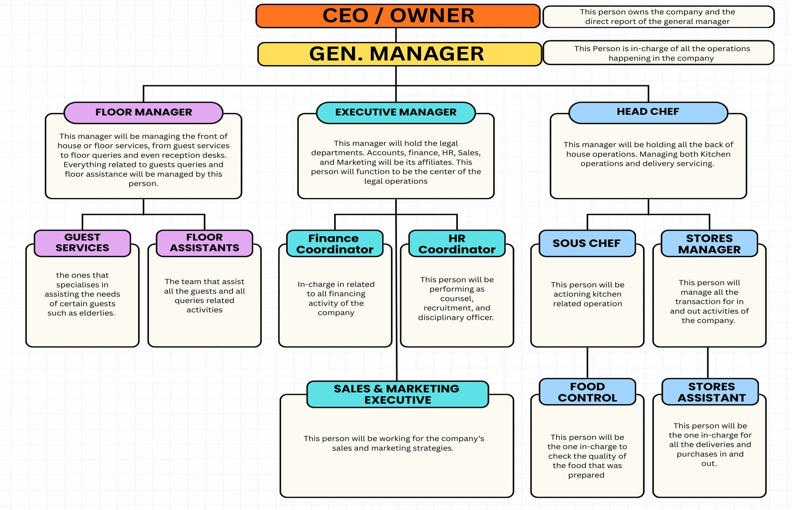
Organisational Chart

Key Milestones

Phase | Milestone | Description | Timeframe
Pre-Launch | Business Registration | Register as a Private Limited Company and complete legal requirements | Month 1
 | Secure Location | Lease a retail unit near Oxford Street | Months 1–2
 | Licensing & Compliance | Obtain food hygiene certificates, insurance, and council approvals | Months 2–3
 | Store Setup | Install equipment, POS systems, and design store layout | Months 3–5
 | Recruitment & Training | Hire and train 35 staff across all roles | Months 4–5
 | Supplier Agreements | Finalise contracts with food and retail suppliers | Months 4–5
 | Marketing Campaign | Launch pre-opening promotions and social media marketing | Month 5
 | Soft Opening | Trial operations and gather feedback before full launch | Month 6
Short-Term | Official Launch | Full opening with promotional offers and campaigns | Month 6
 | Customer Growth | Build steady daily transactions and repeat customers | Months 6–12
 | Brand Awareness | Increase online presence and local recognition | Months 6–12
 | Operational Optimisation | Improve efficiency, service speed, and stock control | Months 7–12
Long-Term | Revenue Growth | Achieve consistent profit and increase annual revenue | Year 1–3
 | Service Expansion | Introduce delivery and elderly-focused services | Year 1–2
 | Partnerships | Collaborate with local businesses and organisations | Year 2–3
 | Expansion | Open additional locations in Central London | Year 3–5

Financial Plan (One Year)

Sources of Finance
It will be funded through a combination of personal investment, external financing, and government support. The owner will contribute initial capital to demonstrate commitment and reduce borrowing risk, while a bank loan will provide most of the funding required for setup and early operations. Additionally, a small business grant will be sought to support start-up costs. This mixed financing approach reduces financial risk and ensures sufficient liquidity during the early stages of the business.

Cash Flow Forecast
Start-up Costs
It reflects the significant investment required to establish a retail and food operation in a prime location such as Oxford Street. The largest expenses include lease deposits and refurbishments, as the store must meet both operational and aesthetic standards. Equipment costs cover kitchen appliances, refrigeration, and point-of-sale systems. Initial stock is required to support opening operations, while marketing expenses are allocated to generate awareness prior to launch. These costs are essential to ensure a professional and competitive market entry.

Fixed Costs
Represents expenses that remain. Relatively constant regardless of sales volume. The most significant fixed cost is rent, reflecting the premium nature of the chosen location. Additional fixed costs include business rates, insurance, and digital infrastructure such as internet and POS systems. Lastly as planned to have 5 managerial positions to have their fixed salaries, all these costs will be covered regardless of business performance, making them critical factor in financial planning and break-even analysis.

Variable Costs
This fluctuates in line with business activity. The largest component is staff salaries, reflecting the labour-intensive nature of a retail and food service operation. Stock costs increase with sales volume, while utilities such as electricity, gas and water very depending on usage levels. Tax contributions, including NI and PAYE, are also linked to staff levels. Effective management of these costs is essential to maintaining profitability as the business grows.

Sales forecast
The sales forecast is based on estimated daily transactions and average customer spending. Given the high footfall on Oxford Street, the business is projected to achieve approximately 180 transactions per day with an average spend of £10. This results in a steady revenue stream through the year. However, as a new business, initial sales may be lower, with gradual growth expected as brand awareness increases and customer loyalty develops.

Profit and Loss Overview
The first-year financial projection indicates a net loss, which is a typical for new businesses operating in high-cost locations. This is due to significant fixed costs, particularly rent and staffing, combined with the time required to build a stable customer base.

Break Even Analysis

Break-even analysis is essential for business planning as it identifies the minimum sales required to cover costs and supports effective financial decision-making (Nugus, 2009). It identifies the point at which total revenue equals total costs, meaning the business is neither making profit nor a loss.
Break-Even Calculation
- Fixed Costs (Annual): £ 486,000
- Average Selling Price per Customer: £10
- Average Variable cost per Customer: £6.50
Contribution per Unit:
£10 - £6.50 = £3.50
Break-even point (units)
£486,000/ £3.50 = 138,857 transactions per year
Break-even per day:
138,857/ 365 days = 380 customers per day
The Business 380 daily transactions to cover all costs compared to the projected 180 daily transactions in the first year, this indicates that the business will operate below break-even initially. However, as customer number increases through marketing, brand recognition, and repeated transactions, the gap is expected to close. Achieving break-even is realistic in the medium term, particularly if operational efficiencies are improved and additional revenue comes in such as delivery and subscription.

Reference List

Johnson, G., Scholes, K. and Whittington, R. (2017) Exploring Corporate Strategy. 11th edn. Harlow: Pearson

Kotler, P. and Keller, K.L. (2016) Marketing Management. 15th edn. Harlow: Pearson

Nugus, S. (2009) Financial Planning Using Excel. 2nd edn. Oxford: Butterworth-Heinemann.

BNP Paribas Real Estate (2022) London’s Oxford Street remains leading shopping destination in Europe. Available at: https://www.realestate.bnpparibas.co.uk/news/londons-oxford-street-remains-leading-shopping-capital-europe?utm_source=chatgpt.com (accessed on 27 March 2026)

Kotler, P and Armstrong , G. (2018) Principles of Marketing. 17th edn. Harlow: Pearson

Appendices:
Table 1 – Cash Flow Forecast
Table 2 – Sales Forecast

Table 3 – Cost of Production Forecast
Cost of Production - Fixed | Per Month
Rent | £15,000.00
Insurance | £1,000.00
Business Rate | £4,000.00
5 emp salary | £20,000.00
Internet/System | £500.00
TOTAL | £40,500.00

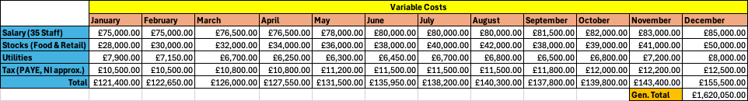
Table 4 - Variable Cost
Table 5 – Start-up Cost
Start-up Cost
Refurbishment | £30,000.00
Equipment | £25,000.00
Marketing | £6,000.00
Rent Deposit | £8,000.00
License/Legal | £2,000.00
Initial Stocks | £10,000.00
TOTAL | £81,000.00

