

Student Name: Abdul Aziz Hamdard

Student ID:2438643

Module Name: International Marketing (Principles
and Practices)

Module Code: LCMB7034

Lecturer’s Name: Dr. Tushara Balendran

Table of Contents
2. Introduction 2
3. Starbucks Marketing Strategies: UK vs U.S Analysis 2
4. The Macro Environment Analysis 3
4.1 Application of the PESTLE Analysis Framework 3
5. Segmentation, Targeting, and Positioning (STP) Analysis 9
5.1 Strategy for Market Segmentation 9
5.2 Targeting Strategies: US vs UK 13
5.3 Strategies for Positioning 13
6. Marketing Mix Analysis (7Ps) 15
7. Starbucks Marketing Analysis: Evaluation, Ethics, and Recommendations 24
8. Starbucks Market Presence: UK vs. US 27
9. Recommendation 27
10. Conclusion 28
11. References- 30

Introduction
Starbucks was founded in 1971 as a humble coffee bean shop at Pike Place Market in Seattle. Today, it is the world’s biggest coffeehouse chain, boasting more than 40,000 stores across over 80 countries (Statista, 2024). Starbucks has done a fantastic job of becoming a “Third Place” between home and work since Howard Schultz took over in 1987 (Cafely, 2024).
This report compares Starbucks’ Marketing strategies between two significant nations: the UK and the U.S. This paper encompasses an insightful look into the macro-environmental factors, STP strategies, 7Ps and performance information. This examination also considers Starbucks’ business ethics in light of how these impact various stakeholders involved with the company.
Starbucks’s most important and most mature market is the US, where 16,935 stores generate around 40% of the company’s global revenues (Cafely, 2024). On the other hand, the UK came in through acquisition in 1998 and now has over 1,200 stores, and its revenue rose by 21.9% during fiscal 2023 (Riley, 2024).
This document critically evaluates the marketing strategies systematically adopted by Starbucks using PESTLE analysis, Hofstede’s paradigm of cultural distance analysis, the 7Ps marketing mix model and SWOT, which confirms that global expansion has substantially increased Starbucks’ revenues, but it is not without challenges.

Starbucks Marketing Strategies: UK vs U.S Analysis
The business first originated as a coffee bean store in the Pike Place Market of Seattle, Washington, back in 1971. Today, it is the world’s biggest coffeehouse chain. The company has over 40,000 stores in more than 80 countries (Statista, 2024). Founded in 1987 by Howard Schultz, Starbucks re-imagined the American coffee shop as an Italian espresso coffee-inspired café (Cafely, 2024).
Starbucks' brand is based on its mission: “With every cup, with every conversation, with every community – we nourish the limitless possibilities of human connection” (Starbucks, 2024). This thought is what makes Starbucks a “Third Place” between home and work to come and relax, have some conversation with one another, rather than just another place that sells cups of coffee.
The company gets all arabica coffee from more than 26 countries in Latin America, Asia Pacific and Africa. Overall, it partners with more than 440.000 coffee farms that have obtained Coffee and Farmer Equity (C.A.F.E.) Practices certification (Starbucks, 2024).
The company has a very successful product; it is also doing well for the bottom line with net sales of $36.18 billion in Fiscal year 2024 (Statista, 2024). Drinks represent 74 per cent of retail sales by company-operated stores. Food Products represent 23% of products in the food category (Statista, 2024). Starbucks operates a roasting facility and multiple distribution centres to support the global market. Since then, there are six store environments, called the Starbucks Reserve Roasteries, located in key cities Seattle, New York City, Chicago, and Milan (Starbucks, 2024).

The Macro Environment Analysis

Application of the PESTLE Analysis Framework
A PESTLE analysis is a strategic tool used to focus on the idea of looking at several factors in order to get a more global perspective, which may affect your business. 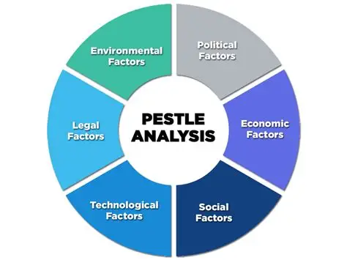
Figure 1: PESTLE Analysis Framework
Source-(Gandhi, 2020)
Political Factor
U.S- While the political environment in the United States is less volatile, Starbucks still must navigate rules and regulations at the federal, state and local levels. Labour is increasingly relevant, and minimum wage rates are driving business costs in many places. Unions have worked harder to get stores to sign up since 2021, and more than 370 stores are expected to have voted to do so by 2024 (Svea Herbst-Bayliss, 2024).
UK-Brexit has totally changed the UK political context to make trade with the EU more difficult and costly, through new trade barriers, customs procedures and regulatory divergences. For instance, the government enforces employers to fund holidays, sickness and parental leave; increasing business costs (Gov.UK, 2025). The National Living Wage is going up every year, and it increases the cost of labour in all UK stores.
While in the US, unionisation and wage pressure create political challenges, in the UK labour force faces increased costs due to labour regulation and Brexit.
Economic Environment
U.S - Interest rate policies of the Federal Reserve influence growth plans and capital spending decisions. The reason Starbucks may be able to get away with charging higher prices is that the US median household income is $75,000 (US Census Bureau, 2024).
UK- In the UK economy, there are opportunities and challenges. The economy has expanded by just 1–2% a year (Office for National Statistics, 2024). Inflation reached over 10% in 2022–2023, eroding consumers’ disposable income and increasing businesses’ costs (Bank of England, 2025). There are also very high commercial property rent costs, particularly in London. And yet the UK’s strong economy and high levels of education maintain demand. The value of the coffee shop market in 2024 is £4.1 billion (World Coffee Portal, 2025).
The US shows a more favourable economic environment due to higher disposable income and less economic uncertainty. While the UK face slower economic growth due to its environmental complexity.
Social Factors
UK- Urbanisation and healthy living are turning Starbucks (i.e. coffee) into a high-end brand. There is a high coffee culture, and independent shops compete with one another (Mintel, 2024).
U.S- Starbucks has a substantial base of loyal customers among Millennials and Gen Z, but it’s becoming increasingly expensive and difficult for those with less financial capacity. Personalisation and lifestyle branding remain the firm's greatest competitive advantages (MarketingWeek, 2024).
Coffee culture is key in both the U.K., prioritising quality and sustainability, and the U.S., taking more of a lifestyle branding approach and emphasis on convenience.
Cultural Factor
UK- Coffee drinking in the U.K. has assimilated into city life, and Starbucks' coffeehouse culture is well-timed for that. UK-based consumers value quality and sustainable coffees, which aligns with Starbucks’ brand.
U.S- In the United States, Starbucks is a “third place” between home and work. US-based consumers really appreciate that the brand is about personalisation and lifestyle branding.
In both countries cultural context is very strong. Coffee culture here in the UK drives up business. The brand of Starbucks works in the US with the American lifestyle and social norms.
Social and Cultural Trends of Starbucks
US Social Trend
Millennials and Gen Z are becoming more health-conscious, leading to growing demand for plant-based and low-sugar offerings. The trend taps into their high-speed lifestyle and concern for the environment.
US Cultural Trend
Starbucks has made itself into a “third place,” a setting for social life outside home and work. This technique fosters brand loyalty by making a customer’s experience unique.
UK Social Trend
The growth in café culture and the popularity of remote work have made coffee shops preferred workspaces.
UK Cultural Trend
The UK’s cultural trend is reflected in menus and inclusivity initiatives. There is also a greater focus on ethical sourcing as demands for sustainability increase.
Hofstede Cultural Dimension Model
Hofstede’s Cultural Dimensions Model is a model that helps us to understand how values in the workplace are influenced by culture, and thus it describes the effects of a society’s culture on the values of its members, and how these values relate to behaviour.
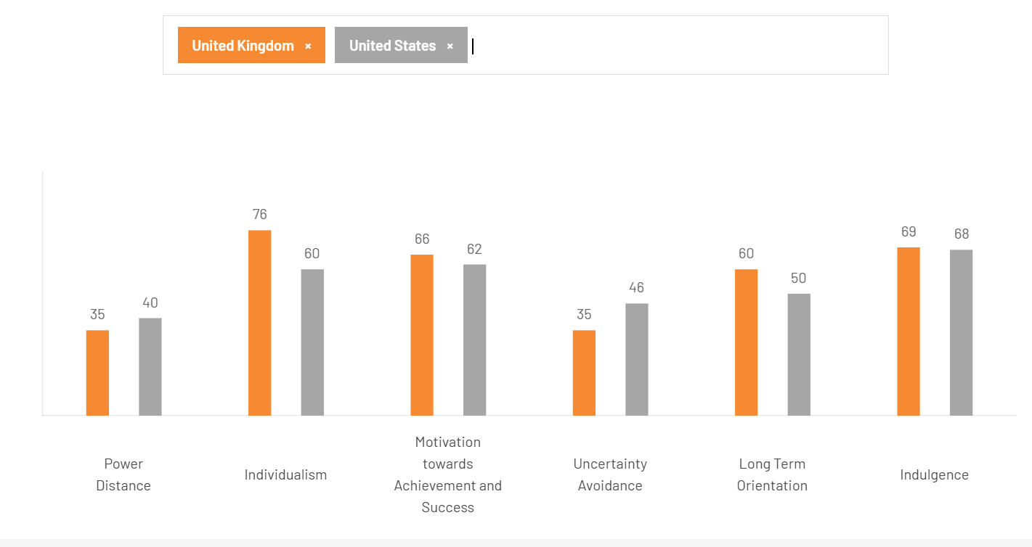
Figure 2-Hofstede’s Cultural Dimensions: US vs UK, Source-(Hofstede, 2025)

Dimension | USA | UK
Power Distance (PDI) | 40 | 35
Individualism (IDV) | 91 | 89
Masculinity (MAS) | 62 | 66
Uncertainty Avoidance (UAI) | 46 | 35
Long-term Orientation (LTO) | 26 | 51
Indulgence (IVR) | 68 | 69
Table- Hofstede’s Cultural Dimensions: US vs UK
Source:(Hofstede, 2025); Wale, 2025)
Dimension-by-Dimension Comparison and Starbucks Impact
Power Distance
The UK and USA also score low, reflecting a preference for egalitarianism and dispersed decision-making. Starbucks benefits from it by promoting diverse leadership (Hofstede, 2025).
Individualism
The USA ranks very high which is code for strong self-reliance. The UK has a high, but lower score. Starbucks capitalises on this with customised products and loyalty schemes (Minkov & Hofstede, 2011
Masculinity
The USA has a higher masculinity index, which means it has more of a competitive and success-oriented culture. The UK also demonstrate moderate masculinity when it comes to success and quality of life. (Smith and Taylor, 2023).
Uncertainty Avoidance
The figure for the UK is lower, which could reveal a greater comfort with ambiguity and openness to innovation. The USA is moderate in preferring structure. Starbucks can more easily roll out new product introductions in the UK. (Hofstede, 2025)
Long-Term Orientation
The UK demonstrates a moderate type of pragmatism, and the USA has even less long-term orientation. Starbucks' sustainability issues may be more with the UK consumers. (Hofstede, 2025)
Indulgence
Both countries come in high, and it’s indicative of whether they have a culture of relaxation and commerce. This aligns with Starbucks and indulgent offerings.
Advantages of Hofstede’s Model
Provides a coherent, comparative structure for cultural analysis.
Assists international corporations in conveying their strategy into local values.
Universally applied in academic and business fields.
Disadvantages of Hofstede’s Model
National Averages (there may be subcultures left out)
Information might be outdated or may not reflect current changes.
Risk of stereotyping them if it is used excessively.
Technological Environment
U.S- The Starbucks app has over 31 million active users in the US, and mobile represents around 26% of all transactions in the US (Cafely, 2024).
UK- The U.K. has embraced digital technology with little resistance, and mobile ordering and digital payments are today’s norm. Furthermore, more than 90% of UK adults use a smartphone at least once a week (Ofcom, 2023), indicating that British consumers are among the highest in smartphone penetration.
Both have good technological environments, and Starbucks’ digital platforms are giving it an edge. But the UK market is adopting online ordering a little more slowly than the US.
Environmental Factor
UK- Environmental sustainability is a significant worry for UK consumers. Starbucks invests in packaging that’s better for the environment, reducing carbon emissions and making sure it sources materials fair. (DEFRA, 2023).
U.S- Starbucks has determined to become resource-positive by eliminating waste and investing in renewable energy, but the pressure is less strict than UK. (Starbucks, 2024).
Both markets are concerned about sustainability, but the U.K. has more rules, while in the U.S., things are a bit more voluntary.
Legal Factor
UK- UK companies must comply with a range of rules relating to employment, including the regulation of minimum wages, discrimination and health and safety. These lead to increased costs but also more stability in things. (Gov.UK, 2025)
U.S- Not all U.S. laws are created equal; they vary by state. Additionally, Starbucks can be susceptible to legal action and has had recent litigation asserting unethical sourcing practices (NBC NEWS, 2024).
The UK has a more solid legal system; the U.S has more breakdowns due to lawsuits and a lack of central control.
PESTLE Comparison: U.S. vs. UK for Starbucks
Similarities- The U.S. and the U.K. face similar labour struggles – in particular, surging wages and regulation. Both countries are inflationary, and that also raises the cost of operation. Starbucks takes advantage of strong coffee consumption in the UK and urban expansion in conjunction with lifestyle-based branding strategies in the US. Both markets have a high mobile ordering demand, with Starbucks featuring sustainability campaigns on the agenda for both. Legal systems in both nations can influence business.
Differences-The U.S. faces a tangle of state laws and obstacles to unionisation, while the UK deals with the challenges of post-Brexit trade barriers. The UK struggles with slower economic expansion and higher inflation, although disposable income is typically higher in the U.S. Digital adoption has happened faster in the U.S., and the UK has stricter environmental controls.

Segmentation, Targeting, and Positioning (STP) Analysis

Strategy for Market Segmentation

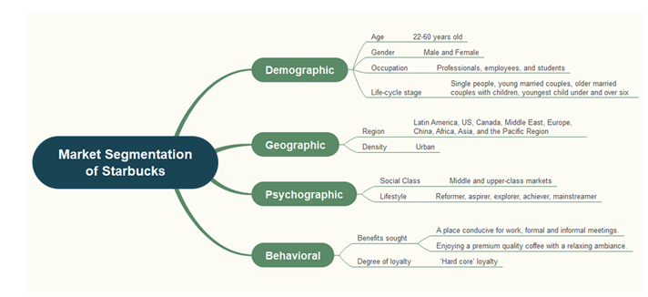
Figure: Starbucks Market Segmentation, Source: EdrawMind, n.d.)
Starbucks uses multiple market segmentation strategies, in relation comprising demographic, geographic, psychographic and others, to identify various customer groups within the UK and US markets.
Segmentation by Demographics
Demographic segmentation is also crucial for the company to follow its strategy. The target market for the company is Men and Women who ‘cross all ages’, although most customers will be aged between 22-60 (Business Model Analyst, 2024).
The US-
Age: 22 to 60, men and women.
- Income: Middle to high, with an average targeted household income of around $90,000.
- Education: Educated; Urban/Professional (Business Model Analyst; 2024; Start. io, 2023).
The UK-
Age: 22 to 60, men and women.
- Income Targets wealthy city residents, particularly those living in large cities such as London. (Hodgson, 2023)
- Education: The workforce is largely white collar and has a college degree.
Geographic Segmentation
The company is widespread in the US, Canada, Latin America, Europe, the Middle East, Africa, China, and the Asia Pacific. Stores are strategically located in high-traffic zones such as shopping areas, office buildings, school campuses and transport hubs. UK geography is also city-centric, with London and the next tier of cities -Manchester, Birmingham, and Edinburgh. Starbucks understands that countries differ and ensures that items are delivered to the appropriate market. (Starbucks, 2024a)
US- more than 15000 stores and focus on urban and upper middle class areas (i.e., not rural, for instance, California and NY) (Cafely, 2024)
UK- Highest store density in cities (such as London, Manchester). The brand does not have a presence in either rural or low-income areas.
Segmentation by Psychographics
Starbucks is looking for the type of consumer who views coffee as an experience, not just a commodity:
US- Busy professionals, “achievers,” “innovators”, and “explorers” are looking for things that make them easy to use, are of a high quality and allow the user to express themselves.
Strong fit with company values: sustainable and ethical production (Business Model Analyst, 2024).
Emotionally branded as a “third place,” between home and work, to relax.
UK- A similar emphasis on experience and lifestyle, but more in terms of community, socialising, and comfort.
Appeals to “consumers” and “advocates” who are interested in ethical consumption, good quality.
There is a high level of environmental consciousness sustainability messaging accentuates the importance.
Example of a VALS Profile:
US: “Innovators” (leaders, influencers and early adopters), “Achievers” (busy, success-driven professionals).
UK: “Thinkers” (information-driven, considered consumption), “Achievers,” and “Experiencers” (social, novelty seeking) (Business Model Analyst, 2024).
Segmenting by behaviour
Starbucks segments customers by their loyalty, people who use the service a lot versus heavy users, for instance. The firm is targeting to attract repeat customers who want good coffee in a comfortable environment, a place to read or work. Benefit segmentation enables businesses to pursue customers who desire various kinds of benefits, like good coffee, pleasant places for conversation or convenient locations for working from home.
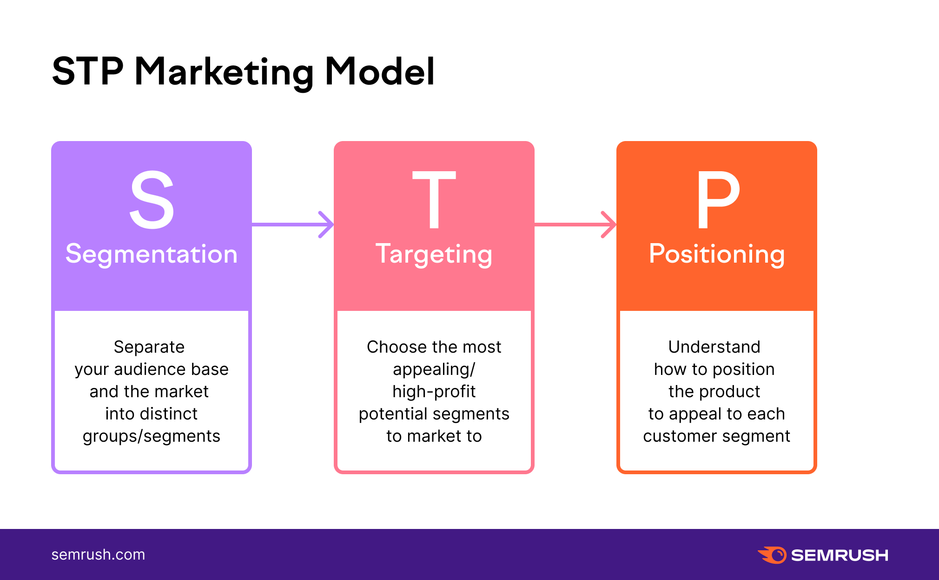
Figure: STP Marketing Model, Source:(intPik.ru, 2025)

Targeting Strategies: US vs UK
US Starbucks employs multi-segment targeting to target different customer groups simultaneously. Millennials are particularly significant targets, as they appreciate quality monotonously and prefer to have a variety of options, including coffee, tea, pastries, and sandwiches. The company focuses on city workers who look for quality goods by presenting itself as a premium drinks brand which owns and operates warm, comfortable bars in which they can consume such beverages.
The UK targeting of Starbucks focuses on health-conscious and eco-conscious customers by offering sugar-free options, posting nutritional information on its websites. Cultural targeting may involve the provision of seasonal food that is consistent with British taste, such as scones and mince pies at Christmas.

Strategies for Positioning
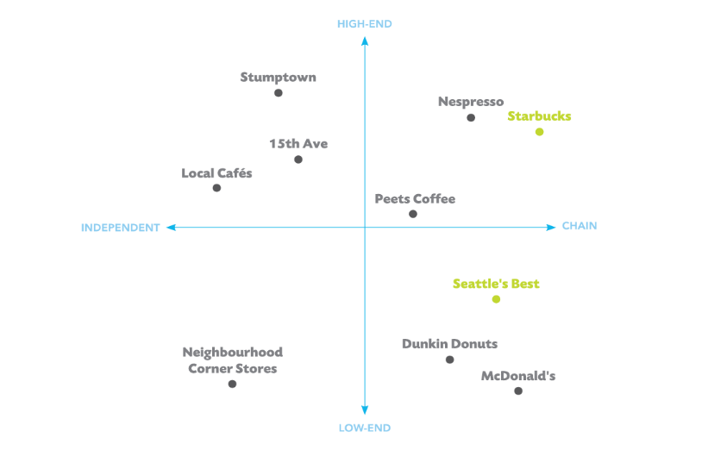
Figure: Starbucks Positioning, Source :(Haskova, 2015)
The following perceptual map contrasts Starbucks with Dunkin' Doughnuts, McDonald's, Nespresso and local Café, showing how customers perceive the product.
Starbucks employs three types of positioning: mono-segment, adaptive and stand-by. Mono segment placement targets affluent consumers who are willing to pay a premium for quality products and services. This same approach applies in the UK and the US, with Starbucks a premium brand that can charge more than its rivals. Adaptive positioning is an indicator that a company is open to changing with the times, recognising shifts in consumer demand. Starbucks came out with low-calorie beverages, Chai Tea Latte, Iced Americano and Caffè Misto because people are more health-conscious. Standby placement is putting a product on the market with the hope that demand will grow over time. For example, Frappuccino drinks took time to gain acceptance in the market before they could really be successful.
Factor | US | UK
Price | Premium vs fast-food chains, justified by brand and consistency (Start.io, 2023) | Premium, competitive with local café operators
Quality | Emphasises speciality beans, ethical sourcing | Same as the US, plus extra emphasis on sustainability (Hodgson, 2023)
Experience | Community, personalisation, “third place” vibe | Focus on socialising, comfort, and eco-consciousness

Similarities and Differences of the STP in the US and UK
Similarities:
The same STP techniques are used by Starbucks in the US and UK, where they concentrate on urban professionals in the middle to upper-middle-class segments. The brand fosters an experiential coffee lifestyle that focuses on quality, sustainability and community connectivity. In addition, Starbucks positions its stores in busy urban areas within both markets, which helps create a loyal customer base which values the convenience and high-quality products.
Differences:
In contrast, although in the US Starbucks appeals to a broad demographic, including the Urban population and Millennials, its UK operation concentrates on encouraging richer city inhabitants, especially those who are concerned about environmental issues and health. The marketing – in the U.S., it’s more of a lifestyle brand, whereas in the UK, it is more about socialising and seasonal gears.

Marketing Mix Analysis (7Ps)
According to Kotler and Armstrong (2016 ), the marketing mix is “the set of tactical marketing tools that the firm blends to produce the response it wants in the target market”. The 7Ps of marketing mix are product, price, promotion, place, people, process and physical evidence.
Products Strategy
Product Variety and Depth
Coffee-based beverages, tea, food and brand name goods are the main products of Starbucks (Kotler & Keller 2016). But the US and UK have very different product lines to cater for local tastes.
The U.S.A. variety:
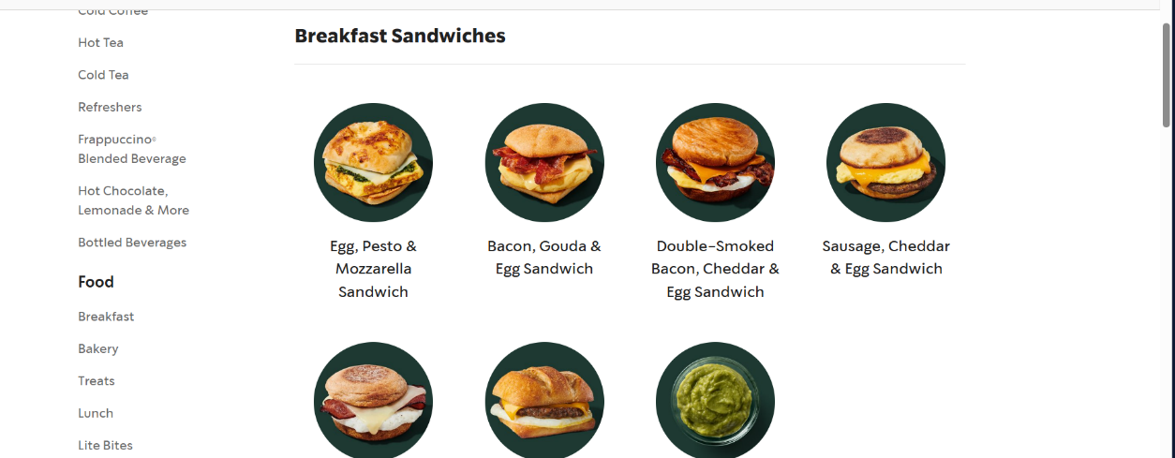
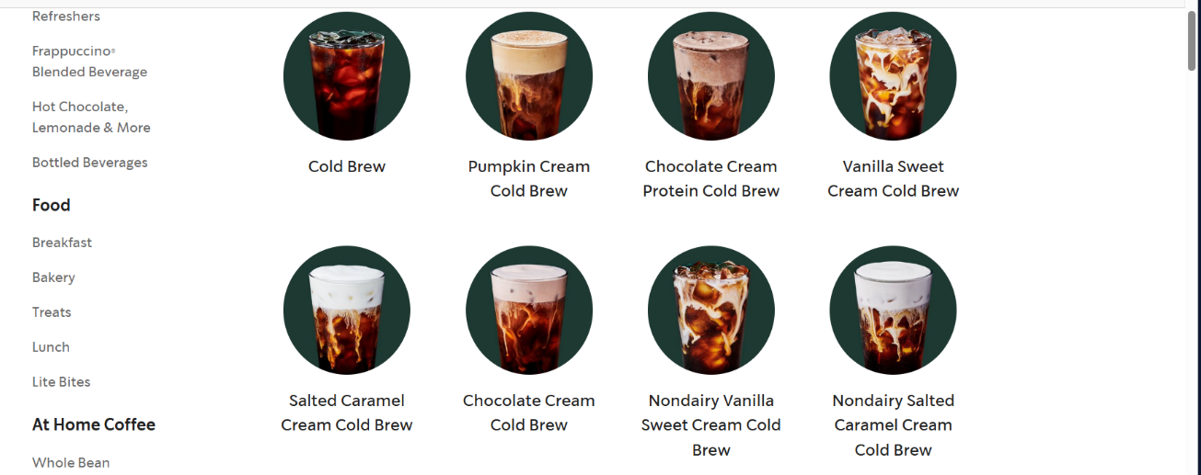
Figures: Starbucks Menu of the USA, Source: (Starbucks.com, 2025)
Their 30+ blends and single origins
Seasonal beverages such as the fall-time Pumpkin Spice Latte
Multiple American-style Frappuccinos and sandwiches for breakfast
(Moon and Quelch, 2006)
The UK Products variety:
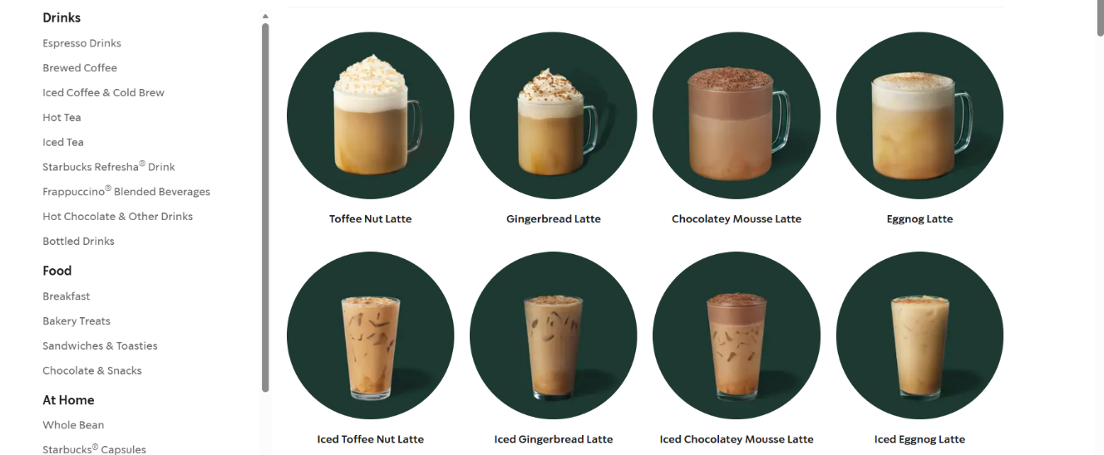

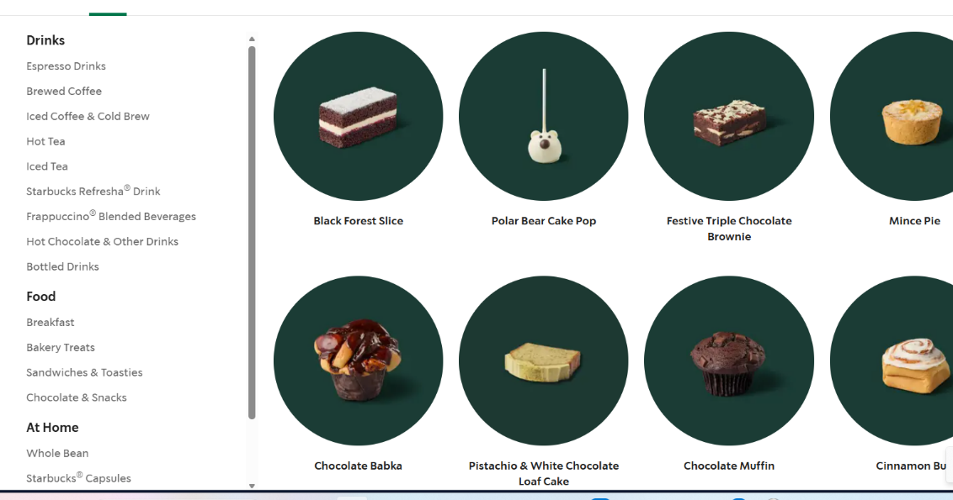
Figures: Starbucks Menu of the UK, Source: (www.starbucks.co.uk, n.d.)
Scones, bacon butties and mince pies, all British classics. Iced Tiramisu Cream Latte, exclusive in the UK (Hollensen, 2019)
Product Depth and Brand Extension
Starbucks expands the brand beyond coffee shops into many other areas, demonstrating both depth in an industry and breadth into new industries (Aaker, 2004).
Extensions in the Same Industry:
Starbucks Reserve (high-end coffee experience)
Teavana (specialised tea)
Seattle's Best Coffee (low-cost)
New Industry Extensions:
Evolution Fresh (juices and health beverages)
Ethos Water (Water bottled for a cause)
Princi (Italian bakery collaboration) (Schultz and Yang, 2019)
These extensions allow Starbucks to communicate with a specific segment of customers, and also capitalise on the brand equity created from its core café business (Keller, 2013).

Price Strategy
USA: Starbucks practices premium pricing, but specifically employs psychological pricing (i.e., $4.95 as opposed $5.00) and tiered pricing based on size. Prices depend upon how the economy in the region performs, as well as how many other businesses are in the area.
UK: prices are usually higher than in the US if you look at them in local currency, but Starbucks adapts to the UK market and to the prices of its competitors to stay premium but competitive.
Pricing by geographic areas includes the cost of doing business, taxes and the local economy also influences geographical determination (Dudovskiy, 2017; Bhasin, 2024).
Distribution/Place Strategies
US- Emphasises various store formats, like drive-thrus, kiosks and big café stores in malls and bustling towns. 15,000+ stores in many places.
UK - The focus is on cafés in high-footfall urban locations, typically city centres, stations and shopping centres. There are fewer drive-thru outlets, which makes it cafe-like.
Where the UK focuses more on café-eqsue social spaces, the US is adding in more of the convenient format of drive-thrus. (Business Model Analyst, 2024)
Direct vs Indirect Distribution

Figure: Starbucks Distribution, Sources: (Starbucks Corporation, 2024; Hollensen, 2019).
Direct Distribution (Main Channel)
Starbucks relies largely on direct distribution through its own stores. This allows the company to completely control how the customer feels and how they themselves want to portray their brand in this environment (Jobber & Ellis-Chadwick, 2020). This vertical integration enables consistent service and immediate feedback from customers.
More than 15,000 company-operated SBUX stores in the US (including traditional cafes, drive-thrus, airport locations and express formats) (Starbucks Corporation, 2024).
UK: There are around 1,000 stores, largely in city centres, train stations shopping malls. There are fewer drive-thru locations (Euromonitor International, 2023).
Indirect Distribution (Secondary Channel)
Starbucks also employs an indirect distribution model, which means collaborating with outlets to sell items such as packaged coffee, ready-to-drink beverages and branded merchandise in groceries, convenience stores and online (Hollensen, 2019). This allows the brand to maintain visibility while reaching an audience broader than those who go to the café itself.
Promotion Strategies
USA: Aggressive digital & Social media marketing, including the successful Starbucks Rewards loyalty app, targeted offers, and seasonal activations such as the Red Cup Campaign. Plenty of influencer marketing and online sales promotions.
UK: Also relies on digital promotions and rewards, but the messages are slightly more conservative, with a focus on community and sustainability. A few events and partnerships in the region to raise visibility of the brand.
Advertising in the UK focused on ethical sourcing and involving people from the community than did advertising in the US (Hodgson, 2023)
Other Promotional Strategies
Advertising: TV and digital display ads during the seasonal launch, but fewer than competitors (Fill and Turnbull, 2019).
Direct Marketing: Using personalised emails specific to potential Rewards members with offers according to their previous purchases (Chaffey and Ellis-Chadwick, 2019).
Loyalty Apps: These are apps that allow you to order, pay and redeem rewards on your phone; 26% of transactions in the US take place on apps (Marketing Week, 2023).
Email marketing: campaigns by product type, seasonal or member exclusivity, that generate higher than industry average open rates (Jobber and Ellis-Chadwick, 2020).
By offering a total solution, customers can engage with the business in countless ways, though its effectiveness depends on the maturity of the market and how fast people are going digital (Hollensen, 2019).
Personal, Process, and Physical Evidence
Personal Strategies
Well-trained and motivated, Starbucks “partners” offer excellent service with a combination of good times (Medium, 2023; Safalta, 2023).
Starbucks spends a great deal of cash on the training of employees and refers to them as “partners” to drive home the concept of shared ownership (Michelli, 2007).
Statistics on US workers:
Approximately 238,000 partners are employed by Starbucks in the US (Starbucks Corporation, 2024). Competitive benefits, such as health care and stock options.
Statistics about UK workers:
There are approximately 7,000 partners based on the UK's shop floors (Retail Gazette, 2023). statutory rights under UK employment law, such as sick leave and holiday pay. The Living Wage Foundation accredits employers in some areas.
The huge gap in employees is a result of variations in store density and market size. Barista training is a key element to ensure employees understand their product lines and offer excellent customer service (Schultz & Yang, 2019).
Process Plans
Systems of operation and delivery of service are in place to maintain customer satisfaction and performance. Ordering at Starbucks is easier in-store, online and on mobile apps (Bhasin, 2024). The use of process strategies in services is to ensure that services are delivered to customers smoothly and easily (Zeithaml et al., 2018).
More user-friendly ordering systems:
Customisation is available in a mobile app.
Point-of-sale registers at stores that remember what their customers like
Drive-thru efficiency (mainly US)
Pre-ordering in-app and collecting your order shortens wait times (Starbucks Corporation, 2024).
Differences in operations between the US and UK: In the US, it’s more about speed and convenience; 26% of transactions are through a mobile app; there are a lot of drive-thru lanes to encourage people to get their food faster (Marketing Week, 2023).
UK: Greater emphasis on café environment, less online sales, conventional-fashioned counter service entailing social interaction and reduced drive-thru facilities to support in-store dining (Mintel 2023).
These contrasts depict how humans from different cultures prefer to consume things. (Hollensen, 2019).
Physical Evidence
Starbucks’ design is ethically driven and modern in nature, which encourages familiarity as well as purposeful variety (Starbucks Store Design, 2024). Every store employs a similar flow for customers and partners, and brand-driven models representing community culture and activity (Starbucks Store Design, 2024). Starbucks revealed its intention to reimagine over 1,000 cafes within each market by 2026 with a focus on local connections and customer experience (Starbucks Stories, 2025).
Starbucks makes “third place” spaces, comfortable in-between home and work spaces, by employing a standardised design across all its stores but adapting it to the local context (Oldenburg, 1999; Schultz & Yang, 2019).
Features of USA Stores:
More square footage on average
Drive-throughs at locations in the suburbs
There were the very conspicuous pick-up shelves in the mobile pub.
Quick-service layout improvement
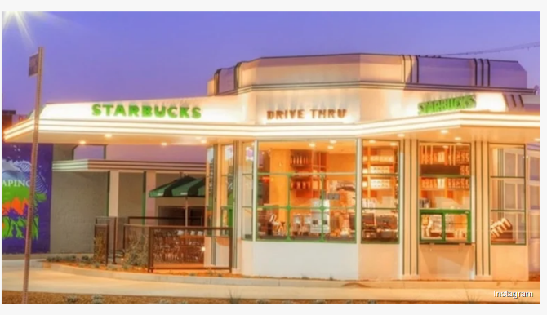
Figure: Starbucks Store in the USA, Source : (Zoeller, 2023)
Features of UK stores:
Smaller footprints due to urban space scarcity
Greater Focus on Shared Seating Earlier in the Day
A traditional café where you can sit for longer periods of time
Limited drive-thru infrastructure

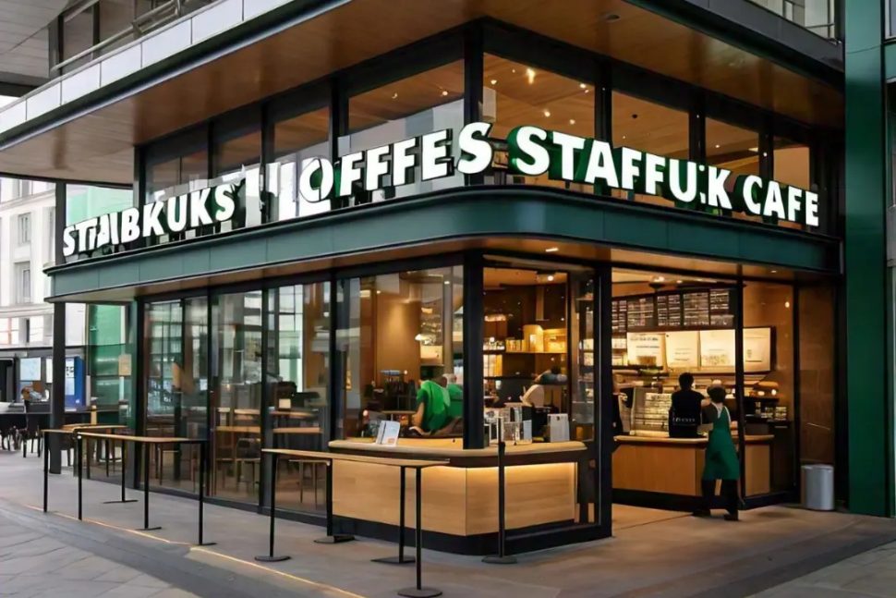
Figure: Starbucks in the UK, Source:(Starbucks, 2024)
Its homogeneity in all markets signifies its commitment to the brand, but it can change locally. But cultural tastes lead to small differences. It has also attracted significantly more outlets in the US- a key to Pret’s success is that its UK branches are designed around social seating and traditional café ambience, while its American ones concentrate on speed, with drive-throughs and mobile pick-up options.
Similarities and Differences of the 7Ps in the US and UK
Similarities:
Starbucks operates with a high-cost pricing strategy and focuses on cities, where they serve customers from modern, tech-heavy locations - including in the UK and the US. Digital marketing campaigns, mobile offerings and staff benefits are important to their strategy in each location. Starbucks has a valued populace and innovation-conscious culture in both regions, placing stores in city centres as well as spots where people are always around.
Differences:
The U.S. offering is more far-reaching, tailor-made to win custom among American consumers compared with the UK one, which features references including scones and tea.
In the USA, therefore use of psychological pricing methods, in contrast to the UK's reliance on setting prices in line with its economy. Starbucks in the U.S. has more drive-thru outlets and kiosks, while the UK’s focus is on café formats. And while the U.S. focuses largely on loyalty programmes and seasonal advertising when it comes to promotional strategies, the UK emphasise community involvement. The U.S. values mobile and drive-thru access, while the UK favours personalised service delivery.

Starbucks Marketing Analysis: Evaluation, Ethics, and Recommendations

Performance, Sales and Strategic Impact Assessment
Starbucks generated consolidated net revenues of $36.2 billion in the U.S. market in fiscal year 2024. But its sales in stores open more than 12 months dropped by 6, as transactions fell by 10 (Starbucks Corporation, 2024). Even though they were investing in advertising, the customers didn’t visit as frequently, which means that their advertising strategy is not successful (Kotler and Keller, 2016).
UK Market Source : The UK had even better revenue at £547.7 million in 2023, a 21.9% spike during hard economic times (Riley, 2024). Starbucks Coffee Company is considering opening 100 more locations in the UK by 2024 –a clear indication that management chains consider there to be significant space for development (Starbucks Stories EMEA, 2024).
Social media marketing
All markets also engage brands very commonly on Instagram, Twitter and TikTok (Chaffey & Ellis-Chadwick, 2019). Campaigns built around user-generated content, particularly for seasonal launches and such, achieve a lot of organic reach. (Marketing Week, 2023).
Reviews from Customers
Online reviews and analyses indicate otherwise. Stores in the US receive mixed reviews regarding the speed-experience trade-off, with UK stores faring better on the environment axis but sometimes coming out worse for value perception (Mintel, 2023). Even now, for easy-to-do service quality in two markets at the same time is difficult (Zeithaml et al., 2018).
Loyalty and Repeat Purchases
The Starbucks Rewards loyalty program is highly successful with 33.8 million active US members, increasing by 4% from the previous year (Starbucks Corporation, 2024). Loyalty program members visit stores 5.6 times per year more often than non-members, so the programs are successful (Jobber & Ellis-Chadwick, 2020). The UK has been slower to catch on than the US in the proliferation of loyalty programs, but usage is increasing (23 Euromonitor International).
Similarities:
US and UK-based marketing campaigns by Starbucks are highly centred on social media. Both markets are filled with campaigns on social platforms such as Instagram, Twitter, and TikTok, particularly those utilising customer-generated content for promotional seasons. Secondly, Starbucks has a strong customer base in both countries. The U.S. has 33.8 million active Starbucks Rewards members. But customer satisfaction with the quality of service is mixed in both markets, even though, generally, the UK has a better store environment.
Differences:
Sales and transactions in the United States decreased, with a 6 per cent shortfall at shops open for more than a year. The United Kingdom, though, recorded a 21.9 per cent sales jump in 2023 despite the state of the economy. Starbucks in the U.S. is serving up fewer customers, while the UK aims to open 100 new stores by 2024 for the future. Plus, the U.S. loyalty scheme has more active members, while the UK programme has only made progress.

Stakeholder Impact and Ethical Assessment
Ethical review reveals numerous controversies which challenge the company's claims of ethical sourcing and labour.
In January 2024, the National Consumers League sued Starbucks, alleging that the company falsely claims to serve "100% ethical" coffee and tea when it knows its coffee and tea come from suppliers with a record of egregious human rights and labour violations (National Consumers League, 2024). For example, in 2022, a labour prosecutor in Brazil filed a complaint against Cooxupé cooperative, Starbucks' largest Brazilian supplier, for slavery-like working conditions (Ables, 2024). Police liberated 17 enslaved workers, including three children, from squalid conditions at Mesas Farm in Brazil (NBC News, 2024). BBC journalists uncovered sexual abuse at the James Finlay plantations in Kenya, where Starbucks sources its tea (Ethical Consumer 2025). The Coffee and Farmer Equity (C.A.F.E.) The practices verification program at Starbucks, which is supposed to determine if environmental standards have been met, does not work the way the coffee shop chain says it does, according to the lawsuit (Kavilanz, 2024).
From 2021, when more than 530 Starbucks shops have achieved independent union recognition, this means that over 12,000 workers are now in a union (Ethical Consumer, 2024). But discussions broke down in December 2024 when workers revealed that CEO Brian Niccol earned 10,000 times the salary of the median barista (Ethical Consumer, 2024).
Back in 2012, a Reuters investigation discovered that Starbucks had UK sales of more than £3 billion but paid corporation tax of only £8.6 million over 14 years (Bergin, 2012). Starbucks did so by charging the UK arm high licensing fees and royalty payments that allowed them to claim they made a loss despite telling investors that the UK business was "profitable" (Tax Journal, 2025).

Starbucks Market Presence: UK vs. US
In 1998, Starbucks entered the UK through acquisition with the purchase of 60 Seattle Coffee Company outlets in a £52 million transformation and rebrand. There are currently over 1,200 Starbucks stores in the UK (Statista, 2024). This is the biggest UK franchisee with around 113 stores and some 1,650 employees. This brings the number of company-operated stores to almost 500 (Starbucks Stories EMEA, 2024). The UK market expanded 21.9% (£547.7m) during the financially strapped fiscal 2023 (Riley, 2024).
On the downside, the United States is still Starbucks’ largest and most mature market. In 2024, the corporation runs 16,935 stores located in the United States of America: 10,158 shops are company-owned, and 6,777 establishments are licensed (Statista, US Retail factsheet). This represented 40% of Starbucks' worldwide estate (Cafely, 2024). The US market is quite concentrated in the revenue, which makes up a huge percentage of its total worldwide revenue estimated at $36.18 billion (Statista, 2024).

Recommendation
US
Starbucks has to undertake a complete strategic reset that addresses both performance and ethical dimensions in the US. That includes making operations less complex, streamlining the menu, and ensuring that baristas connect with customers in a manner that is individual to each of them. Actively manage labour relations to negotiate fair contracts now in partnership with the Starbucks Workers United. If people were paid more, they would not turn over as often, the service would be better, and the brand’s reputation would benefit. Increase the usefulness of the loyalty programme and make it attractive to more people than those who have already joined, who currently account for 50% of sales.
UK
For the U.K., continue to add stores and realise successful positioning. The planned 100 new stores should instead concentrate on places outside London, where the market isn’t being served either, and that will allow the company to reach more segments. Emphasise ethical sourcing messages that UK-based consumers can understand, but this involves getting things right in the supply chain, so marketing claims are as they are in real life. Leverage 23.5 Degrees acquisitions to ensure converted company-operated stores always maintain the discipline of best practice.

Conclusion
This study found that Starbucks applies quite similar strategies of segmentation, targeting and positioning in both markets to urban professionals who wish for an upscale coffee experience. Performance review indicated that the USA market struggled, where comparable store sales fell 6% thus strategies did not help to retain customers. The UK market, however, was strong, showing 21.9% revenue growth (meaning the strategies worked better). But those 33.8 million active Rewards members and that 40.88% market share speak volumes to the strength of the USA brand.
This report highlighted a significant gap which had harmed the position of the brand. Claims of union-busting and huge pay disparities in the US damaged the company’s image as a workplace progressive.
To tackle these ethical minefields, Starbucks need to have an actual set of values that it stands by. Starbucks' operations need to stand up to the marketing claims, all presence in the value chain must be treated fairly, and attention has to return to these core differentiators that have made the brand strong in the first place.

References-

Aaker, D.A. (2004) Brand Portfolio Strategy: Creating Relevance, Differentiation, Energy, Leverage, and Clarity. New York: Free Press. [Accessed: 1 December 2025, 09:00 GMT].
Ables, K. (2024). Starbucks sued for ‘100% ethical’ sourcing claim for tea and coffee. Washington Post. [online] 11 Jan. Available at: https://www.washingtonpost.com/business/2024/01/11/starbucks-sued-lawsuit-ethical-coffee/. [Accessed: 1 December 2025, 09:10 GMT].
Bank of England (2025). Bank of England. [online] Bankofengland.co.uk. Available at: https://www.bankofengland.co.uk/. [Accessed: 2 December 2025, 10:00 GMT].
Bergin, T. (2012). UK committees to examine Starbucks' tax strategies. Reuters. [online] 17 Oct. Available at: https://www.reuters.com/article/business/uk-committees-to-examine-starbucks-tax-strategies-idUSBRE89E0F0/. [Accessed: 2 December 2025, 10:15 GMT].
Bhasin, H. (2024). Marketing mix of Starbucks - Starbucks marketing mix. Marketing91. [online] Available at: https://www.marketing91.com/marketing-mix-of-starbucks/. [Accessed: 2 December 2025, 10:30 GMT].
Bitner, M.J. (1992) 'Servicescapes: The impact of physical surroundings on customers and employees', Journal of Marketing, 56(2), pp. 57-71. Available at: https://doi.org/10.2307/1252042 [Accessed: 2 December 2025, 10:45 GMT].
British Baker (2024) 'Starbucks UK reports strong sales growth', British Baker, 22 March. Available at: https://www.britishbaker.co.uk. [Accessed: 3 December 2025, 11:00 GMT].
Business Model Analyst. (2024). The Business Model Analyst - Business Model Canvas Examples and AnalysisThe Business Model Analyst. [online] Available at: https://businessmodelanalyst.com/starbucks-target-market-analysis/. [Accessed: 3 December 2025, 11:15 GMT].
Cafely (2024). Starbucks Statistics, Facts, & Market Shares (2024 Report). [online] CAFELY. Available at: https://cafely.com/blogs/research/starbucks-statistics. [Accessed: 3 December 2025, 11:30 GMT].
Chaffey, D. and Ellis-Chadwick, F. (2019) Digital Marketing: Strategy, Implementation and Practice. 7th edn. Harlow: Pearson Education Limited. [Accessed: 4 December 2025, 12:00 GMT].
DEFRA (2023). Department for Environment, Food & Rural Affairs. [online] GOV.UK. Available at: https://www.gov.uk/government/organisations/department-for-environment-food-rural-affairs. [Accessed: 4 December 2025, 12:30 GMT].
Dudovskiy, J. (2017). Starbucks Marketing Mix (Starbucks 7Ps of Marketing) - Research-Methodology. [online] Research Methodology. Available at: https://research-methodology.net/starbucks-marketing-mix-starbucks-7ps-of-marketing-2/. [Accessed: 5 December 2025, 13:00 GMT].
Euromonitor International (2023). Starbucks Corp in Food Service (UK). London: Euromonitor International. Available at: https://www.euromonitor.com (Accessed: 5 December 2025, 13:15 GMT).
Fill, C. and Turnbull, S. (2019) Marketing Communications: Touchpoints, Sharing and Disruption. 8th edn. Harlow: Pearson Education Limited. [Accessed: 5 December 2025, 13:45 GMT].
Gandhi, R. (2020). Pestle Analysis: A Mechanism for Analysis of Businesses. [online] Enterslice. Available at: https://enterslice.com/learning/pestle-analysis-a-mechanism-for-analysis-of-businesses/. [Accessed: 6 December 2025, 14:00 GMT].
Gov.UK (2025). Welcome to GOV.UK. [online] GOV.UK. Available at: https://www.gov.uk/. [Accessed: 6 December 2025, 14:30 GMT].
Haskova, K. (2015). Starbucks Marketing Analysis. [online] ResearchGate. Available at: https://www.researchgate.net/publication/284112548_Starbucks_Marketing_Analysis. [Accessed: 6 December 2025, 15:00 GMT].
Hodgson, S. (2023). Starbucks' brand positioning strategy, segmentation, targeting, and marketing. [online] Fabrik Brands. Available at: https://fabrikbrands.com/branding-matters/brand-strategy/starbucks-positioning-strategy-starbucks-brand-position-strategy/. [Accessed: 7 December 2025, 09:00 GMT].
Hofstede, G. (2025). Country Comparison Bar Charts - Geert Hofstede. [online] Geert Hofstede. Available at: https://geerthofstede.com/country-comparison-bar-charts/. [Accessed: 7 December 2025, 09:30 GMT].
Hollensen, S. (2019). Global Marketing. 8th edn. Harlow: Pearson Education Limited. [Accessed: 7 December 2025, 10:00 GMT].
Jobber, D. and Ellis-Chadwick, F. (2020) Principles and Practice of Marketing. 9th edn. London: McGraw-Hill Education. [Accessed: 7 December 2025, 10:30 GMT].
Kavilanz, P. (2024). Starbucks sued for alleged deceptive marketing of its ‘100% ethically’ sourced coffee | CNN Business. [online] CNN. Available at: https://www.cnn.com/2024/01/10/business/starbucks-lawsuit-deceptive-marketing/index.html. [Accessed: 8 December 2025, 11:00 GMT].
Keller, K.L. (2013) Strategic Brand Management: Building, Measuring and Managing Brand Equity. 4th edn. Harlow: Pearson Education. [Accessed: 8 December 2025, 11:30 GMT].
Kotler, P. and Keller, K.L. (2016) Marketing Management. 15th edn. Harlow: Pearson Education Limited. [Accessed: 8 December 2025, 12:00 GMT].
Marketing Week (2022) 'Starbucks UK focuses on sustainability in latest brand campaign', Marketing Week, 8 June. Available at: https://www.marketingweek.com/starbucks-uk-sustainability-campaign. [Accessed: 8 December 2025, 12:30 GMT].
Marketing Week (2023) 'How Starbucks uses digital innovation to drive customer loyalty', Marketing Week, 12 April. Available at: https://www.marketingweek.com/starbucks-digital-loyalty. [Accessed: 9 December 2025, 13:00 GMT].
Mintel (2023) Coffee Shops - UK. London: Mintel Group Ltd. Available at: https://www.mintel.com (Accessed: 9 December 2025, 13:30 GMT).
Michelli, J.A. (2007) The Starbucks Experience: 5 Principles for Turning Ordinary into Extraordinary. New York: McGraw-Hill. [Accessed: 9 December 2025, 14:00 GMT].
Moon, Y. and Quelch, J. (2006) 'Starbucks: Delivering customer service', Harvard Business School Case, 504-016. Available at: https://www.hbs.edu/faculty/Pages/item.aspx?num=32607 (Accessed: 9 December 2025, 14:30 GMT).
National Consumers League (2024). National Consumers League sues Starbucks, alleging coffee giant deceives customers with claims of ‘100% ethical’ coffee, tea. [online] National Consumers League. Available at: https://nclnet.org/national-consumers-league-sues-starbucks-alleging-coffee-giant-deceives-customers-with-claims-of-100-ethical-coffee-tea/. [Accessed: 9 December 2025, 15:00 GMT].
NBC NEWS (2024). NBC News - Breaking News & Top Stories - Latest World, US & Local News. [online] NBC News. Available at: https://www.nbcnews.com/. [Accessed: 9 December 2025, 15:30 GMT].
Ofcom (2023). Home. [online] Ofcom. Available at: https://www.ofcom.org.uk/. [Accessed: 9 December 2025, 16:00 GMT].
Oldenburg, R. (1999) The Great Good Place: Cafés, Coffee Shops, Bookstores, Bars, Hair Salons, and Other Hangouts at the Heart of a Community. New York: Marlowe & Company. [Accessed: 10 December 2025, 09:00 GMT].
Riley, D. (2024). Starbucks reveals plans for 100 new UK stores in 2024. British Baker. Available at: https://bakeryinfo.co.uk/finance/starbucks-reveals-plans-for-100-new-uk-stores-in-2024/689894.article. [Accessed: 10 December 2025, 09:30 GMT].
Starbucks (2024). About Starbucks - Stories to nurture the limitless possibilities of human connection. [online] About Starbucks. Available at: https://about.starbucks.com/. [Accessed: 10 December 2025, 10:00 GMT].
Starbucks (2024a). Starbucks corporation - IR home. [online] Starbucks.com. Available at: https://investor.starbucks.com/ir-home/default.aspx. [Accessed: 10 December 2025, 10:30 GMT].
Starbucks Corporation (2024) Annual Report 2024. Seattle: Starbucks Corporation. Available at: https://investor.starbucks.com/financial-data/annual-reports. [Accessed: 10 December 2025, 11:00 GMT].
Starbucks Stories (2024a) 'Starbucks environmental sustainability commitment and goals', Starbucks Stories. Available at: https://stories.starbucks.com/stories/2024/starbucks-environmental-sustainability-commitment. [Accessed: 10 December 2025, 11:30 GMT].
Starbucks Stories (2024b) 'C.A.F.E. Practices: Ethical coffee sourcing', Starbucks Stories. Available at: https://stories.starbucks.com/stories/2024/cafe-practices-ethical-sourcing. [Accessed: 10 December 2025, 12:00 GMT].
Starbucks Stories EMEA (2024) 'Starbucks announces UK expansion plans', Starbucks Stories EMEA, 15 May. Available at: https://stories.starbucks.com/emea/stories/2024/starbucks-uk-expansion. [Accessed: 10 December 2025, 12:30 GMT].
Svea Herbst-Bayliss (2024). Proxy advisor Glass Lewis backs Starbucks in proxy fight with union. Reuters. [online] 1 Mar. Available at: https://www.reuters.com/business/retail-consumer/proxy-advisor-glass-lewis-backs-starbucks-proxy-fight-with-union-2024-03-01/. [Accessed: 10 December 2025, 13:00 GMT].
Tax Journal. (2025). Starbucks paid no corporation tax on ‘profitable’ UK business. [online] Available at: https://www.taxjournal.com/articles/starbucks-paid-no-corporation-tax-profitable-uk-business-16102012. [Accessed: 10 December 2025, 13:30 GMT].
T.A Knox. (2023). Starbucks, London | T.A. Knox. [online] Available at: https://taknox.co.uk/projects/starbucks-london/. [Accessed: 11 December 2025, 09:00 GMT].
Trefis Team (2024) 'Starbucks sustainability challenges: Progress and criticisms', Forbes, 18 June. Available at: https://www.forbes.com/sites/greatspeculations/2024/06/18/starbucks-sustainability-challenges. [Accessed: 11 December 2025, 09:30 GMT].
US Census Bureau (2025). Census.gov. [online] Census.gov. Available at: https://www.census.gov/. [Accessed: 11 December 2025, 10:00 GMT].
Wale, H. (2025). Hofstede’s Cultural Dimensions Theory. [online] Corporate Finance Institute. Available at: https://corporatefinanceinstitute.com/resources/management/hofstedes-cultural-dimensions-theory/. [Accessed: 11 December 2025, 10:30 GMT].
World Coffee Portal. (2025). World Coffee Portal. [online] Available at: https://www.worldcoffeeportal.com/industry-reports/. [Accessed: 11 December 2025, 11:00 GMT].
Zeithaml, V.A., Bitner, M.J. and Gremler, D.D. (2018) Services Marketing: Integrating Customer Focus Across the Firm. 7th edn. New York: McGraw-Hill Education. [Accessed: 11 December 2025, 11:30 GMT].
Kotler, P. and Armstrong, G. (2016) Principles of Marketing. 16th edn. Harlow: Pearson. [Accessed: 11 December 2025, 12:00 GMT].

