University of Wales Trinity Saint David
Wales Institute of Science and Art


Identify Capacitors

Electrical Control Systems ACHA4010

Lily Yallop
2400645
06.04.2025
Contents
1 Task 3 1
1.1 Scope Time Division Calculations (3) 1
1.2 Function Generator output square wave (3) 1
1.3 Capacitor charge and discharge wave marked at correct points. (3) 1
1.4 Basic Capacitor Calculations (3) 2
1.5 Capacitor discharge table (2) 2
1.6 Plot log(V) Gradient (2) 3
1.7 Gradient Calculations and Compare(4) 3
1.7.1 Gradient Calculations 3
1.7.2 Comparison table 3
1.8 Capacitor Uses (5) 4
1.9 Inaccuracies Question (4) 4
2 References 6

Task 3

Scope Time Division Calculations (3)
Frequency of the wave = 25 Hz
Tim/div = T/10 (as there are 10 divisions across the display.)
T=1/F = 1/250 = 0.004s or 4ms
Time/div = 4/10 = 0.4ms 400µs
This rounds up to 500µs in Hantek

Function Generator output square wave (3)

Capacitor charge and discharge wave marked at correct points. (3)
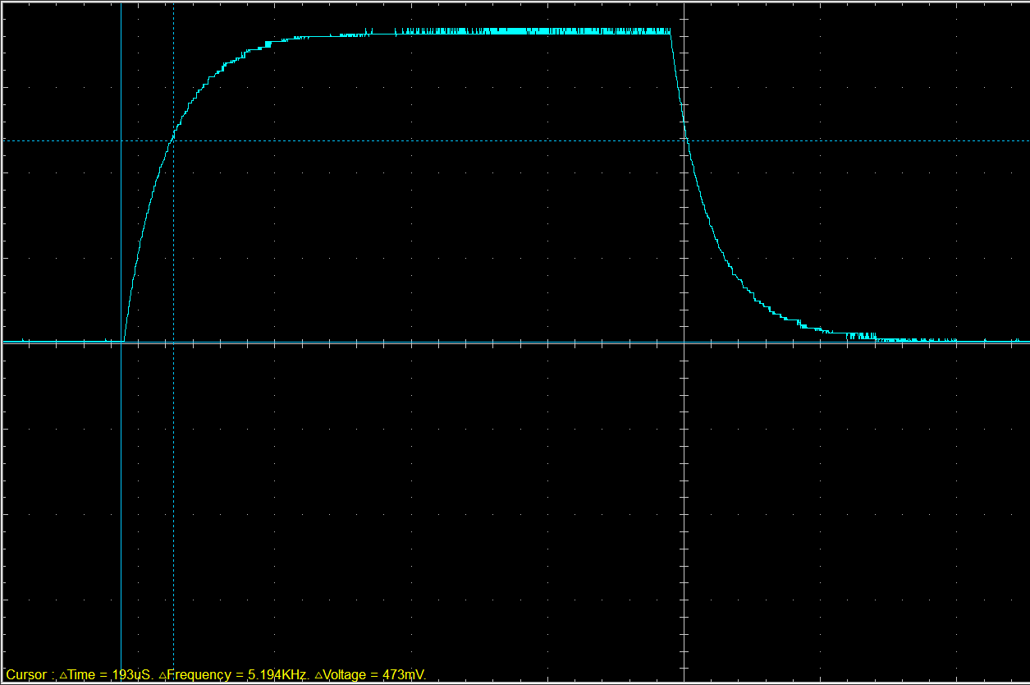
Figure 1 - Screenshot of Wave Form Charge with 63.2% of Peak Voltage Marked
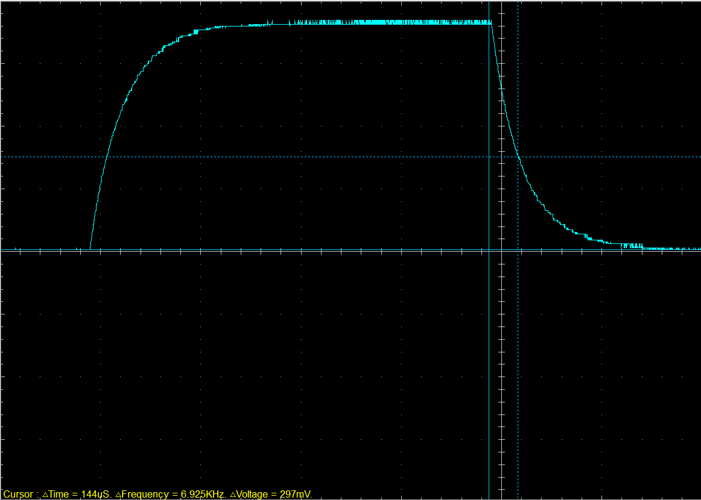
Figure 2 - Screenshot of Wave Form Discharge with 36,8% of Peak Voltage Marked

Basic Capacitor Calculations (3)
$$τ=RC$$
193x10⁻⁶ = 1.93x10⁻⁶ x 100
193x10⁻⁶ / 100 = 1.93x10⁻⁶ = 1.93 µF

Capacitor discharge table (2)
Time (s) | Voltage (V) | ln (V) | dy = y2 – y1  dy = ln(V)2-ln(V)1 | dx = x2- x1  dx = Time2 – Time1 | dy/dx
0.002178 | 0.7969 | -0.22703 | x | x | x
0.002194 | 0.7216 | -0.32628 | -0.09926 | 0.000016 | -6203.64
0.002210 | 0.6588 | -0.41734 | -0.09105 | 0.000016 | -5690.69
0.002226 | 0.6149 | -0.4863 | -0.06896 | 0.000016 | -4310.02
0.002242 | 0.5584 | -0.58268 | -0.09638 | 0.000016 | -6024.01
0.002258 | 0.5145 | -0.66456 | -0.08188 | 0.000016 | -5117.5
0.002274 | 0.4769 | -0.74045 | -0.07589 | 0.000016 | -4743.05
0.002290 | 0.4455 | -0.80856 | -0.06811 | 0.000016 | -4256.85
0.002306 | 0.4141 | -0.88165 | -0.07309 | 0.000016 | -4568.11
0.002322 | 0.3827 | -0.9605 | -0.07886 | 0.000016 | -4928.51

Plot log(V) Gradient (2)

Gradient = -2186.2

Gradient Calculations and Compare (4)

Gradient Calculations

Gradient Calculations – (1/5033.8) / 100 = 1.986x10⁻⁶

Comparison table
 | Capacitance | Delta | Percentage difference
Actual | 1 µF | x | X
Marker Calculation | 1.93 µF | +0.93 µF | +93%
Gradient Calculation | 1.986 µF | +0.986 µF | +98.6%
Marker calculation – 193x10⁻⁶ / 100 = 1.93x10⁻⁶

Capacitor Uses (5)

Power Supply Filtering

Capacitors smooth out voltage fluctuations in DC power supplies by filtering out ripple from rectified AC voltage.

Timing Circuits

Used with resistors in RC circuits to control timing delays (e.g., in indicator lights, wiper delays, or 555 timer circuits).

Signal Coupling and Decoupling

In audio and radio circuits, capacitors pass AC signals while blocking DC to separate stages without affecting biasing.

Energy Storage in Flash Cameras

Capacitors store and rapidly discharge energy to create the high-voltage pulse needed to power camera flashes.

Ignition Systems (CDI - Capacitor Discharge Ignition)

Motorcycles and some cars use capacitors to discharge high voltage into ignition coils for spark generation.

Power Factor Correction

In industrial electrical systems, capacitors improve power factor by offsetting inductive loads from motors and transformers.

Voltage Regulation in Automotive Alternators

Capacitors stabilize the voltage output from alternators and help reduce electrical noise.

Audio Systems (Crossovers and Amplifiers)

Used in crossover circuits to direct high and low frequencies to the correct speakers, and in amplifiers for filtering.

Battery Smoothing in Motorcycles

Capacitors help smooth out power delivery and reduce voltage spikes in battery-less or low-battery motorcycles.

Electric Vehicle Regenerative Braking

Capacitors (especially supercapacitors) store energy recovered during braking and deliver it during acceleration to reduce battery load.

Inaccuracies Question (4)
Discrepancies between calculated and actual capacitance values are common and can arise from various measurement inaccuracies. One major factor is component tolerance, which significantly affects accuracy. Most capacitors and resistors come with a manufacturing tolerance range (typically ±5% or more), influencing the expected RC time constant (RS Components, 2023).
Another contributing factor is oscilloscope probe loading. Connecting probes can inadvertently add resistance or capacitance to the circuit, slightly altering the waveform's behaviour (Tektronix, 2022). Additionally, pinpointing exact voltage levels, such as 63.2% during charging or 37% during discharging, can introduce human error in the analysis.
Other elements that impact measurement clarity and timing accuracy include signal noise, temperature variations, and inconsistent triggering on the oscilloscope (Keysight, 2023). Furthermore, limited oscilloscope sample rates or incorrect time base settings may distort the waveform or result in missed key transition points.
All these factors combined mean that deviations between theoretical models and practical measurements are to be expected and accepted in most laboratory conditions.

References
Electronics Tutorials (2022) Capacitor Basics. Available at: https://www.electronics-tutorials.ws/capacitor/cap_1.html (Accessed: 5 April 2025)
Keysight Technologies (2023) Common Sources of Oscilloscope Measurement Errors. Available at: https://www.keysight.com/ (Accessed: 5 April 2025).
ScienceDirect (2020) Capacitor Discharge Ignition. Available at: https://www.sciencedirect.com/topics/engineering/capacitor-discharge-ignition (Accessed: 5 April 2025)
RideApart (2019) Why Use a Capacitor Instead of a Battery?. Available at: https://www.rideapart.com/news/336709/capacitor-vs-battery-motorcycle/ (Accessed: 5 April 2025)
• RS Components (2023) Understanding Resistor and Capacitor Tolerances. Available at: https://uk.rs-online.com/ (Accessed: 5 April 2025).
• Tektronix (2022) How Probes Affect Your Measurements. Available at: https://www.tek.com/ (Accessed: 5 April 2025).

