ACADEMIC AND EMPLOYABILITY SKILLS
TERM TWO

Student Name: Iulian-Alexandru Dinu
Student ID: 1909113
Lecturer Name: Rita Ukachi-Lois
Module Name: Academic and Employability Skills
Module Code: BMSW4001

Introduction
This report aims to analyze the understanding and the importance of a few of the topics that we learn in the university and how they help us in employability and academic life.
The topics that are going to analyze give us an idea of how we need to act, speak, write, and think. We will speak about five topics, and we will reflect upon them, reaching a conclusion and see how they can improve and help us understand better the academic and employability skill.
The topics that we are going to analyze are the following.
- Summarising
- Paraphrasing
- Analytical and Critical Thinking
- Reflective Writing
- Writing a Cover letter.
The first topic that we are going to analyze is:
Summarising.
Summarising is an overview of an entire discussion, argument, or an article, the ideas or work of another writer in our work can summarise them in one paragraph by pointing the bullet points and facts using your own words.
Lots of people and students are summarising when it comes to a long material by using their own words and style and by cutting the example and the detail. Using summarise, this can save time to increase understanding and give credibility to work.
There are a few steps needed to take for a good summarise:
- Identify the key point, ideas.
- Take notes.
- Organize the ley point and ideas in a logical order.
- Link the ideas.
When you summarise is essential to have a good paraphrasing skill which is very important for a good and an understandable summarise for the readers.
Without paraphrasing, the summarise is not going to be concise and is not going to reflect the key points and the facts which need to reflect the original material
In the article above, we can see the reader took the main points and facts and add them to create a short summarise paragraph, which is easier to read and understand that gives the same information without the examples and details.

The next topic that we are going to analyze is:
Paraphrasing.
Paraphrasing is the skill that gives the ability to write down using own words, something that was said or written by other persons.
Using paraphrasing skill opens one's mind giving a better understanding of the reading and helping write it without copying, writhing down the same words similar to the original material.
Without paraphrasing, they can accuse the writer of unfair practice, which is copying the materials or phrases that are not written by others.
One of the skills that need to improve is that paraphrasing skills are not on the high ends.
The next topic that is going to analyze is
Analytical and Critical Thinking.
Analytical thinking is the skill that gives the ability to break down the problem in more pieces and analyze them bit by bit, allowing the reader to find solutions that can solve the problem that is facing.
If we look carefully, analytical thinking is a problem-solving skill that helps to find a solution to the problems we are facing. There are a few steps involved in the processes when we are using analytical thinking skills when we analyze a problem and find an adequate solution.
- Find and recognize the problems and issues that we are facing.
- Collect information about the problems and issues and organize them
- Put all the pieces of information together.
- After organizing all the pieces draw a proper conclusion
The benefit of having analytical thinking skills help shine in the eyes of the employer in the workplace and helps to do the job more accurately in less time.
Critical thinking is the skill that requires a disciplined Intellectually process of understanding, which allows to apply, analyze information that is generated by the knowledge, and experience which can reflect as a guide and action.
Intellectual values is a base of critical thinking such as good reason and being fair. The word Critical can mean thinking in different ways depends on the situation and context.
- Can refer such as something important
- Furthermore, criticizing something and point the negative aspects.
- Using critical thinking at university is about questioning the information, ideas, arguments that we find in the study.
Using critical thinking at university is about learning with an open mind, ask the right question when reading others work, we need to show that we can come up with different arguments which can improve our ideas and opinion.
Critical thinking is also the ability to reason, which means its better to be an active learner than a passive recipient of information. When we use critical thinking is thinking about things in different ways to find the best possible solution after we reach the best possible conclusion.
Moving forward, we will speak now about our next topic, which is Reflective Writing.
Reflective Writing.
When we speak about reflective writing, we can take into consideration Reflective thinking, the ability to look back at something that happened that can be an event or an idea. By using reflective writing, we can look back at something that happened or make our own story, by giving insights to the writer which can lead to a better understanding and learning.
Reflecting is a process created in our own minds, it is a long process of consideration of opinions that are coming by reflecting those we called them reflections.
When we are using reflective writing to write about a reflection, we need to use a few steps and factors that can help express it:
- Make sure we are mentioning what we are writing.
- Express how do we feel about our writing
- At the moment we are writing how are our emotions
- Furthermore, check our capability of writing reflectively.
There are multiple perspectives in reflective writing, which are essential, like personal experience, other resources, and evidence.
Why reflecting is so vital without reflecting on an experience or event, it is easy to forget and lose what we have learnt.
Gibbs (1988), “It is from the feelings and thoughts emerging from this reflection that generalizations or concepts can generate."(Gibbs, 1988).
With reflective writing, we have learned some frameworks that can help us understand better reflection and what we need to follow and apply.
Gibb's ' Reflecting cycle' (1988)
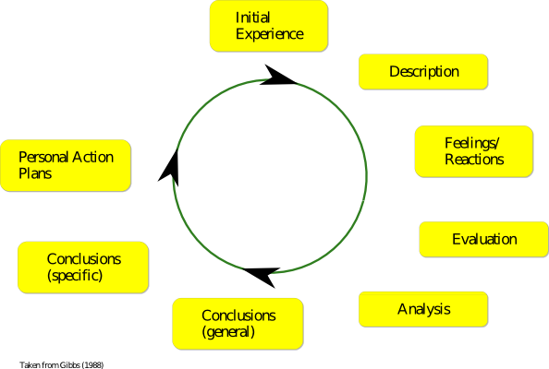
This cycle starts with a description. If the event happened and needs to conclude, just simply describe early.
Fallowed by the feelings and reaction at that moment, not the time for analyzing those at the moment
after we reach the point when we need to evaluate what was good or bad at the experience and try to make an excellent and valuable judgment.
Moving forward, we have the analysis here. We analyze the event and what happened, trying to reach a point where we can have a conclusion about what happened.
Then we have a general conclusion here, and you can understand what happens after we analyze the fact that happened in the event and what can lead to a conclusion.
Reaching a specific it is a work way and, a personal situation.
On the action plan is our reaction in a similar situation, and what we are doing differently, and which steps are we going to take.
Another framework is Kolb’s ‘Experiential Learning Cycle’ (1984)
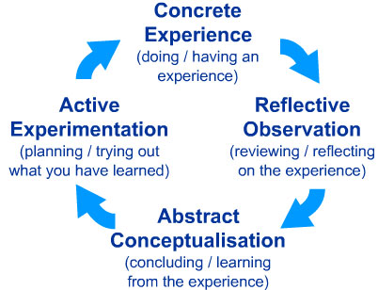

In Kolb's learning cycle, we will see that life is all about a new situation or a reinterpretation of an existing experience.
Reflective observation is about to reflect on the new experience and any inconsistencies between understanding and experience.
The Abstract Conceptualisation gives us new ideas after reflecting.
Active experimentation is when the learner applies to the world around them the hypotheses that he adopted effectively or new experiences that will support and challenge those hypotheses.
The next framework it is Driscoll’s Model (1994).
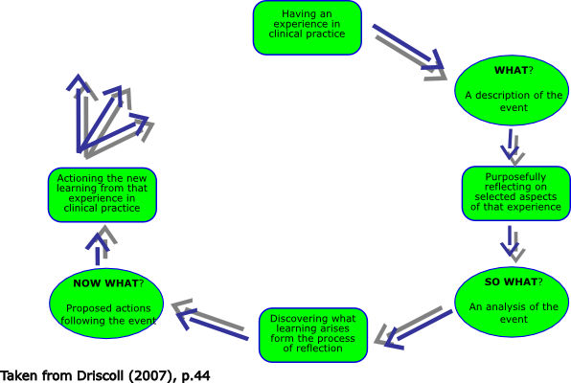
Driscoll's Model was adopted and further developed and matched Barton's (1970) with three stem questions.
What is the first question, it is the purpose of going back or returning to the event, what happened at the event, what did we do and see, the reaction that we had, what other people do, and what key aspects of this situation did we see.
Following the question, and how are your feelings at those times, what is the effect of our actions, which troubles you?
Using next question is now what is going to happen, and what are we going to do about the situation, what is going to happen if we decide to do nothing, and now what are our learning key points from this experience.
The next topic we are going to analyze it is:
Writing a Cover letter.
The covering letter is an extension of the resume providing additional information about themself, their skills, and experience and why they are the right choice for the position they are applying.
Most of the people are thinking that the cover letter is not essential, an optional not important document, but adding this covering letter to their resume can make a difference in obtaining the job they are applying.
Another important thing is to research the company they are applying, see their demands what they are looking for from the applying candidates.
Find what they are doing and why, find the goals that the company has, and make sure they specify how they can help them to achieve their goals.
Write an effective covering letter that needs to include a few essentials.
- The first thing they need to do is introducing yourself.
- Do not forget to write down the full name
- Be sure they are aware of the position they are applying for
- When is writing, the cover letter is like selling the skills, experience, abilities, and aptitude to the employers, making them forget about other applications and chose over them, making the perfect candidate for the position they are offering?
- Explain the previews experience and what they can do for the company.
Let them know that an interview is required.
Furthermore, do not forget to thank them for the time they are spending on reading the letter or email.

Conclusion
What we have learned from this report is that the skills mentioned above are essential for a better understanding of academic and employability skills.
Giving the ability to focus, think, from more points of view and perspectives, giving the ability to reflect upon arguments and events that happened and how to analyze them by using more methods.
Giving a better understanding and making it easier to reach a conclusion or a solution easier by using analytical and critical thinking as well as reflective writing.
Another thing we have learned is how to summarise and paraphrase, which are essential key points in a student's life.
By doing this, we have learned how to analyze by taking the key points from the arguments and studies, compact them so they can be easier to read and understand by the others.
From the cover letter skill analyzed above, we have learned what we can do have to write and the steps that need to obtain the desired job.

References

Bensley, D. A. a. S. R. A., 2014. Improving critical thinking skills and metacognitive monitoring through direct infusion. Think. Skills Creative, 12(55-68).

Cottrell, S., 2017. Critical reflection. Critical thinking skills. Effective analysis, argument and reflection. Macmillan study skills, 12(3), pp. 187-210.

Frankel, E., 2008. "Change in Education: The cost of sacrificing fundamentals". MIT Faculty Newsletter, May/June.pp. XX, 5, 13.

https://www.brookes.ac.uk/students/upgrade/study-skills/reflective-writing/, 2020. [Online]
Available at: https://www.brookes.ac.uk/students/upgrade/study-skills/reflective-writing/

https://www.csu.edu/humanresources/empdev/documents/AnalyticalThinking.pdf, n.d. [Online]
Available at: https://www.csu.edu/humanresources/empdev/documents/AnalyticalThinking.pdf
Johnson, R. H. a. H. B., 2015. A meta-level approach to the problem of defining “Critical Thinking”. Argumentation. Volume 29, pp. 417-430.

Marin, L. M. a. H. D. F., 2011. Pedagogy for developing critical thinking in adolescents: Explicit instruction produces greatest gains. Thinking Skills and Creativity, 6(1), pp. 1-13.

Marzano, R. J., 2010. The Art and Science of Teaching. Summarizing to Comprehend, 67(6), pp. 83-84.

