UWTSD MSc Sustainable Construction

Lloyd Sparkes – Climate Change
Alex Roberts – Energy Performance
Future Proofing Construction.

Case Study – Mount Pleasant Campus.
Grant Alden – Adaptation, Flexibility and Sustainability

“One of the things which we are searching for is a form of architecture which, unlike classical architecture, is not perfect or finite upon completion...We are looking for an architecture rather like some music and poetry which can actually be changed by users, an architecture of improvisation”

Sir Richard Rogers
(Building Arts Forum, 1991)

Contents
Figures 4
Appendices 5
Glossary 7
Executive Summary 10
UWTSD, Mount Pleasant Campus, Swansea 11
1. Introduction 12
2. Site Evaluation 13
3. Section 1 – Adaption, Flexibility & Sustainability. 16
3.1. Adaption. 16
3.2. Flexibility 19
3.3. Sustainability and Future Proofing 24
3.4. Adaption/Refurbishment potential at Mount Pleasant Campus 25
4. Section 2 – Energy Performance 28
5. Section 3 – Climate Change 46
5.1. What is Climate Change? 46
5.1.1. Effects of Climate Change? 46
5.1.2. Adaption to Climate Change 47
5.2. Solar Shading 47
5.3. Heating & Cooling 50
5.3.1. Building Fabric 50
5.3.2. Heating Systems 51
5.4. Renewable Energy Generation 51
5.5. Water Management 52
5.5.1. SuDS 52
5.5.2. Green Roofs 53
5.5.3. Permeable Paving 53
5.5.4. Rainwater Harvesting 53
6. Conclusion 54
7. References 55
8. Appendices 64
8.1. Appendix 1 – Levels of Biomimicry 64
8.2. Appendix 2 – AUDE Report: University Estate Management Data 65
8.3. Appendix 3 - IPCC Resilience Pathway 68
8.4. Appendix 4 – How Long Will It Last? 69
8.5. Appendix 5 – The Socio Economic Effects of Copper Mining in South America 70
8.6. Appendix 6 – Hazardous Materials Used in Silicon PV Cell Production 71
8.7. Appendix 7 – Electrochromic Glazing 72
8.8. Appendix 8 – Solar Thermal Cladding 73

Figures
Figure 1 A graphic illustrating the area of study. 8
Figure 2 Swansea Climate Data 10
Figure 3 Table of Building Information 11
Figure 4 100 Unintended Consequences of Increased Air Tightness 15
Figure 5 Brand's "6 S's" 16
Figure 6 Enablers for Resilient Buildings 17
Figure 7 BS7543:1992 18
Figure 8 Layering of Building Elements 21
Figure 9 Mount Pleasant Campus Interventions 23
Figure 10 Energy use in Higher Education Institutions………………………………………………………………………………………………..28
Figure 11 Projected wholesale gas prices……………………………………………………………………………………………………………………29
Figure 12 When PartL2B Building Regulations are applicable………………………………………………………………………………………29
Figure 13 Heat loss in a typical Higher Education Building……………………………………………………………………………………………31
Figure 14 Heat losses shown in a thermographic survey………………………………..……………………………………………………………32
Figure 15 Typical draft proofing measures……………………………………………………………………………………………………..……………32
Figure 16 Glazed curtain walling on George Thomson Block………………………………………………………………….……………………34
Figure 17 Double and triple glazed windows………………………………………………………………………………………………………………34
Figure 18 Single glazing, metal frames and mould growth seen on George Thomson Block…………………………………………35
Figure 19 Two options for solid wall insulation……………………………………………………………………………………………………………37
Figure 20 Lighting upgrades…………………………………………………………………………………………………………………………………………38
Figure 21 Kitchen Lighting……………………………………………………………………………………………………………………………………………44
Figure 22 A theoretical calculation to demonstrate life cycle costing for windows………………………………………………………47
Figure 23 - An Example of the Existing Solar Shading System at the Cadogan Technology Centre……………………………….48
Figure 24 - A graph of the Anomalies in the Average Temperature of the Earth……………………………………………….…………49
Figure 25 - An example of a Flectofin……………………………………………………………………………………………………………………..……28
Figure 26 - Example of the Films applied to the windows of the George Thompson Block & Library……………………………49
Figure 27- The Roadmap to Efficient Building………………………………………………………………………………………………………………50
Figure 28- Technische Universitat (TU) Automated Photovoltaic Integrated Wooden Lovrer System………………………….52

Tables
Table 1 Typical U-Values for windows….………………………………………………………………………………………………………………………33
Table 2 Inorganic, natural or organic insulation materials….………………………………………………………………………………………..36

Boxes
Box 1 BIM Survey Results………………………………………………………………………………………………………………………………………….42

Appendices

Appendix 1: Levels of Biomimicry
Appendix 2: AUDE Report: University Estate Data
Appendix 3: IPCC Resilience Pathway
Appendix 4: How Long Will It Last?
Appendix 5: The Socio Economic Effects of Copper Mining in South America
Appendix 6: Hazardous Materials Used in the Production of Solar PV Cells
Appendix 7: Electrochromic Glazing
Appendix 8: Solar Thermal Cladding
Appendix 9: Impact Life Cycle Costing Exercise Background Calculations
Appendix 10: DEC Advisory Reports

Glossary
Anthropocentric: Human centred ethical view of planetary systems, determining the uniqueness and importance of
human beings within the living world.
ARCOM : Association of Researchers in Construction Management
AUDE: Association of University Directors of Estate
Biomimicry: The word biomimicry traces its roots to the Greek words “bios”, which means life, and “mimesis”, which means imitate. There are three levels of biomimicry that can be achieved:
Level one: mimicking natural form – At this level, you’re not necessarily creating something sustainable, but mimicking shapes, patterns, textures, colours, etc.; replicating specific organic components without addressing how that organism functions or responds to and interacts with the wider world.
Level two: mimicking natural process – The second stage of biomimicry goes beyond form and looks at how that form is made, mimicking movement and articulation. This level of biomimicry looks at the organism as a system with specific behaviours.
Level three: mimicking natural ecosystem – In this third stage, design takes the whole ecosystem into account; looking beyond the organism and its behaviours to mimic how it interacts with the wider world (Sharman, 2016)
BIM – Building Information Modelling

Bio-mineralisation: growing colonies of bacteria that can develop into structures.
Biosphere: a term first used by the Viennese geologist Eduard Seuss, it has evolved through the work of Vernadasky (Vernadsky, 1926)to mean the global sum of all living things/ecosystems.
Bio-centric: an environmental/philosophical approach developed out of the work of Arne Naess, Aldo Leopold and Rachel Carson and has a less anthropocentric view of the world around us.
BMS – Building Management System

BRE: Building Research Establishment
BREEAM: a UK sustainability assessment method for buildings evaluation.
Brise Soleil: A form of solar shading technology (more information available in Solar Shading Chapter).
CABE: Commission for Architecture and the Built Environment.
Carrying Capacity: The ability of an eco-system to support an organism over a long time period.
CHP - Combined Heat and Power
CIBSE: The Chartered Institution of Building Services Engineers
CIRIA: The Construction Industry Research and Information Association
CO2: Carbon Dioxide.
DEC – Display Energy Certificate

Eco-centric: see Bio-centric.
Eco Retro-fit: post construction installation on low carbon, energy saving measures aimed at reducing carbon emissions over the operation lifetime of the building.
EES - Electrical Energy Storage
Elastic Deformation: the ability to deform from an existing shape and return to the original shape based on stored energy from the deformation.
Flectofin: A form of Solar Shading Device, that utilizes elastic deformation (more information available in Solar Shading Chapter).
Electrochromic Glazing: A type of “Smart Glass” that alters its opacity under certain stimuli
Futureproofing: As highlighted in this document, research would suggest that there is no widely accepted definition of this term recognised by professionals within the building industry.
Green roof: a living medium of plants/shrubs laid over a waterproof layer on top of a roof aimed at improving thermal performance, reducing run-off and improving biodiversity.
Green wall: a living medium of plants/shrubs in a vertical format, forming either part of the external envelope of a building or an internal wall. Used for improving biodiversity and internal air quality.
Greenwash: promoting the perception of environmental friendly improvement whilst not necessarily achieving the stated aims (considered “spin”)
HVAC: Heating, Ventilation and Air Conditioning
Integrated Photovoltaics: Photovoltaic technologies that are part of the structure of a component or object of a building.
IPCC: Inter-governmental Panel on Climate Change
Layering: the separation of building components into layers to facilitate greater flexibility in form and function thereby improving its resilience
LCA – Life Cycle Assessment

LCC – Life Cycle Costing

LED – Light Emitting Diode

Louver: A form of solar shading technology (more information available in Solar Shading Chapter)
Low-emissivity: the low transmission of heat energy from a surface.
M&E: Mechanical and Electrical services within buildings
MPC: Mount Pleasant Campus
PV: Photovoltaic
Retro-fit: Post construction interventions to improve performance or prolong the operational life of a building, often to comply with changing socio-economic changes.
SuDS: Sustainable Urban Drainage Systems
Topography: The natural contours of the landscape
Unintended Consequence: The (usually detrimental) effects of an intervention within a building that were not part of the intended purpose of the intervention.
UWTSD: University of Wales, Trinity St David
Vernacular: Architecture representative of a particular locality, style and/or material use – from the Latin vernaculus meaning domestic or native.
Zero Net Energy (ZNE): Used in construction fields to define the energy used in the operational life of a building, where energy consumed annually is equal of less than that produced by the building through renewable sources. This differs slightly from the term used by ecologists where the concept of net energy includes the production process for various materials used in the building (Hernandez & Kenny, 2010).

Executive Summary
This report makes recommendations for potential changes for how UWTSD can ensure their Mount Pleasant campus is suitable for future building users. The report focusses on adaptability, flexibility, sustainability, energy performance and climate change.
It illustrates how the existing buildings and their functions may be re-purposed or re-developed through the use of future proofing technologies and ideas. The study also illustrate how these interventions support the idea of sustainability and sustainable construction by improving resilience and follows the ethos behind the IPCC resilience pathway and how intervention can determine its long term resilience. It incorporates ideas on building adaption, ideas on flexibility and building layering whilst also looking at sustainability and suggest a number of future proofing solutions specific to this site and its buildings. It also questions whether future proofing building can succeed without reference to the wider environment and as such will critically evaluate some of the possible solutions and the hidden environmental costs of some materials.
For energy performance potential changes were found to include improving energy efficiency through improving building fabric, air tightness, insulation, glazing and lighting. However, in order to futureproof against intermittent energy supplies renewable technologies are required along with electric energy storage. A recurring theme relating to energy performance is one of inertia in the construction sector and this inertia is a barrier preventing future building users from being protected against different energy futures.
There is evidence that the global temperature is trending towards increase. Therefore, this report includes recommendations for the UWTSD Mount Pleasant Campus with regards to “futureproofing” the facility against the potential effects of climate change to ensure its performance for the use of future generations. These include measures for adaption such as the implementation of Solar Shading, Heating and Cooling Systems and Renewable Energy Generation. This report also provides an explanation of what climate change is, as well as its associated impacts. Also, discussed within this report is the potential to improve the existing fabric of the Mount pleasant campus, such as the single glazing of the George Thomson Building, before implementing any additional adaptations for “futureproofing” for example, the use of further Solar Shading devices. In addition, the effect of climate change in relation to rainfall is also discussed, as well as systems for its appropriate management such as Green Roofs & Walls, Rainwater Harvesting, and Permeable Paving. The findings of this study concluded that there will likely be a requirement to adapt existing buildings to cope with the higher temperatures and rainfall of a future climate, as well as the fact that there is no definitive definition of the term “Futureproofing, recognised within the building industry. Further to this, the study also concludes that there is further research required to establish the effect of climate change on the availability of solar resource and its capture.

UWTSD, Mount Pleasant Campus, Swansea

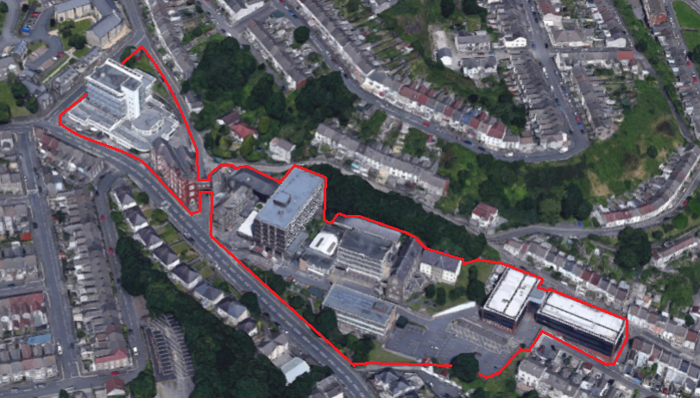
Figure 1- A graphic illustrating the area of study: (Google, 2016)

Introduction
The British University estates sector is comparable in turnover to the biggest companies operating in the UK, with a turnover of £27.3b, putting it in fourth place behind Tesco, Vodafone and SSE (Holmes, 2014).
Maintenance alone accounts for 2 billion pounds per year and the estate equates to 14,300 m² in 2015 – an increase of 200,000 m² from the previous year (Association of University Directors of Estates (AUDE), 2016). As such it is well placed to play a leading role in efforts to reduce carbon emission and improve sustainability in the construction and maintenance sectors – see Appendix 2 for further data.
This study specifically looks at University of Wales Trinity Saint David UWTSD) Mount Pleasant Campus, with the intent of providing a critical analysis or review, with regards to the three topic areas described below. The three areas discussed encompass a range of themes, and in terms of futureproofing Mount Pleasant, complement each other. This report aims to make recommendations for potential changes that could be made in the coming years to ensure the building is suitable for the needs of future users. The report is split into three sections, namely:
- Adaptability, flexibility and sustainability
- Energy performance
- Climate change
The three sections above appear in the futureproofing literature, futureproofing is a term which is focussed on ensuring the needs of future building users are met – however it is poorly defined and there is disagreement on its meaning (Georgiadou et al., 2012).

Site Evaluation

The site is located on the southeast slope of Townhill overlooking the city of Swansea and is positioned at 150 metres above sea level.
The climate is warm and temperate and Swansea has a significant amount of rainfall during the year – recently measured at over a metre annually – see monthly average table for the period 1981-2010 below:
Month | Max. temp  (°C) | Min. temp  (°C) | Days of air frost (days) | Sunshine (hours) | Rainfall (mm) | Days of rainfall >= 1 mm (days) | Monthly mean wind speed at 10m (knots)
Jan | 8.0 | 4.0 | 3.0 | n/a | 95.5 | 15.0 | 15.5
Feb | 7.8 | 3.6 | 3.3 | n/a | 67.0 | 11.0 | 14.3
Mar | 9.5 | 4.8 | 0.7 | n/a | 72.9 | 13.5 | 13.9
Apr | 11.9 | 6.3 | 0.1 | n/a | 58.5 | 10.6 | 12.2
May | 15.0 | 9.2 | 0.0 | n/a | 62.8 | 10.3 | 12.4
Jun | 17.7 | 11.8 | 0.0 | n/a | 63.8 | 9.9 | 10.8
Jul | 19.6 | 13.9 | 0.0 | n/a | 71.9 | 10.1 | 11.7
Aug | 19.7 | 14.0 | 0.0 | n/a | 83.9 | 11.2 | 11.8
Sep | 17.8 | 12.4 | 0.0 | n/a | 77.4 | 11.4 | 12.9
Oct | 14.4 | 9.9 | 0.0 | n/a | 123.1 | 15.4 | 15.1
Nov | 11.1 | 6.9 | 0.3 | n/a | 112.1 | 15.0 | 14.3
Dec | 8.7 | 4.7 | 2.3 | n/a | 110.3 | 14.4 | 15.4
Annual | 13.5 | 8.5 | 9.7 | n/a | 999.2 | 147.9 | 13.3
Figure 2 : Swansea Climate Data
As a largely maritime climate, it has a preponderance of cloudy, wet and windy weather conditions and this climate and elevation means the buildings at the site are likely to suffer any increased risk of extreme weather events due to climate change.
The site itself is made up of 11 buildings of varying ages, totalling 21,496 square metres gross internal area, spread over a six acre site. (Fildes, 2015)
The site has been an educational establishment since the creation of a purpose built grammar school in 1853. The grammar school vacated in 1952 at which point all buildings on the site came under the control of Swansea Technical College, then Swansea Metropolitan University and most recently UWTSD
Over the last 164 years, there have been numerous phases of development incorporating remodelling, refurbishment, demolition and new construction.
For the purposes of the case study it has been decided to evaluate three building phases representing the various stages of development of the site over the last 164 years. They typify the building styles and construction types found at the campus and illustrate the problems and challenges (and opportunities) in prolonging the life of the buildings (CABE, 2009).
These phases are laid out in the table below:
Victorian
Adeilad Dylan Thomas
Composition | Stone walls, slated roof, new aluminium fenestration, and new mezzanine floor. Grade 2 listed.
Building Erected/Cost | 1852/1869
Architect/Design Style | T. Taylor, London/Gothic  Surviving cross-range by B. Bucknall, Swansea/Gothic
Gross Internal Area | 1,056m2/11,367ft2
Substantive Works | Completely refurbished from derelict 1997
Listings Status | Grade 2 listed on 26.07.84 and amended 30.03.1987 [CADW reference 11596]
Red Brick Building
Composition | Basement and three storeys fenestrated red brick listed elevations on three sided, fourth side rendered, r.c. floors and double pitched roof. Grade 2 listed
Building Erected/Cost | 1937
Architect/Design Style | Charles A. Broadhead, Borough Architect (1917) + Ernest E. Morgan, Borough Architect (1936) /Tudor Gothic
Gross Internal Area | 1,379m2/14,843ft.2
Substantive Works | None
Listing Status | Grade 2 listed on 30.03.1987 [CADW reference 11597].
1960’s
George Thompson Block
Composition | Basement plant rooms and three storeys, r.c. frame and floors, galvanized steel curtain walling and rendered brick cladding, both flat and pitched roofs. Built on the land that the original Grammar School building stood in – destroyed during World War II.
Building Erected/Cost | 1960
Architect/Design Style | H.T. Wykes, Borough Architect
Gross Internal Area
Substantive Works | Original pitched roof overlaid with steel in the early 1990s; Refectory completely refurbished, including Upvc windows 1993; first floor area reduced by removal of Staff Dining area to conversion to offices 1994; Lower Refectory completely refurbished 2007
Cadogan Block
Composition | Basement and six storeys, r.c. frame and floors, flat roofs
Building Erected/Cost | 1963 (1)
Architect/Design Style | H.T. Wykes, Borough Architect (1)
Gross Internal Area | 4,149m2/44,661ft2
Substantive Works | Complete external re-clad using aluminium curtain walling over an insulated block work substructure 1999
1970’s
Main Admin Block
Composition | Basement plant rooms & six storeys, r.c. frame and floors, galvanized brick and curtain wall cladding, flat roof
Building Erected/Cost | 1972
Architect/Design Style | J.W. Gwilliam, City Architect
Gross Internal Area | 4,826m2/51,947ft2
Substantive Works | Repairs to external concrete floor edges 2006; roof covering replaced 2009
Figure 3: Table of Building Information
The ad hoc nature of the development of the campus alongside rather incongruous conjunctions between some buildings means the any holistic development of the existing buildings would be problematic but not insurmountable.
Given the long history of education at the site and in particular its association with building and construction fields a continued presence at the site would be desirable if the buildings themselves could be assured of physical longevity through efforts to prolong the lifecycle of the buildings.
The site is fairly indicative of educational estates in its mix of buildings and the study can be illustrative of the national challenges being faced by the educational sector and beyond.
We will also highlight some of the theoretical issues surrounding the sustainability of continual and continued growth of cities and populations and whether this can ever be classed as future proofed or truly sustainable.

Section 1 – Adaption, Flexibility & Sustainability.

Adaption.

“Almost no buildings adapt well. They’re designed not to adapt......But all buildings adapt anyway...”
(Brand, 1994)

There are two basic approaches we can take in addressing the problem of future proofing our buildings:
- install “eco” low carbon measures in existing buildings
- Or demolish and construct new buildings (or as is more likely, a combination of both).
This question can apply to both the domestic and non-domestic sector and has been addressed by a number of studies (Power, 2008) (Crawford, et al., 2014) (Plimmer, et al., 2008)
How we decide on the way forward is not always a straight forward decision – we must understand how a building is performing (Bin & Parker, 2012) (Gul & Patidhar, 2015), how that can be improved and what is appropriate (National Occupational Standards, 2013). This begs the question of what we are measuring, how we measure and the extent to which we understand a building’s pathology (Edwards & Townsend, 2011).
In addition, we should not look at individual buildings in isolation, but rather as parts of the wider community having economic, commercial, historic, social and psychological importance to the towns and cities in which they are sited. (Yung & Chan, 2012), (Plimmer, et al., 2008), (Bullen & Love, 2010) and how infrastructure fits into the picture (DEFRA, 2013).

Putting their Grade II listing aside, if we look at the two Victorian buildings on the site, there may be the perception that they will not perform as well as more modern buildings on the site and that it would be better to construct new buildings that would perform better.
However, a number of studies, (Wallsgrove, 2008) (The National Trust For Historic Preservation, 2012) suggests that older traditional buildings perform far better than some more modern buildings and in fact may be better placed to face the challenges of climate change due to the type of construction, materials used, and heavyweight fabric – a report by Robert Adam Architects shows traditional heavyweight facades with lower amounts of glazing are better suited to rising temperatures and tackling overheating problems due to thermal mass and reduced solar gain (Robert Adams Architects, 2008).
For the purposes of this report we will suggest that refurbishment or adaptive re-use is the more sustainable option as opposed to demolition and new build, as it offers less waste (Letcher & Vallero, 2011), more sustainable city centre rejuvenation potential (Pickard, et al., 2004) (Whelan & Moore, 2016) (Tweed & Sutherland, 2007), is less resource intensive (Yung & Chan, 2012) (Weiler, et al., 2017) (Gaspar & Santos, 2015) and supports cultural capital and social cohesion (Throsby, 2002). However, we must bear in mind the problems presented by political economic incentives (Dowson, et al., 2012) – for example the VAT position on refurbishment and repair.
As a rule of thumb, new builds tend to be 50% labour and 50% materials whilst rehabilitation or renovation tends to be 60-70% labour (Rypkema, 2006). This is beneficial for local economies on 2 levels –local trades people/personnel are more likely to be used, who then go on to spend this money in other local businesses and shops, thereby improving the sustainability and resilience of communities and creating small localised circular economies.

From this we postulate that refurbishment and redevelopment of the buildings is the most sustainable way of future proofing the buildings and the most sustainable pathway to future proofing our buildings incorporates the following principles:
- Less use of materials (Cassar, 2009)
- Improves resilience of local economies (Rypkema, 2006)
- More economic than new build (United States Department of Defence, 2013) (Rios, et al., 2016)
- Less destructive to social cohesion - retains cultural and social significance, improves resilience, and promotes sustainable urban development (Power, 2008) (Tweed & Sutherland, 2007)
- More vernacular less globalised development, as vernacular buildings tend to use indigenous materials, have not been transported over large distances, and are climatically suited to their environment (Carroon, 2010)
- More sustainable (Bin & Parker, 2012)
- Less demands on environment/resources (Bin & Parker, 2012) (Giljum, et al., 2017)
- Promotes holistic thinking through life cycle analysis (Ardente, et al., 2011) (Kamali & Hewage, 2016)
- Solution need to be bespoke– no “One Size Fits All” approach (Ma, et al., 2012) (Menassa, 2011) (Genre, et al., 2000) and include accurate cost evaluation data (Caccavelli & Genre, 2000) (Fennell, et al., 2016)
- Critically evaluate materials availability for low carbon technologies – many rare metals are as the name suggests are not widely available or present in large quantities in the natural environment. This will be problematic if we assume that we can construct our way out of the problem (Speirs, et al., 2014)
- More considered material selection – sourcing renewable materials from sustainable sources (Malakahmad, et al., 2016) or using waste materials instead of new ores (Bribian, et al., 2011)

The buildings that exist on site whilst perhaps not performing as desired or required, all are structurally sound and with the correct type of adaption could continue to function for many years to come. To do so however, we need to fully understand how they function now and what will be required of them in the future. Understanding building pathology is important for without a full understanding interventions can create future problems. As such, unintended consequences can threaten the performance and functionality of the building. (Shrubsole, et al., 2014)

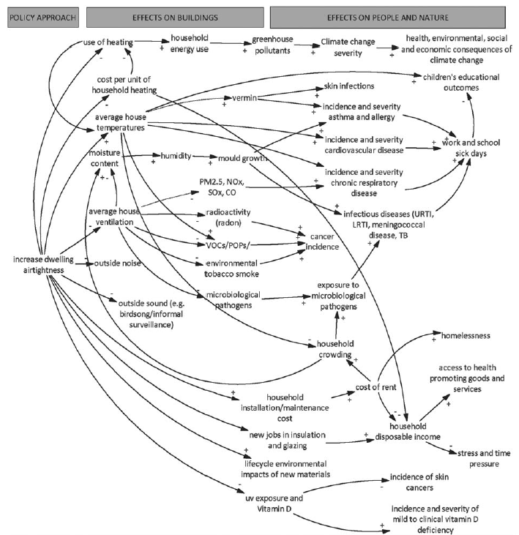

Figure 4 - 100 Unintended Consequences of Increased Air Tightness (Shrubsole, et al., 2014)

Flexibility

“A building properly conceived is several layers of longevity of built components”
Frank Duffy.

Societies change over time and the requirements demanded of buildings also change in form, function and performance. This demands an element of flexibly from our buildings.
It therefore follows that to prolong the lives of our buildings we need to invest in improving the flexibility of our built environment (Vimpari, 2016) (Gosling, et al., 2008) – particularly in education in an effort to improve engagement and approaches to learning (Jones, et al., 2016) (Watson, 2007)
Little investment is made in flexibility due to weighing of initial costs against life cycle costs – capital expenditure versus operational expenditure (Geraedts, 2001)
In an effort to improve buildings flexibility, Stewart Brand (Brand, 1994) suggested an approach which looked at the “six S’s” (which itself was developed from Duffy’s “four S’s” of Shell, Services, Scenery and Set) – see table below:

Site | The physical setting of the building. Elevation, climate, geography, geology, topography, alignment, orientation, interconnectedness and infrastructure all come into play. Future proofing perhaps demands more considered selection – flood risk, coastal erosion, population pressure, infrastructure capacity. This the bedrock upon which the other elements are based and most long lasting.
Structure | The load bearing elements - foundations, frame or walls. Methodology and material selection both play an important role in the longevity of the structure. Very rarely does the structure become the main cause of obsolescence.
Skin | The envelope or external surfaces of the building.
Services | The working parts of the buildings - heating, ventilation and air conditioning (HVAC). The cardiovascular and respiratory systems following the biological analogy suggested by Brand. Tends to require more regular renewal than the previous layers.
Space plan | The internal layout of buildings represented by internal wall divisions, floors and ceilings.
Stuff | The accoutrements of the function of the building – furniture, machinery, equipment, appliances etc.

Figure 5 - Brand's "6 S's"

More recently, Ross et al have developed this idea further with strategies for creating more resilient buildings through flexibility enablers (Ross, et al., 2016) - see table below:

Eleven Strategies (enablers) for creating adaptable buildings resistant to obsolescence
Layering | Building elements will deteriorate at different rates thereby necessitating replacement at different rates. By separating the physical and functional components of a building, we allow for the maintenance, adaption or replacement of those components with minimal interference of the other building elements.
Accurate Information | This is where BIM can play a major role in improving the longevity of buildings. By having accurate data on the history and current performance of a building and its services, building professionals can make considered and timely decisions based on accurate data.
Reserve Capacity | This applies most readily to the elements of a building that are replaced least frequently such as the structure and foundations of a building. Having reserve capacity can ensure that changes to the function of the building, or increased legal or natural demands (for example climate change) can be accommodated and thereby increases the buildings resilience.
Design for Deconstruction | This facilitates the direct re-use of components rather than recycling (and the extra energy/resources that entails) so greater consideration needs to be given to connections between materials and composite materials to ensure disassembly is as easy as possible. Maintenance or refurbishment also needs to ensure that the re-use of materials is not compromised by interventions/upgrades – for example drilling large holes through components that could have a detrimental effect on its future usefulness.
Mechanical connections | Welded and glued fixings can be difficult to de-construct as can concrete embedded steel stud fixings, so thought needs to be given to the type of connections used between different building elements, with mechanical connections being the preferred method.
Access for Assessment | The lifespan of M&E services can be a lot shorter than the structural elements that house them so they should be situated in a way that facilitates they’re easy inspection and replacement if necessary. Remote sensing and health surveillance can also aid the facility manager in this regard.
Simplicity | This creates a more easily understood building structure and pathology and makes future adaptations more straightforward. It can also lead to less waste in initial construction. Repetition of layout and grids can also assist in making future interpretation of the building – see modularity.
Commonality | This can be defined as using the same component sizes and construction details throughout a building, reduces uncertainty and makes replacement and adaption more efficient through universality of components.
Modularity | To distinguish modularity from commonality, it is defined as the standardization of  Components sizes and interfaces; meanwhile, commonality involves the number of different types of components and modules. Thus, a building can have a high degree of modularity and a low degree of commonality if it is built entirely of standardized modules and interfaces, but each module is different.
Appropriate Materials | There are a number of aspects to material selection: durability; toxicity; sustainability of resource, how easily it lends itself to re-use – for example composite materials should be discouraged due to the difficulties in deconstructing them.
Open Plan Layouts | This where the design element can influence a buildings resilience, flexibility and longevity. Open plan layouts, free of structural, mechanical, and other obstructions, allow for adaptation of interior spaces with reduced or no impact on the existing structure and systems. This is why warehouses and to a lesser extent barns which have large open spaces that are easily sub-divided are often converted. They have little complications for the re-modeller as there are few obstructions and are a classic example of the layering system discussed earlier.

Figure 6 - Enablers for Resilient Buildings
Layering of Building components and systems – allows for separation of elements allowing for upgrading of systems that may require replacement at different rates/times. Embedding layers together may appear cost effective initially, but is quite the opposite over the long term.
So in terms of strategies for flexibility and resilience we should follow a number of different steps:
- Integrate the design of installation systems into the structural building design
- Avoid using penetrating connections between support structures & installation systems
- Keep support structures disconnected from infill elements
- Base the structural design for construction and installations on a maximum partition plan
- Make the support structure partition-able
- Set specific requirements for the interconnection of construction and installation components
- Use modular co-ordinated systems
- Make construction and installation components readily accessible
- Provide local (individual) and central measurement and control facilities
- Ensure that there is surplus capacity
- Restrict distribution facilities and ducts
- Make removable user facilities
- Understand the human factor
(Geraedts, 2001)
Category | Description | Life | Typical Examples
1 | Replaceable | Shorter life than the building life and replacement can be envisaged at design stage | Most finishes and service installation components
2 | Maintain | Will last, with periodic treatment, for the life of the building | Most external cladding, doors and windows
3 | Lifelong | Will last for the life of the building | Foundations and main structural elements

Figure 7 : - BS7543:1992 (British Standards Institute, 1992)

AS BS7543:1992 highlights, building elements undergo different rates of change and these differentials in deterioration underpin the principles of layering as discussed by Brand and Duffy (above) and Bullen and Slaughter (below). Layering or dividing building elements allows those responsible for buildings to maintain, adapt and upgrade these layers without affecting (or terminally damaging) other layers (Arge, 2005). This has led to the “Open Building M ovement” advocating building design, construction and maintenance that allows for this layering of building elements according to their functional lifecycles (Gosling, et al., 2013).

The system should take account of a broad range of influences in the decision making process:

“cultural significance, life cycle assessment, heritage significance, sustainability benchmarks, economic sustainably, environmental sustainability, social sustainability, value to local community, orientation of building, influence on local economy, technical ability of the building to adapt and stakeholder views”
(Bullen & Love, 2010).

Another element of flexibility to consider is that of over loading, over engineering or designing for worst case scenarios. Slaughter suggests three types of changes to occur within buildings which can affect its functionality:

- Changes in the function of the space
- Changes in the load
- Changes in the flux of people and forces from the environment
To ensure a high degree of flexibility for such scenarios Slaughter suggests built in overcapacity allied with layering and pre-fabrication (Slaughter, 2001). The reason that many Victorian structures still survive in the UK is that many were over-engineered and used heavyweight hard wearing and long lived materials. Perhaps without actually labelling it as such, they were future proofing their buildings and infrastructure.

Other processes and ideas that should also be considered:

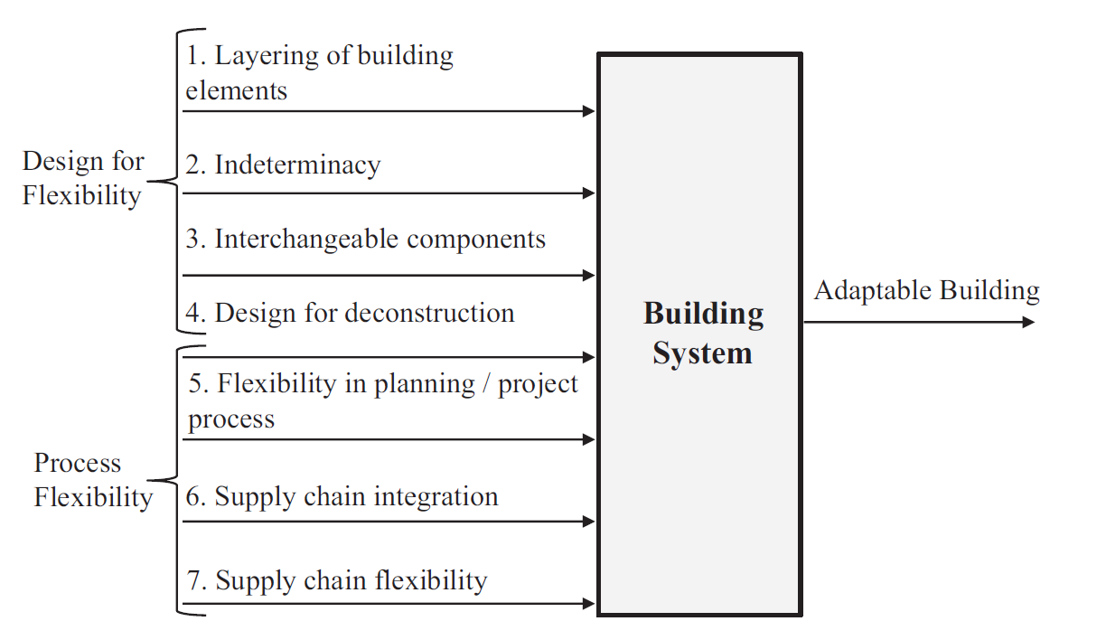

(Gosling, et al., 2013)

This is further elaborated upon by Gosling below (Gosling, et al., 2013):
Layering of Building Elements | As discussed previously: The Open Buildings movement conceptually separates a ‘base-building’ and its interior ‘fit-out’, which should be able to be installed or changed with a minimum of interface problems, therefore enabling the building to adapt to user’s preferences over time  (Kendall & Teicher, 2000).
Interdeterminacy | Schneider and Till (2005a, 2005b) categorise designs as either ‘hard’ or ‘soft’. Hard designs refer to configurations and constructions that more specifically determine the way the building is to be used over time. Soft designs refer to tactics that offer indeterminacy of use, allowing the user to adapt the plan according to their needs. The authors argue that soft use and soft technologies are facilitators of flexible buildings, and that houses should be based on the idea of the ‘incomplete building’ where a basic frame leaves space for personalised interpretation of the user.
Interchangeable Components | Slaughter (2001) suggests the use of interchangeable system components as a strategy for facilitating adaptability. This approach has been seen to be very effective in commercial office design, where the need for adaptability and flexibility are well understood... Office systems highlight how modularity needs to be considered in relation to creating adaptable designs. Prefabrication and standardisation of systems is also beneficial in providing adaptability of services (Webb et al., 1997).
Design for Deconstruction | Regardless how layered, indeterminate and standardised a building design is, it can only be adapted easily if the integration of the components allows for the component removal from the  building... The importance of the integration of building systems to provide adaptable  systems is also identified by Slaughter (2001) who suggests reducing intra-system interactions, improving physical access to systems and providing dedicated system zones, are strategies to maximise adaptability.
Flexibility in Planning / Project Process | Bordass and Leaman (1997) suggest that successful strategies for the future of a building require a well developed briefing process, with due care and attention given to the future needs of users. Key considerations at the briefing stage include context, qualities, implications, assumptions, requirements and expectations. Saari, Kruus, Hamalainen, and Kiiras (2007) highlight the importance of systematic management of flexibility in construction projects. This includes flexible programming and briefing, which includes advance planning for modifiable spaces. Bullen (2007), via a survey of building owners in Western Australia, identified the following factors that should be considered during the decision process: cultural significance, life cycle assessment, heritage significance, sustainability benchmarks, economic sustainably, environmental sustainability, social sustainability, value to local community, orientation of building, influence on local economy, technical ability of the building to adapt and stakeholder views.
Supply Chain Integration | Supply chain integration refers to the level of collaboration between the different members involved in construction supply chains. The supply chain integration thesis argues that all these decision makers need to work together through collaborative mechanism to effectively  Deliver adaptable buildings. Hodges (2005) highlights the importance of the facilities managers in that they bridge the gap between the different phases of the building life cycle, suggesting  that supply chain integration is important well beyond the initial construction phase of a building. The total cost of ownership should be considered early in the project process, and all parties should contribute to ongoing management of the total cost of ownership.
Supply Chain Flexibility | Gosling, Purvis, and Naim (2010) investigate how organisations in the construction industry can configure their supply networks to achieve supply chain flexibility. This can be rationalised by  considering two key antecedents of flexibility, sourcing and vendor flexibility. Sourcing flexibility consists of four ‘abilities’, which include the ability to reconfigure the supply chain, the ability  to adapt to market requirements, the ability to increase supplier responsiveness and the ability to integrate the supply chain. Vendor flexibility includes the combined flexibilities offered by  manufacturing, transport and warehousing links within the supply chain. This determines how responsive the range of companies involved in the lifecycle of a building are to changing requirements.
Figure 8 - Layering of Building Elements

Sustainability and Future Proofing

“The greenest building is the one already built”
(Elefante, 2007)

Brand states: “The whole idea of architecture is permanence.” (Brand, 1994)
This may be true of modern architecture but does not necessarily fit with the whole of human experience – vernacular architecture from around the globe involves semi or non-permanent structures built from materials that grow or exist in the immediate vicinity. Due to the peripatetic nature of some societies there is less requirement for permanence from the built environment and even if the locality of the buildings remains constant the buildings themselves do not, being constantly renewed through the replacement of the construction materials: wood, mud, hides, ice.
As the materials were/are renewable and within the carrying capacity of the local biosphere they became the ultimate sustainable buildings – the local vernacular. This perhaps suggests a way forward.
This is not to say that we all have to live in adobe huts (although cob is still be used for new builds even today) merely that this relationship between our built environment and the ecological environment needs to be re-invigorated so that we design and build within the biospheres carrying capacity (Bjorn, et al., 2015) (Wei, et al., 2016) (Giljum, et al., 2017) and that resilient vernacular design that takes account of local climatic conditions are not lost in the globalisation of architectural practice (Ansari & Goel, 1983) (Bouillot, 2008) (Dipendra, et al., 2016). Materials selection plays an important role in this area as de-carbonising the construction sector will go a long way to facilitating decarbonisation of the wider society. To this end traditional and vernacular materials can be integral to this aspirational change (Godwin, 2011).
The metabolic rate of our cities is one of the key drivers of environmental degradation (Mora, 2007). With current forecasts that urbanisation will continue to rise we need to ask whether this is sustainable.
Even renewable industries such as solar photovoltaic’s may ultimately be unsustainable as components are made from rare metals such as indium and gallium which some estimate have as little as ten years resource left (Cohen, 2007) (Martinez, 2016) – see Appendix 4. Wind turbines and tidal generators and hydro are all users of large amounts of copper and other raw materials which itself has adverse environmental and socio-economic effects in other parts of the globe – see Appendix 5.
Any efforts to future proof our buildings must be incorporated into a wider effort to future proof our societies and economic structures – continued growth is unlikely to be sustainable on a finite planet (Heinberg, 2007) (Jackson, 2009) (McKibben, 2007). By concentrating on just our buildings we merely export the environmental costs, hiding externalities behind “greenwash”.
This critique notwithstanding, the report will illustrate how the site has potential for improved resilience and longevity through the application of future proofing interventions.

Adaption/Refurbishment potential at Mount Pleasant Campus

Victorian
Adeilad Dylan Thomas
Site | Sustainable – close to city centre and transportation routes, no risk of flooding or inundation from sea level rise. Elevated elevation makes it more susceptible to extreme weather events such as high wind loads and driven rain (water ingress) (Laycock & Wood, 2014).
Structure | Existing structure is constructed of heavyweight, and durable materials (stone) from original construction and will therefore have high thermal mass and could mitigate the effects of warmer temperatures forecasted by global warming.
Skin | The building envelope is constructed of stone and slate with modern aluminium fenestration which all lends itself to a resilient and hard wearing skin that weathers well with age and maintains an attractive appearance over time – aesthetics playing a role on the longevity of some buildings (Brand, 1994). More energy efficient glazing could improve this further.
Services | Services originally install at time of refurbishment in 1997. Due to original derelict nature of the building, despite its listing status, it lends itself to a “layering” approach for installation of new services.
Space Plan | As the original lay out is no longer sustained following the 1997 re-fit, it offers flexibility of spacial re-design following the Open Building movements ideas.
Stuff | Urban mining offers potential saving through re-purposing and re-use (UK Green Building Council, 2016) Removable or plug and play facilities.
1960’s
George Thompson Block
Site | Sustainable – close to city centre and transportation routes, no risk of flooding or inundation from sea level rise. The elevated position makes it more susceptible to extreme weather events such as high wind loads and driven rain (water ingress). However, it also offers potential for exploitation wind resources through wind turbines (Lu & Sun, 2014) or even facade integrated turbines (Bayoumi, et al., 2013) alongside solar photovoltaic’s / hot water and green roof technologies.
Structure | Reinforced concrete frame and floors offering some thermal mass potential and steel curtain wall – durable structure lending itself to a more flexible special plan if required. Its performance likely to be more reliant on the materials and systems used for the external envelope when compared to the Victorian buildings.
Skin | Rendered brick cladding and a high percentage of envelope given over to steel frame fenestration which is performing poorly as Alex will illustrate. There is great potential for improved energy performance through re-cladding and improved window systems. The introduction of solar photovoltaic / thermal cladding (O'Hegarty, et al., 2016) would be beneficial given the front elevations south westerly facing alignment. Or a green wall solution would offer a wider interpretation of future proofing through increased biodiversity and more natural materials for solar shading and protection/insulation of the building envelope providing a more “sustainable” solution. Flat roofed areas may lend themselves to green roofing solution in tandem with solar photovoltaic areas. Green roofs can also lead to less overheating (up to 1.5°C) and reduce peak water discharge by 24% relative to impervious roofs (Kok, et al., 2013) Lower thermal mass potential than the Victorian building suggests the introduction of phase change materials may mitigate against overheating which is being addressed by Lloyd.
Space Plan | The concrete frame construction method would lend itself to adaptive re-use and remodelling of spaces. The limited number of load bearing walls internally provides for layering of the building following the open building movement tenets.
Stuff | Urban mining offers potential saving through re-purposing and re-use (UK Green Building Council, 2016) Removable or plug and play facilities.
1970’s
Main Admin Block
Site | Sustainable – close to city centre and transportation routes, no risk of flooding or inundation from sea level rise. Similar to the George Thompson block, its elevation makes it more susceptible to extreme weather events such as high wind loads and driven rain (water ingress). Also makes it good site for exploitation of wind turbines – with the possibility of also incorporating integrated exhaust air duct (Park, et al., 2016). and solar photovoltaic’s/hot water and possible green roof.
Structure | Reinforced concrete frame and floors offering some thermal mass potential and steel curtain wall – durable structure lending itself to a more flexible special plan if required. Performance more reliant on the material and systems used for the external envelope. Repairs to external floor edges in 2006 suggest localised failure of concrete (spalling).
Skin | Rendered brick cladding and a high percentage of envelope given over to steel frame fenestration which is performing poorly. Potential for some re-cladding and improved window systems. Green wall solutions or solar photovoltaic cladding given the front elevations south westerly facing alignment? Flat roofed areas may lend themselves to green roofing solution in tandem with associated energy saving gains – the thermal performance of which can be enhanced with the use of recycled rubber crumbs as the a drainage layer (Coma, et al., 2016). Lower thermal mass potential than the Victorian building suggests the introduction of phase change materials may mitigate against overheating – which Lloyd will address in more detail.
Space Plan | The concrete frame construction method would lend itself to adaptive re-use and remodelling of spaces. The limited number of load bearing walls internally provides for layering of the building following the open building movement tenets.
Stuff | Urban mining offers potential saving through re-purposing and re-use (UK Green Building Council, 2016) Removable or plug and play facilities.

Figure 9 - Mount Pleasant Campus Interventions

Whilst the Victorian buildings at the site offer good thermal mass, the buildings constructed in the sixties and seventies offer other problems and solutions (reflecting the need to approach the pathology of the buildings individually). Curtain wall solutions in retrofits now offer great potential in trying to achieve the goal of zero net energy (ZNE) (Patterson, et al., 2014) (Enos, 2011).
The following all offer potential improvement to existing performance through retrofit interventions:
- Intelligent building envelopes (Conference on Advanced Building Skins, 2016), including electrochromic glazing (Selkowitz, et al., 2013) – See Appendix 7
- solar thermal cladding - see Appendix 8
- green roofs, (Coma, et al., 2016) (Bruderman & Sangkakool, 2017)
- solar photovoltaic’s, / hot water
- roof mounted or facade integrated wind turbines, (Lu & Sun, 2014)
- green walls (internal and external)
- phase change materials,
- urban mining
all can be incorporated into any redevelopment either through refurbishment as educational spaces or adaptive re-use by conversion into accommodation or mixed use live work study spaces (Gann & Barlow, 1996) producing a sustainable urban mix.
By avoiding demolition and rebuilding on the site we can pursue a more sustainable pathway, avoiding waste and energy resources expended during the demolition process (Letcher & Vallero, 2011). A recent refurbishment of the green building councils building saw 98% of fixtures and fittings, reused or repurposed and a 99% reduction in waste sent to landfill (UK Green Building Council, 2016) so dependent on the new use of the buildings there is potential for re-use of materials or “urban mining”.
By retaining structural elements but opening up the internal spaces we can create more flexible and thereby, more resilient buildings.
It is unlikely that climate change will lead to the obsolescence of these buildings directly rather that changing climate will force new political and economic conditions that will then force the hand of building owners everywhere. Few buildings fail structurally whilst still in use – most are brought low though other circumstances to do with utility, economics, legislation and fashion.
However, the current cost minimisation business model does not lend itself to longevity of thought and process. The excessive focus on capital costs precludes adequate investment in preparing for the worst and over-loading capacity (Ross et al’s “reserve capacity”) (Ross, et al., 2016).
In summary, when attempting to future proof our buildings we need to think more globally and holistically and critically evaluate both the potential and limits of future proofing technologies. We should not use them to make our buildings appear sustainable whilst distracting us from the hidden costs to other societies and ecosystems caused by extraction, manufacture and transportation. We need to ensure that we attempt to reduce the built environments impact on the biosphere but in a way that does not compromise other parts of the biosphere. In other words, not only do we need to do the right thing, but to do the right thing, right. (Pers Comm - Cullis, 2016).

Section 2 – Energy Performance

4.1 Introduction to energy performance section
HEIs spend significant amounts on energy (Carbon Trust, 2012). The major energy uses in HEIs buildings are shown in Figure 10. Analysis of UWTSD energy bills shows over £1m was spent on energy across all of its estates in 2015/16 (T Yearly, Personal Communication, 2016).

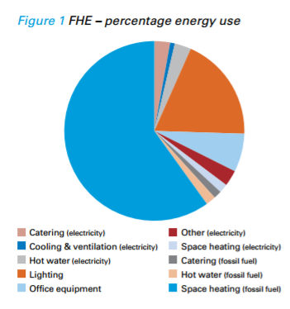
Energy prices have continued to increase since 2000 and a rise of 100% between 2008 and 2018 may be seen with costs expected to rise further into the 2020s (DECC 2012). See Figure 11.
Figure 10 Energy use in Higher Education Institutions (Carbon Trust 2012).

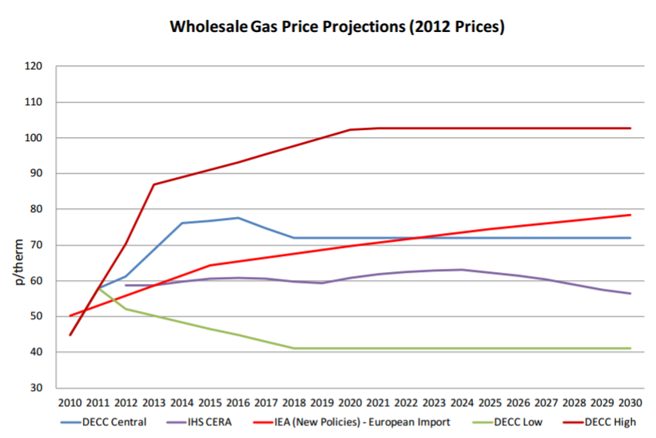
Figure 11 Projected wholesale gas prices (DEC 2012)

Energy efficiency and carbon reduction of estates is an issue as major refurbishment or extensions are required to achieve energy performance standards in Part L2B Building Regulations (see Figure 12). These are expected to become more stretching in future (Georgiadou et al., 2012).
Many HEI’s are publically committed to reducing carbon emissions to mitigate climate change, in part to enhance reputations and attract students and funding (Meredith and Stubbs 2014).
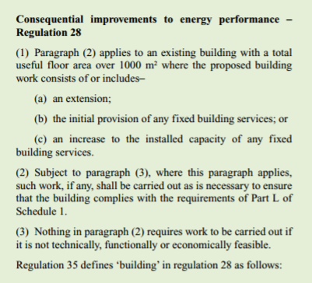

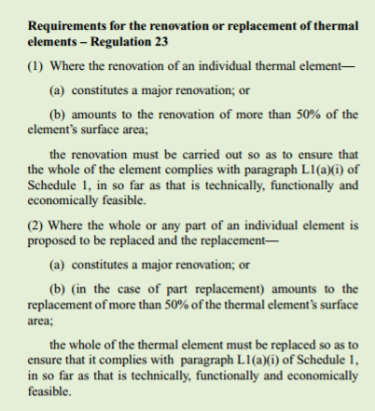
Figure 12 When PartL2B Building Regulations are applicable (HM Government 2016)

Figure 3 When PartL2B Building Regulations are applicable
Finally, there is potential for energy security challenges in the future that may lead to intermittent supply (Jewell et al., 2013; Georgiadou et al., 2012).
To ensure these future energy challenges and scenarios don’t prevent Universities from effectively meeting the needs of future building users, they should consider making changes to their built facilities (Yazan 2011).

  - Potential changes that could be made in the coming years

    - A fabric first approach

Building fabric has been considered first as a key rule of improving energy efficiency of a building is to take a fabric first approach (BRE 2016). Fabric is fundamental to energy performance and contributes significantly to the efficiency of a building by mitigating air infiltration and providing insulation from outdoor temperatures (Paterson and Noble 2014).
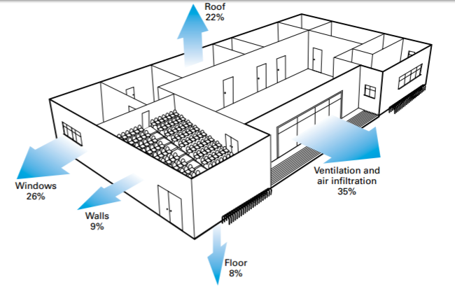
Figure 13 shows typical thermal losses of a higher education building, reducing these losses improves energy performance (Carbon Trust 2012).
Figure 13 Heat loss in a typical Higher Education Building (Carbon Trust 2012)

To understand how thermal energy is escaping the buildings a thermographic survey could be completed and quick gains could be achieved on each of the buildings through draft proofing and closing leakage gaps through the use of expanding foam, insulation tape and sealants, as illustrated in Figures 14 & 15 (BSRIA 2016). The survey will show where the thermal energy is being lost so remedial action can be prioritised, which would likely involve improving airtightness (Thorpe 2013).
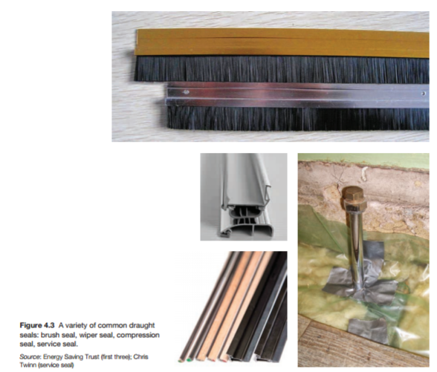
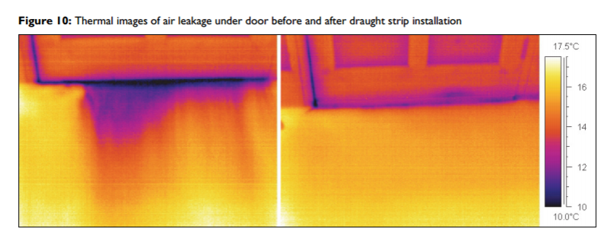
During major refurbishment an air barrier could be installed around the building envelopes which would create one continual and robust airtight layer & improve air tightness (BRE 2016). These are major works and for them to be cost effective they will likely need to be programmed in with major planned refurbishment (Thorpe 2013).
Figure 15 Typical draft proofing measures (Thorpe 2013)
Figure 14 Heat losses shown in a thermographic survey before and after draft proofing measures have been installed (CIBSE 2016)

    - Improving glazing
Heat loss through glazing is an issue on the George Thomson Block due to the extent of single glazed curtain walling with metal frames which will have a high U-value, see Table 1. Metal curtain walling systems were an innovative practice of the early 20th Century in response to new steel framing techniques for multi-story building, however now they’re undermining energy performance; largely due to metal frames acting as a conductor causing heat losses (Patterson 2014). The metal frames can cause condensation and this is evident in George Thomson Block (Patterson 2014) (see Figure 18). This shows how innovation can lead to future problems that were unforeseen at the time.
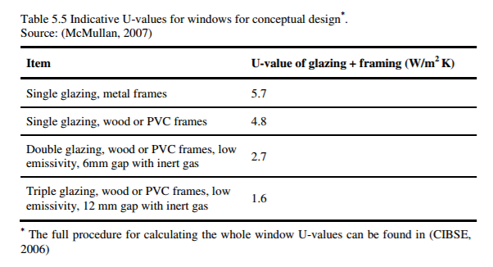
If a building has single glazing and metal frames they should definitely be replaced (Thorpe 2013). Façade renovation of this type is an increasing trend however an acceleration in the construction sector is required if energy performance targets are to be met (Patterson 2014). This inertia is in part due to cost and disruption associated with the major renovation works and curtain wall retrofits are a long way from providing optimal energy efficient solutions (Patterson 2014).
Table 1: Typical U-Values for windows (McMullan 2007)

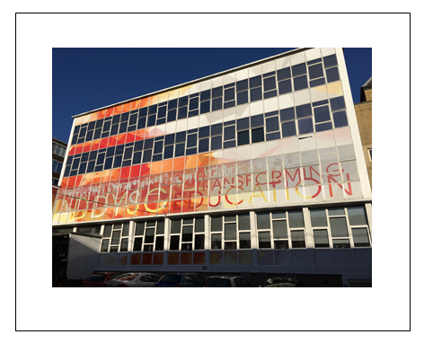
UWTSD could install double or triple glazing (see Figure 17) to reduce thermal energy loss through the curtain walling on George Thomson Block and the windows on the Main Admin Building. However this would be very disruptive and expensive and have a long payback period (Patterson 2014). Also, triple glazing is not always more efficient and attention will need to be paid to the specification of the glass to select the most efficient (BRE 2016b). One way of increasing cost effectiveness would be to only use triple glazing on the north facing façade (Carbon Trust 2012).
Large areas of glazing
Infill panels that can improve energy performance, but can restrict natural light
Figure 16 Glazed curtain walling on George Thomson Block

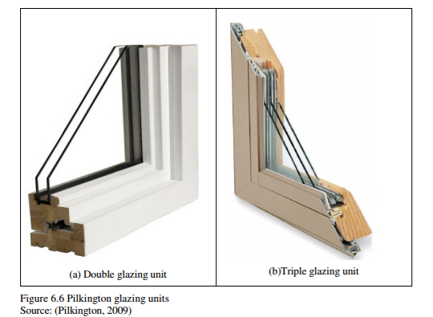
Figure 17 Double and triple glazed windows (Yanzan 2011).

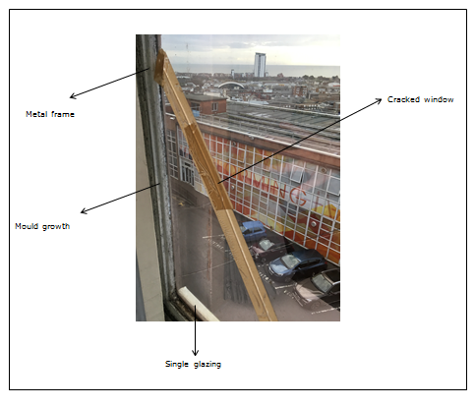
Figure 18 Single glazing, metal frames and mould growth seen on George Thomson Block
Mould growth
Metal frame
Single Glazing
Crack

Low emissivity coverings could be applied to the inside pane of the glass on all buildings (Thorpe 2013). These can significantly reduce radiative heat losses by allowing solar radiation in and then reflecting infrared wavelengths back into the building (Giovenetti et al., 2014).

    - The importance of insulation
Wall insulation retains heat when outside temperature is cool, excludes heat when the outside temperature is warm and prevents ingress of solar gain through absorption of radiation from the outside of walls (Baker 2009). Wall insulation will generally always bring positive benefits, however in some instances the benefits may be small in comparison with cost, technical difficulty and/or unacceptable visual which is often the case with historic buildings (Baker 2009). A strategy for retrofitting insulation will vary depending on building type and the highest possible standard of insulation should be targeted (Thorpe 2013). The final decision on insulation should be determined by budget, space available and choice of material (Thorpe 2013).
The Adeilad Dylan Thomas building has Grade II status, therefore insulation solutions are restricted. DEC Advisory Reports (see Appendix 1) recommend improving internal wall insulation to the single skin structure. This would improve the U-value and reduce thermal energy lost through walls. Two options for internal wall insulation are shown in Figure 9. Carbon Trust (2012) explain how internal wall insulation can be disruptive to install and UWTSD will need to decide if the loss of internal space and visual impact are acceptable. Cost savings should not be assumed as actual savings are often far less than expected for three reasons which are inaccurate assumptions on baseline energy use, error in installation and changes in occupant behaviour once the insulation is installed (Milsom 2016).
Baker (2009) advises a cautious approach and is wary of interstitial condensation caused by installing solid wall insulation which is caused by water vapour diffusing through the structure to an area that is below the dew point of the air.
If sustainability is to be considered decision making then the environmental impact of insulation should be minimised - natural or organic insulation rather than inorganic materials should be used, as shown in Table 2.

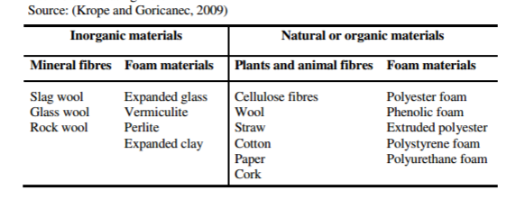
Table 2 Inorganic, natural or organic insulation materials

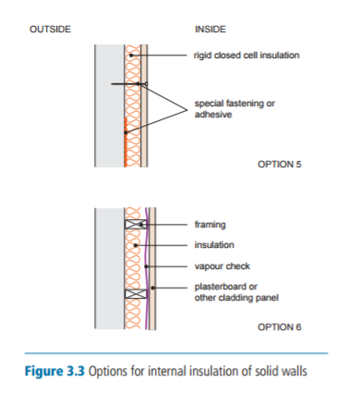
Figure 19 Two options for solid wall insulation (Thorpe 2013)

    - Efficient lighting

Carbon Trust (2012) state on average 20% of total energy costs in HEIs could be from lighting. Lighting was noted as a high impact action in DEC advisory reports for each building (see Appendix 2).
On each of the three buildings inefficient lights are installed, for example in the kitchen a T12, 28mm fluorescent light is used. This could be replaced with a 26mm (T8) fluorescent tube that could save 15-20% on electricity costs (Carbon Trust 2012). Also, the discoloured diffuser could be replaced with a prismatic controller (see Figure 20) which would not reduce consumption but would increase light by up to 60% (Carbon Trust 2012).
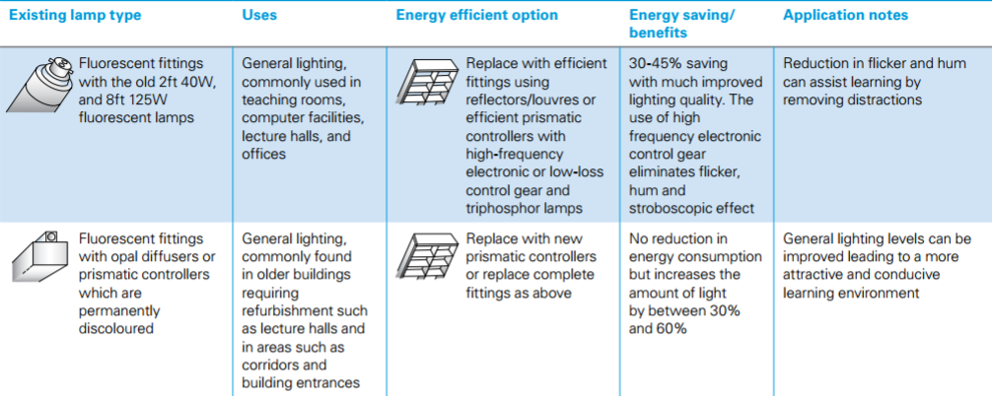
LED lighting could be installed as LEDs use 80% less energy and can last for 50,000 hours (Carbon Trust 2012).
Figure 20 Lighting upgrades (Carbon Trust 2012)

4.2.5 True future-proofing: Reducing grid reliance
Reducing energy consumption will help future users to reduce the impact of rising cost however there is still a reliance on grid energy. To truly futureproof future users against different energy futures, the buildings on the campus will need to be “net zero energy source” through use of renewable energy (Aksamija 2015).
Three commonly used renewable energy sources used in commercial buildings include solar, ground source heating and biomass and these are widely adopted (Boyle 2012). In a case study Aksamija (2105) was able to achieve net zero energy status through uses of solar photovoltaics, biomass and wind energy on a refurbishment of a commercial building. A renewable energy feasibility study could be completed to determine the best solution.
EES provides a solution to intermittent supply of renewable energy, however at present the technologies are not cost effective or mature enough for widespread implementation (Luo et al., 2014). Batteries used for EES need to consider material abundance, eco-efficient synthetic processes and life-cycle analysis for them to be truly sustainable, few existing technologies address these issues (Larcher and Tarascon 2014).

4.2.6 Additional options – Maintenance, BMS, CHP and Biomimicry
The DEC Advisory Report suggests ensuring maintenance of HVAC is serviced and up to date and systems are updated when feasible. Carbon Trust (2012) state on average 10% annually can be saved by properly servicing boilers.
An upgraded BMS could be installed to control energy; this was part of a strategy used by Bristol University to reduce energy use by 27% (Carbon Trust 2012). Lewry (2016) comments that generally energy control using a BMS in non-domestic buildings is poor despite there being proven technologies on the market – he explains requirements in building codes are simple and therefore the superior technologies are overlooked, demonstrating technology is there but there is a lack of uptake in the construction sector. Lewry highlights benefits of a BMS but stresses the importance of ensuring the system selected is programmable to ensure it’s flexible to adapt to changes in technology so it does not become obsolete.
A CHP system could be installed. Biomass could be integrated into the CHP which could provide significant sustainability benefits (Aksamij 2015).
Potential lies in Biomimicry which could take inspiration from the natural world to influence architecture and temperature regulation (Pawlyn 2016). However there is a long way before these ideas are anywhere near mainstream and Pawlyn explains a key question is how we can accelerate the pace of innovation in the construction sector.

4.2.7 Building Information Modelling (BIM)
BIM could be used to improve decision making (Ham and Fard 2015). However, for existing buildings assumptions are often inaccurate as they don’t account for diminishing thermal resistances of building materials from deterioration (Ham and Fard 2015). To improve the reliability of BIM-based energy modelling Ham and Fard present a system with new methods for automated association and updating of actual thermal property measurements. This is an example of continuous improvements in BIM that Huijbregts et al., (2003) explain could help the building sector respond more effectively to future proofed design decisions.
However, 14 years on from their paper and despite the potential of BIM, there is inertia in the construction sector and lack of uptake. Butt et al., (2015) explain BIM uptake on existing buildings is limited compared to new construction. Further illustrating the inertia is a survey by NBS (2016) the results of which are shown in Box 1.

BIM adoption
- A majority are now aware of and using BIM on at least some of their projects (54%), 42% said they were just aware of BIM, and 4% were neither aware nor using.
- Regardless of where they are now, in a years' time 86% expect to be using BIM on at least some of their projects - and that number increases to 97% in five years' time making BIM universal and routine assuming good intentions are realised.
- Indicative data on BIM adoption by region suggests prevalence in London, the North East, Northern Ireland and Wales. The area with the lowest rate of BIM adoption appears to be the East of England.
Skills and abilities
- Almost half of respondents describe themselves as being 'very' or 'quite' confident of their BIM knowledge and skills, leaving a majority who are not. 23% describe themselves as being 'in between', while 28% descibe themselves as 'not very' or 'not at all' confident in BIM.
- Immediate colleagues are the most likely source of BIM information, external professionals were cited by 57% of respondents.NBS were cited by 65% of people, while organisations including the UK BIM Task Group, RIBA and others were also suggested.
Use of standards
- 65% of respondents believe that BIM is not yet sufficiently standardised. 22% neither agree or disagree and 13% disagreed with the statement.
- Standards cited by respondents as being used include the RIBA Plan of Work 2013 (40%), PAS 1192-2:2013 (29%), PAS 1102-3:2014 (23%), BS 1192:2007 (25%).
Creating designs
- 80% of respondents produce 2D models, and 70% 3D. 74% said that they have adopted collaborative techniques and this collaboration extends to sharing models (56% said they had shared such models with design team members outside their organisation, 45% have shared across different disciplines.
- A minority (37%) use models from the start of a project to the very end, suggesting that for most BIM is restricted to the design stages. 30% produce a model that is software dependent and just 16% pass on a model to those responsible for the management of a building.
- When producing drawings, Revit is the most popular tool, followed by ArchiCAd, then Vectorworks. As such a range of tools was cited the need for a standardised non-proprietary format seems clear.
Attitudes towards BIM
- People continue to be largely positive with three quarters seeing it as the future of project information. That said, free text comments from respondents suggest a small number of people who are resistant to BIM and do not see the benefits.
- There is some ambivalence about how trustworthy information on BIM is - less than a third trusting what they hear with a significant minority (though it is a minority) feeling BIM is just for larger organisations.
- 76% of people disagree that BIM is a synonym for 3D CAD drawings, 62% disagree that 'it's all about the software'.
- People have a clear appetite for BIM objects - 71% want manufacturers to provide them.
- 90% of users and non-users agreed that BIM implementation requires changes in workflow practices and procedure. The benefits, however, are clear - a majority citing improved co-ordination of documents and project visualisation.
- Those who have adopted BIM are more likely to be positive towards it that those who have yet to - with 69% of adoptees saying that clients will 'increasingly insist' on it, and a majority feeling it brings cost efficiencies and improves client outcomes.64% believe adopting BIM has given them a competitive advantage.
Box 1 BIM Survey Results (NBS 2016)
4.2.8 Life cycle costing (LCC) and life cycle assessment (LCA)
LCC provides an opportunity to evaluate costs over a buildings life time and can deliver advantages rather than burdens to successive users and could be adopted to make decisions on the campus (Galle et al., 2015). However limited assessment methods exist and more case studies are need to illustrate usefulness (Galle et al., 2015).
One LCC method has been produced through Innovate UK is called IMPACT (see Appendix 2). To illustrate how LCC could potentially be used an exercise has been carried out for windows using assumed area of glazing simply to demonstrate how it can inform decision making, see Figure 21.
A development of LCC is LCA (Cabeza et al., 2014 and Buyle et al., 2013). However, uptake of LCA is limited which is said to be due to perceptions of high cost, industry culture and the poor availability of product and building-level carbon data. Opportunities to overcome these barriers include earlier engagement of professionals along the supply chain, effective use of whole-life costing, and changes to contract and tender documents (Cabeza et al., 2014).
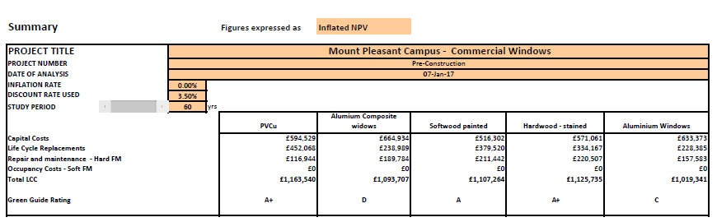
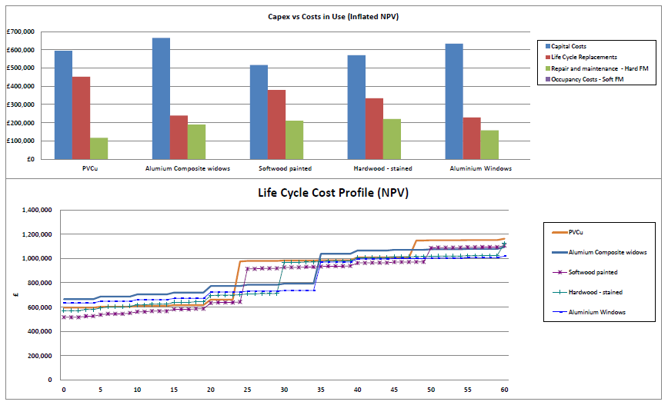
Figure 21 A theoretical calculation to demonstrate life cycle costing for windows (see Appendix 2 for more information on calculations)

  - Conclusion of energy performance section
Future energy scenarios pose challenges to future building users due to rising costs, regulatory changes and future intermittent supply. Potential methods to improve energy efficiency include improvements to building fabric, insulation and lighting. These different options will need to be investigated in more detail, with considerations such as potential disruption, cost/benefit and wider sustainability implications considered to inform a robust energy strategy.
For the most robust decision making energy modelling and BIM should be utilised and LCC carried out so to not burden future building users with high running costs.
To truly protect future building users from future energy scenarios the campus will need to be net zero energy and obtain energy from renewable sources. Battery storage will be required however the technology is currently not cost effective or mature enough for widespread implementation.
There is a reoccurring theme of inertia within the construction sector in several areas relating to energy performance, which are acting as a barrier to achieving the most futureproofed scenarios. The sector is well geared up and there is an extensive academic and industrial literature on energy efficiency improvements; however the more innovative areas which are the pathways to truly energy futureproofed buildings, such as BIM, life cycle costing and assessment, energy storage, superior BMSs, energy efficient façades and BIM are not seeing widespread uptake – a key question is how do we speed up innovation in the construction sector?

Section 3 – Climate Change

This Section provides a critical review of the existing UWTSD Mount Pleasant campus, Swansea, (herein where appropriate referred to as MPC). As part of the review process, potential recommendations for adaptions to MPC shall be suggested, to ensure it meets the needs of future generations. The intended scope of these recommendations includes managing or “futureproofing” the potential effects of climate change. As shown above in Figure 1, MPC consists of various built structures, each of which, as well as the surrounding grounds, present opportunities for “futureproofing” with regards to climate change. However, this is solely a desktop study, and no investigation of the structural viability of any of the suggestions contained within this report has been carried out. In addition, there has been no assessment of likely disruption for the retrofitting of adaptive measures. These factors would have to be assessed by suitably trained professionals before any suggestions below could be implemented.

What is Climate Change?

Climate change is an extensive, continuing change in global average temperature and weather, which has occurred throughout the Earth’s existence (Met Office, 2016). It is conceivable that ongoing warming of the globe is being contributed to by humans, due to increased levels of Greenhouse Gas emissions that are causing the planet’s temperature to rise (NASA, 2016). However, regardless of the evidence that human activity effects the Earth’s temperature, current research suggests there is denial about climate change amongst the public (Jylha, 2017). Therefore, public opinion surrounding these recommendations would be subjective dependant on the reader. It is notable that research demonstrates there is no definitive definition of the term ‘futureproofing’ recognised by professionals in the building industry (Georgiadou et al, 2012).

Effects of Climate Change?

The major effects of climate change are summarised as follows; this list is not exhaustive, however encapsulates key concerns. These are:
- Higher Temperatures
- Changing Rainfall
- Effects the behaviour and patterns of nature
- Rising Sea Levels
- Melting Glaciers
- Declining Arctic Sea Ice
- Shrinkage of Ice Sheets

Above examples from: (Met Office, 2016)
The following recommendations aim to combat some of the above consequences of climate change to ensure MPC’s functionality for future generations.

Adaption to Climate Change

It is estimated that 87% of UK building stock is expected to remain in use until 2050 (UK Green Build Council, 2017). Therefore, UK building stock will require adaption to “futureproof” against climate change. Additional research states that significant proportions of existing building stock are unlikely to handle the effects of the changing climate, which poses a great challenge for adaption (Gething & Puckett, 2013). This evidence indicates that the consensus in industry is that the adaption of buildings for climate change is necessary. Therefore, MPC will require the provision of such adaptions to ensure that it continues to function appropriately.

Solar Shading

In terms of “futureproofing”, solar shading is a potential factor that could be considered at MPC. A previous study has suggested that by comparison to technologies such as air conditioning, solar shading can counteract overheating in cost effective way. (CIBSE, 2006). In addition, research exists that demonstrates shading devices are vital in locations that have abundant solar radiation (such as mount pleasant, due to its location and topography) during the summer, which can also reduce the cooling requirements of buildings (Bellia et al, 2014). Examples of existing solar shading on the Cadogan Technology Centre Building, are shown below:
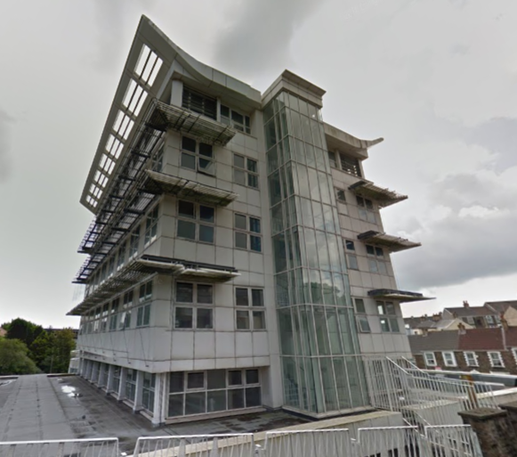
Above image source: (Google, 2017)
Figure 23 - An Example of the Existing Solar Shading System at the Cadogan Technology Centre
Additional implementation to the existing solar shading may be beneficial. Research suggests that in the last 136 years, 10 of the hottest years were after the year 2000, with 2015 being the warmest (NASA, 2016). This change in global average temperature is shown below:


Above image source: (Met Office, 2016)
Figure 24 - A graph of the Anomalies in the Average Temperature of the Earth
Figure 24 suggests the current course of global temperature is trending towards increase, therefore justifying implementation of further solar shading. An example of a possible option is the Flectofin. The Flectofin is based on biomimicry principles of the bird of paradise flower (Strelitzia reginae) (Palwyn, 2016). The technology is hinge-less and based on elastic deformation. (ITKE, 2011). The system operates automatically in response to solar energy entering the attached PV modules, however there is the option of a manual override (Hammer, 2016) . An example of this technology is shown below:
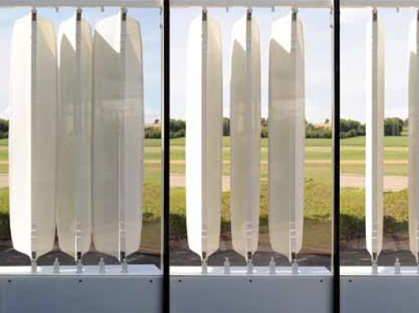
Above image source: (ITKE, 2011), Credit: (Miklautsch, 2011)
Figure 25 - An example of a Flectofin
Figure 25 indicates that utilising this technology may obscure view from windows whilst in operation and static. In relation to solar shading recent research advises that automated shading can be disliked if:
- The system is visibly seen to move, and does so more than once or twice a day
- The shading blocks view out, extending below standing eye height (1.7 m) for side windows
- There is motor noise as the shading changes position
- There is no occupant override
Above examples from: (BRE, 2015)
As Flectofins entail features suggested above, there is potential for the system to be unpopular with occupants of buildings. However, if during future times of peak solar gain, cooling requirements outweigh visual use of windows, this system could contribute to “futureproofing” against rising temperatures.
Additionally, the use of Brise Soleil systems, like those utilised on the Cadogan Technology Centre building, could be an option. Therefore, it could be argued that elements of “futureproofing” are already considered at MPC. A Brise Soleil System can be fitted to existing buildings, whilst maintaining the operation of and full view of the existing windows (CIBSE, 2006). When comparing the statement of CIBSE (2016) to that of the BRE (2015), this technology would likely be unobtrusive to the view, silent and static (unless an active system is used). Therefore, this system could further “futureproof” MPC.

At MPC, multiple structures have had films applied to their windows, shown below:
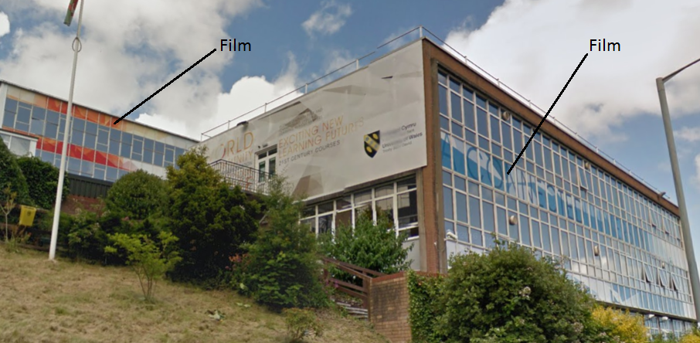
Above image source: (Google, 2017)
Figure 26 - Example of the Films applied to the windows of the George Thompson Block & Library
It is known that sunlight can be excluded from the interior of a building using as thin films (Trubiano, 2013). A film technology that could be implemented in this scenario is Low-emissivity coatings. When this technology is used, it limits the solar gain that is transmitted into the glass, and therefore the building (Trubiano, 2013). This technology excludes the short-wave section of the light spectrum, whilst allowing the diffusion of long wave radiation to pass through its surface, providing light and excluding heat (Trubiano, 2013). Therefore, their use could contribute to “futureproofing” MPC against the potentially higher temperatures of future climate.

Heating & Cooling

Building Fabric

At MPC, there is potential to regulate the transfer of heat by improving the existing fabric. Climate change is a challenge of both the present and future, and is grounds to design buildings to ensure they manage energy for the long term (Georgiadou et al, 2012). An example of where the fabric could be improved is the single glazing of the George Thompson Building. It is known that energy efficient windows keep the interior of buildings warmer at winter and cooler in summer (Glass and Glazing Federation, 2008). Replacing such elements could therefore be beneficial as the services of a building a need only to be designed to achieve what cannot be attained passively, if the efficiency of the building fabric is first ensured (Brady, 2016). Therefore, improving existing fabric at MPC, could potentially reduce demand on heating and cooling systems, which should be considered first, as demonstrated in the Roadmap to Efficient Building:
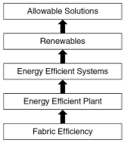
Above image source: (Brady, 2016)
Figure 27 - The Roadmap to Efficient Building

Heating Systems

Further to ensuring that the fabric of a building is functioning appropriately, there are many heating and cooling systems that could be utilized. Examples include:
- Active Solar Thermal
- Combined Heat and Power
- Heat Pumps
- Thermal Storage
Above examples from: (International Energy Agency, 2011)

When considering which system would be the most appropriate to adopt with regards to climate change, current research suggests that the effects of climate change on available solar energy are not entirely known. (Burnett et al, 2014). This is due to the fact that change in climate can influence the coverage of clouds in the atmosphere, which could affect solar energy capture (Burnett et al, 2014). Additional literature also states the costs of utilizing high density thermal storage are high, which makes them unsuitable for many sites, and the CO2 emissions savings for Combined Heat and Power, as well as heat pumps are dependent on where the systems energy is sourced (International Energy Agency, 2011). However, it is also known that heat pumps can provide larger amounts of useful heating and cooling energy than the electrical energy they are supplied with (International Energy Agency, 2011). Therefore, the utilization of heat pumps could be a favourable option, given they are supplied with clean renewable energy, as they are not considered renewable systems and if their energy supply is sourced from the grid, it could be produced at low efficiency (Brady, 2016).

Renewable Energy Generation

Many options are available for renewable energy generation at MPC. However, research suggests that Photovoltaics that are combined with glazing are amongst some of the greatest potentially beneficial systems, owed to the cooling, energy generation and heating benefits they provide (Gorgolis & Karamanis, 2016). Opposing, previous research conducted by Burnett et al (2014) concluded that the effects of climate change on the availability of solar resource are yet unknown. Additionally, further research suggests systems that utilise Photovoltaics, demonstrate respectable performance in anticipated future climate (Shen & Lior, 2016). Therefore, there is much debate in the utilisation of Solar Energy in a future climate, and a recommendation in this area could be that further research is required to establish if the adoption of solar based renewable energy is appropriate.

In relation research suggests that the most effective section of a building suited to innovation for energy production and savings, is the building envelope, as its exposed directly to the elements (Trubiano, 2013). Therefore, modifying the existing building envelopes at MPC, to adapt to and utilise the climate could be beneficial. An example would be to incorporate an automated louver system with integrated photovoltaics, such as that displayed in the 2007 US Solar Decathlon Competition by Technische Universitat (TU) Darmstadt (Trubiano, 2013). An example of which is shown below:
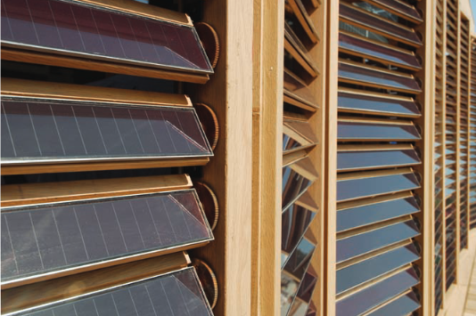
Above image source: (Trubiano, 2013)
Figure 28 - Technische Universitat (TU) Automated Photovoltaic Integrated Wooden Lovrer System
Figure 28 shows, in terms of “futureproofing” against climate change this system is multifunctional. It produces renewable energy, whilst protecting the interior of the building from unwanted solar gain (Trubiano, 2013). Therefore, if utilized at MPC, this system would contribute to “futureproofing” against climate change.

Water Management

SuDS

In terms of water management, consideration could be given at MPC, for SuDS. The intent of SuDS is to control the volume and rate of surface water runoff, by mimicking natural drainage, and some of the most effective systems are those that use vegetative units (Welsh Government, 2016). Therefore, several water management systems are discussed below, some of which utilise flora.

Green Roofs

Current research suggests the change in the pattern and intensity of rainfall has been linked to higher temperatures, associated with climate change (Wasko & Sharma, 2017). Given that the global temperature continues to increase, as suggested in data from the Met Office (2016), the change in rainfall patterns is likely to be a concern for the future environment. Therefore, MPC could be “futureproofed” for the potential change in rainfall. Previous research suggests that Green Roofs can store rainwater in the flora that inhabit their surfaces, as well as the substrate in their construction, whilst the processes of transpiration and evaporation occur, allowing moisture to return to the natural surroundings (CIRIA, 2007). Additional research also suggests that Green Roofs promote the management of storm water, as well as providing other additional benefits (Monsoor et al, 2017).
Further studies propose that Green Walls as well as Green Roofs have the potential to improve biodiversity, storm water management and lessen the heat island effect (Manso & Castro-Gomes, 2015). Therefore, the implementation of such technologies could contribute to “futureproofing” MPC; however, it would have to be ascertained by suitably trained professionals within the construction industry, if the facilities at MPC are suitable for utilising such technologies, to ensure they are safe and structurally sound/capable.

Permeable Paving

Recent guidance advises that where rainwater is not collected for use, it should be allowed to filter naturally into the ground (Welsh Government, 2016). This could be achieved by utilising permeable paving systems. These have the potential to reduce the loadings of drainage systems at peak times, using materials such as Permeable Pavers and Porous Asphalt & Concrete (Charlesworth et al, 2017). At MPC, there are large sections of the surrounding area, such as the car parking area, that are covered by surfacing materials that may not allow for natural water percolation. Therefore, the implementation of more permeable surfaces could contribute to “futureproofing” MPC, in relation to changing rainfall in a future climate.

Rainwater Harvesting

Recent SuDS guidance also advises that capture and use of rainwater can reduce demand on potable water sources, and reduce the quantity of surface water runoff that requires management (Welsh Government, 2016). The utilization of rainwater can also alleviate pressures on freshwater availability, and be used for applications were potable water is unnecessary, without needing extensive treatment (Silva & Ghisi, 2016). This research suggests that the harvesting of rainwater is beneficial at least for non-potable applications, and its implementation could contribute to “futureproofing” rainwater management at MPC.

Conclusion

Given the nature of their construction most of the buildings on the site would lend themselves to a more open, flexible space plan and with the introduction of the interventions suggested in this report would mean improvements in performance, lower operational costs and greater long term resilience against climate change.
Improving energy efficiency is relatively straightforward with the main barriers being disruption and cost/benefit of the different options. Renewable technologies are common place and seen working effectively on many commercial buildings and could be installed to further reduce energy costs. Decision making on the best options can be made robust with the use of tools such as BIM, energy modelling and Life Cycle Costing.
The biggest challenge in terms of futureproofing energy performance surrounds achieving net zero energy status and not being reliant on the gas and electric grid. There is inertia within the construction sector preventing this status being achieved and this inertia needs to be addressed, until then, a truly futureproofed scenario may not be achieved.
Finally, to conclude futureproofing against climate change, there is a current rising trend in global temperatures, and that the activities of humans are contributing to this change. It is also likely that change in climate will cause issues for the way in which existing buildings perform and manage their internal environments. Therefore, it is also likely that existing buildings will require adaption to this change; Examples and recommendations for which, are suggested above for a case study of the UWTSD MPC. These include measures for the protection of the facility from unwanted excessive solar gain, the heating and cooling requirements and the appropriate management of water in a future climate, as it is likely that climate change will impact those areas. In addition to this, consideration has also been given to generation of renewable energies, which considered the evidence that the availability of the future solar resource is yet unknown. Therefore, in view of the research discussed within this report, recommendations include:
- The further research of the effects of climate change on the availability of Solar Resource and its capture for the purposes of energy generation

- The further education of all persons with regards to climate change and its impact, as there is evidence that there is still doubt with regards to the subject amongst the public

- Further research of the effects of the implementation of Solar Shading devices on the attitudes of the occupants of buildings – potentially via an extensive desktop study such as a large survey, of the opinions of users of buildings where solar shading devices have been implemented.

References

Abdallah, M. & El-Rayes, K., 2015. Optimizing the selection of building upgrade measures to minimize the operating negative impacts of existing buildings. Building and Environment, Volume 84, pp. 32-43.
Aksamij, A. 2015 Regenerative Design of Existing Buildings for Net-Zero Energy Use. Procedia Engineering. Vol 118 Pages 72-80
Ansari, A. & Goel, N., 1983. Imperativesness of Local Building Materials. Indian Architect, 25(12), pp. 268-275.
Ardente, F., Beccali, M., Cellura, M. & Mistretta, M., 2011. Energy And Environmental Benefits in Public Buildings As A Result Of Retrofit Actions. Renewable and Sustainable Energy Reviews, Volume 15, pp. 460-470.
Arge, K., 2005. Adaptable office buildings: theory and practice. Facilities, 23(3/4), pp. 119-127.
Association of University Directors of Estates (AUDE), 2016. AUDE Estate Management Report 2016, s.l.: AUDE.
Baker, N. V. 2009 The Handbook of Sustainable Refurbishment: Non-Domestic Buildings. London: Earthscan
Bayoumi, M., Fink, D. & Hausladen, G., 2013. Extending the feasibility of high-rise façade augmented wind turbines. Energy and Buildings, Volume 60, pp. 12-19.
Bellia et al, 2014. Bellia L. Marino C. Minichiello F. Pedace A., An overview on solar shading systems for buildings. [Online]
Available at: http://www.sciencedirect.com/science/article/pii/S1876610214034237
[Accessed 11th December 2016].
Bin, G. & Parker, P., 2012. Measuring buildings for sustainability: Comparing the initial and retrofit ecological footprint of a century home – The REEP House. Applied Energy, Volume 93, pp. 24-32.
Bjorn, A. et al., 2015. Strengthening the Link between Life Cycle Assessment and Indicators for Absolute Sustainability To Support Development within Planetary Boundaries. Environmental Science and Technology, 49(11), pp. 6370-6371.
Bosher, L., 2014. Built in Resilience Through Disaster Risk Reduction: Operational Issues. Building Research and Information, 4(2), pp. 240-254.
Bouillot, J., 2008. Climatic Design of Vernacular Housing in Different Provinces of China". Journal of Environmental Management, 87(2), pp. 287-299.
Brady, L., 2016. Low- and Zero-Carbon Technologies in Buildings. In: A. A. S. Begum Sertyesilisik, ed. The Sustainable Built Environment: Technical, managerial, legal and economic aspects. London: PALGRAVE, pp. 90-91.
Brand, S., 1994. How Buildings Learn. 1st ed. New York: Penguin.
BRE, 2015. IHS, Daylight and shading. [Online]
Available at: www.ihsti.com
[Accessed 7th December 2016].
BRE 2016 Passivhaus primer: Airtightness Guide Airtightness and air pressure testing in accordance with the Passivhaus standard. Accessed online on 08/01/17 at http://www.passivhaus.org.uk/filelibrary/Primers/Passivhaus-Airtightness-Guide.pdf

BRE 2016b Is bigger always better – triple better than double? Accessed online on 08/01/17 at https://www.bre.co.uk/page.jsp?id=3388
Bribian, I., Capilla, A. & Uson, A., 2011. Life cycle assessment of building materials: Comparative analysis of energy and environmental impacts and evaluation of the eco-efficiency improvement potential. Building and Environment, 46(5), pp. 1133-1140.
British Standards Institute, 1992. Guide to Durability of Building Elements, Products and Components, London: British Standards Institute.
BSRIA 2011 Thermal Imaging of Building Fabric. Accessed online on 08/01/17 at https://www.bsria.co.uk/services/compliance/airtightness/guidance-to-download/
Building Arts Forum, 1991. The Artist and the Scientist. In: Bridging the Gap. New York: Van Nostrand Reinhold.
Bullen, P. A. & Love, P. E., 2010. The rhetoric of adaptive reuse or reality of demolition: Views from the field. Cities, Volume 27, pp. 215-224.
Burnett et al, 2014. Dougal Burnett, Edward Barbour, Gareth P. Harrison, The UK solar energy resource and the impact of climate change. Renewable Energy , Volume 71, pp. 333-343.
Butt, T,E; Francis, T, J; Greenwood, K,G; Jones, K, G; Jones, A, M; Nasir, A,M 2015. The Role Of BIM In Tackling Obsolescence, Climate Change, And Sustainability. WIT Transactions on The Built Environment. Vol 149 Pages

Buyle, M; Braet, J; Audenart; A 2013 Life cycle assessment in the construction sector: A review. Renewable and Sustainable Energy Reviews.Volume 26, Pages 379–388

CABE, 2009. New From OLd: Transforming Secondary Schools Through Refurbishment, London: Commission for Architecture and the Built Environment (CABE).

Cabeza, L, F; Rincon, L; Vilarino, V’ Perez, G; Castell, A 2014 Life cycle assessment (LCA) and life cycle energy analysis (LCEA) of buildings and the building sector: A review. Renewable and Sustainable Energy Reviews. Volume 29, Pages 394–416.
Caccavelli, D. & Genre, J.-L., 2000. Diagnosis of the degradation state of building and cost evaluation of induced refurbishment works. Energy and Buildings, Volume 31, pp. 159-165.
Carbon Trust 2012 Further and Higher Education: Training Colleges and Universities to be Energy Efficienct. London.
Carroon, J., 2010. Sustainable Preservation: Greening Existing Buildings. 1st ed. New Jersey: John Wiley and Sons.
Cassar, M., 2009. Sustainable Heritage: Challenges and Strategies for the Twenty-First Century. APT Bulletin, 40(1), pp. 3-11.
CIBSE, 2006. Design for improved solar shading control. [Online]
Available at: www.ihsti.com
[Accessed 12th December 2016].
Cohen, D., 2007. Earth's natural wealth: an audit. New Scientist, 23rd May, pp. 34-41.
Coma, J. et al., 2016. Thermal assessment of extensive green roofs as passive tool for energy savings in buildings. Renewable Energy, Volume 85, pp. 1106-1115.
Conference on Advanced Building Skins, 2016. 11th Conference on Advanced Building Skins. Bern, Business Wire.
Crawford, K. et al., 2014. Demolitionn or Refurbishment of Social Housing?, LOndon: UCL.
Dade-Robertson, M., 2016. The cities of the future could be built by microbes. The Conversation, 8th August.
DECC 2013 Digest of UK Energy Statistics. Accessed online on January 08, 2017 at
https://www.gov.uk/government/collections/digest-of-uk-energy-statistics-dukes
DEFRA, 2013. The National Adaption Programme, London: The Stationary Office.
Dipendra, G. et al., 2016. Disaster Resilient Vernacular Housing Technology In Nepal. Environment, 3(1), pp. 1-14.
Dowson, M., Poole, A., Harrison, D. & Susman, G., 2012. Domestic UK Retrofit Challenge: Drivers, Barriers and Incentives. Energy Policy, Volume 50, pp. 294-305.
Edwards, J. & Townsend, A., 2011. Buildings Under Refurbishment and Retrofit, London: Chartered Institutue of Buildings (CIOB).
Elefante, C., 2007. The Greenest Building Is...One That is Already Built. Forum Journal, 21(4), pp. 26-3.
Enos, C., 2011. Retrofitting the Curtain Wall. Sustainable Facility, 3rd October, pp. 1-4.
Fennell, P., Ruyssevelt, P. & Smith, A. Z., 2016. Financial viability of school retrofit projects forclients and ESCO's. Building Research and Information, pp. 1-18.
Fildes, G., 2015. Swansea Campus Buildings History, Swansea: UWTSD Archive.
Galle, W; Vandenbrouke, M; Temmerman, N, D 2015 Life Cycle Costing as an Early Stage Feasibility Analysis: The Adaptable Transformation of Willy Van Der Meeren's Student Residences. Procedia Economics and Finance. Volume 21. Pages 14-22.
Gann, D. M. & Barlow, J., 1996. Flexibility in Building Use: The Technical Feasibility of Converting Redundant Offices Into Flats. Construction Management and Economics, Volume 14, pp. 55-66.
Gaspar, P. L. & Santos, A. L., 2015. Embodied energy on refurbishment vs. demolition: A southern Europe case study. Energy and Buildings, Volume 87, pp. 386-394.
Genre, J.-L., Flourentzos, F. & Stockli, T., 2000. Building refurbishment: habitat upgrading. Energy and Buildings, Volume 31, pp. 155-157.
Georgiadou, M, C; Hacking, T; Guthrie, P 2012. A conceptual framework for future-proofing the energy performance of Buildings. Energy Policy. Volume 47. Pages 144-155.
Georgiadou et al, 2012. Maria Christina Georgiadou, Theophilus Hacking, Peter Guthrie, A conceptual framework for future-proofing the energy performance of buildings. Energy Policy, Volume 47, pp. 145-155.
Geraedts, R. P., 2001. Upgrading the Flexibility of Buildings. Wellington, CIB World Building Congress.
Gething & Puckett, 2013. Bill Gething, Katie Puckett, Design for Climate Change. 1st ed. London: RIBA Publishing.
Giljum, S., Lutter, S. & Bruckner, M., 2017. Measuring Natural Resource Use from the Micro to the Macro Level. Green Economy Reader, Volume 6, pp. 161-182.
Godwin, P. J., 2011. Building Conservation and Sustainability in the United Kingdom. Procedia Engineering, Volume 20, pp. 12-21.
Google Maps, 2016. Google Maps. [Online]
Available at: https://www.google.co.uk/maps/place/Swansea/@51.6235734,-3.9469255,291m/data=!3m1!1e3!4m5!3m4!1s0x486e45555a4e97b1:0x3d77128e2fe7cb74!8m2!3d51.62144!4d-3.943646
[Accessed 20 December 2016].
Google, 2016. Google Maps, Image of Swansea Metropolitan University, Mount Pleasant. [Online]
Available at: https://www.google.co.uk/maps/place/University+of+Wales+Trinity+Saint+David+%7C+Mount+Pleasant/@51.6240633,-3.9504277,392m/data=!3m1!1e3!4m5!3m4!1s0x486ef566142579cf:0x14c520a91dca472f!8m2!3d51.62406!4d-3.948239
[Accessed 6th December 2016].
Google, 2017. Google Maps, Image of Cadogan Technology Centre. [Online]
Available at: https://www.google.co.uk/maps/@51.6249997,-3.9496881,3a,89.9y,155.61h,112.35t/data=!3m6!1e1!3m4!1syqDL4idPGqn9yFNL6XaONg!2e0!7i13312!8i6656
[Accessed 02 January 2017].
Google, 2017. Google Maps, Image of UWTSD Mount Plesant Library. [Online]
Available at: https://www.google.co.uk/maps/@51.6234884,-3.9481742,3a,47.8y,69.89h,104.49t/data=!3m6!1e1!3m4!1sfia6kX6pvveSWAweQJW_gQ!2e0!7i13312!8i6656!6m1!1e1
[Accessed 02 January 2017].
Gorgolis & Karamanis, 2016. Solar energy materials for glazing technologies. Solar Energy Materials and Solar Cells, Volume 144, pp. 559-578.
Gosling, J. et al., 2008. Flexible Buildings For An Adaptable And Sustainable Future. Cardiff, ARCOM.
Gosling, J., Sassi, P., Naim, M. & Larl, R., 2013. Adaptable Buildings: A Systems Approach. Sustainable Cities and Society, Volume 7, pp. 44-51.
Gul, M. S. & Patidhar, S., 2015. Understanding the energy consumption and occupancy of a multi-purpose academic building. Energy and Buildngs, Volume 87, pp. 155-165.
Ham, Y; Golparver-Fard, N 2015 Mapping actual thermal properties to building elements in gbXML-based BIM for reliable building energy performance modelling. Automation in Construction. Pages 214–224.
Hammer, A., 2016. Climate Adaptive Building Shells for Plus-Energy-Buildings, Designed on Bionic Principles. International Science Index, 10(2), pp. 4,5.
Heinberg, R., 2007. Peak Everything: Waking up to the Century of Decline in the Earth's Resources. London: Claireview Books.
Hernandez, P. & Kenny, P., 2010. From net energy to zero energy buildings: Defining life cycle zero energy buildings (LC-ZEB). Energy and Buildings, 42(6), pp. 815-821.
HM Government 2016 Approved document Part L2B Conservation of Fuel and Power in existing buildings other than dwellings. Accessed online 08/01/2017 at https://www.gov.uk/government/uploads/system/uploads/attachment_data/file/540329/BR_PDF_AD_L2B_2013_with_2016_amendments.pdf
Huijbregts, M, A, J, Gilijamse; Ragas, A; Reijnders, L 2003 Evaluating Uncertainty in Environmental Life-Cycle Assessment. A Case Study Comparing Two Insulation Options for a Dutch One-Family Dwelling Environ. Sci. Technol., Volume 37 Issue 11 Pages 2600–2608
Holmes, S., 2014. Future Proofing the Higher Education Estate. Building Magazine, 7th October.
International Energy Agency, 2011. Technology Roadmap Energy-efficient Buildings: Heating and Cooling Equipment, Paris: IEA.
ITKE, 2011. Institute of Building Structures and Structural Design, Flectofin, A Hinge-less Flapping Mechanism Inspired By Nature. [Online]
Available at: www.itke.uni-stuttgart.de/download.php?id=486
[Accessed 10th December 2016].
Jackson, T., 2009. Properity Without Growth, London: Sustainable Development Commission.
Jackson, T., 2009. Prosperity Without Growth. 1st ed. London: Sustainable Development Commission.
Jewell, J; Cherp, A; Riah, K. 2014 Energy security under de-carbonization scenarios: An assessment framework and evaluation under different technology and policy choices. Energy Policy. Volume 65. Pages 743-760.
Jones, S., Sutcliffe, M. J., Bragg, J. & Harris, D., 2016. To what extent is capital expenditure in UK higher education meeting the pedagogical needs of staff and students?. Journal of Higher Education Policy and Management, 38(4), pp. 477-489.
Jylha, 2017. Denial Versus Reality of Climate Change. Reference Module in Earth Systems and Environmental Sciences.
Kamali, M. & Hewage, K., 2016. Lifecycle performance of modular buildings: A critical review. Renewable and Sustainable Energy Reviews, Volume 62, pp. 1171-1183.
Khaddaj, M. & Srour, I., 2016. Using BIM to retrofit existing buildings. Procedia Engineering, Volume 145, pp. 1526-1533.
Kok, K. et al., 2013. Evaluation of green roof as green technology for urban stormwater quantity and quality controls. Earth and Environmental Science, 16(1).
Krauter, S. et al., 1999. Combined photovoltaic and solar thermal systems for facade integration and building insulation. Solar Energy, 67(4-6), pp. 239-248.
Lai, C,M; Hokoi, S 2015 Solar façades: A review. Building and Environment. Volume 91, Pages 152–165
Lane, J.-E., 2016. Implementation: Decarbonisation and Economic Growth. Applied Economics and Finance, 3(3), pp. 193-213.
Larcher, D; Tatascon 2015 Towards greener and more sustainable batteries for electrical energy storage. Nature Chemistry. Volume 7. Pages 19-29.
Laycock, E. & Wood, C., 2014. Understanding and controlling the ingress of driven rain through exposed, solid wall masonry structures.. Geological Society Special Publication, Volume 391, pp. 175-191.
Letcher, T. & Vallero, D., 2011. Waste: A Handook For Management. 1st ed. Oxford: Academic Press.
Lewry, A 2016 Energy Management and Building Controls. BRE. Watford. Accessed online on 08/01/17 at https://www.bre.co.uk/filelibrary/pdf/rpts/115133EMandBuildingControls.pdf
Lu, L. & Sun, K., 2014. Wind power evaluation and utilization over a reference high-rise building in urban areas. Energy and Buildings, 68(A), pp. 339-350.
Luo, X; Wang, J; Dooner, M; Clarke, J 2014. Overview of current development in electrical energy storage technologies and the application potential in power system operation. Applied Energy. Volume 137. Pages 511-536.
Malakahmad, A., Kok, J. & Gardezi, S., 2016. Carbon Footprint Reduction in Building Construction By Less Useage of Ore-Based Materials. In: D. Kim, J. Jung & J. Seo, eds. Advances in Civil, Architectural, Structural and Constructional Engineering . London: Taylor and Francis Group, pp. 179-183.
Martinez, J., 2016. Too Many Humans, Dwindling Resources, and Not Enough Space. Earth Jurisprudence and Environmental Justice, Volume 6, pp. 108-118.
Ma, Z., Cooper, P., Daly, D. & Ledo, L., 2012. Existing building retrofits: Methodology and state-of-the-art. Energy and Buildings, Volume 55, pp. 889-902.
McKibben, B., 2007. Deep economy: The wealth of communities and the durable future. 1st ed. New York: Henry Holt.
McMullan, R. 2007 Environmental Science in Building. 6th edition. Hampshire: Palgrave Macmillan.
Menassa, C. C., 2011. Evaluating sustainable retrofits in existing buildings under uncertainty. Energy and Buildings, 43(12), pp. 3576-3583.
Meredith, R; Stubbs, W 2014. Integrating Environmental Sustainability Into Universities. Higher Education. Volume 67 Issue 1, Pages 67-71.
Met Office, 2016. Global-average temperature records. [Online]
Available at: http://www.metoffice.gov.uk/climate-guide/science/temp-records
[Accessed 10th December 2016].
Met Office, 2016. Met Office, What is cliamte change?. [Online]
Available at: http://www.metoffice.gov.uk/climate-guide/climate-change
[Accessed 6th December 2016].
Miklautsch, B., 2011. Image of Flectofin. [Art] (Universitat Stuttgart).
Milsom, E 2016 Solid wall heat losses and the potential for energy saving Consequences for consideration to maximise SWI benefits: A route-map for change. BRE. Watford.
Mora, E. P., 2007. Life cycle, sustainability and the transcendent quality of building materials. Building and Environment, Volume 42, pp. 1329-1334.
Mulvaney, D., 2013. Hazardous MaterialsUsed in Silicon PV Cell Production: A Primer. Solar Industry, 6(8).
NASA, 2016. Global Climate Change Vital Signs of the Planet. [Online]
Available at: http://climate.nasa.gov/evidence/
[Accessed 31 December 2016].
NASA, 2016. Global Climate Change Vital Signs of the Planet. [Online]
Available at: http://climate.nasa.gov/vital-signs/global-temperature/
[Accessed 10th December 2016].
National Occupational Standards, 2013. Evaluate the appropriate options for the introduction of energy efficiency measures to older and traditional buildings, London: NOS - National Occupational Standards.
NBS 2016 National BIM Report. NBS. Newcastle Upon Tyne. Accessed online on 08/01/2016 at file:///C:/Users/robertsa/Downloads/BIM%20Report%202016.pdf
O'Hegarty, R., Kinnane, O. & McCormack, S. J., 2016. Review and Analaysis of Solar Thermal Facades. Solar Energy, Volume 135, pp. 408-422.
Palwyn, M., 2016. Biomimicry in Architecture. 2nd ed. Newcastle upon Tyne: RIBA Publishing.
Park, J. H., Chung, M. H. & Park, J. C., 2016. Development of a small wind power system with an integrated exhaust air duct in high-rise residential buildings. Energy and Buildings, Volume 122, pp. 202-210.
Patterson, M., Vaglio, J. & Noble, D., 2014. Incremental façade retrofits: Curtainwall technology as a strategy to step existing buildings toward zero net energy. Energy Procedia, Volume 57, pp. 3150-3159.
Pickard, R., Brown, D. F. G., Hayes, H. & Warshaw, J., 2004. The Role of Historic Buildings in Urban Regeneration, London: Office of Deputy Prime Minister - Stationary Office.
Plimmer, F. et al., 2008. Knock it down or do it up? Sustainable house building: New build and refurbishment in the Sustainable Communities Plan, Watford: Building Research Establishment (BRE).
Power, A., 2008. Does demolition or refurbishment of old and inefficient homes help to increase our environmental, social and economic viability?. Energy Policy, Volume 36, pp. 4487-4501.
Rios, F. C., Parrish, K. & Chong, W. K., 2016. Low-Investment Energy Retrofit Framework for Small and Medium Office Buildings. Procedia Engineering, Volume 145, pp. 172-179.
Robert Adams Architects, 2008. A Study of the Energy Performance of Two Buildings With Lightweight and Heavyweight Facades, Winchester: Robert Adams Architects.
Ross, B. E., Chen, D. A., Conejos, S. & Khademi, A., 2016. Enabling Adaptable Buildings: Results of a Preliminary Expert Survey. Procedia Engineering, Volume 145, pp. 420-427.
Rypkema, D. D., 2006. Economics, sustainability, and historic preservation. Forum Journal, 20(2).
Sachs, J., 2015. The Age of Sustainable Development. 1st ed. New York: Columbia University Press.
Selkowitz, S., Aschehoug, O. & Lee, E. S., 2013. Advanced Interactive Facades – Critical Elements for Future Green Buildings?. Pittsburgh, s.n.
Sharman, J., 2016. Biomimicry, taking our cue from the consumate engineers. [Online]
Available at: https://www.thenbs.com/knowledge/biomimicry-taking-our-cue-from-the-consumate-engineers
[Accessed 30th December 2016].
Shen & Lior, 2016. Pengyuan Shen, Noam Lior, Vulnerability to climate change impacts of present renewable energy systems designed for achieving net-zero energy buildings. Energy, Volume 114, pp. 1288-1305.
Shrubsole, S., Macmillan, A., Davies, M. & May, N., 2014. 100 Unintended consequences of policies to improve the energy efficiency of the UK housing stock. Indoor and Built Environment, 23(3), pp. 340-352.
Silva & Ghisi, 2016. Arthur Santos Silva, Enedir Ghisi, Uncertainty analysis of daily potable water demand on the performance evaluation of rainwater harvesting systems in residential buildings. Journal of Environmental Management, Volume 180, pp. 82-93.
Slaughter, S., 2001. Design Strategies to Increase Building Flexibility. Building Research and Information, 29(3), pp. 208-217.
Speirs, J. et al., 2014. Materials Availability for Low Carbon Technologies, London: United Kingdom Energy Research Centre (UKERC).
The National Trust For Historic Preservation, 2012. The Greenest Building, Washington DC: The National Trust For Historic Preservation.
Thorpe, D 2013 Energy Management in Buildings: The Earthscan Expert Guide. Earthscan. Oxford
Throsby, D., 2002. Cultural Capital and Sustainability Concepts in the Economics of Cultural Heritage, Los Angeles: The Getty Institute.
Trubiano, F., 2013. Design and Construction of High-Performance Homes - Building Envelopes, Renewable Energies and Intergrated Practice. 1st ed. Oxon: Routledge.
Tweed, C. & Sutherland, M., 2007. Built cultural heritage and sustainable urban development. Landscape and Urban Planning, Volume 83, pp. 62-69.
Tweed, C. & Sutherland, M., 2007. Built cultural heritage and sustainable urban development. Landscape and Urban Planning, Volume 83, pp. 62-69.
UK Green Build Council, 2017. Climate Change Adaption. [Online]
Available at: www.ukgbc.org
[Accessed 04 January 2017].
UK Green Building Council, 2016. Office Refurb Project 2016. [Online]
Available at: http://www.ukgbc.org/about-us/uk-gbc-office-refurb-project-2016
[Accessed 2nd January 2017].
United States Department of Defence, 2013. Demonstrating the Environmental & Economic Cost-Benefits of Re-using DoD's Pre-World War II Buildings, s.l.: USDOD.
Vernadsky, V. I., 1926. The Biosphere. Moscow: s.n.
Vimpari, J., 2016. Theory of valuing building life-cycle investments. Building Research and Information, 44(4), pp. 345-357.
Wallsgrove, J., 2008. The Justice Estate's Energy Use. Context, Volume 103.
Watson, L., 2007. Building The Future Of Learning. European Journal Of Education, 42(2).
Watts, J., 2014. The Guardian - Ecuador indigenous leader found dead days before planned Lima protest. [Online]
Available at: https://www.theguardian.com/world/2014/dec/06/ecuador-indigenous-leader-found-dead-lima-climate-talks
[Accessed 20 December 2016].
Weiler, V., Harter, H. & Eicker, U., 2017. Life cycle assessment of buildings and city quarters comparing demolition and reconstruction with refurbishment. Energy and Buildings, Volume 134, pp. 319-328.
Wei, Y., Cui, H., Li, J. & Xie, L., 2016. An evaluation model for urban carrying capacity: A case study of China's mega-cities. Habitat International, Volume 53, pp. 87-96.
Welsh Government, 2016. Recommended non-statutory standards for sustainable drainage (SuDS) in Wales – designing, constructing, operating and maintaining surface water drainage systems. [Online]
Available at: http://gov.wales/docs/desh/publications/151230-suds-standards-en.pdf
[Accessed 28 December 2016].
Whelan, Y. & Moore, N., 2016. Heritage, memory and the politics of identity: New perspectives on the cultural landscape. 1st ed. Oxford: Rooutledge.
Wypych, G., Kuberski, S. & Lee, F., 2004. Sealant failure morphology—the important criterion of equipment selection for weathering studies.. Durability of Building and Construction Sealants and Adhesives..
Yazan, A. 2011 Climate Change and the Built Environment. An evaluation of refurbishment options for high education buildings in the UK. Thesis for the University of Birmingham. School of Civil Engineering and Physical Sciences.
Yung, E. H. & Chan, E. H. W., 2012. Implementation challenges to the adaptive reuse of heritage buildings: Towards the goals of sustainable low carbon cities.. Habitat International, Volume 36, pp. 352-361.
Zari, M. P., 2007. Biometric Approaches to Architectural Design for Increased Sustainability, Wellington, New Zealand: Victoria University, Wellington.

Appendices

Appendix 1 – Levels of Biomimicry
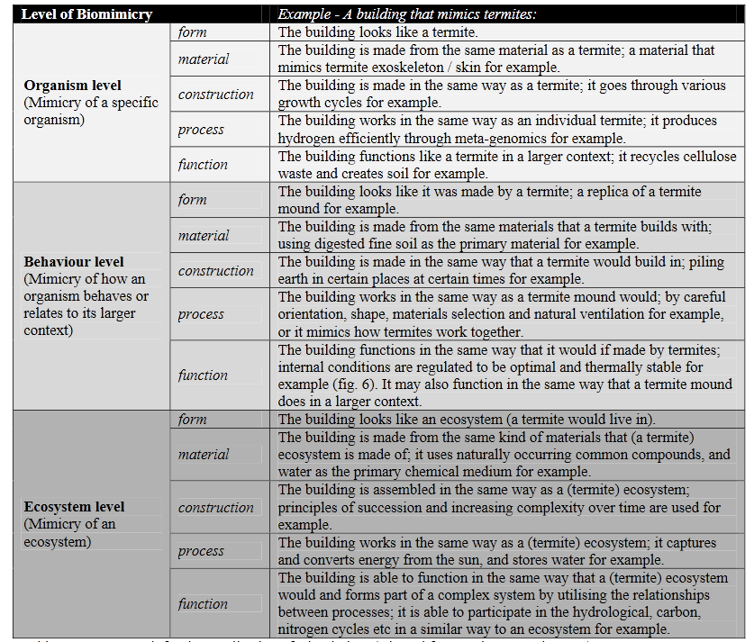
(Zari, 2007)

Appendix 2 – AUDE Report: University Estate Management Data
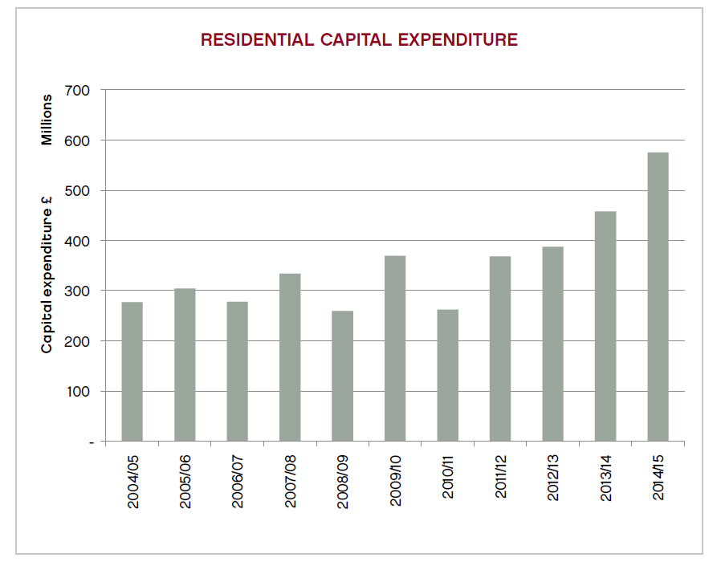
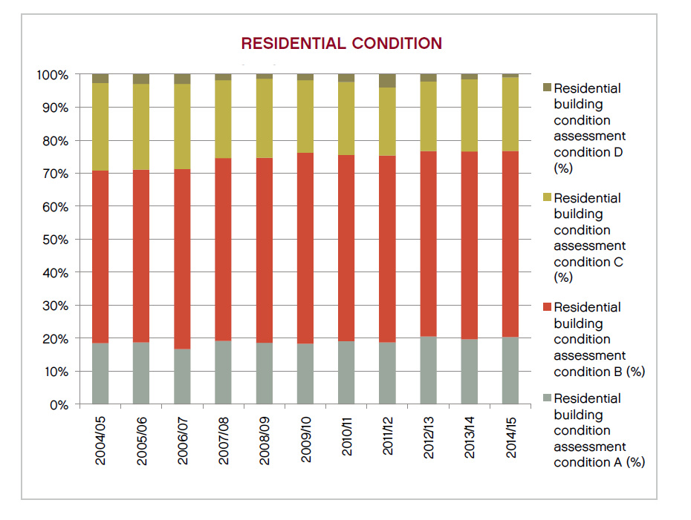

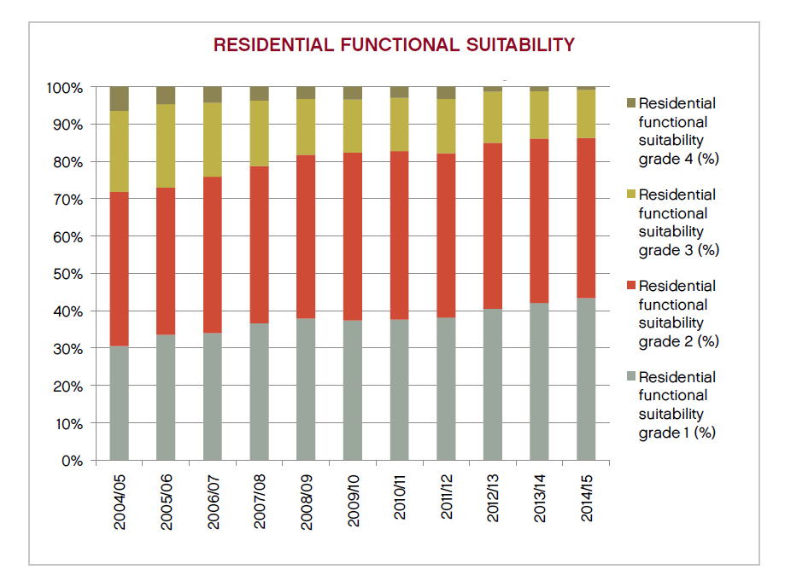
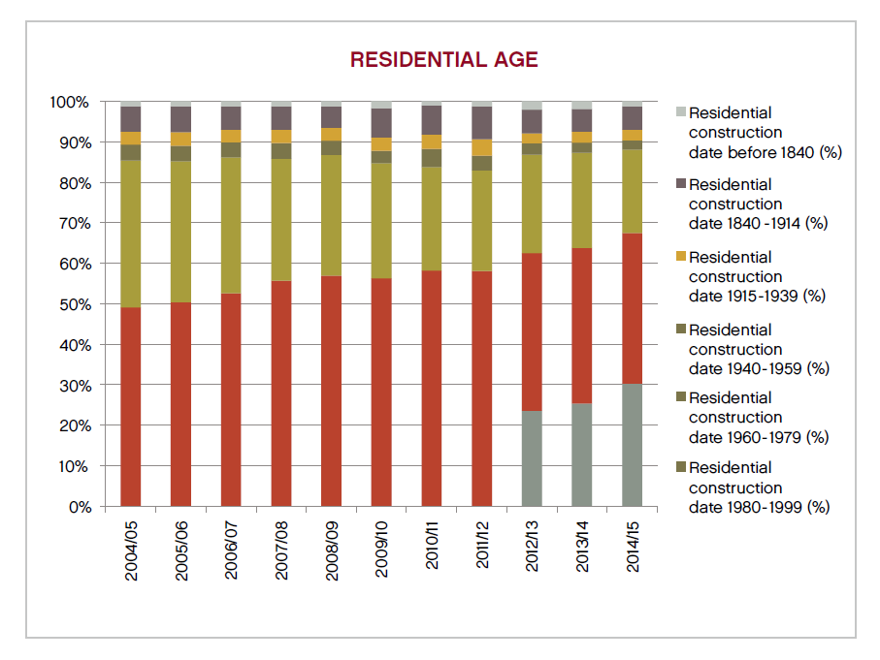

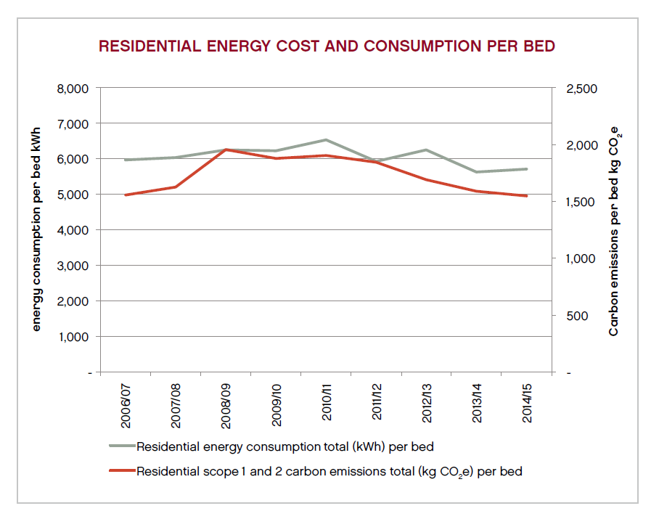
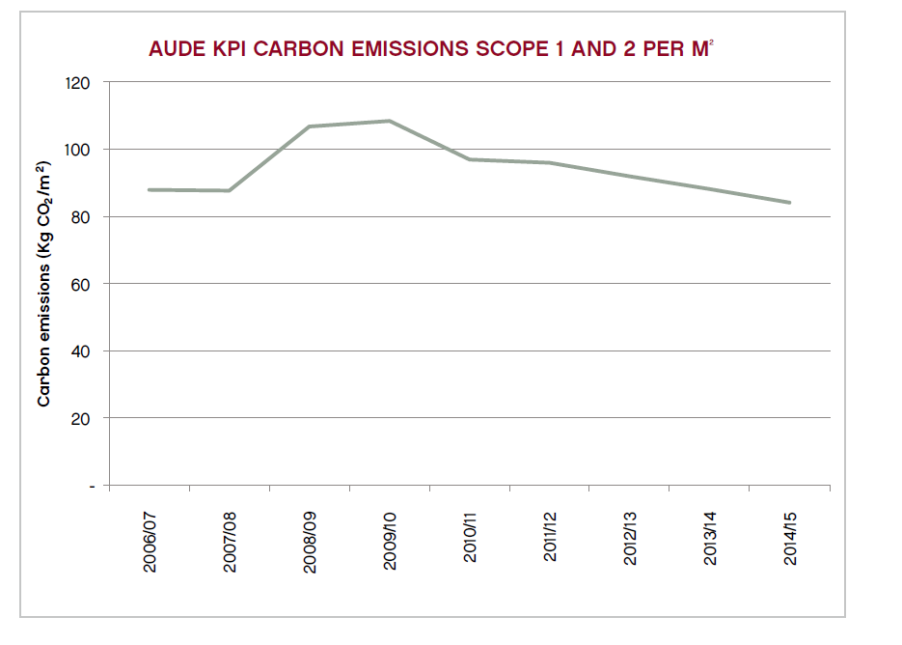

Appendix 3 - IPCC Resilience Pathway
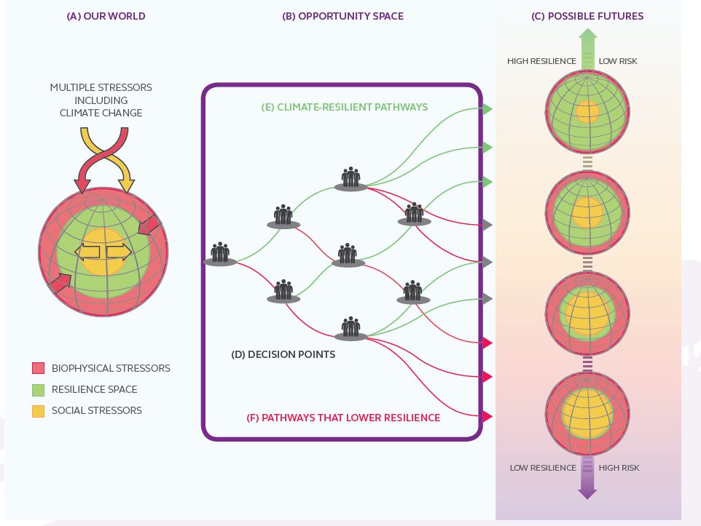

Appendix 4 – How Long Will It Last?
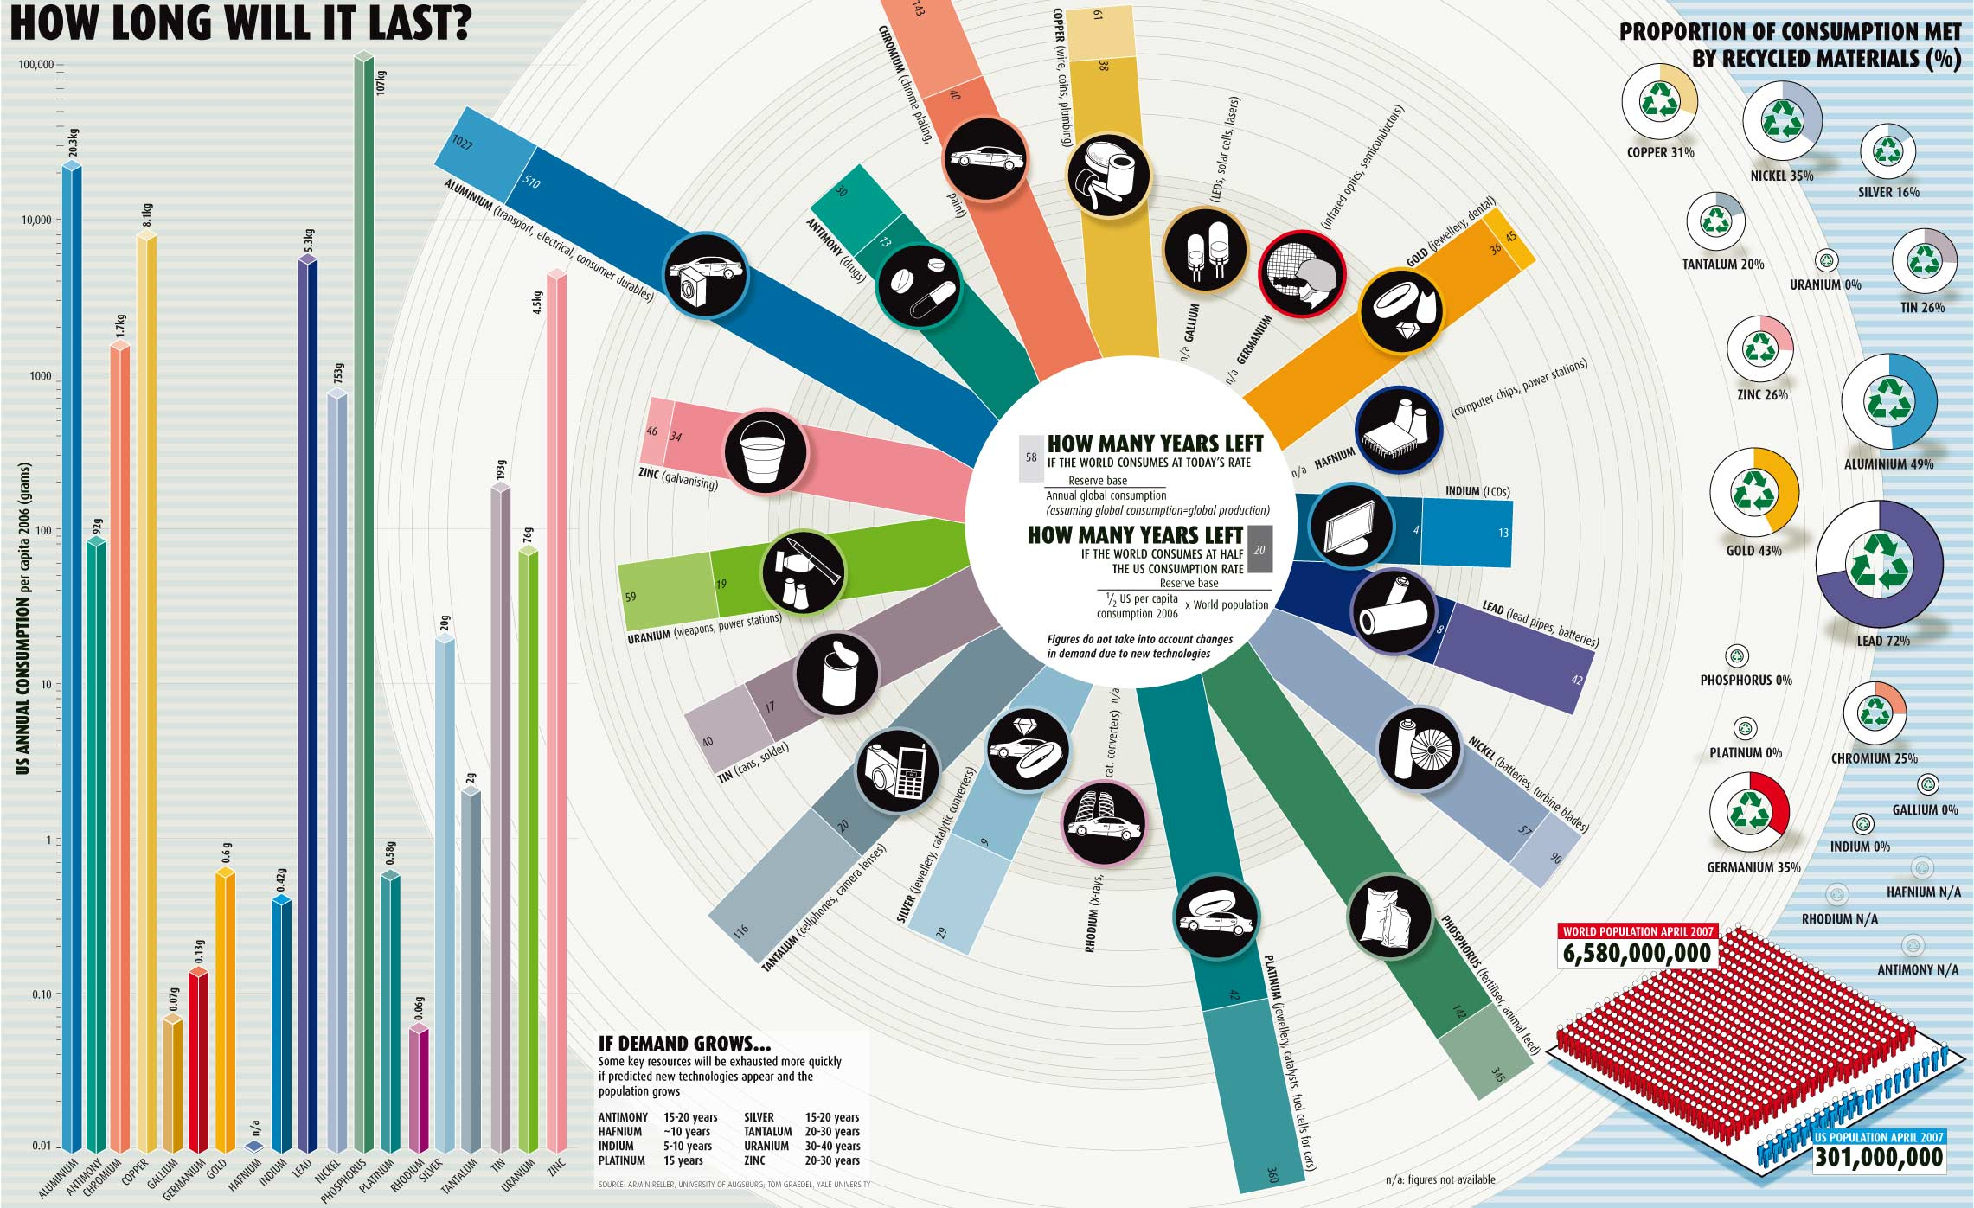
(Cohen, 2007)
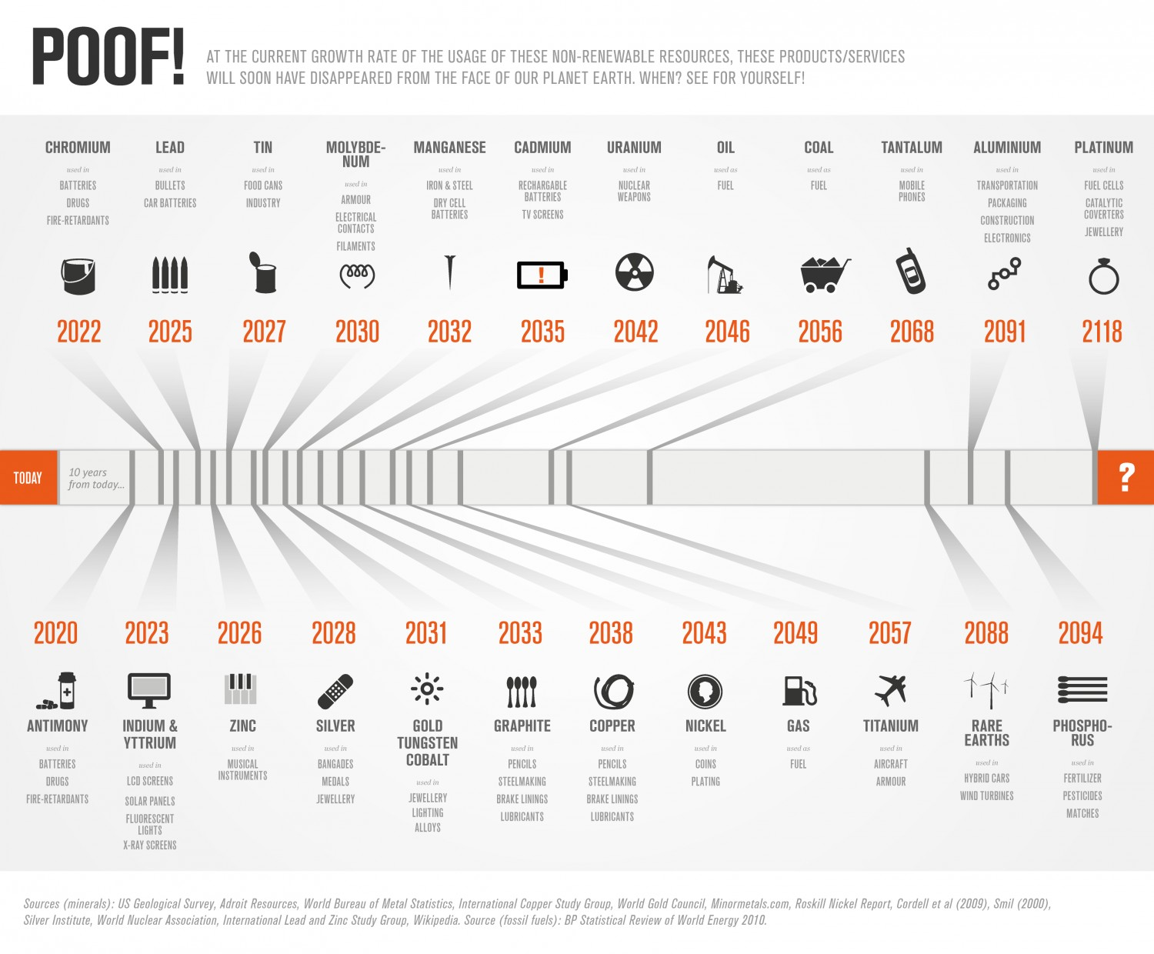

Appendix 5 – The Socio Economic Effects of Copper Mining in South America – News Report Ecuador indigenous leader found dead days before planned Lima protest (2014)

The body of an indigenous leader who was opposed to a major mining project in Ecuador has been found bound and buried, days before he planned to take his campaign to climate talks in Lima.
The killing highlights the violence and harassment facing environmental activists in Ecuador, following the confiscation last week of a bus carrying climate campaigners who planned to denounce president Rafael Correa at the United Nations conference.
The victim, José Isidro Tendetza Antún, a former vice-president of the Shuar Federation of Zamora, had been missing since 28 November, when he was last seen on his way to a meeting of protesters against the Mirador copper and gold mine. After a tip-off on Tuesday, his son Jorge unearthed the body from a grave marked “no name”. The arms and legs were trussed by a blue rope.
Tendetza had been a prominent critic of Mirador, an open-cast pit that has been approved in an area of important biodiversity that is also home to the Shuar, Ecuador’s second-biggest indigenous group.
The project is operated by Ecuacorriente – originally a Canadian-owned firm that was brought by a Chinese conglomerate, CCRC-Tongguan Investment, in 2010. According to the Confederation of Indigenous Nationalities of Ecuador, the project will devastate around 450,000 acres of forest.
“This is a camouflaged crime,” said Ankuash. “In Ecuador, multinational companies are invited by the government and get full state security from the police and the army. The army and police don’t provide protection for the people; they don’t defend the Shuar people. They’ve been bought by the company.
Several other Shuar opponents of Mirador have died as a result of the conflict in recent years, including Bosco Wisum in 2009 and Freddy Taish in 2013, according to Amazon Watch.
An initial autopsy said the circumstances of Tendetza’s death were unclear. Harold Burbano, of the human rights organisation INREDH, said there was a suspicion that the killing was related to his work as a land defender.
“There has been a rise of conflicts since the transnational mining company entered the area, significantly increasing the risks faced by community leaders,” he said.
Tendetza had planned to condemn the project at a Rights of Nature Tribunal organised by NGOs at the climate talks which are taking place this week in the Peruvian capital.
Luis Corral, an advisor to Ecuador’s Assembly of the People of the South, an umbrella group for indigenous federations in southern Ecuador, said that if Tendetza had been able to travel to the COP20 it would have put in “grave doubt the honorability and the image of the Ecuadorean government as a guarantor of the rights of nature”.
The activists said they were held back because president Correa wants to avoid potentially embarrassing protests at the climate conference over his plan to drill for oil in Yasuni, an Amazon reserve and one of the most biodiverse places on earth.
Once lauded for being the first nation to draw up a “green constitution”, enshrining the rights of nature, Ecuador has seen its environmental reputation nosedived in recent years as Correa has put more emphasis on exploitation of oil, gas and minerals, partly to pay off debts to China.
(Watts, 2014)

Appendix 6 – Hazardous Materials Used in Silicon PV Cell Production
PV (c-Si) production technologies - the most common technology found in the solar sector.
As with the production of silicon chips, production of c-Si wafers begins with the mining of silica, found in the environment as sand or quartz. Silica is refined at high temperatures to remove the oxygen and produce metallurgical grade silicon
The high temperatures required for c-Si production make it an extremely energy-intensive and expensive process, and also produces large amounts of waste. As much as 80% of the initial metallurgical grade silicon is lost in the process.
.Sawing c-Si wafers creates a significant amount of waste silicon dust called kerf, and up to 50% of the material is lost in air and water used to rinse wafers.
The extremely potent greenhouse gas sulphur hexafluoride is used to clean the reactors used in silicon production. The Intergovernmental Panel on Climate Change considers sulphur hexafluoride to be the most potent greenhouse gas per molecule; one ton of sulphur hexafluoride has a greenhouse effect equivalent to that of 25,000 tons of CO2.
Other chemicals used in the production of crystalline silicon that require special handling and disposal procedures include the following:
- Large quantities of sodium hydroxide are used to remove the sawing damage on the silicon wafer surfaces. In some cases, potassium hydroxide is used instead. These caustic chemicals are dangerous to the eyes, lungs and skin.
- Corrosive chemicals like hydrochloric acid, sulphuric acid, nitric acid and hydrogen fluoride are used to remove impurities from and clean semiconductor materials.
- Toxic phosphine or arsine gas is used in the doping of the semiconductor material. Though these are used in small quantities, inadequate containment or accidental release poses occupational risks. Other chemicals used or produced in the doping process include phosphorous oxychloride, phosphorous trichloride, boron bromide and boron trichloride.
- Isopropyl alcohol is used to clean c-Si wafers. The surface of the wafer is oxidized to silicon dioxide to protect the solar cell.
- Lead is often used in solar PV electronic circuits for wiring, solder-coated copper strips, and some lead-based printing pastes.
- Small quantities of silver and aluminium are used to make the electrical contacts on the cell.
- Chemicals released in fugitive air emissions by known manufacturing facilities include trichloroethane, acetone, ammonia and isopropyl alcohol.

Efforts are being made to make thinner wafers - microcrystalline Si and nanocrystalline Si - that use less silicon, but these require manufacturing techniques from nanotechnology that may pose new kinds of occupational risks.
(Mulvaney, 2013)

Appendix 7 – Electrochromic Glazing
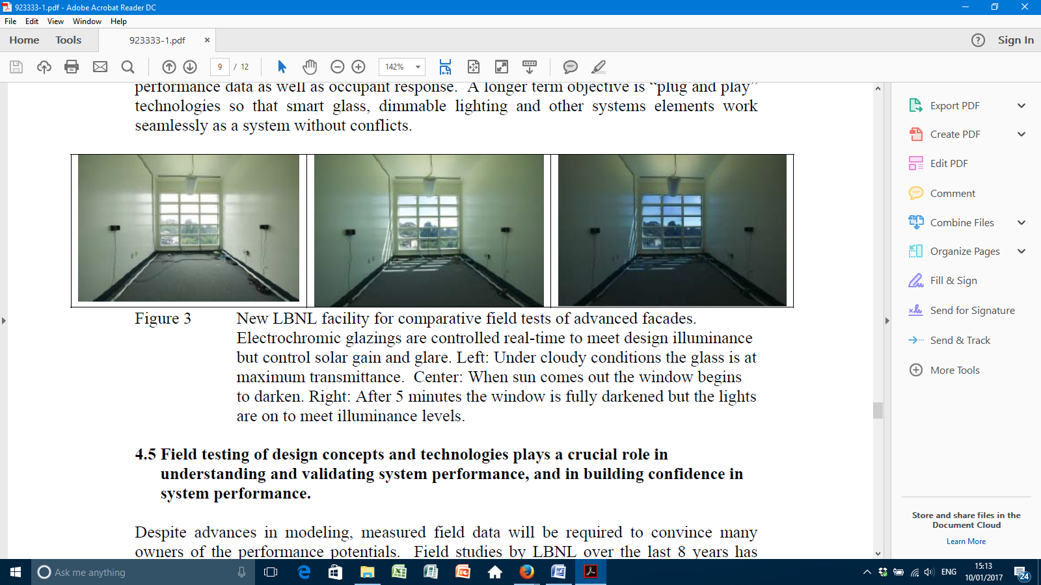

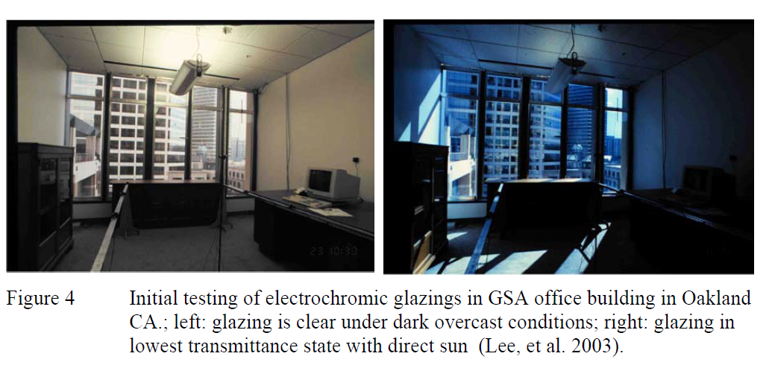
(Selkowitz, et al., 2013)

Appendix 8 – Solar Thermal Cladding
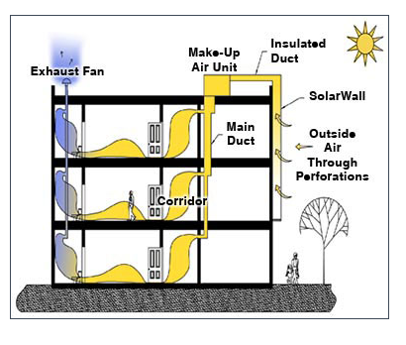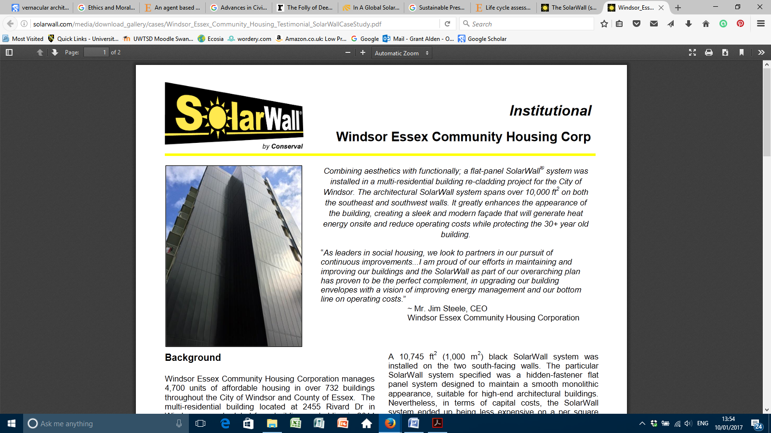

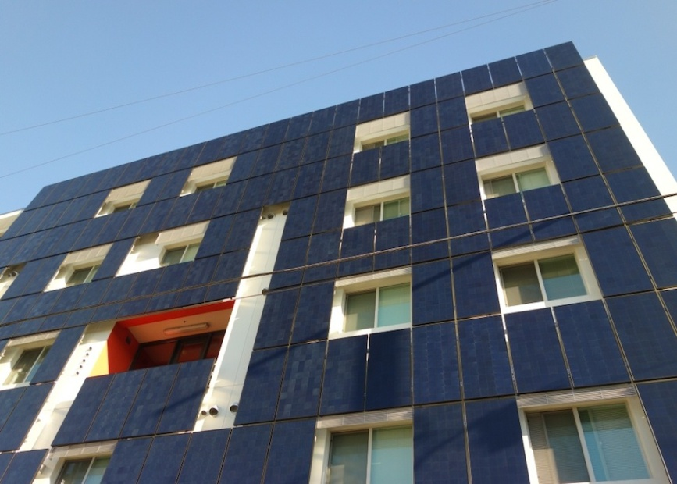
Combined photovoltaic and solar thermal systems offer both thermal improvement and generational potential whilst also offering combination with water cooling systems:
“HYTIPVE, a hybrid thermal insulating PV facade element combined with a water cooling system, which could also serve for heating up water, lowers the operating cell temperature by 20 K and increases electrical yield by 9% compared with conventional curtain PV facades” (Krauter, et al., 1999).
Emerging solar thermal façade solutions include solar collectors integrated into balcony rails, shading devices, louvers, windows or gutters (O'Hegarty, et al., 2016).

APPENDIX 9

DEC Advisory Reports

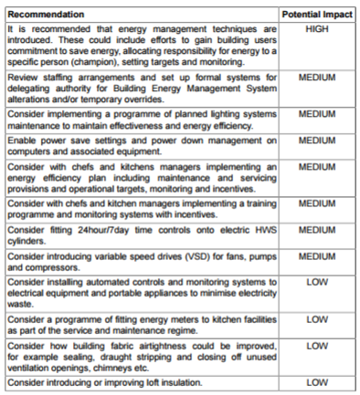

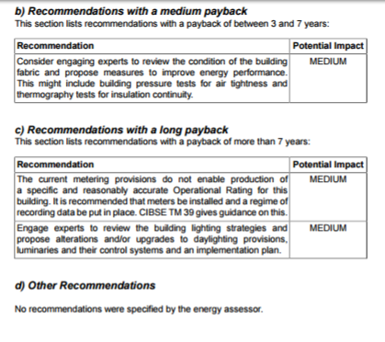

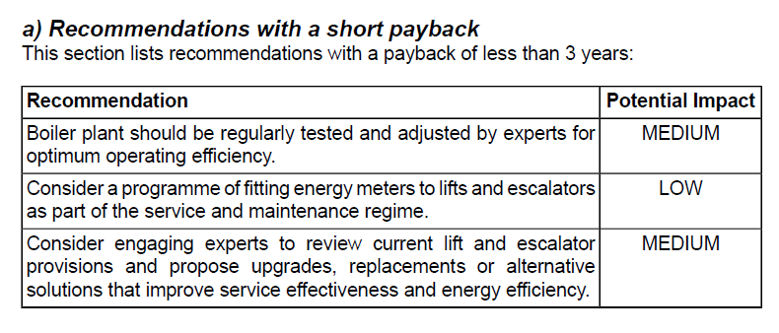
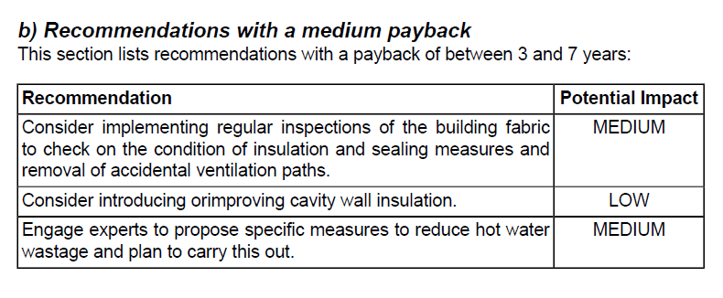
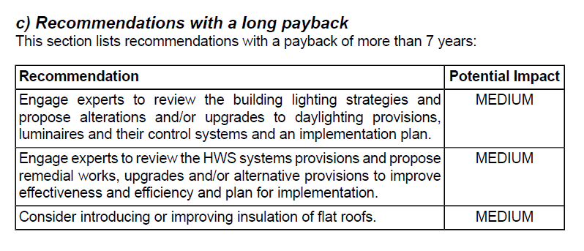

APPENDIX 10
IMPACT LIFE CYCLE COSTING EXERCISE BACKGROUND CALCULATIONS

(Taken from Willmott Dixon standardised data developed with BRE for the purposes of Life Cycle Costing – for more information see http://gtr.rcuk.ac.uk/projects?ref=400153)



