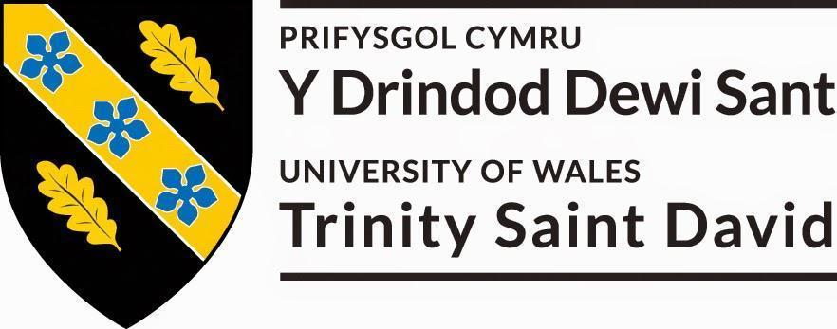

THPD6002
Interdisciplinary Arts

Tutor: Gwyn Emberton

BA Dance
2017-2018

Module Aims
- To provide students with opportunities to create innovative performance work that utilises other art forms and/or organisations.
- To enable students to hone skills developed during the course of their studies to create an innovative interdisciplinary performance work.

Module Overview

Collaborative practice forms an integral part of the arts industry, influencing many creative art works. Professional companies are actively exploring the potential of collaboration as a means of developing innovative interdisciplinary performance work.

This module will enable you to create an innovative interdisciplinary performance work in collaboration with practitioners from another art form and/or organisation. You will be required to utilise professional links that have been initiated and developed through the course of study. Professional links may be initiated with artists, sculptors, sound specialists, film makers and/or community arts organisations.

You will investigate the dialogue between dance and other arts forms and/or organisations through comprehensive research and conceptual exploration. You will explore a wide range of interdisciplinary possibilities fully analysing their potential. It is a requirement that you carry out research during directed study time.

It is a requirement of this module that you complete an evaluation that reviews, critically analyses and evaluates the process and final performance work. It is essential that all findings are supported by research. It is important to note that although you are working through collaborative methods you will be assessed as an individual.

Assessment Criteria

Component A: Extended Performance Piece
During this module you are expected to initiate and develop an innovative interdisciplinary work that utilises other arts forms. The work should fully explore the potential of collaborative practice and critically investigate the dialogues that exist and develop throughout the process. You will be expected to create the work with the guidance of an industry professional, namely Gwyn Emberton from Gwyn Emberton Dance.
Criteria 1: Critically investigate the dialogues between dance performance works and other art forms and/or organisations.  Criteria 2: Explore the potential of collaborative practice in full by working in partnership with professionals in the creative industries.  Criteria 3: Initiate and develop an innovative interdisciplinary work that utilises other art forms and/or organisations. | 75%
Component B: Critical Evaluation (1500 words)
In a process workbook and 1500 word essay you are expected to critically evaluate the process and final performance work through reflective analysis at an advanced level. You will need to reflect on the practical development and realisation of the work, making reference to your conceptual understanding. It is expected at this level that you provide supporting evidence to prove your point of view, and reference any sources accurately. Please refer to the module criteria when completing this evaluation.
Criteria 4: Critically evaluate the process and final performance work. | 25%

Overall mark = 100%

Please note the overall mark is an average of the two components listed above.

Assessment Deadline: 5pm on Friday 19th April 2018
Please refer to the Programme of Study Handbook for submission policies and procedures. Failure to submit will result in formal action.

Week of January 8th
Weekly Aims:
Meeting Gwyn and other artists and introduction to the project.
Begin working physically, exploring movement/choreographic style and methods of working.
Participate in morning warm-up classes, to work on technique and practical skills, as well as strength and flexibility in preparation for the process and performances.
Research, explore and create physical material taught and devised individually and in small groups.
Make considerations about potential directions of the future work – abstract, responding to artists work or a response to stories of steelworkers, community and identity.
Consider conceptual aspects of ‘Power’ and the steelworks themselves, and the impact of deindustrialisation of Port Talbot, Sheffield and the rest of the UK.
Read Bleddyn Penny’s thesis – Introduction, chapters three and five in particular.
Research, identify and share video source material of steel-workers physical habits.
Reflection and evaluation of week.
Week of January 14th
Weekly Aims:
Participate in morning warm up classes, to work on technique and practical skills, as well as strength and flexibility in preparation for the process and performances.
Develop devised work and expand on previous week’s material. Exploring its potential to facilitate more conceptual aspects.
Improvisation based on research findings.
Work with creative propositions and tasks to generate further material, responding to research into steel workers physicality and movements.
Respond to the concepts and themes of Steel and Power in the development of the material.
Begin to focus on direction of work.
Talk with an ex-steelworker. Develop task work based on this to respond physically and conceptually.
Read the conclusion of Bleddyn Penny’s thesis.
Research uniforms/clothing for costume ideas.
Reflection and evaluation of week.

Week of January 21st
Weekly Aims:
Participate in morning warm up classes, to work on technique and practical skills, as well as strength and flexibility in preparation for the process and performances.
Continue to develop devised work and expand on previous week’s material. Making decisions on potential of conceptual material.
Research character and narrative from the works to explore and embody physicality of characterisation.
Develop character and narrative-arcs if necessary.
Refine and rehearse developed material.
Improvisation based on research findings. Recording and capturing material from improvisation.
Other reading from list.
Reflection and evaluation of week.
Week of January 28th
Weekly Aims:
Participate in morning warm up classes, to work on technique and practical skills, as well as strength and flexibility in preparation for the process and performances.
Deepen practical understanding of movement language and embed narrative aspect if necessary.
Improvisation of work’s themes as identified through research.
Refine and develop conceptual and physical understanding of individual roles in work.
Develop material and deepen physical and conceptual understanding of it.
Self rehearsal.
Consider audience experience and the impact it will have on the work.
Reflection and evaluation of week.
Week of February 4th
Weekly Aims:
Participate in morning warm up classes, to work on technique and practical skills, as well as strength and flexibility in preparation of the process and performances.
Refine and develop conceptual and physical understanding of individual roles in work.
Self rehearsal.
Consider audience experience and the impact of on the work.
Testing sections and modules for structural purposes.
Full run-throughs of sections, and notes.
Visit by artists – receive feedback.
Costumes decisions to be made.
Reflection and evaluation of week.
Week of February 11th
Weekly Aims:
Participate in morning warm up classes, to work on technique and practical skills, as well as strength and flexibility in preparation of the process and performances.
Consolidate work into a final structure for both Ignite and for Sheffield launch. Identify differences in performative expectations of the two performance spaces.
Consider audience experience, journey and situation for Sheffield launch performance. Test audience journey.
Analyse red line of work – dramaturgical through-line – and make adjustments to structure, character or conceptual structure.
Combine piece with sound score.
Refinement and rehearsal of movement language and performative delivery.
Full run-throughs, and notes.
Reflection and evaluation of week.

Suggested bibliography
Below is a selection of relevant reading material that will help you with this module. You are not expected to read everything on the list; you should consult what seems useful for the tasks you are doing. You will find that the library has other relevant materials as well and you should feel free to use them even if they are not on this reading list.

Essential
Auslander, P. Liveness: Performance in a Mediatized Culture. London: Routledge, 1999.
Cave, R. Collaborations: Ninette De Valois and William Butler Yeats. London: Dance Books,
2011.
Ede, M., Mason, M. Titian/Metamorphosis: Art Music Dance; A Collaboration between the
Royal Ballet and the National Gallery. Art/Books: London 2013.

Recommended
Burrows, J. A Choreographer’s Handbook. Taylor & Francis, 2010.
Carter, A. & O’Shea, J. The Routledge Dance Studies Reader. Routledge, 2010
Climenhaga, R. The Pina Bausch Sourcebook: The Making of Tanztheater. Routledge, 2013
Oliver, W. & Risner, D. S. Dance and Gender: An Evidence-based Approach. University Press of Florida, 2017.
Spier, S. William Forsythe and the Practice of Choreography: It Starts From Any Point. Routledge, 2011.

Papers
Bleddyn Penny Class, Work and Community Port Talbot’s Steelworkers, 1951-1988 Submitted to Swansea University in fulfilment of the requirements for the Degree of History (Doctor of Philosophy) (2016)
Valerie Walkerdine and Luis Jimenez’s ‘psycho-social’ study of a Welsh ‘Steeltown’, Gender, Work and Community after Deindustrialization (2012)
C.C. Harries’ Redundancy and Recession in South Wales, a study of the effects of unemployment in the steel industry on family life and the community,39

Websites
http://www.sheffieldontheinternet.co.uk/bizhist.html

https://steelvoices.wordpress.com/2015/07/26/here-was-a-future-for-hands-of-skill-steel-and-post-punk-in-the-1980s/

https://www.nationaltheatrewales.org/were-still-here

http://www.bbc.co.uk/news/uk-wales-35161054

https://www.youtube.com/watch?v=6lqq3_1YjWA

http://www.gwynembertondance.com/

http://www.sarah-hopkins.co.uk/

http://www.illustriouscompany.co.uk/
http://www.sanderswood.com/

Liv

