

Postgraduate/Distance Learning
Assignment coversheet & feedback form

THIS SHEET MUST BE THE FIRST PAGE OF THE ASSIGNMENT YOU ARE SUBMITTING (DO NOT SEND AS A SEPARATE FILE)

For completion by the student:
Student Name: Amanda Page

Student University Email: 2218536@student.uwtsd.ac.uk
Module code: HPCA7016  Module title: Researching Contemporary Cosmologies | Student ID number:  2218536 |  |  | Educational support needs:  Yes/
Research Project in Contemporary Cosmology: Attitudes to Plant Intelligence amongst Regenerative Horticulture Practitioners

Assignment due date: 1st May 2025 (+1 week differentiated deadline 8th May 2025)
This assignment is for the 1st 2nd 3rd 4th X 5th 6th module of the degree
I confirm that this is my original work and that I have adhered to the University policy on plagiarism.
Signed ……………………………………………………………
Email submission:if you are submitting this form via email, please tick this box 
(as a substitute for your signature) to confirm that you agree to the above declaration.
Assignment Mark
1st Marker’s Provisional mark
2nd Marker’s/Moderator’s provisional mark
External Examiner’s mark (if relevant)
Final Mark

NB. All marks are provisional until confirmed by the Final Examination Board.

For completion by Marker 1 :
Comments:

Marker’s signature: |  |  | Date:
For completion by Marker 2/Moderator:

Comments:

Marker’s Signature: |  | Date:
External Examiner’s comments (if relevant)

External Examiner’s Signature: |  | Date:

Attitudes to Plant Intelligence amongst Regenerative Horticulture Practitioners
5.046 words
Introduction
Through researching beliefs about plant intelligence held by regenerative gardeners and growers, this project seeks to explore Theodore Roszak’s theory that an animist worldview imposes ‘an ethical restraint upon exploitation [of the environment]. Although Roszak is not writing about plant intelligence per se, referring specifically to animism, the belief that plants are persons is explicitly linked. Graham Harvey's description of animists is helpful here: ‘people who recognise that the world is full of persons, only some of whom are human, and that life is always lived in relationship to others.’ Plants dominate the biomass on Earth at 80%, yet they seem to be sitting at the bottom of a hierarchy headed by humans. This is not the relationship Harvey advocates—industrial farming methods that have trashed ecosystems are not respectful, careful, or constructive. My own experiences with plants have made me more ecologically minded; I now see myself as part of an interconnected web of life full of mutually beneficial and reciprocal relationships, which is closer to the animist worldview. I wondered if other people had similar beliefs; therefore, I decided to focus on other local practitioners. Regenerative horticulture centres on creating thriving ecosystems and includes practices such as permaculture, organic and biodynamic growing. I was curious to see if this group’s beliefs about plants’ intelligence had motivated them away from the dominant Western exploitative and controlled growing systems, and what lessons could be learned for the wider community. As such, I also aimed to uncover any specific experiences in which an emotional connection to plants established an ethical restraint or modified the respondents’ personal cosmology.
The research is situated within an ecospiritual framework, working to Julia Itel's definition of it as ‘an amalgamation of personal spiritual quests and ecological awareness’, as a ‘response to the growing disenchantment with materialistic and technocratic worldviews’ that mirrors my own experience. Further, it seeks to build on Hunter’s foundational assumption that ‘permaculture seems to provide a framework for understanding inter-species communication and non-human consciousness.’ The research method I employed sits under Bell and Waters' definition of qualitative research to understand how people understand or see the world. This project’s findings and discussion focus on five themes: plants as beings; extraordinary experiences with plant communication; relationship and reciprocity; embodied connection and Childhood memories.
Lastly, it is worth highlighting that most of the respondents were women (83%) when the ratio of practitioners in the area is approximately equal between men and women, with a very small percentage being nonbinary. Although it is not within the scope of this project to discuss the findings under an ecofeminist framework, it is an area for further research in the future.

Literature Review
In addition to Itel’s ecospiritual framework, the main academic theorists for this project are Jack Hunter, Monica Gagliano, Robin Wall Kimmerer, Stephen Harrod Buhner and to a lesser extent, Jeremy Naydler and Patrick Curry. Gagliano describes her spiritual and scientific experiences with plants in the descriptively titled – Thus Spoke the Plant. Through shaman ritual, drinking plant medicine, Gagliano connected with the deities of the plants, and they spoke to her, telling her what experiments she needed to conduct to prove plant intelligence. The result of this conversation helped Gagliano prove that plants use pheromones to communicate with other plant species, and specifically that Mimosa plants can remember, learn and act individually. The Amazonian plant Ayahuma (Couroupita guianensis) told her to use a maze to train pea plants to follow a food source, thereby enabling Gagliano to prove that plants recognised signs and could imagine food. By shifting her perception, opening a door to imagination, she communicated with the spirit of the plants to prove plant cognition in the scientific world. I wanted to know if any of the respondents had similar experiences where plants spoke directly to them.
Jack Hunter’s paper on extraordinary experiences in permaculture provides the rationale for my project. Hunter reports instances of ‘non-ordinary communication’ with plants (plus animals and others) over the two to three years he was studying with permaculture practitioners. He goes on to suggest that this particular horticultural practice highlights that all life is connected. Being close to the web of life seems not only to present opportunities for extraordinary experiences to occur, they also enable a development of what he calls ‘ecological consciousness’. Another term for this same idea could be what Itel calls ‘ecosensitivity’, which she credits for the move towards ‘a more direct, intuitive interaction' with the natural world. A key area of this project was to define this interaction in terms of plant intelligence to add to Hunter’s body of work on the same subject.
Robin Wall Kimmerer’s works detail the importance of indigenous knowledge of working with the land rather than against it and positions plants as the leaders to teach humanity. Had there been any experiences where the plants had taught people something? Stephen Harrod Buhner argues that humans have always had extraordinary experiences in the natural world. Further, his work informs discussion on childhood as he states that humans are born with the required perception needed to converse with plants. The Secret Teachings of Plants illuminates the embodied connection discussion point of this paper, with his theory about the heart being the ‘organ of perception’, making communication with plants possible. I wanted to know if this group had a strong connection to plants, and if so, where in their body did they feel it to test Buhner’s theory? Lastly, Patrick Curry provides a platform to discuss his idea of enchantment in this paper, and Jeremy Naydler provides a sense of context for the belief in nature spirits.

Methodology
Qualitative data cannot be proven as it’s based on an individual’s thoughts and feelings (collected at a particular place and time). Methods of gathering qualitative data include but are not limited to questionnaires and surveys, interviews, narrative accounts and case studies. I used mixed methods to collect my data: questionnaires initially, and a follow-up of semi-structured interviews to allow the participants room to elaborate on their answers. I used Google Forms to create an online survey populated with questions formulated during the design cycle process as described by Hennick et al (the link can be found in the appendix.) Two of the questions used are the same as those asked in Hunter’s paper, since this project seeks to contribute to the conversation. The questionnaire link was shared on local Facebook groups such as Talgarth, Bronllys and Hay-on-Wye community pages, and I targeted three specific organisations by emailing a ‘gatekeeper’ whose members and students are practising regenerative growing. These were Grow for Talgarth, Hay Regenerative Soils and Black Mountains College. I received nineteen responses from growers and gardeners living locally, aged between 26 to 75 years old; the majority had been practising for more than 5 years and were currently practising these principles at a rate of 5 to 15 hours per week. I invited five respondents (four women and one man) to a follow-up semi-structured interview of approximately one hour, where I repeated the longer questions. Hennick et al offered a good source of information on conducting an interview, such as how to build and maintain rapport, show empathy and respect, as well as the skills required to motivate and when and how to ask probing questions, and I reread this section before the first interview. Bell describes an interview as a way to gain insight that may be hidden in the written questionnaire response, and this is what I experienced. All the interviews were conducted in person, four were in an outdoor setting, and one was in a garden room; as such, all were in the company of plants and trees, as I felt strongly they should be included in an interview process that was about them. I referred to the university's ethical guidelines as suggested by Bell and did not start the interviews until I restated the purpose of my research and detailed how their data would be stored and used. I obtained spoken permission at the start of each recording, and to maintain confidentiality, each of the five respondents chose a pseudonym. These are Echinacea, Tajinaste, Ginkgo, Pine Cone and Plantain.

Reflexivity
No conversation about methodology is complete without a short discussion on the researcher's position to make ‘explicit their potential influence’ on the process. I am an insider in that I grow regeneratively, and I believe that plants communicate with human beings. I targeted groups (students, retirees, market gardeners) to ensure variety in background, age, level of experience, length of practice in years and hours spent working weekly to ensure a good range of responses across the (albeit restricted) board. I personally know four of the five interviewees. There is a close-knit community of growers in this area, partly due to the foundational collaboration required for these types of growing systems and partly due to general public interest in adapting food systems as the climate changes. Further, I believe the rapport built with the interviewees was partly to do with us knowing each other as well as them being very motivated about the topic of plant intelligence. Knowing the respondents meant they were more willing to confide in me, which was an advantage when talking about a subject that is not the consensus (yet). However, the data is heavily influenced by talking almost exclusively to the like-minded, who are probably not likely to challenge the underlying assumptions of the questionnaire (one being that plants are intelligent, as proved by 0% negative response to that implicit question on the survey). The fact that the respondents are practising sustainable growing methods means they already understand the benefits of an ecology based on regenerative and not exploitative methods. However, this should not detract from the rich source of data they have shared about their experiences. The respondents’ relationship with plants informs their world view as much as it does my own; therefore, my own experiences with plant intelligence are included when relevant and can add to the discussion. The final point to make is that I have made use of longer, direct quotes from the interview transcripts to ensure the voices of the people who participated are heard. This is an ethical consideration based on a) wanting to share what the interviewees said explicitly and not my interpretation (although I am aware of the need to be selective of themes when presenting this paper); b) to take a respectful and careful approach to presenting what they said is in keeping with what they shared overall and not out of context, and c) to ensure each participant had an equal say in the research paper.

Findings and Discussion
This section is a discussion on the five themes that came after filtering the data and aims to link what was discovered with the relevant theorists. It is prudent to start with a general overview of the findings. When asked if they believed plants were intelligent – although there was a variety of understandings and comments about what this may mean, ranging from what could be scientifically tested to the more spiritual aspects, such as the existence of a plant consciousness that included agency and personhood – not one of the nineteen respondents answered no. Most questionnaire respondents described a strong connection to a plant, and everyone named a favourite plant or described a plant that grew in their garden. Respondents found metaphorically encoded personal meanings through a memory about, an experience with or an association to a particular plant: as one respondent put it, ‘I think there are many metaphors/analogies in nature that can be used to explain life’. Each interviewee had a story about individual plants or trees that described their relationship with them; they used words such as ‘friend’ and ‘teacher’, one even received ‘healings and insights’. There was a correlation between the scientific and spiritual aspects as described by both Kimmerer and Gagliano that aligns with Itel’s suggestion that an ecosensitivity requires both understanding the ecological science and ‘experiencing its [the Earth’s] mystical and intuitive dimensions.’ What follows is a discussion of these aspects related to plant intelligence.

Plants as Beings
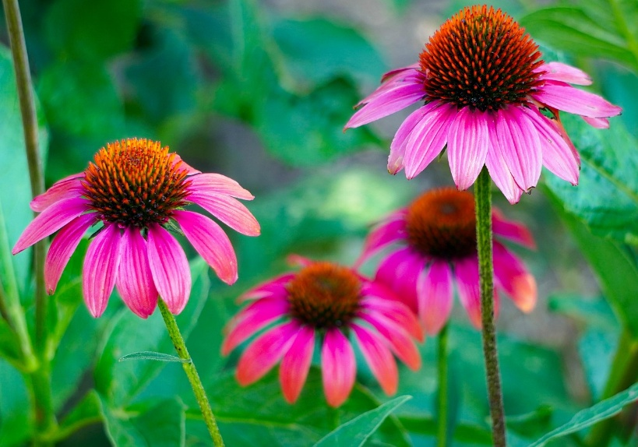
Figure 1. Echinacea. Pixabay free images, https://pixabay.com/images, accessed 27th April 2025.
When asked to describe how plants were intelligent, some responses aligned with Gagliano’s findings about how plants communicate, such as plants – ‘connect and communicate with each other, adapt to environments, problem solve and have relationships – the definition of intelligence’ and ‘Mycorrhizae connect plants together; they communicate, just differently from us’. However, responses saying ‘plants themselves know what they’re up to’ and ‘can judge what they need’ seem to go beyond biological explanations to where plants have a sense of personhood. There was a strong juxtaposition between science and plants as spirit in the data. For example, ‘plants refusing to grow in places where conditions seem right’ or ‘[medicinal] plants growing near your house that you or your children need.’ At the mystical end of the scale, Ginkgo called her tree ‘a primaeval kind of spirit’, and Echinacea told me she believed the plants growing in the garden she tends are ‘guardians of the place that have stopped the garden from being sold.’ She told me that she prayed to the plants every day, asking for their help and soon after, the garden owner said he would not sell after all, claiming the garden was hers to manage for the foreseeable future. In Gagliano’s case, the plants showed her that ‘the reality we perceive is a narrow set of familiar things and contexts we feel at home with.’ Echinacea talks to the plants and says she listens to them. Perhaps this act of opening to the possibility of communication has taken her beyond the familiar, where the spirit of the garden plants heard and answered her prayers.
Jeremy Naydler documents the history of gardens as places of worship and connection to the divine in his book Gardening as a Sacred Art. English medieval chronicles detailed talk of fairies and elves, where people felt nature to be ‘alive, ensouled and full of spirits’. I suggest, then, that our medieval ancestors were just like the animists of today, and that the beliefs of this group are nothing new – they are just reclaiming a forgotten wisdom that understood plants as beings. To believe the world is full of spirits and magical beings changes the dynamic about how one treats it. Patrick Curry is clear on this when he says, ‘disenchanting the world… is a fundamental prerequisite to commodifying and exploiting it’. From an ecospiritual standpoint, this disenchantment has been a key driver for people to establish their personal spiritual quests embedded in ecology as a response. My research suggests that regenerative gardeners are beginning to ‘re-attune’ with the spirits of place where plants are beings and individuals. It also highlights the similarity in life journeys (or pilgrimage) of the respondents. Extraordinary experiences seem to play a large role in establishing an animist outlook.

Extraordinary Experience
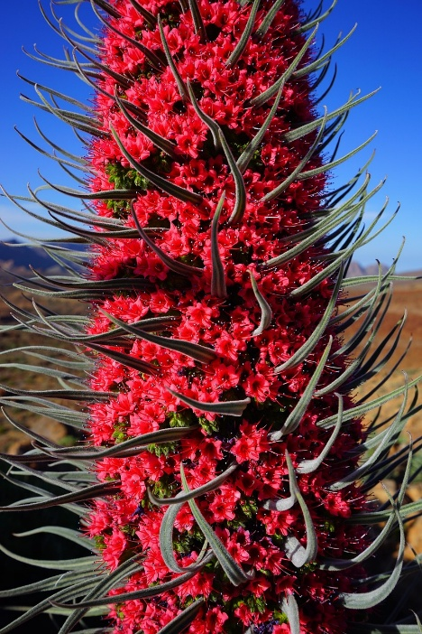
Figure 2. Tajinaste. Pixabay free images, https://pixabay.com/images, accessed 27th April 2025.
There were more records of extraordinary experiences than I can describe here, with evidence of people making strong emotional connections with plants that were sustained through time. (I have added the questionnaire responses to the appendix below for further reading.) These experiences are described as of great personal significance, one was imbued with a numinous quality that ‘brought to tears at sights in nature too beautiful for words’. An experience left one feeling ‘they had been taught something about themselves and the natural world’ and another who ‘experienced communication with trees and wild plants.’ All these experiences took place outdoors in direct contact with plants and trees, which seems to confirm Hunter’s argument that ‘it is through interaction that non-human intelligences manifest.’ The data collected seems overwhelmingly to confirm Hunter’s argument, and out of many examples, here are four equally valid ones to show how interaction with plants has enabled this phenomenon:
- For one respondent, the scent of a nemesia at a garden centre broke a year-long haze of grief after her daughter died. She then took up horticulture as a career change.
- ‘I remember looking up at the canopy of the trees above me, and all the leaves like shimmering, and it was just absolutely beautiful. But in that same breath, I noticed there were certain trees which had no foliage in their canopies whatsoever. And those were ash trees. And it was one of the experiences that led me to sort of pursue more tree surgery work and woodland management and that sort of thing.’
- ‘Being transported to a different plane while still walking along the same path and perceiving the smell of the bracken. Everything seemed to be emanating wisdom and friendship, and I was just taking it in and being part of it in a way that can't be put in words.’
- ‘My sister and I were in this little tiny caravan, and outside there were beautiful trees and shrubs, and it was one of those days where the clouds came over and then it was sunny. She was holding my hand, but she could see when the sun was coming before the sun came because the trees were getting excited, and then we could see the whole thing kind of lit up like a light show, and then we were just seeing the same thing at the same time. She's like, ‘it's coming, it's coming up! I can feel it telling me it's coming,’ and then there was a proper light show, like how you see online of something psychedelic, and it was just so beautiful light and colours running through the leaves. I thought it was an example of our consciousness being intermingled.’
These experiences left the respondents closer to nature than previously, with the first three respondents above following an ecological path: they either started to study regenerative horticulture, coppicing or soil health or retrained to change their career. This again confirms Hunter’s idea that post-experience, a person is left with ‘an enhanced sense of connection to the environment.’ The last experience listed was my own, and its impact was to confirm that I was part of ‘a wider network of relationships’ as well as rewarding my faith in plant intelligence by producing such extraordinary experiences as confirmation.

Relationship and Reciprocity
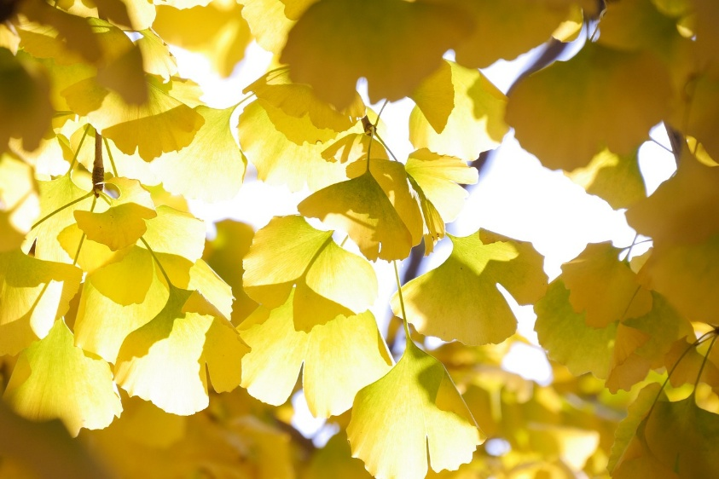
Figure 3. Ginkgo biloba. Pixabay free images, https://pixabay.com/images, accessed 27th April 2025.
Robin Wall Kimmerer talks a lot about reciprocity. Her book, The Serviceberry, is about the relationships the tree supports. It provides food and shelter to birds and insects in return for spreading its seeds. However, there is an overabundance of fruit, which means all can share in the harvest, which had less to do with an exchange and more to do with a gift economy. Her point is that these ecosystem relationships exist and indigenous people have known about them for centuries, long before the 17th century, post-mechanisation, when this knowledge was effectively wiped out from our culture. The way to a flourishing world is to follow ‘the lead of our oldest teachers, the plants,’ she says. What did learning from plants do for the regenerative horticulture group? I believe it opened a door to begin to build a relationship with plants. I asked the group if they had ever had an intuition about where to grow a certain plant. This was to ascertain if any had moved away from what they had learned from books to an innate, one may say, indigenous knowledge or understanding deep inside them. As well as asking the plant or nature directly before channelling an answer, one answered, ‘over time, you begin to intuit,’ another replied, ‘I feel my antennae for such things growing’, which could describe a growing consciousness. Being immersed in nature, over time, allows for these patterns of reciprocity and relationship to be revealed. A respondent gave an example of the lupins which grow in their garden: ‘Each year, one of the group is attacked by aphids, but never the same one two years in a row. I feel they are taking it in turns.’ Watching to learn and a growing intuition are steps on the way to uncovering a deeper wisdom. I collected a few stories, but Plantain’s is the most pertinent for my point about innate understanding. Plantain says:
I found myself seeing and hearing plants and approaching plants and going, ‘they’re poisonous,’ without knowing they're poisonous. There was just something that told me about the way the flowers were, the way they held themselves. After that, I had to leave where I was living because I needed to understand plants more and just seek out this relationship.
Plaintain worked extensively with Himalayan balsam, which grows invasively along the river Wye, and this next excerpt shows the depth of the formed relationship over time.
There was such a lesson in grief and mourning and circular systems. And what I ended up creating from the Himalayan balsam were urns to be buried again. And it was this whole what comes from the earth must eventually go back. And it's just kind of created this framework in me of we are nature, which, again, is cliche as hell. Like we grow, we learn, we live, and we die, and it's we're not. It's not the end. It's a part of a process that has just supported so much in me, that's like, feels like language doesn't do it justice. You know? It's a feeling that can't be explained.
To return to Kimmerer, it seemed that my interviewees were engaging in their ‘own process of becoming indigenous’ and were at different stages of the same journey towards complete understanding (or one may say full ecological consciousness). Ecospirituality is about celebrating and respecting the indigenous wisdom that holds the world to be interconnected, as much as it emphasises a ‘deep, embodied engagement’ with the world around us.

Embodied Connection
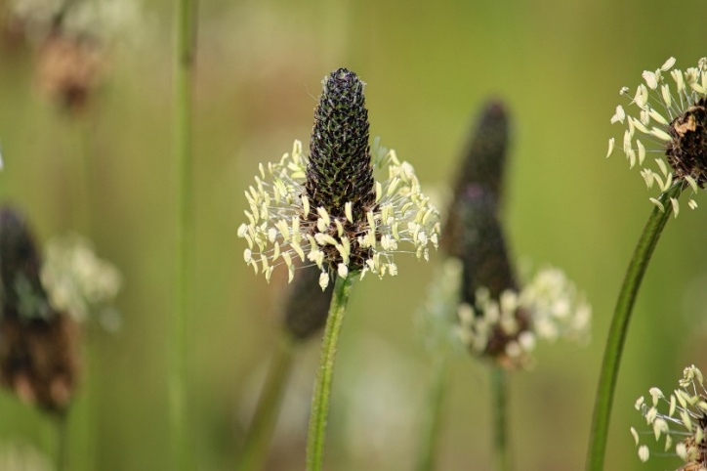
Figure 4. Plantain. Pixabay free images, https://pixabay.com/images, accessed 27th April 2025.
Ecospirituality is achieved by perceiving through ‘heightened awareness of our senses.’ Therefore, I asked respondents where in their bodies they felt the strongest connection to plants, giving the choices: head, heart, hands, none or all of these. During our interview, Ginkgo responded with the following statement about where she felt the strongest connection to plants:
When I said that my toes were tingling, and in fact, they're still tingling. So that's because, of course, you walk on the ground, but there's definitely something there, and there's a warmth there right now. But I think, and I'm touching my heart right now, and I'm talking with my head, as it were, so I feel thinking all of them, yeah, yeah. The whole body. It’s a resonance, like a hum.
However, the most common response on the questionnaire was heart at 69%, and when asked again in the interview, all but one said the heart. Buhner writes that the self resides not in the mind but in the heart, and it is through the heart that we understand the living world. Further, he asks if plants communicate through a ‘living dialogue’ that has been with us since we emerged, humans and plants, from the cosmos. These next examples show in detail both an embodied connection and heightened awareness, as well as hints of a living dialogue, albeit one outside human understanding:
- ‘I believe plants are singing to us in many ways with a very ancient language that takes us from the temporal realm to the transcendent realm where we commune with the essence of everything.’
- ‘It’s an empathic, felt connection that resonates through me and is me’
- ‘It's embraceful’ and described feeling, ‘a sense of awe to it. It's feeling held, which is so nice.’
- A trust – that this is ‘an instinctual and primal connection.’
There was a definite split between what was felt and the language used to describe it. For example, a hum or resonance or embrace indicates a movement or feeling, an embodiment attached to the heart, but when the feeling is described, filtered through the mind, language seems to be insufficient for some. The idea of a ’ very ancient language’ recurred repeatedly among the correspondents – it manifested in something that ‘can't be put in words’ or when Tajinaste stated she ‘can’t put my finger on what the word is’ when trying to describe the emotion linked to the heartfelt connection; Plantain says ‘language doesn’t do it justice… It’s a feeling that can’t be explained.’ It seems this connection is beyond human language to explain what it is or how it works. It exists in the instinctual, mystical realm and is felt with the heart: what Buhner describes as ‘the organ of perception’.

Childhood Openings
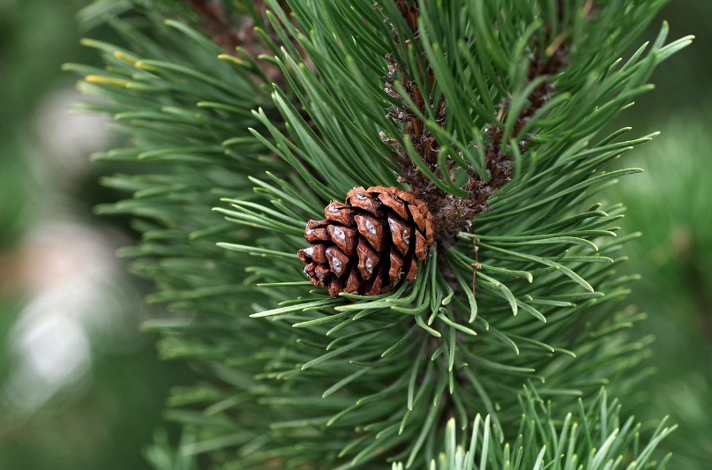
Figure 5. Pine. Pixabay free images, https://pixabay.com/images, accessed 27th April 2025.
This final section discusses how experiences in childhood experiences could predispose one to an animist outlook. Echinacea, Pine Cone and Tajinaste describe a coming to an ecological awareness slowly, after being conscious of it as a child, before losing this connection, then re-discovering it again through books, teachers and mentors or extraordinary experiences. Indeed, Buhner argues that culture and, in particular, Western schooling has blocked understanding and closed our deeper perception of the world around us – one of interrelationship with everything in the world, yet he claims each human can re-ignite this child-like perception. This response is a key example in agreement: ‘despite having felt innately connected as a child with the natural world, I suppose being socialised in an anthropocentric world contributed to a disconnect.’ Another writes of ‘early childhood experiences of being completely integrated into the natural world’ which resonates with a lot of the interviewees, and me included.
The next three accounts describe a childhood experience in nature. These are not just memories to be recounted, as they seem to have had a profound impact on each respondent, and each fits with Buhner’s description of child-like perception of the relationship between humans and plants and trees. They depict a relationship where plants and trees are healers, teachers and playmates – they are not things, as there is a definite sense of personhood.
Echinacea –
I have had it [the belief that plants are intelligent] since a child, definitely. I remember a teacher, Miss Enoch, who was like a travelling Welsh teacher in schools in Powys, and she came and said that you can talk to plants, and although I hadn't before, and my parents didn't talk about or talk to plants, I feel it was just there in me.
At times in my life, I have not been well: as a young child, I would sit in hazels to get a long-term perspective of health.
Pine Cone had this to say about a childhood experience –
When I was a child, my mother used to, if I was crying or something, my mum would take me outside underneath the tree, and the sound of the wind through the leaves would calm me down, like that was something that she told me, you know, I don't know a little while ago, but it was really nice thing to know.
Tajinaste –
I remember that kind of feeling as a child, like I could go up into the trees and a big part of it and feeling very comfortable, feeling that same time, I know I can't put my finger on what the word is – it is a funny kind of emotion. Yes, so that's one and then when I see flowers, so so different environments like in the Canary Islands, the difference or the sensation or emotions that come up, but very heart-centred. I feel them there. A sadness in a way, but not like bad sadness as such, you know, which is like a grief, almost it's almost like yeah I'm I'm sort of grieving, or are the plants grieving?
A childhood experience of nature like the one above was common to more respondents than I could present for this project. However, I wanted to add my recollection, here to end this section. I moved around a lot as a child, and when I was seven years old, my family moved to this area of Mid-Wales. My parents were neglectful, and I spent a lot of my time alone and outdoors playing alongside the Monmouthshire and Brecon canal and the river Usk. My friends were the plants and trees growing in the ancient woodland. I never felt lonely when I was in their company. Years later, when it became possible to move anywhere in the country, I yearned to return to the place where I’d felt the most loved. And that was in this landscape, and it was not people who I felt loved by.

Conclusion
This project was an exploration of regenerative gardeners and growers' beliefs about plant intelligence to explore Theodore Roszak’s theory that an animist worldview imposes ethical restraint. I made my own conscious, ethical consideration to include as many of the responses as I could in part to honour the fundamental principles of permaculture, which is to encourage a diverse ecosystem. The research has shown that some respondents' belief in plant intelligence was a motivator in their moving away from the dominant Western exploitative and controlled growing systems; therefore, their personal cosmology has imposed a restraint. I have presented examples where people have been guided by their emotional connection to plants, seeing plants as teachers, healers and motivators; changing their careers and worldviews to be more in tune with a living earth. The data has it that regenerative gardeners are beginning to re-attune with the spirits of place, albeit at different rates, and that these moments of connection have left the respondents closer to nature than previously. The research also points to agreement with the ecospiritual framework that marries scientific and intuitive knowledge together to produce a certain sensitivity or ecological consciousness because of a sense of disenchantment with the technocratic and mechanistic world. However, it seems this consciousness is yet beyond our capacity to describe it in human language. Perhaps that is because any communication is filtered through the brain when plant to human consciousness is felt with the heart. A finding that I think could be of importance for the future is that childhood memories of nature connection have not been forgotten by this group and form a strong foundation for their beliefs and world view.
References
Bell, Judith, and Stephen Waters, Doing Your Research Project: A Guide For First-Time Researchers, 6th ed (McGraw-Hill Education, 2014)
‘Black Mountains College - We Are Teaching the Future’ <https://blackmountainscollege.uk/> [accessed 26 April 2025]
Buhner, Stephen Harrod, Plant Intelligence and the Imaginal Realm: Beyond the Doors of Perception into the Dreaming of Earth (Bear & Company, 2014)
——, The Secret Teachings of Plants: The Intelligence of the Heart in the Direct Perception of Nature (Bear & Company, 2004)
Curry, Patrick, Ecological Ethics: An Introduction, 2. ed., fully revised&expanded (Polity Press, 2011)
Gagliano, Monica, Thus Spoke the Plant: A Remarkable Journey of Groundbreaking Scientific Discoveries and Personal Encounters with Plants (North Atlantic Books, 2018)
Grow For Talgarth <https://en-gb.facebook.com/GrowForTalgarth> [accessed 26 April 2025]
Harvey, Graham, Animism: Respecting the Living World, Second edition, revised and updated edition (Hurst & Company, 2017)
Hennink, Monique, Inge Hutter, and Ajay Bailey, Qualitative Research Methods, 1. publ (Sage, 2011)
Hunter, Jack, ed., Greening the Paranormal: Exploring the Ecology of Extraordinary Experience (August Night Press, 2019)
——, ‘Preliminary Report on Extraordinary Experiences in Permaculture: Collapsing the Natural/Supernatural Divide’, Journal of Exceptional Experiences and Psychology, 2018 <https://www.academia.edu/37600186/Preliminary_Report_on_Extraordinary_Experiences_in_Permaculture_Collapsing_the_Natural_Supernatural_Divide>
Itel, Julia, ‘Ecospirituality: Bridging Science and Spirituality’, 20 November 2023 <https://politicsrights.com/ecospirituality-bridging-science-spirituality/>
Jacques, JOYARD, ‘Distribution of Biomass on the Planet’, Encyclopedia of the Environment, 31 October 2022 <https://www.encyclopedie-environnement.org/en/life/distribution-biomass-planet/>
Kimmerer, Robin Wall, The Serviceberry: Abundance and Reciprocity in the Natural World, 1st ed (Scribner, 2024)
——, ‘Weaving Traditional Ecological Knowledge into Biological Education: A Call to Action’, BioScience, 52.5 (2002), pp. 432–38, doi:10.1641/0006-3568(2002)052[0432:WTEKIB]2.0.CO;2
Naydler, Jeremy, Gardening as a Sacred Art (Floris Books, 2011)
worms, Hay! We got, ‘Hay! We Got Worms’, Hay! We Got Worms <https://haywegotworms.bigcartel.com/> [accessed 28 April 2025]

Appendix
Questionnaire link
https://forms.gle/v2biEeiKtvoLNUBNA

Questionnaire – Long and short answers
Have you ever had an intuition about where to grow a certain plant in your garden? Did you listen? What happened?
No
They flourished!
unsure
I'm not sure if it was intuition or just what I'd had learnt - I definitely knew instinctually that the fig tree I'd been gifted would prefer the warmth of our stone walls.
not really, I ask you - someone who knows! Or I look for a 'spot'
I wanted to plant an apple tree, it felt right to plant it in the bottom right hand corner of the garden - I walked the ground and planted it there. It's thriving.
I have, and tend to grow this way, together with bits of knowledge about what conditions a plant generally likes.
I feel that if you truly observe plants and notice what and how they respond to growing conditions over time you begin to to intuit what they need and this leads you to choose with more care where to plant
No. A knowledge about the plant’s requirements in terms of available light, soil conditions and it’s hardiness to annual weather conditions are important.
They thrived
Yes, yes, it grew well.
Yes, I don’t plan too much so that most things fall into place
Yes, many times, I asked nature where she'd grow it
Yes but it’s because I’d imagine how it would look and make me feel, in combination with whether the plant is best suited to those conditions.
Always listen to the environments, and when things don’t work I feel I can surrender to hearing the landscape tell me why
Not sure how much is intuition and how much is knowledge gleaned over my life

Do you believe plants are intelligent?
Plants are incredible
They have been around for much longer than humans and evolved to survive without being able to run away when faced with a threat
I am very low-intervention in my garden, preferring to just let it do its thing and plants to seed and spread wherever they want to. Seeing that happen year after year gives you a strong sense of their ability to judge what they need in terms of light/shade/moisture. They know how to get what they need.
To some extent, in that they respond to stimuli.
The more we find out about their communities the more astounding it becomes. Mycorrhizae connect plants together, they communicate, just differently from us
Intelligent is an interesting term to use, it implies thought rather than consciousness. I'm unsure we as humans can really comprehend 'plant intelligence' through human understanding. Are plants intelligent in an academic sense? No. Are they intelligent in a practical functionable manner? Yes. Are they intelligent in a conscious aware way? Perhaps...
Sometimes I talk to trees and touch them in a friendly way.
I believe all life has an intelligence, not necessarily the same as humans, but of their own kind
Plant intelligence is very different to animal intelligence, however they way they react to certain stimulus and situations make me believe that they have their own version of cognitive behaviour
Only what I have read about it. Being able to communicate with each other
Trees moreso than plants. I have a strong connection with trees, whereas plants make me feel at ease because they tickle my senses.
I know too much to be naive to that question, they connect and communicate with each other, adapt to their environments, problem solve and have relationships- the definition of intelligence
They seem to be good communicators and communication is an attribute of intelligence and an indicator of being part of a community. We might have forgotten, with our individualistic narrow view, that we are also part of the same community but when we are surrounded by nature our sense of wellbeing improves and our ability to connect with ourselves and our thoughts increases. I believe that the plants are 'singing' to us in many ways with a very ancient language that takes us from the temporal realm to the transcendental realm and there we commune with the essence of everything.
While it depends what you mean by intelligent, they respond in tune with other things in nature, eg light, environment, predation, etc. and I believe they communicate in some way with one another.

Where in your body do you feel the strongest connection to plants?
It's an empathic, felt connection, that resonates through me and is in me. I can't say it's a particular body 'part'. particular
flowers, they make me happy, herbs - they are practical and I can use them in cooking
Celandines - lovely carpet of yellow in the spring
Echinacea

Have you ever had a dream or been in a dream-like state (for example during meditation or when relaxed) where a particular plant has appeared in your mind's eye enough for you to remember and comment on it?
I can't remember at the moment
during a meditative state I often journey with plants, flowers and in natural environment
An ancient oak tree, that talked to me.
Monarda bee balm
Roses, tomatoes, clematis
A Liberty Cap Mushroom.
Blackberry
Always mugwort and borage

Has an unusual plant just 'arrived' in your garden - enough for you to notice it and comment on? For example a wildflower that you have not seen before.
Wild orchid
Tajinaste (when I lived in the Canary Islands)
Hemlock
Monk's Hood - beautiful, deadly, suddenly there in the bed at the back.
Evening primrose
I think it was blue viper’s bugle
Various wild flowers
Cowslip
Haven’t looked it up yet
I don't know what it is/was.
Small blue flower in winter
An Aquilegia a few years ago, and a Galanthus this year.
I’ve had so many gardens over the last 6 years I don’t recall, I simply accept and assume it’s always there
A spotted orchid

Is there a particular plant you have a strong connection to?
Peonia
Elderflower, many reasons- symbol of childhood, childhood garden, the aroma of the flowers, medicinal properties, intertwined long history with humans
Gingko biloba - I studied German and spent time near Weimar in former East Germany. Goethe's poem about a Gingko tree is a source of great personal significance as East Germany is where I experienced my first love. The bifurcated gingko leaf is a symbol of love and duality and has always seemed to embody that time for me - loving someone who I knew I could probably never be with (unless I settled behind the Iron Curtain).
Calla Lily, it clears my mind, it's simplicity, beauty and wonder makes me still.
The copper beech by the chicken shed - dark red leaves in spring and summer, smooth trunk, a feeling that it's watching over the path and the other trees.
Wild strawberries, make me happy.
Poppies
Amelanchia as it’s above my dog’s grave
Columbines. They gave been on every patch og griund I’ve gardened on
The plant is a tree. I've always felt connected to trees and now more than ever, growing them, planting them, putting tree guards on them, maintaining them, pruning them, pollarding them, carving them, felling them and burning them. From chopping wood, collecting kindling, sitting by a warm fire on a Windsor chair. Having a roof over my head supported by wooden beams and wooden floorboards under my feet. They are so much a part of my life, that I almost can't help but feel connected to them.
Oak trees
Plantain- it’s one of the first plants I had a growing relationship with and I think it’s really ancient, a bit like chickens are to dinosaurs
A particular ancient oak tree, I stop and talk to it each time I'm passing, I ask it questions and feel its answers
Roses, but also Nemesia ‘Wisley Vanilla’, as the scent of it in a garden centre broke a year-long haze of grief after my daughter died, and brought back memories in an instant. I then took up Horticulture as a career change.
Mugwort

Have you ever had an experience that might be called 'intelligence' in nature? Please explain.
No
Using plant medicines like marijuana, mushrooms, plants growing near the house that you or your family need
I'm not sure I have (yet) and yet as I deepen my connection to plants through my growing interest in horticulture I suspect I will do. I can feel my antennae to such things growing.
I can't recall
Not sure - might need more context for this one? What do you mean by intelligence? (Example maybe?)
I have noticed how plants have agency in deciding where to grow.
I don’t think so
Perceiving their energy aura so they can tell me how healthy they are
A psychedelic experience on magic mushrooms, that left me feeling like I had been taught something about my'self' and the natural world.
We once had some hens and a cockrel. Sometimes I would dig the compost up so they could eat worms.
We had an old black hen that laid few eggs, and several younger red hens that laid daily.
The young hens ran to feed on the protein, but the old black hen was unaware of the moment and was missing out.
When the cock saw it he ran as fast as he could flapping his wings and squawking to the black hen. He chased her like that down to where the worms were.
I receive messages from my horses and other animals regularly
Yes, many times, but one example is a group of 3 lupins....each year 1 of the group is attacked by aphids ...but never the same 1 2 years in a row, I feel they are taking it in turns.
I don’t know whether it is intelligence but it was a connection. My daughter died and everything was blurry except for the bluebells at the time, and an oak tree reminded me that life continues, in a comforting way. Also, and this might not count, but last year I decided to combat my severe anxiety by microdosing mushrooms. The anxiety went away, I was able to regulate my emotions, but incredibly bizarre coincidences and synchronicities began to happen. I do not take enough to feel obvious effects, it’s purely to keep the anxiety at bay, but it was/is extraordinary, and something I don’t take for granted. I truly believe there is a powerful connection there…intelligence, perhaps!
Plants refusing to grow in places where conditions seem right

Have you ever had an experience of communication with plants beyond everyday interaction, or any other experiences in nature that you would consider 'extraordinary' or 'supernatural'? Please describe in detail.
No
early childhood experiences of being completely integrated into the natural world, use of plant medicines with psychoactive properties- telepathy
Not yet
only during a journey or meditative state. I am very calm and feel in the presence of wise ancient beings when I touch tree trunks in real life but it's something I am receiving not giving, not a connection/relationship as such
I feel connected to trees, they feel like individuals. There's a yew up in the woods that I talk to when I walk the dog, and it feels like it's listening to me, and could help shape the days ahead. That's probably the closest to it.
I have experienced communication with trees and wild plants. I have been drawn to the energies of certain trees, and received healings and insights.
I have regularly been brought to tears at sights in nature that are too beautiful for words and makes you feel that there is more to life than can be explained by science
As above
I have placed my hand on the trunk of a tree, asked if I may take a branch or some fruit and waited for permission before doing so.
Maybe trees, I always take my hat off when walking in a forest as I feel them above me
See oak tree answer
Yes! I just remembered! A couple of years ago I was casually seeing a guy who rented a beautiful old cottage in a little clearing within Mortimer Forest. We’d often spend the night drinking etc, which meant waking up groggy (feeling awful!). I was going through a time of bad anxiety and uncertainty about where my life was heading, but I remember waking up on a sunny morning there in September, sitting bolt upright in bed, and needing to go outside. I was barefoot, the grass was covered in dew, and I followed the stream that wound through the garden, until I found an old oak tree. I remember feeling inner peace, so much love, and lay down beneath its branches on the grass and slept. I awoke with the determination that my work path was a slightly different route to that I was in, and felt empowered. It was such a magical moment. A month later the guy declared he was moving to Brighton and I sobbed because I didn’t want to leave that house and garden and tree. I felt so connected to it (way more than to him!!). Anemones grew in front of the crumbling cottage and I get so upset whenever I see them because they remind me of that place.
This might not be allowed but it was under the influence of LCD, after this experience I saw patterns in nature I didn’t see before, I also noticed connections and felt an overwhelming sense of connection with plants.
Walking in Bradgate Park, Leicester, among the very old oaks and the bracken and somehow being transported to a different plane while still walking along the same path and perceiving the smell of the bracken. Everything seemed to be emanating wisdom and friendship and I was just taking it in and being part in a way that can't be put in words.

Do you think a certain plant has 'taught' you something? Please describe the plant and what the lesson was.
No
Tree peonies, so robust but very delicate flowers
marijuana- amplify ability to be aware of information sensed by the body, mushrooms- the interconnection of everything,
The Hazel tree has been consistently welcoming, offering a place to rest into a playful attitude to life.
I think there are many metaphors/ analogies in nature that can be used to explain life - planting bulbs / seeds - hope for the future. The life cycle of plants - human life cycle
Conditions it doesn’t like
Where it likes to grow
Most trees demonstrate a rugged endurance and to ‘keep on keeping on’.
I found anarchy in a potato, A chitting I planted two years ago, That refused to move and grew and grew, Where every year I find a few when I hadn't expected to.
Not as far asI know
Growing all them teaches me to work with nature
Oak tree - patience
Probably the oak tree(s) mentioned previously.
I think for me growing plants teaches me a lot, also foraging, everyday I feel I’m learning something about plants and their medicinal properties and spiritual connection.
Plants are forever teaching me about beauty, trust, care, God, how different things are interwoven, patience, hope etc.

Is there a certain plant that has 'healed' you in some way? Please describe the plant and how it helped.
No
My apple tree
mushrooms (not sure if you are exclusively referring to plants...)- reset unhealthy thought patterns from childhood
Not a certain plant but spending more time walking in nature - in a conscious, forest-bathing kind of way - has definitely helped ease my psoriasis and the inflammation associated with it.
Comfrey helped to heal torn ankle ligaments.
I feel healed , revived every day through working , observing plants . If I’m feeling stressed / unhappy I choose to tend plants and feel better
Jasmine has a glorious perfume that gives a sense of wellbeing
Most trees
The hemp plant. I regularly take CBD to help with pain, stress and immunity.
Rosemary infusions helped me a lot with inflammation
Mugwort, self care
Oak tree, taught me patience and strength
All plants heal, but specifically probably the Nemesia and oak tree(s) examples…and of course the mushrooms.
Not specifically, I’m landscape orientated as opposed to specific plants healing me. The entire ecosystem has healed me
I use herbs for a few things such as mint to soothe a stomach pain, thyme for a sore throat.

Is there anything else you would like to share regarding the theme of plant intelligence and communication?
No
I think for a long time I was less conscious of plant intelligence and communication (despite having felt innately connected as a child with the natural world), I suppose being socialised in an anthropocentric world contributed to this. After learning, from reading and from some very wise teachers/mentors, more about plant intelligence and communication I feel much more aware.
Yes, although I'm still learning, I feel very strongly that plants are conscious and alive - and therefore vulnerable - to whatever I may 'do' to them. That sensibility also explains why I'm very low intervention in my garden. It's not just laziness (!), it's that I recognise that the plants themselves know what they're up to.
I suppose it is a bit one-sided, it's often the way they make me feel rather than 'communication' as in what I am saying or doing for them. Maybe if my hands were in the soil more it would be more of a shared experience - a longer interaction to build a connection. I know I feel better around plants, I like caring for them, I enjoy repotting babies and nurturing them but as in forming special relationships - that's still to come.
intelligence has a typo. Again, this might need more unpacking, an example or two? Maybe 'have you every talked to plants or felt that they have talked back to you, maybe on an issue they have?' It's a good question but maybe a question or two before it, to build up to it?
Thanks for contributing towards validating plant intelligence and communication.
I really believe there is a connection between plants and animals, a sense, instinctual and primal. Both harmonious and conflicting which we are losing as we advance technologically and become more disconnected from nature.
I believe that all life is connected and communicates with itself if we listen
SAVE SOILS SAVE PLANTS
My mum always sung to her house plants because she believed that they listened and so talking or singing to them will make them healthier.
As I said at the start, it all depends how you see intelligence, but I firmly believe plants communicate with one another and that plants try to communicate with me and I with plants in some way.

Greening the Paranormal: Exploring the Ecology of Extraordinary Experience, ed. by Jack Hunter (August Night Press, 2019), p. 38.
Graham Harvey, Animism: Respecting the Living World, Second edition, revised and updated edition (Hurst & Company, 2017), p. xi.
JOYARD Jacques, ‘Distribution of Biomass on the Planet’, Encyclopedia of the Environment, 31 October 2022 <https://www.encyclopedie-environnement.org/en/life/distribution-biomass-planet/>.
Harvey, Animism, p. xi.
Itel, Julia, ‘Ecospirituality: Bridging Science and Spirituality’, 20 November 2023, p. 7 <https://politicsrights.com/ecospirituality-bridging-science-spirituality/>.
Itel, Julia, ‘Ecospirituality’, p. 1.
Jack Hunter, ‘Preliminary Report on Extraordinary Experiences in Permaculture: Collapsing the Natural/Supernatural Divide’, Journal of Exceptional Experiences and Psychology, 2018, p. 17 <https://www.academia.edu/37600186/Preliminary_Report_on_Extraordinary_Experiences_in_Permaculture_Collapsing_the_Natural_Supernatural_Divide>.
Judith Bell and Stephen Waters, Doing Your Research Project: A Guide For First-Time Researchers, 6th ed (McGraw-Hill Education, 2014), p. 9.
Monica Gagliano, Thus Spoke the Plant: A Remarkable Journey of Groundbreaking Scientific Discoveries and Personal Encounters with Plants (North Atlantic Books, 2018).
Gagliano, Thus Spoke the Plant, p. 64.
Gagliano, Thus Spoke the Plant, p. 90.
Hunter, ‘Preliminary Report on Extraordinary Experiences in Permaculture’.
Hunter, ‘Preliminary Report on Extraordinary Experiences in Permaculture’, p. 15.
Hunter, ‘Preliminary Report on Extraordinary Experiences in Permaculture’, p. 14.
Hunter, Greening the Paranormal, p. 21.
Itel, Julia, ‘Ecospirituality’, p. 7.
Robin Wall Kimmerer, The Serviceberry: Abundance and Reciprocity in the Natural World, 1st ed (Scribner, 2024), p. 105.
Stephen Harrod Buhner, Plant Intelligence and the Imaginal Realm: Beyond the Doors of Perception into the Dreaming of Earth (Bear & Company, 2014), p. 18.
Buhner, Plant Intelligence and the Imaginal Realm, p. 19.
Stephen Harrod Buhner, The Secret Teachings of Plants: The Intelligence of the Heart in the Direct Perception of Nature (Bear & Company, 2004), p. 95.
Patrick Curry, Ecological Ethics: An Introduction, 2. ed., fully revised&expanded (Polity Press, 2011).
Jeremy Naydler, Gardening as a Sacred Art (Floris Books, 2011).
Bell and Waters, Doing Your Research Project, p. 9.
Monique Hennink, Inge Hutter, and Ajay Bailey, Qualitative Research Methods, 1. publ (Sage, 2011), pp. 29–60.
Hunter, ‘Preliminary Report on Extraordinary Experiences in Permaculture’, p. 13.
Grow For Talgarth <https://en-gb.facebook.com/GrowForTalgarth> [accessed 26 April 2025].
Hay! We got worms, ‘Hay! We Got Worms’, Hay! We Got Worms <https://haywegotworms.bigcartel.com/> [accessed 28 April 2025].
‘Black Mountains College - We Are Teaching the Future’ <https://blackmountainscollege.uk/> [accessed 26 April 2025].
Hennink, Hutter, and Bailey, Qualitative Research Methods, pp. 123–24.
Bell and Waters, Doing Your Research Project, p. 178.
The plants that made themselves known during the interviews were Green Alkanet in Echinacea’s garden, Elder at the Talgarth Mill community garden, Nettle by the Wye river in Hay, Larch at the Penpont Estate and Great Western Cedar in my garden in Bronllys.
Bell and Waters, Doing Your Research Project, p. 178.
Hennink, Hutter, and Bailey, Qualitative Research Methods, p. 19.
Gagliano, Thus Spoke the Plant, p. 90.
Naydler, Gardening as a Sacred Art.
Naydler, Gardening as a Sacred Art, p. 38.
Curry, Ecological Ethics, p. 103.
Itel, Julia, ‘Ecospirituality’, p. 1.
Naydler, Gardening as a Sacred Art, p. 98.
Hunter, Greening the Paranormal, p. 24.
Hunter, Greening the Paranormal, p. 21.
Hunter, Greening the Paranormal, p. 20.
Hunter, Greening the Paranormal, p. 22.
Kimmerer, The Serviceberry.
Kimmerer, The Serviceberry, p. 105.
Robin Wall Kimmerer, ‘Weaving Traditional Ecological Knowledge into Biological Education: A Call to Action’, BioScience, 52.5 (2002), pp. 432–38 (p. 437), doi:10.1641/0006-3568(2002)052[0432:WTEKIB]2.0.CO;2.
Itel, Julia, ‘Ecospirituality’, p. 5.
Itel, Julia, ‘Ecospirituality’, p. 7.
Buhner, The Secret Teachings of Plants, p. 71.
Buhner, The Secret Teachings of Plants, p. 113.
Buhner, Plant Intelligence and the Imaginal Realm, p. 19.

