Reflection on Study Skills Assignment

Hayden Taylor

10/01/2024

Table of Contents
2 Table of Figures 2
3 List of Tables 2
4 Section 1 – Presentation 3
5 Section 2 – Skills Evaluation 4
6 Section 3 – Application 6
6.1 Sub-section A – Looking after your data. 6
6.2 Sub-section B – Time management and self-organisation 7
6.3 Sub-section C – Independent study 7
7 Section 4 – Conclusion and Evaluation 8
8 Section 5 – Appendix 9
9 Section 6 – References 15

Table of Figures
Figure 1 - Work calendar month November and December 9
Figure 2 - Work calendar week 9
Figure 3 - Personal development plan for university and work 10
Figure 4 - Training record 10
Figure 5 - Presentation slide 1 (home life) 11
Figure 6 - Presentation slide 2 (football) 11
Figure 7 - Presentation slide 3 (work) 12
Figure 8 - Presentation slide 4 (free time) 12
Figure 9 - University skills 13
Figure 10 - Personality type test 13
Figure 11 - Traits from personailty test 14

List of Tables
Table 1 - Properties of Torpex [1] 14

Section 1 – Presentation
The presentation section of this report will contain a review on the strengths and weaknesses from the presentation that was taken place to the class on 02/11/2023. It will include screengrabs of the presentation a review on the presentation and the changes that will be made for the future presentations. There will also be a part on what makes a good presentation and what was learnt from research and lecture on presentations.
In the presentation that was made there were multiple slides that covered various aspects of life, these included a slide on home life (figure 5), football (figure 6), work (figure 7) and free time (figure 8). On each of the slides they have multiple bullet points and photos linking to the learner's life, by having these it allowed for the audience to read and see how the learner views themselves. First slide includes the area that the learner lives which was a small village called hook which is located in between Basingstoke and Reading, they live with their parents and sister and own two cats. This shows an insight into what their home life and allowed for an explanation. The second slide of the presentation included the team the learner plays football for and their position and the team that they support. The third slide included the places of work that they had completed which were a swim teacher role and a football coach but also included the employment that they are doing now which is an applied science technician at AWE. The final slide included the free time the learner has and what they spend other time doing, this included activities like going to the gym, meeting up with mates in the pub. By having pictures and bullet points it allowed the learner to elaborate on these and meant that they weren't just reading from the slides. This helped it become a presentation and allowed for the audience to interact and ask questions on the slides.
From completing the presentation, it was noticeable that there were strengths and weaknesses from the presenter. These were seen in both the making of the presentation and the action of presenting in front of people. The first strength that was noticed was the slides had photos and bullet points, by having the presentation laid out in this way it allowed the audience to have a visual representation of the presenter’s life. By having bullet points it allowed the presenter to use the presentation as a guide rather than a script, it allowed them to elaborate on each point and keep eye contact with their audience throughout the presentation. An important part of the presentation is knowing what to say before doing it, to combat this problem practicing the presentation was important. This practicing was done in front of friends and family so that it was done in front of people, and they could also submit feedback which allowed for the adequate changes to be made before the day of presenting.
On the other hand, there were some weaknesses that were given back in the feedback, these included the time management. The presentation had to last five minutes and because of nerves the presenter rushed through their presentation with meant that essential information was missed out and there was too much time for questions at the end. To improve this the presenter will need to look at the time more and slow down how quickly they talk through. If the presenter completes more presentations, it will be a more natural situation for them to be in which will see them improve in these scenarios. Another aspect that will help improve future presentations is body language and standing still, when presenting it is important to keep all the audience engaged for the whole time so by moving and showing confidence it allows the presenter to know whether everyone is engaged. If the audience is engaged, they will be looking at you and your movement and if its noticeable someone is not doing this a question may be asked to get them back listening. By doing this the audience will be able to remember more from your presentation and hold onto that knowledge.
Before starting the creation of the presentation, it was important to learn about presentations and how a good presentation can be made and presented. To do this a lecture presented by Dr Mark Broadhead occurred, this contained information on presentation skills. When presenting to multiple people it is important to know that people may have different learning difficulties, so it was important to make sure the presentation was concise and did not include loads of writing, some people find pictures and videos easier to understand. The fonts and colours could also affect people, so it was important to keep the same fonts and allow the colours to be visible from all distances. Timing for presentations is also vital as people may need to be other places so ensuring you do not run over the time or go under the time, to help with this a watch is helpful. The body language of the presenter is also particularly important for a good presentation, this includes being open, confident, in control of the room, receptive and non-threatening. By ensuring the body language follows these steps it allows people to be engaged in what the presenter is saying. The last point that was made was to ensure that the presenter is not reading off the slides and is able to elaborate on their points.

Section 2 – Skills Evaluation
In section two this will include some research into the different skills that will be needed to complete the OME level 4 course, how the skills can be transferred between work and university, there will be a completion of some personality tests and these will be explained, the short term and long term targets of the learner, four action plans that confine with the SMART target format.
The OME level 4 course is a higher education course so the skills that the learner needs change from the skills that would be needed for school and college course. Some of the skills are new to the learner but some have been learnt before and these skills can also be transferable to work and day to day life. There are six skills that are particularly important for life as a university student, these include academic writing, communication, soft skills, time management, critical thinking and reading (figure 9). These are all skills that will aid the learner when it comes to lectures, assignment, and exams. One part of the academic writing that will a new skill for the learner is writing in third person and referencing. These are also skills that will be needed for in work as the learner becomes more competent, they will need to draft reports on the work they have completed. The referencing style for the OME course is the IEEE so it is important for the learner to understand the correct order and referencing style for this course. All reports and assignments need to be written in third person and this can be difficult especially when the assignment includes talking about something they have done. To combat this rereading the working can help.[4]
Skills in that are learnt at university can be transferred to work life as well, this is because the skills are often professional skills that a person needs in multiple actions of life. A couple professional skills that are used in both areas are teamwork, organisation, communication. Firstly, teamwork is important for both areas as there will be tasks that need the learner to share tasks or work together to achieve the same goal. Being able to work together can aid the completion of the task. Organisation is another skill that is needed in both work and University life. One way to ensure the learner can stay organised is to use calendars, these allow for the learner to manage their time more effectively. This will allow for less stress as they will know which times, they have for the different tasks that need completion. The last example is communication, another important skill that is needed in both work and University. To complete tasks effectively with other colleague's it is important that communication is effective, this is because to ensure the task is being done correctly and nothing is being forgotten about. [5]
The next section of this report is about personality tests to find out the learner's personality types, strengths and weaknesses and career suggestions. The first personality type that the learner completed gave them an executive personality ESTJ-A/ESTJ-T. The description of the executive personality style is “Executives are representatives of tradition and order, utilizing their understanding of what is right, wrong, and socially acceptable to bring families and communities together. Embracing the values of honesty, dedication and dignity, people with the Executive personality type are valued for their clear advice and guidance, and they happily lead the way on difficult paths. Taking pride in bringing people together, Executives often take on roles as community organizers, working hard to bring everyone together in celebration of cherished local events, or in defence of the traditional values that hold families and communities together.” [6] The personality test also showed the learners traits as percentages, and this can be seen in figure 11. From the results of this personality tests the learner agrees but also disagrees with some of the results. This test gave a breakdown of different sections so that the learner can read in depth about their personality type. One of these sections is the strengths and weaknesses, the strengths include dedicated, strong-willed, direct and honest, loyal patient and reliable, enjoyable creating order, excellent organisers. The weaknesses include inflexible and stubborn, uncomfortable with unconventional situations, judgemental, too focused on social situations, difficulty expressing emotion. The learner agrees with the weakness being judgemental as they have been told before that often looks and words can be that of a judgmental nature which can come across as negative. Another part that the learner agrees with is the strong-willed, they believe that they often have this trait when it comes to the opinions they have. On the other hand, the learner disagrees with the excellent organiser trait as they believe that this is an area that sometimes lacks. They think that the way they organise can be improved as it can often end up rushed or panicked before a deadline. With this personality type it also suggests job roles that the learner would be good at, these include law enforcement, military service, hospitals and legal firms. The reason these are the suitable is because of the personality types of loyalty trait and often stay in one employment for as long as possible. This is accurate to the learner as well. From completing this personality test exercise, the learner has learnt some traits about themselves that they never really knew they had, it has also made them realise why some situations occur. Overall, this exercise was important to find out about the learner and their different traits. One of the weaknesses that the learner would like to improve on is the being uncomfortable with unconventional situations as they believe that being put in these situations can increase the chances of finding new exciting hobbies and situations that they would enjoy. By doing this they would be expanding their thought process.
Goal setting is an important part for people to improve and there are two different goals people set, these are short- and long-term goals. The learner's main short term academic goal is to pass paper one of the maths that will be completed in January 2024. To do this the learner will put time aside to revise for this exam using past papers. Looking to the long-term goals academically he wants to complete the level 4 OME course while passing all exams and assignments, once this has been completed, he may look to do further level 6. In terms of personal short-term goals, the learner wants to be involved in as many trials as possible and helping wherever it is needed. Long term goal is to become competent in chamber h10.2 and become a firing officer. By doing this the learner will have a better understanding of explosives which can aid in work but also with the OME course.
SMART targets are a method used to make sure the targets of the learner hit all the sections needed of specific, measurable, attainable, relevant, time bound.

SMART target 1
Specific – Pass maths exam and study skills assignment
Measurable - Get the pass grade of over 40% in both maths exam and study skills assignment
Attainable – Complete revision for the maths exam using past papers and put time away to complete the assignment throughout the month before the deadline
Relevant – Need to pass these modules to pass OME
Time bound – Exam is on the 09/01/2024 and the assignment is due in on 10/01/2024
SMART target 2
Specific – Pass level 4 OME course
Measurable – Get above the 40% mark on all assignments and exams
Attainable – Ensure that all assignments are completed on time, take time out to revise before exams
Relevant – Need to have qualification for work
Time bound – The end of the 2 years 6-month course
SMART target 3
Specific – Be involved with as many trials as possible at work
Measurable – Explosive logbook kept up to date with trials
Attainable – Volunteer to be involved in every trial and disposal when in work
Relevant – Helps with career progression
Time bound – Throughout 2024
SMART target 4
Specific – Become a competent firing officer
Measurable – Gain license to become a firing officer in h10.2
Attainable – Be involved with trials and take the lead on some disposals
Relevant – Next stage of the career development
Time bound – By 2026

Section 3 – Application

Sub-section A – Looking after your data.
Through the OME course a lot of work and documents will be needed and making sure that the learner can always access this and use it to their advantage, it is important to look after all the data. There is multiple several aspects that need to be considered.
Firstly, a data backup is where the documents are copied from a primary location to a secondary location which allows them to be saved twice, by completing this the data will be protected from accidents or malicious action. This data backup needs to be completed regularly for time at university because it is not an extenuating circumstance to not hand in a report or assignment in on time. Without this it will cost the learner marks as they will be capped at 40%. The two most common reasons behind data loss are from drive problems and human error. To combat this problem the 3-2-1 backup rule is used. This rule suggests that there should be 3 copies of the data, 2 copies should be stored in separate locations and 1 copy should be an off-site copy. This rule allows for a proficient level of robust data protection, it means that there is always a way to access the data. It avoids the drive problems by making sure that there is a paper copy which is important as technology can become faulty, and the data may not be saved or could end up lost. By making sure the data is stored on different devices if one breaks then there is still access for the leaner via the other device. By having it in three separate locations it gives the leaner the knowledge that they do not need to worry about losing the work. Overall, the 3-2-1 rule for backing up data works effectively and will help throughout the university course.

Sub-section B – Time management and self-organisation
Balancing a full-time job and completing the OME course being organised and aware of time management are two of the most important skills the learner will need to be able to have. Before starting the course, it was placed in the agreement that 20% of the working time was given for university work to taken place. By having this time, it allows the learner to draft reports, complete some research and revise for exams. Using this time effectively will help the learner to get the best grades possible from the course. It is important to plan so using work calendars to book time away from work duties will be important throughout the 2-year course (figure 1) (figure 2). The purple sections are the time taken out of the day complete Uni work, this allows the learners colleagues to know that they are busy during these periods and gives the learner certain timings to complete their work. By using resources effectively, it gives them a good balance of time and all the jobs that they need to complete can still be done on time. By splitting up the Uni time into smaller one- and two-hour sections it allows them to concentrate better and work more effectively. By giving them goals for each session it also helps for their time management as they know exactly how much work needs to be done to stay on track before the deadline.
Personal development plans are used in universities and workplaces to set goals and track the development of the individual overtime. These plans have set goals, timescales and people who will contribute to the goal. The personal development plan seen in figure 3 shows the learners goals for both work and university, this allows them to see whether they are on track with their development or not. The development plan includes tasks that will take 6 months to complete but also tasks that will need a couple of years, they layout allows for them to see which need to focus on sooner and which have more time to complete. Figure 4 shows the training record that the learner users to gain new knowledge and skills for in the workplace i.e., explosive workplace rules and first aid.

Sub-section C – Independent study
This subsection includes a literature review all about torpex, the additional notes from the research are in the appendices (section 5). It will include what torpex is, the contents of torpex, why it is used and where it can be found.
Torpex is a secondary explosive which is used in weapons to allow them to be effective and work how they are wanted to. One mixture of torpex is known to be 42% RDX 40% TNT and 18% aluminium powder (table 2). The tests that have been completed on torpex show that it is 50% more powerful than TNT by mass, this suggests that when using this in the weapon it will be more dangerous and powerful. This means that when building a weapon to get the results acquired the use of torpex is especially important.[3]
Aluminium powder is used in the mixture of torpex is to improve the performance of the explosive. By including the 18% aluminium into the mixture it helps with the secondary reaction phase, this is after the detonation phase has occurred, it works by releasing a large amount of reaction heat. The benefit of this is an increase level of heat, an increase in specific volume which both allow for a higher work capacity. The introduction of the aluminium powder allows the weapon to be stronger and work more effectively. [2]
Another part of torpex is the RDX which stands for research department explosive, and this can be prepared via two processes, these are the Woolwich process and the direct nitrolysis process. RDX contains some important properties that are needed in torpex to help with the effectiveness of the explosive, these are it has a high chemical stability, high explosive power, and not much lower aromatic nitro compounds. By having these properties, it means that the explosive needs a lot of energy to detonate but when given the detonation is at the right amount it has a lot of power. RDX is also compared to other explosives like HMX and PETN because they have similar characteristics, these are flexible, moldability, waterproof and safety in handling. [1]
High explosives have been used in weapons for a lengthy period and this means they have been adapted to improve the performance and higher impulse blasts which allow for them to become more effective. With these changes torpex has been made. [1]
An example of one weapon that contains the mixture torpex is the torpedoes. The reason that they use and contain torpex is because of the properties and characteristics that can be found in torpex devices. One big bonus is the waterproof nature as the torpedo will be used under water and making sure that it can still complete its desired output it has to withstand this. The addition of the aluminium also helps as it will improve the power and therefore help get through the tough materials it may face. [1]

Section 4 – Conclusion and Evaluation
This assignment investigated the learner's personality, the skills of the learner, the learner's targets, the learner's ability to complete research and reference correctly, looking after data correctly. Throughout this assignment the learner had to ensure they included everything that had been written in the assignment brief but also when using the internet, they referenced the sights correctly. Section one included how a presentation should be made and delivered. Section two investigated how someone should make targets and set them out. Section three investigated important skills that will be needed when completing the level 4 OME course. Section 4 was an independent study into torpex.

Section 5 – Appendix


Figure 1 - Work calendar month November and December

Figure 2 - Work calendar week
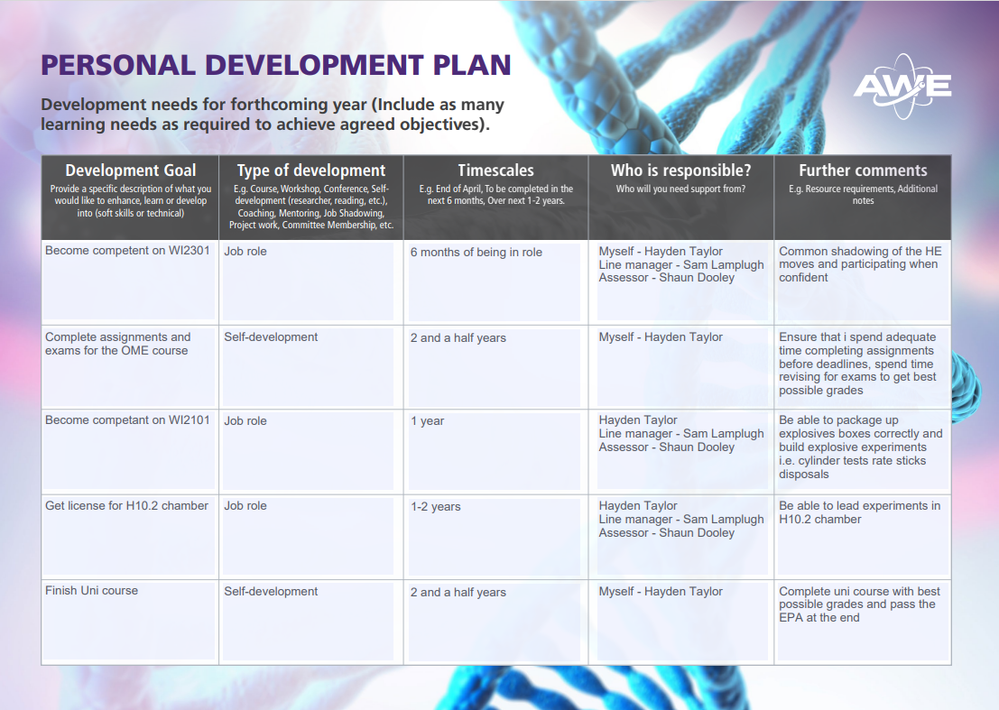
Figure 3 - Personal development plan for university and work
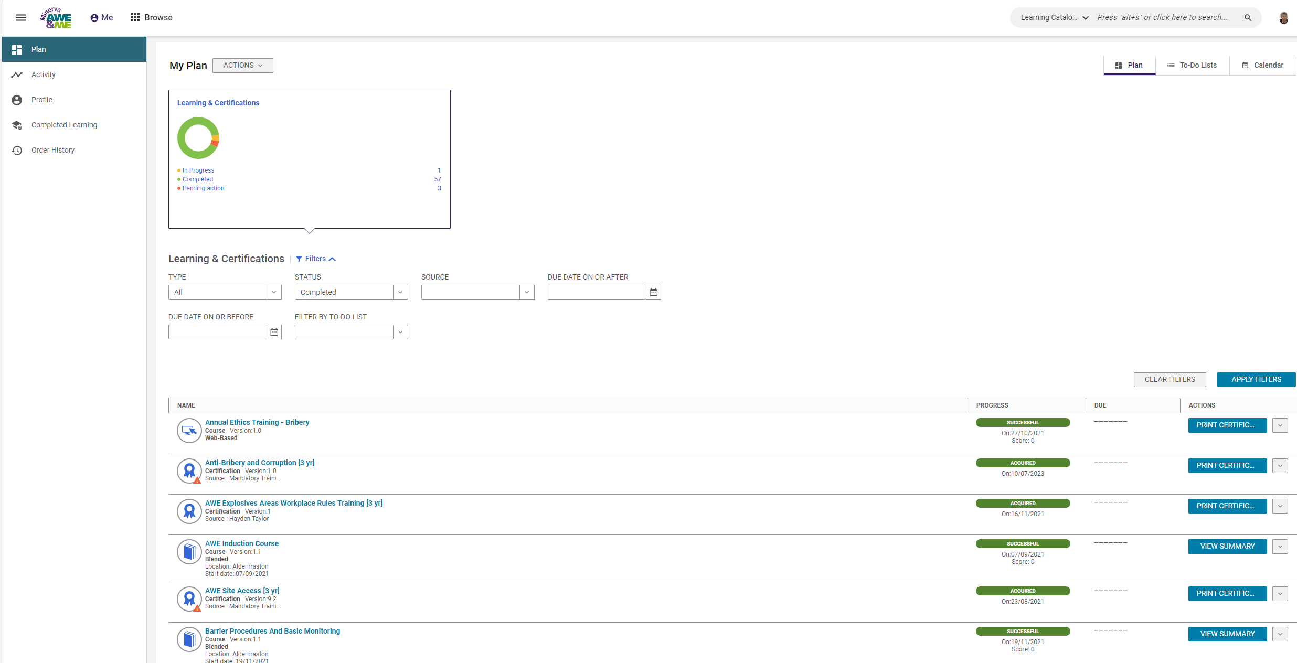
Figure 4 - Training record

Figure 5 - Presentation slide 1 (home life)
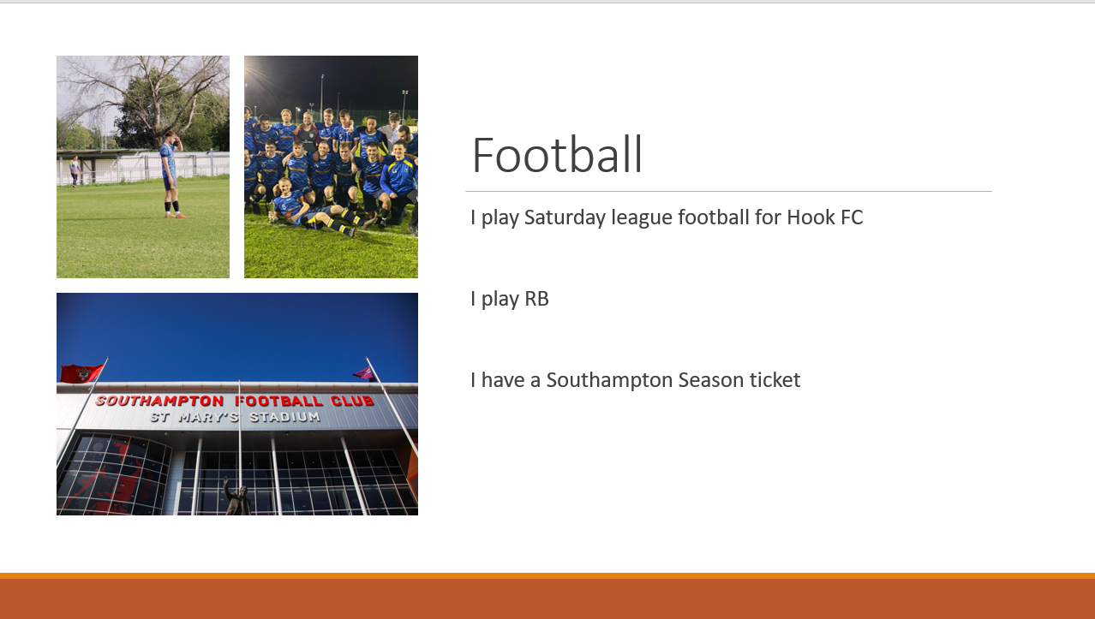
Figure 6 - Presentation slide 2 (football)
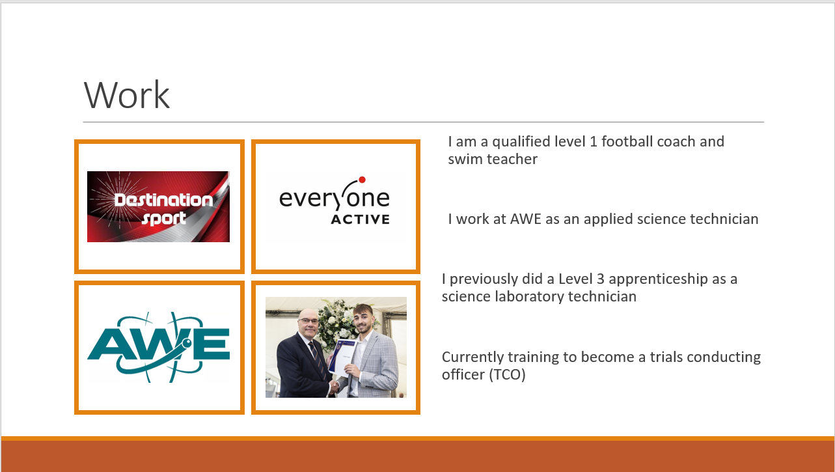
Figure 7 - Presentation slide 3 (work)
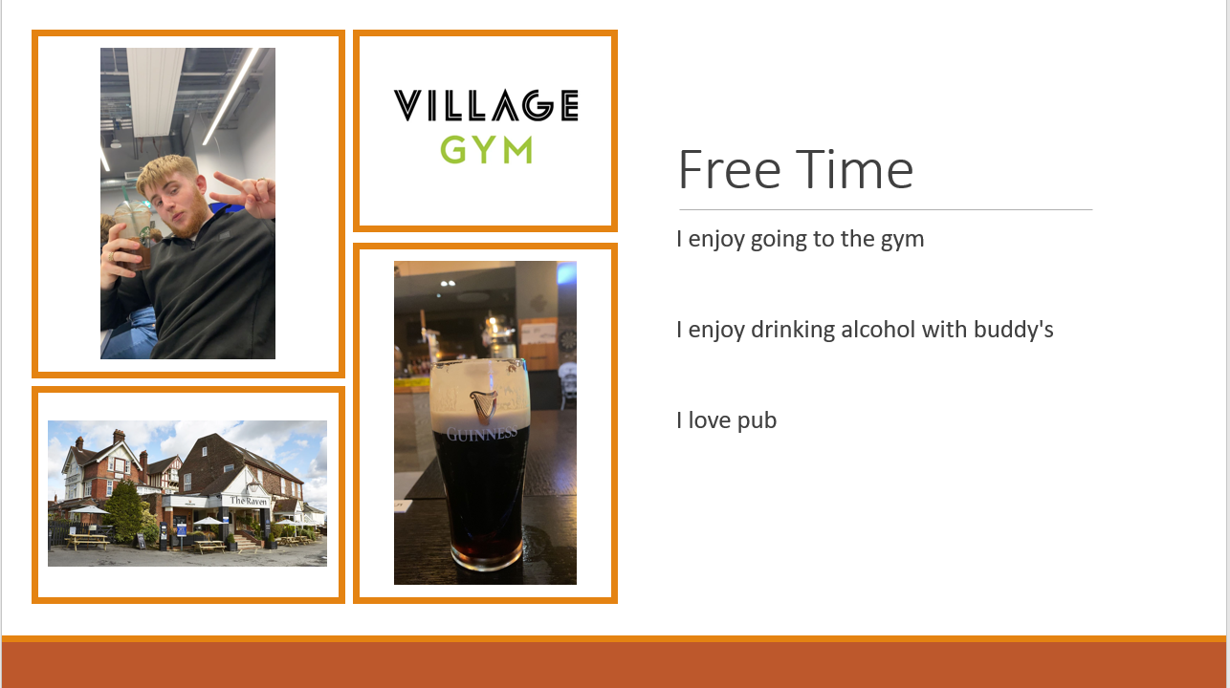
Figure 8 - Presentation slide 4 (free time)
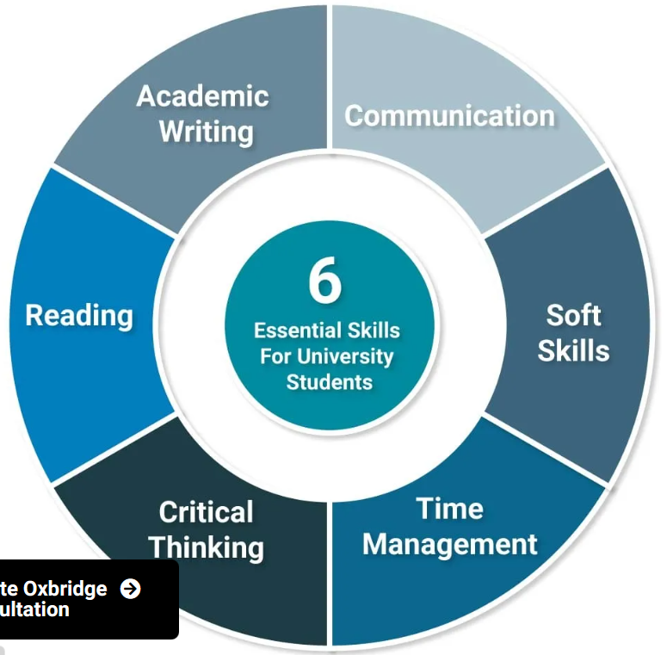
Figure 9 - University skills
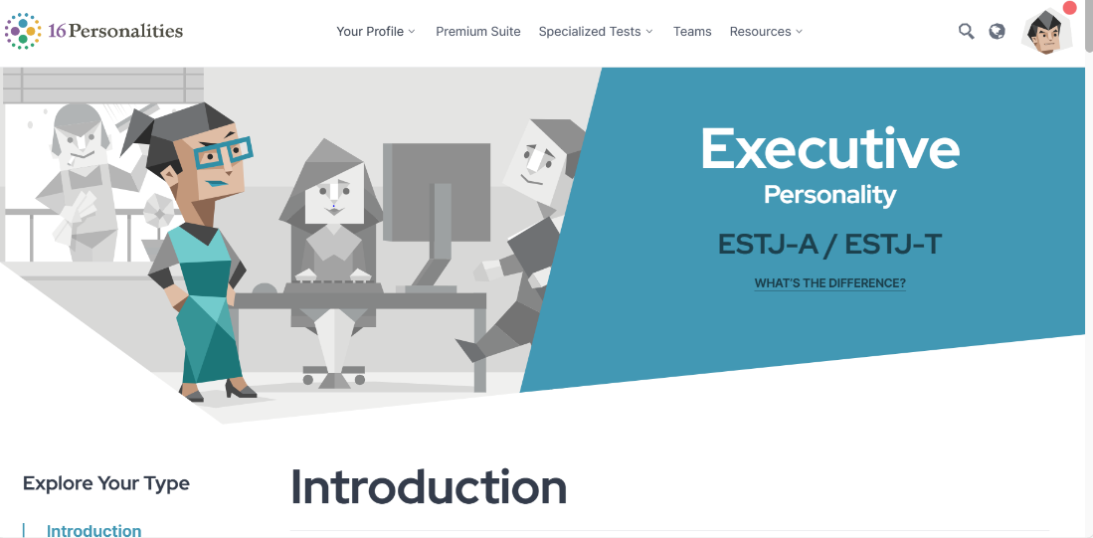
Figure 10 - Personality type test
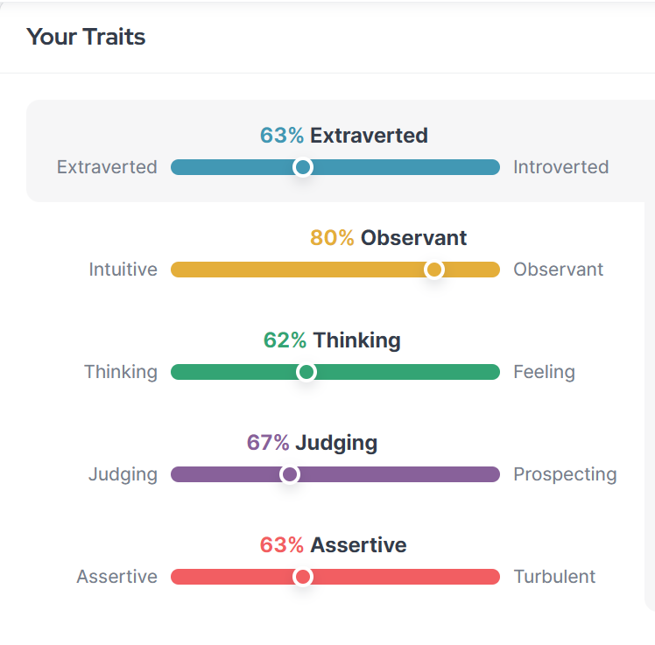
Figure 11 - Traits from personailty test
Torpex Notes
- Treating hexamethylene tetramine directly with large excess of strong HNO³ at 20-25 degrees Celsius
- RDX properties – high chemical stability, not much lower aromatic nitro compounds and high explosive power
- Detonation velocity of 8600ms⁻¹ and detonation pressure of 33.8GPa at a density of 1.77gcm⁻³
Explosive | Formulation | Density g cm⁻³ | Velocity of detonation ms⁻¹
Torpex 1 | RDX/TNT/Al  45/37/18 | 1.78 | 7440
Torpex 2 | RDX/TNT/Al  42/40/18 | 1.85 | 7360
Torpex 2B | RDX/TNT/Al  42/40/18  +5.5% Desensitizer | 1.77 | –
Torpex 5 | RDX/TNT/Al  30/50/20  +2% C black | 1.78 | 6990
Table 1 - Properties of Torpex [1]

Section 6 – References
[1]
J. P. Agrawal, High Energy Materials: Propellants, Explosives and Pyrotechnics. Weinheim: Wiley-VCH, 2012.
[2]
J. Dong et al., “Effects of nano aluminium powder on the mechanical sensitivity of RDX-based explosives,” Nanomaterials (Basel, Switzerland), https://www.ncbi.nlm.nih.gov/pmc/articles/PMC8470581/ (accessed Dec. 13, 2023).
[3]
R. Gannon, “Torpex,” Wikipedia, https://en.wikipedia.org/wiki/Torpex (accessed Dec. 12, 2023).

[4]
R. Needleman, “What are the 6 essential skills for university students?,” UniAdmissions, https://www.uniadmissions.co.uk/application-guides/6-essential-skills-for-university-students/ (accessed Dec. 12, 2023).
[5]
J. Herrity, “15 types of professional soft skills (with definitions) - indeed,” 15 Types of Professional Soft Skills (With Definitions), https://www.indeed.com/career-advice/career-development/professional-skills (accessed Dec. 13, 2023).
[6]
E. Burke, “Introduction: Executive (ESTJ personality),” 16Personalities, https://www.16personalities.com/estj-personality (accessed Dec. 13, 2023).

‌

