Games Architecture and Mechanics Semester 2 Report
ACCA5017 Games Architecture and Mechanics
Rhys Lewis (1802146)
2020
Table of Contents
Video Link 2
Task 1 3
Implementation 3
Testing 3
Task 2 5
Implementation 5
Testing 5
Task 3 7
Implementation 7
Testing 7
Appendix 9
Header Files 9
Display.h 9
GameObject.h 9
globals.h 10
mesh.h 10
objloader.h 11
transform.h 13
Source Files 14
Display.cpp 14
GameObject.cpp 17
mesh.cpp 17
objloader.cpp 19
Source.cpp 21
transform.cpp 25
References 26

Video Link
Here is the link to the video demonstrating the code, the video has been cut down for brevity, but any tests shown in the demonstration can be recreated using the program submitted.
Link: https://uowtsd-my.sharepoint.com/:v:/g/personal/1802146_student_uwtsd_ac_uk/EXH7m_TMJnJGoOvZvDX1f9UBTrCFD_Cft2JOxUS8RyQ8fA?e=7FrHM0

Task 1

Implementation
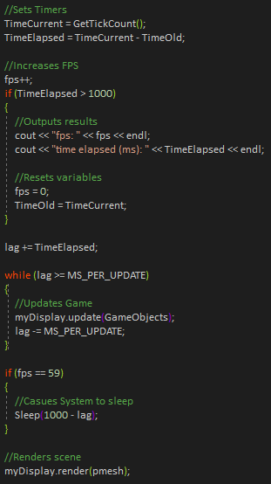
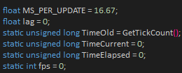
For task 1, the author was tasked to create a timer for the game loop that outputted a frame rate every second, the author chose to make this frame rate fixed, as it allows for consistency between devices. To achieve this, the author makes use of a sleep pattern, whereupon reaching 60 frames per second (FPS) causes the system to sleep until the period of a second (1000 milliseconds) has passed, capping the FPS at 60 [1]. FPS is increased by one for every loop in the system. Once the timer reaches 1 second, the system outputs the total elapsed time in milliseconds and the current FPS (which should always be 60). The FPS and timing are then reset, and the cycle continues. Timing is calculated by using the “GetTickCount” function to calculate the time that has elapsed since the system has started [2]. For the purposes of this program, it is simply used to measure time. Elapsed time is calculated by subtracting the current tick count from the initial tick count, known as “TimeOld”. This results in the number of ticks that have passed since the program began, as “TimeOld” is defined using “GetTickCount” at the beginning of the program and during every reset.
Figure 2: Game Loop
Figure 1: Initial variable declarations

Testing
To test this, the author simply set the program to run, with his setup, the program should output around 1000 milliseconds every second and output a consistent 60 fps.
Test No. | Time Elapsed | Setup Required | Result | Pass/Fail
1 | 5 seconds | The program needs to run | 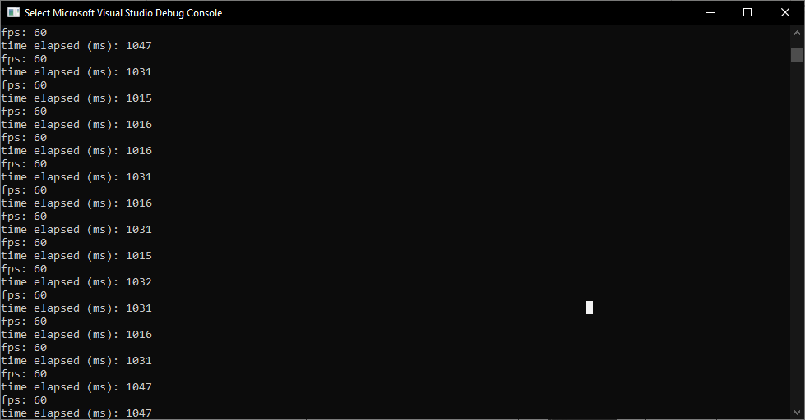 | Pass

Test No. | Time Elapsed | Setup Required | Result | Pass/Fail
2 | 10 seconds | The program needs to run |  | Pass

Test No. | Time Elapsed | Setup Required | Result | Pass/Fail
3 | 15 seconds | The program needs to run |  | Pass

Task 2

Implementation
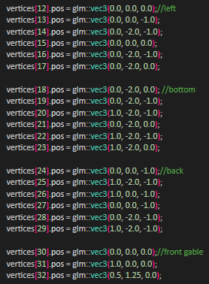
For task 2, the author was instructed to modify an existing object loader provided for him by the university to have it work with the new game loop to render .obj files. Originally, the loop would simply assign a set of values to an array of vertices and have the system draw that by assigning the vertices to a mesh class. This approach is incredibly ineffective as the system will only be able to draw this one shape through hard code and to draw another, you would have to hard code another shape.
Figure 3: Section of previous shape implementation
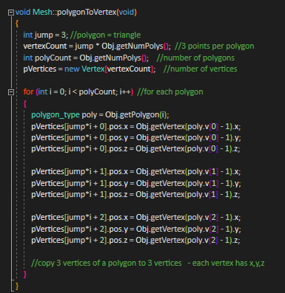
The provided .obj loader accomplished most of the necessary tasks already, it just needed to be retooled for this loop. The author did this by first re-specifying the mesh class to accept an .obj file with a file name prompt rather than a list of vertices. The inputted file name would be placed into the obj loader’s file loading function. It would then call a new function added to the obj loader named “polygonToVertex”, this function would loop through the obj file, converting the polygons in the file to vertices to be used by the rendering function.
Figure 4: polygonToVertex function
These steps were all that was needed to integrate the obj loader into the game loop.

Testing
Testing for this setup is rather straightforward. For this assessment, 3 .obj files were provided for use with the program. These files will each be loaded into the program to see if the program loads the file.
Test No. | Obj file | Setup Required | Result | Pass/Fail
1 | “house.obj” | 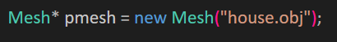  The file is present in the project folder.  The file name is typed correctly into mesh declaration. | 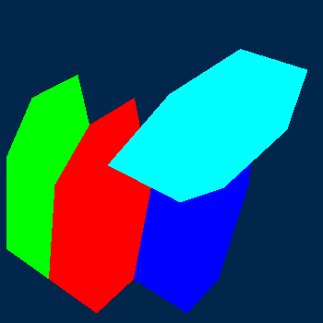 | Pass

Test No. | Obj file | Setup Required | Result | Pass/Fail
2 | “blob.obj” | The file is present in the project folder.  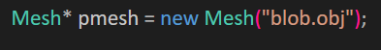  The file name is typed correctly into mesh declaration. | 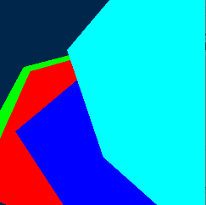 | Pass

Test No. | Obj file | Setup Required | Result | Pass/Fail
3 | “blendermonkeyobj.obj” | The file is present in the project folder.  The file name is typed correctly into mesh declaration. | 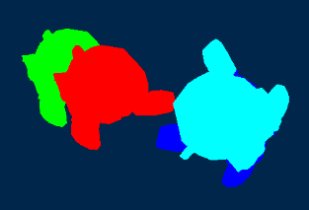 | Pass

The 3 obj files were rendered successfully with no need to alter the loader in any way between tests. Judging by these results, the author assumes the program will be able to render any obj given if the setup is performed correctly.

Task 3

Implementation
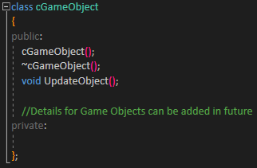
For task 3, the author was required to include an update manager for a container class representing game objects. For this task, the author created an entirely new class named “cGameObject”. The class contains an update function and room for future users to implement details. Currently, the update function is empty as it does not need to contain any details as the necessary code would be added by future users.
Figure 5: cGameObject class
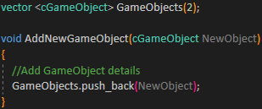
To update game objects, they must be initialized. At the beginning of the program, a vector of “cGameObject” is created. The author also included a function named “AddNewGameObjects”, which can be used to add new game objects in future.
Figure 6: Initialization of Vector and AddNewGameObject function
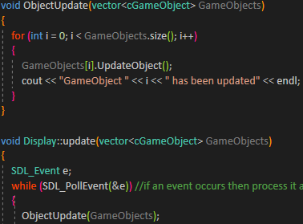
The only other thing needed is to implement the update function into the game loop’s update pattern. To do this, the existing update function was modified to add the newly initialized vector as an argument, now that the update function has access to the vector, a new function was created named “ObjectUpdate” that looped through every single item in the vector and called its update function. To prove that it is working, the system would then output an update message on each cycle. This function would then be called inside of the update function, meaning so upon every update, the game objects will all update.
Figure 7: ObjectUpdate function and it being called inside of Display::update

Testing
To test this setup, the author will set the vector to different initial sizes and will record whether or not the system outputs the desired results.
Test No. | Vector size | Setup Required | Result | Pass/Fail
1 | 2 | The initial Vector size is correct | 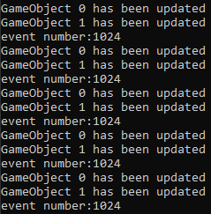 | Pass

Test No. | Vector size | Setup Required | Result | Pass/Fail
2 | 10 | The initial Vector size is correct | 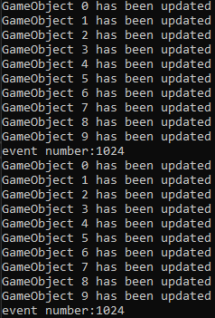 | Pass

Test No. | Vector size | Setup Required | Result | Pass/Fail
3 | 5 | The initial Vector size is correct | 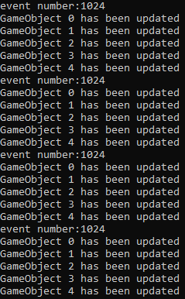 | Pass

Appendix

Header Files

Display.h
#ifndef DISPLAY_H
#define DISPLAY_H
#include <sdl2/SDL.h>
#include <GL/glew.h>
#include <string>
#include "mesh.h"
#include "globals.h"
using namespace std;

//uses SDL2 to create a window to display our OGL stuff
class Display
{
public:
Display(int width, int height, std::string title);
virtual ~Display();
void swapBuffers();
bool isClosed();
void update(vector<cGameObject> GameObjects);
void clear(void);
void render(Mesh *pMesh);
private:
bool closed;
SDL_Window* window; //pointer to window
SDL_GLContext glContext; //context for drawing OGL to SDL window
};

#endif //DISPLAY_H

GameObject.h
#pragma once

class cGameObject
{
public:
cGameObject();
~cGameObject();
void UpdateObject();

//Details for Game Objects can be added in future
private:

};

globals.h
#pragma once
#include "GameObject.h"
#include <vector>

mesh.h
#ifndef MESH_H
#define MESH_H

#include <glm/glm.hpp>
#include <gl/glew.h>
#include <SOIL/SOIL.h>
#include "objloader.h"
#define NUM_BUFFERS 1
typedef struct {
glm::vec3 pos;
}Vertex;

class Mesh
{
public:
object_type Obj;
Mesh(const char* f);
//int loadOBJ();
void polygonToVertex(void);
void draw();
virtual ~Mesh();
private:
Vertex *pVertices;
GLuint vertexArrayObject; //for use with Modern OGL
GLuint vertexArrayBuffers[NUM_BUFFERS]; //for use with Modern OGL
GLuint vertexCount;

};

#endif

objloader.h
#ifndef OBJLOAD
#define OBJLOAD
/*****************************************************************************************
*Loads obj file - limited to vertices, faces, normals, texture maps
*loads to object structure as defined in .h file
******************************************************************************************/

#define MAX_VERTICES 8000 // Max number of vertices (for each object)
#define MAX_POLYGONS 8000 // Max number of polygons (for each object)
#define MAX_NORMALS 8000 // Max number of polygons (for each object)

// Our vertex type
typedef struct {
float x, y, z;
}vertex_type;

// Our normal type
typedef struct {
float i, j, k;
}normcoord_type;

// The polygon (triangle), 3 numbers that aim 3 vertices
typedef struct {
int v[3], t[3], n[3];
}polygon_type;

// The mapcoord type, 2 texture coordinates for each vertex
typedef struct {
float u, v;
}mapcoord_type;

// The object type
class object_type {
public:
int id_texture;
object_type() {}
~object_type() {}
int objloader(const char *p_filename);
int objdatadisplay();
int getNumPolys(void) {return polygons_qty;}
polygon_type getPolygon(int i) { return polygon[i]; }
vertex_type getVertex(int i) { return vertex[i]; }

private:
char name[20];
int vertices_qty;
int polygons_qty;
int mapcoord_qty;
int normcoord_qty;

vertex_type vertex[MAX_VERTICES];
mapcoord_type mapcoord[MAX_VERTICES];
normcoord_type normcoord[MAX_NORMALS];
polygon_type polygon[MAX_POLYGONS];

};

#endif

/*************************************************************/

transform.h
#ifndef TRANSFORM_H
#define TRANSFORM_H
#include <glm/glm.hpp>
#include <GL/glew.h>
#include <string>

//Holds a mesh's transform
class Transform
{
public:
Transform();
Transform(glm::mat4x4* m);
virtual ~Transform();

void UpdateMV(glm::mat4x4* m);

private:
glm::mat4x4 mv;
};

#endif

Source Files

Display.cpp
#include "display.h"
//#include<GL/GLU.h>

#include <GL/glew.h>
#include <string>
#include <iostream>
using namespace std;

Display::Display(int width,int height, std::string title)
{
SDL_Init(SDL_INIT_EVERYTHING);//uses SDL2 to create

//std::cout << "hello world" << std::endl;

SDL_GL_SetAttribute(SDL_GL_RED_SIZE, 8);
SDL_GL_SetAttribute(SDL_GL_GREEN_SIZE, 8);
SDL_GL_SetAttribute(SDL_GL_BLUE_SIZE, 8);
SDL_GL_SetAttribute(SDL_GL_ALPHA_SIZE, 8);
SDL_GL_SetAttribute(SDL_GL_BUFFER_SIZE, 32); //THESE SIZES ARE AT LEAST THESE VALUES.
SDL_GL_SetAttribute(SDL_GL_DOUBLEBUFFER, 1); //1 turns double buffering on in SDL.

window = SDL_CreateWindow(title.c_str(), 100,100/* SDL_WINDOWPOS_CENTERED, SDL_WINDOWPOS_CENTERED*/, width, height, SDL_WINDOW_OPENGL | SDL_WINDOW_RESIZABLE );

glContext = SDL_GL_CreateContext(window); //create the context
SDL_GL_SetSwapInterval(0);
GLenum status = glewInit(); //glew searches to find every single OGL function supported.
if (status != GLEW_OK)
{
cerr << "Glew failed to initialize" << endl;
}

closed = false;
glShadeModel(GL_FLAT); //uses GL_SMOOTH or GL_FLAT

//set viewport to screen size and initialize projection matrix. Leave with matrixmode = Modelview
glViewport(0, 0, width, height); //make sure openGL view port is scaled to size of new window (if you want!) - why didn't I use freeglut?
glMatrixMode(GL_PROJECTION);
glLoadIdentity();
glFrustum(-1.0, 1.0, -1.0, 1.0, 1.5, 20.0);
// l,r,bot,top,near,far
glMatrixMode(GL_MODELVIEW);

}

Display::~Display()
{
SDL_GL_DeleteContext(glContext);

SDL_DestroyWindow(window);
SDL_Quit();
//std::cout << "bye bye" << std::endl;
}

void Display::swapBuffers(void)
{
SDL_GL_SwapWindow(window);
}
void Display::render(Mesh* pMesh)
{

clear();// makes the point that the frame buffer is usually cleared before redrawing
glLoadIdentity();
//glTranslatef(-5, -2, -10);//
gluLookAt(5.0, 5.0, 5.0, 0.0, 0.0, 0.0, 0.0, 1.0, 0.0);
// 5,5,5 - place camera ; 0,0,0 - aim lens towards 0,0,0;
// 0,1,0 - the up vector defines an unique orientation
glColor3f(0.0, 1.0, 0.0);
pMesh->draw();
glTranslatef(1.0, 0.0, 0.0);
glColor3f(1.0, 0.0, 0.0);
pMesh->draw();
glTranslatef(2.0, 0.0, -1.0);
glRotatef(90.0, 0.0, 1.0, 0.0);
glColor3f(0.0, 0.0, 1.0);
pMesh->draw();//mesh.draw(); // draw the model (s)
//glScalef(0.5f, 0.5f, 0.5f);
glRotatef(90, 0, 0, 1);
glTranslatef(0.5, 0, 0);
glColor3f(0.0, 1.0, 1.0);
pMesh->draw();
swapBuffers();
}
bool Display::isClosed()
{
return closed;
}

void ObjectUpdate(vector<cGameObject> GameObjects)
{
for (int i = 0; i < GameObjects.size(); i++)
{
GameObjects[i].UpdateObject();
cout << "GameObject " << i << " has been updated" << endl;
}
}

void Display::update(vector<cGameObject> GameObjects)
{
SDL_Event e;
while (SDL_PollEvent(&e)) //if an event occurs then process it and repeat til event queue is empty - catches SDL_QUIT if it is in the queue
{
ObjectUpdate(GameObjects);

cout << "event number:" << e.type << endl;
if (e.type == SDL_QUIT)
closed = true;

if (e.window.event == SDL_WINDOWEVENT_RESIZED)
{
glViewport(0, 0, e.window.data1, e.window.data2); //make sure openGL view port is scaled to size of new window (if you want!) - why didn't I use freeglut?
cout << "resized to " << e.window.data1 << " , " << e.window.data2 << endl;
glMatrixMode(GL_PROJECTION);
glLoadIdentity();
glFrustum(-1.0, 1.0, -1.0, 1.0, 1.5, 20.0);
// l,r,bot,top,near,far

glMatrixMode(GL_MODELVIEW);
}
}
}

void Display::clear(void)
{
glClearColor(0.0f, 0.15f, 0.3f, 1.0f);
glClear(GL_COLOR_BUFFER_BIT);
}

GameObject.cpp
#include "globals.h"

cGameObject::cGameObject()
{
}

cGameObject::~cGameObject()
{
}

void cGameObject::UpdateObject()
{
//Place GameObject Update Code here
}

mesh.cpp
#include "mesh.h"
#include <iostream>
#include <fstream>
#include <string>
using namespace std;

Mesh::Mesh(const char* f)
{
Obj.objloader(f);
polygonToVertex();
cout << "Loaded" << endl;
//vertexCount = numVertices;
//pVertices = vertices;
//glGenVertexArrays(1, &vertexArrayObject);
//glBindVertexArray(vertexArrayObject);
//glGenBuffers(NUM_BUFFERS, vertexArrayBuffers);
//glBindBuffer(GL_ARRAY_BUFFER,vertexArrayBuffers[0]);
//glBufferData(GL_ARRAY_BUFFER, numVertices * sizeof(vertices[0]), vertices, GL_STATIC_DRAW);
//
//glEnableVertexAttribArray(0);
//glVertexAttribPointer(0, 3, GL_FLOAT, GL_FALSE, 0, 0);
//glBindVertexArray(0);
}

Mesh::~Mesh()
{
//glDeleteVertexArrays(1, &vertexArrayObject);
}

void Mesh::draw()
{
//glBindVertexArray(vertexArrayObject);
//glDrawArrays(GL_TRIANGLES, 0, vertexCount);
for (int i = 0; i < vertexCount; i+=3)
{
glBegin(GL_TRIANGLES);

glVertex3f(pVertices[i].pos.x, pVertices[i].pos.y, pVertices[i].pos.z);

glVertex3f(pVertices[i+1].pos.x, pVertices[i+1].pos.y, pVertices[i+1].pos.z);

glVertex3f(pVertices[i+2].pos.x, pVertices[i+2].pos.y, pVertices[i+2].pos.z);

glEnd();
}
}

void Mesh::polygonToVertex(void)
{
int jump = 3; //polygon = triangle
vertexCount = jump * Obj.getNumPolys(); //3 points per polygon
int polyCount = Obj.getNumPolys(); //number of polygons
pVertices = new Vertex[vertexCount]; //number of vertices

for (int i = 0; i < polyCount; i++) //for each polygon
{
polygon_type poly = Obj.getPolygon(i);
pVertices[jump*i + 0].pos.x = Obj.getVertex(poly.v[0] - 1).x;
pVertices[jump*i + 0].pos.y = Obj.getVertex(poly.v[0] - 1).y;
pVertices[jump*i + 0].pos.z = Obj.getVertex(poly.v[0] - 1).z;

pVertices[jump*i + 1].pos.x = Obj.getVertex(poly.v[1] - 1).x;
pVertices[jump*i + 1].pos.y = Obj.getVertex(poly.v[1] - 1).y;
pVertices[jump*i + 1].pos.z = Obj.getVertex(poly.v[1] - 1).z;

pVertices[jump*i + 2].pos.x = Obj.getVertex(poly.v[2] - 1).x;
pVertices[jump*i + 2].pos.y = Obj.getVertex(poly.v[2] - 1).y;
pVertices[jump*i + 2].pos.z = Obj.getVertex(poly.v[2] - 1).z;

//copy 3 vertices of a polygon to 3 vertices - each vertex has x,y,z
}
}

objloader.cpp
#include <iostream>
#include <fstream>
#include "objloader.h"

using namespace std;
int object_type::objloader(const char * f)
{
FILE *l_file; //File pointer

int ipolygon = 0, imap = 0, ivertex = 0, inormal = 0;
char l_char; //Char variable
char myString[256];
// int vertex;
unsigned short l_face_flags; //Flag that stores some face information

if (( l_file=fopen(f, "rt")) == NULL) return 0; //Open the file

while (!feof(l_file)) //Loop to scan the whole file
{

fscanf(l_file, "%c", &l_char);
if (l_char == '\n')//read char if'/n' -skip to next and read
fscanf(l_file, "%c", &l_char);
switch (l_char) //parse
{
default: fgets(myString, 256, l_file);
break;
case 'v': //a vertex or a normal or a text co-ord
fscanf(l_file, "%c", &l_char);
switch (l_char)
{
case ' ': //a vertex -expect and so read 3 floats next
fscanf(l_file, "%f %f %f", &vertex[ivertex].x, &vertex[ivertex].y, &vertex[ivertex].z);

ivertex++;
break;
case 'n': //a normal -expect and so read 3 floats next
fscanf(l_file, "%f %f %f", &normcoord[inormal].i, &normcoord[inormal].j, &normcoord[inormal].k);
inormal++;
break;
case 't': //a texture map coord-expect and so read 2 floats next
fscanf(l_file, "%f %f", &mapcoord[imap].u, &mapcoord[imap].v);
imap++;
break;
} //end switch
break;
case 'f': //a face read next assume format is -> f 1/1/1 2/2/2 3/3/3
for (int i = 0; i < 3; i++) //for each vertex of polygon (triangle)
{
fscanf(l_file, "%c", &l_char); //read space char - ignore this
fscanf(l_file, "%d", &polygon[ipolygon].v[i]); //read vertex.
fscanf(l_file, "%c", &l_char); //read space char - ignore this
fscanf(l_file, "%d", &polygon[ipolygon].t[i]); //read text coord.
fscanf(l_file, "%c", &l_char); //read space char - ignore this
fscanf(l_file, "%d", &polygon[ipolygon].n[i]); //read normal.

}
ipolygon++;
break;

} //end switch
}
fclose(l_file); // Closes the file stream
vertices_qty = ivertex;
polygons_qty = ipolygon;
mapcoord_qty = imap;
normcoord_qty = inormal;
return 0;

}

Source.cpp
#include "mesh.h"
#include "Display.h"
//
#include "glut.h"
#include <Windows.h>
#include <iostream>
#include "objloader.h"
#include <ctime>
using namespace std;

vector <cGameObject> GameObjects(5);

void AddNewGameObject(cGameObject NewObject)
{
//Add GameObject details
GameObjects.push_back(NewObject);
}

int main(int argc, char *args[])
{

Display myDisplay(800, 800,"OGL Window"); //create and open a window

//specify a list of vertices to draw - this will be loaded into our mesh object
//we'll replace this array with a file mesh loader later - see .obj loader notes.

//Vertex vertices[48];
//Vertex myV;
////a triangle
///*vertices[0].pos = glm::vec3(-0.5, -0.5, 0.0);
//vertices[1].pos = glm::vec3(0.0, 0.886-0.5, 0.0);
//vertices[2].pos = glm::vec3(0.5, -0.5, 0.0);*/
////A House
//vertices[0].pos = glm::vec3(0.0, 0.0, 0.0);//front
//vertices[1].pos = glm::vec3(0.0, -2.0, 0.0);
//vertices[2].pos = glm::vec3(1.0, 0.0, 0.0);
//vertices[3].pos = glm::vec3(0.0, -2.0, 0.0);
//vertices[4].pos = glm::vec3(1.0, -2.0, 0.0);
//vertices[5].pos = glm::vec3(1.0, 0.0, 0.0);

//vertices[6].pos = glm::vec3(1.0, 0.0, 0.0);//right
//vertices[7].pos = glm::vec3(1.0, -2.0, 0.0);
//vertices[8].pos = glm::vec3(1.0, -2.0, -1.0);
//vertices[9].pos = glm::vec3(1.0, 0.0, 0.0);
//vertices[10].pos = glm::vec3(1.0, -2.0, -1.0);
//vertices[11].pos = glm::vec3(1.0, 0.0, -1.0);

//vertices[12].pos = glm::vec3(0.0, 0.0, 0.0);//left
//vertices[13].pos = glm::vec3(0.0, 0.0, -1.0);
//vertices[14].pos = glm::vec3(0.0, -2.0, -1.0);
//vertices[15].pos = glm::vec3(0.0, 0.0, 0.0);
//vertices[16].pos = glm::vec3(0.0, -2.0, -1.0);
//vertices[17].pos = glm::vec3(0.0, -2.0, 0.0);

//vertices[18].pos = glm::vec3(0.0, -2.0, 0.0); //bottom
//vertices[19].pos = glm::vec3(0.0, -2.0, -1.0);
//vertices[20].pos = glm::vec3(1.0, -2.0, -1.0);
//vertices[21].pos = glm::vec3(0.0, -2.0, 0.0);
//vertices[22].pos = glm::vec3(1.0, -2.0, -1.0);
//vertices[23].pos = glm::vec3(1.0, -2.0, 0.0);

//vertices[24].pos = glm::vec3(0.0, 0.0, -1.0);//back
//vertices[25].pos = glm::vec3(1.0, -2.0, -1.0);
//vertices[26].pos = glm::vec3(1.0, 0.0, -1.0);
//vertices[27].pos = glm::vec3(0.0, 0.0, -1.0);
//vertices[28].pos = glm::vec3(0.0, -2.0, -1.0);
//vertices[29].pos = glm::vec3(1.0, -2.0, -1.0);

//vertices[30].pos = glm::vec3(0.0, 0.0, 0.0);//front gable
//vertices[31].pos = glm::vec3(1.0, 0.0, 0.0);
//vertices[32].pos = glm::vec3(0.5, 1.25, 0.0);

//vertices[33].pos = glm::vec3(0.0, 0.0, -1.0);//back gable
//vertices[34].pos = glm::vec3(0.5, 1.25, -1.0);
//vertices[35].pos = glm::vec3(1.0, 0.0, -1.0);
//

//vertices[36].pos = glm::vec3(0.0, 0.0, 0.0);//left roof
//vertices[37].pos = glm::vec3(0.5, 1.25, 0.0);
//vertices[38].pos = glm::vec3(0.5, 1.25, -1.0);
//vertices[39].pos = glm::vec3(0.0, 0.0, 0.0);
//vertices[40].pos = glm::vec3(0.5, 1.25, -1.0);
//vertices[41].pos = glm::vec3(0.0, 0.0, -1.0);

//vertices[42].pos = glm::vec3(0.5, 1.25, 0.0);//right roof
//vertices[43].pos = glm::vec3(1.0, 0.0, 0.0);
//vertices[44].pos = glm::vec3(1.0, 0.0, -1.0);
//vertices[45].pos = glm::vec3(0.5, 1.25, 0.0);
//vertices[46].pos = glm::vec3(1.0, 0.0, -1.0);
//vertices[47].pos = glm::vec3(0.5, 1.25, -1.0);

Mesh* pmesh = new Mesh("blendermonkeyobj.obj");

float MS_PER_UPDATE = 16.67;
float lag = 0;
static unsigned long TimeOld = GetTickCount();
static unsigned long TimeCurrent = 0;
static unsigned long TimeElapsed = 0;
static int fps = 0;
while (!myDisplay.isClosed()) // Application loop - it's ok as a first attempt
{

//myDisplay.clear();// makes the point that the frame buffer is usually cleared before redrawing
//glLoadIdentity();
////glTranslatef(-5, -2, -10);//
//gluLookAt(5.0, 5.0, 5.0, 0.0, 0.0, 0.0, 0.0, 1.0, 0.0);
//// 5,5,5 - place camera ; 0,0,0 - aim lens towards 0,0,0;
//// 0,1,0 - the up vector defines an unique orientation
//pmesh->draw();
////glTranslatef(1.0, 0.0, 0.0);
////glColor3f(0.0, 1.0, 0.0);
////mesh.draw();
////glTranslatef(2.0, 0.0, -1.0);
////glRotatef(90.0, 0.0, 1.0, 0.0);
////glColor3f(0.0, 0.0, 1.0);
////mesh.draw();//mesh.draw(); // draw the model (s)
////glScalef(0.5f, 0.5f, 0.5f);
////glRotatef(90, 0, 0, 1);
////glTranslatef(0.5, 0, 0);
////mesh.draw();

//static unsigned long dwOldTime = GetTickCount();
//static unsigned long dwTimeElapsed;
//static int fps = 0; //frame count;
//dwTimeElapsed = GetTickCount() - dwOldTime;
//fps++;
//if (dwTimeElapsed > 5000)
//{
// cout << "frames per sec = " << (float)fps / 5.0 << std::endl;
// fps = 0;
// dwOldTime = GetTickCount();

//}
//myDisplay.update(GameObjects);
//myDisplay.render(pmesh);

//start = clock();

//int buffer = 0;
////Player Inputs would go here
//for (int i = 0; i < 1000000; i++)
//{
// buffer++;
//}
//end = clock();
//float diff = end - OldTime;
//OldTime = diff;
//lag += diff;
//static int fps = 0; //frame count;
//fps++;

//while (lag >1/60)
//{
// myDisplay.update(GameObjects);
// lag -= 1.0 / 60.0;
//}
//cout << "frames per sec = " << (float)fps << endl;
//fps = 0;
//myDisplay.render(pmesh);

//Sets Timers
TimeCurrent = GetTickCount();
TimeElapsed = TimeCurrent - TimeOld;

//Increases FPS
fps++;
if (TimeElapsed > 1000)
{
//Outputs results
cout << "fps: " << fps << endl;
cout << "time elapsed (ms): " << TimeElapsed << endl;

//Resets variables
fps = 0;
TimeOld = TimeCurrent;
}

lag += TimeElapsed;

while (lag >= MS_PER_UPDATE)
{
//Updates Game
myDisplay.update(GameObjects);
lag -= MS_PER_UPDATE;
}

if (fps == 59)
{
//Casues System to sleep
Sleep(1000 - lag);
}

//Renders scene
myDisplay.render(pmesh);

//This will soon need to be revised so we can update model positions, look after timers/ do physics/ deal with events.
}
return 0;
}

transform.cpp
#include "transform.h"
Transform::Transform()
{

}
Transform::Transform(glm::mat4x4* m)
{

}
Transform:: ~Transform()
{

}

void Transform::UpdateMV(glm::mat4x4* m)
{

}

References

[1] | R. Nystrom, "Game Programming Patterns: Game Loop," [Online]. Available: https://gameprogrammingpatterns.com/game-loop.html.
[2] | Microsoft, "GetTickCount function," Microsoft, 5 December 2018. [Online]. Available: https://docs.microsoft.com/en-us/windows/win32/api/sysinfoapi/nf-sysinfoapi-gettickcount.

