Levelling survey report
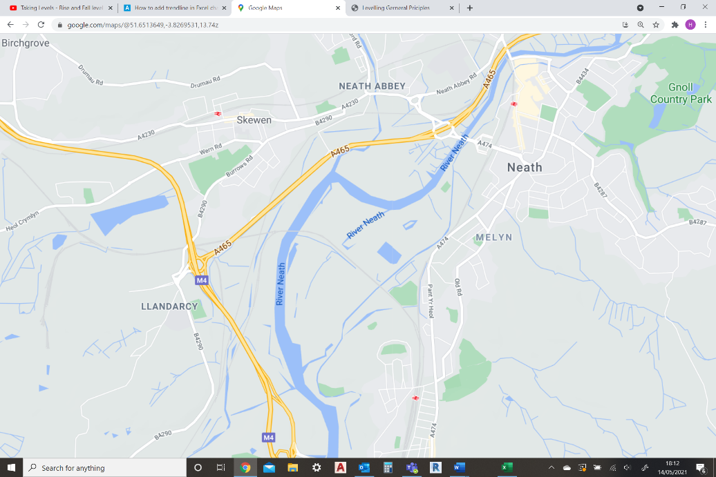
(Google maps 2021)
- Introduction
In this Essay I will begin with the equipment used in a levelling survey. After this I will discuss the process of how a levelling survey occurs, what is considered during the survey and the outcomes.
Then I will discuss the relevant information from the scenario to inform the client as to the volume of the soil that will be required to be cut / filled.
In this scenario a client has consulted with myself to conduct a levelling survey for an upcoming construction between Llandarcy and Neath. I have been given the readings from a site survey. The data provided for me was observed spots taken at every 25 meters over the course of a kilometre. This data I have used to calculate the reduced level at each of the 40 station points.

- Overview of levelling surveying
Levelling is the most widely used method of obtaining the elevations of ground points to relative to a reference datum. The basic concept of levelling involves the measurement of vertical distance relative to the horizontal line of sight. A survey of this variety will occur very early on within the build schedule as having an accurate land survey allows the earth works to being in a more effective way. A relatively simple process that can yield great accuracy which is especially important at this stage. Levelling surveying allows a contractor to calculate the amount of cut and fill required on a site. especially important in a civil engineering environment as a civil site can involve infrastructure that in many cases extends miles in a given direction. Correctly calculating the level of cut and fill required improves the efficiency of a build considerably as cut soil can be used to fill lower areas of a site without the use of expensive soil importation or disposal. In theory a build will try and keep the amount of excess or soil debt to a minimum in order to achieve maximum efficiency. A levelling survey will usually be carried out by a small team or individual with a variety of tools and equipment to ensure high levels of accuracy.

3.0 Equipment used in levelling surveying
Level / dumpy level
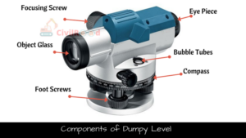
Invented in 1832 by William Gravatt, the level is an optical instrument used for surveying and levelling operations. Constructed with a number of integrated components. The telescope, focusing screw, adjusting collars and levelling screws. The telescope is observed through with the assistance of the focusing screw. A levelling bubble is installed onto the unit with a compass to allow the unit to be aligned correctly. These components allow the level to be rotated 360 degrees horizontally, allowing the operator to determine elevation with the assistance of a levelling staff. By establishing a visual relationship between two points a reading can be taken so the elevation can be calculated relative to the primary point. Allowing, over the course of a series of points, an elevation map to be constructed. (Civilread) 2021
(Civilread2021)
Tripod
Provides a strong and adjustable base for the level to be mounted on, by the use of a plumb bob or sight bubble the legs can be adjusted to provide a horizontal base for accurate level readings. They are usually constructed out of aluminium/steel, older units are constructed with wood. Many of the units have sharp feet to provide strength and stability for the level. (Civilread) 2021
Plumb bob
Dating back to the Egyptian period, a plumb bob is a weight usually attached to a line or string, it is used to find a vertical reference line. The plumb bob can be used in setting up a level or theodolite to achieve an accurate horizontal level. (Johnson)2021
Staff bubble
Bubbles installed onto a component or piece of equipment in the horizontal and vertical planes, they allow the operator to adjust a tripod or piece of equipment into the required orientation
Measuring tape
A very simple traditional surveyors tool. Generally available in lengths up to 50 meters, a very quick tool to use with little training involved. They are usually woven metallic tapes and wound onto a plastic holder. This tool cannot be used for highly accurate surveying as the woven material can stretch, another issue is as the tape is lain on the ground it follows the contours causing an inaccurate reading. (CivilSeek) 2018
Levelling staff
A levelling staff is a rod with measurements printed onto it to evaluate the difference in elevation in between two points, with the assistance of a dumpy level. Usually constructed out of lightweight aluminium to a height of 2.5m as it is used regularly on foot. They have a practicable distance of 125m. Higa (2021)

Field book
A field book is a crucial piece of kit for a surveyor as it allows the surveyor to make notes of the land, its condition, features, any issues presenting that may cause problems for construction later on. These notes involve the types of trees, wildlife that might be of relevance.

4.0 Levelling procedure
To begin the levelling procedure the levelling surveyor will set up. This set up begins with setting up the tripod for the dumpy level to sit on. Using the bubble level on the tripod or a plumb bob to make sure the tripod provides a horizontal level for the dumpy level to set up on. After the dumpy level has been screwed onto the tripod. Once the optics for the dumpy level are calibrated to the focal range of the users eye the chain man would take the levelling staff to the first reading point/ back sight. Making sure the staff is level the first reading can be taken.
The chainman will then move to the foresight , following the chain man with the dumpy level a second reading can be taken. After this the chain man will then move to the change point, a final reading will be taken and the dumpy level and tripod will be moved to this point.
Once set up at the new point the method remains the same. Making sure to log all the points in the field book with either the height of collimation method or the rise and fall method.
The level of accuracy for these surveys are very tight, construction levelling has an accuracy level of 3mm which the surveyor will have to be confident of. LSSLTD(2021)
After the survey has been complete most likely a contractor will begin the process of cutting and filling the earth and soil. The notes made in the surveyors field book will be of particular importance to the contractor as they will locate trees or wildlife of particular importance that should be avoided. The cut and fill will be carried out by plant, e.g: excavators and bulldozers until the land is flat enough to use a grader.

5.0 Computation and plotting of level
Student number 2013414:
Therefore Reduced level start number: 414
Reduced level calculated with the rise and fall method.
BS | IS | FS | Rise | Fall | RL | Station | Chainage | Remarks
1.371 |  |  |  |  | 414.000 | TBM | 0.000
 | 2.354 |  |  | 0.943 | 413.057 | STN 1 | 25.000
 | 1.222 |  | 1.132 |  | 414.189 | STN 2 | 50.000
 | 2.591 |  |  | 1.369 | 412.820 | STN 3 | 75.000
1.432 |  | 3.587 |  | 0.996 | 411.824 | STN 4 | 100.000 | CHANGE PT.A
 | 1.872 |  |  | 0.44 | 411.384 | STN 5 | 125.000
3.250 |  | 0.573 | 1.299 |  | 412.683 | STN 6 | 150.000 | CHANGE PT.B
 | 1.925 |  | 1.325 |  | 414.008 | STN 7 | 175.000
3.015 |  | 0.496 | 1.429 |  | 415.437 | STN 8 | 200.000 | CHANGE PT.C
1.456 |  | 0.499 | 2.516 |  | 417.953 | STN 9 | 225.000 | CHANGE PT.D
 | 3.853 |  |  | 2.397 | 415.556 | STN 10 | 250.000
 | 5.433 |  |  | 1.58 | 413.976 | STN 11 | 275.000
 | 5.200 |  | 0.233 |  | 414.209 | STN 12 | 300.000
 | 4.000 |  | 1.2 |  | 415.409 | STN 13 | 325.000
3.876 |  | 3.067 | 0.933 |  | 416.342 | STN 14 | 350.000 | CHANGE PT.E
 | 4.533 |  |  | 0.657 | 415.685 | STN 15 | 375.000
 | 5.433 |  |  | 0.9 | 414.785 | STN 16 | 400.000
 | 5.867 |  |  | 0.434 | 414.351 | STN 17 | 425.000
 | 5.133 |  | 0.734 |  | 415.085 | STN 18 | 450.000
1.734 |  | 3.064 | 2.069 |  | 417.154 | STN 19 | 475.000 | CHANGE PT.F
 | 1.280 |  | 0.454 |  | 417.608 | STN 20 | 500.000
 | 1.390 |  |  | 0.11 | 417.498 | STN 21 | 525.000
3.467 |  | 2.076 |  | 0.686 | 416.812 | STN 22 | 550.000 | CHANGE PT.G
 | 4.147 |  |  | 0.68 | 416.132 | STN 23 | 575.000
3.371 |  | 1.976 | 2.171 |  | 418.303 | STN 24 | 600.000 | CHANGE PT.H
 | 2.395 |  | 0.976 |  | 419.279 | STN 25 | 625.000
 | 2.562 |  |  | 0.167 | 419.112 | STN 26 | 650.000
 | 2.591 |  |  | 0.029 | 419.083 | STN 27 | 675.000
1.432 |  | 3.587 |  | 0.996 | 418.087 | STN 28 | 700.000 | CHANGE PT.I
 | 1.872 |  |  | 0.44 | 417.647 | STN 29 | 725.000
1.675 |  | 0.573 | 1.299 |  | 418.946 | STN 30 | 750.000 | CHANGE PT.J
1.734 |  | 3.064 |  | 1.389 | 417.557 | STN 31 | 775.000 | CHANGE PT.K
 | 2.280 |  |  | 0.546 | 417.011 | STN 32 | 800.000
 | 2.390 |  |  | 0.11 | 416.901 | STN 33 | 825.000
3.467 |  | 3.000 |  | 0.61 | 416.291 | STN 34 | 850.000 | CHANGE PT.L
 | 4.147 |  |  | 0.68 | 415.611 | STN 35 | 875.000
3.371 |  | 1.976 | 2.171 |  | 417.782 | STN 36 | 900.000 | CHANGE PT.M
 | 1.395 |  | 1.976 |  | 419.758 | STN 37 | 925.000
 | 1.562 |  |  | 0.167 | 419.591 | STN 38 | 950.000
 | 1.859 |  |  | 0.297 | 419.294 | STN 39 | 975.000
 |  | 2.587 |  | 0.728 | 418.566 | STN 40 | 1000.000

Cut and fill estimations
By using the cells on the graph and the 25m distance between stations the cut and fill can be estimated.
7.75 cells cut (2 x 25)x7.75= 387.5 meters squared
8.25 cells fill (2 x 25)x8.25 = 412.5 meters squared
Assuming a road width of 10 meters:
Volume of earth cut = 3875m^​3
Volume of earth to fill = 4125m^​3
Therefore 250m^​3 deficit of soil required for the levelling process.

6.0 Conclusion
In conclusion, by using a selection of surveyors equipment a survey has been conducted on the site in question. The information provided has been used to calculate the reduced level and therefore allowed the plotting onto a graph and an estimation of the cut and fill volume of earth to be calculated. This information will be taken to the client and then to a contractor to begin the levelling process of the building plan. In this particular instance there is a deficit of soil that will be required to fill to therefore create a level surface to begin construction onto.

References:
- Google (2021) Google maps. Available at: https://www.google.com/maps/@51.6508798,-3.8203906,13.49z (14/05/21)
- Krishna/Civilread (2021) Dumpy level surveying. Available at: https://civilread.com/dumpy-level-surveying/ (12/05/21)
- Johnsonlevel(2021) plumb bob. Available at: https://www.johnsonlevel.com/News/PlumbBob (12/05/21)
- Herman Limo(2018) Civilseek- surveying tapes. Available at: https://civilseek.com/surveying-tapes/ (12/05/21)
- Meg Higa (2021) what is a level staff?. Available at : https://www.infobloom.com/what-is-a-level-staff.htm (14/05/21)
- Lssltd(2021) how to carry out a levelling traverse. Available at: https://www.lssltd.net/how-to-carry-out-a-levelling-traverse-or-run/ (14/05/21)

