ROYAL MAIL

Click here for the power point presentation link:

https://docs.google.com/presentation/d/1e2kxLc0M_vwtYbaX77N6MGoS2fFMMfrmj-O3u4J6Bdg/edit - slide=id.p1

Student names: Coordinator:
Roxana Rad (2023709) Dr. Gregory Cowan
Elena Miloshevska (2024564)
Ilya Radichev (2023563)
Ionela Peltea (2023156)
Galina Gancheva (2022711)

Table of Contents

Introduction 3
ROYAL MAIL - Roxana Rad (2023709) 4
An organisational and its relationship with organisational culture -Elena Miloshevska (2024564) 7
Leadership and management approaches within organisation-Ilya Radichev (2023563) 11
Factors influencing group and team behaviours – Ionela Peltea(2023156) 15
Motivation and perception linked to organisational performances - Galina Gancheva (2022711) 20
Conclusion 24
References 25

Introduction

In this presentation we will talk about a large company that is very well known in the UK, this being Royal Mail. We will talk in some detail about the profile of the Royal company in May, how it handled privatization, what the word privatization means, but also in what year it took place. We will focus or focus more on different criteria such as the relationship with different organizations, the structure of Royal mail organizations, the relationship between structures, leadership and management, types of Leadership, the importance of management in Leadership, about factors that influence a team or a group, about the impact that covid had on this organization but finally about motivation and perception. This essay will be able to answer all the questions related to the Royal mail company, but it will also touch on a critical section, and the moment of privatization. This essay explains most of the important factors that the Royal company went through, but also how it came to develop what management strategies it includes.

ROYAL MAIL - Roxana Rad (2023709)

Royal mail is a British multinational company that offers and provides various services such as courier and postal services. This company was founded in 1516 by the English government. The subsidiary of Royal Mail group limited cooperates with Logistics systems and worldwide parcel, in short Royal mail operates with parcels and postal service like letters. This company offers both delivery and collection services throughout the United Kingdom. The letters but also the parcels end up being stored in different mailboxes, or they are either directly collected by companies and placed in a bulk and then it is transported to different sorting offices of the Royal Mail company. Royal mail not only owns and maintains the pillar boxes that were originally red and have become quite distinct throughout the United Kingdom hose pillars were first introduced in 1852Royal Post Office operates throughout the week except on public holidays and on Sundays, but deliveries are also made only once a day. The company was founded by Carol 1 at that time called The Post Office in 1635, the company became very large and later in the 90's it was divided into two large segments: one dealing with the media and the other dealing with the post. The Post Office in 2002 became quite well known in the United Kingdom, under the name Royal mail group. Royal Mail offers collection services and solutions operating across the United Kingdom. The royal post office was divided into 3 catering divisions (Mustchin, 2017)
The first are personal customers who meet their daily needs by delivering small packages to people in the United Kingdom. The second is for medium and small businesses that must deliver packages to their customers or other businesses. And the last is the public and corporate sector addressing large corporations in developing or expanding the customer base but want to deliver to send packages to different companies and individuals.
Royal mail in recent years has been very successful as a joint stock company. This success being reflected later in the turnover account, these being annual. Royal Mail, with strange success, has witnessed competition over the years. The Royal Mail Company needed to develop and advance in need of sophisticated technology to become better and better. In 2006, the online postal system was introduced for the first time, which would make many people's lives easier and save time in which customers can pay online, this factor being beneficial for all ages and helping a lot in shortening the state one line or another. In 2003 Royal Mail, part of the group was privatized. And in 2016 Royal mail included the most daring privatization. The two operating divisions were comprised of Royal mail UKPIL (United Kingdom Parcels, Intervention & letters), GLS (general logistics system). (Martin, 2013)
In 2010 the government tried to announce its intention to privatize consumer groups and trade union opposition grew and the threat of a strike by the CWU (Communication Workers' Union) made its presence felt and emerged. The privatization of Royal mail can mean or be defined as the end of state control, in the 500 years of control. Vince Cable believed that complete privatization was in fact or was in fact a way to make Royal Mail a sustainable and resilient business. There are also some more theoretical benefits in the case of privatization. The possibility to access the provision of capital funds for necessary investments, of course, as in the case of the Treasury. (John & Jeremy, 2018 .03) (Tonks, 2014) (College, 2015). Currently we have the opportunity or the option I don't know how to put it more correctly, to follow both our packages and our letters online in their online application, accessing Royal Mail .com easily and quickly. Modernization bringing with it very good things for this company but also very beneficial. Royal mail is one of the longest-lived companies in the UK which of course belongs to the British government.

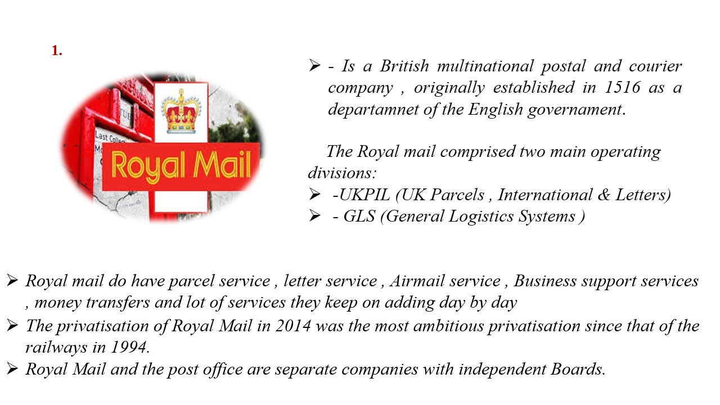
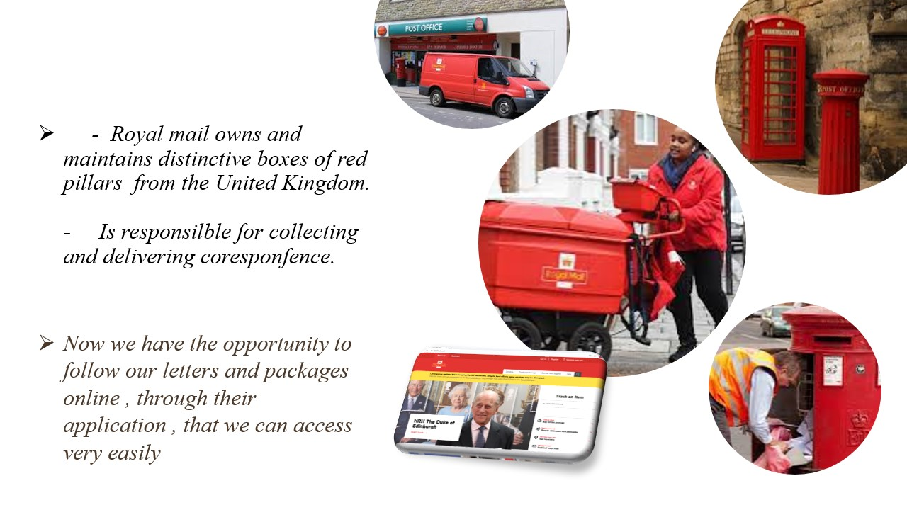

An organisational and its relationship with organisational culture -Elena Miloshevska (2024564)

The organisational structure of a company is a framework that defines how specific tasks are driven to attain strategic objectives. Such operations should provide the implementation of laws, tasks, and obligations. The organisational framework also governs how knowledge works inside this group. Organizational systems are heavily used by companies of all sizes including dimensions (Seidel, 2016). They describe a basic organisation. An effective clearly identifies each contractor's role and how it blends into the larger picture. Put bluntly, the corporate arrangement specifies who can do what for the enterprise to achieve its goals.

Organisational Structure of Royal Mail

The Royal Mail Group's arrangement adjusted on April 1, 2012, and compliance assignments have really been settled upon nationwide, depending largely around which company comprises their properties in question. It is critical to track this advice to prevent misunderstanding in relationships with the appropriate regulation officers and even the new companies. Royal mail Group limited, which is owned by Royal mail Holdings PLC, currently has three primary companies, that are Post Office Ltd, which is now operated by Royal Mail Holdings PLC, Royal Mail Group Ltd- Operations and Modernisation, Parcelforce worldwide and General Logistics systems or GLS. When two companies occupy this very common location, they should indeed be handled individually, and compliance distribution really shouldn't be determined more by support large in the open doors, as is usually the case. Regulation could meet the geographic boundary or within premises, as the companies already would have agreed to, on all locations where policy responsibility may be exchanged by separate jurisdictions (Hall, and Weeghman, 2019).
Arrive to another position that while there is more free flow of talent through the organisation, our position in career progression now is to open the conversation and conversations, mainly inside these sessions. As a result, providing adequate detailed data in advance of all these discussions to examine industry giants and enable them to look deeper away from the centre in terms of possible predecessors is critical. The organisational structure of the company is designed in such a way (Daunton, 2015).

Relationship between Organisational Structure with Organisational Culture

Company culture describes a foundation's organisation structure in several ways, but the arrangement also determines workplace goals in some ways. It is indeed possible to say that the arrangement serves as a basis for implementing the philosophy, when the cultural identity decides how the organisation can be organised. When the society begins to deteriorate, it will only be a waste of waiting before the system continues. The longer it will take for information to move across the various layers of something like the bureaucracy will have a significant impact on business success in a Productive Organisation system, allowing the organisation very sluggish to adapt to modern technologies, political issues, the environment, so on and so forth. It usually has a limited range of authority, which can lead to limitations of individual speech and capacity, resulting in work frustration and demotivation. Company performance affects output, which in turn affects company success. Co-workers may be unaware of the larger picture or the importance of their own role. For Royal Mail, Employees would have had a poor opinion about jobs, or that something is so poorly described, and contact is scarce, it may also result in this more diverse disposition or disposition, impacting the work environment, productivity, and having a negative impact on business results (Szydło, and Grześ-Bukłaho, 2020). Departmentalization, on the other hand, provides more stability due to lower layers of administration. This adaptability to transition makes it efficient, allowing it to respond quickly to consumer desires and needs, resulting in improved results. Improving communication allows individuals to take the initiative and influence to make choices, allowing them a sense of self-sufficiency, resulting in more motivated workers, which has a positive impact on companies. Royal mail considers the fact that, Staff are offered the leeway to innovate and dream creatively. Creativity is promoted and valued. The environment is fluid, and functions are not necessarily well established. It differs significantly from the rest of the business models. It is just not important for one form of tradition to prevail within an organisation, just as it is not appropriate for one type of system to prevail all throughout organisation (Reino, Rõigas and Müürsepp, 2020).

Cohesive Organisation Structure

The quality of solidarity in a collective is referred to as cohesiveness. It demonstrates the degree to which participants are drawn to one another when striving for a common purpose or to meet the cognitive and personal public demands. People of a highly cohesive community share many characteristics: they value others, completely agree to group decisions, provide transparency among stakeholders, and presume good motivators. Royal Mail should be because, Organizations are preoccupied with everyday affairs and tasks to achieve their objectives. Their primary interest is what else, not how to do it. These are chiefly worried with contradictions of the achievement of the targets. Entities seem to be really concerned with their fundamental area of employment that often do not have the time to think on those other aspects that might be incredibly valid (Listopad, 2020).
Cohesive teams outperform less competitive teams in terms of productivity, which may be either more cooperative teams become a little more productive, or much more effective teams become far more competitive. When a group succeeds more than fails, it maintains its cohesion. As a result, it is critical to foster three critical conditions for team performance: skill, inspiration, and teamwork technique. This is how organisational structure is related to organisational culture.
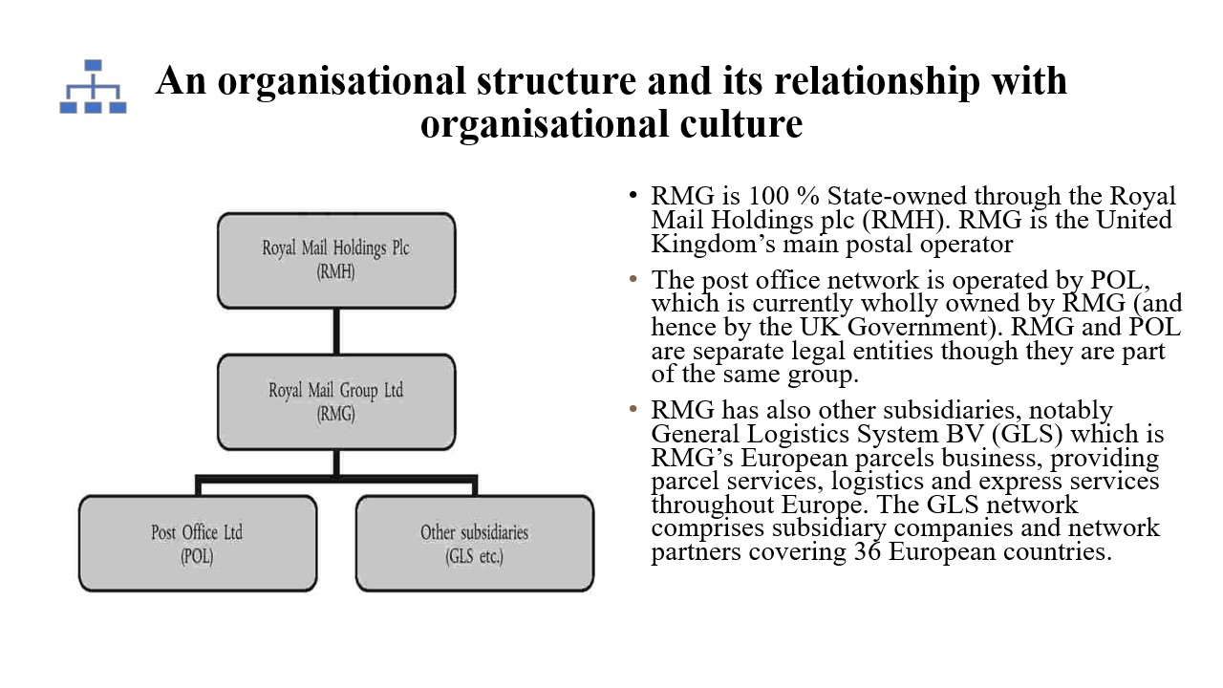
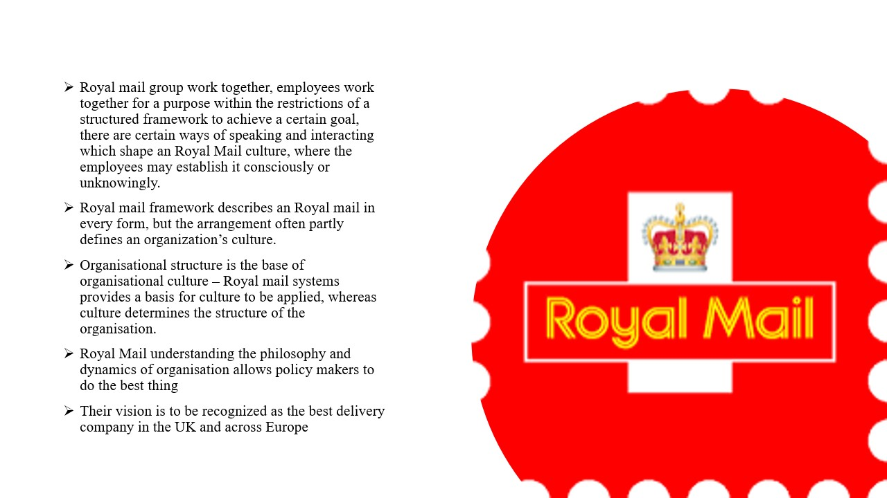

Leadership and management approaches within organisation-Ilya Radichev (2023563)

Both the Leadership and management approaches are key aspects of enterprises across the globe. As a result, such approaches play a major role in shaping the organizational management procedure in best possible manner. That is why, in this presentation work, both the leadership as well as management approaches would be discussed based on the selected enterprise Royal Mail which is a postal and Courier Company located in United Kingdom (UK).
The selected enterprise is Royal Mail which is basically a postal and courier service headquarters in London, United Kingdom (UK). The main target objective of this enterprise is to deliver letters and messages to people all over UK via courier service in best possible manner.

Types of leadership and management approach

One of the major leadership approaches which are opted within the selected corporation culture, Royal Mail, is the strategic leadership approach (Daniëls et al., 2019). It encourages the interaction between the leading operations with its growth as well. With the help of this leadership approach in Royal Mail, it initiates strategic thinking within the minds of the individual employees that makes better parcel and courier functions within the corporation culture. (Daniëls et al., 2019).
The other leadership approach which is opted is the Coach Style leadership approach that is implicated in the Royal Mail (Ruben and Gigliotti, 2019). One of the major benefits of this leadership style is that it assists the leaders of Royal mail to nurture the strengths of its employees and helps initiate team work thus allowing the development and growth of the employees. It helps to conduct the business and deliver the couriers in best possible manner (Ruben and Gigliotti, 2019).
One of the management approaches opted within the selected corporation culture, Royal Mail is the human relation approach. This is one of the major approaches which focus more on the formation of formal organizational structure of Royal Mail (Ladewski and Al-Bayati, 2019). This management approach focuses more on the nature and the behavior of the employees towards the consumers to deliver their satisfactory needs. This management approach develops the self confidence level of the employees of Royal Mail which further play major role in delivering the courier service to consumers in much more effective manner (Ladewski and Al-Bayati, 2019).
One of the major aspects of classical management approach is that it plays a major role in developing universal principals which further assist the selected enterprise Royal Mail to gain the trust of the consumers on terms of courier delivery (Intezari and Pauleen, 2018). This management approach not only tends to enhance and improvise the organizational economic aspects but also, assists the managers of Royal Mail to carefully observe the organizational outcomes (Intezari and Pauleen, 2018).

Importance for management and leadership approaches
Management and leadership are necessary for creating the foundation of the organization and it is essential as they ensure the smooth functioning of the company as a whole. It is therefore necessary for organisations to have a suitable style of leadership and management. As the style of management for the Royal Mail has been established in the previous section, it is therefore necessary to understand the importance of these techniques as the process of transition of an employee into a leader can often be difficult (Ladewski and Al-Bayati, 2019). It has been seen that an individual needs to have a number of qualities and traits for them to become a capable leader. Royal Mail has been conducting development and training programmes for this purpose so that efficient leaders are selected through this process. Furthermore, this task of selection of the ideal candidate is one of the most beneficial approaches undertaken by the organisation. There are several ways in which the leadership programmes can be developed. It can be done with the help of valuable steps like identification of the ideal candidate by evaluating their annual performance and their alignment with the kind of traits and knowledge required for this role. This can also be done by highlighting the need for development and the constant requirement for gaining more knowledge to stay updated about the market requirements. This process would help in enhancing the profitability of the organisation as a whole. Lastly, by tracking the progress of the employees through efficient management techniques, like the ones implemented by the Royal Mail, the ideal candidates for leadership can be identified. The management usually does this by tracking the progress of the individuals and taking notes of their ability to lead a group. The techniques of leadership used by the management of Royal Mail has a positive impact on the overall profitability of the organisation (Intezari and Pauleen, 2018). They have noticed that by this method the organisation has been able to retain its employees and also have been able to recruit many talented candidates. It has also been noticed that the leadership and management techniques have increased the efficiency and productivity of the company because of which the employees have been able to produce error free work to further promote the overall profitability of the organisation. The employees also get a role model who they can look up to in difficult situations. It creates a participatory environment where the employees have someone to guide them through situations where management of risk is required. It allows the organization to avoid situations in which external risks are posed on them. This allows Royal Mail to implement important strategies and make decisions in crucial situations as well. Therefore, these are the main reasons behind the leadership and management approaches of the chosen organisation and their importance in the business industry (Daniëls et al., 2019).
Throughout this report work what exactly has been understood is the fact that the factors and features of Leadership and management approaches for undertaken enterprise Royal mail is beneficial for its future because of this fact, both the Leadership and management approaches has been explained clearly with two approaches in each feature which is implicated within organizational culture of Royal Mail.
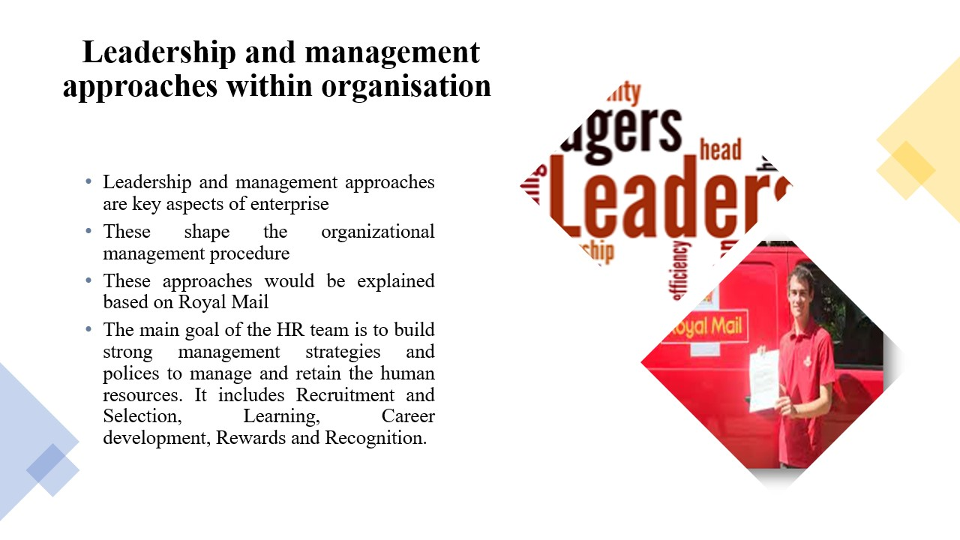
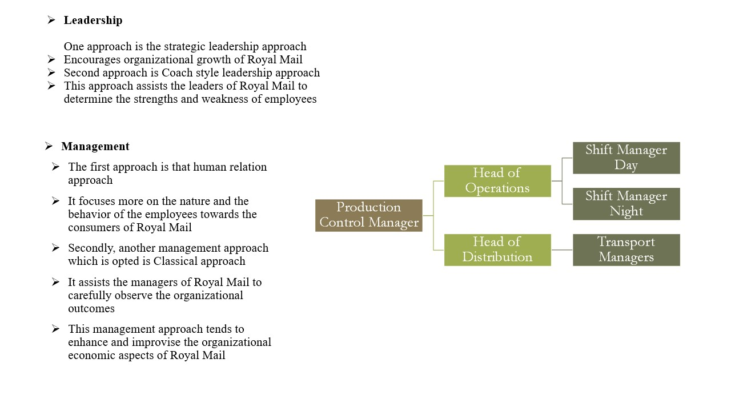

Factors influencing group and team behaviours – Ionela Peltea(2023156)

A group is one or more person that they are working together for the same interest. They can be formal or informal group. Stage of group development:
- Forming – team member gets together and understand what they must do
- Storming- team members start to tell their opinions, and conflict may arise between them.
- Norming – responsibility and roles are much clearly defined, and the expectation is set up
- Performing – team work together to achieve the task
- A team is a group that works together to achieve the goal and share the responsibility. They can be problem- solving, functional, virtual, self-managed or cross-functional. A team o has results should be an effective team, and their characteristics are:
- Clear Goals
- Relevant Skills
- Mutual Trust
- Unified Commitment
- Good Communication
- Negotiating Skills
- Appropriate Leadership
- Internal Support
- External Support
The factors that may promote or stop the evolution of effective teamwork are:
- Group size – represent the number of the people
- Group norms – prefer to follow the rules
- Group synergy -the people, work together and their result is better than they contribute
- Group cohesiveness- the team are attracted to each other, and they are motivated to stay together.
- Group knowledge
- Group skills and ability- understanding the value and culture.
The groups can be different from the teams in different ways:
- Task: Teams require to do some tasks and activities to achieve the goals. Groups do not need to focus on specific mission or goals.
- Purpose: Teams are done for a specific reason. Groups can exist as a matter of fact; for example, a group can include staff of the same nationality, ethnic or department.
- Formal structure: Team role and duties are well detailed and working together are straightforward. Generally, the groups are more informal; parts do not need to be assigned, and behavior does not need to develop.
- Knowing the team members: Team members are informed which people they collaborate with since they start their tasks and activities. Members of a group can have already known the staff or have some knowledge of each other without interactions.
Royal Mail – “We work together to create a positive working environment for everyone”. The company has very high standards expectation from their personal. Their Values are:
- Be Positive – trust each other and every time to the right thing. Use Thank You if the job is well done.
- Be Brilliant – deliver excellent services, never stop improving the job
- Be Part of It – listen to all the team what they have to say. Appreciate diversity because getting ideas for everyone it will make the team better.
Royal Mail expectation is to make the group the best it can be, which mean that there are making some commitment and what they are the expectation from the team. However, their commitment to:
- Provide a secure, safe, healthy, and productive place to work.
- All the staff to be treated fair and with respect
- Protect the team from inappropriate or bullying behaviour
- Work with the law.
As an employee, Royal Mail wants all the people to behave in line with their standards and values all the time:
- Act most of the time, honestly
- During the working hours, be productive
- Follow the standard and policies of the group
- Must show respect for each staff.
“Speak Up” -is an online helpline that all the team can access to raise their concern or ask for advice. This helpline will protect the reputation of the Royal Mail from any incidents.
Factors that can influence Royal Mail are:
- Privatisation – the only one how loose in this was the taxpayer
- Cost factor
Price on their parcel is affected by more competitors across the Uk such as Dpd, Hermes, Tnt. Some competitors are delivering package also Sundays; they also have same-day delivery services. At this moment, the parcel industry is now uncertain because of the click and collect benefits.
The volume decline of letters being send-collected – sorted -delivered, which give the fixed costs of running a delivery service point to higher fixed costs and increasing losses.
Some of the costs are harder to control; for example, the price of fuel can affect their work and will have an impact on profit
- Technology
The internet access impact and other technologies(mobile phones) is a massive threat for Royal Mail. These days, people like more to send an email and secure everything in their cloud storage than to send a letter through the post. The people start to be more comfortable and prefer the easy way to send the letter. With 3D printing at home, the business may reduce its parcel volume. Also, social media facilitate sending the cards.
- Covid – 19 impact
In a pandemic, Royal Mail was remained open for business, but they were prioritising the delivery of vaccination letter and test kits
They have high growth in delivery parcels DIY, gardening and especially medical products
Employees were off absent/sick or self-isolated – do the business to go slow
Social distancing measures have a significant impact on Royal Mail. For example, they have to look to an additional vehicle, protective equipment
- Brexit
Has a lot of uncertainty for Royal Mail. Delivery costs can be affected by the increase of tariffs exported from the Uk to the EU.
Customers are required to attach a Customs Declaration Form to all items send abroad, including the EU. The only ones that are exempt are letters, postcards and documents.
When receiving goods from the EU, you will have to pay duties and VAT. The VAT and duties are depending on the value and type of the goods.
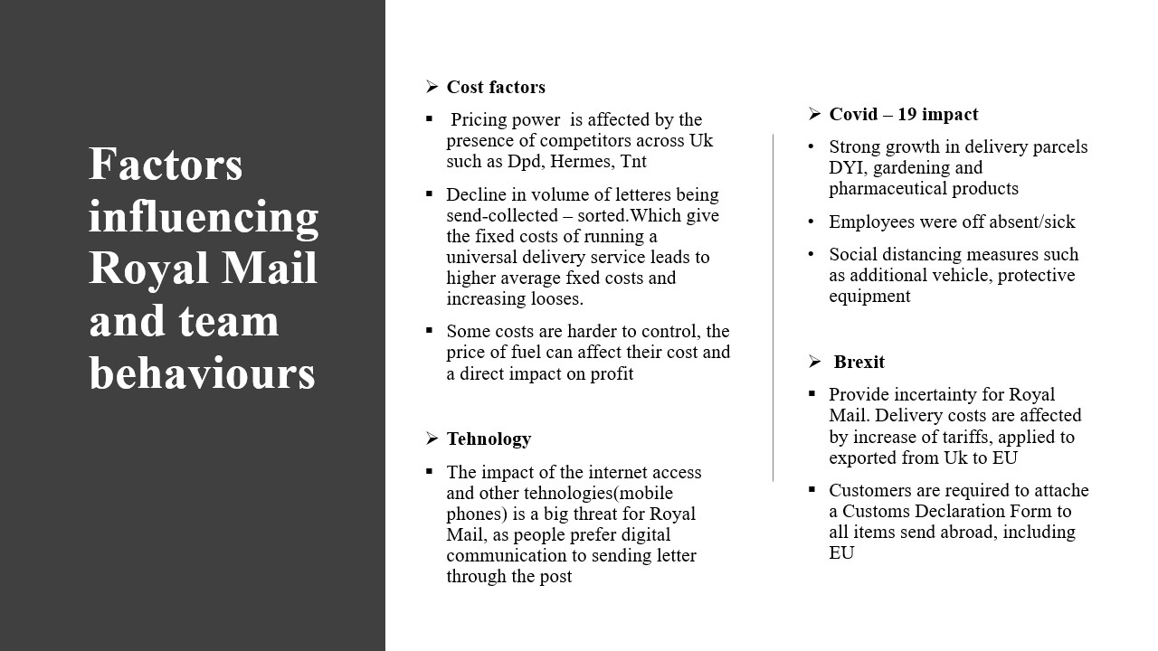
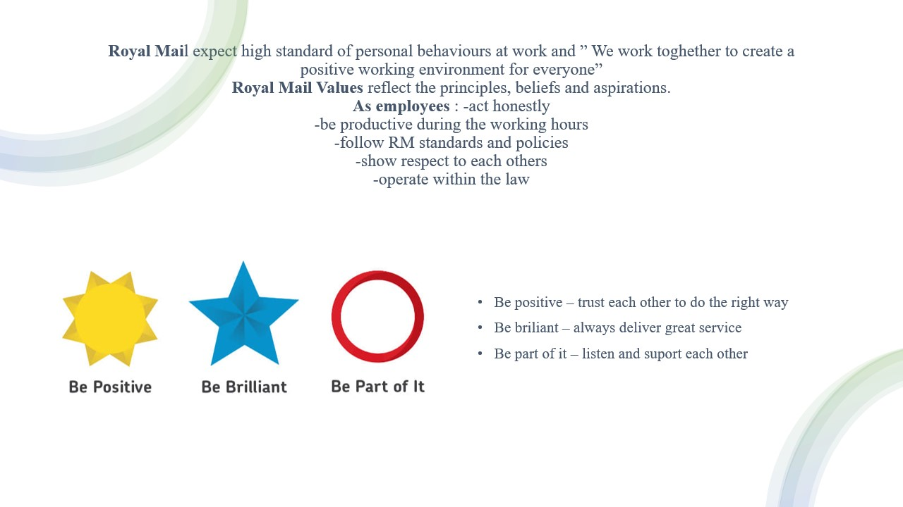

Motivation and perception linked to organisational performances - Galina Gancheva (2022711)

Motivation reflects something unique about each one of us and allows us to gain valued outcomes like improved performance, enhanced well-being, personal growth, or a sense of purpose. Motivation is a pathway to change our way of thinking, feeling, and behaving. Motivation is the process of stimulating action by understanding the needs of employees and by utilizing their motives. The motivator is the technique used for motivation such as pay bonuses, promotion, among others. “Motivation" has common elements with "motor", "moment", "mobile", etc. These are words that demonstrate movement, physical action. The vital product of motivation is physical action. Motivation is not what people think or feel, but what they do physically. When motivating people to achieve results, challenge them to perform exactly those actions that will bring the desired results.
There are articles that advise leaders who need to motivate people and teams to achieve results, to do so not through presentations and speeches, but through leadership conversations. The presentation conveys information. However, when you want to motivate people, you need to do more than just convey information. You need to make them believe in you and follow you. A key outcome of any leadership conversation is the physical action that leads to results. Motivation is driven by emotion. "Emotion" has the same root as the word "Motion". When you want to challenge people to action, focus on their emotions. The act of motivation is an act of emotion. With any new strategic management endeavour, you should make sure that the people around you have a strong emotional commitment to realize it. Motivation is not what we do to others, but motivation is what others do to themselves. The truth is that we cannot motivate anyone to do anything. Only the people we want to motivate can be motivated. The motivator and the motivated are always the same person.
Royal Mail Group is the UK’s pre-eminent delivery company. Well-known and well-loved brands, they deliver a range of letters, parcels and more to around 330 million addresses across the UK, working six days a week.
Royal Mail’s culture is linked to their vision to be recognise as the best delivery company in the UK and across Europe. Their mission is to form positive relationship with customers, communities, and environment. In an increasingly challenge and competitive marketplace, they put corporate responsibility at the heart of what they do. They recycle 99% of the materials used. They try stopping scam mail and are helping the economy. They work with charity organisations Action for Children, Mind, Mental Health UK, and The Prince’s Trust on a campaign covering work placements, training and other awareness raising activities. According to Worthington (2006) recognising and responding to cultural differences between countries can have and important impact on how successful organisations are in international trade. But is it possible to generalise about to country’s culture? One academic who has made a significant contribution in this area is Professor Geert Hofstede Worthington (2006), who has developed a theory of culture which allows comparisons to be made between the main cultural characteristics in different countries. Based on his research Hofstede Identified for cultural dimension. These dimensions can be used to compare value systems as different levels, from the family through to the state. The five cultural dimensions are as follows: power distance, uncertainly avoidance, masculinity, long – term orientation and respect for tradition.
Royal Mail’s social economic impact is the seventh largest contribution of any UK company to the UK economy. One in every 194 jobs in the UK is provided by Royal Mail. Another social contribution is a free postage service for blind and partially sighted people. A motivation for good performance is rewarding people fairly – people play an important role in the business. They rely on them to delivery high quality customer service and to represent Royal Mail. So engaging people within a fair Rewarding and customer focused culture is very important. (See Appendix Fig 2 Organisational Performance)
Royal Mail publish the result of annual UK pay review. They have plan to relate on them to delivery high quality customer service and to represent Royal Mail. So engaging people within a fair Rewarding and customer – focused culture is very important. Publish the result of annual UK pay review. They have plan to release cash to invest in the required restricting activities to restore profitability to the UK. About COVID19, they have imputed safety measures for staff customers like social distancing. Having only one person in Royal Mail delivery vehicle. The Royal Mail (Document Library, 2021) has an award-winning Springboard women’s development programme has been specifically designed for women in non-management grades to help assess their current situation and work development. It teaches individuals with the positive attitude and skills to accept responsibility for their own development. The Springboard Programme is a key part of the Gender Action Plan, helping women to know what they want and have the confidence to go out and get it. It is already helping women address issues in the workplace and at home and improve their experience of working for Royal Mail Group. The Springboard Programme enables frontline women to reach their full potential, while helping to make this business an employer of choice for those joining the workforce in the next five years. Any business that does not recognise women’s role in making it successful will inevitably fail. The UK is one of the most developed e-retail markets in the world, with approximately 13 per cent of all retail sales conducted online. The market is expected to continue growing to an estimated 16 per cent by 2019. B2C (business-to-consumer) and C2X (consumer-to-all parties) deliveries currently account for nearly two-thirds of UK parcel. Consumers expect a range of convenient and reliable delivery and easy returns options, with tracking. Home delivery remains the most attractive fulfilment option for customers (Annual Report, 2021). The motivation for successes helps them developed and adapt to change in the pandemic conditions of COVID19. This helps them play a key role and grow. In their organisation they develop other activities that are important. Royal mail has the motivation to try new and different things, that are part of successful performance.
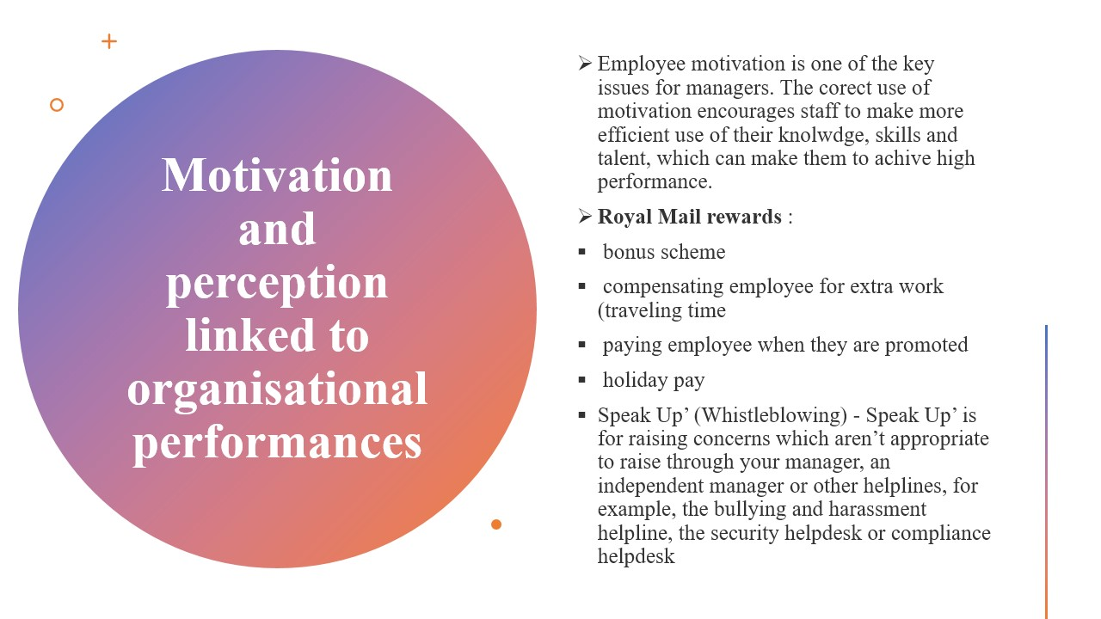
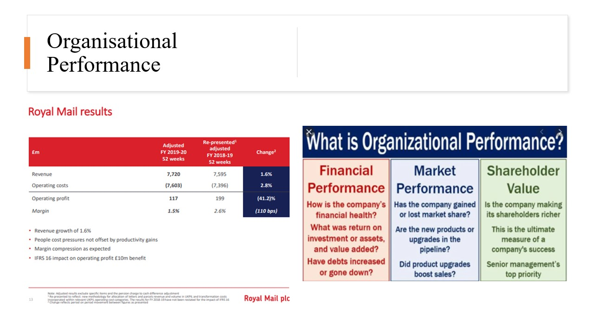

Conclusion

This presentation made us understand that the Royal company to survive in this huge range of market, it needs to include modernization and to revise or restructure business ideas.it must implement marketing strategies but also develop strong policies. The privatization of the Royal company will increase efficiently, and the benefits of privatization may vary or may be the reduction of monopoly organizations, the increase of the company's productivity but also the increase of the competitive level. The organization ends up making some changes or small adjustments in terms of privatization, modernization of all operations, solving problems of conflicts between staff and management. Some forces sometimes influence the structure of this organization including the attitude of employees sometimes different from person to person, can be negative decreasing the progress of the organization such as quarrels but management and employees or positive helping to increase the profile but also the Royal Mail company.

References

Mustchin, S., 2017. Public sector restructuring and the re‐regulation of industrial relations: the three‐decade project of privatisation, liberalisation and marketisation in Royal Mail. Industrial Relations Journal, 48(4), pp. 294-309.
John, B. Q. & Jeremy, L., 2018 .03. Whistling for Dismissal and Detriment Remedies: Royal Mail Ltd v Jhuti.. Industrial Law Journal, 47(1), pp. 121-134 , 14.
Martin, B., 2013. Interpretations of management and modernisation at the UK Royal Mail: shifting boundaries and patterns of resistance?. New technology, work & empoyment, 28(2), pp. 116-129, 14.
Tonks, J., 2014. Empire : A journey to the remote edges of the Brithis Empire. UK: Stockport:Dewi Lewis Pulishing.
College, E., 2015. Slideshare. [Online]
Available at: https://www.slideshare.net/geoffriley/royal-mail-privatisation
[Accessed 05 05 2021].
Daunton, M.J., 2015. Royal Mail: The post office since 1840. Bloomsbury Publishing.
Hall, D. and Weghmann, V., 2019. Public ownership, benefits and compensation II: Pension funds and employee ownership of water and energy grid companies.
Listopad, S.V., 2020. Functional structure of the cohesive hybrid intelligent multiagent system. Sistemy i Sredstva Informatiki [Systems and Means of Informatics], 30(2), pp.78-88.
Reino, A., Rõigas, K. and Müürsepp, M., 2020. Connections between organisational culture and financial performance in Estonian service and production companies. Baltic Journal of Management.
Seidl, D., 2016. Organisational identity and self-transformation: An autopoietic perspective. Routledge.
Szydło, J. and Grześ-Bukłaho, J., 2020. Relations between National and Organisational Culture—Case Study. Sustainability, 12(4), p.1522.
Adams, D., Kutty, G.R. and Zabidi, Z.M., (2017). Educational leadership for the 21st century. International online Journal of educational leadership, 1(1), pp.1-4.
Bush, T., Bell, L. and Middlewood, D. eds., (2019). Principles of educational leadership & management. Sage.
Daniëls, E., Hondeghem, A. and Dochy, F., (2019). A review on leadership and leadership development in educational settings. Educational research review, 27, pp.110-125.
Hallinger, P. and Kovačević, J., (2021). Science mapping the knowledge base in educational leadership and management: A longitudinal bibliometric analysis, 1960 to 2018. Educational Management Administration & Leadership, 49(1), pp.5-30.
Hallinger, P., (2018). Surfacing a hidden literature: A systematic review of research on educational leadership and management in Africa. Educational Management Administration & Leadership, 46(3), pp.362-384.
Harris, A. and Jones, M., (2018). The dark side of leadership and management.
Intezari, A. and Pauleen, D.J., (2018). Conceptualizing Wise Management Decision‐Making: A Grounded Theory Approach. Decision Sciences, 49(2), pp.335-400.

Ladewski, B.J. and Al-Bayati, A.J., (2019). Quality and safety management practices: The theory of quality management approach. Journal of safety research, 69, pp.193-200.
Podsakoff, P.M. and Podsakoff, N.P., (2019). Experimental designs in management and leadership research: Strengths, limitations, and recommendations for improving publishability. The Leadership Quarterly, 30(1), pp.11-33.
Ruben, B.D. and Gigliotti, R.A., (2019). An Overview of Foundational Perspectives on Leadership. Leadership, Communication, and Social Influence.
Bourea. And Haddon,D. 2009.An evidence-based approach to developing HR strategy: transformation in Royal Mail, Vol 9, p 10-16
Mullins,Laurie J. and McLean,Jacqueline E, 12th ed, 2019. Organisational behaviour in the workplace(electronic resource)
- HYPERLINK "https://www.myroyalmail.com/sites/default/files/document_library/Our%20Business%20Standards%20-%20April%202019.pdf" https://www.myroyalmail.com/sites/default/files/document_library/Our%20Business%20Standards%20-%20April%202019.pdf
- HYPERLINK "https://eur-lex.europa.eu/legal-content/EN/TXT/?uri=CELEX%3A32012D0542" https://eur-lex.europa.eu/legal-content/EN/TXT/?uri=CELEX%3A32012D0542
Daniëls, E., Hondeghem, A. and Dochy, F., 2019. A review on leadership and leadership development in educational settings. Educational research review, 27, pp.110-125.
Ruben, B.D. and Gigliotti, R.A., 2019. An Overview of Foundational Perspectives on Leadership. Leadership, Communication, and Social Influence.
Ladewski, B.J. and Al-Bayati, A.J., 2019. Quality and safety management practices: The theory of quality management aThree key factors for motivation through leadership, Available at https://www.novavizia.com/trite-kliyuchovi-faktora-za-motivaciya-chrez-liderstvo/ Accessed on 20.04.21
Worthington, Ian and Briton, Chris (2006), The business environment Prentice Hall; Leicester business school, De Monfort University, Leichester; publisher: Pearson Prentice Hall, fifth edition;
Royal Mail (2021) HYPERLINK "https://www.myroyalmail.com/sites/default/files/document_library/0261%20Springboard%20Leaflet%20online.pdf" https://www.myroyalmail.com/sites/default/files/document_library/0261%20Springboard%20Leaflet%20online.pdf Accessed on 28.04.2021 8.00 pm
HYPERLINK "https://www.royalmailgroup.com/en/insights-innovation/" https://www.royalmailgroup.com/en/insights-innovation/
Royal Mail (2021) https://www.annualreports.com/HostedData/AnnualReportArchive/R/LSE_RMG_2015.pdf
29.04.2021 11.35 AMpproach. Journal of safety research, 69, pp.193-200.

