HNC Process Operations Engineering

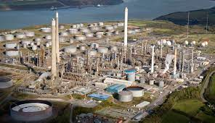

Module- Process safety systems
Assignment- Process safety management
Learner- Noah Davies
Lecturer- Rhys Hutton
Learner Contact- 153883@pembrokeshire.ac.uk

Contents
Intro 3
Task 1 4
Task 2 10
Task 3 12
References 16

Intro

The purpose of this assignment was to demonstrate an understanding and appreciation of process safety systems in the workplace. In this assignment the workplace being Valero Pembroke oil refinery keeping it specific to the storage of hydrocarbon through tankage.

Task 1
When working at a refinery such as Valero Pembroke there are many storage tanks filled with hydrocarbons which can cause catastrophic events if protection isn’t in place. The pillars or protection systems are continuously reviewed and updated to prevent events occurring. A famous example of protection systems not being followed or failing can be the Buncefield explosion where an overflow of petrol caused a vapor cloud explosion resulting in the release of over 300 tons of petrol (Elmac, 2019). It was later revealed during investigation that the protection and safety systems were not followed which is why process safety is continually updating. The image below is a protection system relevant to the storage of hydrocarbon within tankage. There are nine relevant points and each of which will be discussed below.

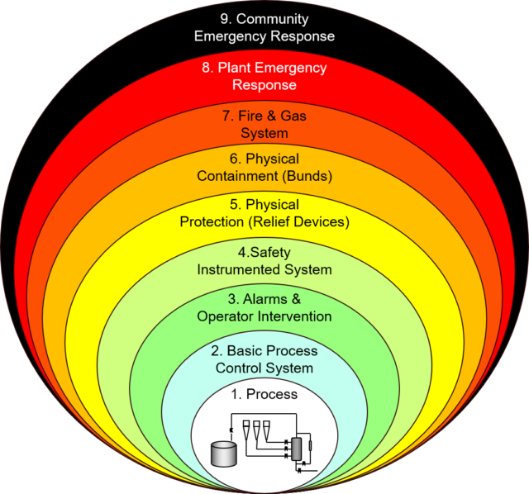
Figure 1- Nine layers of protection in tankage

Process
Process is the implementation and monitoring of equipment such as:
- Pressure Gauges
- Temperature Gauges
- Flow Rate Gauge
- Level Gauges
- Equipment checks
- Preventative maintenance
- Area checks

Monitoring and upkeep of the equipment and the process helps keeps the condition of the process with safe and acceptable limits of operation. Process checks are normally completed by the operators of the equipment as they are the most familiar and can easily identify if conditions change.

Basic Process Control System
Basic process control systems are control systems which allow for more extensive monitoring as well as allowing for remote operation of equipment.
The main control/monitoring system used at Valero for tank monitoring and equipment operation is Tis view and Delta V.
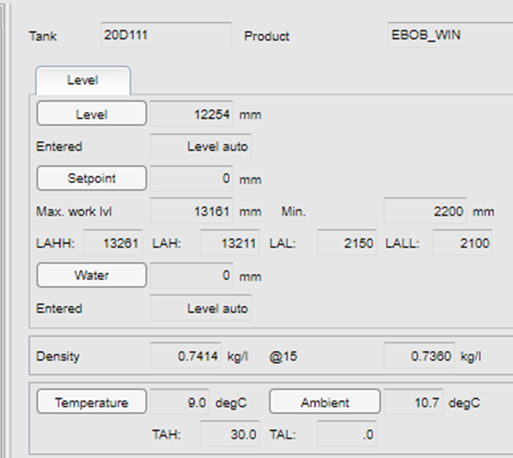
Figure 2- TIS

Alarms and Operator intervention
Alarms are used to alert operators to conditions that could potentially be dangerous. Alarms can come in different priorities depending on the severity of consequences if conditions escalate. For example, high priority alarms include, tank high level alarms, gasoline blending, fire/gas detection, crude blending and gasoline blending. Low level priorities alarms include tank temperatures, high/low line pressure alarms and tank level variation alarms. For high priority alarms operator intervention is necessary, this involves an operator checking over the equipment to makes sure there are no problems.

Safety instrumented systems
Safety instrument safety systems can operate in such a way to stop operations which can lead to dangerous situations. Examples with respect to the tank farm occupation include gasoline blending or crude imports.
Aops valves are used for gasoline blend and crude imports due to the consequences of tank overfill especially in regards with these two hydrocarbon types. An Aops valve is a device used to prevent tank overfill. Aops stands for “Automated Overfill Prevention System”, this shuts the valve to the tank without input from the control operator. With gasoline blending and crude imports the rate in with the tanks are filled is so great the time a high-level alarm for the tank is sounded and action is taken to stop blending or the ship import it may be too late.

Physical Protection
The most common physical protection on an oil refinery is pressure release devices such as PSVs and TSVs. These two devices are used to divert pressure from as system or pipeline to a predetermined location. These pressure release devices are designed to “lift” at a present pressure to prevent unsafe conditions of a pipeline or process equipment.
A PSV can be used on vessels, process equipment such as steam turbine and pressurised storage tanks (LPG tanks). The PSV are normally used for operation that are greatly pressurised under normal operating conditions. A TSV is used for pipeline pressure release commonly with regards to thermal expansion. The diverted pressure can go to flare, other process lines or atmosphere.

Physical containment
Physical containment is used to prevent the spread of product if leaks or overfill occurs. The most common form of containment is bunds. Bunds are a common containment measure for storage tanks. A bund is designed to contain all the contents of a tank, this prevents the spread of product to more at risk areas such as natural bodies of water, sewers and drains, other process equipment and buildings. With flammable product, containment also helps reduce the chance of sources of ignition being introduced.
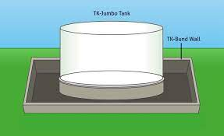
Figure 3- Tank bund

Fire and Gas systems
The most common place in a refinery tank farm the has gas detection is the sphere storage area. The sphere tanks are pressurised and contain flammable liquid gas such as propane, butane, and olefins. The systems in place at my place of work includes multiple gas detectors and sirens in this type of area. As well as this there is signage to inform people to leave the area is the siren is sounded.
Fire detection is also used of certain tanks, this included the sphere storage tanks and crude tanks. These alarms sound in the control room and action is taken by the field operator to ensure the tanks are safe and no fire is present, this is done as these alarms are prone to false alarms due to environmental factors.
Plant Emergency Response/ Community emergency response
Plant emergency response is the response of certain personal with regards to a site emergency. Depending on job role different responsibilities are carried out. Maintenance/contractors will muster and one of the designated muster points. Operations personal are exempt from mustering but other jobs are assigned. The main responsibilities at blending and shipping include shift team leader will oversee the incident and communicate with other complex areas, lead operator will oversee the response in the field, control operators will ensure effective communication between the STL, operators attending the incident and security office. Other responsibilities include Tank farm technician attending the firehall and putting on fire gear to help the fire department, wastewater operating the emergency fire water pumps/tank if necessary.

Human Factors
All these layers of protection depend on human factors. Human factors need to ensure these layers of protection are in place and the proper procedures are followed. The layers of protection can be compromised in several ways if they are neglected. Operators could not carry out the necessary check on equipment, alarms can be silenced, safety systems can be bypassed, PSV and TSV can be isolated, gas and fire detector can be ignored. All these are human factor with greatly impact the safety and effectiveness of protection.

Task 2

Process control measures play a crucial role in preventing incidents in refinery tank farms by ensuring the safe and efficient operation of the facilities. Refinery tank farms are complex environments where various volatile and flammable substances are stored, making the implementation of process control measures essential for mitigating risks and enhancing overall safety.

Automated Monitoring and Control Systems:
Refinery tank farms employ automated monitoring and control systems to continuously oversee various parameters such as temperature, pressure, level, and flow rates. These systems use sensors and actuators to detect deviations from normal operating conditions and automatically make adjustments to maintain optimal parameters. By closely monitoring these variables, the risk of incidents resulting from equipment malfunctions or deviations from safe operating conditions is significantly reduced.

Emergency Shutdown Systems (ESD):
Emergency Shutdown Systems are critical components of process control measures in tank farms. These systems are designed to rapidly and safely shut down the operation in case of an emergency. They can be triggered manually or automatically based on predefined criteria. ESD systems help prevent incidents by quickly isolating the affected area and minimising the potential for escalation of events that could lead to accidents or spills (EEMUA, 2020).

Tank Gauging Systems:
Accurate measurement of the levels of stored substances is crucial for preventing overfill incidents. Tank gauging systems utilise instruments such as radar, ultrasonic, or float-based level sensors to monitor and control inventory levels. Alarms and automated actions are triggered when levels approach critical points, preventing overflows and spillage (Emerson, 2019).

Real-time Data Analysis:
Advanced data analytics tools are employed to analyse real-time process data, enabling the identification of trends or anomalies that may indicate potential issues. By leveraging predictive analytics, refinery operators can take proactive measures to address emerging problems before they escalate into safety incidents.

Task 3

In the petrochemical industry hazards and risk are extremely high in the day-to-day operation of the refinery, this is why following guidance from the HSE and legislation such as the Health and Safety at Work Act 1974 is vital in ensuring the safety of workers, the public and the environment. The Health and Safety at Work Act is the main legislation that covers working conditions and practices in the workplace and is the main body legislation that puts responsibility on employers and employees to ensure work is done as safely “as far as is reasonably practicable”.

Permit to Work
Before any work/job can be started on site a permit to work needs to be created and given to the person who is going to be carrying out the work/job. The permit to work is authorisation papers which gives a worker valuable information. Such information includes PPE needed, isolations carried out, equipment/tools to be used, location of the job, equipment number and the types of hazards that may affect the job such as breaking containment. If something is missing from the permit this needs to be discussed with a supervisor and the permit can be amended if needed. Permits last for one shift/day and workers need to sign on to the back of the permit before starting work. Each job needs its own permit so if your carryout multiple jobs in one day them you will need a permit for each job (HSE, 2016).
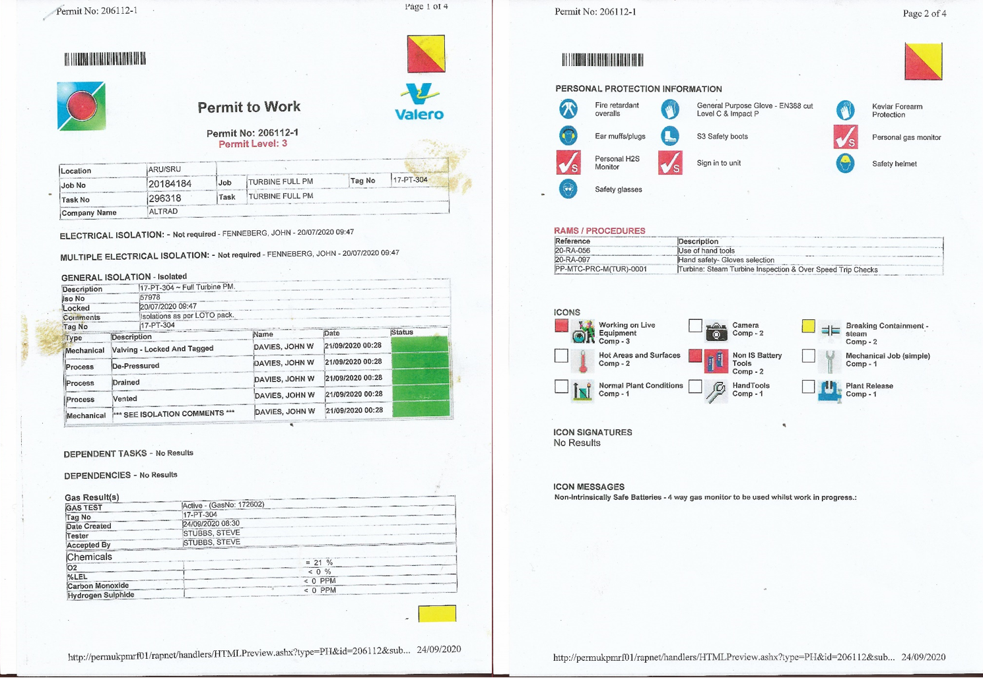
Figure 4- Valero permit

As of 2022 Valero introduced joint job site visits to ensure workplace safety is at an enhanced standard. The meeting is between the operator and the permit receiver such as maintenance. The job scope, safety, and other relevant information/questions are to be discussed. The permit is only deemed live once both parties have signed the JJSV (Valero, 2023).

Risk Assessments
Risk assessments are carried out extensively throughout Pembroke Refinery. Risk assessments are completed for every job, location and potential hazard. Risk assessment are the building block for the creation of permits, procedures, and working practices in every workplace. Risk assessments done by the employer give workers permits which tells them the PPE they need, tools/equipment to use, mandatory and controlling actions to follow. Risk assessment done by the employer provide procedures and practices to follow while carrying out the job, this will tell worker the safest way to complete the job as well as hazards at each step. A risk assessment is also carried out by the worker before work starts this is called JHA (Job hazard analysis), this is to identify any last-minute hazards. Before any work is carried out a risk assessment is carried out by all workers (management, 2019).

Personal Protective Equipment
The PPE you need to wear at Pembroke refinery can be identified from the three different coloured zones red, amber, and green. This will also be stated on the permit. The red zone is where you need the most PPE normally located in the refining units and blending and shipping. The red zone PPE needed includes fire retardant overalls, H2S monitor, safety helmet, safety boots, safety glasses, ear protection and impact gloves. The amber zone is most areas on site and includes overalls, safety boot, H2S monitor as well as a hard hat and safety glasses. The last zone is the green zone, PPE includes long sleeve tops, long trousers, and suitable footwear. Additional PPE may be started on your permit for the job being carrying out some examples include jobs in the alkylation unit, working with chemicals and working with hot components. The different zones are identified from the solid painted lines on the floor (Legislation.gov, 2022).

Valero’s Life Saving Rules
Always work with a valid work permit

Verify energy isolation before starting work

Obtain authorization before entering a confined space

Obtain authorization before overriding or bypassing a safety system

Use life protection equipment/PPE

Protect yourself from falls when working at heights

Smoke in designated areas only
These are some of the many safety systems in place at Valero to maintain a safe workplace. With these in place the likelihood of hazards causing harm is reduced.

References
EEMUA, 2020. emergency shut down system. [Online]
Available at: https://www.eemua.org/glossary/e/emergency-ss#:~:text=Emergency%20Shutdown%20System%20(ESD).,Safety%20Instrumented%20System%20(SIS).
[Accessed 12 January 2024].
Elmac, 2019. Elmac. [Online]
Available at: https://elmactechnologies.com/buncefield-explosion/
[Accessed 12 January 2024].
Emerson, 2019. Emerson. [Online]
Available at: https://www.emerson.com/en-gb/automation/measurement-instrumentation/tank-gauging-system
[Accessed 13 January 2024].
HSE, 2016. permit to work. [Online]
Available at: https://www.hse.gov.uk/comah/sragtech/techmeaspermit.htm
[Accessed 14 January 2024].
Legislation.gov, 2022. PPE regulations. [Online]
Available at: https://www.legislation.gov.uk/uksi/2022/8/contents/made
[Accessed 15 January 2024].
management, P. s., 2019. Pro safety management. [Online]
Available at: https://www.prosafetymanagement.co.uk/legal-requirement/
[Accessed 15 January 2024].
Valero, 2023. Permitery. Pembroke: Valero.

