

‘Exploring the Relationship between Sensation Seeking and the Likelihood of Engaging in Risky Behaviours’
Student Number: 1701786
University of Wales Trinity Saint David

Abstract
The purpose of this study was to determine the possibility of there being a positive correlation between RDB and sensation seeking. This entailing that whether the increased levels of sensation seeking found in drivers had increased the likelihood of the driver engaging in dangerous driving behaviours. Participants had been tasked with completing two questionnaires online relating to sensation seeking and RDB. The responses had been scored and tallied, using a Pearson’s R test to determine the correlational value between the two variables. Participants had been comprised of single-honours Psychology and joint-honours Counselling and Psychology, 26 in total, 5 males and 21 females. 24 participants held full driving licenses whilst 2 held provision driving licences. The results of the study had shown that there was a weak negative correlation. However, the results had been shown to be non-significant, resulting in the provided hypothesis to be rejected and possibly prompting further research into this topic, with additional variables and new sample parameters to be considered for future studies. Ensuring these requirements may serve to provide more accurate results in the future, whilst also taking additional factors’ effects on RDB into account.

Introduction
Risky Driving Behaviour (RDB) has led to several different concerns as reports had suggested that the numerous motor vehicle incidents have led to costs placed at approximately $230.6 billion for the United States in 2000 (NHTSA, 2003, as cited in Dahlen Martin, Ragan & Kuhlman, 2005). Reports had also indicated that the leading cause of the death in the United States are motor vehicles, with 42,643 deaths recorded because of these incidents, with 2,899,000 recorded injuries (NHTSA, 2003, as cited in Dahlen et al, 2005). Factors have been attributed to influence RDB, amongst these includes impulsivity and sensation seeking as the most notable due to the results discussing the link between these factors and RDB in these studies (Dahlen et al., 2005; Jonah, 1997). To determine whether there is a link between these factors and RDB, it is important to understand the meaning behind these factors as well as RDB. Impulsivity is referred to as a risk-taking action which is seen to be like that of sensation seeking, however, impulsiveness refers to the level of control an individual possesses over their behavioural and thought patterns (Barratt, 1972, as cited in Dahlen et al., 2005) whereas sensation seeking refers to the individual’s choice to engage in sensational and risky behaviours (Zuckerman, 1994, as cited in Dahlen et al., 2005). As for risky driving behaviour, this would include a situation in which a driver may engage in behaviour which may result in the harm of themselves as well as potentially other individuals (Ulleberg & Rundmo, 2003).

As previously mentioned, there are studies which have discussed these factors such as impulsivity, sensation seeking and personality traits and their correlation with RDB (Dahlen et al, 2005; Jonah, 1997; Ulleberg & Rundmo, 2003; Hatfield, Williamson, Kehoe & Prabhakharan, 2017; Bachoo, Bhagwanjee, Govender, 2013). Dahlen et al (2005) for example, had undergone a study to determine whether there was a link between sensation seeking, impulsiveness, boredom proneness and driving anger and whether these factors can be used to predict RDB. The study had comprised 224 participants in which 70% were female, 30% male and were undergraduate volunteers as part of the psychology and social rehabilitation services classes in the University of Southern Mississippi. Participants had been required complete various forms, describing various anger-inducing scenarios whilst driving, the frequency of risky driving behaviour outcomes, impulsiveness measurements, sensation seeking measurements, etc. Results from Dahlen et al (2005) study had detailed participant’s measurements for sensation seeking, impulsiveness and boredom proneness due to lack of external stimulation had all correlated positively with each other, there was no correlation between sensation seeking and boredom proneness to a lack of external stimulation however. This demonstrates a positive correlation between these factors and RDB. Another recent study by Hatfield et al (2017) examined youthful motivations such as sensation seeking and their potential link to RDB. This involved a focus upon the potential link between response inhibition, impulsivity and the response to events. This had been done through tasking 72 first-year Psychology students, who had comprised the participants, with completing a simulated driving session to detect various behaviours such as impulsive RDB. Results had demonstrated that those with poor impulse control had engaged in RDB, establishing a link between RDB in younger drivers and issues with impulse control. Based upon this literature provided, there would seem to be a consensus from various studies that factors such as impulsivity and sensation seeking are linked to RDB due to the strong evidence provided by various texts (Dahlen et al, 2005; Hatfield et al, 2017; Jonah, 1997; Bachoo et al, 2013). As such, the hypothesis of the study suggests there will be a positive correlation between sensation seeking and RDB. Provided an instance in which the hypothesis if accepted, this may serve to further bolster previous findings, providing additional credibility to the findings discovered here, as well as past and future studies.

Methods
Participants
For this study, there were a total of 26 participants from a single honours psychology course and a joint-honours counselling and psychology course. Students had been sent emails to request participation in the study. The study had consisted of 5 males and 21 females, age range consisting of 18-60 years old (M=27.58, SD=11.13). 24 of the participants had possessed full driving licences whilst 2 participants had possessed provisional driving licences.

Design
The design of the study consists of SPSS correlational calculations, using a Pearson R test to measure the correlation between two variables to determine the extent of the relationship between the two. These variables include the level of sensation seeking in correlation with the level of RDB. To measure this, two Likert scale questionnaires had been used. The study involved a within-subjects design.

Materials
The materials for this study had included two Likert scale questionnaires, one which measured the level of sensation seeking of the participant, known as the Brief Sensation Seeking Scale (BSSS), an example of the questions provided in the questionnaire included “I would like to explore strange places”, answers ranged 1-5 points from Strongly disagree=1, Disagree=2, Neither disagree not agree=3, Agree=4 and Strongly agree=5. The range of scores were 8-40, with higher scores indicating high sensation seeking tendencies (Stephenson, Hoyle, Slater & Palmgreen, 2003). The other questionnaire measured the level of RDB of participants. An example of a question from the questionnaire includes “Speed up if someone is trying to pass”, requesting the participants to provide an answer, ranging from a point scale of 0-4. These answers included Very often=4, Often=3, Sometimes=2, Hardly ever=1 and Never=0 (Ivers, Senserrick, Boufous, Stevenson, Chen, Woodward & Norton, 2009).

Procedure
Participants had undertaken the study through completing online questionnaires, this had begun with the participants providing consent to participate in the study through a consent form (Appendix A) through an online format, before the questionnaires were provided. The form detailed the procedure of the study as well as ensuring the participants that all information provided in the study is confidential, being held in accordance to the Data Protection Act. Once participants have read the information provided, they are to state they do or not understand the information provided as well as provide or not provide consent to undertaking the study. The RDB questionnaire (Appendix B) had then been provided for the participants to complete, requiring participants to answer various questions, related to RDB. After the first questionnaire had been completed, the BSSS questionnaire (Appendix C) had then been provided for the participant to complete, detailing questions in relation to the sensation seeking tendencies of the participants. Once both questionnaires are completed, a debrief form (Appendix D) had been provided online to the participants, providing detail of the purpose for the study as well as informing the participants of their right to withdraw, along with contact details of the researcher. Participants were then prompted with submitting their answers, completing the study.

Results

Results from the Pearson’s R test had shown that participants’ total sensation seeking measurements (M=25.89, SD=4.49) and total RDB (M=14.58, SD=7.88) had shown a weak negative correlation as shown in the calculation, with r calculated to 2 decimal points (r= -.08, n= 26, p >.05), indicating the results to be non-significant as seen in (sig. 2-tailed = .712). As evident of the results shown in figure 1, the directional hypothesis for this study will be rejected as a non-significant negative, weak correlation between RDB and sensation seeking had been determined, suggesting no correlation due to the lack of a significant relationship between the two variables.

Discussion
As demonstrated in the results section, the hypothesis of the study has been rejected as it had been suggested that a positive correlation would be determined, however, a non-significant, weak negative correlation had been established instead. This would then entail that the two variables of RDB and sensation seeking work inversely with each other in opposition to the suggested hypothesis, however, this would be to a non-significant effect. This would then infer that there is no correlation between RDB and sensation seeking and the two do not affect each other due to the lack of a significant relationship. This contradicts the provided literature such as Dahlen et al (2005), Hatfield et al (2017), Jonah (1997), etc. Each of these studies presented a positive correlation between RDB and sensation seeking, however, there were factors that had been considered for these studies, such as anger, driving attitudes (Bachoo, 2013) or impulsivity (Hatfield et al, 2017). These may be key factors that influence the level of RDB found in participants. An example of this can be seen in Bachoo et al (2013) in which drivers had been described as more prone to RDB if levels of anger were higher, suggesting a correlation between the two. Considering the possibility of factors affecting the level of RDB found in participants, perhaps the parameters for the analysis proved to be a limitation as there may be numerous other factors that affect the driving behaviours of the individual, besides sensation seeking as we have seen in the provided literature. In addition to this, 2 participants had possessed provisional licenses, entailing that their driving behaviour would be monitored whilst driving, as required by law (GOV.UK, n.d.). This may infer that perhaps the results from these 2 participants may be somewhat inaccurate as their suggested behaviour in the questionnaires, may not be entirely truthful to the reality of their driving behaviour without supervision, as they would not have had the opportunity to drive without supervision of some sort due to threat of violating the law. While this may have merely and slightly altered the results, they are an inaccurate alteration nonetheless and measures can possibly be taken in future to account for this, such as exclusively including participants with full driving licences. However, further research would be required to confirm that driving behaviour is affected by supervision, to justify this as possible factor upon the accuracy of the results.

In conclusion, the results of this study found a non-significant negative correlation between RDB and sensation seeking, as such, perhaps another study in the future which considers various other factors such as anger or driving attitudes, as has been seen in other studies, would prove beneficial as this may provide more insight into how these various other factors influence the driving behaviours of individuals, with the possibility of additional sample parameters exclusively requiring participants with full driving licenses to be acknowledged as well. Provided these requirements are met, it may be possible that future research will demonstrate similar results to what has come before and provide further credibility to the possible role that sensation seeking may play in the levels of RDB found in drivers.

Word Count (Excluding titles, quotations, abstract and references): 1,650

Reference List:
Bachoo, S., Bhagwanjee, A. & Govender, K. (2013). The influence of anger, impulsivity,
sensation seeing and driver attitudes on risky driving behaviour among post-graduate
university students in Durban, South Africa. Accident Analysis & Prevention. 55. p. 67-
76.
Dahlen, E.R., Martin, R.C., Ragan, K & Kuhlman, M.M. (2005). Driving anger, sensation
seeking, impulsiveness and boredom proneness in the prediction of unsafe driving.
Accident Analysis & Prevention. 37(2) p. 341-348.
GOV.UK. (n.d.). Legal obligations of drivers and riders. Retrieved from
https://www.gov.uk/legal-obligations-drivers-riders
Hatfield, J., Williamson, A., Kehoe, J.E. & Prabhakharan, P. (2017). An examination of the
relationship between measures of impulsivity and risky simulated driving amongst young
drivers. Accident Analysis & Prevention. 103. p. 37-43.
Ivers, R., Senserrick, T., Boufous, S., Stevenson, M., Chen, H-Y., Woodward, M. & Norton.
(2009). Novice drivers’ risky driving behaviour, risk perception, and crash risk: Findings
from the DRIVE study. American Journal of Public Health, 99(9), p. 1638-1644.
Jonah, B.A. (1997). Sensation Seeking and Risky Driving: A Review and Synthesis of the
Literature. Accident Analysis & Prevention. 29(5). p. 651-665.
Stephenson, M.T., Hoyle R.H., Slater, M.D., & Palmgreen, P. (2003). Brief measures of
sensation seeking for screening and large-scale surveys. Drug and Alcohol Dependency,
72. p. 279-286
Ulleberg, P. & Rundmo, T. (2003). Personality, attitudes and risk perception as predictors
of risky driving behaviour among young drivers. Safety Science. 41(5). p.
427-443.

Appendices
Appendix A: Consent form
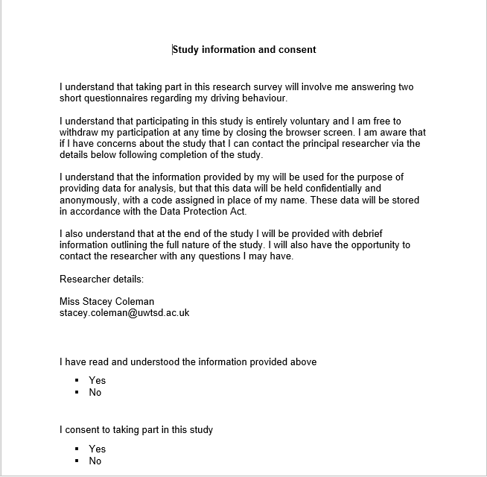
Appendix B: RDB Questionnaire
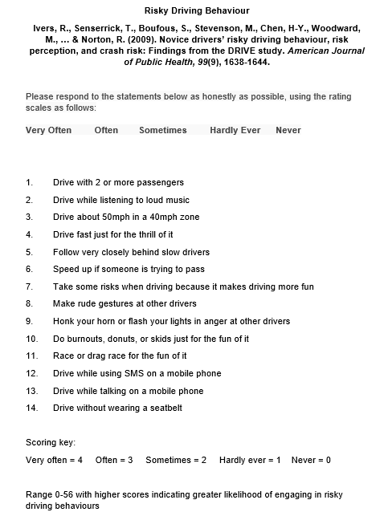

Appendix C: BSSS Questionnaire
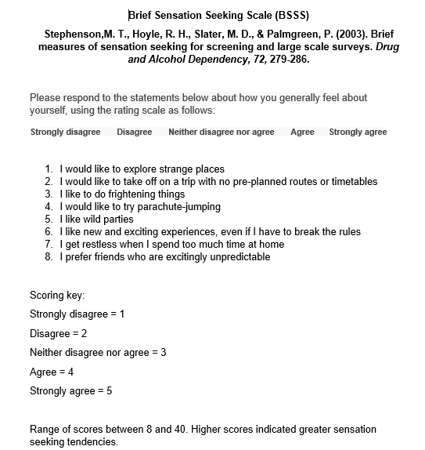
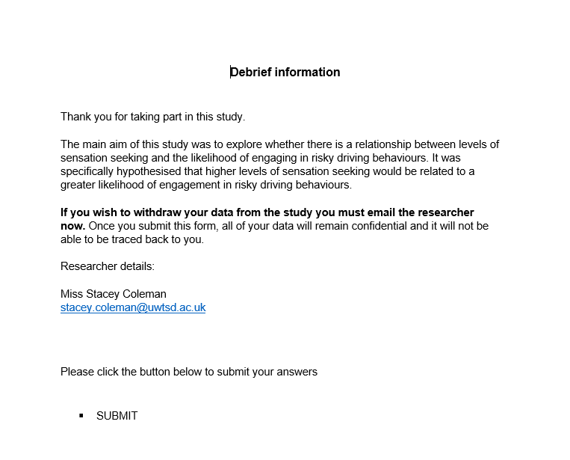
Appendix D: Debrief form

Appendix E: SPSS Output


