Safety in the Workplace

Measure Signs of Illness on the go with Global Temp Analyser

Salma Bibi (1711171)
Module name and code:
Developing Innovation and Creativity for Business Advantage
BMSW6102
Modul Tutor: Dr Md Nazmul Hasan

Learner Group: 3

Table of Contents
Introduction to Innovation 2
Introduction to Drone Markets 2
Innovative Service, Name of Venture and Target Market 2
Where and How I will sell my Product 3
How I Intend to Sustain my Innovative Business Proposition 4
Competitors 4
E-Commerce 4
Using a Marketplace and Creating Content 4
Payment Services 5
Marketing 6
Target Customers and how I will reach them 6
Email Marketing 7
Role of Customer Journeys 7
Pre-Launch Marketing Strategies 7
References 8
Appendices 10
Appendix A 10
Appendix B 15

Introduction to Innovation
Schumpeter (1934) refers innovation to new methods and technology as well as changes in the methods of production and transportation of a new product. Organisations exist in competitive situations and competitors are always producing different ways and altering their product to make it more acceptable to customers to generate more sales. Therefore, companies are trying to out-innovate each other making products which are more interesting to the customers and therefore gives them more opportunity to survive in the market. Innovation is the driving force which results in economic change creating creative destruction.

Introduction to Drone Markets
During uncertainty where priorities are shifting towards the daily global health emergency, different business industries have responded fast to help others through the crisis. Many industries rely on drone services today such as the medical sector, construction, agriculture photography and the filming industry (CompTIA, 2019). Over the years, the drone has become an essential tool in a variety of industries and people have started businesses by using this electronic device. Based on the increase in demand for the services from different industries, the global drone market is expected to grow from 4.4 billion dollars in 2019 to over 63.6 billion dollars by 2025 (Markets and Markets, 2020). Businesses have been using drone services in more innovative ways during the corona virus outbreak from delivering blood samples and results to clinical labs as well as delivering medical prescriptions to the retirement community (Bursztynsky, 2020; Hawkins, 2020). This technology not only helps to maintain social distancing measures but to respond to the challenges of healthcare in the future (BBC NEWS, 2020). These new approaches and emerging technologies are the future of trends to engage with customers in creative ways and to reshape business models.

Innovative Service, Name of Venture and Target Market
A body temperature measurement solution is what the entire world is demanding today; therefore, in order to help customers in this pandemic; my unique plan to deliver value in new ways will be through a disruptive innovative service to implement a new mobile counter-drone service and scanning system. I came up with an attractive name for the venture Global Temp analyser which may increase the chances of selling and would cost £100 in the market. This will monitor and spot signs of illness such as temperature, coughing and infections in the most hazardous public locations such as leisure centres, schools, supermarkets, hotels, train stations, hospitals and airports. Christensen et al, (2015) describes disruptive innovation as any new start up or technology that aims to shake up an industry and alter its competitive patterns. This innovation is an additional software which will be installed in the drone devices and is believed to have potential for solid market opportunity and growth. Businesses will have the opportunity to add the Global Temp analyser as a tool for screening at the entrances to their facilities without the need for complex installations. This service will help improve the process to measure body temperature and signs of illness on the go; which in turn will increase the safety for customers/staff as well as to help solve the spread of the virus. It will provide a solution for the community as it will help businesses deliver better data sets for the NHS and the government.

As most things are done remotely today, this will be a contactless, a very precise and rapid piece of technology which will monitor temperature of multiple people at the same time. As the drone cameras are improving dramatically the key features of this service will allow human face recognition which will consist of a HD vision and thermal network camera used specifically to indicate covid-19 symptoms with an optional alarm if high temperature is detected. This unique deliverable service will capture high resolution images and video’s that will be taken from above that cannot be matched to a face to face scan.

Where and How I will sell my Product
During global economic uncertainty and cities going under lockdown, more people are adapting to shop online while customers are generally avoiding public places. Statista (2019) forecasts over 2.14 billion people worldwide are expected to buy goods and services online in 2021, up from 1.66 billion global digital buyers in 2016. The global e-retail sales continue to grow, and figures are expected to reach from 14.1% to 22% in 2023 (Statista, 2020).

As purchasing goods online has become a common practice, it is believed by utilising third party company eBay with the addition of creating my own online website will increase sales as a wider audience can reach my product. The Global Temp Analyser will also be advertised and sold via online marketing, through Facebook and Instagram. These are renowned platforms where people choose and make online purchases. However, although there’s a good audience on these specific platforms to build a good relationship; there is also a disadvantage with this concept because customers can do a price comparison to similar products on that same platform. They might see other similar items of the specific product roughly the same price or cheaper. Therefore, it is important that I increase my conversions, and this will be done via communicating and building trust using these platforms; consumers need to have the assurance that I can deliver on what I am promising.

How I Intend to Sustain my Innovative Business Proposition
In order to create a sustainable and a unique value business; the Global Temp Analyser will focus on differentiating itself beyond customer service to identify the specific illness and communicate on how to solve a customer’s problem. So, it will identify and acknowledge the customers’ needs and show that it will help solve that problem.

Competitors
Today, artificial intelligence and smart technologies are transforming how we live, produce and consume. Innovation has ideally made everyone’s lives better by achieving competitive advantage and distinguishing themselves from other businesses by providing original solutions to the existing problems. Since the context of covid-19 pandemic situation, many body temperature measurement devices have been invented to detect people who can possibly be infected with the illness. Bray (2020) states stick on body sensors called NIRA Temp, is similar to a fitness tracker smart watch but is cheaper, smaller and a lot simpler which is attached to the body like an adhesive bandage. This device can detect changes in body heat that may indicate the infection. Similarly, a respiratory infections virus detector called a reverse transcription polymerase chain reaction, (RT-PCR) can detect even tiny number of viruses -- but at the same time it can be time consuming and prone to error (ScienceDaily, 2020; Qiu, et al, 2020). Data shows the global temperature sensor market size, has stood at USD 5.02 billion in 2018 and is projected to reach USD 7.88 billion by 2026 (The fortune business insights, 2020).

E-Commerce
Consumers are shifting their spending from in-store to online and e-commerce since the global pandemic has changed everyday lifestyle. It has become critical for businesses to rely on online platforms to sell their products from digital goods, hand crafted items, grocery to online education courses.

Using a Marketplace and Creating Content
At first, I started to do my market research, where the demand for the product will be really high, what people are looking for and what they actually require. Then, in order to sell the product online I checked amazon and eBay which are huge third party platforms and it’s likely that my target customers will be on those platforms so I want to have my listing on those platforms as well as creating my own e-commerce website and selling it on there. There are advantages and disadvantages to both of these concepts, therefore I believe it is better to use both eBay and e-commerce. Please see (Appendix A) where I have created my own website via Wix and will make use of search engine optimization so I’m showing up on Google for queries that are relevant to my product as well as being active on social media platforms such as Instagram and Facebook where I can build a community to advertise my product.

In order to get to the top of the search result I will have to pay Google ads which is another opportunity to show my service. Within google there’s Organic Results and these are the things that Google puts in the search results for free when there is a really high-quality content and Google knows it will provide a Solution. However, to get to the top of the search results there is a charge. The benefit of using Google payed ads is that it will accelerate my results and the way it works is how I tell them that I want my ad to be on the top of the search results. Only when someone searches with a certain targeted keyword or a long-tail key word, for instance if they type in the sentence “covid-19 temp measurement” I know the person searching is much more likely to buy my product than someone that’s searching more generic. I will pay google only when customers take action by clicking on the ad to visit the website so I’m not losing out (Google Ads, 2020). Even though I’ll be paying Google every time someone clicks on my ad and on average if every ten people who click on the website, I make a sale and profit in return. So, spending £10 to make a £100 is not so bad.

In order to make more sales the product has been listed on eBay marketplace (Appendix B) accompanying more active buyers on this platform; with daily transactions reaching 182 million consumers worldwide (Statista, 2020). Before I got started, I browsed a few listings in order to experiment eBay’s search features and read through selling policies. This platform will allow me to list my item for sale without any confusion as eBay is simple to use. Setting up an account and profile on eBay is pretty straightforward and can start selling immediately. Customers can type in the name of a temperature analyser in the search bar which will bring up a list of the relevant items that match that description.

Payment Services

The payment card industry data security standard (PCI DSS) was developed to enhance and encourage data security for card holders, and to facilitate the broad adoption of consistent data security measures globally. It applies to all service providers and merchants that store, process or transmit cardholder data. Although as a merchant I will be using PayPal to accept payments as this is the safest option for people to handle money between accounts, my business will be accepting their information therefore my business will be required to be PCI compliant. PayPal has been operating since the beginning of online transaction; it’s a platform where different currencies in the world can operate through PayPal. This means I can be selling my product globally via PayPal and customers are eligible for money back guarantee. PayPal acts as a digital wallet and when people need to send money it will come from the savings, debit or credit account. At times when customers do not have a card on them it is convenient for them to use PayPal.

General Data Protection Regulation (GDPR) cover things that could identify people. eBay have redesigned their registration process and privacy consent, so it empowers people who give their data; contact details such as name, address as well as personal data and provide users more control and to be more transparent. Organisations will have to prove they have a lawful reason for holding people’s data and show that they’re keeping it safe. eBay allows people to access their own personal data, modify or delete their personal information (eBay, 2020). Some campaigners say this is a chance for the biggest companies to rebuild trust with their customers after scandals involving the misuse of data.

Marketing

The Product life cycle, developed by Raymond Vernon 1966 is a widely used theoretical model that’s useful for marketing and business strategy which describes the stages a product goes through from the moment its developed and launched on to the market all the way through to the end of its life and the stages in between. The product life cycle identifies five stages which are product development, introduction, growth phase, a maturity phase and followed by the end decline phase. Once the product id launched it enters the introduction phase and then as sales and profits accelerate it enters the growth phase, then the product is in mature phase and eventually dies. Some goods go through all four stages while others stay in the maturity phase for some time. Due to the evolving lifestyle I feel this theoretical model will be useful to determine how to target and position my product in the market.

Target Customers and how I will reach them
The product will be advertised on social media platforms such as Instagram and Facebook Marketplace which is absolutely free. It is important that I build a network, connection and above all build trust with users; as a result, people will buy from me for who I am and not what I do. I will network who I truly am as a person, who really cares about people and not just for marketing purpose and finding customers. Once I have identified my target market, I can then start reaching out to customers based on their needs. My target customers vary from small businesses to large organisations who are supermarkets, offices, factories, schools, public transport companies, train station and airports. The product can be used in key access points to help institutions, businesses and venues to provide a safer environment for customers, staff and visitors. Customers will be reached though google ads, Search engine optimization (SEO), and social media platforms. The difference between google ads and (SEO) is that google ads is easier to set up and it immediately takes effect.

Email Marketing
Email marketing is a method for telling customers about a product or service that a business offers. It’s a tool that allows us to give them insight about the product and it’s a good way to build a good working relationship with them. Email marketing is the most underrated digital marketing channel as not everyone has Facebook or uses social media channels, but everyone has an email address. As an entrepreneur, the email list is a portable asset which can grow with me, because there’s so many digital marketing channels that has value today which might not have tomorrow as they change dramatically.

Role of Customer Journeys
In the competitive economy, I will build a community from transactional to meaningful customer relationships. Here, I will ensure that I support my customers before, during and after their purchase of the product by maintaining privacy limits. I will adhere to the customers preference on which channel to reach them on; either by email phone or message. For a business that deals with many customers, this approach makes it possible to make every customers interaction personal. Having empathy will allow me to connect with customers and have a meaningful interaction. The main thing is they have a good experience, so they remain my loyal customers. By getting feedback on the product or service I will identify my blind spots and know where I can work on to improve also knowing if their purchase is actually transforming their lives and giving them the results will create a meaningful customer service and experience.

Pre-Launch Marketing Strategies
Before I start selling my product, I will start blogging on social media platforms as information sells much easier than a product does. I will pre-sell my product with a discount before initially launching; this will allow my product to grow its hype and market as well as collecting feedback, in order to earn more trust from customers when I initially introduce the venture. I can invite influencers to share stories, interview them or get them to post on my site with feedback.

References

- BBC NEWS (2020) Available at; https://www.bbc.co.uk/news/av/uk-england-essex-54600585
- Bray, H (2020). Available at; https://www.bostonglobe.com/2020/07/27/business/stick-on-body-sensors-offer-new-hope-against-covid-19/
- Bursztynsky, J (2020) Available at; https://www.cnbc.com/2020/04/27/coronavirus-cvs-ups-delivering-prescriptions-with-drones.html
- Christensen, C. M., McDonald, R. and Raynor, M. (2015). ‘What is disruptive innovation?’. Harvard Business. Review, 93, 44-53
- CompTIA, (2019) Available at; https://www.comptia.org/content/research/drone-industry-trends-analysis
- eBay (2020). Available at; https://www.ebay.com/help/selling/selling/gdpr-obligations-selling-ebay?id=4768
- Google Ads (2020) Available at; https://ads.google.com/intl/en_uk/home/pricing/
- Hawkins, A.J (2020) Available at; https://www.theverge.com/2020/4/27/21238196/ups-cvs-drone-delivery-medicine-florida-coronavirus
- Markets and Markets (2020). Available at; https://www.marketsandmarkets.com/Market-Reports/drone-services-market-80726041.html
- Qiu, G. Gai, Z. Tao, Y. Schmitt, J. Kullak-Ublick, G and Wang, J. (2020). Dual-Functional Plasmonic Photothermal Biosensors for Highly Accurate Severe Acute Respiratory Syndrome Coronavirus 2 Detection. Available at; https://pubs.acs.org/doi/10.1021/acsnano.0c02439. ACS Nano 2020 14 (5), 5268-5277. DOI: 10.1021/acsnano.0c02439
- Schumpeter, J.A. (1934), The theory of economic development: an inquiry into profits, capital, credit, interest and the business cycle, Harvard Economic Studies, Vol. 46, Harvard College, Cambridge, MA.
- ScienceDaily, (2020). Swiss Federal Laboratories for Materials Science and Technology (EMPA). A new biosensor for the COVID-19 virus: Detection in the environment. Available at; https://www.sciencedaily.com/releases/2020/04/200421112520.htm
- Statista (2019). Available at; https://www.statista.com/statistics/251666/number-of-digital-buyers-worldwide/
- Statista (2020). Available at; https://www.statista.com/statistics/534123/e-commerce-share-of-retail-sales-worldwide/
- Statista, (2020). Available at; https://www.statista.com/statistics/242235/number-of-ebays-total-active-users/
- The fortune business insights (2020) Available at; https://www.fortunebusinessinsights.com/temperature-sensor-market-102434

Appendices

Appendix A

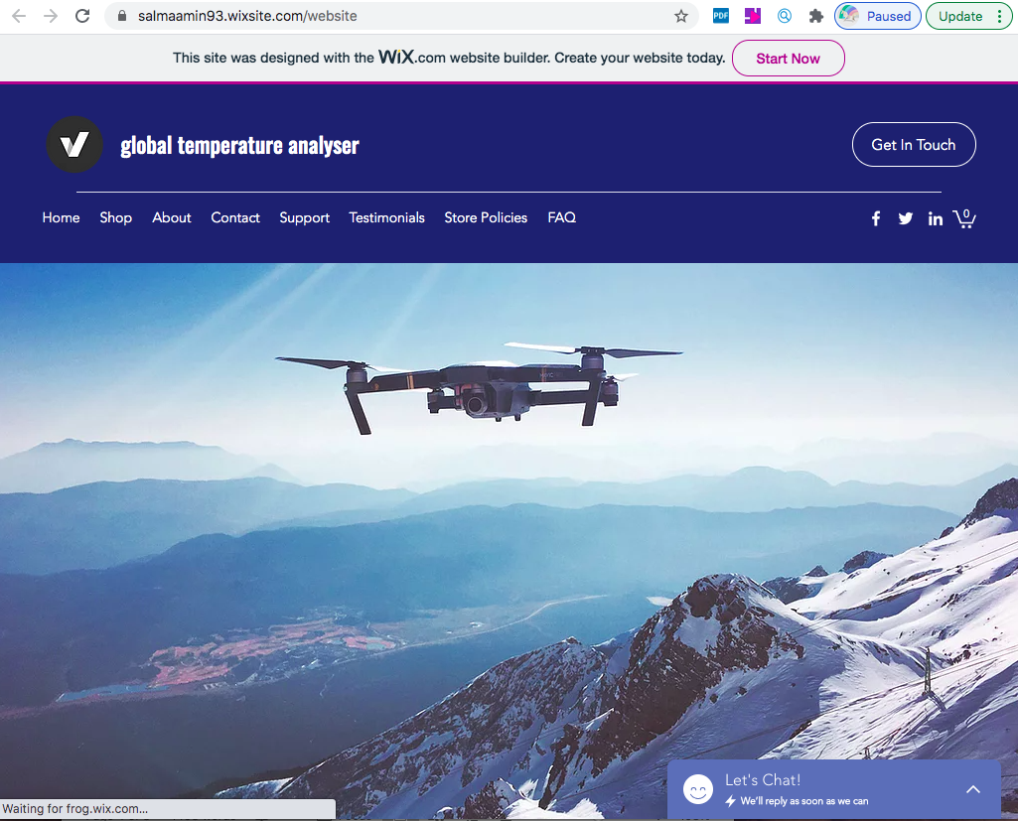

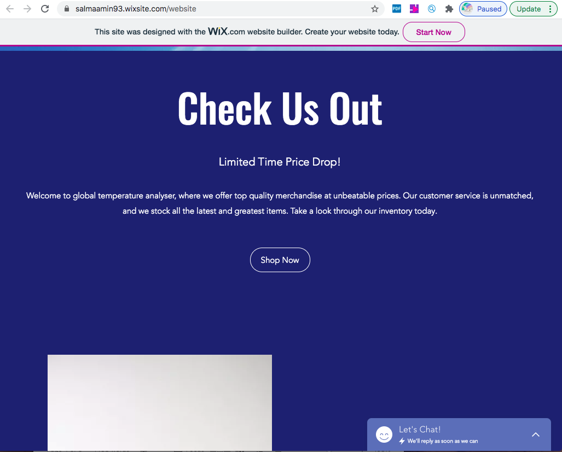

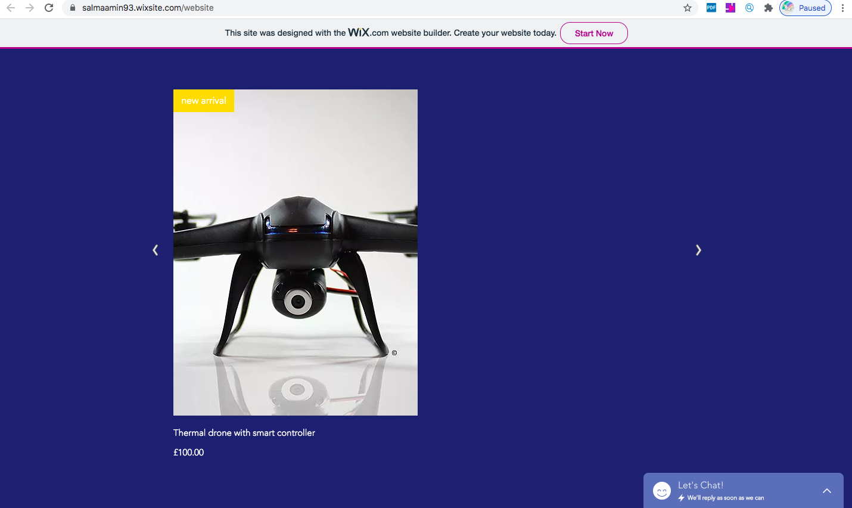

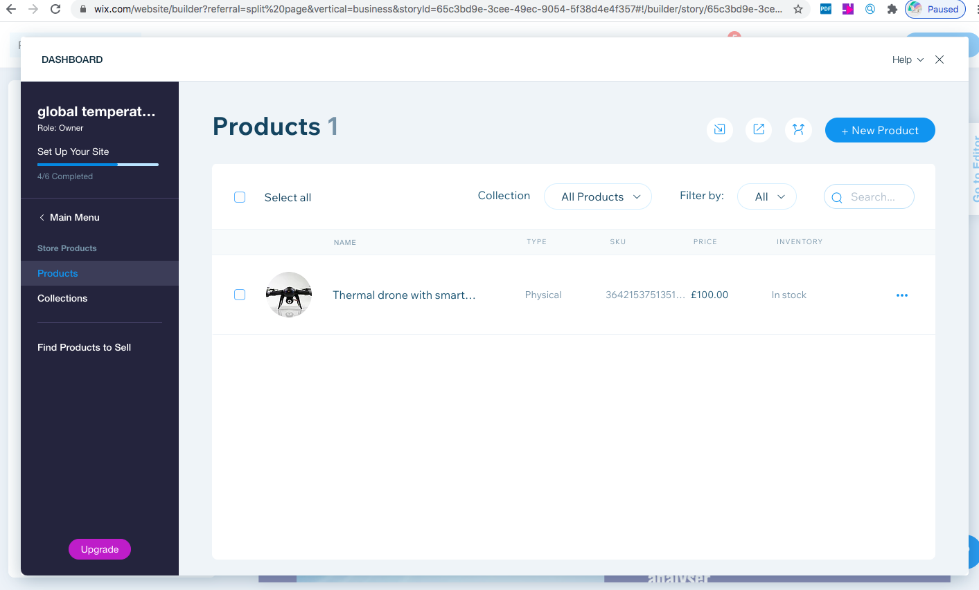

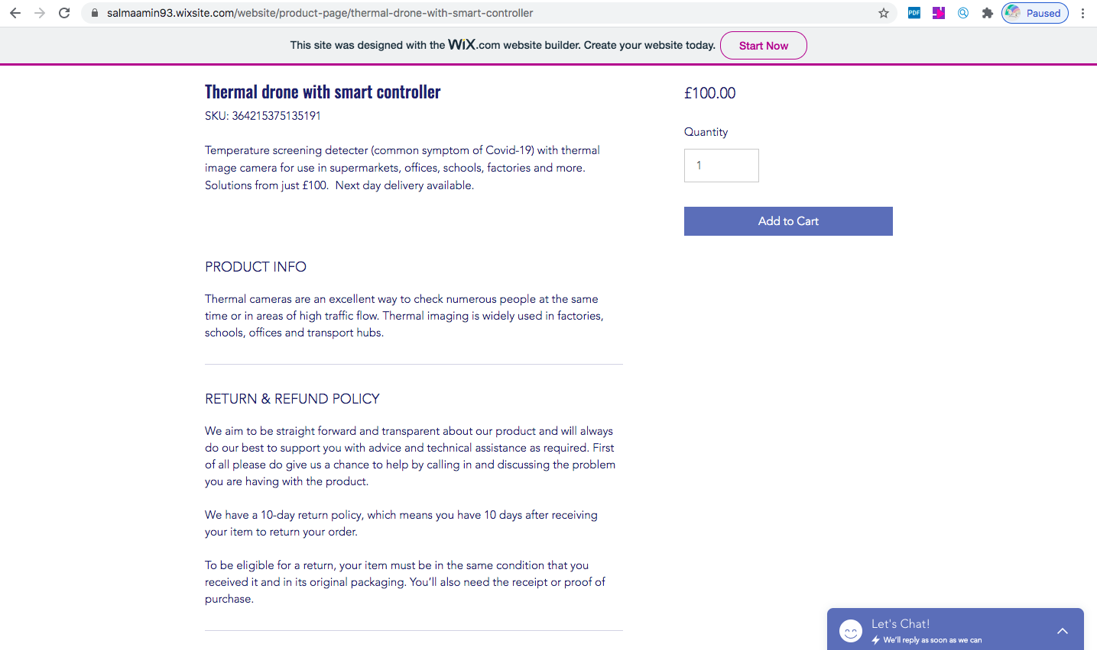

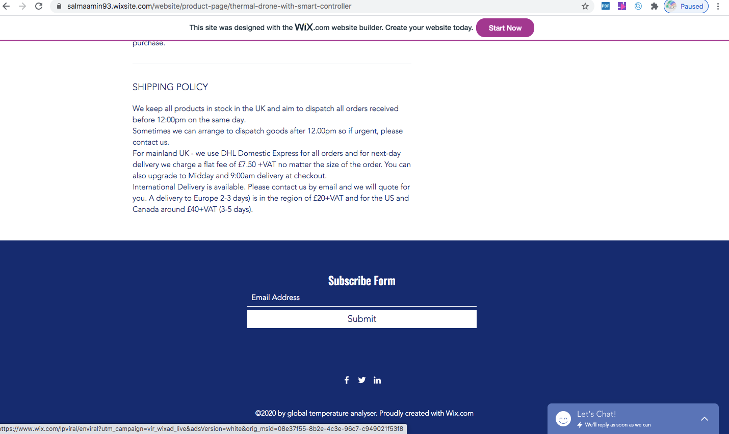

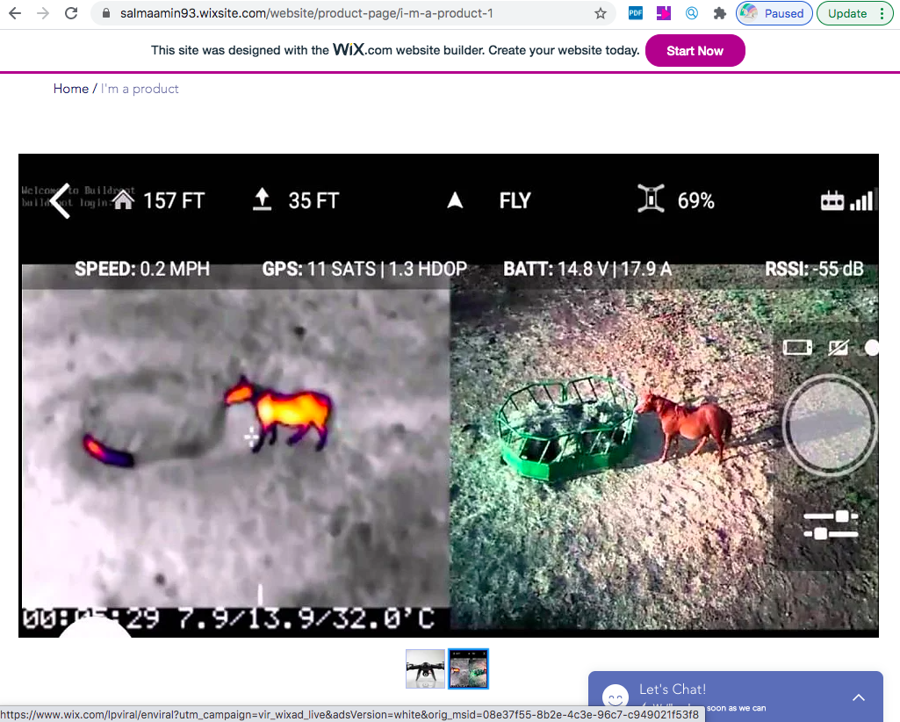

Available at; https://salmaamin93.wixsite.com/website

Appendix B



